Easy English

Young People Inclusion Plan
2021 - 2023

Cover image: By Bonni McLaren

The V.E.C. respects the Aboriginal people
of Victoria.

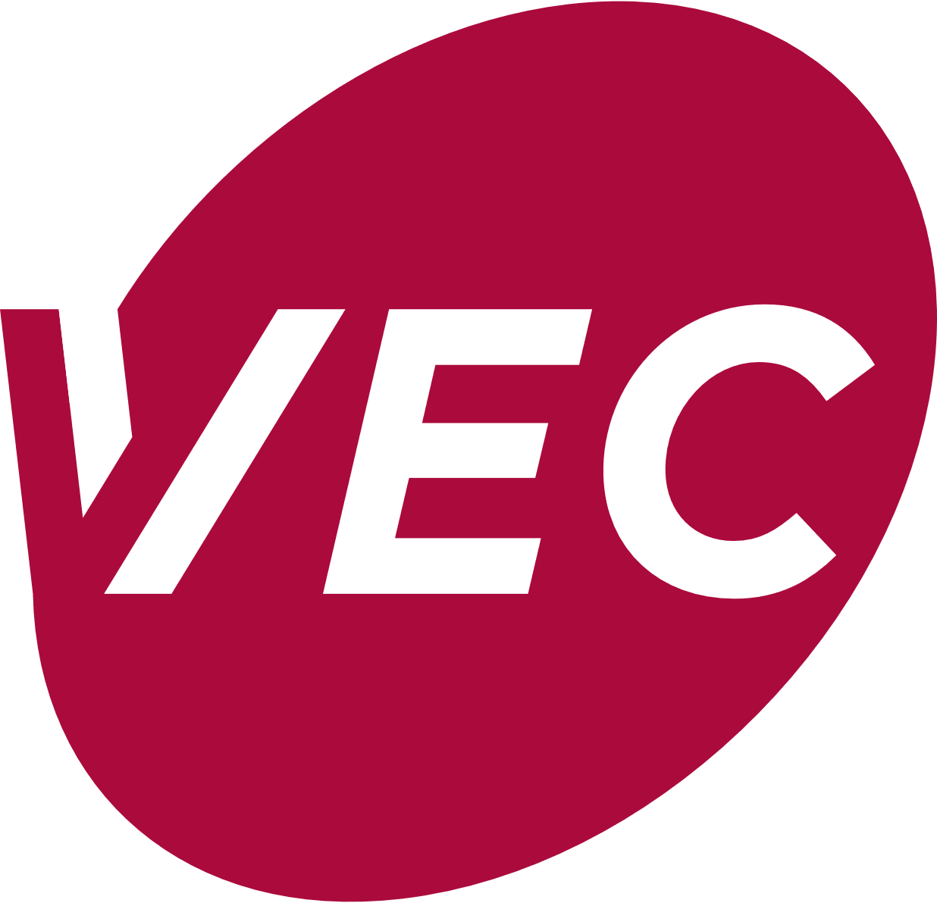
This information is from the
Victorian Electoral Commission.
We write V.E.C. when we talk about us.
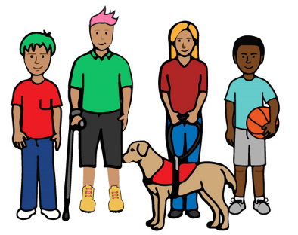
This plan is for and about young people across Victoria. We will write ‘Young People’ when we talk about them.

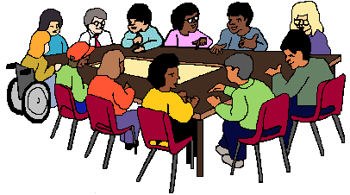
We will form a group to help us do our work.
They will be called the Young People Advisory Group.

From the Electoral Commissioner
Warwick Gately, AM
He is the boss of the V.E.C.
He is called the Electoral Commissioner.

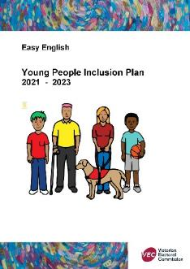
This is our plan to be better at our work
with young people.

We have worked with young people before

but

we can do more.

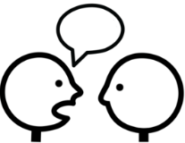
We talked to different young people groups in the community and people who work at the VEC.

This plan helps us

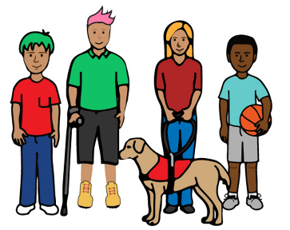
• work more closely with young people
and
• work out what we can do better
- for young people in their communities
- for young people at the V.E.C.

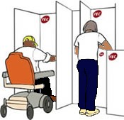
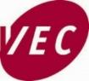

About the V.E.C.

The V.E.C. runs
- the Victorian State elections
- the local council elections.

What we say about people who speak to us about voting
The V.E.C. includes everyone. The V.E.C.
- is independent
- is fair
- tells us all what they do.

The V.E.C.
- respects everyone in the community
- uses new ideas to make things better.

The V.E.C. is not part of the government.

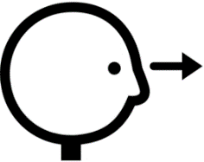
Things we have done
The V.E.C. has done lots of work with young people like
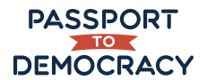
- the Passport to Democracy Program for students in grade 4 to year 10
- the Partner Up program for students in year 11 and 12
- the Victorian Student Representative Council and YMCA Victoria.

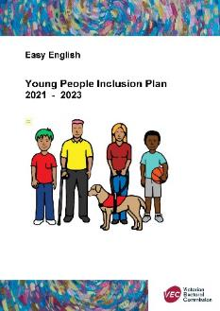
About this plan

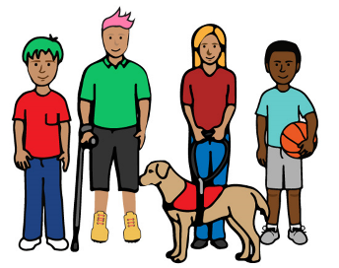
We talked about this plan with

- young people in the community
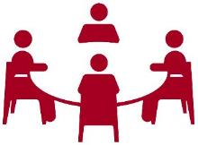
- V.E.C. staff
- staff from other places

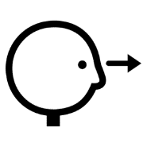

We will do a big review of this plan in 2023.
This is in 2 and a half years.

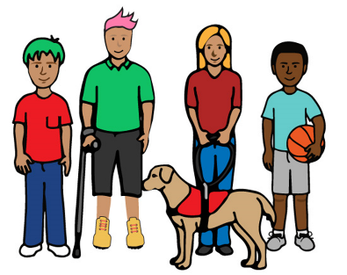
We want more people to know how to vote like

- young people
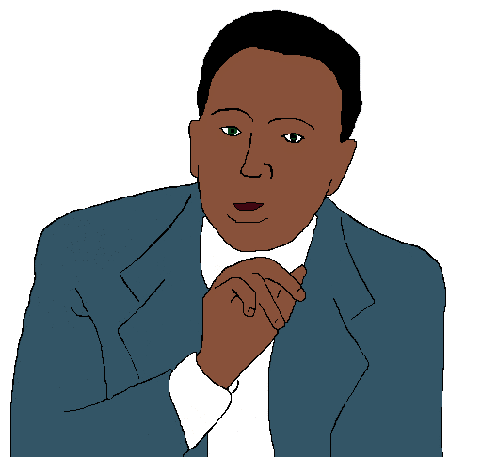
- people from many cultures

- Aboriginal and Torres Strait Islander peoples

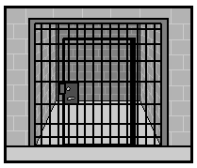
• people who do not have a home
• people in prisons.

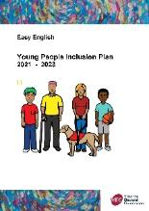
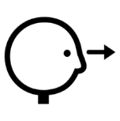

The plan
This plan is for 2021 to 2023.
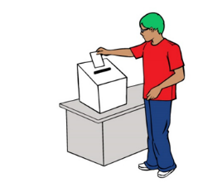
This plan is about
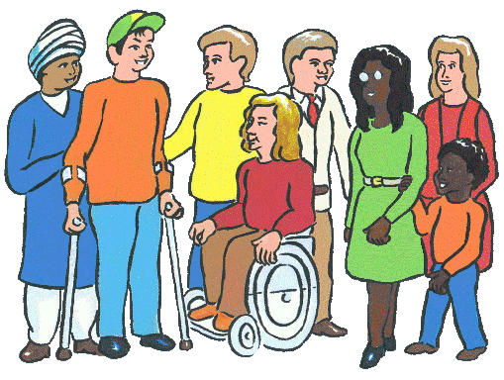
- Access.

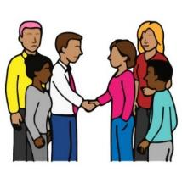
2. The people who work for us.
- Working together in the community.
- Staff skills. Be the best we can.

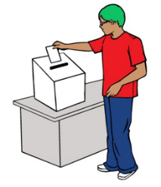
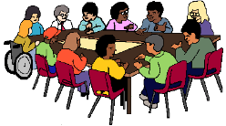
1. Access
- We will make a group called the Young People Advisory Group and meet more than 2 times a year.
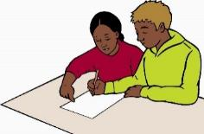
- We will ask young people to help with our social media.
- We will teach young people who are not at school about voting.
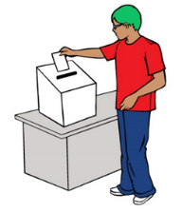
- We will think of young people when we plan places to vote.

2. The people who work for us
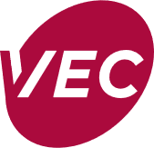
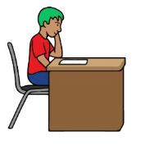
- We will have more young people work at the V.E.C.
- We will have young people work at the next State election.
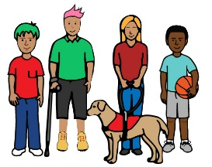
- We will have a special team of young people called Democracy Ambassadors teach young people about voting before the State election.

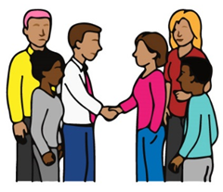
3. Working together in
the community

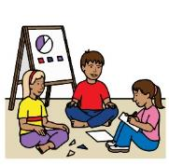
- We will help groups that work with young people.
- We will help teams of young people.
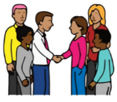
- We will find new people in the community who support young people and help them too.
- We will make sure the Passport to Democracy Program is taught to lots of different young people in Victoria.
- We will work with teachers, so they know more about the Passport to Democracy Program.

4. Staff skills.
Be the best we can be

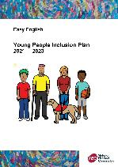

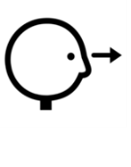
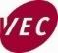

a. We will hire a young person to help with our plan to be better at our work with young people.

b. We will ask young people to help us when we make new plans and lessons.

c. We will teach V.E.C. staff about working with lots of different people.

Reports

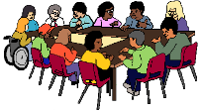
We will tell the Young People Advisory Group what we have done.

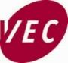
We write a report about this plan
each year.

This report will be part of the V.E.C. big report each year. It is called the V.E.C. Annual Report.

More information

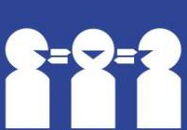
Interpreter 9209 0112.

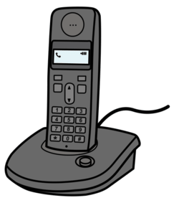
Phone 03 8620 1100

Email info@vec.vic.gov.au

V.E.C.
Level 11.
530 Collins Street. Melbourne 3000.

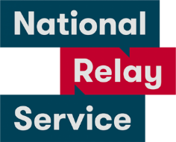
National Relay Service 1800 555 600.

Images
We used images from
- Inspired Services
- Picto-selector
- Pinterest
- The Noun Project
- Tobii-Dynavox
and
- VEC images.

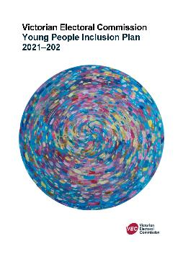
This plan is based on the V.E.C. Young People Inclusion Plan 2021 - 2023.

© State of Victoria (Victorian Electoral Commission) 2021.
This work, VEC Young People Inclusion Plan, is licensed under a Creative Commons Attribution 4.0 licence (http://creativecommons.org/licenses/ by/4.0/). You are free to re-use the work under that licence, on the condition that you credit the State of Victoria (Victorian Electoral Commission) as author, indicate if changes were made and comply with the other licence terms. The licence does not apply to any branding, including government logos.
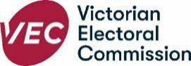
Level 11, 530 Collins Street
Melbourne Victoria 3000
T 131 832
info@vec.vic.gov.au
vec.vic.gov.au

