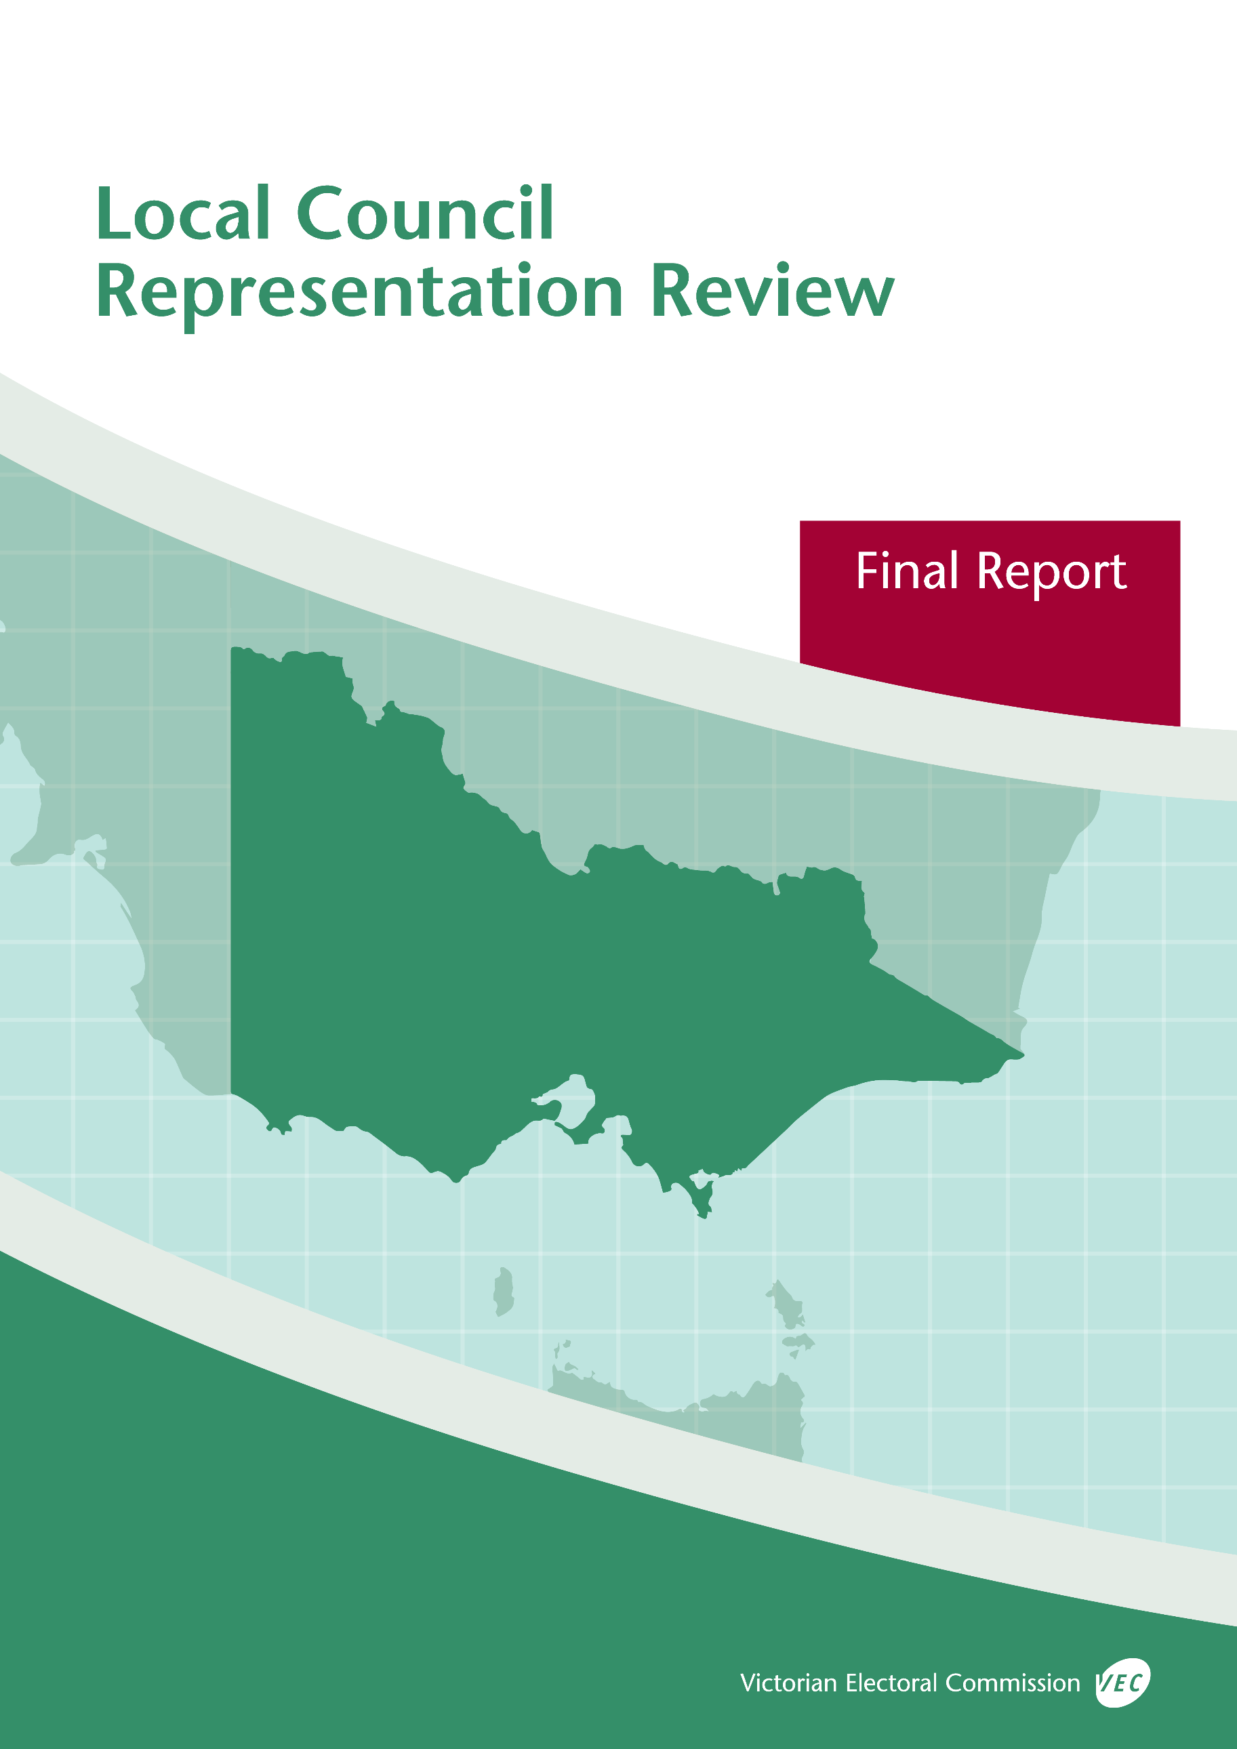



**Greater   
Dandenong City Council**

**October 2019**

© State of Victoria (Victorian Electoral Commission)   
Wednesday 9 October 2019

Version 1  
  
cid:image001.png@01D4D431.F774F3F0

This work, Local Council Representation Review Final Report – Greater Dandenong City Council, is licensed under a Creative Commons Attribution 4.0 licence [<http://creativecommons.org/licenses/by/4.0/>]. You are free to share this work under that licence, on the condition that you do not change any content and you credit the State of Victoria (Victorian Electoral Commission) as author and comply with the other licence terms. The licence does not apply to any branding, including Government logos.

Contents

Recommendation 1

Executive summary 2

Legislative basis 4

Public engagement 4

The VEC’s principles 5

Developing recommendations 6

Greater Dandenong City Council representation review 8

Profile of Greater Dandenong City Council 8

Current electoral structure 11

Preliminary submissions 11

Preliminary report 12

Public response 16

Response submissions 16

Public hearing 18

Findings and recommendation 20

The VEC’s findings 20

The VEC’s recommendation 23

Appendix 1: Public involvement 24

Appendix 2: Map 26

Appendix 3: Public information program 28

Recommendation

The Victorian Electoral Commission recommends that consist of 11 councillors elected from four wards with adjustments to the current ward boundaries (three three-councillor wards and one two-councillor ward).

This recommendation is submitted to the Minister for Local Government as required by the *Local Government Act 1989*.

Please see Appendix 2 for a detailed map of this recommended structure.

Executive summary

The *Local Government Act 1989* (the Act) requires the Victorian Electoral Commission (VEC) to conduct an electoral representation review of each municipality in Victoria before every third council general election.

The purpose of an electoral representation review is to recommend an electoral structure that provides fair and equitable representation for people who are entitled to vote at a general election of the council. The matters considered by a review are:

* the number of councillors
* the electoral structure of the council (whether the council should be unsubdivided or divided into wards and, if subdivided, the details of the ward boundaries and the number of councillors per ward).

The VEC conducts all reviews based on three main principles:

1. taking a consistent, State-wide approach to the total number of councillors
2. if subdivided, ensuring the number of voters represented by each councillor is within   
   plus-or-minus 10% of the average number of voters per councillor for that local   
   council
3. ensuring communities of interest are as fairly represented as possible.

Current electoral structure

Greater Dandenong City Council currently comprises 11 councillors elected from four wards (three three-councillor wards and one two-councillor ward). More information on Greater Dandenong City Council and the current electoral structure is available in the council fact sheet on the VEC website at [vec.vic.gov.au](http://vec.vic.gov.au).

Prior to the last representation review in 2008, Greater Dandenong City Council was comprised of 11 councillors elected from 11 single-councillor wards. Visit the VEC website at [vec.vic.gov.au](http://www.vec.vic.gov.au/) to access a copy of the 2008 review final report.

Preliminary submissions

Preliminary submissions opened at the commencement of the current review on Wednesday   
19 June 2019. The VEC received 22 submissions for the representation review of by the deadline at 5.00 pm on Wednesday 17 July 2019.

Preliminary report

A preliminary report was released on Wednesday 14 August 2019 with the following options for consideration:

* Option A (preferred option)  
  **Greater Dandenong City Council consist of 11 councillors elected from four wards with adjustments to the current ward boundaries (three three‑councillor wards and one two-councillor ward).**
* Option B (alternative option)  
  **Greater Dandenong City Council consist of 11 councillors elected from four wards with adjustments to the current ward boundaries, different to Option A (three three‑councillor wards and one two-councillor ward).**

Response submissions

The VEC received 14 submissions responding to the preliminary report by the deadline at   
5.00 pm on Wednesday 11 September 2019.

Public hearing

The VEC conducted a public hearing for those wishing to speak about their response submission at on Wednesday 18 September 2019. One person spoke at the hearing.

Recommendation

**The Victorian Electoral Commission recommends that Greater Dandenong City Council consist of 11 councillors elected from four wards with adjustments to the current boundaries (three three‑councillor wards and one two-councillor ward).**

This electoral structure was designated as Option A in the preliminary report. The recommended ward boundaries include a minor adjustment from those designated in Option A in the preliminary report.

Please see Appendix 2 for a detailed map of this recommended structure.

Background

Legislative basis

The Act requires the VEC to conduct a representation review of each local council in Victoria before every third general council election, or earlier if gazetted by the Minister for Local Government.

The Act states that the purpose of a representation review is to recommend the number of councillors and the electoral structure that provides ‘fair and equitable representation for people who are entitled to vote at a general election of the Council.’[1]

The Act requires the VEC to consider:

* the number of councillors in a local council
* whether a local council should be unsubdivided or subdivided.

If a local council is subdivided, the VEC must ensure that the number of voters represented by each councillor is within plus-or-minus 10% of the average number of voters per councillor for that local council.[2] On this basis, the review must consider the:

* number of wards
* ward boundaries
* number of councillors that should be elected for each ward.

Public engagement

### Public information program

The VEC conducted a public information program to inform the community of the representation review, including:

* public notices printed in local and State-wide papers
* a public information session to outline the review process and respond to questions from the community
* a media release announcing the commencement of the review and the release of the preliminary report
* a submission guide to explain the review process and provide background information on the scope of the review
* an information email campaign targeted at known community groups and communities of interest in the local council area
* sponsored social media advertising geo-targeted to users within the local council   
  area
* ongoing information updates and publication of submissions on the VEC website.

More information on the VEC’s public information program for the representation review of can be found at Appendix 3.

### Public consultation

Public input was accepted by the VEC via:

* preliminary submissions at the start of the review
* response submissions to the preliminary report
* a public hearing that provided an opportunity for people who had made a response submission to expand on their submission.

Public submissions are an important part of the review process but are not the only consideration. The VEC ensures its recommendations comply with the Act and are formed through careful consideration of public submissions, independent research, and analysis of all relevant factors.

The VEC’s principles

Three main principles underlie all the VEC’s work on representation reviews:

1. **Taking a consistent, State-wide approach to the total number of councillors.**

The VEC is guided by its comparisons of local councils of a similar size and category to the council under review. The VEC also considers any special circumstances that may warrant the local council having more or fewer councillors than similar local councils.

1. **If subdivided, ensuring the number of voters represented by each councillor is within plus-or-minus 10% of the average n****umber of voters per councillor for that local council.**

This is the principle of ‘one vote, one value’, which is enshrined in the Act. This means that every person’s vote counts equally.

1. **Ensuring communities of interest are as fairly represented as possible.**

Each local council contains a number of communities of interest. Where practicable, the electoral structure should be designed to ensure they are fairly represented, and that geographic communities of interest are not split by ward boundaries. This allows elected councillors to be more effective representatives of the people and interests in their particular local council or ward.

Developing recommendations

The VEC bases its recommendations for particular electoral structures on the following information:

* internal research specifically relating to the local council under review, including data from the Australian Bureau of Statistics and .id[3]; voter statistics from the Victorian electoral roll; and other State and local government data sets
* small area forecasts provided by .id for relevant local council areas
* the VEC’s experience conducting previous electoral representation reviews of local councils and similar reviews for State elections
* the VEC’s expertise in mapping, demography and local government
* careful consideration of all input from the public in written submissions received during the review and via oral submissions at the public hearing
* advice from consultants with extensive experience in local government.

### Deciding on the number of councillors

The Act allows for a local council to have between five and 12 councillors but does not specify how to decide the appropriate number.[4] In considering the number of councillors for a local council, the VEC is guided by the Victorian Parliament’s intention for fairness and equity in the local representation of voters under the Act.

The starting point in deciding the appropriate number of councillors for a local council is comparing the local council under review to other local councils of a similar size and type (Principle 1). Generally, local councils that have a larger number of voters will have a higher number of councillors. Often large populations are more likely to be diverse, both in the nature and number of their communities of interest and the issues of representation.

However, the VEC also considers the particular circumstances of each local council which could justify fewer or more councillors, such as:

* the nature and complexity of services provided by the Council
* geographic size and topography
* population growth or decline
* the social diversity of the local council.

### Deciding the electoral structure

The Act allows for a local council ward structure to be unsubdivided—with all councillors elected ‘at-large’ by all voters—or subdivided into a number of wards.

If the local council is to be subdivided into wards, there are three options available:

1. single-councillor wards
2. multi-councillor wards
3. a combination of single-councillor and multi-councillor wards.

A subdivided electoral structure must have internal ward boundaries that provide for a fair and equitable division of the local council.

The Act allows for wards with different numbers of councillors, as long as the number of voters represented by each councillor is within plus-or-minus 10% of the average number of voters per councillor for that local council (Principle 2). For example, a local council may have one   
three-councillor ward with 15,000 voters and two single-councillor wards each with 5,000 voters. In this case, the average number of voters per councillor would be 5,000.

Over time, population changes can lead to some wards in subdivided local councils having larger or smaller numbers of voters. As part of the review, the VEC corrects any imbalances and considers likely population changes to ensure ward boundaries provide equitable representation for as long as possible.

In considering which electoral structure is most appropriate, the VEC considers the following matters:

* the VEC’s recommendation at the previous representation review and the reasons for that recommendation
* the longevity of the structure, with the aim of keeping voter numbers per councillor within the 10% tolerance for as long as possible (Principle 2)
* communities of interest, consisting of people who share a range of common concerns, such as geographic, economic or cultural associations (Principle 3)
* the number of candidates in previous elections, as outcomes from previous elections indicate that large numbers of candidates can lead to an increase in the number of informal (invalid) votes
* geographic factors, such as size and topography
* clear ward boundaries.

representation review

Profile of Greater Dandenong City Council

The City of Greater Dandenong covers an area of 130 square kilometres and is approximately   
24 kilometres south-east of Melbourne’s CBD. The traditional owners of the lands known as Greater Dandenong City Council include the Bunurong/Boonwurrung and Wurundjeri people of the Kulin Nation.[5]

The City of Greater Dandenong’s suburbs include Noble Park (with a population of 30,998 at the 2016 Census), Dandenong (29,906), Keysborough (25,785), Dandenong North (22,451), Springvale (21,714), Springvale South (12,768), Noble Park North (7,468), Bangholme (784), Dandenong South (160), and a part of Lyndhurst.[6] Most of the residential and commercial areas are located in the northern and central part of the local council area. The southern part of the local council area includes a large industrial precinct and Green Wedge areas that are part of the wider South East Green Wedge.[7] The industrial precinct in Dandenong South employs people in manufacturing, wholesale and transport, postal and warehousing, and the precinct is ‘one of Australia’s most significant and productive manufacturing areas’.[8]

The City of Greater Dandenong’s population is ethnically diverse and the City is home to residents from 157 different birth countries.[9] The population of residents born overseas also includes a substantial number of refugee and humanitarian arrivals. According to the 2016 Census, the most common origins are Vietnam, India, Cambodia, Sri Lanka and Afghanistan. Approximately 64.5% of households speak a language other than English, which is well above 27.8% for Victoria generally. After English, the most common languages spoken at home are Vietnamese, Khmer, Punjabi, Mandarin and Cantonese.[10] Close to a quarter of the City’s population born overseas are not proficient in English (at 24.5%), which is significantly higher than 13.3% for Greater Melbourne generally.[11]

The median age in the City of Greater Dandenong is 35 years, which is slightly younger than the median age of 36 years for Greater Melbourne.[12] The age profile is similar across the suburbs, except for the semi-rural suburb of Bangholme in the south, with a median age of 68 years old.

There are approximately 38,473 families in the City of Greater Dandenong. Of these families, 49% are couples with children and 29.7% are couples without children – compared to 48.5% and 34.5% respectively for Greater Melbourne. Households are generally larger in the City of Greater Dandenong at an average of 2.9 persons per household compared to Greater Melbourne’s average of 2.7. There is a larger percentage of one-parent families in the City of Greater Dandenong (18.7%) compared to Greater Melbourne (15%).[13]

According to the Socio-Economic Index for Areas (SEIFA) Index of Relative Disadvantage, the City of Greater Dandenong’s score is 896, making it the second most disadvantaged Victorian local council area after Central Goldfields Shire.[14] The level of socio-economic disadvantage is also reflected in other demographic characteristics. Average income is lower in the City of Greater Dandenong compared to the Victorian average. The unemployment rate, at 10.3%, is also higher than the average for Victoria at 6.6%.[15]

The top five industries of employment in the City of Greater Dandenong include manufacturing (15.8%), health care and social assistance (11.2%), retail trade (10.4%), construction (7.3%) and accommodation and food services (6.9%). The top five occupations include labourers (17.2%), technicians and trade workers (15.5%), professionals (13.5%), machinery operators and drivers (12.1%) and clerical and administrative workers (11.4%).[16] The City of Greater Dandenong has a higher proportion of people employed as labourers, technicians and trade workers and machinery operators compared to Greater Melbourne generally.[17]

The Dandenong Activity Centre is a major retail and commercial hub in the metropolitan south-east and is known for its shopping and food experiences, and its cultural precincts, which include the Afghan Bazaar and Little India. Springvale has the City’s second largest activity centre, which is known for its Asian-themed groceries and restaurants. Noble Park’s activity centre is the third largest, and includes family businesses, large supermarkets and specialist grocery stores catering for a range of cultural groups.[18]

The City of Greater Dandenong’s population is expected to grow by an average annual rate of 1.5% to reach 218,560 people by 2036, adding about 52,470 people in the next two decades.[19] Population growth will be concentrated in and around the activity centres in Dandenong and Springvale, Noble Park, and in the south of Keysborough.[20]

Current electoral structure

Greater Dandenong City Council currently comprises 11 councillors elected from four wards (three three-councillor wards and one two-councillor ward). Prior to the last representation review in 2008, Greater Dandenong City Council was comprised of 11 councillors elected from 11 single-councillor wards.

Preliminary submissions

At the close of submissions on Wednesday 17 July 2019, the VEC received 22 submissions for the representation review of . A list of people who made a preliminary submission can be found in Appendix 1.

### Number of councillors

Most submissions supported the current number of councillors. Submitters commonly noted that the City of Greater Dandenong is very culturally and linguistically diverse, has complex land-use, and the population generally experiences a higher level of socio-economic disadvantage. Submitters stated that these reasons justified more councillors than the current population size and number of voters would warrant. While most submissions supported continuing with 11 councillors, two expressed interest in increasing the number to 12 for similar reasons. In its submission, the Proportional Representation Society of Australia (Victoria-Tasmania) Inc. (PRSA) supported the current number of councillors, as an odd number of representatives would avoid tied votes during the Council’s decision-making.

### Electoral structure

Most submissions, including Greater Dandenong City Council’s submission, supported the existing electoral structure, focusing on the positives of multi-councillor wards and in some cases, highlighting the negatives of single-councillor wards. There was no support among submitters for returning to a single-councillor ward structure.

**Support for multi-councillor wards**

The majority of submitters commented that the current structure was ‘working well’ and supported its continuation with the necessary changes to ensure that Red Gum Ward would be returned to the legislated voter‑to‑councillor ratio. Submitters generally conveyed a sense that the four wards captured communities of interest by grouping key suburbs together in the same wards (for example, all of Springvale and Springvale South are in Lightwood Ward and all of Dandenong is in Red Gum Ward). It was commonly noted that multi-councillor wards had promoted greater diversity on the Council, which was important in a local council area as diverse as the City of Greater Dandenong. Submitters also commented that multi-councillor wards provided voters with a wider choice of candidates at elections, as well as more choice of councillors to approach in each ward. A number of submitters further commented that multi-councillor wards were more likely than single-councillor wards to encourage councillors to work collaboratively. Multi-councillor wards also enabled councillors to share their work, which supported strategic planning in the City of Greater Dandenong.

**Modifying Red Gum Ward**

Three submitters supported more substantial changes to Red Gum Ward. In a submission that included a map, one of these submitters illustrated a preference to split Red Gum Ward in half and extend the area encompassed by Paperbark Ward further south, to include the new residential developments south of Keysborough as well as semi-rural Bangholme and Green Wedge areas. Two other submitters from Keysborough similarly requested that areas in the southern part of Keysborough be included in a ward with the rest of ‘older Keysborough’ rather than stay in Red Gum Ward. These submitters commented that Dandenong was ‘increasingly urban’ and a ‘low socio-economic area’, as well as being generally a first place of settlement for new migrants. Dandenong also has a generally larger rental population. In contrast, they stated Keysborough was ‘largely middle class’, ‘suburban’, ‘largely owner-occupied’ and that ‘Dandenong residents rarely visit Keysborough and vice versa’.

Preliminary report

A preliminary report was released on Wednesday 14 August 2019. The VEC considered public submissions and research findings when formulating the options presented in the preliminary report.

### Number of councillors

Based on the City of Greater Dandenong’s population size, the VEC noted that Greater Dandenong City Council was within the range of nine‑councillor metropolitan local council areas. However, the VEC recognised through its analysis and the information provided in submissions that the City of Greater Dandenong had its own unique characteristics and challenges. The VEC therefore considered that 11 continued to be the most appropriate number of councillors for Greater Dandenong City Council.

A significant percentage of the City of Greater Dandenong’s population were born overseas and arrived in Australia in the last five years. There is also a distinctly large percentage of residents in the local council area who are not proficient in English compared to Greater Melbourne generally, adding to the complexity of representing communities in the local council area. The VEC’s research confirmed several submitters’ comments that residents in the City of Greater Dandenong were more likely to experience a higher level of social and economic disadvantage. The VEC also acknowledged the more complex land-use in the City of Greater Dandenong, which it considered would present additional challenges for the Council in terms of planning and development, and in representing community views.

While the VEC considered 11 councillors to be appropriate, it did not consider 12 councillors to be warranted. The VEC found that the City’s population size and forecast growth, while substantial, was moderate compared to local councils in Melbourne’s urban/rural interface and the City’s forecast growth was likely to bring it more comfortably within the 11-councillor range of local council areas in the next decade. The VEC also acknowledged that most submitters supported 11 councillors and submitters commented that the existing number would continue to provide appropriate representation in the City of Greater Dandenong.

### Electoral structure

As part of the review, the VEC considered the relevant election statistics for Greater Dandenong City Council’s last three general elections (2008, 2012 and 2016).

Overall, the VEC observed that Greater Dandenong City Council has had a high informal vote and comparatively low voter turnout at its last three general elections. The VEC took into account that numbers of candidates tend to be smaller in single-councillor wards than in multi-councillor wards, which could lower the rate of informal voting in the City’s elections. However, the VEC considered that the characteristics of a high informal vote and comparatively low voter turnout were more likely to be a result of demographic factors specific to the local council area and the use of attendance voting, rather than the electoral structure. Based on this finding and the fact that there was considerable community support for the existing structure, the VEC did not consider other models with a greater number of wards.

The VEC therefore focused its modelling on variations to the current structure. It considered the following options to be the two strongest models to include for further consultation at the preliminary stage of the review. Option A would be a minimal change option that made proposed boundary modifications to return Red Gum Ward to be within the legislated average number of voters-to-councillor. Option B, on the other hand, considered three submitters’ requests to separate the area south of Keysborough from Dandenong and Red Gum Ward.

**Option A: Retaining the current model with modified boundaries**

In Option A, the VEC proposed to modify the boundary between Red Gum and Silverleaf wards using Heatherton Road as the new ward boundary. By making this boundary modification, Red Gum Ward would be returned to the legislated voter‑to‑councillor ratio.

The modification to the boundary between Red Gum and Silverleaf wards necessitated one further boundary modification to ensure that Silverleaf Ward would remain within the legislated voter-to-councillor ratio. The boundary between Silverleaf and Lightwood wards was shifted from the eastern boundary of the Springvale Botanical Cemetery to Elonera Road and Jacksons Road.

The VEC listed the potential benefits of Option A for fair and equitable representation in the City of Greater Dandenong. Option A, it reasoned:

* would be a minimal-change option that reflected community support for the current structure. In total, 5,481 voters or 5.38% of the total enrolment would be affected by the boundary modifications proposed
* ensured that all wards complied with the legislated ratio of voters-to-councillor at present and in the period until the next scheduled review
* would unite all of Dandenong North in Silverleaf Ward (Dandenong North is currently divided between Silverleaf and Red Gum wards)
* would improve the boundary between Red Gum and Silverleaf wards, which used several roads. The VEC’s proposed boundary would consist entirely of Heatherton Road, making it a clear and more easily identifiable boundary.

A possible drawback of Option A was that it would move an area in Noble Park North into Lightwood Ward, dividing Noble Park North between Silverleaf and Lightwood wards. The VEC considered that this was a necessary modification to accommodate growth in the south.

**Option B: Retaining the current model with different boundaries**

The VEC considered that Option B retained the fundamental elements of the current structure. However, it placed the growing residential area in the south of Keysborough into a larger Paperbark Ward with the rest of the suburb. Option B would group all of Keysborough in one ward.

The most significant boundary change proposed in Option B was to increase the size of Paperbark Ward by extending it southwards to the southern boundary of the local council area. This would affect 8,376 voters in the southern part of Keysborough and in Bangholme currently in Red Gum Ward. Due to this change, other consequential changes were required to ensure that all wards in Option B would remain within the legislated voter‑to‑councillor ratio.

The VEC considered that there were several potential benefits in Option B. Like Option A, it would return Red Gum Ward to be within the legislated voter‑to‑councillor tolerance and ensure that all wards would be sustainable until the next scheduled review. Option B would also:

* potentially better reflect different communities of interest for Keysborough and Dandenong
* use clearer boundaries – the Eastlink Tollway and Heatherton Road
* potentially reduce the workload for Red Gum Ward councillors who currently represent 68% of the local council area.

There were also potential drawbacks to this option:

* Option B necessitated more boundary adjustments and affected a greater number of voters compared to Option A (in total, 16,276 voters or 15.98% of all voters)
* it would further split Noble Park and place a part of Noble Park in a ward north of the Princes Highway
* it would leave Dandenong North still divided between Red Gum and Silverleaf wards.

The VEC reasoned that this option presented more potential drawbacks than the ‘minimal change’ option presented as Option A in the preliminary report.

### Options

After careful consideration, the VEC put forward the following options:

* Option A (preferred option)  
  **Greater Dandenong City Council consist of 11 councillors elected from four wards with adjustments to the current ward boundaries (three three‑councillor wards and one two-councillor ward).**
* Option B (alternative option)  
  **Greater Dandenong City Council consist of 11 councillors elected from four wards with adjustments to the current ward boundaries, different to Option A (three three‑councillor wards and one two-councillor ward).**

Public response

Response submissions

The VEC accepted submissions responding to the preliminary report from Wednesday 14 August 2019 until 5.00 pm on Wednesday 11 September 2019. The VEC received 14 response submissions. A list of people who made a response submission can be found in Appendix 1. Table 1 indicates the level of support for each option.

|  |  |  |
| --- | --- | --- |
| Preferences expressed in response submissions | | |
| **Option A** | **Option B** | **Other** |
| 9* | 3† | 2 |

*Two submitters supported Option A with adjustments to its boundaries

†One submitter supported Option B with adjustments to its boundaries

### Numbers of councillors

Most response submissions did not directly comment on the number of councillors in Greater Dandenong City Council. The Council reiterated its preliminary submission by stating that the current number of 11 councillors should be retained.

There were just two submissions that requested the VEC change the number of councillors in Greater Dandenong City Council. The PRSA supported 11 councillors but it also supported nine councillors, which it reasoned would enable the VEC to consider three three-councillor wards. The PRSA commented that wards with equal numbers of councillors provided a fairer arrangement, as all councillors would need to reach the same quota of votes to be elected. In a brief submission, Colin Nash of Noble Park wrote that there were ‘too many’ councillors in the City of Greater Dandenong. Mr Nash believed that one councillor per ward was needed and no more, stating that the City of Greater Dandenong appeared to be “over represented”.

### Electoral structure

Most submissions (nine) supported Option A but there was some support for Option B (three). Two submitters did not clearly indicate which of the two options they supported. They included the PRSA, which supported multi-councillor wards over single-councillor wards as a principle, as it would best suit the delivery of proportional representation in the local council area. Mr Nash also seemed to support the current four-ward structure, without stating a preference for one option over the other.

**Support for Option A**

Most submitters argued that Option A was better than Option B. These submitters commonly stated that Option A would affect the smaller number of voters, which minimised confusion for voters regarding which ward they were in. They also argued that Option A was preferable because it was closest to the current arrangement, which was ‘working well’ and so there was no reason to make a substantial change to the electoral structure.

Some supporters of Option A also maintained that this option was better for communities of interest as it would keep all of Dandenong North together in Silverleaf Ward. Louisa Willougbhy of Springvale commented that this would mean ‘one fewer community that the Red Gum [Ward] councillors need to attend to’. Several supporters of Option A stated that Noble Park was better preserved as a community of interest in this option.

Some supporters of Option A acknowledged Option B had its merit, namely in its consideration of Keysborough. But they generally believed that this came at the cost of other communities of interest in the local council area. Option B, they argued, would affect many more voters (triple the number); Dandenong North would continue to be split between Red Gum and Silverleaf wards, and more of Noble Park would be divided in Option B. In its submission, Greater Dandenong City Council stated that it did not believe there was an ‘appropriate community of interest’ between the areas of Noble Park (south of Princes Highway) and the remaining areas of Dandenong North that formed the balance of Silverleaf Ward in Option B.

**Support for Option B**

Three submitters supported Option B, arguing that it better recognised communities of interest by incorporating all of Keysborough into one ward (Paperbark Ward). These submitters commented favourably on the separation of Keysborough from Dandenong and Red Gum Ward. They commonly stated that there were demographic differences between Keysborough and Dandenong. Supporters of Option B also considered this option a better reflection of the connection between Noble Park and Keysborough, given that residents in Keysborough were more likely to access areas in Noble Park and relied on Noble Park for public transport.

These submitters also preferred Option B as it reduced the size of Red Gum Ward. They argued that Option B was better because it reduced the travel time and the workloads of the councillors in Red Gum Ward. Nina Kelly of Keysborough commented that Option B would also allow the councillors of Red Gum and Paperbark wards ‘the ability to focus on the whole suburb’ instead of needing to serve constituents in Dandenong and Keysborough. Ms Kelly also preferred Option B because this option contained a mix of different land-uses in each ward, encouraging councillors to share these challenges. The option would also mean that councillors in Red Gum and Paperbark wards would not need to cross ‘major physical barriers such as Eastlink’ to access their constituents.

**Boundary adjustments proposed by submitters**

The VEC received three proposals for further boundary adjustments to the options.

**Adjustments to Option A**

Greater Dandenong City Council proposed following Yarraman Creek (rather than Eastlink) as the boundary between Red Gum and Paperbark Wards. This would mean the average number of voters-per-councillor would be set lower in Red Gum Ward, but remain within the legislated plus or minus 10% of the average number of voters to councillor across the local council area. By making this further adjustment to Red Gum Ward, the Council reasoned that it would better accommodate the higher growth and continued residential development expected in areas within the ward.

In her individual submission, Councillor Maria Sampey of Dandenong North proposed three boundary adjustments. These included returning the western boundary of Silverleaf Ward to the eastern boundary of the cemetery in Springvale; adjusting the boundary between Red Gum and Silverleaf wards to follow Heatherton Road, Gladstone Road, McFees Road, Stud Road and part of the Monash Freeway. Cr Sampey’s final change was to adjust the boundary between Red Gum and Paperbark wards to follow Gladstone Road, Jones Road and Bennet Street to Cheltenham Road – this would mean an area to Dandenong’s west would be in Paperbark Ward.

Cr Sampey argued that in Option A, the VEC’s proposed adjustment of the western boundary of Silverleaf Ward to Elonera and Jacksons roads would create a ‘pocket of Noble Park North properties that have no natural connection to the remaining sections of Lightwood Ward’. The Council had a similar comment in its submission, but it did not propose any adjustments to address this potential issue.

**Adjustment to Option B**

Caitlin Ryan of Keysborough, whose submission supported Option B, requested that the northern boundary of Paperbark Ward be brought down to Isaac Road in Keysborough. Ms Ryan argued that with the increased development in the southern parts of Keysborough, it was important that Keysborough residents have representatives who could support all of Keysborough. Ms Ryan believed that her structure would also remove the perceived divide between ‘old and new Keysborough’.

Public hearing

The VEC conducted a public hearing for those wishing to speak about their response submission at 6.00 pm on Wednesday 18 September 2019 at the Greater Dandenong Civic Centre, Level 2, 225 Lonsdale Street, Dandenong. The VEC heard from one speaker, Cr Sampey of Silverleaf Ward at the public hearing.

Cr Sampey spoke in support of her proposed boundary adjustments to Option A. Cr Sampey told the VEC’s public hearing panel that the 1,885 voters in the Noble Park North area who would be affected in Option A shared little community of interest with Springvale and Lightwood Ward, and had more in common with the rest of Noble Park North and areas of Dandenong North and should therefore remain in Silverleaf Ward.

Cr Sampey confirmed that her other proposed boundary adjustments were made to accommodate her proposal for Silverleaf Ward and to ensure that the voter-to-councillor ratios would balance in the all wards. Cr Sampey provided other reasons for the boundary adjustments she proposed, commenting that the adjustment to the boundary between Red Gum and Silverleaf wards would not greatly impact voters in Dandenong North, as many were already in Red Gum Ward in the existing electoral structure. Cr Sampey also commented that residents in Dandenong North, like residents in Noble Park North, tended to gravitate northwards to the Waverley Gardens Shopping Centre.

The VEC requested more information from Cr Sampey about the proposed third and final boundary adjustment between Red Gum and Paperbark wards. Cr Sampey commented that the adjustment would recognise a community of interest between residents in Dandenong’s west and Noble Park.

Findings and recommendation

The VEC’s findings

The VEC proposed two options in its preliminary report. Both options would provide fair and equitable representation in accordance with the Act. The VEC considered the key themes expressed in the submissions as well as internal research and analysis to develop its final recommendation. Following a detailed analysis of submissions responding to the preliminary report, the VEC recommends Option A, with a minor adjustment to use Yarraman Creek as part of the boundary between Red Gum and Paperbark wards instead of Eastlink.

### Number of councillors

Determining the number of councillors for Greater Dandenong City Council was not a substantially disputed element of this review. The VEC’s final recommendation on the number of councillors for Greater Dandenong City Council is consistent with the findings of its preliminary report. It recommends the existing number of 11 councillors based on the substantial population growth expected over the next decade and the special circumstances in this local council area. These circumstances include significant cultural and linguistic diversity, substantial differences in land-use across the local council area, and the generally higher levels of social and economic disadvantage in the City of Greater Dandenong.

### Electoral structure

In its final assessment, the VEC noted that Options A and B would both return Red Gum Ward to be within the legislated voter-to-councillor tolerance and were both likely to ensure all wards remained within the legislated requirements through to the next scheduled review. Both options would also continue to deliver proportional representation, which was strongly supported throughout the review. On balance, the VEC assessed Option A to be a preferred model to   
Option B.

### Option B

The VEC put forward Option B because it recognised the differences between Keysborough and Dandenong and reduced the size of the current Red Gum Ward. However, the VEC noted in its preliminary report that Option B would affect a greater number of voters – about triple the number (16,276 or 15.98% of voters in the local council area) compared to Option A. The VEC further considered that while Option B would separate Keysborough from Red Gum Ward, the boundary adjustments that were then necessary to ensure all of the other wards stayed within the legislated voter-to-councillor tolerance – led to changes that could disadvantage effective representation for other parts of the local council area.

As noted in the VEC’s preliminary report, this option continues to divide Dandenong North between Red Gum and Silverleaf wards. At the public hearing, Silverleaf Ward councillor,   
Cr Sampey, told the VEC that Dandenong North residents, like Noble Park North residents, tended to gravitate northwards to the Waverley Gardens Shopping Centre, suggesting that it would be more appropriate to include all of Dandenong North in Silverleaf Ward.

As discussed in its preliminary report, the VEC also considered that in Option B, Noble Park would be divided across Silverleaf and Paperbark wards more substantially than is currently the case. In Option B, Noble Park would be divided across three wards. In Option A, the suburb is mainly contained in Paperbark Ward with a smaller section in Lightwood Ward. The VEC also considered that in Option B the northern boundary of Paperbark Ward would lie close to the Noble Park Activity Centre. The VEC reasoned that this was a particular disadvantage of   
Option B. Several response submitters, including two from Noble Park, commented that Option B was not a favourable outcome for Noble Park residents. The Council’s response submission stated that it did not believe there was an appropriate community of interest between the areas of Noble Park, south of Princes Highway, and the remaining areas of Dandenong North that formed the balance of Silverleaf Ward in Option B.

While the VEC acknowledged that the existing division of the south of Keysborough from Keysborough proper was less than ideal, overall, submissions did not indicate that Keysborough or any other community of interest were seriously challenged by a lack of representation under the current electoral structure. The VEC considered that the impact of keeping the southern area of Keysborough with the rest of Keysborough was more detrimental because of the flow-on effect for other voters across the local council area given that the change would affect two other communities of interest.

**Proposed boundary adjustment to Option B**

The VEC explored the variation to Option B presented in the response submission from   
Ms Ryan. It found the proposed adjustment to Option B would create a Paperbark Ward that almost exclusively contained Keysborough and excluded Noble Park. The VEC identified several drawbacks to this boundary adjustment. It would separate Keysborough from Noble Park, despite the connections that bring these two suburbs together. Other boundary adjustments were also necessary to ensure all wards complied with the legislated voter-to-councillor tolerance. This meant changing the numbers of councillors in Paperbark and Lightwood wards. The adjustment would also require the drawing of boundaries around Lightwood Ward that were less than ideal. For these reasons, the VEC did not consider this proposed adjustment any further.

### Option A

During this review, the VEC observed that Option A, the least-change option, had the majority of support from submissions. This suggests that residents and ratepayers were generally satisfied with the existing ward arrangements, and that there was no strong call for more substantial changes to the electoral structure.

Most submitters in favour of Option A supported this option because it would affect a much smaller number and percentage of voters across the local council area (at 5,481 or 5.38% of voters). This would maximise continuity for residents with the existing electoral structure while still making the necessary changes to address enrolment imbalances.

The VEC acknowledges that Option A could create ‘a pocket’ of Noble Park North residents who were less connected with Springvale and Lightwood Ward. It notes that containing suburbs within wards is often impossible due to the need for wards to remain within the legislated voter-to-councillor tolerance. For example, in Option A, the suburb of Noble Park would continue to be divided as it is in the existing structure.

In its final assessment of both options, the VEC considered that Option A provides a better balance for representing all communities of interest in the City of Greater Dandenong, including major suburbs such as Dandenong in Red Gum Ward and Springvale in Lightwood Ward.

Option A also presented further advantages by including all of Dandenong North in Silverleaf Ward, which meant Dandenong North would no longer be split across two wards. At the public hearing, the VEC heard that residents of Dandenong North tended to gravitate north, providing further support for the full inclusion of Dandenong North in Silverleaf Ward in Option A.

The VEC also observed that Noble Park is divided across a smaller number of wards in Option A than in Option B. In Option A, a substantial part of Noble Park is contained in Paperbark Ward and a small section of Noble Park is included in the adjacent Lightwood Ward. In contrast,   
Option B would divide Noble Park across three wards.

The VEC also considered that boundaries in Option A used more clearly identifiable features than in Option B. In Option A, the Heatherton Road boundary between Red Gum and Silverleaf wards follows a main road. Similarly, the continued use of Princes Highway as the northern boundary for Paperbark Ward was clear and easy to identify. For these reasons, the VEC considered Option A to present more advantages and less drawbacks than Option B.

**Proposed boundary adjustments to Option A**

The VEC considered the proposed adjustments to Option A put forward by Cr Sampey.   
Cr Sampey’s boundaries would ensure that the 1,885 Noble Park North residents who would be affected by Option A’s proposed boundary adjustments would remain in Silverleaf Ward, but would lead to the splitting of communities at several points elsewhere within the local council area. The proposed boundary between Red Gum and Paperbark wards would split Dandenong and lead to a western section of Dandenong being in Paperbark Ward. The boundaries used in Cr Sampey’s model were also less ideal to those used in Option A. On this basis, the VEC did not consider Cr Sampey’s proposal further.

**Minor adjustment to the boundary between Red Gum and Paperbark wards**

The VEC has adopted Greater Dandenong City Council’s proposal to use Yarraman Creek, which is the locality boundary between Dandenong and Noble Park and Keysborough, instead of Eastlink, as the boundary between Red Gum and Paperbark Wards. Adopting the creek as the boundary affects a small number of voters (133) in Red Gum Ward. The VEC views this minor adjustment as an improvement to Option A. The adjustment means Red Gum Ward will better accommodate forecast growth and more comfortably remain within the legislated voter-to-councillor tolerance. The VEC also observed that for these residential pockets wedged between the Yarraman Creek and Eastlink – the creek forms a natural boundary to the east and this neighbourhood is likely to be more connected to the west.

The VEC’s recommendation

**The Victorian Electoral Commission recommends Greater Dandenong City Council consist of 11 councillors elected from four wards with adjustments to the current boundaries (three three‑councillor wards and one two-councillor ward).**

This recommendation is submitted to the Minister for Local Government as required by the *Local Government Act 1989*. The final recommended electoral structure includes a minor adjustment to one of the ward boundaries from what was designated as Option A in the VEC’s preliminary report for this review.

Please see Appendix 2 for a detailed map of this recommended structure.

# Appendix 1: Public involvement

Preliminary submissions

Preliminary submissions were made by:

|  |
| --- |
| Alam, Syed Faraz |
| Alvarez, Claire and Daniel |
| Anderson, Luke |
| Birkett, Edith |
| Greater Dandenong City Council |
| Kelly, Nina |
| Kenny, Richard |
| Korb, Kevin |
| Mastrogiovanni, Charlie |
| Mastrogiovanni, Silvia |
| Paech, Matthew |
| Perera, Ryan |
| Proportional Representation Society of Australia (Victoria-Tasmania) Inc. |
| Puglisi, Amanda |
| Puglisi, Carmel |
| Rodriguez, Pablo |
| Sims, Nyssa |
| Sullivan, Michael |
| Westcott, Nataly |
| Willoughby, Louiisa |
| Wyndom, Noel |
| Wyndom, Noel (Second Submission) |

Response submissions

Response submissions were made by:

Brown, Peter

Greater Dandenong City Council

Kelly, Nina

Korb, Kevin

Malone, Phillip

Nash, Colin

Newman, Adam

Proportional Representation Society of Australia (Victoria-Tasmania) Inc.

Ryan, Caitlin

Sampey, Brian

Sampey, Maria (Councillor)

Sullivan, Michael

Willoughby, Louisa

Wyndom, Noel

Public hearing

The following individuals spoke at the public hearing:

Sampey, Maria (Councillor)

# Appendix 2: Map

The map is provided on the next page.

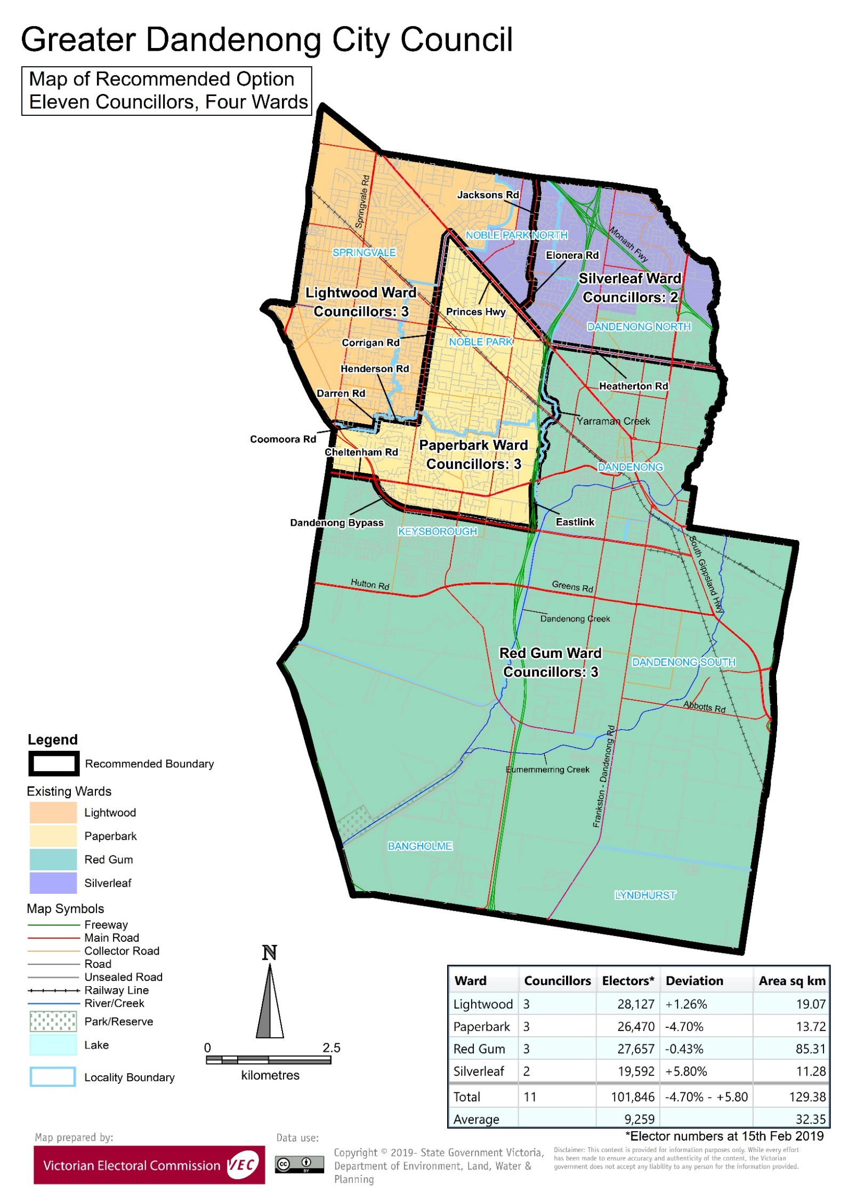

# Appendix 3: Public information program

Advertising

In accordance with the Act, public notices of the review and the release of the preliminary report were placed in the following newspapers:

|  |  |  |
| --- | --- | --- |
| **Newspaper** | **Notice of review** | **Notice of preliminary report** |
| *Herald Sun* | Thursday 6 June | Wednesday 7 August |
| *Greater Dandenong Leader* | Monday 17 June | Monday 12 August |
| *Dandenong Journal* | Monday 17 June | Monday 12 August |

Media releases

A media release was prepared and distributed to local media to promote the commencement of the review. A further release was distributed with the publication of the preliminary report. A final media advisory was circulated on the publication date of this final report.

Public information session

A public information session for people interested in the review process was held on Wednesday 19 June 2019 at the .

Submissions guide

A submission guide was developed and made available on the VEC website, or in hardcopy on request, throughout the review timeline. The submission guide provided information about the review, the review timeline and how to make submissions to the review.

Online submission tool

An online submission tool was developed and made available during the submission periods of the review. The tool allowed people to make a submission from the VEC website. During the preliminary submission stage, users also had the opportunity to map out their preferred subdivisions through the online submission tool using Boundary Builder. Boundary Builder included real elector numbers so that users could see if their preferred structures and numbers of councillors met the plus-or-minus 10% rule.

VEC website

The VEC website delivered up-to-date information to provide transparency and facilitate public participation during the review process. All public submissions were published on the website.

Email and social media engagement

The VEC delivered an information email campaign targeted at known community groups and communities of interest in the local council area. This included a reminder email at each milestone of the representation review process.

The VEC also published sponsored social media advertising that was geo-targeted to users within the local council area. This included advertising at both the preliminary submission and response submission stages. The total reach of these posts was 10,394 during the preliminary submission stage and 9,606 during the response submission stage.

Council communication resources

The VEC provided the Council with a communication pack that included information on the review in various formats. While the council is encouraged to distribute this information and raise awareness about the review, the VEC is an independent reviewer and all communications resources include reference and links to the VEC website and core materials.

This page has been left intentionally blank

This page has been left intentionally blank

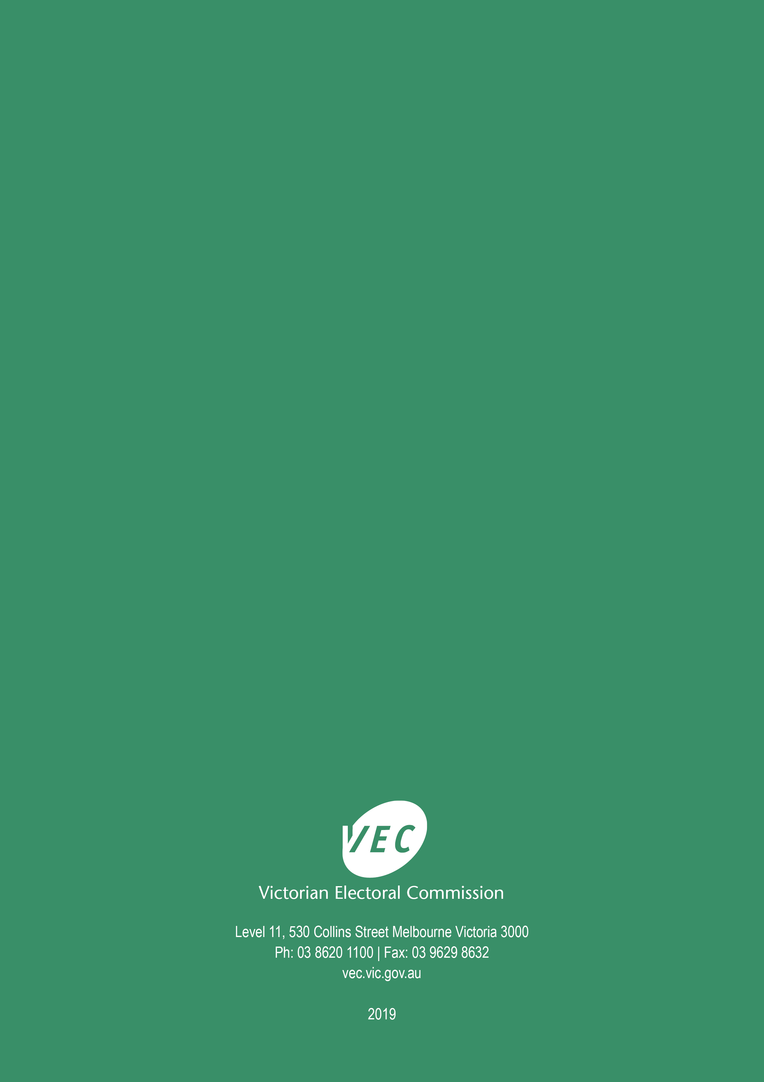

1. Section 219D of the *Local Government Act* *1989.*
2. Ibid.
3. .id is a consulting company specialising in population and demographic analysis and prediction information products in most jurisdictions in Australia and New Zealand.
4. Section 5B(1) of the *Local Government Act 1989.*
5. Greater Dandenong City Council, Reconciliation Action Plan December 2017 – December 2019, Greater Dandenong City Council, 2017, p. 9, accessed 20 August 2019, <http://www.greaterdandenong.com/document/2641/aboriginal-and-torres-strait-islander-community>.
6. See for example, Australian Bureau of Statistics (ABS), ‘2016 Census Quickstats: Dandenong (SSC)’, accessed 20 August 2019, <https://quickstats.censusdata.abs.gov.au/census_services/getproduct/census/2016/quickstat/SSC20702?opendocument>. Lyndhurst is also in the City of Casey.
7. Greater Dandenong City Council, ‘Greater Dandenong Green Wedge’, accessed 20 August 2019, <http://www.greaterdandenong.com/document/25299/green-wedge-management-plan>.
8. Greater Dandenong City Council, City of Greater Dandenong: Our Place, Greater Dandenong City Council, [no date], p. 7, accessed 20 August 2019, available from: <http://www.greaterdandenong.com/document/26003/greater-dandenong-economic-profiles>.
9. Greater Dandenong City Council News, ‘Greater Dandenong Officially Nations Most Culturally Diverse Community’, 12 February 2018, accessed 2 October 2019, <https://www.greaterdandenong.com/news/2319/greater-dandenong-officially-nations-most-culturally-diverse-community>.
10. ABS, ‘2016 Census Quickstats: Greater Dandenong (C)’, accessed 20 August 2019, <https://quickstats.censusdata.abs.gov.au/census_services/getproduct/census/2016/quickstat/LGA22670?opendocument>.
11. ABS, ‘2016 Data by Region: Greater Dandenong (LGA)’, accessed 20 August 2019, <https://itt.abs.gov.au/itt/r.jsp?RegionSummary&region=22670&dataset=ABS_REGIONAL_LGA2018&geoconcept=LGA_2018&maplayerid=LGA2018&measure=MEASURE&datasetASGS=ABS_REGIONAL_ASGS2016&datasetLGA=ABS_REGIONAL_LGA2018&regionLGA=LGA_2018&regionASGS=ASGS_2016>. ABS,’2016 Data by Region: Greater Melbourne’, accessed 20 August 2019, <https://itt.abs.gov.au/itt/r.jsp?RegionSummary&region=2GMEL&dataset=ABS_REGIONAL_ASGS2016&geoconcept=ASGS_2016&measure=MEASURE&datasetASGS=ABS_REGIONAL_ASGS2016&datasetLGA=ABS_REGIONAL_LGA2018&regionLGA=LGA_2018&regionASGS=ASGS_2016>.
12. ABS, ‘2016 Census Quickstats: Greater Dandenong (C)’. See also relevant Quickstats’ entries for the suburbs in Greater Dandenong City Council.
13. Ibid.
14. The SEIFA indexes are based on the Census statistics on characteristics such as, the percentage of low-income households, unemployment rate, percentage of people in low-skilled occupations and people without qualifications, among other indicators. For more, see ABS, ‘Socio-Economic Indexes for Areas’, accessed 20 August 2019, <https://www.abs.gov.au/websitedbs/censushome.nsf/home/seifa>.
15. ABS, ‘2016 Census Quickstats: Greater Dandenong (C)’.
16. ABS, ‘Data by Region, Greater Dandenong (C) (LGA) (22670)’.
17. ABS, ‘2016 Census Quickstats: Greater Dandenong (C)’. See also, ABS, ‘2016 Census Quickstats: Greater Melbourne’, accessed 20 August 2019, <https://quickstats.censusdata.abs.gov.au/census_services/getproduct/census/2016/quickstat/2GMEL?opendocument>.
18. Profiles of the activity centres in the City of Greater Dandenong are available at: Greater Dandenong City Council, ‘Activity Centre Profiles’, accessed 20 August 2019, <http://www.greaterdandenong.com/document/30476/activity-centre-profiles>. These documents are revised every three to five years to capture the changes in the activity centres.
19. Department of Environment, Land, Water and Planning (Victoria), *Victoria in Future: population projections, 2016 to 2056*, State Government of Victoria: Melbourne, 2019, p.12.
20. Greater Dandenong City Council, *Greater Dandenong Housing Strategy, 2014-2024, Greater Dandenong City Council*, 2014, p. 18. Available at: <http://www.greaterdandenong.com/document/22281/greater-dandenong-housing-strategy-2014-24>.