Corangamite Shire Council

Local council electoral structure review

March 2023

Preliminary   
Report

Acknowledgement of Country

The electoral representation advisory panel acknowledges the Eastern Maar and Wadawurrung peoples as the Traditional Custodians of the lands and waters on which it is holding this review and pays respects to ancestors and Elders past, present and emerging. The panel acknowledges their custodianship for many thousands of years and their continuing living culture.

Document history and version control

|  |  |  |  |
| --- | --- | --- | --- |
| **Version** | **Date approved** | **Approved by** | **Brief description** |
| 1 | 21 March 2023 | Electoral Commissioner | Final version |

# Contents

Executive summary 4

Developing electoral structure models 4

Preliminary submissions 4

Electoral structure models 4

Next steps 4

Background 5

About the 2023–24 electoral structure reviews 5

The electoral representation advisory panel 5

Public engagement 6

Developing recommendations 6

About Corangamite Shire Council 9

Profile 9

Current number of councillors and electoral structure 10

Last electoral structure review 10

Preliminary submissions 11

Number of councillors 11

Electoral structure 12

Preliminary findings and models 13

Number of councillors 13

Electoral structure 14

Models for public feedback 17

Next steps 18

Response submissions 18

Public hearing 19

Final report 19

References 20

Appendix 1: Model maps 21

Appendix 2: Additional models considered 25

Appendix 3: List of preliminary submitters 26

# Executive summary

An independent electoral structure review panel appointed by the Minister for Local Government has reviewed the structure of Corangamite Shire Council.

The panel looked at:

* whether the council had an appropriate number of councillors
* whether it should be unsubdivided or subdivided.

This report outlines the preliminary models that the panel is presenting for the proposed new electoral structure of Corangamite Shire Council to meet the requirements of Victoria’s *Local Government Act 2020* (the Act).

More information about the background to the reviews is available on page 5.

## Developing electoral structure models

The panel considered a range of factors when deciding on the models in this report, including:

* research and analysis
* voter growth or decline over time
* public submissions (see below).

More information on the way the panel decided on the models is available on page 6.

## Preliminary submissions

The panel received 21 preliminary submissions. Of these, one submission included maps.

A full analysis of submissions received can be found on page 11.

## Electoral structure models

After considering submissions and research, the panel is presenting the following electoral structure models for further public consultation:

* Model 1: an unsubdivided electoral structure with 7 councillors.
* Model 2: a subdivided electoral structure with a total of 8 councillors, 4 wards and 2 councillors per ward.
* Model 3: a subdivided electoral structure with a total of 7 councillors, 7 wards and one councillor per ward.

Details on these models, including maps, are available in Appendix 1.

## Next steps

The panel is now seeking feedback on the electoral structure models. You can make a response submission to these models until Wednesday 12 April 2023. If any response submitters wish to speak at a public hearing, the panel will hold an online public hearing on Tuesday 18 April 2023. Following this, it will present its final recommendation to the Minister by Wednesday 17 May 2023.

More information about the review process is available on the Victorian Electoral Commission (VEC) website at [vec.vic.gov.au](https://www.vec.vic.gov.au/electoral-boundaries/council-reviews/electoral-structure-reviews)

# Background

## About the 2023–24 electoral structure reviews

In October 2022, the Minister for Local Government formed 2 electoral representation advisory panels to review the electoral structures of 39 local councils, under section 16 of the *Local Government Act 2020* (the Act). If the Minister accepts the electoral structures the panels recommend, they will take effect at the October 2024 elections.

The Act introduced several changes to local government representation, including the types of electoral structures local councils may have. Large and small rural shire councils (including Corangamite Shire Council) can have one of 3 electoral structures:

* + unsubdivided (entire council area with no wards)
  + single-councillor wards
  + multi-councillor wards with the same number of councillors per ward.

For Corangamite Shire Council, the electoral representation advisory panel is examining:

* the number of councillors
* whether the council should be subdivided into wards or unsubdivided.

For subdivided structures, it is also examining:

* + the number of wards
  + where the ward boundaries should be
  + the name of each ward
  + how many councillors should be elected for each ward.

The Act requires electoral structures to provide fair and equitable representation and facilitate good governance. For subdivided structures, each ward must have an approximately equal number of voters per councillor (within +/-10% of the average).

## The electoral representation advisory panel

The panel conducting the electoral structure review of Corangamite Shire Council has 3 members:

* Ms Julie Eisenbise (Chairperson)
* Mr Tim Presnell
* Deputy Electoral Commissioner, Ms Dana Fleming (Electoral Commissioner delegate).

The panel is independent of councils and the State government.

Under the Act, the VEC is not responsible for reviewing council electoral structures but must provide administrative and technical support to the panel. The Electoral Commissioner (or their delegate) must be a member of each panel.

## Public engagement

### Public information program

To educate and inform the public about the Corangamite Shire Council electoral structure review, the VEC began a public information program in mid-December 2022. The VEC:

* + printed public notices in state-wide newspapers
  + held public information sessions to outline the review process and respond to questions from the community
  + sent out media releases to announce the start of the review
  + published information on its social media channels
  + provided updated website content on [vec.vic.gov.au](http://www.vec.vic.gov.au/), including:
    - information on the review process
    - submission guides and fact sheets for each council under review with background information
    - preliminary submissions from the public.

The VEC will continue to promote the review during the response submissions stage via media releases, the VEC’s social media channels and updated content on the VEC website.

### Public consultation

The panel encouraged public input to the review of Corangamite Shire Council via preliminary submissions at the start of the review. The panel now invites further input via:

* + response submissions to this preliminary report
  + an online public hearing to provide anyone who makes a response submission the opportunity to expand on their submission.

Public submissions are an important part of the review process but the panel also considers other factors during a review. These are outlined below.

## Developing recommendations

The panel’s electoral structure models presented in this preliminary report comply with the Act and were developed through careful consideration of:

* + research and analysis conducted by the VEC support team, including geospatial and demographic factors
  + rates or patterns of population and voter growth or decline over time, and relevant forecasts of growth or decline based on forecast information provided by .id (informed decisions, a company specialising in demographics and forecasting)
  + input received from the public in written submissions during the preliminary submissions phase.

### Deciding on the number of councillors

The Act allows local councils to have between 5 and 12 councillors, but neither the Act nor the Local Government (Electoral) Regulations 2020 specify how to determine the number of councillors a council needs. Therefore, the models put forward by the panel in this report are guided by the Act’s intention for fairness and equity in voter representation.

In examining the number of councillors Corangamite Shire Council should have, the panel considered these factors:

* + the population and number of voters in the council area, compared to other councils with a similar population size and number of voters in the same category (for example, metropolitan, interface, regional city, large rural shire, small rural shire)
  + patterns of population change and voter growth or decline in the council area over time
  + the current and past numbers of councillors
  + the representation needs of the communities of interest in the council area
  + if a particular type of electoral structure best suits the council (see ‘Deciding the electoral structure’ below)
  + any matter raised in public submissions not already listed above.

Generally, local councils with a larger number of voters will have a higher number of councillors. Large populations are often more likely to have greater diversity, both in the type and number of communities of interest and issues relating to representation. However, the ideal number of councillors can also be influenced by the particular circumstances of a council, such as the:

* + nature and complexity of services the council provides
  + geographic size and topography of the area
  + forecast population and voter growth or decline
  + social diversity.

### Deciding the electoral structure

The electoral structure of large and small rural shire councils can be:

* + unsubdivided (entire council area with no wards)
  + made up of single-councillor wards

or

* + made up of multi-councillor wards with the same number of councillors per ward.

When developing electoral structure models for Corangamite Shire Council, the panel considered these main criteria:

* + whether the structure would comply with section 15(2) of the Act (see below), and for how long it would likely comply
  + the appropriate number of councillors, as outlined above
  + whether meaningful and effective ward boundaries can be established and whether these would be easily identifiable to local communities
  + representation of communities of interest
  + the voter distribution and physical features of the area, and the impact these may have on the shape and size of any wards
  + past elections for the council, including:
    - numbers of candidates nominating
    - incidences of uncontested elections
    - rates of informal voting.
  + other matters raised in public submissions not already listed above.

Under section 15(2) of the Act, subdivided structures must aim for an approximately equal number of voters per councillor in each ward. This means the number of voters represented by each councillor in a ward should be within +/-10% of the average number of voters per councillor for all wards.

The panel recommends structures that will comply with section 15(2) at the October 2024 local council elections and uses current voter numbers and forecasts of population and voter change to assess this with as much accuracy as possible. In some cases, population changes and other factors mean it is not possible for a subdivided electoral structure to comply with section 15(2) based on current voter numbers. If this occurs, compliance at the 2024 local government elections will be the priority to ensure each vote has approximately equal value.

# About Corangamite Shire Council

## Profile

Corangamite Shire Council is in south-western Victoria. The shire is bounded by Moyne Shire in the west, Colac Otway Shire in the east, Golden Plains Shire in the northeast, Pyrenees Shire in north, and a small section of Ararat Rural City in the northwest. The Victorian coastline forms the southern boundary of the shire.

The Traditional Custodians of the Corangamite area are the Wadawurrung and Eastern Maar peoples.

### Landscape

The shire covers an area of 4,407 km2 and extends from Port Campbell in the south to Skipton in the north. The shire contains part of the Great Ocean Road and includes the Twelve Apostles, a major tourist attraction. A large system of lakes, including Lake Corangamite, are located throughout the central and northern areas of the shire.

The current population is 16,115, with 53% of residents living in the service towns of Camperdown, Terang, and Cobden and the smaller towns of Skipton, Lismore, Port Campbell, Derrinallum, and Noorat. The remaining 47% reside in rural areas across the shire.

The Princes Highway runs from Geelong through Camperdown and Terang toward Warrnambool. The Warrnambool railway line also runs through the shire, stopping at Camperdown and Terang, carrying both freight and passengers.

### Community

Corangamite Shire has a median age of 48, higher than the median of 43 found in regional Victoria (ABS, 2021b). The shire’s population growth has been relatively flat in the last decade, declining from 16,376 in 2011 to 16,115 currently (ABS, 2011). Between 2022 and 2028, the population is projected to fall by an annual rate of -0.3%.

Of the population, 84.7% were born in Australia, and 90.3% speak only English at home, compared with 81% and 86.4% respectively for regional Victoria (ABS, 2021b). The proportion of Aboriginal or Torres Strait Islander people in the population was 1.1% at the 2021 census, below the 2% in regional Victoria (ABS, 2021b).

The shire has a large agricultural base. It is a well-known farming region, producing dairy, beef, wool, lamb, crops, and grain (Corangamite Planning Scheme, 2022, p. 5). The agriculture, forestry and fishing industry make up 31.9% of employment with other major sources of employment found in health care and social assistance (12%), manufacturing (7.7%), education and training (7.6%), retail trade (7.4%), and construction (7.2%) (ABS, 2021a). The tourism economy is strong in the shire, with over 2.8 million people visiting per year, particularly in the coastal region (Corangamite Planning Scheme, 2022, p. 16).

Home ownership is common, with 46% owning their property outright, and a further 29% owning with a mortgage. This contrasts to the regional Victoria rate of 39.3% outright ownership, and 33.2% owned with a mortgage (ABS, 2021b). Overall, fewer people rent in Corangamite (17.8%) (ABS, 2021a) than in regional Victoria (23.6%) (ABS, 2021b).

The weekly median income is $1,263, less than the regional Victorian median of $1,386 (ABS, 2021b).

## Current number of councillors and electoral structure

Corangamite Shire Council is currently divided into 5 wards with a total of 7 councillors:

* one ward with 3 councillors (Central Ward)
* 4 wards with one councillor each (Coastal, North, South-Central, and South-West wards).

There are approximately 13,826 voters in Corangamite Shire Council, with a ratio of 1,975 voters per councillor.

Visit the VEC website at [vec.vic.gov.au](https://www.vec.vic.gov.au/electoral-boundaries/local-councils/corangamite-shire-council) for more information on Corangamite Shire Council.

## Last electoral structure review

The VEC conducted an electoral representation review of Corangamite Shire Council in 2015. This representation review was carried out under the *Local Government Act 1989* (Vic)*,* which was replaced by the *Local Government Act 2020* (Vic).

After conducting the review, the VEC recommended that Corangamite Shire Council continue to consist of 7 councillors elected from 5 wards (one ward with 3 councillors and 4 wards with one councillor each).

Visit the VEC website at [vec.vic.gov.au](https://www.vec.vic.gov.au/electoral-boundaries/local-councils/corangamite-shire-council) to access a copy of the 2015 representation review final report.

# Preliminary submissions

The panel received 21 preliminary submissions from the public by the deadline of 5 pm on Wednesday 22 February 2023. You can view these submissions on the VEC website at [vec.vic.gov.au](https://www.vec.vic.gov.au/electoral-boundaries/council-reviews/electoral-structure-reviews/corangamite) and find a list of people or organisations who made a submission in Appendix 3.

The table below provides an overview of preferences in the preliminary submissions. You can read an analysis of submissions below this table.

|  |  |  |  |  |  |
| --- | --- | --- | --- | --- | --- |
|  | Unsubdivided structure | Single-councillor wards | Multi-councillor wards | Subdivided structure (unspecified) | No comment on structure |
| Decreased number of councillors | - | - | - | - | - |
| Maintain current councillor number | 2 | 8 | - | - | - |
| Increased number of councillors | - | 1 | - | - | - |
| No comment on number of councillors | - | - | - | 8 | - |

*2 submissions were out of scope

## Number of councillors

A total of 11 submissions commented on councillor numbers, with 7 councillors being the most favoured number.

### Maintaining 7 councillors

There was strong public support for retaining the current number of councillors, with 10 submissions advocating this position. Most of these submissions wanted to see the least change to the status quo or felt that 7 councillors was the right number for the shire relative to other councils.

### Reducing councillor numbers

No submissions wanted to see a decrease in councillor numbers.

### Increasing councillor numbers

One submission proposed increasing councillors but did not specify how many. Alan Kerr from Timboon argued that increasing the number of councillors ‘would lessen the load thus giving a wider range of people opportunity to stand for council election.’ Kerr added that more councillors would make it harder for vested influences to sway council decision making.

## Electoral structure

Most public submissions proposed retaining a ward structure, half of which wanted single-councillor wards, with the other half suggesting various ward structures. There were 2 submissions that advocated for an unsubdivided ward structure.

### Unsubdivided

The 2 submissions proposing an unsubdivided structure argued that it would decrease perceived parochialism, create shire-wide accountability, and help reduce the high prevalence of uncontested elections. Janet O’Herir felt that in such instances electors had no choice in who to elect, and councillors elected uncontested were possibly less accountable as a result.

Michael Lines-Kelly argued that an unsubdivided council would encourage stronger candidates to nominate for council, as it would open ‘the field to a wide range of candidates, including well-qualified residents who would be excluded in a wards-based shire.’ Lines-Kelly felt it would also mean ‘the loudest voice or sectional interest cannot as easily dominate the agenda or proceedings.’

### Single-councillor wards

There was significant support in submissions for adopting a single-councillor ward structure. A total of 9 submitters supported this position, including Corangamite Shire Council. The council referred to the shire’s diversity in relation to different agricultural industries between the north and south and various other geographic and demographic differences, reasoning that single-councillor wards would best represent these distinct communities of common interest.

Others, such as Chris Lang, proposed single-councillor wards as more likely to result in local candidates that understood local issues. Lang felt voters and residents had strong connections with their local representative and that single-councillor wards would maintain those connections. Denise Butler made similar points when suggesting the shire’s smaller towns and communities are vibrant and benefit from being represented by candidates from within these communities.

### A subdivided shire

A further group of 8 submitters wanted the shire subdivided into wards but did not specify the number of wards or the number of councillors per ward. They generally felt wards catered to the shire’s communities of interest.

Judy Buchholz argued a subdivided ward model ensured the remote and less populated areas had a voice and could elect candidates that were knowledgeable of these areas. Buchholz further suggested that ‘[a]n unsubdivided structure is only equitable if the community is homogeneous in their interests and geography’.

Similarly, the Derrinallum Progress Association argued that wards foster the ‘best representation for [the] local area’ and support from local councillors that were familiar with the area and committed to local interests.

# Preliminary findings and models

## Number of councillors

After taking into consideration the requirements of the Act, public submissions and the agreed criteria, the panel found 7 or 8 councillors to be an appropriate number for Corangamite Shire Council.

The panel considered the characteristics of the shire in relation to similar rural shire councils, including its size and geography, population and the number and distribution of voters across the shire. 

|  |  |  |  |  |  |  |
| --- | --- | --- | --- | --- | --- | --- |
| Similar rural shire councils to Corangamite Shire Council | | | | | | |
| Local council | Area (km2) | Number of voters at 2020 election | Population (2021 Census) | Current total estimate of voters | Number of councillors | Number of voters per councillor |
| Hepburn Shire* | 1,473 | 14,858 | 16,604 | 16,283 | 7 | 2,326 |
| Moyne Shire | 5,482 | 13,968 | 17,374 | 14,375 | 7 | 2,054 |
| Indigo Shire | 2,041 | 13,651 | 17,368 | 14,279 | 7 | 2,040 |
| Murrindindi Shire | 3,880 | 13,607 | 15,197 | 14,231 | 7 | 2,033 |
| **Corangamite Shire** | **4,407** | **13,283** | **16,115** | **13,826** | **7** | **1,975** |
| Southern Grampians Shire | 6,654 | 13,058 | 16,588 | 13,151 | 7 | 1,879 |
| Alpine Shire | 4,788 | 11,169 | 13,235 | 11,566 | 7 | 1,652 |
| Central Goldfields Shire* | 1,533 | 11,169 | 13,483 | 11,329 | 7 | 1,618 |
| Strathbogie Shire* | 3,303 | 9,806 | 11,455 | 10,910 | 5 | 2,182 |

*This local council is undergoing an electoral structure review during 2023–24.

**Maintaining 7 councillors**

Taking into consideration the forecast population growth, area of the shire and its various communities of interest, retaining 7 councillors was found to be appropriate. This is consistent with similar rural shire councils and was also supported in public submissions.

**Increasing to 8 councillors**

Increasing councillor numbers was also considered appropriate if it enabled a favourable multi-councillor ward structure for the shire. The Act stipulates that an electoral structure with multi-councillor wards must have an equal number of councillors in each ward, which is not possible with 7 councillors. There was also some support in submissions for an increase in councillor numbers.

## Electoral structure

To identify the most appropriate electoral structure, various factors were considered. This included the requirements of the Act, the communities of interest in Corangamite Shire, public submissions, the appropriateness of ward boundaries, and which models offered the most fair and equitable representation.

In developing the preliminary models presented in this report, a range of models were considered. The strongest 3 models have been put forward for further public comment.

The panel proposes 3 models for the consideration of the Corangamite Shire community:

* an unsubdivided electoral structure with 7 councillors (Model 1)
* a subdivided electoral structure comprising 4 wards, each with 2 councillors (Model 2)
* a subdivided electoral structure comprising 7 single-councillor wards (Model 3).

Diagrams of the preliminary models are included in Appendix 1.

### Unsubdivided structure (Model 1)

Under this model, Corangamite Shire Council would adopt an unsubdivided electoral structure, represented by 7 councillors.

The main strengths of the 7-councillor unsubdivided model is that it maintains the current number of councillors, had some support in public submissions and will not involve any divisions of towns and communities to satisfy the +/-10% requirement. Furthermore, an unsubdivided electoral structure has the potential to foster a greater shire-wide perspective in council business and address the high levels of uncontested elections for the shire.

While the panel recognised the shire’s distinct communities of interest (namely Camperdown and surrounds, the dryland north, the dairy farming communities throughout the middle and south of the shire, and the tourist-oriented south) it considered an unsubdivided structure could still provide representation for these communities as well as the smaller towns and localities.

In some cases, unsubdivided structures can see an increase in voter informality, due to a potential increase in the number of candidates on the ballot paper. However, Corangamite Shire Council has had relatively low voter informality at past elections, and this would not necessarily increase under an unsubdivided electoral structure.

Of more concern was the historically low number of candidates nominating for election and the number of uncontested elections. An unsubdivided electoral structure would likely reduce incidences of uncontested elections and thus provide voters with more choice at election time.

Noting that public submissions are largely supportive of subdivided electoral structures, the panel seeks community feedback on an unsubdivided model.

### Multi-councillor ward structure (Model 2)

Under this model, Corangamite Shire Council would adopt a 4-ward structure. Each ward would be represented by 2 councillors, in line with the requirement of the Act for there to be the same number of councillors per ward.

This was considered to adequately reflect the shire’s communities of interest and public support for a subdivided structure, particularly as this would enable the major town of Camperdown to be contained within one ward.

Noting the public’s preference for the current electoral structure and that the multi-councillor ward structure had worked well for Corangamite Shire in the past, model 2 was considered the most favourable multi-councillor ward structure that complied with the requirements of the Act.

Model 2 captures the shire’s major communities of interest within wards, with Camperdown and surrounds, the dryland north, the towns of Terang and Cobden, and a large area in the south all contained within wards. Recognisable boundaries are used throughout, including railway lines, major roads, and creeks/rivers.

Although this model requires an increase in councillor numbers, this can be justified by the benefits of 4 equal wards effectively containing communities of interest. As such, the panel is interested in further community feedback on this model.

### Single-councillor ward structure (Model 3)

Under this model, Corangamite Shire Council would adopt a 7-ward structure. Each ward would be represented by 1 councillor, in line with the requirements of the Actfor there to be the same number of councillors per ward.

This model was considered to be a viable option due to significant support in public submissions, effective representation of communities of interest, and its similarities with the current structure. It was noted that this model, with some variation to ward boundaries to adhere to the +/-10% requirement, was much the same as that proposed by Corangamite Shire Council.

The model does have a number of drawbacks. A single-councillor ward structure could continue to see high numbers of uncontested elections. At the last 3 council elections, 3 out of 5 wards in the shire were uncontested, with voters in those wards having no opportunity to elect a representative of their choice. The panel was of the view that further subdivision may exacerbate this issue.

Additionally, to adhere to the +/-10% requirement, it was necessary to divide Camperdown between wards. While this could not be considered ideal, this may be an acceptable division of Camperdown with boundaries the community recognises. The council proposed a similar split of Camperdown using similar boundaries along the Princes Highway and Leura Street. For these reasons, the panel considers it an appropriate model for further community feedback.

### Models considered but not put forward

#### Multi-councillor ward structure: 3 wards with 2 councillors per ward

The panel considered variations of a multi-councillor ward structure, including a 3-ward structure with each ward represented by 2 councillors. While this model roughly captured the shire’s communities of interest, namely the dryland farming north, the major town of Camperdown, and the dairy and tourist activities in the south, it was determined to have a number of drawbacks.

For example, the town of Terang was included in an expanded northern ward to satisfy the +/-10% requirement. Arguably, Terang would be best located in a ward with connections to the south and with surrounding townships. Additionally, the borders of the new northern ward extended further south compared with the current North Ward. These boundary adjustments compromised the integrity of the northern ward, which lead to strong reservations on the viability of the model.

Moreover, this model decreased councillor numbers to 6, which the panel considered to be a major drawback for the shire’s communities. It was felt that a decrease may impact representation and increase councillor workloads. As the shire covers a large geographic area, councillors already travel large distances to connect with voters and communities and any decrease in their numbers may result in increased travel demands.

Finally, there was no support for such a model in public submissions, and no submitters proposed a decrease in the number of councillors. As such, the panel feels this model presented too many drawbacks to be further considered.

## Models for public feedback

The panel considers all models outlined below to offer fair and equitable representation for voters in Corangamite Shire Council. Please see Appendix 1 for detailed maps of these models.

### Model 1

Corangamite Shire Council has 7 councillors and be unsubdivided.

### Model 2

Corangamite Shire Council has 8 councillors and is divided into 4 wards with 2 councillors per ward.

### Model 3

Corangamite Shire Council has 7 councillors and is divided into 7 wards with 1 councillor per ward.

### Ward names

The panel has suggested ward names to identify the wards in Models 2 and 3 and invites comments from the community on these names as part of submissions responding to the preliminary report.

# Next steps

## Response submissions

Any person or group, including the local council under review, can make a response submission to the electoral representation advisory panel. In your submission, you should address the models proposed by the panel in this preliminary report.

You can make a submission:

|  |  |
| --- | --- |
|  | **Online** Visit [vec.vic.gov.au](http://vec.vic.gov.au/" \o "Homepage of VEC website) to make a submission online.  You will need to make an account to use the online Public Submission Tool and can save a draft submission to finish later. |
|  | **By email**  [Corangamite.ERAPSubmissions@vec.vic.gov.au](mailto:Corangamite.ERAPSubmissions@vec.vic.gov.au) |
|  | **By post**  Electoral Representation Advisory Panel c/o Victorian Electoral Commission Level 11, 530 Collins St Melbourne VIC 3000 |

The panel must receive all response submissions before 5 pm on Wednesday 12 April 2023. If you post your submission, make sure it has enough time to reach the panel before the deadline. Late submissions will not be accepted.

### Required information

For your submission to be considered, you must include your:

* full name
* contact phone number or email address
* postal or residential address.

The panel will not consider submissions without this information. If you are submitting as a group or organisation, you must include the name of a nominated contact person who is authorised to submit on behalf of your group.

The VEC will handle information provided by submitters in accordance with the privacy policy available at [vec.vic.gov.au/privacy](http://www.vec.vic.gov.au/privacy).

### Public access to submissions

To ensure transparency in the electoral structure review process, your submission will be published on the VEC website at [vec.vic.gov.au](http://www.vec.vic.gov.au/). The VEC will remove your signature and contact details, including residential and postal addresses, from all public copies but must publish your full name (or group name) and locality (suburb or town).

## Public hearing

If you make a response submission, you can also ask to speak at an online public hearing to support your submission and expand on your views.

The online public hearing is scheduled for:

Time: 2 pm

Date: Tuesday 18 April 2023

The panel encourages participation in the public hearing. If you wish to speak at the public hearing, you **must** indicate this in your response submission. The public hearing will not be held if there are no requests to speak.

Anyone can attend a public hearing, but you will only be able to speak if you asked to in your response submission. If you ask to speak, the VEC will contact you to arrange a time for you at the hearing. You will have 10 minutes to address the public hearing panel, which will include at least 2 of the review panel members. The members of the public hearing panel may ask you questions.

Visit the VEC website at [vec.vic.gov.au](http://vec.vic.gov.au/) for more information on public hearings.

## Final report

Following the public hearing, the review panel will consider all evidence gathered and publish a final report for the Minister for Local Government containing a recommendation for the number of councillors and the electoral structure for the local council.

The final report is scheduled to be published on Wednesday 17 May 2023. If the recommendation is accepted, any changes will apply at the October 2024 local council elections.

The final report will be available on the VEC website at [vec.vic.gov.au](http://vec.vic.gov.au/) or you can request a printed copy by calling 131 832.

# References

Australian Bureau of Statistics. (2011). *Census 2011 Quick Stats, Corangamite.* [*https://www.abs.gov.au/census/find-census-data/quickstats/2011/LGA21830*](https://www.abs.gov.au/census/find-census-data/quickstats/2011/LGA21830)accessed 1 March 2023.

Australian Bureau of Statistics. (2021a). *Census 2021 Quick Stats, Corangamite.* [*https://www.abs.gov.au/census/find-census-data/quickstats/2021/LGA21830*](https://www.abs.gov.au/census/find-census-data/quickstats/2021/LGA21830)accessed 1 March 2023.

Australian Bureau of Statistics. (2021b). *Census 2021 Quick Stats, Rest of Vic.* [*https://www.abs.gov.au/census/find-census-data/quickstats/2021/2RVIC*](https://www.abs.gov.au/census/find-census-data/quickstats/2021/2RVIC)accessed 1 March 2023.

Department of Transport and Planning*.* (2022). *Corangamite Planning Scheme.* <https://planning-schemes.app.planning.vic.gov.au/static/1677774875218/pdf/2534717.pdf> accessed 1 March 2023.

*Local Government Act 1989* (Vic)

*Local Government Act 2020* (Vic)

*Local Government (Electoral) Regulations 2020* (Vic)

# Appendix 1: Model maps

The following maps are included in this report:

|  |  |
| --- | --- |
| Map | Page |
| Model 1 – an unsubdivided electoral structure with 7 councillors | 22 |
| Model 2 – a multi-councillor ward structure with 8 councillors, 4 wards and 2 councillors per ward | 23 |
| Model 3 – a single-councillor ward structure with 7 councillors, 7 wards and one councillor per ward | 24 |

Forecast information in the text of this report is based on forecasts prepared by .id – informed decisions [id.com.au](http://www.id.com.au/) .id and its licensors are the sole and exclusive owners of all rights, title and interest subsisting in that part of the report content where .id are identified. Some of .id content is a derivative of ABS Data, which can be accessed from the website of the Australian Bureau of Statistics at [abs.gov.au](http://www.abs.gov.au/), and licensed on terms published on the ABS website.

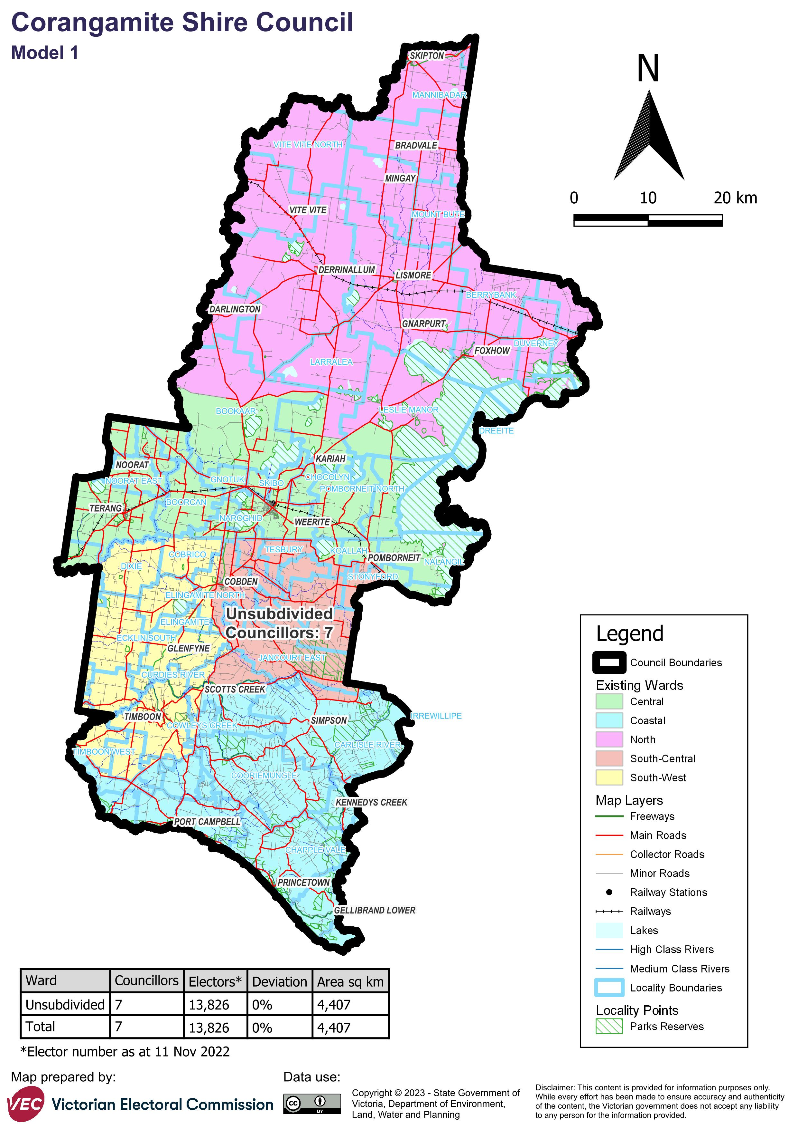

Model 2 is a multi-councillor ward structure with 4 wards and 2 councillors in each ward. The wards are named: Lovely Banks Ward, Lake Ward, Central Ward, Coastal Ward. Please contact the VEC if you require the content of this map in an alternative format.


Model 3 is a single-councillor ward structure with 7 wards. The wards are named: North Ward, Leura Ward, Tandarook Ward, Coastal Ward, Ecklin Ward, Gnotuk Ward, Mount Emu Ward. Please contact the VEC if you require the content of this map in an alternative format.


# Appendix 2: Additional models considered

The following models were closely considered by the panel but are not being put forward for further public consultation. See Models considered but not put forward for further information.

#### Multi-councillor ward structure: 3 wards with 2 councillors per ward

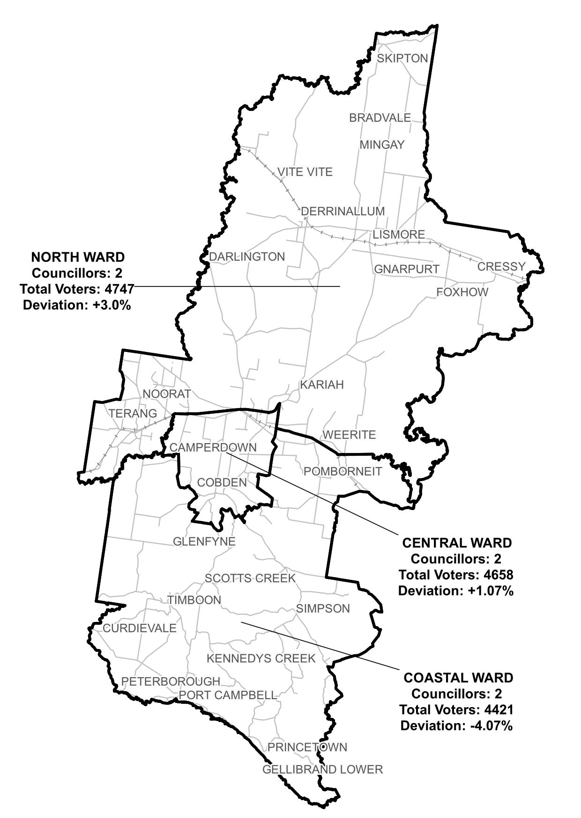

# Appendix 3: List of preliminary submitters

The review received 21 preliminary submissions.

Preliminary submissions were made by:

Bell, Kathy and Adrian

Buchholz, Judy

Butler, Denise

Corangamite Shire Council

Derrinallum Progress Association

Farquharson, Nola

Gibson, Sandy

Glazebrook, John

Hunneybell, David and Susan

Kerr, Alan

Lang, Chris

Lang, Chris (second submission)

Lang, Valerie

Lines-Kelly, Michael

Lovejoy, Victoria

Lovejoy, Victoria (second submission)

Matheson, Wendey

O’Hehir, Janet

Skipton Progress Association Inc

Thornton, Marie

Walsh, Heather