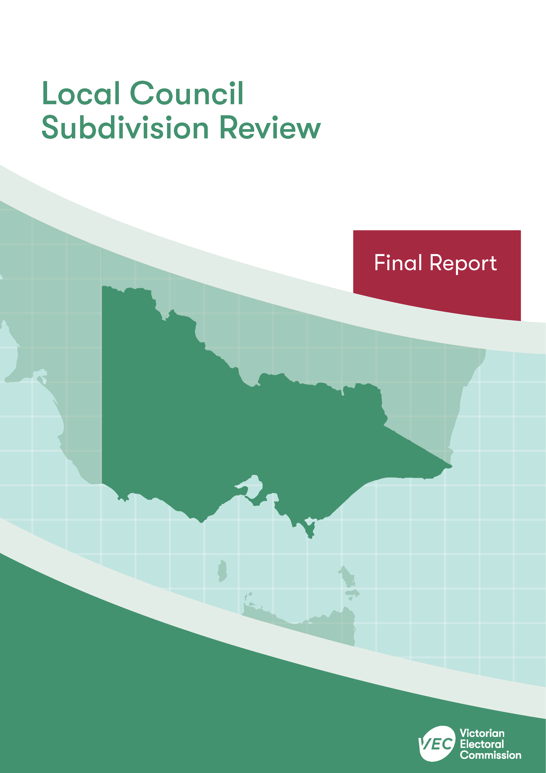



**Surf Coast Shire Council**

**April 2020**

Contents

Recommendation 1

Executive summary 2

Background 4

Legislative basis 4

The VEC’s approach 5

Profile of Surf Coast Shire Council 7

Population trends 8

Current number of councillors and electoral structure 8

Current subdivision review 10

Preliminary report 10

Public response 13

Response submissions 13

Public hearing 17

Findings and recommendation 21

The VEC’s findings 21

The VEC’s recommendation 25

Appendix 1: Public involvement 26

Appendix 2: Recommended ward boundaries map 27

Appendix 3: Public information program 29

Recommendation

The Victorian Electoral Commission recommends adjustments to the boundaries of the following wards within Surf Coast Shire Council:

* Anglesea Ward
* Lorne Ward
* Torquay Ward
* Winchelsea Ward

This recommendation is submitted to the Minister for Local Government as required by the *Local Government Act 1989*.

Please see Appendix 2 for a detailed map of the recommended ward boundaries.

Executive summary

The *Local Government Act 1989* (LG Act) requires the Victorian Electoral Commission (VEC) to conduct a subdivision review to ensure the equitable representation of all voters in a local council.[1] The LG Act prescribes that the number of voters per councillor in each ward must be within plus-or-minus 10% of the average number of voters per councillor across the local council. [2] This is known as the ‘equality requirement’.

As population changes affect voter numbers and distribution in subdivided local councils, one or more wards may be unlikely to meet this requirement at the next general election. In such circumstances, the VEC recommends adjustments to internal ward boundaries to ensure that all wards meet the equality requirement before the next election and ideally, until the next scheduled electoral representation review.

Current number of councillors and electoral structure

Surf Coast Shire Council currently comprises nine councillors elected from four wards (one four-councillor ward, two two-councillor wards and one single-councillor ward). More information on Surf Coast Shire Council is available on the VEC website at [vec.vic.gov.au](http://vec.vic.gov.au).

In 2018, the VEC notified the Minister for Local Government that one or more wards were unlikely to meet the equality requirement at the 2020 general election. Accordingly, the Minister notified the VEC that a subdivision review of Surf Coast Shire Council was required before the 2020 general election.

Preliminary report

A preliminary report was released on Wednesday 12 February 2020 proposing adjustments to the boundaries that affect all wards within Surf Coast Shire Council:

* Anglesea Ward
* Lorne Ward
* Torquay Ward
* Winchelsea Ward

Response submissions

The VEC received 17 submissions responding to the preliminary report by the deadline of 5.00 pm on Wednesday 11 March 2020.

Public hearing

The VEC conducted a public hearing for those wishing to speak about their response submission at 5.00 pm on Tuesday 17 March 2020. Five people spoke at the hearing.

Recommendation

The Victorian Electoral Commission recommends adjustments to the boundaries of the following wards within Surf Coast Shire Council:

* Anglesea Ward
* Lorne Ward
* Torquay Ward
* Winchelsea Ward

This recommendation is submitted to the Minister for Local Government as required by the *Local Government Act 1989*.

Please see Appendix 2 for a detailed map of the recommended ward boundaries.

Background

Legislative basis

The *Local Government Act 1989* (LG Act) requires the Victorian Electoral Commission (VEC) to conduct a subdivision review to ensure the equitable representation of all voters in a local council. The LG Act prescribes that the number of voters per councillor in each ward must be within plus-or-minus 10% of the average number of voters per councillor across the local council. [3] This is known as the ‘equality requirement’.

As population changes affect voter numbers and distribution in subdivided local councils, one or more wards may be unlikely to meet this requirement at the next general election. In such circumstances, the VEC recommends adjustments to internal ward boundaries to ensure that all wards meet the equality requirement before the next election and ideally, until the next scheduled electoral representation review.

Subdivision reviews only apply to subdivided councils:

* that are not scheduled for an electoral representation review before the next general election

and

* where, two years before the council is to hold a general election, the VEC considers one or more wards are unlikely to meet the equality requirement at the time of the next general election.

### Scope

A subdivision review only considers the location of ward boundaries. A subdivision review cannot consider changes to the number of councillors or wards.

These changes are considered in a council’s periodic electoral representation review. The next scheduled representation review for Surf Coast Shire Council will be held before the 2024 general election. An earlier review may take place if required.

A subdivision review also cannot change the external boundaries of the local council, divide local councils, or amalgamate local councils. These changes can only be made by an Order in Council.

The VEC’s approach

### Public information program

The VEC conducted a public information program to inform the community of the subdivision review, including:

* a public notice printed in local papers
* a media release announcing the release of the preliminary report
* an information email campaign targeted at known community groups and communities of interest in the local council area
* sponsored social media advertising geo-targeted to users within the local council   
  area
* ongoing information updates and publication of submissions on the VEC website.

More information on the VEC’s public information program for the subdivision review of Surf Coast Shire Council can be found at Appendix 3.

### Public consultation

Public input was encouraged by the VEC via:

* response submissions to the preliminary report
* a public hearing that provided an opportunity for people who had made a response submission to expand on their submission.

### Developing recommendations

The VEC bases its recommendations for ward boundaries on:

* internal research specifically relating to the local council under review, including voter statistics from the Victorian electoral roll
* small area forecasts provided by .id[4]
* the VEC’s expertise in mapping, demography and local government
* consideration of all input from the public in written submissions received during the review.

In determining which ward boundaries are most appropriate, the VEC considers the:

* number of voters in each ward, to ensure that each ward meets the equality requirement for the next election
* number of voters affected by the changes, with the aim of affecting as few voters as possible
* communities of interest
* significance of natural and man-made features (such as roads and waterways), to ensure clear and identifiable ward boundaries
* geographic factors, such as size and topography
* longevity of the structure.

### Communities of interest

Each local council contains a number of communities of interest. Where practicable, ward boundaries should be designed to ensure they are fairly represented, and that geographic communities of interest are not split. This allows communities with shared concerns to elect a councillor.

Surf Coast Shire Council

Profile of Surf Coast Shire Council

Surf Coast Shire is located in the Barwon South West region of Victoria, about 125 kilometres from Melbourne. The Shire covers an area of 1,552 square kilometres, and includes a large stretch of coastline, various coastal townships, part of the Otway Ranges and a large rural hinterland.

Torquay, which is urban in character, is the largest town in the Shire and is located about 20 kilometres south of Geelong. The other main coastal towns include Anglesea, Aireys Inlet and Lorne, all of which are located along the Great Ocean Road. Situated on the Barwon River, Winchelsea is the largest of the inland towns and is an important service town for surrounding farming districts. It is also an important link to the Otway Ranges and Western Victoria.

The Shire is a major tourist destination, including attractions such as the Great Otway National Park, Erskine Falls and the world-famous Bells Beach. It is also a popular holiday destination for those living in Melbourne and surrounds. Almost 42% of all dwellings in the Shire were unoccupied on Census night, with much higher rates in Lorne (78.1%), Aireys Inlet (67.9%) and Anglesea (65%).[5] During the peak holiday period the Shire’s population, particularly in the coastal towns, swells considerably.

There is a high rate of home ownership across the Shire. Over three-quarters of all dwellings are owned outright or with a mortgage, which is higher than the averages for regional Victoria (67.6%) and Greater Melbourne (66.4%).[6] Health care and social assistance (12.7%), construction (11.7%) and education and training (11.2%) are the main industries of employment.[7] Farming, including grazing and viticulture, plays an important role in the local economy and is the main form of land-use, predominantly in the north of the Shire.

Population trends

Surf Coast Shire Council has undergone a relatively high rate of growth when compared with other country Victorian councils. Since 2011, or about the time of the last representation review, the population has increased by 5,585 people, from 26,666 to 32,251.[8] It will continue to grow at a rate of 1.9% per year from 2018 to 2036, which is greater than the average for regional Victoria.[9] The population is expected to increase to 38,920 by 2026 and 42,790 by 2031.[10]

Most of the growth has and will continue to occur in the east of the Shire, in Torquay and Jan Juc. Between 2016 and 2031, Torquay is projected to grow by over 8,500 people, which will account for about 75% of total growth for the Shire over this period.[11]

There are limited opportunities for growth in the main coastal towns of Anglesea, Aireys Inlet and Lorne due to the natural geography; Winchelsea and surrounds is projected to increase by about 950 people from 2,089 to 2,928.[12] As such, Anglesea, Lorne and Winchelsea Wards are declining in population relative to the growth taking place in Torquay Ward.

Current number of councillors and electoral structure

Surf Coast Shire Council currently comprises nine councillors elected from four wards (one four-councillor ward, two two-councillor wards and one single-councillor ward). Prior to the last representation review in 2012, Surf Coast Shire comprised nine councillors elected from an unsubdivided electoral structure.

Diagram 1 illustrates this structure and voter statistics by ward as at 15 October 2019.

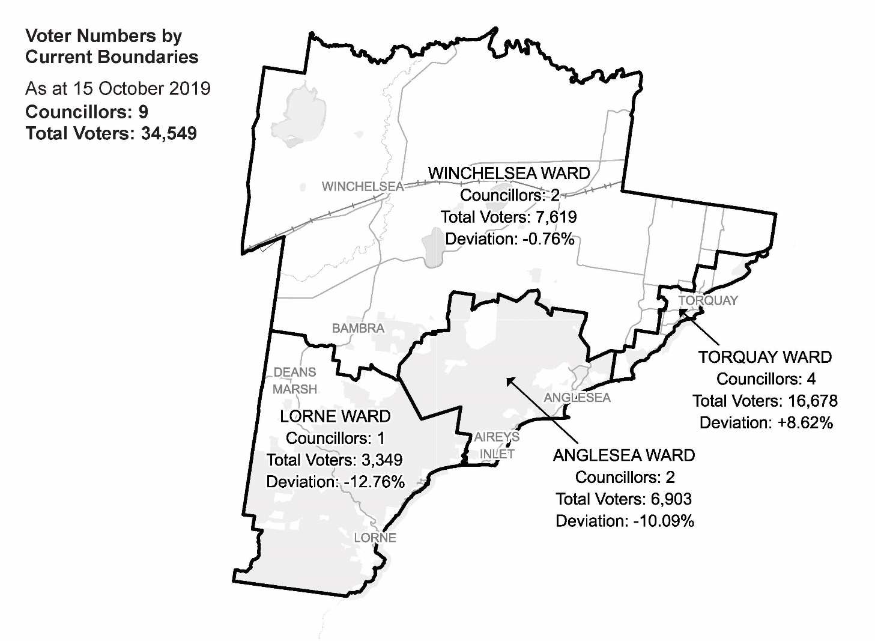  
Diagram 1: Surf Coast Shire Council electoral structure and voter statistics

Current subdivision review

The current subdivision review of Surf Coast Shire Council was required due to the voter-to-councillor ratio in Anglesea and Lorne Wards being more than 10% below the average voter-to-councillor ratio for the local council. Voter projections indicated that the voter-to-councillor ratio in Torquay Ward was unlikely to meet the equality requirement at the 2020 general election. Consequently, Anglesea, Lorne and Torquay Ward boundaries needed to be adjusted so that voter enrolments in these wards were within the 10% tolerance at the 2020 general election.

Table 1 shows the number of voters in each ward as at 15 October 2019, ranked by the percentage this deviates from the average number of voters per councillor for the whole local council.

|  |  |  |  |
| --- | --- | --- | --- |
| ***Table 1: Voter numbers per ward*** | | | |
| **Ward** | **Councillors** | **Voters** | **Deviation (%)** |
| Lorne | 1 | 3,349 | -12.76% |
| Anglesea | 2 | 6,903 | -10.09% |
| Torquay | 4 | 16,678 | +8.62% |
| Winchelsea | 2 | 7,619 | -0.76% |
| **Total for council** | **9** | **34,549** |  |

Preliminary report

The VEC’s subdivision review of Surf Coast Shire Council commenced with the release of a preliminary report on Wednesday 12 February 2020. The report contained proposed ward boundary changes based on analysis of enrolment information and internal research.

To bring Lorne Ward within the accepted plus-or-minus 10% deviation, the VEC proposed extending the ward boundary with Anglesea Ward east to Painkalac Creek. This was considered to provide a natural boundary between the communities of Fairhaven and Airey’s Inlet and was preferred to extending Lorne Ward too far north into Winchelsea Ward. The change affected 768 voters and at +7.25% brought Lorne Ward comfortably within plus-or-minus 10% of the average number of voters per councillor.

To bring Anglesea Ward within the accepted 10% deviation, the VEC proposed moving the ward boundary separating Anglesea and Torquay Wards east to include the entire Bells Beach locality. The VEC considered the incorporation of Bells Beach to be a natural extension of Anglesea Ward’s geography. The change affected 142 voters. However, this change was not enough to bring Anglesea Ward within the 10% tolerance for the next general election.

The VEC therefore proposed extending Anglesea Ward north into Bellbrae and part of Paraparap, to include 958 voters from Winchelsea Ward. The Bellbrae area was considered to have a close connection with Anglesea along the Great Ocean Road. It allowed the necessary number of voters to be added to Anglesea Ward without taking more voters from the southern or western parts of Torquay Ward and potentially dividing communities.

The two boundary changes to Anglesea Ward impacted a total of 1,100 voters and brought the ward to -5.76% of the average number of voters per councillor.

The flow-on effects of these adjustments to the Anglesea Ward boundary required changes to the Winchelsea-Torquay Ward boundaries to ensure both were within the accepted 10% deviation for the 2020 general election.

The change proposed was to move the Torquay–Winchelsea Ward boundary further south from Grossmans Road to follow Spring Creek, a property boundary, Alleyne Avenue and Beach Road. This change impacted 750 voters in Torquay Ward who would be contained within the boundary of Winchelsea Ward.

Given the need to decrease the number of voters in Torquay Ward and re-balance Winchelsea Ward, this boundary adjustment was considered the least disruptive option for voters.

Table 2 details the number of voters in each ward resulting from the proposed ward boundary changes and the percentage these wards deviate from the average number of voters per councillor for the whole local council.

|  |  |  |  |
| --- | --- | --- | --- |
| ***Table 2: Voter numbers per ward with proposed boundaries*** | | | |
| **Ward** | **Councillors** | **Voters** | **Deviation (%)** |
| Lorne | 1 | 4,117 | +7.25% |
| Anglesea | 2 | 7,235 | -5.76 |
| Torquay | 4 | 15,786 | +2.81 |
| Winchelsea | 2 | 7,411 | -3.47 |
| **Total for council** | **9** | **34,549** |  |

The proposed ward boundary changes brought all wards within the 10% tolerance for the 2020 general election, with a total of 2,618 voters (7.58% of the total) being allocated to different wards. The VEC believed that the proposed boundaries grouped geographic communities of interest within wards as far as possible.

Public response

Response submissions

The VEC accepted submissions responding to the preliminary report from Wednesday   
12 February 2020 until 5.00 pm on Wednesday 11 March 2020. The VEC received   
17 response submissions. A list of people who made a response submission can be found in Appendix 1.

There was significant opposition to the ward boundary changes proposed in the preliminary report. For example, ten submitters argued against the proposed ward boundary change to Lorne and Anglesea Wards and eight submitters argued against the proposed boundary adjustment to Torquay Ward.

### Anglesea-Lorne Ward boundary

Various submitters argued against the proposal to move the Anglesea-Lorne Ward boundary to Painkalac Creek, as it would divide the township of Fairhaven from Aireys Inlet. Most of these submitters suggested that Fairhaven had common needs and interests with Aireys Inlet and weak connections with Lorne.

Surf Coast Shire Council suggested that Fairhaven and Aireys Inlet were closely connected, shared social and environmental values and should not be split as proposed.

The Aireys Inlet and District Association Inc. (AIDA) argued that Fairhaven is part of the broader Aireys Inlet, Moggs Creek and Eastern View community and shares with it a postcode, services and other significant facilities. It submitted that there was little connection between this community and Lorne, and further suggested that splitting Fairhaven from Aireys Inlet would exacerbate the unfortunate situation whereby Eastern View and Moggs Creek are already split from the broader community to which they belong.

The Committee for Lorne submitted that Fairhaven is closely aligned with Aireys Inlet and looks to it to fulfil community needs related to education, health care, shopping and other services. Barbara Hammond argued that the two towns of Fairhaven and Aireys Inlet had common opportunities, needs and interests. As a long-term resident of Fairhaven, she connected with Anglesea, not Lorne, and considered that a councillor from Anglesea would be familiar with the shared needs of Fairhaven and Aireys Inlet. She further suggested that two councillors for Anglesea Ward had ensured the needs of Fairhaven were represented. Ms Hammond also argued that if Fairhaven was to be included in Lorne Ward, it would be very unlikely that the single councillor would come from Fairhaven or represent the interests of the area effectively.

Donald Baldwin argued that Fairhaven and Aireys Inlet operate as one community, sharing shops, schools and other services, and should not be divided between wards as proposed. Mr Baldwin also suggested that councillor numbers in either Anglesea or Torquay should be increased to accommodate population growth.

Gary Johnson likewise opposed dividing Fairhaven and Aireys Inlet, as it would be contrary to the shared needs and interests of the towns. Mr Johnson also pointed out that the two communities are involved in a number of joint projects and initiatives.

Gary Allen did not accept the proposed adjustment to the Anglesea-Lorne Ward boundary, as Fairhaven and Aireys Inlet are closely connected and share common values. Mr Allen argued that under the VEC’s proposal, Lorne Ward would consist of three separate communities, which would be challenging for one councillor to represent.

Allan Lamb argued that it was important to keep the coastal communities of Fairhaven and Moggs Creek together with Aireys Inlet in the same ward. Mr Lamb was not convinced by the argument against extending Lorne Ward north into Winchelsea Ward and argued conversely that Moggs Creek and Fairhaven did not have a strong connection with Lorne.

Mr Ryan similarly argued that those areas just west of Painkalac Creek had no connection with Lorne, which would leave affected voters without representation.   
Mr Ryan suggested that the VEC’s proposal would divide Aireys Inlet and Fairhaven, which are culturally and geographically united, have common interests and share various services. Mr Ryan did not agree that Painkalac Creek provided a good ward boundary.

Andrew Cherubin suggested keeping Fairhaven and Aireys Inlet together in Lorne Ward and proposed subsequent adjustments to the Anglesea, Torquay and Winchelsea Wards.

Some of those submitters opposed to the proposal to move the Lorne-Anglesea Ward boundary east to Painkalac Creek, including the Council, AIDA, Mr Ryan, Mr Allen and the Committee for Lorne, suggested that a better solution would be to extend the Lorne Ward boundary north.

The Council argued that this would be more appropriate as Lorne had shared interests with Deans Marsh and other communities currently contained in Lorne Ward. Mr Ryan similarly argued that Lorne had strong connections with Deans Marsh to its north, including issues related to tourism, transport and fire management; and the Committee for Lorne suggested that Lorne is a community of interest and shares much in common with Deans Marsh, such as employment, education and recreation.

AIDA proposed retaining the current Lorne-Anglesea Ward boundary to keep Fairhaven united with Airey Inlet, though it would have rather seen Eastern View, Moggs Creek, Fairhaven and Aireys Inlet united within Anglesea Ward. Using voter statistics, AIDA mapped the expansion of Lorne Ward north to encompass Birregurra, Bambra, Winchelsea South and Wensleydale.

### Torquay-Winchelsea Ward boundary

Many submitters argued against the proposal to adjust Torquay Ward boundary so that some voters in Torquay would be in Winchelsea Ward

The 3228 Residents’ Association Inc. submitted that it was unacceptable to continually adjust the ward boundaries so that an increasing number of Torquay residents would be in Winchelsea Ward. It argued that Winchelsea Ward was predominantly rural and could not effectively represent Torquay voters and residents.

Jorgen Peeters submitted that he and his family lived in Torquay and had close links with the Torquay community, including work, education, shopping and recreational connections, and that these interests would not be effectively represented if he was in Winchelsea Ward. He also suggested that the links between Torquay and Winchelsea were weak and that under the proposed change Winchelsea Ward councillors would not effectively represent the Torquay residents affected. Mr Cherubin argued that those residents living in Torquay but contained within Winchelsea Ward had not been properly represented. This was because, he argued, Winchelsea Ward has a rural focus, whereas Torquay voters require representatives that understand coastal communities.

Cal Stewart argued that Torquay residents had particular needs that could not be addressed or represented by Winchelsea Ward councillors. He did not feel it was appropriate to have to vote for a Winchelsea Ward councillor or for more areas of Torquay to be transferred to Winchelsea Ward. Mr Stewart also suggested that more councillors should be allocated to Torquay Ward to accommodate growth in population.

Some submitters from Torquay already in Winchelsea Ward as a result of the last representation review in 2012 suggested that the Torquay Ward boundary should be adjusted to include all Torquay residents. This was particularly the case for residents north of Grossmans Road and north of South Beach Road. They argued that since the last review, residents living in the greater Torquay area but contained within Winchelsea Ward had not been represented.

Sue O’Shanassy argued that residents in Torquay had not been adequately represented since the introduction of the current ward structure in 2012. She suggested that Torquay residents do not have shared interests with Winchelsea Ward residents; and added that it was not fair for the VEC to avoid splitting Jan Juc and Torquay while proposing to reallocate more Torquay residents into Winchelsea Ward.

AIDA mapped a proposal to adjust the western part of the proposed Torquay Ward boundary so that fewer voters in this area would be in Winchelsea Ward and a section of Torquay would be returned to Torquay Ward from Winchelsea Ward. AIDA also proposed moving the northern boundary of Torquay Ward south, so that a large section of the northern side of Torquay and Breamlea would be in Winchelsea Ward.

Other submitters suggested that a full representation review would be more appropriate, particularly in relation to the representation needs of Torquay. Although the Council did not object to the proposed changes to Torquay Ward, it did suggest the need for a representation review to address the representation needs of the greater Torquay area.

Mr Cherubin argued that a full review of the electoral structure for Surf Coast Shire was required to address ward boundaries and the appropriate number of councillors. The 3228 Residents’ Association Inc. also suggested that a full representation review was necessary, and that Torquay and Jan Juc residents should have more councillors representing them.

### Anglesea-Torquay Ward boundary

Mr Donelly opposed the proposal to extend Anglesea Ward boundary north, so that voters in Bells Beach would be in Anglesea Ward. Mr Donelly argued that Bells Beach had always been part of the Torquay surfing community and further suggested there was no community connection between Bells Beach and Anglesea.

Mr Cherubin proposed extending the Anglesea-Torquay Ward boundary north, so that a number of voters in Jan Juc would be in Anglesea Ward. He argued that it was preferable for residents in Torquay and Jan Juc to be spread across the Torquay and Anglesea Wards rather than being allocated to Winchelsea Ward.

### Anglesea-Winchelsea Ward boundary

There was little opposition to the proposal to move Anglesea Ward boundary north to encompass Bellbrae and Paraparap in Anglesea Ward. However, one submitter argued that Bellbrae had close links with the Torquay-Jan Juc community. AIDA mapped an alternative proposal to extend Anglesea Ward north only as far as Gundrys Road and Spring Creek, which would affect fewer voters than what was proposed in the preliminary report.

Public hearing

The VEC conducted a public hearing for those wishing to speak about their response submission at 5.00 pm on Tuesday 17 March 2020. The hearing was conducted online using CISCO Webex. Those unable to use the online facility spoke at the public hearing via telephone. A list of people who spoke at the hearing can be found in Appendix 1.

Barbara Fletcher and David Quin spoke on behalf of the Aireys Inlet and District Association Inc. (AIDA). Ms Fletcher stated that AIDA is an important community group, with over 500 members and therefore in a strong position to advocate for the local community’s needs and interests. When proposing ward boundary adjustments, Ms Fletcher suggested that consideration should be given to the impact of splitting communities and not just the need to satisfy the plus-or-minus 10% equality rule. She argued that Fairhaven as well as Eastern View and Moggs Creek share services, shops and other amenities with Aireys Inlet and should not be split between different wards.

Ms Fletcher suggested that Lorne is a different community to Fairhaven and Aireys Inlet. She added that the communities of Eastern View and Moggs Creek currently in Lorne Ward have had little contact with the Lorne Ward councillor, whereas in contrast, both Anglesea Ward councillors are active and aware of the needs of the broad Aireys Inlet-Fairhaven area. Ms Fletcher concluded by stating that Eastern View, Moggs Creek, Fairhaven and Aireys Inlet should be united in the one ward.

David Quin also spoke on behalf of AIDA, particularly regarding its mapping submission, which provided alternative ward boundaries to those put forward by the VEC in the preliminary report. He commenced by stating the difficulties meeting the plus-or-minus 10% equality requirements with regard to Lorne and Anglesea Wards and the impossibility of including Moggs Creek and Eastern View in the same ward as Fairhaven and Aireys Inlet. Mr Quin submitted that AIDA’s mapping submission shifted Surf Coast’s ward boundaries in a clockwise direction, whereas the VEC had moved the boundaries anti-clockwise. He also submitted that AIDA’s ward boundary proposals performed better on ward deviations than that put forward by the VEC.

Mr Quin argued that AIDA’s submission would do a better job reflecting and representing the Shire’s communities of interest than the VEC’s proposal. For example,

* Lorne Ward, which it argued should extend north (as was also suggested by the Committee of Lorne), would reflect the connections between Lorne and the communities to its north
* Torquay Ward, which as proposed by AIDA would address the concerns of Torquay residents, would keep the historical area of Torquay and Jan Juc in the one ward and better accommodate population growth

Mr Quin argued that it was preferable to adjust the ward boundaries in the north of Torquay area rather than affecting the more established areas of Torquay as proposed by the VEC.

Mr Quin also suggested that a full representation review was required and that it would be difficult for the outcome of this review to please everyone in the Shire.

Barbara Hammond argued against adjusting the Lorne-Anglesea Ward boundary east so that Fairhaven would be in Lorne Ward. Ms Hammond suggested that a councillor elected from the Anglesea Ward would have a much better understanding of the issues facing Aireys Inlet and Fairhaven than a councillor from Lorne, including issues such as road maintenance, public parking and other council services.

As a long-term resident of Fairhaven-Aireys Inlet area, Ms Hammond argued that the two localities were in fact one community and that her life and interests were closely connected to the area and Anglesea more broadly. She felt that her local area was and would continue to be best represented by the two Anglesea Ward councillors; because of this, the proposed Painkalac Creek ward boundary was not an effective ward boundary and would divide the cohesive Fairhaven-Aireys Inlet community.

Ms Hammond felt that it would be more appropriate for Moggs Creek to be in the same ward as Fairhaven and Aireys Inlet, and that the Lorne community was very different in character to Fairhaven, Aireys Inlet and surrounds. Ms Hammond also suggested that it was contradictory for the VEC to argue that separating Jan Juc and Torquay would divide communities, but then propose dividing Fairhaven and Aireys Inlet.

Sue O’Shanassy, a long-term resident of Torquay-Jan Juc and also a member of the local residents’ association and the Torquay Alliance, objected to the proposed ward boundary changes that would see a number of Torquay residents in Winchelsea Ward. She referred to the previous representation review in 2012, which resulted in a large number of Torquay residents being contained in Winchelsea Ward, to argue that this was not acceptable from a communities of interest perspective and disenfranchised those voters affected. Ms O’Shanassy suggested that it was contradictory for the VEC to propose expanding the Winchelsea Ward into the urban area of Torquay yet not be prepared to expand Lorne Ward north into the Shire’s rural areas.

Ms O’Shanassy argued that it would be unrealistic and unfair to expect Winchelsea Ward councillors to represent the large and growing geographical area of the ward. She argued that Torquay, as a rapidly growing coastal town, had very different needs and interests to the rural areas encompassed in Winchelsea Ward; and shifting the Winchelsea Ward boundary further east would adversely impact more Torquay residents and voters.

Ms O’Shanassy also suggested the following: Fairhaven and Aireys Inlet should remain in Anglesea Ward; Bells Beach has always been connected to the surfing community and culture of Torquay, but she preferred Bells Beach to be contained in Anglesea Ward rather than having to expand Winchelsea Ward further.

In general, Ms O’Shanassy argued that it was preferable to keep the coastal communities together in the same wards, such as Torquay and Anglesea, rather than having Winchelsea Ward further encroach into these communities.

Sherree Dalton-Darby began by asking the panel why residents were not properly informed about the subdivision review and its impact on voters.

Ms Dalton-Darby opposed the proposed adjustments to the Winchelsea-Torquay Ward boundary. She suggested that councillors elected from the predominantly rural ward of Winchelsea and at such a distance from Torquay would not be able to effectively represent the interests of Torquay voters. Ms Dalton-Darby raised concerns about the local services, including schools and childcare centres, that would now be contained in Winchelsea Ward as a result of the proposed ward boundary changes. Ms Dalton-Darby also wanted to connect with councillors from the local Torquay area and argued that it would be a disadvantage having to connect with councillors elected from Winchelsea. Ms Dalton-Darby did not feel she could seek representation from a councillor outside of her ward.

Ms Dalton-Darby expressed concerns about the timing of the review and argued that more time should have been provided to engage and consult with the community, especially those affected by the proposed changes.

Geoffrey Darby suggested that Coombs Road should be the boundary between Winchelsea and Torquay Wards and not Grossmans Road, as this area had a close affinity with the Torquay community.

Findings and recommendation

The VEC’s findings

The VEC recognises that there are strong geographic communities of interest within Surf Coast Shire, with the physical and socio-economic characteristics between different parts of the Shire reinforced by people’s sense of identification with their own area. For a start, there is a clear distinction between the coastal communities and the rural inland part of the Shire. Each of the coastal communities also has its own strong sense of identity. Naturally, people want their representatives to be dedicated to their own area, rather than have their attention divided in a ward composed of several disparate sections. However, by law, the equality of voters by numbers is paramount; the number of voters per councillor in any ward cannot vary by more than 10% from the average for the Shire. In a subdivision review, the VEC cannot change the number of councillors for wards, as some submitters urged. This means that ward boundaries will inevitably cut across communities of interest to some extent. The VEC aims to ensure that the boundaries comply with communities of interest as much as reasonably possible, within the constraints of the legislation.

The VEC is required to bring all wards within Surf Coast Shire Council to within plus-or-minus 10% of the average number of voters per councillor. This requires both Lorne and Anglesea Wards to be increased in size and voter numbers; Torquay Ward is projected to be above 10% of the average number of voters per councillor by the next general election and therefore needs to be reduced in size and voter numbers. In coming to its final recommendation, the VEC assessed population and voter data, communities of interest and the arguments presented in submissions.

The VEC acknowledges significant community opposition to many of the ward boundary changes proposed in the preliminary report and where possible has sought to address and respond to these concerns appropriately.

Notwithstanding the introduction of the *Local Government Act 2020,* the VEC remains bound by the schedule of representation reviews, which determines that full representation reviews are to be undertaken after every third general council election. The last representation review took place prior to the 2012 elections and the next scheduled representation review for Surf Coast Shire is due to occur prior to the 2024 elections. Furthermore, this subdivision review can only recommend ward boundary changes and cannot recommend any change to the number of councillors or overall electoral structure for Surf Coast Shire Council.

The VEC agreed with submitters on the concerns raised about the proposal to extend the Lorne-Anglesea Ward boundary east to Painkalac Creek. It considered the ward boundary as proposed in the preliminary report would split the Fairhaven and Aireys Inlet communities. However, it was not possible to also include Eastern View and Moggs Creek in Anglesea Ward, as this would have reduced Lorne Ward’s enrolment to more than 10% below the average.

On further assessment of voter numbers and projections, and the connections between Lorne and areas to its north, including Deans Marsh and Bambra, it was determined that a more appropriate solution would be to extend the Lorne Ward boundary north.

As such, the VEC recommends that the Lorne Ward boundary be extended north to Cape Otway Road, south along Wurdale Road, east along Wormbete Station Road and south on Knights Track. This makes use of a clear boundary in Cape Otway Road and the Winchelsea South locality boundary and is similar to that proposed by AIDA. As a result of this change, Bambra, Winchelsea South and parts of Birregurra and Wensleydale would be contained in Lorne Ward. The change would affect 371 voters, which is significantly fewer than that proposed in the preliminary report, and at -3.12%, the recommendation would bring the voter-to-councillor ratio for Lorne Ward comfortably within the accepted plus-or-minus 10% deviation. The Lorne-Anglesea Ward boundary would remain unchanged from the current electoral structure.

The retention of Fairhaven in Anglesea Ward means that Anglesea Ward does not have to expand as far to the north as in the VEC’s preliminary report. The VEC considered the proposed extension of the Anglesea Ward boundary north so that 142 voters in Bells Beach would be included in Anglesea Ward to be acceptable from a community of interest perspective. The expansion of Anglesea Ward north to include all of Bells Beach was also considered essential to increase the number of voters in Anglesea Ward. While the VEC acknowledges the links between Bells Beach and Torquay-Jan Juc, Bells Beach is considered an extension of the Anglesea Ward’s geography. Moreover, with two councillors covering the Anglesea Ward, the VEC is confident that voters in Bells Beach will not be disadvantaged by this change.

The VEC recommends a slight adjustment to the proposed Anglesea-Winchelsea ward boundary, which is more in line with that suggested by AIDA in its submission. The ward boundary runs along Gundrys Road and then the Great Ocean Road. This too provides a clear ward boundary and results in far fewer voters being affected than the changes put forward in the preliminary report. A total of 278 voters in Winchelsea Ward will be in Anglesea Ward compared with 958 under the initial proposal. Furthermore, the recommended ward boundary change keeps most of Bellbrae and all of Paraparap within Winchelsea Ward, which is considered a minor change when compared with the current electoral structure. As a result of the changes to the Anglesea-Torquay Ward boundary and the Anglesea-Winchelsea Ward boundary, the voter-to-councillor deviation from the council average in Anglesea Ward is -4.62%, which is well within the legislated limits.

Adjustments to the ward boundaries in order to reduce the number of voters in Torquay Ward was the most difficult issue to resolve. Legislation requires the VEC to make a recommendation to bring the voter-to-councillor ratio in Torquay Ward to within plus-or-minus 10% of the council average, which means that part of Torquay has to be transferred to another ward. In coming to a final recommendation on Torquay Ward, the VEC considered voter numbers and projections as well as the arguments presented in submissions.

The VEC considered the proposal put forward by AIDA would affect a far greater number of voters currently in Torquay Ward and result in large areas of land in the north of Torquay and Breamlea being contained within Winchelsea Ward.

The VEC determined that it was not appropriate to reallocate the part of Torquay currently contained within Winchelsea Ward to Torquay Ward, as requested by some submitters. This area has been in Winchelsea Ward for the past two general elections, with voters in the area having to elect Winchelsea Ward councillors in 2012 and 2016. Adopting such a change would cause significant disruption to voters and would in turn require a different and larger area of Torquay to be within Winchelsea Ward.

The VEC considered the adjustments to Torquay Ward as proposed in the preliminary report and affecting 750 voters as an extension of the changes made at the last review. The VEC reasoned that there would now be a larger number of residents and voters (more than 2,000 voters) that identify with Torquay but who are contained in Winchelsea Ward. This gives voters in the affected areas a better chance of having their needs and interests represented by a councillor elected from Winchelsea Ward.

The VEC considered the concerns raised by Torquay residents impacted by the change about the lack of representation they felt would result by having to elect and be represented by councillors from the predominantly rural Winchelsea Ward. The VEC notes that councillors do not have to reside in the ward from which they are elected, nor do all of the Winchelsea Ward councillors necessarily have to live in the town of Winchelsea. Furthermore, while voters elect councillors from the ward they live in, residents can connect with and seek assistance from councillors outside of their ward, including Torquay Ward.

With regard to the concerns raised about services and facilities, such as schools, which are in the locality of Torquay but would now be in Winchelsea Ward, the VEC determined that many of these relate to interests shared across wards and the whole of Shire and/or are not specific to local government. Moreover, it was also considered that an alternative change to Torquay Ward as proposed in some submissions would equally result in other services and facilities being in Winchelsea Ward.

Finally, the VEC modelled different boundaries in the Torquay area, but did not consider it fair or appropriate to recommend them, as the public would have had no opportunity to consider and comment on the changes.

As a result of this recommendation, the deviation from the average number of voters per councillor in Torquay Ward would be +2.81%, well within accepted limits; with these changes and those proposed to the Anglesea-Winchelsea Ward boundary, Winchelsea Ward would be +0.60% above the average.

The VEC considers that on balance, the recommended ward boundary changes reflect communities of interest and respond appropriately to the concerns raised in submissions. Ward boundary changes to Torquay Ward are unavoidable and the VEC considers these changes to involve a minimal level of disruption to voters and on balance to be fair and equitable. Compared with the proposed ward boundary changes put forward in the preliminary report, the recommended changes affect fewer voters, and overall, perform better on the accepted deviations (see Table 3).

|  |  |  |  |
| --- | --- | --- | --- |
| ***Table 3: Voter numbers per ward of recommended ward boundaries*** | | | |
| **Ward** | **Councillors** | **Voters** | **Deviation (%)** |
| Anglesea | 2 | 7,323 | -4.62 |
| Lorne | 1 | 3,716 | -3.20 |
| Torquay | 4 | 15,786 | +2.81 |
| Winchelsea | 2 | 7,724 | +0.60 |
| **Total for council** | **9** | **34,549** |  |

The VEC’s recommendation

The Victorian Electoral Commission recommends adjustments to the boundaries of the following wards within Surf Coast Shire Council:

* Anglesea Ward
* Lorne Ward
* Torquay Ward
* Winchelsea Ward

This recommendation is submitted to the Minister for Local Government as required by the *Local Government Act 1989*.

Please see Appendix 2 for a detailed map of the recommended ward boundaries.

# Appendix 1: Public involvement

Response submissions

Response submissions were made by:

3228 Residents’ Association Inc.

Aireys Inlet and District Association Inc. (AIDA)

Allan, Gary

Baldwin, Donald

Cherubin, Andrew

Committee for Lorne

Coombs, Mark

Dalton-Darby, Sherree

Donelly, Peter

Hammond, Barbara

Johnson, Gary

Lamb, Allan

O’Shanassy, Sue

Peeters Jorgen

Ryan, Chris

Stewart, Cal

Surf Coast Shire Council

Public hearing

The following individuals spoke at the public hearing:

Fletcher, Barbara and Quin, David (AIDA)

Dalton-Darby, Sherree & Darby, Geoffrey

Hammond, Barbara

O’Shanassy, Sue

# Appendix 2: Recommended ward boundaries map

The map is provided on the next page.

# Appendix 3: Public information program

Advertising

Public notices of the release of the preliminary report were placed in the following newspapers:

|  |  |
| --- | --- |
| **Newspaper** | **Date of publication** |
| *Surf Coast Bellarine Times* | Thursday 6 February 2020 |
| *Geelong Advertiser* | Saturday 8 February 2020 |

Media releases

A media release was prepared and distributed to local media to promote the publication of the preliminary report on Thursday 6 February 2020. A final media advisory was circulated on the publication date of this final report.

VEC website

The VEC website delivered up-to-date information to provide transparency and facilitate public participation during the review process. All public submissions were published on the website.

### Online submission tool

An online submission tool was developed and made available during the submission period of the review. The tool allowed people to make a submission from the VEC website.

Email and social media engagement

The VEC delivered an information email campaign targeted at known community groups and communities of interest in the local council area. This included a reminder email at each milestone of the subdivision review process.

The VEC also published sponsored social media advertising that was geo-targeted to users within the local council area. The total reach of these posts was 5,176.

Council communication resources

The VEC provided the Council with a communication pack that included information on the review in various formats. While the council is encouraged to distribute this information and raise awareness about the review, the VEC is an independent reviewer and all communications resources include reference and links to the VEC website and core materials.

|  |
| --- |
| **© State of Victoria**  (Victorian Electoral Commission) **April 2020** |
| This work, the Local Council Subdivision Review – Surf Coast Shire Council, is licensed under a Creative Commons Attribution 4.0 licence (http://creativecommons.org/ licenses/ by/4.0/). You are free to re-use the work under that licence, on the condition that you credit the State of Victoria (Victorian Electoral Commission) as author, indicate if changes were made and comply with the other licence terms. The licence does not apply to any branding, including government logos. |
|  | |
| Level 11, 530 Collins Street  Melbourne Victoria 3000  T 131 832  info@vec.vic.gov.au  vec.vic.gov.au | |
|  | |



1. Section 219H of the *Local Government Act* *1989.*
2. Section 219L of the *Local Government Act* *1989.*
3. Section 219L of the *Local Government Act* *1989.*
4. .id is a consulting company specialising in population and demographic analysis and prediction information products in most jurisdictions in Australia and New Zealand.
5. See ABS, ‘2016 Quickstats’ for ‘Lorne, Vic (SSC)’, ‘Aireys Inlet, Vic (SSC)’ and ‘Anglesea, Vic (SSC)’, <https://www.abs.gov.au/websitedbs/D3310114.nsf/Home/2016%20QuickStats>, accessed 17 January 2020.
6. See ABS, ‘2016 Quickstats’ for ‘Surf Coast (S)’, ‘Rest of Vic. (GCCSA)’ and ‘Greater Melbourne (GCCSA)’, <https://www.abs.gov.au/websitedbs/D3310114.nsf/Home/2016%20QuickStats>, accessed 20 January 2020.
7. .id, Surf Coast Shire: community profile’, <https://profile.id.com.au/surf-coast>, accessed 20 January 2020.
8. .id, ‘Surf Coast Shire: community profile’, <https://profile.id.com.au/surf-coast>, accessed 17 January 2020.
9. Department of Environment, Land, Water and Planning (DELWP), *Victoria in Future 2019,* 2019, <https://www.planning.vic.gov.au/land-use-and-population-research/victoria-in-future> , accessed 17 January 2019.
10. Ibid.
11. .id, ‘Surf Coast Shire: population forecast’, <https://forecast.id.com.au/surf-coast>, accessed 17 January 2020.
12. Ibid.