Local council electoral structure review

## About the review

Under Victoria’s *Local Government Act 2020*, Melton City Council must now have a single-councillor ward electoral structure.

The Minister for Local Government has appointed an electoral representation advisory panel to review the electoral structure of Melton City Council and advise on the most appropriate single-councillor ward structure.

The panel is looking at:

* the appropriate number of councillors and wards
* the location of ward boundaries
* appropriate ward names.

Electoral structure reviews are an important part of democracy and your input is valuable. As a local, you know your council area better than anyone. This is your chance to tell the panel your thoughts about the single-councillor ward structure you believe would best provide representation for your community.

You can have your say:

1. in a response submission to the preliminary report
2. at an online public hearing, if you ask to speak in your response submission.

About Melton City Council

The Traditional Custodians of the land in Melton City Council area are the Wurundjeri, Bunurong and Wadawurrung peoples.

Melton City Council is about 30 km west of central Melbourne and covers 528 km2. In 2021 it was home to 178,960 people. Through continued rapid growth the population is expected to double by 2040.

Formerly a shire centred on the satellite town of Melton, the area changed significantly from the 1990s onwards, when Melton and suburbs such as Caroline Springs and Taylors Hill became of part of the suburban fringe. In recognition of this changing urban profile, Melton became a city council in 2012.

On the eastern edge of the Victorian Volcanic Plain, the council area is largely flat and fertile. It is serviced by the Western Highway, which runs from Melbourne to Ballarat and Adelaide, as well as the Ballarat and Bendigo regional train lines.

The council is culturally diverse, with about 55% of the population having both parents born overseas. People born in India account for 8% of the population. Other large cultural groups include people with Maltese, Italian, and Filipino ancestry.

## Current structure

Melton City Council is divided into 3 wards with a total of 9 councillors:

* one ward with 4 councillors
* one ward with 3 councillors
* one ward with 2 councillors.

## Last review

The VEC conducted an electoral representation review of Melton City Council in 2015.

Visit the VEC website at [vec.vic.gov.au](https://www.vec.vic.gov.au/) to access a copy of the 2015 review final report.

Review process

Monday 23 and Tuesday 24 October

### Information sessions

Session 1: 12 noon, Monday 23 October

Session 2: 6 pm, Tuesday 24 October

These sessions will give you more information about the review process. You will be able to register for a session on the VEC website.

Wednesday 25 October

### Preliminary report

The panel will release a preliminary report with one or more options for the electoral structure on Wednesday 25 October.

**You can make a response submission from this date.**

Wednesday 15 November

### Response submissions

The panel must receive your submission by   
5 pm on Wednesday 15 November.

The panel will not accept late submissions.

Wednesday 22 November

### Public hearing

The panel will hold an online public hearing if anyone asks to speak about their response submission at 10 am on Wednesday 22 November.

The public hearing will not be held if no one asks to speak.

Wednesday 20 December

### Final report

The panel will submit a final report to the Minister for Local Government including its advice for the electoral structure on Wednesday 20 December.

The minister will consider the panel’s advice before recommending a change to the electoral structure. Any change is expected to apply at the next local council general election.

## Submission guide

You can download a submission guide from the VEC website at [vec.vic.gov.au](http://vec.vic.gov.au/)

## How to make a submission Untitled-1

On the VEC website at [vec.vic.gov.au](http://vec.vic.gov.au/)

By email to:

[Melton.ERAPSubmissions@ vec.vic.gov.au](mailto:Melton.ERAPSubmissions@vec.vic.gov.au)

LetterBy post to:

Electoral representation advisory panel  
c/o Victorian Electoral Commission  
Level 11, 530 Collins St  
Melbourne VIC 3000

Submissions must include your:

* full name
* contact phone number or email address
* residential or postal address.

Your submission will be published on the VEC website, including your name and suburb or town but not your full address or contact details. See the submission guide or VEC website at [vec.vic.gov.au/privacy](https://www.vec.vic.gov.au/privacy) for privacy information.

## One vote, one value

The ‘one vote, one value’ democratic principle is enshrined in the *Local Government Act 2020*. This means every person’s vote counts equally.

When a local council is subdivided into wards, the number of voters each councillor represents in each ward must be plus-or-minus 10% of the average number of voters per councillor for all wards.

The map below includes the current number of voters in each ward and the ward’s current deviation from the average. The panel will consider likely population and voter changes to ensure the structure remains equitable.

If you make a submission online, you can use a mapping tool to build your preferred electoral structure. The tool uses current voter numbers to tell you the deviations of the wards you make. This will help you propose a structure that meets the requirements of the Act.

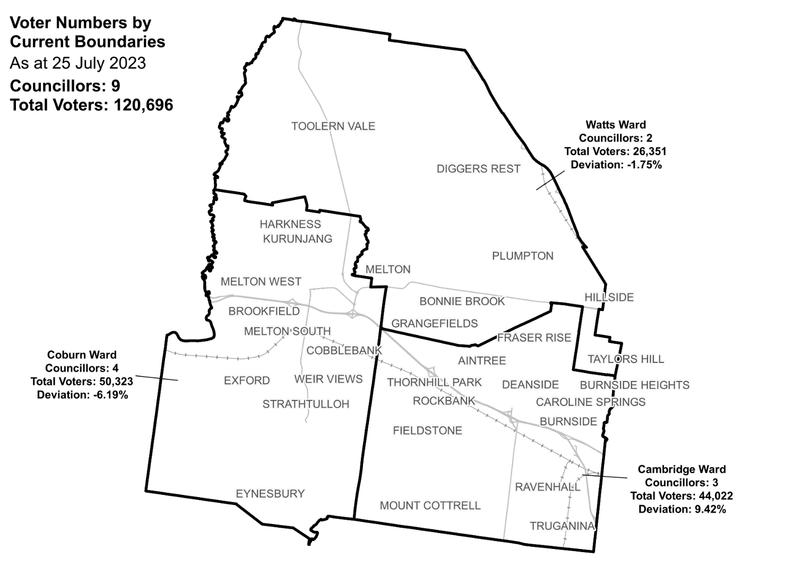Current electoral structure

|  |  |  |  |
| --- | --- | --- | --- |
| Ward | Councillors | Voters | Deviation |
| Cambridge Ward | 3 | 44,022 | +9.42% |
| Coburn Ward | 4 | 50,323 | -6.19% |
| Watts Ward | 2 | 26,351 | -1.75% |

## Statistics

Area (km2) 528

Voters

### Voters per square km

228.6

### Average voters per councillor

13,410

Population

### Current population

178,960

### Forecast population growth

5.2 % p.a.

More Census statistics available at [abs.gov.au](https://www.abs.gov.au/census/find-census-data/search-by-area)

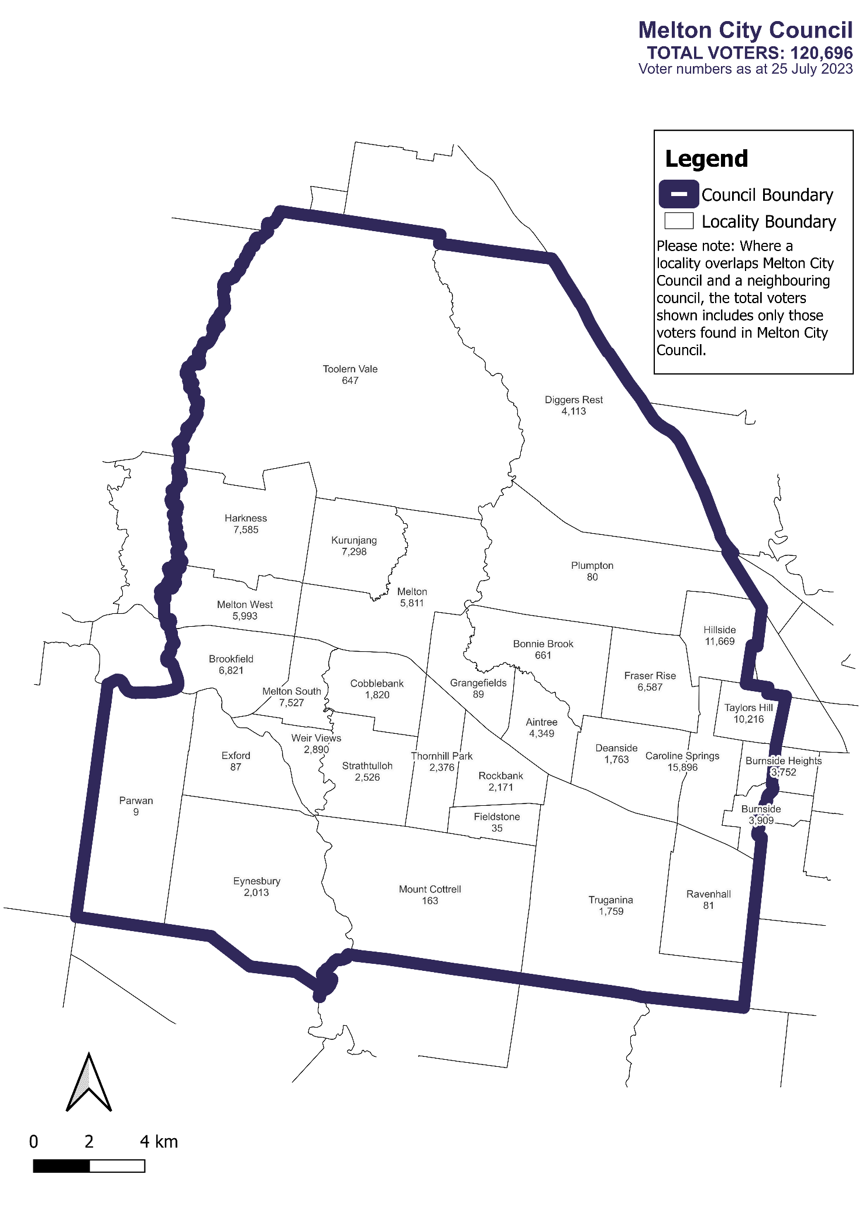Voter numbers by locality (map)

Voter numbers by locality (table)

## Melton City Council voter numbers at 25 July 2023

|  |  |
| --- | --- |
| Locality | Voters |
| Aintree | 4,349 |
| Bonnie Brook | 661 |
| Brookfield | 6,821 |
| Burnside | 3,909 |
| Burnside Heights | 3,752 |
| Caroline Springs | 15,896 |
| Cobblebank | 1,820 |
| Deanside | 1,763 |
| Diggers Rest | 4,113 |
| Exford | 87 |
| Eynesbury | 2,013 |
| Fieldstone | 35 |
| Fraser Rise | 6,587 |
| Grangefields | 89 |
| Harkness | 7,585 |
| Hillside | 11,669 |
| Kurunjang | 7,298 |
| Melton | 5,811 |
| Melton South | 7,527 |
| Melton West | 5,993 |
| Mount Cottrell | 163 |
| Parwan | 9 |

|  |  |
| --- | --- |
| Locality | Voters |
| Plumpton | 80 |
| Ravenhall | 81 |
| Rockbank | 2,171 |
| Strathtulloh | 2,526 |
| Taylors Hill | 10,216 |
| Thornhill Park | 2,376 |
| Toolern Vale | 647 |
| Truganina | 1,759 |
| Weir Views | 2,890 |