Local council electoral structure review

## About the review

Under Victoria’s *Local Government Act 2020*, Whittlesea City Council must now have a single-councillor ward electoral structure.

The Minister for Local Government has appointed an electoral representation advisory panel to review the electoral structure of Whittlesea City Council and advise on the most appropriate single-councillor ward structure.

The panel is looking at:

* the appropriate number of councillors and wards
* the location of ward boundaries
* appropriate ward names.

Electoral structure reviews are an important part of democracy and your input is valuable. As a local, you know your council area better than anyone. This is your chance to tell the panel your thoughts about the single-councillor ward structure you believe would best provide representation for your community.

You can have your say:

1. in a response submission to the preliminary report
2. at an online public hearing, if you ask to speak in your response submission.

About Whittlesea City Council

The Traditional Custodians of the lands in Whittlesea City Council are the Wurundjeri and the Taungurung peoples.

Whittlesea City Council is located about   
20 km north of central Melbourne and covers an area of 490 km2. It makes up part of Melbourne’s peri-urban fringe, straddling an urban–rural interface, with the south comprising mainly urban living and the north rural and farming land.

It is the fifth largest Victorian council by population, which in 2021 numbered 229,396 people. Rapid growth is forecast to continue, with the population expected to be over 277,000 by about 2028 and 360,000 by 2041.

Post-war immigration and more recent changes to the Melbourne urban growth boundary have shaped the council. The Thomastown area saw significant growth during the 1950s and 1960s with many Italian, Macedonian, and Greek migrants.

More recently, residential growth has continued north along Epping Road to Epping, Wollert and Donnybrook and along Plenty Road to South Morang, Mernda and Doreen.

## The outer growth areas are typified by younger families with a range of cultural identities. Many residents live in free-standing houses owned with a mortgage and commute by car.

## Current structure

Whittlesea City Council is divided into 3 wards with a total of 11 councillors:

* one ward with 3 councillors
* 2 wards with 4 councillors each.

## Last review

A representation review for Whittlesea City Council ceased in April 2020 when the *Local Government Act 2020* was introduced.

The final report for the Whittlesea City Council representation review was not published.

Review process

Monday 23 and Tuesday 24 October

### Information sessions

Session 1: 12 noon, Monday 23 October

Session 2: 6 pm, Tuesday 24 October

These sessions will give you more information about the review process. You will be able to register for a session on the VEC website.

Wednesday 25 October

### Preliminary report

The panel will release a preliminary report with one or more options for the electoral structure on Wednesday 25 October

**You can make a response submission from this date.**

Wednesday 15 November

### Response submissions

The panel must receive your submission by   
5 pm on Wednesday 15 November.

The panel will not accept late submissions.

Tuesday 21 November

### Public hearing

The panel will hold an online public hearing if anyone asks to speak about their response submission at 2 pm on Tuesday 21 November.

The public hearing will not be held if no one asks to speak.

Wednesday 20 December

### Final report

The panel will submit a final report to the Minister for Local Government including its advice for the electoral structure on Wednesday 20 December.

The minister will consider the panel’s advice before recommending a change to the electoral structure. Any change is expected to apply at the next local council general election.

## Submission guide

You can download a submission guide from the VEC website at [vec.vic.gov.au](http://vec.vic.gov.au/)

## How to make a submission Untitled-1

On the VEC website at [vec.vic.gov.au](http://vec.vic.gov.au/)

By email to:

[Whittlesea.ERAPSubmissions@ vec.vic.gov.au](mailto:Whittlesea.ERAPSubmissions@vec.vic.gov.au)

LetterBy post to:

Electoral representation advisory panel  
c/o Victorian Electoral Commission  
Level 11, 530 Collins St  
Melbourne VIC 3000

Submissions must include your:

* full name
* contact phone number or email address
* residential or postal address.

Your submission will be published on the VEC website, including your name and suburb or town but not your full address or contact details. See the submission guide or VEC website at [vec.vic.gov.au/privacy](https://www.vec.vic.gov.au/privacy) for privacy information.

## One vote, one value

The ‘one vote, one value’ democratic principle is enshrined in the *Local Government Act 2020*. This means every person’s vote counts equally.

When a local council is subdivided into wards, the number of voters each councillor represents in each ward must be plus-or-minus 10% of the average number of voters per councillor for all wards.

The map below includes the current number of voters in each ward and the ward’s current deviation from the average. The panel will consider likely population and voter changes to ensure the structure remains equitable.

If you make a submission online, you can use a mapping tool to build your preferred electoral structure. The tool uses current voter numbers to tell you the deviations of the wards you make. This will help you propose a structure that meets the requirements of the Act.

Current electoral structure

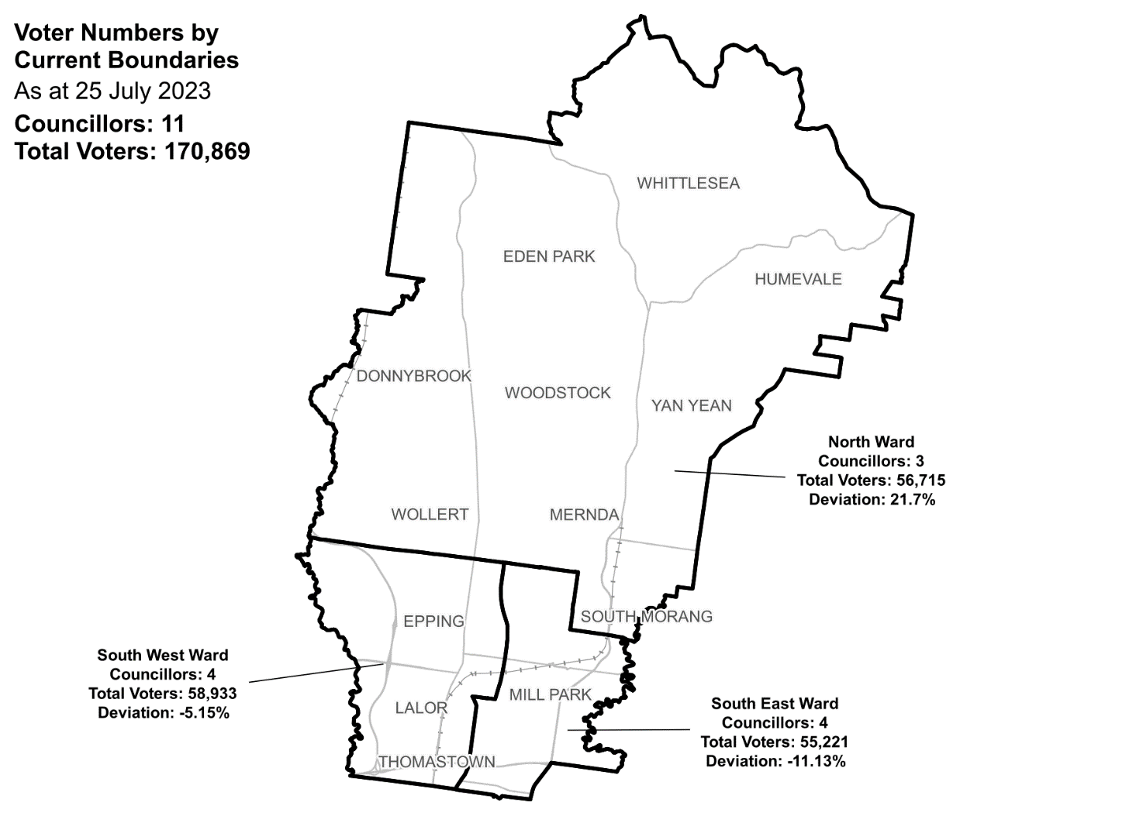

|  |  |  |  |
| --- | --- | --- | --- |
| Ward | Councillors | Voters | Deviation |
| North Ward | 3 | 56,715 | +21.7% |
| South East Ward | 4 | 55,221 | -11.13% |
| South West Ward | 4 | 58,933 | -5.15% |

## Statistics

Area (km2) 490

Voters

### Voters per square km

348.2

### Average voters per councillor

15,533

Population

### Current population

229,396

### Forecast population growth

4.2 % p.a.

More Census statistics available at [abs.gov.au](https://www.abs.gov.au/census/find-census-data/search-by-area)

Voter numbers by locality (map)

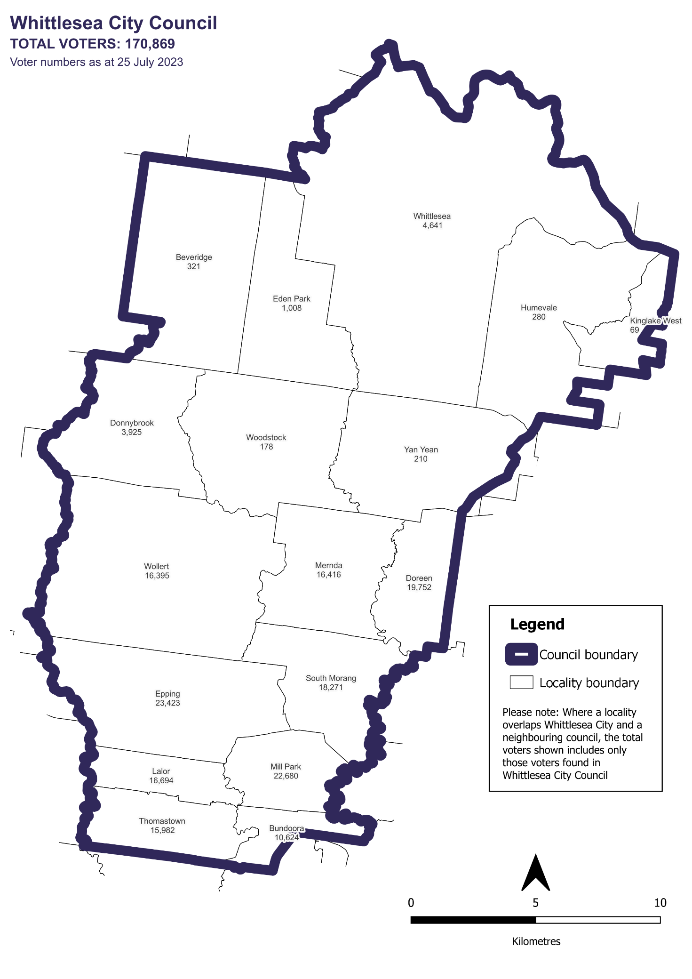

Voter numbers by locality (table)

## Whittlesea City Council voter numbers at 25 July 2023

|  |  |
| --- | --- |
| Locality | Voters |
| Beveridge | 321 |
| Bundoora | 10,624 |
| Donnybrook | 3,925 |
| Doreen | 19,752 |
| Eden Park | 1,008 |
| Epping | 23,423 |
| Humevale | 280 |
| Kinglake west | 69 |
| Lalor | 16,694 |
| Mernda | 16,416 |
| Mill Park | 22,680 |
| South Morang | 18,271 |
| Thomastown | 15,982 |
| Whittlesea | 4,641 |
| Wollert | 16,395 |
| Woodstock | 178 |
| Yan Yean | 210 |