Local council electoral structure review

## About the review

Under Victoria’s *Local Government Act 2020*, Greater Bendigo City Council must now have a single-councillor ward electoral structure.

The Minister for Local Government has appointed an electoral representation advisory panel to conduct an electoral structure review of the council. The panel will advise the Minister on the most appropriate single-councillor ward structure for Greater Bendigo City Council.

The panel is looking at:

* the appropriate number of councillors and wards
* the location of ward boundaries
* appropriate ward names.

Electoral structure reviews are an important part of democracy, and your input is valuable. As a local, you know your local council area better than anyone. This is your chance to let the panel know your thoughts about the single-councillor ward electoral structure that you believe would best provide representation for your community.

There are 2 opportunities for you to have your say on the electoral structure of the council:

1. in a response submission to the preliminary report
2. in an online public hearing, if you request to speak in your response submission.

About Greater Bendigo City Council

The Traditional Custodians of the land in Greater Bendigo City Council are the Dja Dja Wurrung and the Taungurung peoples.

Greater Bendigo City Council is about 150 km north-west of Melbourne, with a population of 121,470 in 2021 and a forecast annual growth rate of 2%.

Covering an area of 3,000 km2, the council area includes urban centres of Axedale, Bendigo, Elmore, Goornong, Heathcote and Marong.

Greater Bendigo City Council shares its borders with 5 other councils: Campaspe Shire Council in the north, Strathbogie and Mitchell shire councils in the east, Mount Alexander Shire Council in the south, and Loddon Shire Council in the west.

The council area is home to the Greater Bendigo National Park and extensive Box-Ironbark forests. The Campaspe River flows through the municipality into Lake Eppalock. Major roads service the area including the Calder, McIvor, Midland, Loddon Valley, Northern and Wimmera highways.

More Greater Bendigo City Council residents worked in health care and social assistance than any other industry in 2021. These industries employed 19.1% of residents.

The median age in 2021 was 40, which was lower than the rural and regional Victorian overall median age of 43.

Most people in the municipality (70.5%) owned their own home either outright or with a mortgage in 2021, when the median weekly household income was $1,448.

## Current structure

Greater Bendigo City Council is divided into 3 wards with a total of 9 councillors:

* 3 wards with 3 councillors each.

## Last review

The VEC conducted an electoral representation review of Greater Bendigo City Council in 2011.

Visit the VEC website at [vec.vic.gov.au](https://www.vec.vic.gov.au/) to access a copy of the 2011 review final report.

Review process

Monday 26 and Tuesday 27 June

### Information sessions

Session 1: 12 noon, Monday 26 June

Session 2: 6 pm, Tuesday 27 June

Information sessions are for anyone wanting to find out more about the review process. Links to register for an information session will be available on the VEC website.

Wednesday 28 June

### Preliminary report

The panel will release a preliminary report including one or more options for the electoral structure on Wednesday 28 June.

**Response submissions open from this date.**

Wednesday 19 July

### Response submission close

The panel must receive all submissions by 5 pm on Wednesday 19 July.

Late submissions will not be accepted.

Tuesday 25 July

### Public hearing

The panel will hold an online public hearing if anyone requests to speak about their response submission at 2 pm on Tuesday 25 July.

The public hearing will not be held if there are no requests to speak.

Wednesday 23 August

### Final report

The panel will submit a final report to the Minister for Local Government including its advice on the electoral structure on Wednesday 23 August.

The Minister will then consider the panel’s advice before recommending a change to the electoral structure. Any change to the electoral structure of the council following the review is expected to apply at the next local council elections.

**How to make a submission**

**On the VEC website at [vec.vic.gov.au](http://vec.vic.gov.au/)

By email to

[GreaterBendigo.ERAPSubmissions  
@vec.vic.gov.au](mailto:GreaterBendigo.ERAPSubmissions@vec.vic.gov.au)

LetterBy post to

Electoral representation advisory panel  
c/o Victorian Electoral Commission  
Level 11, 530 Collins Street  
Melbourne VIC 3000

Submissions must include your:

* full name
* contact phone number or email address
* residential or postal address.

All submissions will be published on the VEC website. Your name and locality (suburb or town) will be published, but your full address and contact details will be removed. See the submission guide and VEC website at [vec.vic.gov.au/privacy](https://www.vec.vic.gov.au/privacy) for privacy information.

## Submission guide

Download the submission guide from the VEC website at [vec.vic.gov.au](http://vec.vic.gov.au/) for more information on the review process and making a submission.

## One vote, one value

The ‘one vote, one value’ democratic principle is enshrined in the *Local Government Act 2020*. This means that every person’s vote counts equally.

When a local council area is subdivided into wards, the number of voters each councillor represents in each ward must be within plus-or-minus 10% of the of the average number of voters per councillor for all the wards.

The map below includes the current number of voters in each ward and the ward’s current deviation from the average. The panel will consider likely population and voter changes to ensure the structure remains equitable.

If you make a submission online, you can use a mapping tool to build your preferred electoral structure. The tool uses current voter numbers to tell you the deviations of the wards you make. This will help you propose a structure that meets the requirements of the Act.

Current electoral structure

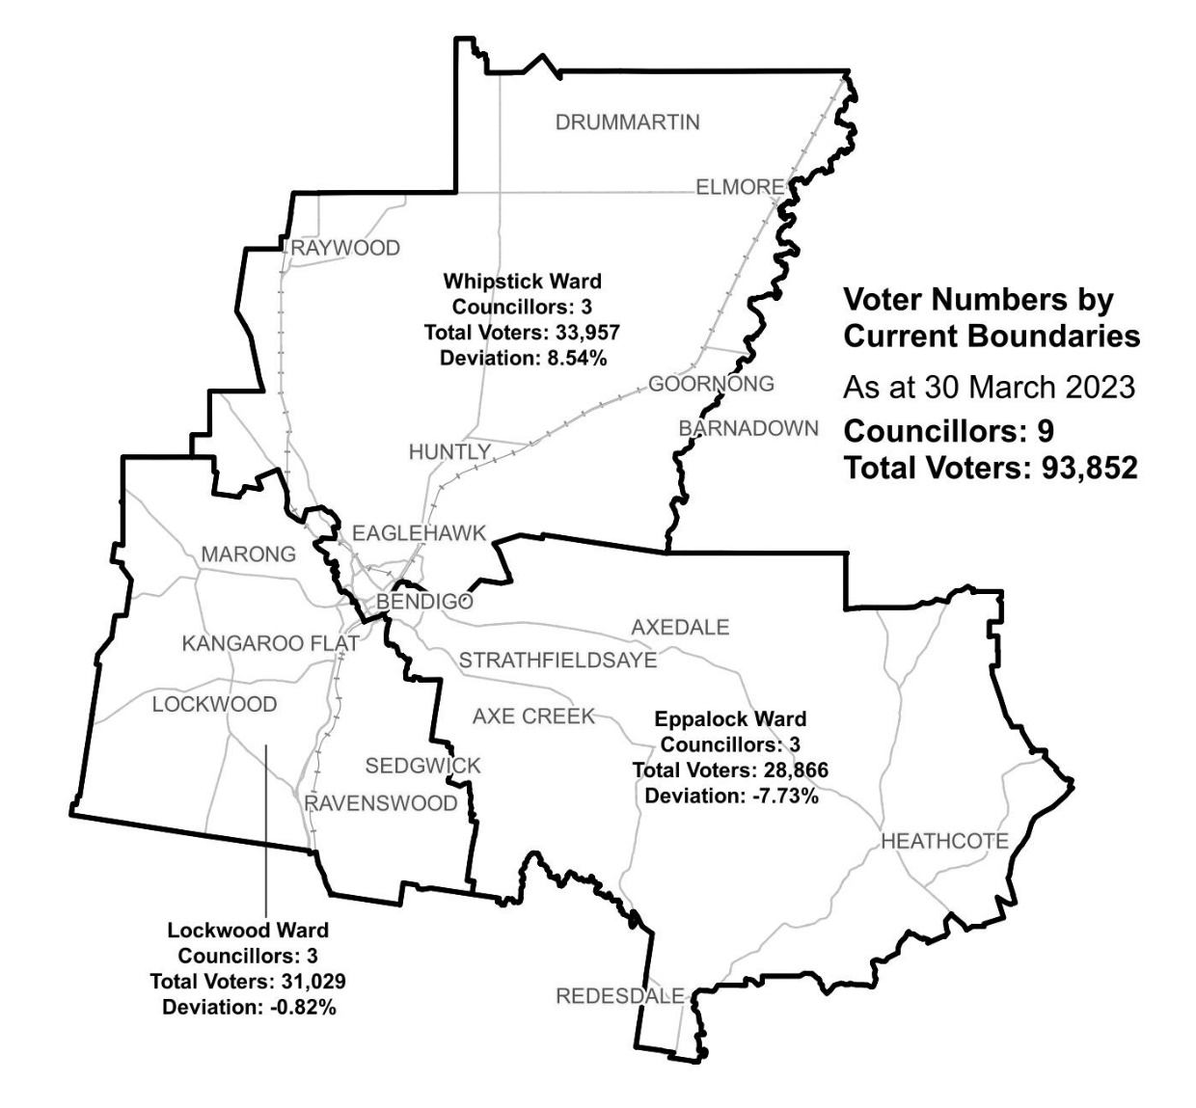

|  |  |  |  |
| --- | --- | --- | --- |
| Ward | Councillors | Voters | Deviation |
| Eppalock | 3 | 28,866 | -7.73% |
| Lockwood | 3 | 31,029 | -0.82% |
| Whipstick | 3 | 33,957 | +8.54% |

## Statistics

Area (km2) 3,000

Voters

### Voters per square km

31.3

### Average voters per councillor

10,428

Population

### Current population

121,470

### Forecast population growth

2.0 % p.a.

Further census statistics available at [abs.gov.au](https://abs.gov.au/)

Voter numbers by locality (map)

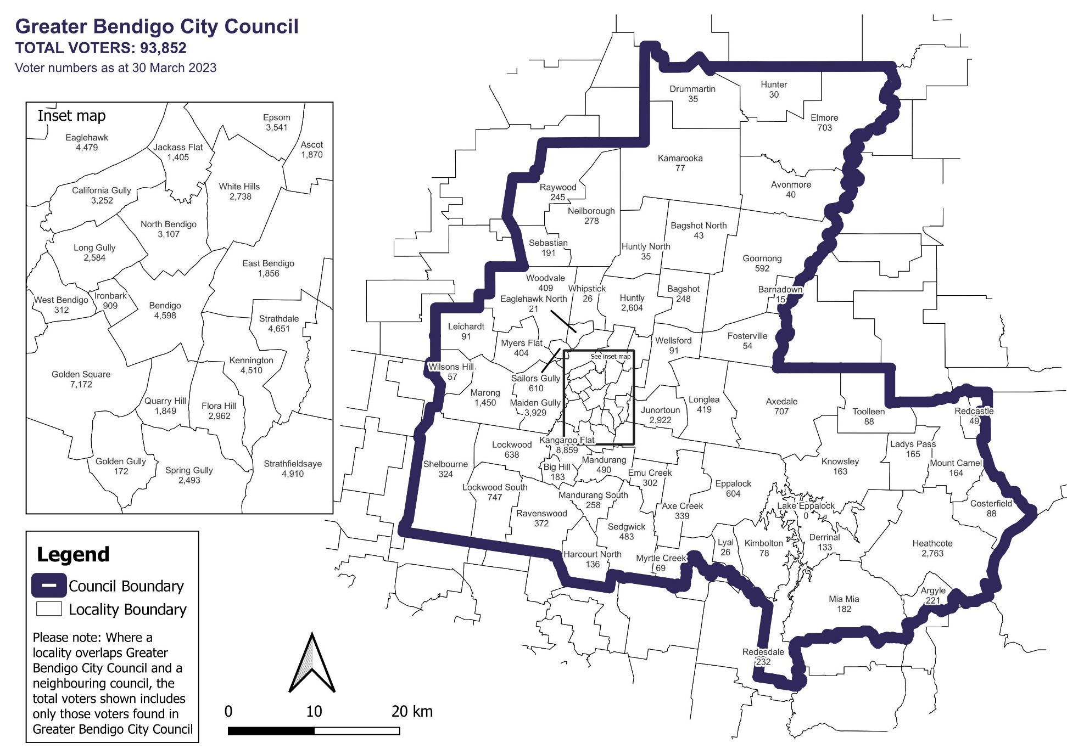

Voter numbers by locality (table)

## Greater Bendigo City Council voter numbers at 30 March 2023

|  |  |
| --- | --- |
| Locality | Voters |
| Argyle | 221 |
| Ascot | 1,870 |
| Avonmore | 40 |
| Axe Creek | 339 |
| Axedale | 707 |
| Bagshot | 248 |
| Bagshot North | 43 |
| Barnadown | 15 |
| Bendigo | 4,598 |
| Big Hill | 183 |
| California Gully | 3,252 |
| Costerfield | 88 |
| Derrinal | 133 |
| Drummartin | 35 |
| Eaglehawk | 4,479 |
| Eaglehawk North | 21 |
| East Bendigo | 1,856 |
| Elmore | 703 |
| Emu Creek | 302 |
| Eppalock | 604 |
| Epsom | 3,541 |
| Flora Hill | 2,962 |

|  |  |
| --- | --- |
| Locality | Voters |
| Fosterville | 54 |
| Golden Gully | 172 |
| Golden Square | 7,172 |
| Goornong | 592 |
| Harcourt North | 136 |
| Heathcote | 2,763 |
| Hunter | 30 |
| Huntly | 2,604 |
| Huntly North | 35 |
| Ironbark | 909 |
| Jackass Flat | 1,405 |
| Junortoun | 2,922 |
| Kamarooka | 77 |
| Kangaroo Flat | 8,859 |
| Kennington | 4,510 |
| Kimbolton | 78 |
| Knowsley | 163 |
| Ladys Pass | 165 |
| Lake Eppalock | 0 |
| Leichardt | 91 |
| Lockwood | 638 |
| Lockwood South | 747 |

|  |  |
| --- | --- |
| Locality | Voters |
| Long Gully | 2,584 |
| Longlea | 419 |
| Lyal | 26 |
| Maiden Gully | 3,929 |
| Mandurang | 490 |
| Mandurang South | 258 |
| Marong | 1,450 |
| Mia Mia | 182 |
| Mount Camel | 164 |
| Myers Flat | 404 |
| Myrtle Creek | 69 |
| Neilborough | 278 |
| North Bendigo | 3,107 |
| Quarry Hill | 1,849 |
| Ravenswood | 372 |
| Raywood | 245 |
| Redcastle | 49 |
| Redesdale | 232 |
| Sailors Gully | 610 |
| Sebastian | 191 |
| Sedgwick | 483 |
| Shelbourne | 324 |

|  |  |
| --- | --- |
| Locality | Voters |
| Spring Gully | 2,493 |
| Strathdale | 4,651 |
| Strathfieldsaye | 4,910 |
| Toolleen | 88 |
| Wellsford | 91 |
| West Bendigo | 312 |
| Whipstick | 26 |
| White Hills | 2,738 |
| Wilsons Hill | 57 |
| Woodvale | 409 |