Local council electoral structure review

## About the review

Under Victoria’s *Local Government Act 2020*, Ballarat City Council must now have a single-councillor ward electoral structure.

The Minister for Local Government has appointed an electoral representation advisory panel to conduct an electoral structure review of the council. The panel will advise the Minister on the most appropriate single-councillor ward structure for Ballarat City Council.

The panel is looking at:

* the appropriate number of councillors and wards
* the location of ward boundaries
* appropriate ward names.

Electoral structure reviews are an important part of democracy, and your input is valuable. As a local, you know your local council area better than anyone. This is your chance to let the panel know your thoughts about the single-councillor ward electoral structure that you believe would best provide representation for your community.

There are 2 opportunities for you to have your say on the electoral structure of the council:

1. in a response submission to the preliminary report
2. in an online public hearing, if you request to speak in your response submission.

About Ballarat City Council

The Traditional Custodians of the land in Ballarat City Council are the Wadawurrung and Dja Dja Wurrung peoples.

Ballarat City Council is in the Central Highlands region of Victoria, about 110 km west of Melbourne.

Covering an area of 739 km², the council includes Victoria’s largest inland city of Ballarat. While mainly residential, the city also includes substantial industrial, commercial and rural areas.

Health care, education and training are the top employment sectors in the city, accounting for almost 30% of jobs.

Tourism is an important industry, attracting over 2.3 million visitors to the council each year, with features such as Sovereign Hill, Ballarat Wildlife Park, Mount Buninyong, and Lake Wendouree.

Population growth has been strong over the last decade. At the 2021 Census, Ballarat City Council had a population of 113,763, an increase of 20,262 (21.6%) since 2011. The median age of the population is 39 years, lower than that of rural and regional Victoria overall (43 years).

People born in Australia make up 83.7% of the population (compared to 81% in regional Victoria overall), and 88.1% of residents speak only English at home, compared to 86% in rural and regional Victoria overall.

The weekly median household income in Ballarat City Council is $1,429, slightly above the rural and regional Victorian median of $1,386.

## Current structure

Ballarat City Council is divided into 3 wards with a total of 9 councillors:

* 3 wards with 3 councillors in each ward.

## Last review

The VEC conducted an electoral representation review of Ballarat City Council in 2015.

Visit the VEC website at [vec.vic.gov.au](https://www.vec.vic.gov.au/electoral-boundaries/local-councils/ballarat-city-council) to access a copy of the 2015 review final report

Review process

Monday 26 and Tuesday 27 June

### Information sessions

Session 1: 12 noon, Monday 26 June

Session 2: 6 pm, Tuesday 27 June

Information sessions are for anyone wanting to find out more about the review process. Links to register for an information session will be available on the VEC website.

Wednesday 28 June

### Preliminary report

The panel will release a preliminary report including one or more options for the electoral structure on Wednesday 28 June.

**Response submissions open from this date.**

Wednesday 19 July

### Response submission close

The panel must receive all submissions by 5 pm on Wednesday 19 July.

Late submissions will not be accepted.

Tuesday 25 July

### Public hearing

The panel will hold an online public hearing if anyone requests to speak about their response submission at 10 am on Tuesday 25 July.

The public hearing will not be held if there are no requests to speak.

Wednesday 23 August

### Final report

The panel will submit a final report to the Minister for Local Government, including its advice on the electoral structure, on Wednesday 23 August.

The Minister will then consider the panel’s advice before recommending a change to the electoral structure. Any change to the electoral structure of the council following the review is expected to apply at the next local council elections.

## Untitled-1How to make a submission

On the VEC website at [vec.vic.gov.au](http://vec.vic.gov.au/)

By email to

[Ballarat.ERAPSubmissions  
@vec.vic.gov.au](mailto:Ballarat.ERAPSubmissions@vec.vic.gov.au)

LetterElectoral representation advisory panel  
c/o Victorian Electoral Commission  
Level 11, 530 Collins Street  
Melbourne VIC 3000

Submissions must include your:

* full name
* contact phone number or email address
* residential or postal address.

All submissions will be published on the VEC website. Your name and locality (suburb or town) will be published, but your full address and contact details will be removed. See the submission guide and VEC website at [vec.vic.gov.au/privacy](https://www.vec.vic.gov.au/privacy) for privacy information.

## Submission guide

Download the submission guide from the VEC website at [vec.vic.gov.au](http://vec.vic.gov.au/) for more information on the review process and making a submission.

## One vote, one value

The ‘one vote, one value’ democratic principle is enshrined in the *Local Government Act 2020*. This means that every person’s vote counts equally.

When a local council area is subdivided into wards, the number of voters each councillor represents in each ward must be within plus-or-minus 10% of the of the average number of voters per councillor for all the wards.

The map below includes the current number of voters in each ward and the ward’s current deviation from the average. The panel will consider likely population and voter changes to ensure the structure remains equitable.

If you make a submission online, you can use a mapping tool to build your preferred electoral structure. The tool uses current voter numbers to tell you the deviations of the wards you make. This will help you propose a structure that meets the requirements of the Act.

Current electoral structure

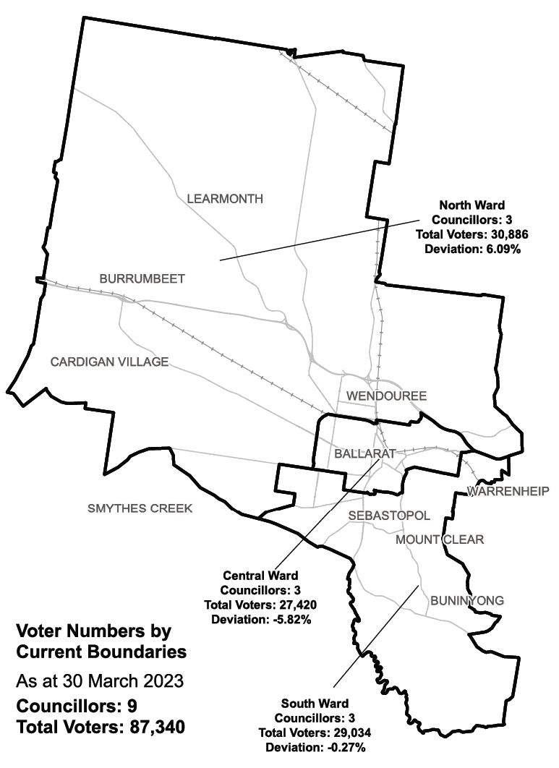

|  |  |  |  |
| --- | --- | --- | --- |
| Ward | Councillors | Voters | Deviation |
| Central Ward | 3 | 27,420 | -5.82% |
| North Ward | 3 | 30,886 | +6.09% |
| South Ward | 3 | 29,034 | -0.27% |

## Statistics

Area (km2) 739

Voters

### Voters per square km

118.2

### Average voters per councillor

9,704

Population

### Current population

113,763

### Forecast population growth

1.8% p.a.

Further census statistics available at [abs.gov.au](https://abs.gov.au)

Voter numbers by locality (map)

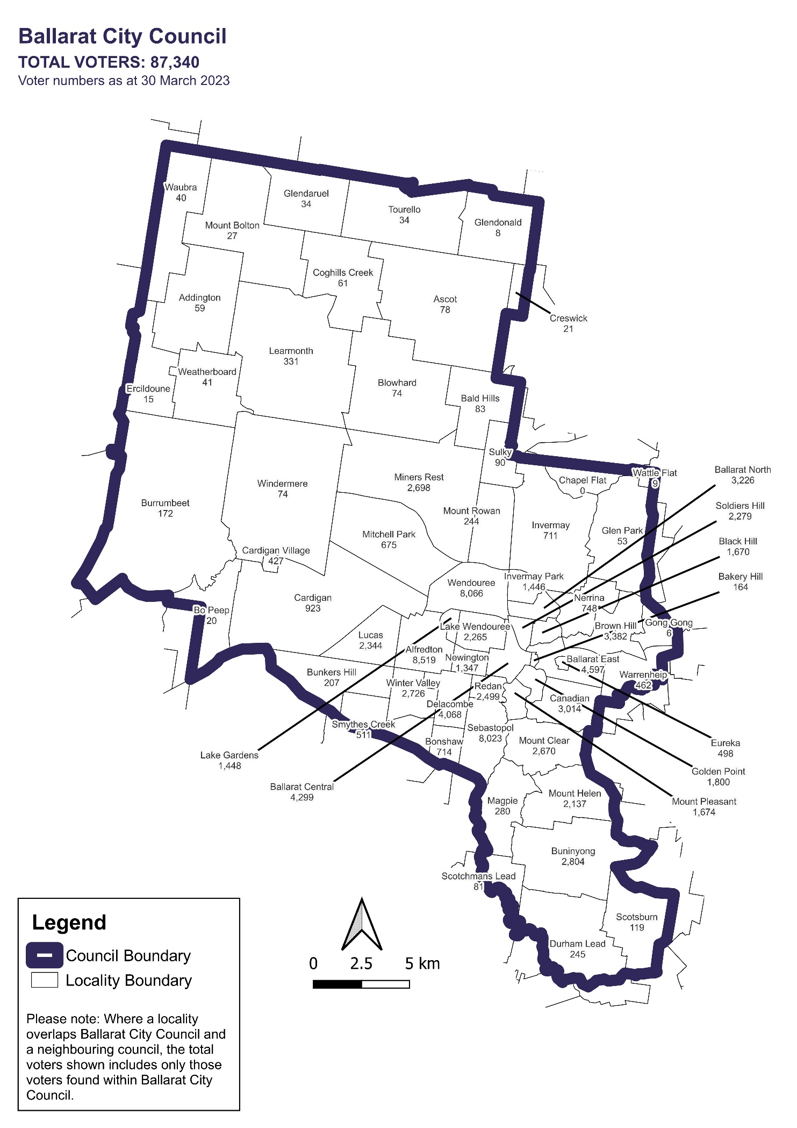

Voter numbers by locality (table)

## Ballarat City Council voter numbers at 30 March 2023

|  |  |
| --- | --- |
| Locality | Voters |
| Addington | 59 |
| Alfredton | 8,519 |
| Ascot | 78 |
| Bakery Hill | 164 |
| Bald Hills | 83 |
| Ballarat Central | 4,299 |
| Ballarat East | 4,597 |
| Ballarat North | 3,226 |
| Black Hill | 1,670 |
| Blowhard | 74 |
| Bo Peep | 20 |
| Bonshaw | 714 |
| Brown Hill | 3,382 |
| Buninyong | 2,804 |
| Bunkers Hill | 207 |
| Burrumbeet | 172 |
| Canadian | 3,014 |
| Cardigan | 923 |
| Cardigan Village | 427 |
| Chapel Flat | 0 |
| Coghills Creek | 61 |
| Creswick | 21 |

|  |  |
| --- | --- |
| Locality | Voters |
| Delacombe | 4,068 |
| Durham Lead | 245 |
| Ercildoune | 15 |
| Eureka | 498 |
| Glen Park | 53 |
| Glendaruel | 34 |
| Glendonald | 8 |
| Golden Point | 1,800 |
| Gong Gong | 6 |
| Invermay | 711 |
| Invermay Park | 1,446 |
| Lake Gardens | 1,448 |
| Lake Wendouree | 2,265 |
| Learmonth | 331 |
| Lucas | 2,344 |
| Magpie | 280 |
| Miners Rest | 2,698 |
| Mitchell Park | 675 |
| Mount Bolton | 27 |
| Mount Clear | 2,670 |
| Mount Helen | 2,137 |
| Mount Pleasant | 1,674 |

|  |  |
| --- | --- |
| Locality | Voters |
| Mount Rowan | 244 |
| Nerrina | 748 |
| Newington | 1,347 |
| Redan | 2,499 |
| Scotchmans Lead | 81 |
| Scotsburn | 119 |
| Sebastopol | 8,023 |
| Smythes Creek | 511 |
| Soldiers Hill | 2,279 |
| Sulky | 90 |
| Tourello | 34 |
| Warrenheip | 462 |
| Wattle Flat | 9 |
| Waubra | 40 |
| Weatherboard | 41 |
| Wendouree | 8,066 |
| Windermere | 74 |
| Winter Valley | 2,726 |