Local council electoral structure review

## About the review

Under Victoria’s *Local Government Act 2020*, Hume City Council must now have a single-councillor ward electoral structure.

The Minister for Local Government has appointed an electoral representation advisory panel to review the electoral structure of Hume City Council and advise on the most appropriate single-councillor ward structure.

The panel is looking at:

* the appropriate number of councillors and wards
* the location of ward boundaries
* appropriate ward names.

Electoral structure reviews are an important part of democracy and your input is valuable. As a local, you know your council area better than anyone. This is your chance to tell the panel your thoughts about the single-councillor ward structure you believe would best provide representation for your community.

You can have your say:

1. in a response submission to the preliminary report
2. at an online public hearing, if you ask to speak in your response submission.

About Hume City Council

The Traditional Custodians of the land in Hume City Council are the Wurundjeri people.

Located 20 km north-west of the Melbourne CBD, Hume City Council covers an area of 503 km2. It includes large areas of farmland, the satellite town of Sunbury, Melbourne Airport and a large industrial precinct.

The council area is the fourth most populated in Victoria and is set to increase from 243,901 to over 395,000 by 2041. The population is concentrated in Broadmeadows, Craigieburn, Greenvale, Mickleham and Kalkallo.

The council area provides important access points to Melbourne’s north via major roads and freeways, 3 commuter train lines and national freight links.

Hume is a major contributor to the state economy, with $32 billion in output. The industrial area in Somerton is critical in meeting Melbourne’s manufacturing and logistics demands. Sunbury plays a valuable role as an employment centre and a link to regions in and beyond the council area.

Hume is culturally diverse, with about 40% of the population born overseas. The largest cultural groups are Indian, Iraqi and Turkish.

## Current structure

Hume City Council is divided into 3 wards with a total of 11 councillors:

* 2 wards with 4 councillors each
* one ward with 3 councillors

## Last review

The VEC conducted an electoral representation review of Hume City Council in 2012.

Visit the VEC website at [vec.vic.gov.au](https://www.vec.vic.gov.au/) to access a copy of the 2012 review final report.

Review process

Monday 30 and Tuesday 31 October

### Information sessions

Session 1: 12 noon, Monday 30 October

Session 2: 6 pm, Tuesday 31 October

These sessions will give you more information about the review process. You will be able to register for a session on the VEC website.

Wednesday 1 November

### Preliminary report

The panel will release a preliminary report with one or more options for the electoral structure on Wednesday 1 November.

**You can make a response submission from this date.**

Wednesday 22 November

### Response submissions

The panel must receive your submission by   
5 pm on Wednesday 22 November.

The panel will not accept late submissions.

Wednesday 29 November

### Public hearing

The panel will hold an online public hearing if anyone asks to speak about their response submission at 10 am Wednesday 29 November.

The public hearing will not be held if no one asks to speak.

Wednesday 24 January 2024

### Final report

The panel will submit a final report to the Minister for Local Government including its advice for the electoral structure on Wednesday 24 January 2024.

The Minister will consider the panel’s advice before recommending a change to the electoral structure. Any change is expected to apply at the next local council general election.

## Submission guide

You can download a submission guide from the VEC website at [vec.vic.gov.au](http://vec.vic.gov.au/)

## How to make a submission Untitled-1

On the VEC website at [vec.vic.gov.au](http://vec.vic.gov.au/)

By email to:

[Hume.ERAPsubmissions@ vec.vic.gov.au](mailto:hume.erapsubmissions@vec.vic.gov.au)

LetterBy post to:

Electoral representation advisory panel  
c/o Victorian Electoral Commission  
Level 11, 530 Collins St  
Melbourne VIC 3000

Submissions must include your:

* full name
* contact phone number or email address
* residential or postal address.

Your submission will be published on the VEC website, including your name and suburb or town but not your full address or contact details. See the submission guide or VEC website at [vec.vic.gov.au/privacy](https://www.vec.vic.gov.au/privacy) for privacy information.

## One vote, one value

The ‘one vote, one value’ democratic principle is enshrined in the *Local Government Act 2020*. This means every person’s vote counts equally.

When a local council is subdivided into wards, the number of voters each councillor represents in each ward must be plus-or-minus 10% of the average number of voters per councillor for all wards.

The map below includes the current number of voters in each ward and the ward’s current deviation from the average. The panel will consider likely population and voter changes to ensure the structure remains equitable.

If you make a submission online, you can use a mapping tool to build your preferred electoral structure. The tool uses current voter numbers to tell you the deviations of the wards you make. This will help you propose a structure that meets the requirements of the Act.

Current electoral structure

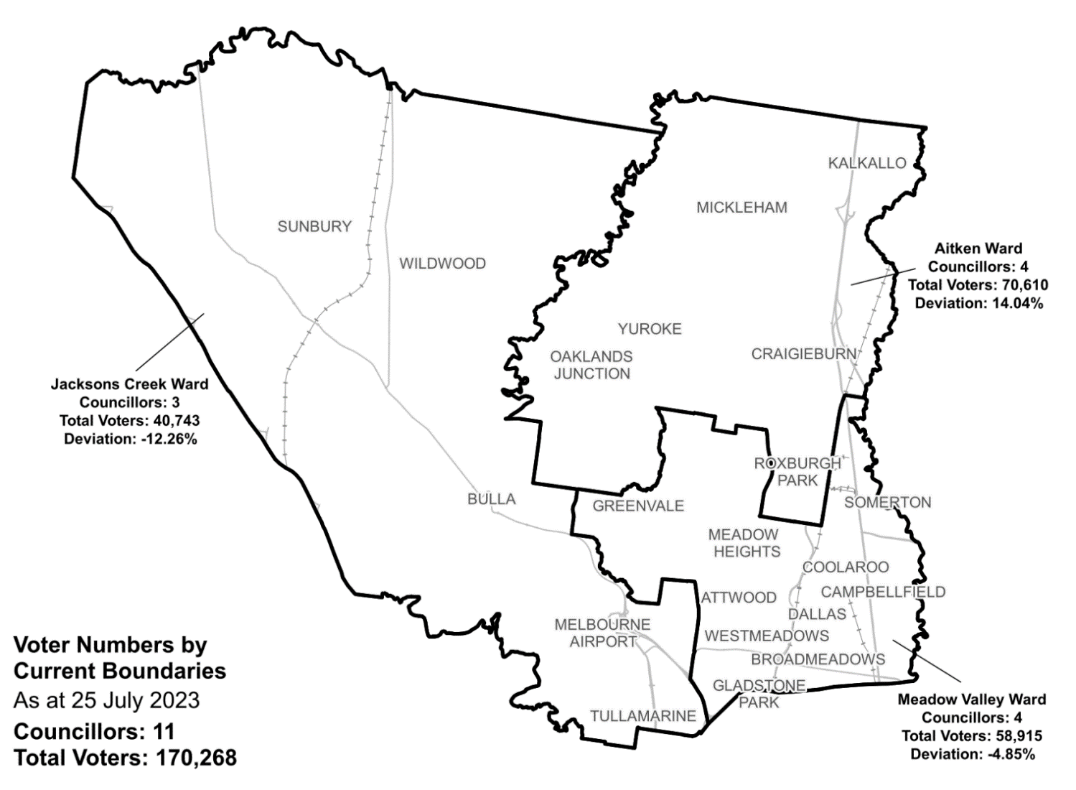

|  |  |  |  |
| --- | --- | --- | --- |
| Ward | Councillors | Voters | Deviation |
| Aitken Ward | 4 | 70,610 | +14.04% |
| Jacksons Creek Ward | 3 | 40,743 | -12.26% |
| Meadow Valley Ward | 4 | 58,915 | -4.85% |

## Statistics

Area (km2) 503

Voters

### Voters per square km

339

### Average voters per councillor

15,478

Population

### Current population

243,901

### Forecast population growth

3% p.a.

More Census statistics available at [abs.gov.au](https://www.abs.gov.au/census/find-census-data/search-by-area)

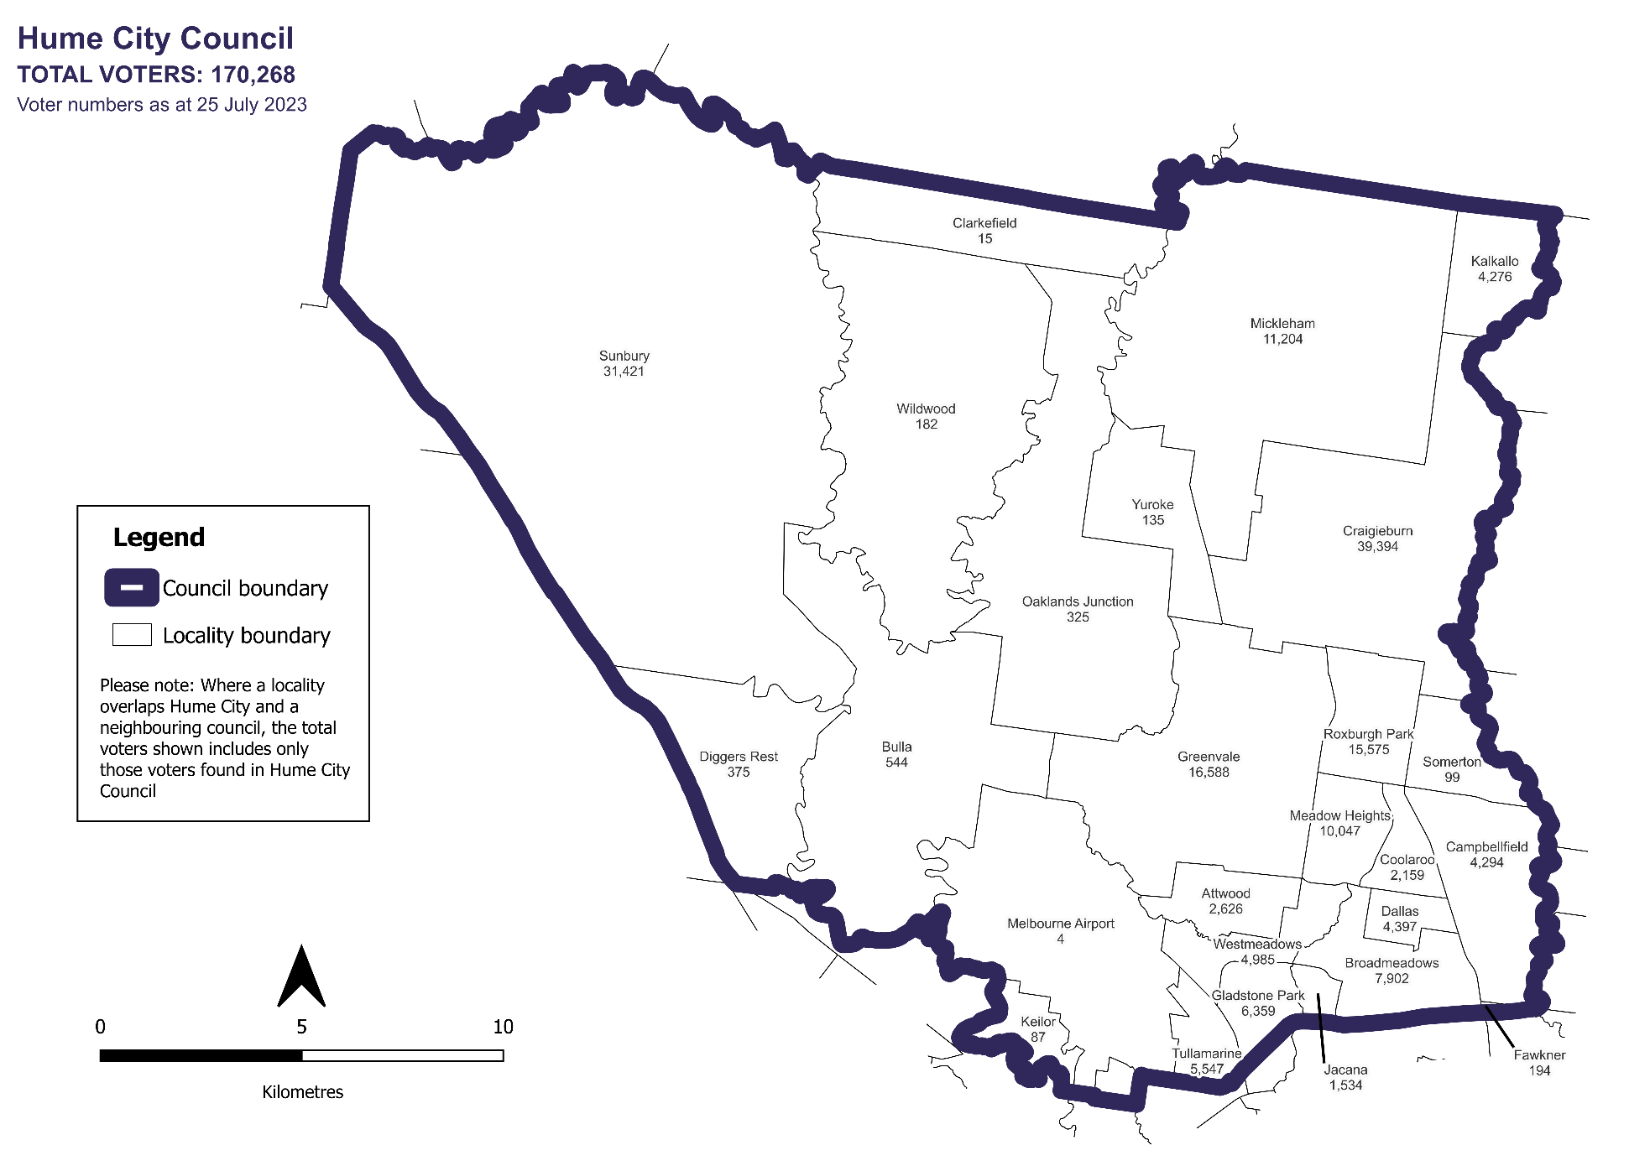Voter numbers by locality (map)

Voter numbers by locality (table)

## Hume City Council voter numbers at 25 July 2023

|  |  |
| --- | --- |
| Locality | Voters |
| Attwood | 2,626 |
| Broadmeadows | 7,902 |
| Bulla | 544 |
| Campbellfield | 4,294 |
| Clarkefield | 15 |
| Coolaroo | 2,159 |
| Craigieburn | 39,394 |
| Dallas | 4,397 |
| Diggers Rest | 375 |
| Fawkner | 194 |
| Gladstone Park | 6,359 |
| Greenvale | 16,588 |
| Jacana | 1,534 |
| Kalkallo | 4,276 |
| Keilor | 87 |
| Meadow Heights | 10,047 |
| Melbourne Airport | 4 |
| Mickleham | 11,204 |
| Oaklands Junction | 325 |
| Roxburgh Park | 15,575 |
| Somerton | 99 |
| Sunbury | 31,421 |

|  |  |
| --- | --- |
| Locality | Voters |
| Tullamarine | 5,547 |
| Westmeadows | 4,985 |
| Wildwood | 182 |
| Yuroke | 135 |