Local council electoral structure review

## About the review

Under Victoria’s *Local Government Act 2020*, Hobsons Bay City Council must now have a single-councillor ward electoral structure.

The Minister for Local Government has appointed an electoral representation advisory panel to review the electoral structure of Hobsons Bay City Council and advise on the most appropriate single-councillor ward structure.

The panel is looking at:

* the appropriate number of councillors and wards
* the location of ward boundaries
* appropriate ward names.

Electoral structure reviews are an important part of democracy and your input is valuable. As a local, you know your council area better than anyone. This is your chance to tell the panel your thoughts about the single-councillor ward structure you believe would best provide representation for your community.

You can have your say:

1. in a response submission to the preliminary report
2. at an online public hearing, if you ask to speak in your response submission.

About Hobsons Bay City Council

The Traditional Custodians of the land in the Hobsons Bay City Council area are the Bunurong people.

Hobsons Bay is located at the northern end of Port Phillip Bay, between 7 and 20 km south-west of central Melbourne. Covering an area of 65 km2, it is home to around 91,322 people and is forecast to grow to 120,000 by 2041.

The boundaries of the council area include the Westgate Freeway in the north and the Princes Freeway in the north and west. A national freight train line runs through the council area, along with 2 suburban train lines.

The council area includes significant industrial sites and activity centres. Its residential areas are diverse, ranging from historic Williamstown and Newport in the east to the newer Altona Meadows and Seabrook in the west. There are strategic redevelopment sites for new housing in Altona North, Spotswood, South Kingsville and near major activity centres and transport hubs.

With over 20 km of coastline, the council area contains coastal wetlands, creek systems, remnant native grasslands and important flora and fauna habitats.

Hobsons Bay residents are culturally diverse, coming from over 130 countries, speaking over 100 languages and observing over 80 faiths. More than a quarter speak a language other than English at home.

## Current structure

Hobsons Bay City Council is divided into 3 wards with a total of 7 councillors:

* one ward with 3 councillors
* 2 wards with 2 councillors each.

## Last review

The VEC conducted an electoral representation review of Hobsons Bay City Council in 2012.

Visit the VEC website at [vec.vic.gov.au](https://www.vec.vic.gov.au/) to access a copy of the 2012 review final report.

Review process

Monday 16 and Tuesday 17 October

### Information sessions

Session 1: 12 noon, Monday 16 October

Session 2: 6 pm, Tuesday 17 October

These sessions will give you more information about the review process. You will be able to register for a session on the VEC website.

Wednesday 18 October

### Preliminary report

The panel will release a preliminary report with one or more options for the electoral structure on Wednesday 18 October.

**You can make a response submission from this date.**

Wednesday 8 November

### Response submissions

The panel must receive your submission by   
5 pm on Wednesday 8 November.

The panel will not accept late submissions.

Wednesday 15 November

### Public hearing

The panel will hold an online public hearing if anyone asks to speak about their response submission at 2 pm on Wednesday 15 November.

The public hearing will not be held if no one asks to speak.

Wednesday 13 December

### Final report

The panel will submit a final report to the Minister for Local Government including its advice for the electoral structure on Wednesday 13 December.

The minister will consider the panel’s advice before recommending a change to the electoral structure. Any change is expected to apply at the next local council general election.

## Submission guide

You can download a submission guide from the VEC website at [vec.vic.gov.au](http://vec.vic.gov.au/)

## How to make a submission Untitled-1

On the VEC website at [vec.vic.gov.au](http://vec.vic.gov.au/)

By email to:

[HobsonsBay.ERAPSubmissions@ vec.vic.gov.au](mailto:HobsonsBay.ERAPSubmissions@vec.vic.gov.au)

LetterBy post to:

Electoral representation advisory panel  
c/o Victorian Electoral Commission  
Level 11, 530 Collins St  
Melbourne VIC 3000

Submissions must include your:

* full name
* contact phone number or email address
* residential or postal address.

Your submission will be published on the VEC website, including your name and suburb or town but not your full address or contact details. See the submission guide or VEC website at [vec.vic.gov.au/privacy](https://www.vec.vic.gov.au/privacy) for privacy information.

## One vote, one value

The ‘one vote, one value’ democratic principle is enshrined in the *Local Government Act 2020*. This means every person’s vote counts equally.

When a local council is subdivided into wards, the number of voters each councillor represents in each ward must be plus-or-minus 10% of the average number of voters per councillor for all wards.

The map below includes the current number of voters in each ward and the ward’s current deviation from the average. The panel will consider likely population and voter changes to ensure the structure remains equitable.

If you make a submission online, you can use a mapping tool to build your preferred electoral structure. The tool uses current voter numbers to tell you the deviations of the wards you make. This will help you propose a structure that meets the requirements of the Act.

Current electoral structure

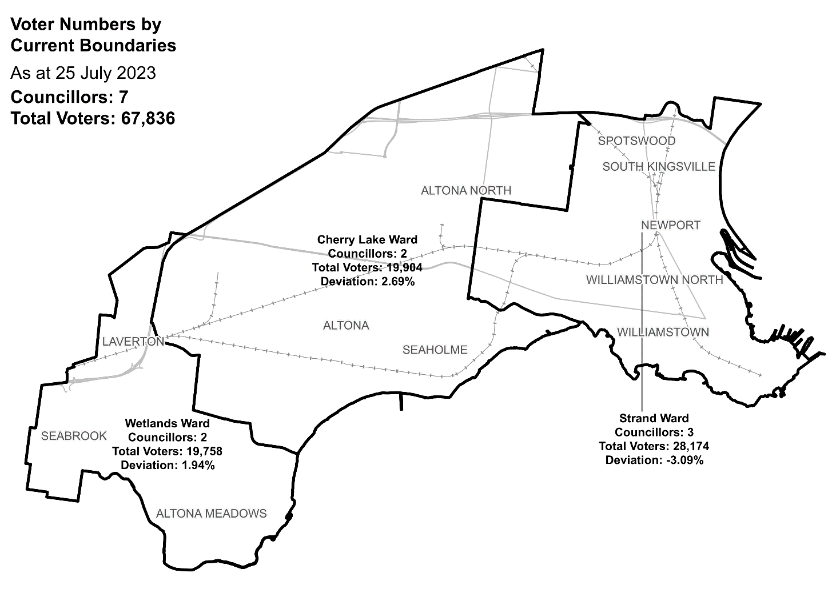

|  |  |  |  |
| --- | --- | --- | --- |
| Ward | Councillors | Voters | Deviation |
| Cherry Lake Ward | 2 | 19,904 | +2.69% |
| Strand Ward | 3 | 28,174 | -3.09% |
| Wetlands Ward | 2 | 19,758 | +1.94% |

## Statistics

Area (km2) 65

Voters

### Voters per square km

1,044

### Average voters per councillor

9,690

Population

### Current population

91,322

### Forecast population growth

1.2% p.a.

More Census statistics available at [abs.gov.au](https://www.abs.gov.au/census/find-census-data/search-by-area)

Voter numbers by locality (map)

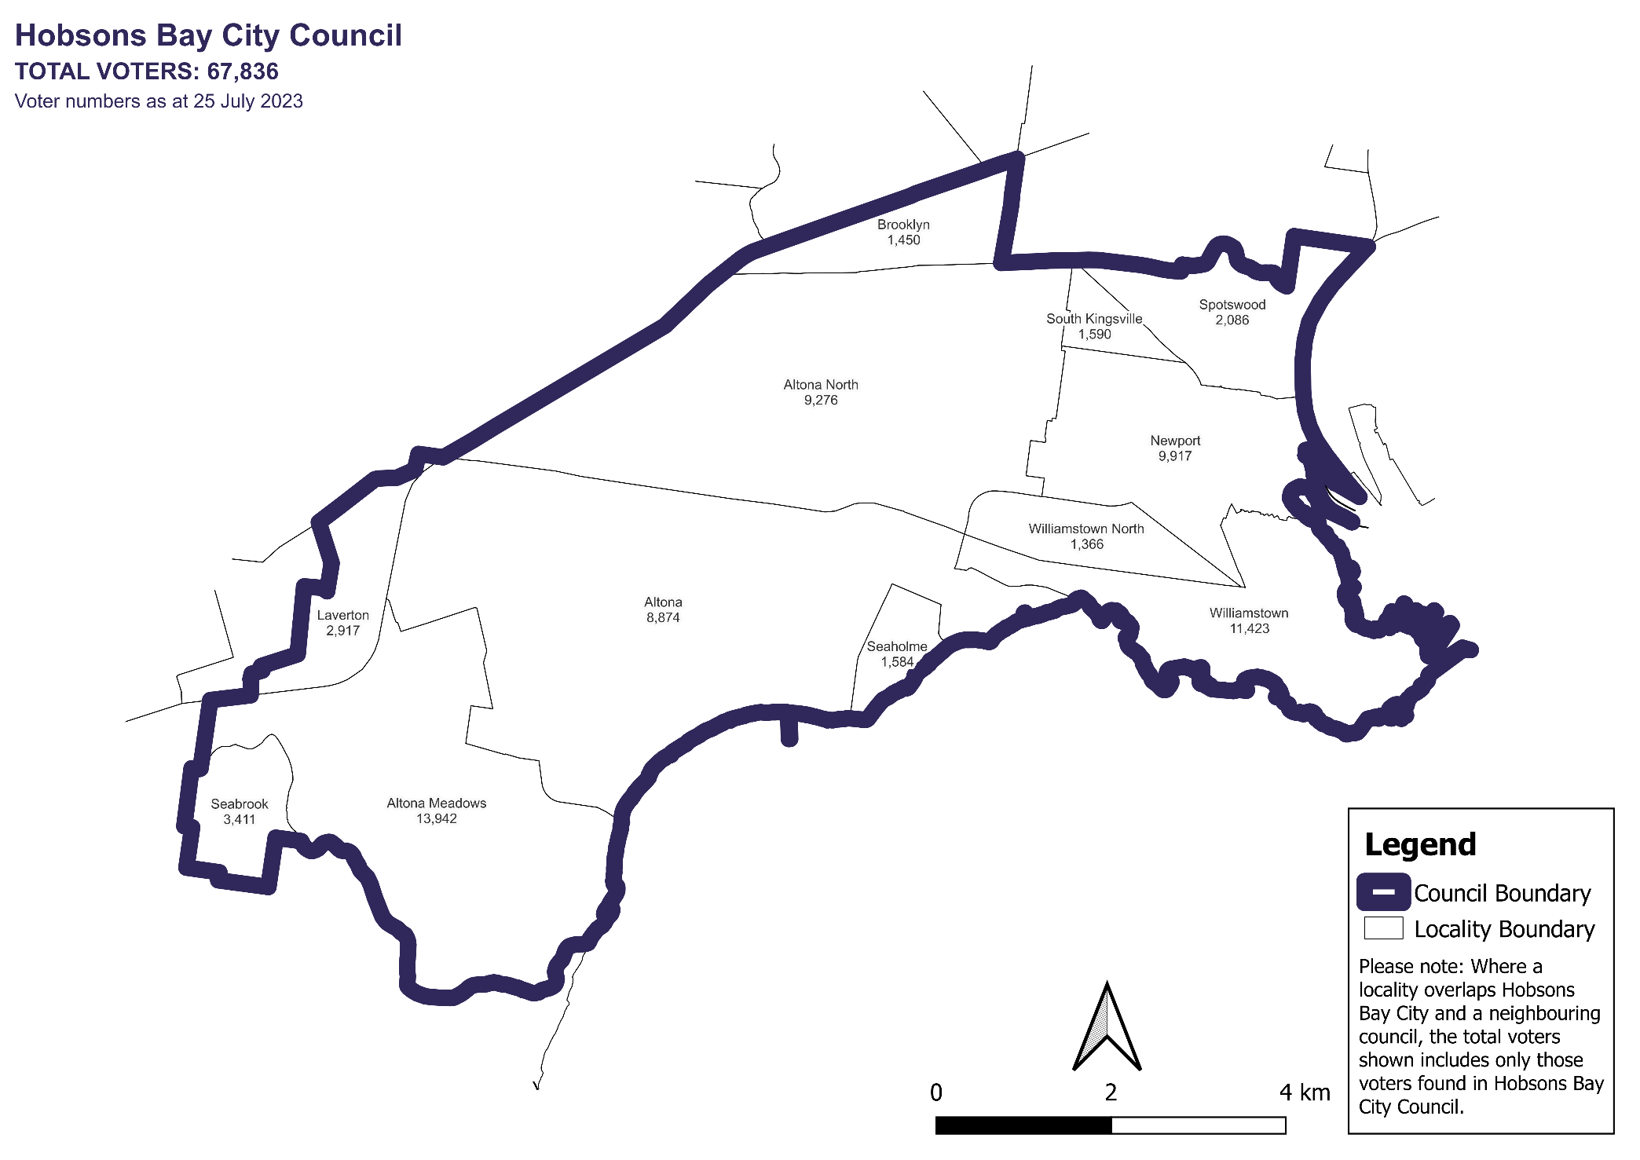

Voter numbers by locality (table)

## Hobsons Bay City Council voter numbers at 25 July 2023

|  |  |
| --- | --- |
| Locality | Voters |
| Altona | 8,874 |
| Altona Meadows | 13,942 |
| Altona North | 9,276 |
| Brooklyn | 1,450 |
| Laverton | 2,917 |
| Newport | 9,917 |
| Seabrook | 3,411 |
| Seaholme | 1,584 |
| South Kingsville | 1,590 |
| Spotswood | 2,086 |
| Williamstown | 11,423 |
| Williamstown North | 1,366 |