Local council electoral structure review

## About the review

Under Victoria’s *Local Government Act 2020*, Greater Shepparton City Council must now have a single-councillor ward electoral structure.

The Minister for Local Government has appointed an electoral representation advisory panel to conduct an electoral structure review of the council. The panel will advise the Minister on the most appropriate single-councillor ward structure for Greater Shepparton City Council.

The panel is looking at:

* the appropriate number of councillors and wards
* the location of ward boundaries
* appropriate ward names.

Electoral structure reviews are an important part of democracy, and your input is valuable. As a local, you know your local council area better than anyone. This is your chance to let the panel know your thoughts about the single-councillor ward electoral structure that you believe would best provide representation for your community.

There are 2 opportunities for you to have your say on the electoral structure of the council:

1. in a response submission to the preliminary report
2. in an online public hearing, if you request to speak in your response submission.

About Greater Shepparton City Council

The Traditional Custodians of the land in the Greater Shepparton City Council area are the Yorta Yorta people.

Greater Shepparton City Council is in north-eastern Victoria. Next to the Goulburn River, the main administrative and commercial hub of Shepparton is about 200 km from Melbourne. The council area covers 2,422 km2 and has a population of 68,409.

The main population centres in the council are Shepparton, Mooroopna, Kialla, and Tatura. Smaller towns include Murchison, Merrigum, Toolamba, Dookie, and Katandra West.

The region is renowned for its agricultural output, with the council area producing vast quantities of fruit, dairy, livestock, and cereal crops. In 2021, the median age in Greater Shepparton was 39, which was slightly younger than the overall regional Victorian median of 43. Just over 25% of the population was over the age of 60.

The council is relatively diverse with the 2021 Census showing 75% of the population born in Australia and speaking only English at home. This compared with 81% and 86% respectively across rural and regional Victoria overall.

Home ownership is common in Greater Shepparton, with 67.6% of the population owning their home in 2021, although this was lower than the rural and regional Victorian overall average of 72.5%. More people rented (27.8%) in Greater Shepparton in 2021 than in regional Victoria overall (23.6%). The median weekly household income was $1,400, compared to $1,386 for rural and regional Victoria overall.

## Current structure

Greater Shepparton City Council is unsubdivided with a total of 9 councillors.

## Last review

The VEC conducted an electoral representation review of Greater Shepparton City Council in 2015.

Visit the VEC website at [vec.vic.gov.au](https://www.vec.vic.gov.au/) to access a copy of the 2015 review final report.

Review process

Monday 3 and Tuesday 4 July

### Information sessions

Session 1: 12 noon, Monday 3 July

Session 2: 6 pm, Tuesday 4 July

Information sessions are for anyone wanting to find out more about the review process. Links to register for an information session will be available on the VEC website.

Wednesday 5 July

### Preliminary report

The panel will release a preliminary report including one or more options for the electoral structure on Wednesday 5 July.

**Response submissions open from this date.**

Wednesday 26 July

### Response submissions close

The panel must receive all submissions by 5 pm on Wednesday 26 July.

Late submissions will not be accepted.

Tuesday 1 August

### Public hearing

The panel will hold an online public hearing if anyone requests to speak about their response submission at 2 pm on Tuesday   
1 August.

The public hearing will not be held if there are no requests to speak.

Wednesday 30 August

### Final report

The panel will submit a final report to the Minister for Local Government including its advice on the electoral structure on Wednesday 30 August.

The Minister will then consider the panel’s advice before recommending a change to the electoral structure. Any change to the electoral structure of the council following the review is expected to apply at the next local council elections.

## Untitled-1How to make a submission

On the VEC website at [vec.vic.gov.au](http://vec.vic.gov.au/)

By email to

[GreaterShepparton.ERAPSubmissions  
@vec.vic.gov.au](mailto:GreaterShepparton.ERAPSubmissions@vec.vic.gov.au)

LetterBy post to

Electoral representation advisory panel  
c/o Victorian Electoral Commission  
Level 11, 530 Collins Street  
Melbourne VIC 3000

Submissions must include your:

* full name
* contact phone number or email address
* residential or postal address.

All submissions will be published on the VEC website. Your name and locality (suburb or town) will be published, but your full address and contact details will be removed. See the submission guide and VEC website at [vec.vic.gov.au/privacy](https://www.vec.vic.gov.au/privacy) for privacy information.

## Submission guide

Download the submission guide from the VEC website at [vec.vic.gov.au](http://vec.vic.gov.au/) for more information on the review process and making a submission.

## One vote, one value

The ‘one vote, one value’ democratic principle is enshrined in the *Local Government Act 2020*. This means that every person’s vote counts equally.

When a local council area is subdivided into wards, the number of voters each councillor represents in each ward must be within plus-or-minus 10% of the of the average number of voters per councillor for all the wards.

The map below includes the current number of voters in each ward and the ward’s current deviation from the average. The panel will consider likely population and voter changes to ensure the structure remains equitable.

If you make a submission online, you can use a mapping tool to build your preferred electoral structure. The tool uses current voter numbers to tell you the deviations of the wards you make. This will help you propose a structure that meets the requirements of the Act.

Current electoral structure

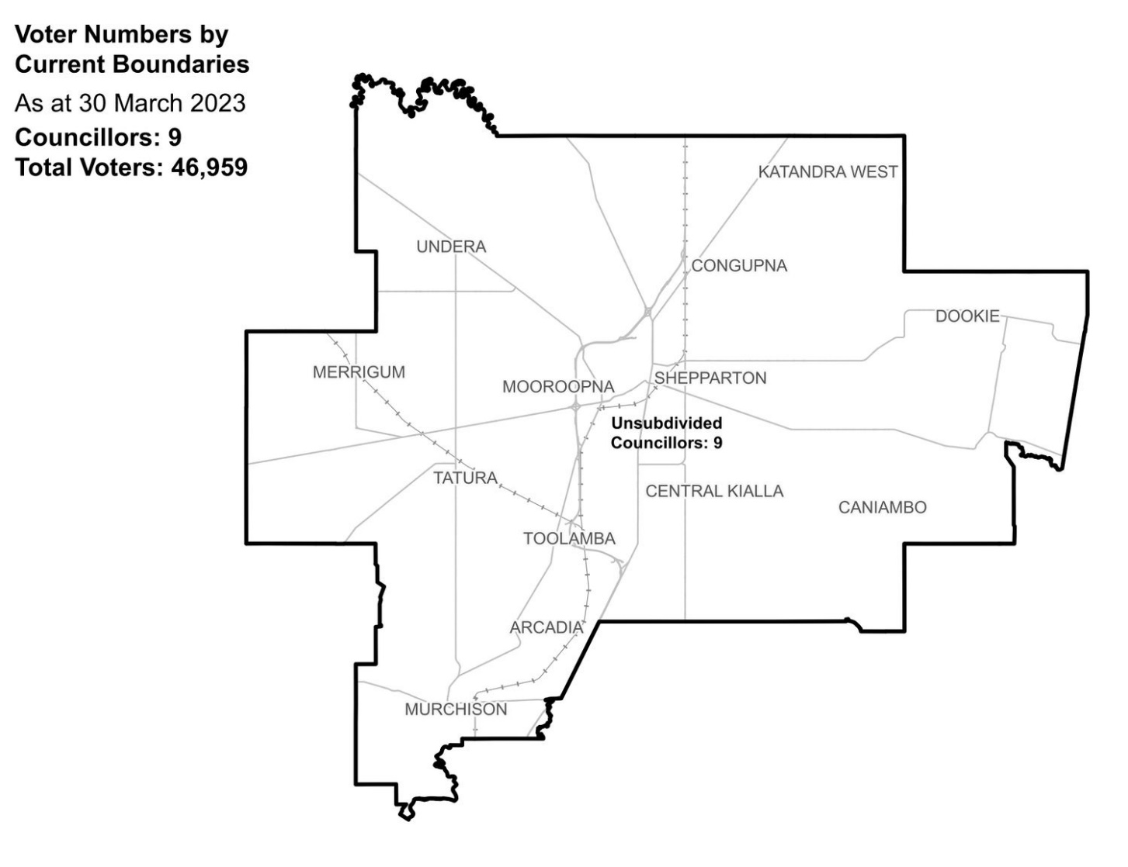

|  |  |  |  |
| --- | --- | --- | --- |
| Ward | Councillors | Voters | Deviation |
| Unsubdivided | 9 | 46,959 | n/a |

## Statistics

Area (km2) 2,422 km²

Voters

### Voters per square km

19.4

### Average voters per councillor

5,217

Population

### Current population

68,409

### Forecast population growth

1.1 % p.a.

Further census statistics available at [abs.gov.au](https://abs.gov.au/)

Voter numbers by locality (map)

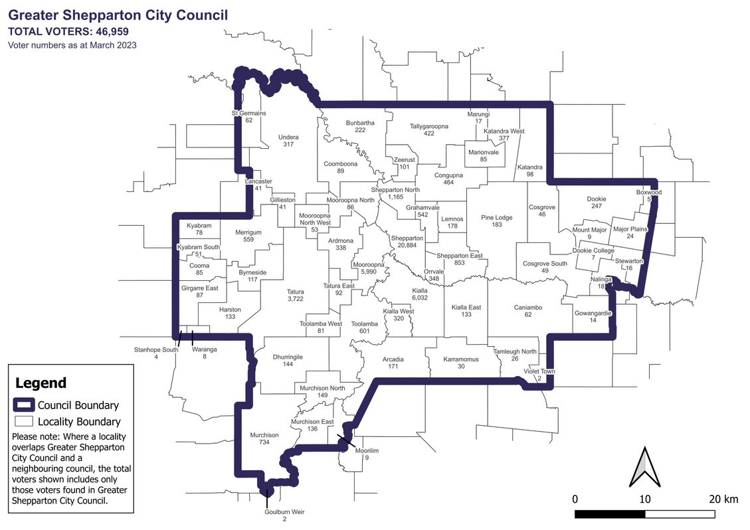

Voter numbers by locality (table)

## Greater Shepparton City Council voter numbers at March 2023

|  |  |
| --- | --- |
| Locality | Voters |
| Arcadia | 171 |
| Ardmona | 338 |
| Boxwood | 5 |
| Bunbartha | 222 |
| Byrneside | 117 |
| Caniambo | 62 |
| Congupna | 464 |
| Cooma | 85 |
| Coomboona | 89 |
| Cosgrove | 46 |
| Cosgrove South | 49 |
| Dhurringile | 144 |
| Dookie | 247 |
| Dookie College | 7 |
| Gillieston | 41 |
| Girgarre East | 87 |
| Goulburn Weir | 2 |
| Gowangardie | 14 |
| Grahamvale | 542 |
| Harston | 133 |
| Karramomus | 30 |
| Katandra | 98 |

|  |  |
| --- | --- |
| Locality | Voters |
| Katandra West | 377 |
| Kialla | 6,032 |
| Kialla East | 133 |
| Kialla West | 320 |
| Kyabram | 78 |
| Kyabram South | 51 |
| Lancaster | 41 |
| Lemnos | 178 |
| Major Plains | 24 |
| Marionvale | 85 |
| Marungi | 17 |
| Merrigum | 559 |
| Moorilim | 9 |
| Mooroopna | 5,990 |
| Mooroopna North | 86 |
| Mooroopna North West | 53 |
| Mount Major | 9 |
| Murchison | 734 |
| Murchison East | 136 |
| Murchison North | 149 |
| Nalinga | 18 |
| Orrvale | 348 |

|  |  |
| --- | --- |
| Locality | Voters |
| Pine Lodge | 183 |
| Shepparton | 20,884 |
| Shepparton East | 853 |
| Shepparton North | 1,165 |
| St Germains | 62 |
| Stanhope South | 4 |
| Stewarton | 16 |
| Tallygaroopna | 422 |
| Tamleugh North | 26 |
| Tatura | 3,722 |
| Tatura East | 92 |
| Toolamba | 601 |
| Toolamba West | 81 |
| Undera | 317 |
| Violet Town | 2 |
| Waranga | 8 |
| Zeerust | 101 |