Local council electoral structure review

## About the review

Under Victoria’s *Local Government Act 2020*, Yarra City Council must now have a single-councillor ward electoral structure.

The Minister for Local Government has appointed an electoral representation advisory panel to conduct an electoral structure review of the council. The panel will advise the Minister on the most appropriate single-councillor ward structure for Yarra City Council.

The panel is looking at:

* the appropriate number of councillors and wards
* the location of ward boundaries
* appropriate ward names.

Electoral structure reviews are an important part of democracy, and your input is valuable. As a local, you know your local council area better than anyone. This is your chance to let the panel know your thoughts about the single-councillor ward electoral structure that you believe would best provide representation for your community.

There are 2 opportunities for you to have your say on the electoral structure of the council:

1. in a response submission to the preliminary report
2. in an online public hearing, if you request to speak in your response submission.

About Yarra City Council

The Traditional Custodians of the land in the Yarra City Council area are the Wurundjeri Woi Wurrung people.

Yarra City Council is in inner north-west Melbourne, about 5 km from the city centre. The council area covers 20 km2 and had a population of 90,114 in 2021.

Yarra City Council includes the suburbs of Abbottsford, Burnley, Carlton North, Clifton Hill, Collingwood, Cremorne, Fitzroy, Fitzroy North, Princes Hill, Richmond, and parts of Alphington and Fairfield.

The council area is well serviced by public transport, with connections to the Sandringham, Frankston, Pakenham, Cranbourne, Lilydale, Belgrave, Glen Waverley, Alamein, Mernda, and Hurstbridge railway lines, as well as numerous tram and bus lines. The Eastern Freeway terminates at Clifton Hill, and the City Link toll road runs through Cremorne and Burnley near the council’s southern boundary.

Yarra City Council’s gross regional product is estimated to be just over $14 billion. In 2021, over half the working population was employed in either professional services, health care and social assistance or retail and food services.

Home ownership, at 44.1% in 2021, was significantly lower than the Greater Melbourne rate of 66.8% (including properties owned outright and with a mortgage). The proportion of households that were renting in 2021 was significantly higher (53.4%) than the Greater Melbourne overall rate of 30.2%.

The weekly median income of Yarra City Council was $2,270 in 2021, which was more than the Greater Melbourne median of $1,901.

## Current structure

Yarra City Council is divided into 3 wards with a total of 9 councillors:

* 3 wards with 3 councillors each.

## Last review

The VEC conducted an electoral representation review of Yarra City Council in 2011.

Visit the VEC website at [vec.vic.gov.au](https://www.vec.vic.gov.au/) to access a copy of the 2011 review final report.

Review process

Monday 10 and Tuesday 11 July

### Information sessions

Session 1: 12 noon, Monday 10 July

Session 2: 6 pm, Tuesday 11 July

Information sessions are for anyone wanting to find out more about the review process. Links to register for an information session will be available on the VEC website.

Wednesday 12 July

### Preliminary report

The panel will release a preliminary report including one or more options for the electoral structure on Wednesday 12 July.

**Response submissions open from this date.**

Wednesday 2 August

### Response submission close

The panel must receive all submissions by 5 pm on Wednesday 2 August.

Late submissions will not be accepted.

Wednesday 9 August

### Public hearing

The panel will hold an online public hearing if anyone requests to speak about their response submission at 10 am on Wednesday 9 August.

The public hearing will not be held if there are no requests to speak.

Wednesday 6 September

### Final report

The panel will submit a final report to the Minister for Local Government including its advice on the electoral structure on Wednesday 6 September.

The Minister will then consider the panel’s advice before recommending a change to the electoral structure. Any change to the electoral structure of the council following the review is expected to apply at the next local council elections.

## How to make a submission

On the VEC website at [vec.vic.gov.au](http://vec.vic.gov.au/)

By email to

[Yarra.ERAPSubmissions@vec.vic.gov.au](mailto:Yarra.ERAPSubmissions@vec.vic.gov.au)  
By post to

LetterElectoral Representation Advisory Panel  
c/o Victorian Electoral Commission  
Level 11, 530 Collins Street  
Melbourne VIC 3000

Submissions must include your:

* full name
* contact phone number or email address
* residential or postal address.

All submissions will be published on the VEC website. Your name and locality (suburb or town) will be published, but your full address and contact details will be removed. See the submission guide and VEC website at [vec.vic.gov.au/privacy](https://www.vec.vic.gov.au/privacy) for privacy information.

## Submission guide

Download the submission guide from the VEC website at [vec.vic.gov.au](http://vec.vic.gov.au/) for more information on the review process and making a submission.

## One vote, one value

The ‘one vote, one value’ democratic principle is enshrined in the *Local Government Act 2020*. This means that every person’s vote counts equally.

When a local council area is subdivided into wards, the number of voters each councillor represents in each ward must be within plus-or-minus 10% of the of the average number of voters per councillor for all the wards.

The map below includes the current number of voters in each ward and the ward’s current deviation from the average. The panel will consider likely population and voter changes to ensure the structure remains equitable.

If you make a submission online, you can use a mapping tool to build your preferred electoral structure. The tool uses current voter numbers to tell you the deviations of the wards you make. This will help you propose a structure that meets the requirements of the Act.

Current electoral structure

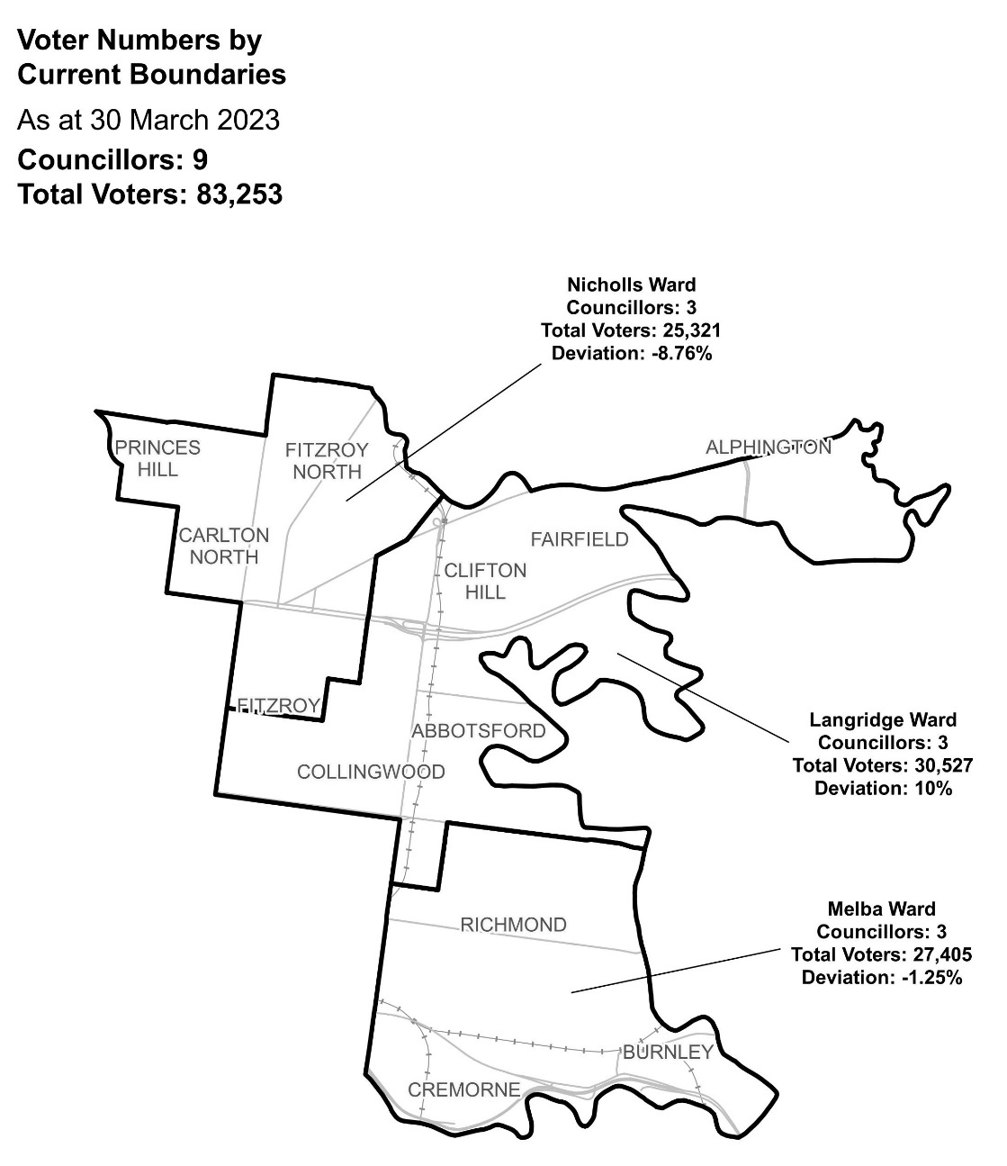

|  |  |  |  |
| --- | --- | --- | --- |
| Ward | Councillors | Voters | Deviation |
| Langridge | 3 | 30,527 | 10% |
| Melba | 3 | 27,405 | -1.25% |
| Nicholls | 3 | 25,321 | -8.76% |

## Statistics

Area (km2) 20

Voters

### Voters per square km

4,162

### Average voters per councillor

9,250

Population

### Current population

90,114

### Forecast population growth

2.2% p.a.

Further census statistics available at [abs.gov.au](http://www.abs.gov.au)

Voter numbers by locality (map)

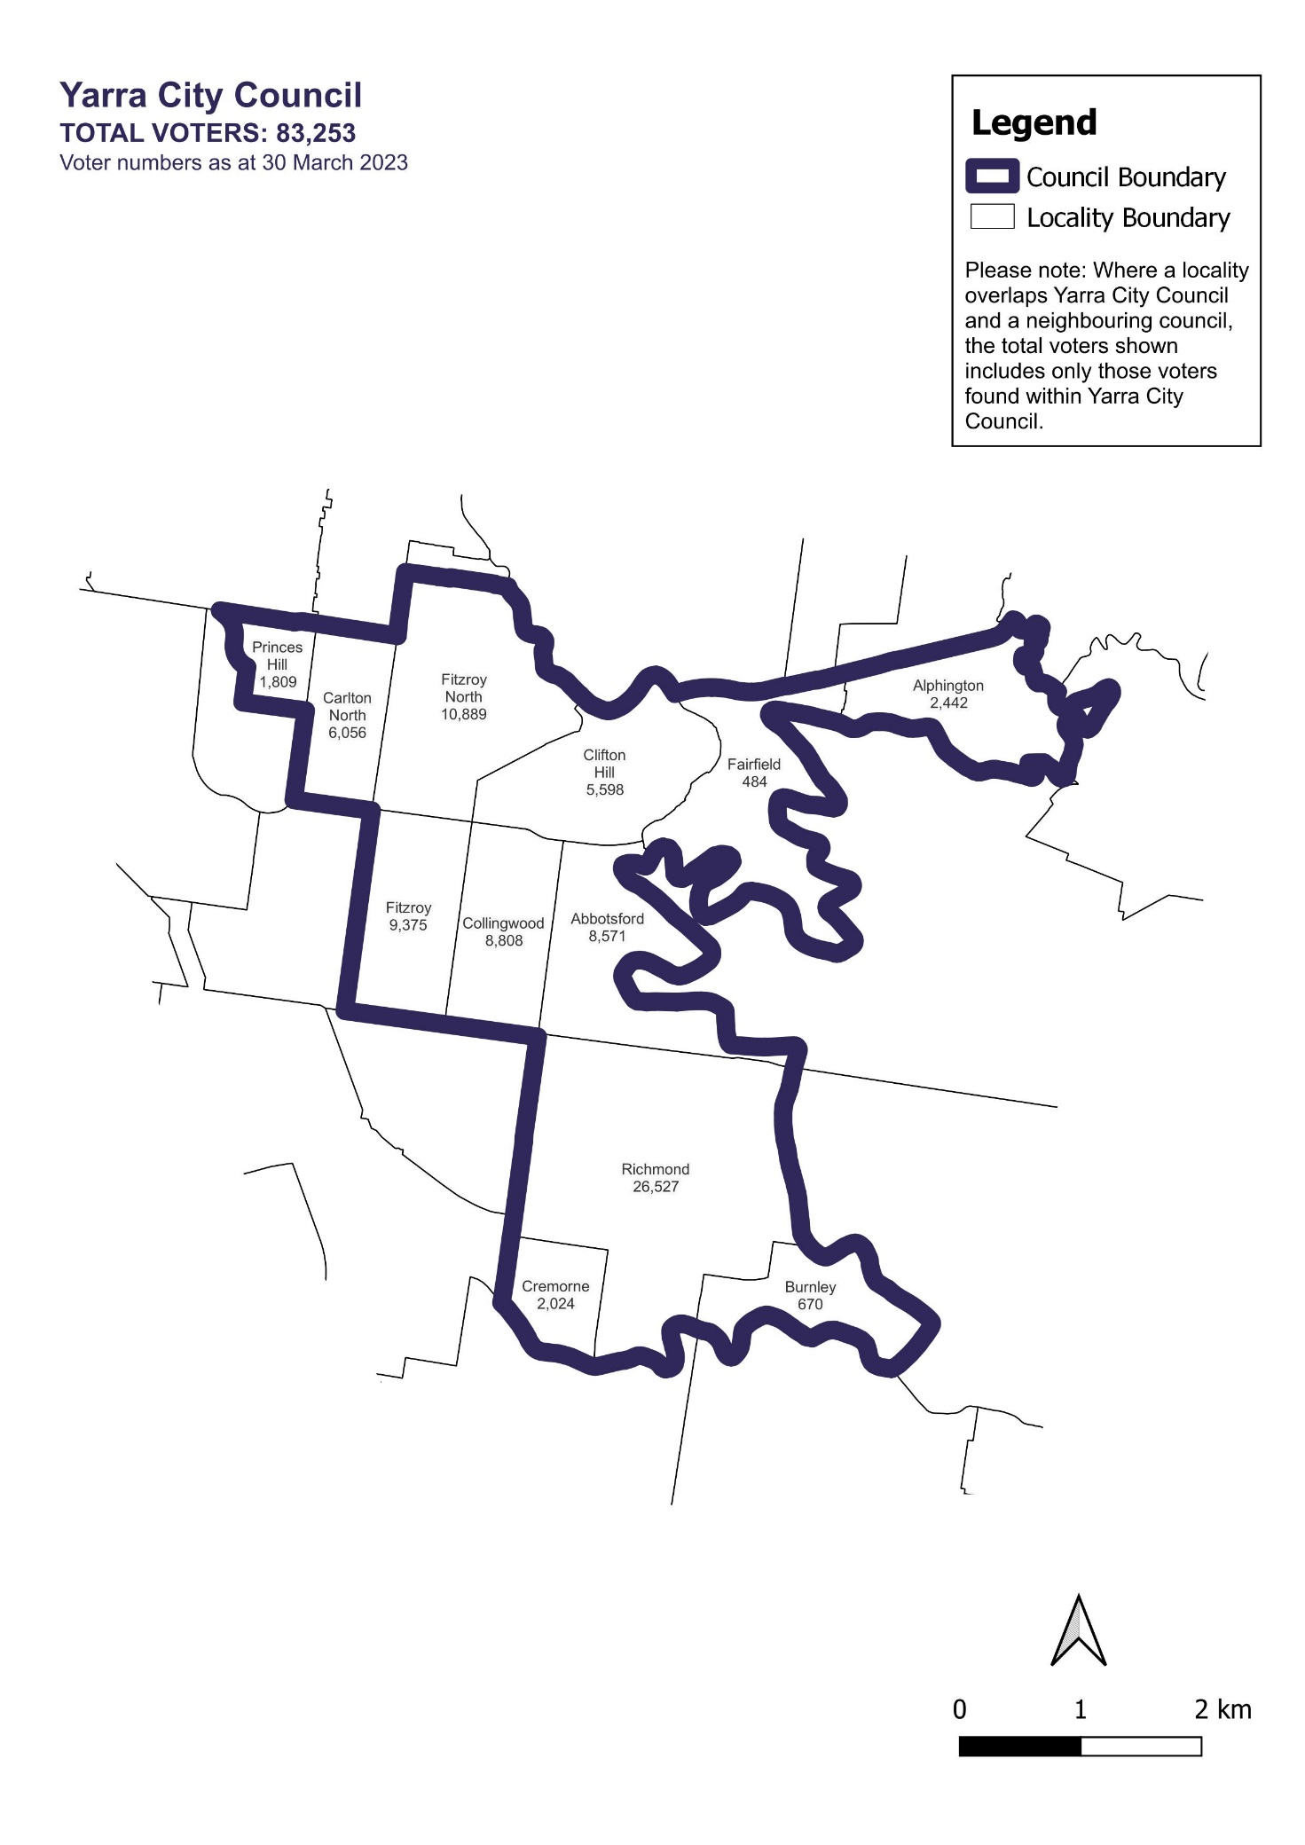

Voter numbers by locality (table)

|  |  |
| --- | --- |
| Locality | Voters |
| Abbotsford | 8,571 |
| Alphington | 2,442 |
| Burnley | 670 |
| Carlton North | 6,056 |
| Clifton Hill | 5,598 |
| Collingwood | 8,808 |
| Cremorne | 2,024 |
| Fairfield | 484 |
| Fitzroy | 9,375 |
| Fitzroy North | 10,889 |
| Princes Hill | 1,809 |
| Richmond | 26,527 |

## Yarra City Council voter numbers at March 2023