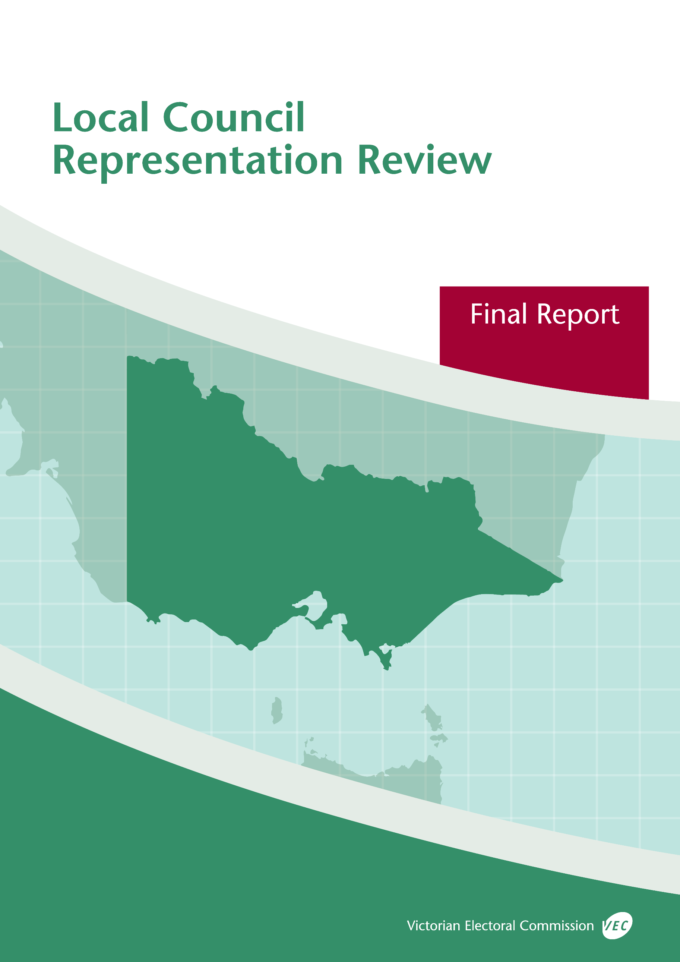

**Moira Shire Council**



**May 2019**

© State of Victoria (Victorian Electoral Commission)   
Wednesday 29 May 2019

Version 1  
  
cid:image001.png@01D4D431.F774F3F0

This work, Local Council Representation Review Final Report – Moira Shire Council, is licensed under a Creative Commons Attribution 4.0 licence [<http://creativecommons.org/licenses/by/4.0/>]. You are free to share this work under that licence, on the condition that you do not change any content and you credit the State of Victoria (Victorian Electoral Commission) as author and comply with the other licence terms. The licence does not apply to any branding, including Government logos.

Contents

Recommendation 1

Executive summary 2

Legislative basis 4

Public engagement 4

The VEC’s principles 5

Developing recommendations 6

Moira Shire Council representation review 8

Profile of Moira Shire Council 8

Current electoral structure 9

Preliminary submissions 9

Preliminary report 10

Public response 13

Response submissions 13

Public hearing 15

Findings and recommendation 18

The VEC’s findings 18

The VEC’s recommendation 22

Appendix 1: Public involvement 23

Appendix 2: Map 25

Appendix 3: Public information program 27

Recommendation

The Victorian Electoral Commission recommends that Moira Shire Council consist of nine councillors elected from three three-councillor wards.

This recommendation is submitted to the Minister for Local Government as required by the *Local Government Act 1989*.

Please see Appendix 2 for a detailed map of this recommended structure.

Executive summary

The *Local Government Act 1989* (the Act) requires the Victorian Electoral Commission (VEC) to conduct an electoral representation review of each municipality in Victoria before every third council general election.

The purpose of an electoral representation review is to recommend an electoral structure that provides fair and equitable representation for people who are entitled to vote at a general election of the council. The matters considered by a review are:

* the number of councillors
* the electoral structure of the council (whether the council should be unsubdivided or divided into wards and, if subdivided, the ward boundaries and the number of councillors per ward).

The VEC conducts all reviews based on three main principles:

1. taking a consistent, State-wide approach to the total number of councillors
2. if subdivided, ensuring the number of voters represented by each councillor is within   
   plus-or-minus 10% of the average number of voters per councillor for that local   
   council
3. ensuring communities of interest are as fairly represented as possible.

Current electoral structure

Moira Shire Council currently comprises nine councillors elected from an unsubdivided electoral structure. Prior to the 2007 representation review, Moira Shire Council was comprised of nine councillors elected from three three-councillor wards.

Visit the VEC website at vec.vic.gov.au to access a copy of the 2007 review final report.

Preliminary submissions

Preliminary submissions opened at the commencement of the current review on Wednesday   
6 February 2019. The VEC received 15 submissions for the representation review of Moira Shire Council by the deadline at 5.00 pm on Wednesday 6 March 2019.

Preliminary report

A preliminary report was released on Wednesday 3 April 2019 with the following options for consideration:

* Option A (preferred option)  
  **Moira Shire Council consist of nine councillors elected from an unsubdivided electoral structure.**
* Option B (alternative option)  
  **Moira Shire Council consist of nine councillors elected from three three-councillor wards.**

Response submissions

The VEC received 26 submissions responding to the preliminary report by the deadline at   
5.00 pm on Wednesday 1 May 2019.

Public hearing

The VEC conducted a public hearing for those wishing to speak about their response submission at 6.00 pm on Wednesday 8 May 2019. Seven people spoke at the hearing.

Recommendation

**The Victorian Electoral Commission recommends that Moira Shire Council consist of nine councillors elected from three three-councillor wards.**

This electoral structure was designated as Option B in the preliminary report. Please see Appendix 2 for a detailed map of this recommended structure.Background

Legislative basis

The Act requires the VEC to conduct a representation review of each local council in Victoria before every third general council election, or earlier if gazetted by the Minister for Local Government.

The Act states that the purpose of a representation review is to recommend the number of councillors and the electoral structure that provides ‘fair and equitable representation for people who are entitled to vote at a general election of the Council.’[1]

The Act requires the VEC to consider:

* the number of councillors in a local council
* whether a local council should be unsubdivided or subdivided.

If a local council is subdivided, the VEC must ensure that the number of voters represented by each councillor is within plus-or-minus 10% of the average number of voters per councillor for that local council.[2] On this basis, the review must consider the:

* number of wards
* ward boundaries
* number of councillors that should be elected for each ward.

Public engagement

### Public information program

The VEC conducted a public information program to inform the community of the representation review, including:

* public notices printed in local and state-wide papers
* public information sessions to outline the review process and respond to questions from the community
* media releases announcing the commencement of the review and the release of the preliminary report
* a submission guide to explain the review process and provide background information on the scope of the review
* an information email campaign targeted at known community groups and communities of interest in the local council area
* sponsored social media advertising geo-targeted to users within the local council   
  area
* ongoing information updates and publication of submissions on the VEC website.

More information on the VEC’s public information program for the representation review of Moira Shire Council can be found at Appendix 3.

### Public consultation

Public input was accepted by the VEC via:

* preliminary submissions at the start of the review
* response submissions to the preliminary report
* a public hearing that provided an opportunity for people who had made a response submission to expand on their submission.

Public submissions are an important part of the review process but are not the only consideration. The VEC ensures its recommendations comply with the Act and are formed through careful consideration of public submissions, independent research, and analysis of all relevant factors.

The VEC’s principles

Three main principles underlie all the VEC’s work on representation reviews:

1. **Taking a consistent, State-wide approach to the total number of councillors.**

The VEC is guided by its comparisons of local councils of a similar size and category to the council under review. The VEC also considers any special circumstances that may warrant the local council having more or fewer councillors than similar local councils.

1. **If subdivided, ensuring the number of voters represented by each councillor is within plus-or-minus 10% of the average number of voters per councillor for that local council.**

This is the principle of ‘one vote, one value’, which is enshrined in the Act. This means that every person’s vote counts equally.

1. **Ensuring communities of interest are as fairly represented as possible.**

Each local council contains a number of communities of interest. Where practicable, the electoral structure should be designed to ensure they are fairly represented, and that geographic communities of interest are not split by ward boundaries. This allows elected councillors to be more effective representatives of the people and interests in their particular local council or ward.

Developing recommendations

The VEC bases its recommendations for particular electoral structures on the following information:

* internal research specifically relating to the local council under review, including data from the Australian Bureau of Statistics and .id[3]; voter statistics from the Victorian electoral roll; and other State and local government data sets
* the VEC’s experience conducting previous electoral representation reviews of local councils and similar reviews for State elections
* the VEC’s expertise in mapping, demography and local government
* careful consideration of all input from the public in written submissions received during the review and via oral submissions at the public hearing
* advice from consultants with extensive experience in local government.

### Deciding on the number of councillors

The Act allows for a local council to have between five and 12 councillors but does not specify how to decide the appropriate number.[4] In considering the number of councillors for a local council, the VEC is guided by the Victorian Parliament’s intention for fairness and equity in the local representation of voters under the Act.

The starting point in deciding the appropriate number of councillors for a local council is comparing the local council under review to other local councils of a similar size and type (Principle 1). Generally, local councils that have a larger number of voters will have a higher number of councillors. Often large populations are more likely to be diverse, both in the nature and number of their communities of interest and the issues of representation.

However, the VEC also considers the particular circumstances of each local council which could justify fewer or more councillors, such as:

* the nature and complexity of services provided by the Council
* geographic size and topography
* population growth or decline
* the social diversity of the local council.

### Deciding the electoral structure

The Act allows for a local council ward structure to be unsubdivided—with all councillors elected ‘at-large’ by all voters—or subdivided into a number of wards.

If the local council is to be subdivided into wards, there are three options available:

1. single-councillor wards
2. multi-councillor wards
3. a combination of single-councillor and multi-councillor wards.

A subdivided electoral structure must have internal ward boundaries that provide for a fair and equitable division of the local council.

The Act allows for wards with different numbers of councillors, as long as the number of voters represented by each councillor is within plus-or-minus 10% of the average number of voters per councillor for that local council (Principle 2). For example, a local council may have one   
three-councillor ward with 15,000 voters and two single-councillor wards each with 5,000 voters. In this case, the average number of voters per councillor would be 5,000.

Over time, population changes can lead to some wards in subdivided local councils having larger or smaller numbers of voters. As part of the review, the VEC corrects any imbalances and considers likely population changes to ensure ward boundaries provide equitable representation for as long as possible.

In considering which electoral structure is most appropriate, the VEC considers the following matters:

* the VEC’s recommendation at the previous representation review and the reasons for that recommendation
* the longevity of the structure, with the aim of keeping voter numbers per councillor within the 10% tolerance for as long as possible (Principle 2)
* communities of interest, consisting of people who share a range of common concerns, such as geographic, economic or cultural associations (Principle 3)
* the number of candidates in previous elections, as large numbers of candidates can lead to an increase in the number of informal (invalid) votes
* geographic factors, such as size and topography
* clear ward boundaries.

Moira Shire Council representation review

Profile of Moira Shire Council

Moira Shire Council is a rural local council area in northern Victoria, which shares a border with New South Wales. It has a rich agricultural history due to the major irrigation systems built during the 20th century in the wider Goulburn Valley Region of Victoria. Moira Shire is characterised by its four main towns (Cobram, Nathalia, Numurkah and Yarrawonga), and each of these has a distinct identity.

The Shire encompasses significant natural landscapes. It is bound by the Murray, Goulburn and Ovens Rivers. The west of the Shire includes Barmah National Park, which, with the adjoining Millewa Forest in New South Wales, forms the largest River Red Gum forest in the world.[5] The town of Yarrawonga is located on the Lake Mulwala foreshore, which is a popular holiday destination. Moira Shire is also home to the Broken-Boosey State Park, a linear corridor of bushland and one of the few remaining remnants of high-quality grey box woodland on Victoria’s northern plains.[6]

The Yorta Yorta and the Bangerang people are the main traditional custodians of the land.

At the 2016 Census, Moira Shire’s population was 29,112. Its largest town is Yarrawonga with a population of 7,930, followed by Cobram at 6,014, Numurkah at 4,477 and Nathalia at 1,880.[7] The remaining population is dispersed across 18 smaller communities. While the Shire’s population is expected to decline in the west and remain largely static in the centre, population growth will continue to occur in Yarrawonga which is a popular tourist destination as well as a destination for downsizing empty-nesters and retirees.[8]

The top three industries of employment in the Shire are agriculture, forestry and fishing (16.2%), manufacturing (12.9%), and health care and social assistance (11.3%). The unemployment rate in the Shire is approximately 5%, which is slightly below the average for rural and regional Victoria at 6%.

While agriculture and food processing support the Shire’s economy, there are some differences in the key industries for each of the four main towns. Yarrawonga’s local employment is centred on tourism and aged care services; horticulture and dairying are prominent in Cobram; Numurkah has major oilseed processors; and Nathalia has strong ties with local Indigenous communities and a focus on tourism and the arts. Nathalia is also a significant education hub for the wider area.

Moira Shire’s residents have, on average, lower median weekly personal, family and household incomes compared to the average for rural and regional Victoria. The median household income is $1,014 compared to the average for the rest of regional Victoria at $1,124. The median age of residents is 46 years, which is above the median for rural and regional Victoria at 42 years. The average age of Moira Shire’s residents increases from the west to the east, with residents in Yarrawonga registering an average age of 50 years.

The Shire largely presents as culturally and linguistically homogenous. Exceptions to this include a strong Indigenous community in the west as well as an Italian community in Cobram dating back to after the Second World War. A small Arabic-speaking community mainly from Iraq have also settled in Cobram since the mid to late 1990s.[9]

Current electoral structure

Moira Shire Council currently comprises nine councillors elected from an unsubdivided electoral structure. Prior to the 2007 representation review, Moira Shire Council was comprised of nine councillors elected from three three-councillor wards.

Visit the VEC website at vec.vic.gov.au to access a copy of the 2007 review final report.

Preliminary submissions

At the close of submissions on Wednesday 6 March 2019, the VEC had received 15 submissions for the representation review of Moira Shire Council. Submissions were received from individuals residing in the Shire, individual councillors, as well as Moira Shire Council itself and the Proportional Representation Society of Australia (Victoria-Tasmania) Inc. (PRSA). The submissions were made available on the VEC website.

A list of people who made a preliminary submission can be found in Appendix 1.

### Number of councillors

Eleven submissions identified nine as the appropriate number of councillors for Moira Shire Council. Two submissions did not comment on the number of councillors, while one submission wanted fewer councillors and another submission wanted more councillors.

### Electoral structure

Most submissions expressed a desire to change to a subdivided electoral structure. Various subdivided electoral structures were put forward in the preliminary submissions. The most common proposal was a structure consisting of three three-councillor wards, which is similar to the electoral structure in place prior to the 2007 representation review. This structure would consist of a ward for Yarrawonga and its surrounds in the east of the Shire, a ward for Cobram and surrounds in the central part of the Shire, and a ward for Numurkah and Nathalia and their surrounds in the western part of the Shire.

Two preliminary submissions expressed a preference for four wards that would give each of the four major towns in the Shire a ward. One of these submissions was open to either three or four wards. One submission requested five wards for ten councillors. Some of the submissions that called for a subdivided electoral structure were specific in their advocacy for Yarrawonga, claiming that Yarrawonga does not receive fair representation on council. These submitters requested wards to guarantee a certain number of councillors (two, three, or four) to represent a ward encompassing Yarrawonga and its surrounding towns.

Five submissions expressed a preference for the status quo of nine councillors elected from an unsubdivided electoral structure. Moira Shire Council’s submission outlined its support for what voters in the Shire wanted, but the council also favoured retaining the status quo.

Preliminary report

A preliminary report was released on Wednesday 3 April 2019. The VEC considered public submissions and research findings when formulating the options presented in the preliminary report.

### Number of councillors

When considering the appropriate number of councillors for a municipality, the VEC assesses population data and other factors which may warrant increasing or decreasing the number of councillors, such as projected population growth or special circumstances relating to distinct communities of interest.

In the VEC’s table of comparative councils, Moira Shire Council is situated between seven- and nine-councillor local councils in Country Victoria. The VEC recognised that due to its population size, Moira Shire Council is at the bottom of the range of comparable nine-councillor rural Victorian local councils.[10]

The VEC considered nine to be the most appropriate number of councillors for Moira Shire Council with no reason to change the number of councillors. Moira Shire is not forecast to grow significantly overall. The Shire continues to be one of the larger local council areas in Victoria and its distinct and diverse communities of interest were also considered a reason not to reduce the number of councillors.

### Electoral structure

The VEC found that the submissions advocating for a return to wards did so based on the argument that wards would ensure Moira Shire’s major towns and their surrounding communities would be guaranteed local representation. Recognising the support for a subdivided electoral structure, the VEC modelled various options based on the comments received in the submissions and on the three three-councillor ward structure that was in place prior to the last review.

These options included nine councillors elected from three wards, nine councillors elected from four wards and nine councillors elected from five wards. In its modelling, the VEC attempted to keep smaller towns in the same ward as their nearby major town. This was challenging due to the uneven population distribution in the shire and a faster growing population in Yarrawonga. The VEC found that most of these models were not viable, as one or more wards were outside the legislated requirement of the number of voters represented by each councillor remaining within +/- 10% of the average number of voters-to-councillors. This requirement meant it was often not possible to include in the same ward, some of the smaller townships known to access services from a nearby town centre. One proposed structure that subdivided the Shire into five wards resulted in a long south ward that would divide the towns in the south from the north, which did not fit with the descriptions of communities of interest received by the VEC in both present and past reviews.

However, by modelling these variations, the VEC was able to develop a subdivided electoral structure that would accommodate three three-councillor wards, with each ward encompassing a part of Moira Shire (East, Central and West). This option was considered to achieve good representation of the geographic communities of interest, provide an equal number of councillors for each part of the Shire, and remain within the legislated requirement of voters‑to‑councillors at present and up to 2028. This option was presented as Option B in the preliminary report for further consideration by the community.

In its preliminary report, the VEC considered the present unsubdivided electoral structure and Option B in terms of their relative advantages and disadvantages. The VEC observed that generally, based on the uneven population distribution and the different growth rate between Yarrawonga in the east and Nathalia and Numurkah in the west, it could be difficult for wards to be drawn around the east, central and western parts of the Shire without separating some of the smaller towns from their major town centre. This had been a key issue in the previous review. The VEC also stated that another general drawback for subdivided structures in Moira Shire is a greater likelihood of a significantly larger sized ward in the west in the future.

The VEC noted that in the current electoral structure there is a reasonable spread of councillors across the Shire. In the current structure, there are councillors representing each major town and there is one councillor from the smaller rural locality of Burramine South. Notwithstanding the preliminary submitters who advocated for wards and a ward that would include Yarrawonga, the VEC considered that, on balance, the possible disadvantages with wards outweighed their possible merits for the Shire and recommended the present structure as Option A. This decision also considered the observation that the present unsubdivided electoral structure was delivering a reasonable spread of councillors across the Shire.

### Options

After careful consideration, the VEC put forward the following options:

* Option A (preferred option)  
  **Moira Shire Council consist of nine councillors elected from an unsubdivided electoral structure.**
* Option B (alternative option)  
  **Moira Shire Council consist of nine councillors elected from three three-councillor wards.**

Public response

Response submissions

The VEC accepted submissions responding to the preliminary report from Wednesday 3 April 2019 until 5.00 pm on Wednesday 1 May 2019. The VEC received a total of 46 response submissions. These submissions were mainly from residents, including a submission from the Bundalong Action Group (BAG) and a separate proforma submission signed by 21 residents from Bundalong. Moira Shire Council provided a response submission, and Councillor Kevin Bourke provided a personal response submission to the review. A list of people who made a response submission can be found in Appendix 1. Table 1 indicates the level of support for each option.

|  |  |  |
| --- | --- | --- |
| Table 1: Preferences expressed in response submissions | | |
| **Option A** | **Option B** | **Other** |
| 4 | 37 | 5* |

*This figure includes three submitters who proposed alternative models and two submitters whose submissions did not clearly state a preference for Options A or B.

### Number of councillors

While the preliminary submissions had demonstrated a slightly broader mix of views on what the appropriate number of councillors for the Shire should be, most response submissions supported nine councillors. Submitters reasoned that Moira Shire is large and diverse enough in terms of area, population and communities to warrant nine councillors. There were no response submissions that advocated for more councillors. One submitter proposed eight councillors to be elected across four two-councillor wards to ensure that all four towns have appropriate and equal representation in each ward.

### Electoral structure

As outlined in Table 1, most submitters favoured the Option B from the preliminary report, a subdivided electoral structure of three three-councillor wards. Of the 37 submitters who favoured this option, 21 submitters had signed a proforma submission representing residents from the town of Bundalong close to Yarrawonga.

Three submitters proposed alternative structures to the VEC’s options in their submissions. These alternatives included a proposal for eight councillors elected from four two-councillor wards; nine councillors elected from three wards that would ensure four councillors in the ward containing Yarrawonga; and nine councillors elected from three wards with different boundaries that would group towns based on their shared business and farming interests.

The VEC considered these additional proposals as part of its deliberations for this review. Considering the proposal of four wards containing two councillors each, the VEC did not find the smaller number of councillors to be appropriate for Moira Shire. The second proposal suggested increasing the number of councillors in the proposed East Ward to four councillors. This model did not remain within the legislated voter-to-councillor requirement in terms of the projected population for the Shire to the next review, scheduled to take place after the 2028 local government elections. The East Ward in this model would have to include parts of the central-west, which was not as representative of geographic communities of interest as the wards proposed in Option B.

The final model proposed was viable in meeting the legislated voter-to-councillor ratio and providing an equal number of councillors for each region but was, overall, less advantageous than Option B and had some significant drawbacks. This model was proposed by Councillor Bourke who also spoke to the model at the public hearing. Councillor Bourke told the VEC that his model would instead group the towns in the Shire primarily based on their shared business and farming interests. Responding to questions from the VEC at the public hearing about the larger Central Ward proposed in his model compared to the smaller Eastern Ward, and whether it would pose any problems for candidates and councillors in the central part of the Shire, Councillor Bourke commented that the travel would not be an issue for those councillors, and his Central Ward was no larger than the proposed Western Ward in Option A. The VEC noted that the Western Ward in Option B has some mostly forested areas. In the absence of his model being accepted, Councillor Bourke stated that he would also support Option B.

#### Support for Option A

Supporters of Option A included Moira Shire Council, two residents from Kotupna and Numurkah, as well as the PRSA. In its submission, the Council reiterated its view that the decision to remain unsubdivided or to introduce wards should be informed by the views of the Shire’s voters. However, the Council cautioned that there should be careful consideration of the ‘unintended consequences’ resulting from a change to wards. The Council’s submission noted that wards can create the perception that a local councillor is elected to represent the interests of the ward, which is not consistent with councillors’ legislated duty to govern in the interests of the entire local council area. The Council also noted that wards could separate the smaller townships from their main town centre, and that wards would require boundaries to be ‘reset’ in the future, reiterating some of the VEC’s preliminary findings.

A resident from Kotupna argued that the current structure was better as it would ensure that the ‘varying competing needs of communities across the electorate are being routinely weighed up’, while a resident from Numurkah stated his ‘reluctant’ support for Option A. This submitter reasoned that the different rates of growth across the Shire’s main towns require a council that will ensure all parts of the Shire progress. Considering the drawbacks to a subdivided structure outlined by the VEC in its preliminary report, this submitter commented that until the populations in Nathalia and Numurkah are larger and more on par with the populations in the centre and east, there will always be difficulties in creating equitable subdivided structures for the Shire.

The PRSA has made submissions to every local council representation review supporting electoral structures that enable proportional representation to apply ‘in a symmetrical even‑handed manner’ with all candidates needing to reach the same or a very similar quota of votes to be elected. The PRSA has argued that the proportional representation system is the fairest system as it maximises the number of effective votes in a local council area.

#### Support for Option B

Most response submitters supported Option B over an unsubdivided electoral structure. Submitters in support of Option B reasoned that Moira Shire is one of the larger local council areas in Victoria and changing to a subdivided electoral structure would reduce the need to travel for the Shire’s councillors, as well as improve their understanding of local issues and increase their accountability to voters in each ward.

Supporters of Option B also reasoned that there are four main towns in the Shire which would be better served by a three-ward structure that distinguished between Moira Shire’s three main regions.

Submitters from Yarrawonga and Bundalong stated that their towns were not receiving fair and equitable representation from a council elected in an unsubdivided electoral structure, and that Option B was more likely to ensure an equitable spread of councillors located across the Shire dedicated to representing voters in their ward.

Public hearing

The VEC conducted a public hearing for those wishing to speak about their response submission at 6.00 pm on Wednesday 8 May 2019 at the Cobram Civic Centre, Punt Road, Cobram. A list of people who spoke at the hearing can be found in Appendix 1.

Eight persons spoke at the public hearing. Fred Douglas and Peter Elliot spoke on behalf of the Bundalong Action Group (BAG). The Mayor, Councillor Libro Mustica, and Deputy Mayor, Councillor Peter Lawless, spoke to the submission by Moira Shire Council. Councillors Kevin Bourke and Peter Mansfield presented their respective views at the hearing.[11] Two residents of the Shire spoke to their own submissions at the hearing: Joe Cillia and Michelle Church, both from Yarrawonga.

Moira Shire Council supported Option A while all other speakers supported Option B.

### Lack of representation for Yarrawonga and Bundalong

Ms Church of Yarrawonga observed that there had been ‘little change’ in Yarrawonga over the years while the council has directed more investment and development in Cobram. The BAG told the VEC that following the 2010 floods, the Council did not provide the necessary action to repair flood damage to Bundalong with the result being that three of the town’s main streets flooded. BAG representatives also told the VEC that council representation during their regular committee meetings is now inconsistent. In response to the VEC’s questions, the Mayor and Deputy Mayor commented that after the floods every small community in the Shire wanted everything fixed at the same time and that the Council could not allocate funds to every town at once. Councillor Mansfield spoke independently of the Council’s submission and in support of Option B, reasoning that it would ensure equitable representation for Yarrawonga. He commented that the current number of councillors from Yarrawonga is not in proportion to its population and the rates paid by residents and property owners in Yarrawonga.

### Communities of interest

During the public hearing, all speakers reiterated the key theme in the submissions of there being three main regions in the Shire: east, central and west. Councillor Bourke expressed support for Option B but also commented on his alternative model of nine councillors elected from three wards, which would group towns in the Shire based on their shared business and farming interests. The VEC responded that Councillor Bourke’s model would see the grouping of communities to the south of Yarrawonga, including towns like Wilby, into a proposed central ward with Cobram. The VEC noted that it has consistently heard that smaller towns access services from their nearest main town and that a town like Wilby would tend towards Yarrawonga for these purposes.[12] Councillor Bourke responded to the VEC’s questions by confirming that Wilby residents would likely access services from Yarrawonga. Representing council, Councillor Mustica (Mayor) and Councillor Lawless (Deputy Mayor) commented on the town-based identity in Moira Shire which is ‘deeply rooted’.

### Council support for the current unsubdivided electoral structure

As the only speakers to support the current unsubdivided electoral structure, the Mayor and Deputy Mayor stated that in the current structure candidates who stand for council are more likely to come with and to develop a broad knowledge of the Shire, and that this is one of the advantages of a council elected from an unsubdivided structure. They also commented that in an unsubdivided structure it is clear that all elected councillors need to govern in the interest of the whole shire. They acknowledged a preference from the eastern region for subdivision but argued that the perception of underrepresentation in Yarrawonga would not be resolved by a change in the electoral structure. They reiterated that wards can encourage parochialism and divide the Shire by town. There is also a risk that a ward can be dominated by a larger town with the smaller communities having their representation diluted.

### Lack of diversity among councillors

The final speaker at the hearing, Ms Church, commented on how wards could increase diversity among candidates and councillors, providing different perspectives on council and encouraging high-quality candidates to stand, who would not normally stand for election. Ms Church told the VEC, for example, that women who are in her age bracket (in their mid-fifties) are underrepresented in local government, often due to their obligations to work and family. She noted that her demographic would have limited time to be able to serve the whole of Moira Shire, which is large in size, but if they were focused on a ward they could better serve their community and would be more likely to stand during the Shire’s elections.

Findings and recommendation

The VEC’s findings

The VEC considered the key themes expressed in the submissions and public hearing, as well as internal research and analysis to develop its final recommendation. Its recommendation complies with the legislative equality requirement and acknowledges communities of interest. The VEC recommends Moira Shire Council change from the present unsubdivided electoral structure to consist of nine councillors elected from three three-councillor wards (Option B).

### Number of councillors

In its preliminary report, the VEC noted that Moira Shire Council is situated between seven- and nine-councillor rural Victorian local council areas in the VEC’s banding table. While Moira Shire Council is at the bottom of comparable nine-councillor rural council areas in terms of its population, the VEC believes that nine councillors are appropriate for Moira Shire Council.

Moira Shire Council is one of the larger local council areas in Victoria, covering 4,045 square kilometres and measuring approximately 130 kilometres from west to east.[13] Submitters commented on the larger area covered by Moira Shire and some of the councillors drew attention to the extensive travel required to maintain contact with communities across the Shire. Further, Moira Shire has diverse communities of interest with over 17 smaller towns coalescing around the four main town centres, which have distinct identities and needs that the VEC considers are best served by the present number of councillors. The VEC did not see any reason to reduce the number of councillors and noted that population densities vary across the four main towns, which also present distinct challenges for the Council.[14]

While Yarrawonga is growing at a faster rate, Moira Shire Council’s forecast population growth is a modest 0.7% to 2031 overall. It is not among the fastest-growing regional local council areas in Victoria, indicating that a larger number of councillors would not be justified.[15] In this review, the VEC also observed that there was no significant call from submitters to change the number of councillors, indicating that the present number is serving the community well.

### Electoral structure

The VEC proposed two options in its preliminary report. Both options would provide fair and equitable representation in accordance with the Act. Each option however, had certain advantages and disadvantages, which were discussed in the VEC’s preliminary report. In the final stage of the review, the VEC carefully considered both options in relation to its own research, the submissions received, and the evidence given at the public hearing and considered Option B to provide, on balance, more advantages for Moira Shire.

Throughout the review, the VEC consistently heard that there are three main geographic communities of interest, consisting of eastern, central and western Moira Shire. During the public hearing, while the Council representatives spoke in support of Option A, they too commented on the differences between the main centres in the Shire. They described Yarrawonga’s residents as having access to services from nearby towns in the North-East Region and potentially identifying more with that region. On the other hand, the western and central parts of Moira Shire are more closely connected to the City of Greater Shepparton and the Goulburn Valley Region. Council representatives acknowledged that these differences are not something the VEC can address in the review and that the Council needed to work hard to build a shire-wide identity. While the VEC is not of the view that the current electoral structure has failed the community, it recognises that Option B could better reflect Moira Shire’s distinct, ‘deeply rooted’ geographic communities of interest.

The VEC recognises that the current locations of elected representatives may be contributing to the view that Yarrawonga and the eastern part of the Shire are being neglected. Of the current councillors, three are located in Cobram, two in Yarrawonga, two in Numurkah, one in Nathalia and one in Burramine South. In its preliminary report, the VEC noted that there is currently a reasonable spread of councillors from across the Shire, with none of the major towns being unrepresented. The VEC considers that three three-councillor wards would provide a structure that ensures there is an equal number of councillors representing each main region in the Shire. It would also ensure that the slower growing populations in and around Nathalia and Numurkah are being served by an equal number of councillors.

In its submission, Moira Shire Council cautioned that wards can create the perception that a local councillor is elected to represent the interests of the ward, which is ‘not consistent with their legislated duty to govern in the interests of the entire shire’. The VEC has observed that the present spread of councillor locations suggest that towns are already voting for their own local candidates. In submissions to the review and at the public hearing, the VEC heard that local concerns are generally of greater importance to the Shire’s voters. At the public hearing, Ms Church commented that ‘micro issues’ (such as youth unemployment, access to services, and town improvements and infrastructure) are potentially more important than ‘macro issues’ for voters in the Shire, particularly given the size of the Shire and the local nature of its communities of interest. While an unsubdivided structure is already delivering representation for the three main areas in the Shire, Option B is more likely than Option A to provide local representatives who are accountable and accessible to local communities.

The VEC recognises that there are also disadvantages to wards. At the public hearing, council representatives stated that if there was a change to wards, candidates from smaller towns would be less likely to be elected than in the current unsubdivided electoral structure. The VEC recognises that if Moira Shire is divided into wards, candidates nominating from higher density areas may find campaigning easier as they have access to a significant proportion of the voting population.

Considering the past general elections, the VEC notes that there has been a decrease in the number of councillors from smaller localities, even in the current unsubdivided electoral structure. While the 2012 election returned seven councillors elected across the four main towns, it returned one councillor each from the smaller localities of Strathmerton and Katamatite. At the most recent election in October 2016, eight councillors were elected across the four main towns and one councillor was elected from Burramine South. Although the smaller wards will possibly disadvantage a small-town candidate who will need to appeal to voters in their main town, the ward will be much smaller, and the task of campaigning will be reduced for candidates who would not need to campaign across the entire shire.

At the public hearing, council representatives commented that a person with broad interests would find it harder to be elected in Option B. The VEC considers that proportional representation will still provide opportunities for candidates appealing to minority groups to be elected to council. In addition, the VEC considered that smaller wards can increase diversity among candidates and councillors. One of the advantages of subdividing a large council area, which the VEC has heard from submitters more generally, is that it can support candidates such as women who are underrepresented in local government, often due to their obligations to work and family, to stand during council elections. The VEC considers that the smaller scale wards in Option B might encourage people to stand who would not normally be able to in Moira Shire, which covers a large area.

The VEC notes that past elections have also generally seen a smaller number of candidates in the western part of the Shire. In the 2008 election, there were no candidates from Nathalia and Numurkah. The 2012 and 2016 elections had two candidates each from Nathalia and Numurkah. As noted in the VEC’s preliminary report, these numbers indicate there are just enough potential candidates in the proposed West Ward; a smaller number of candidates in the west could lead to the possibility of uncontested elections.

While there are potential drawbacks to Option B, there are also potential benefits. In its preliminary report, the VEC observed that there has been an increase in informal voting in the Shire. In the 2008 general election the percentage of informal voting was 4.11%. In the 2012 election it was 6.72% and in the 2016 election it was 7.03%. The increase in informal voting may be the result of the larger number of candidates at the 2012 and 2016 elections. The VEC has observed that informal voting rates tend to increase as more candidates are listed on the ballot paper.[16] This is one of the drawbacks of an unsubdivided electoral structure, which can encourage larger fields of candidates at elections and lengthier ballot papers. Longer ballot papers can be confusing for voters and more difficult for voters to fill out correctly, leading to higher levels of informal voting through voter error. With a return to wards in the VEC’s Option B, and subsequently smaller ballot papers, there could be a reduction in the percentage of informal votes in the Shire.

Having described the general challenges of recommending subdivided electoral structures for Moira Shire in its preliminary report, the VEC notes that subdivision remains viable in the Shire at present. The wards in Option B remain within the legislated voter-to-councillor ratio; they provide an equal number of councillors for each part of the Shire; and the size of the wards in the central and western parts of the Shire are not so large that they would present an inequitable workload for the three councillors compared to the proposed East Ward. If Yarrawonga experiences significant future growth, this will necessitate changes to ward boundaries for Moira Shire in the future. However, based on current projections, the VEC notes that the electoral structure presented in Option B will remain valid until the next scheduled review prior to the 2032 local government elections.

In the 2008 review, a key consideration was ensuring that smaller townships were grouped with their main town centre. Significantly, during the current review, there has been no substantial opposition to the proposed boundaries in Option B, suggesting that a structure providing recognition of the three main regions in the Shire is of importance for the Shire’s voters. On balance, the VEC found that there were marginally more advantages to a subdivided electoral structure over the current unsubdivided electoral structure. The VEC also notes that the next review in approximately 12 years’ time will provide an opportunity to reassess the viability of the subdivided electoral structure.

The VEC’s recommendation

**The Victorian Electoral Commission recommends that Moira Shire Council consist of nine councillors elected from three three-councillor wards.**

This recommendation is submitted to the Minister for Local Government as required by the *Local Government Act 1989*. The model was designated as Option B in the preliminary report.

Please see Appendix 2 for a detailed map of this recommended structure.

# Appendix 1: Public involvement

Preliminary submissions

Preliminary submissions were received from:

Bennett, Jeanette; Matheson, Ian; Scantleton, Lyn; Eagles, Glenn

Buck, Wendy

Campbell, Geoff

Church, Michelle

Cilia, Joseph

Cooper, Mary

Cox, Edward

Crothers, Joe and Kay

Mansfield, Peter

Moira Shire Council

Proportional Representation Society of Australia (Victoria – Tasmania) Inc.

Quinn, Shaun

White, Helen

Williams, Alan

Wilson, Jeanette and Douglas

Response submissions

Response submissions were received from:

Arndt, Kerry

Bourke, Kevin

Bright, Lindy

Bundalong Action Group

Bye, Ameliah

Bye, Robert

Bye, Vikki

Campbell, Geoff

Canobie, Allen and Margaret

Church, Michelle

Cilia, Joe

Cooper, Mary

Cowell, Robyn

Eagles, Glenn

Giffard, John

Kempton, Patrick

Maloney, Wendy

McLean Anne

McNamara Dianne

Moira Residents (representing 21 residents form Bundalong)

Moira Shire Council

Oakes, Michael

Proportional Representation Society of Australia (Victoria – Tasmania) Inc.

Rokesky, David

Rudd, Pam

Schapper, Philippa

Public hearing

The following individuals spoke at the public hearing:

Bourke, Kevin Cr

Church, Michelle

Cilia, Joe

Douglas, Fred and Elliot, Peter for Bundalong Action Group

Mansfield, Peter Cr

Mustica, Libro Cr (Mayor) and Lawless, Peter Cr (Deputy Mayor) for Moira Shire Council

# Appendix 2: Map

The map is provided on the next page.

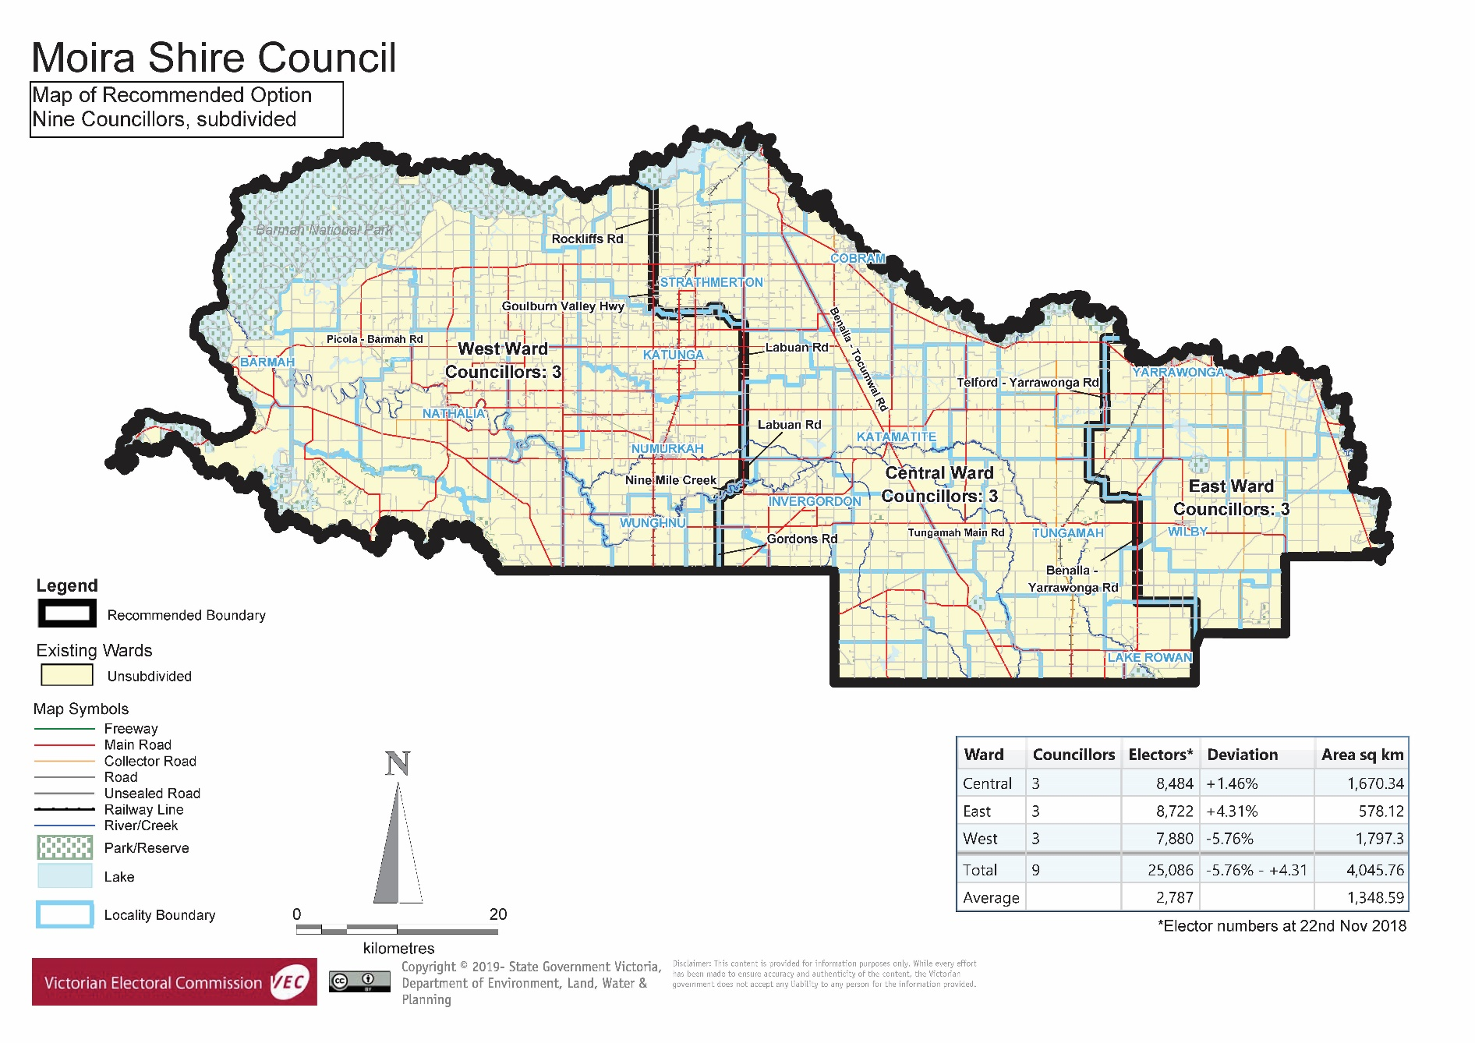

Appendix 3: Public information program

Advertising

In accordance with the Act, public notices of the review and the release of the preliminary report were placed in the following newspapers:

|  |  |  |
| --- | --- | --- |
| **Newspaper** | **Notice of review** | **Notice of preliminary report** |
| *Herald Sun* | Thursday 7 January | Wednesday 10 March |
| *Cobram Courier* | Wednesday 30 January | Wednesday 3 April |
| *Numurkah Leader* | Wednesday 30 January | Wednesday 3 April |
| *Yarrawonga Chronicle* | Wednesday 30 January | Wednesday 3 April |

Media releases

A media release was prepared and distributed to local media to promote the commencement of the review on Wednesday 6 February 2019. A further release was distributed with the publication of the preliminary report on Wednesday 3 April 2019. A final media advisory was circulated on the publication date of this final report.

Public information sessions

Public information sessions for people interested in the review process were held on:

* Tuesday 5 February 2019 in the Numurkah Presidents Room, 99 Melville Street, Numurkah
* Tuesday 5 February 2019 at the Cobram Civic Centre, Punt Road, Cobram
* Wednesday 6 February 2019 at Yarrawonga Town Hall, 100 Belmore Street, Yarrawonga

Submission guide

A submission guide was developed and made available on the VEC website, or in hardcopy on request, throughout the review timeline. The submission guide provided information about the review, the review timeline and how to make submissions to the review.

Online submission tool

An online submission tool was developed and made available during the submission periods of the review. The tool allowed people to make a submission from the VEC website. During the preliminary submission stage, users also had the opportunity to map out their preferred subdivisions through the online submission tool Boundary Builder. Boundary Builder included real elector numbers so that users could see if their preferred structures and numbers of councillors met the plus-or-minus 10% rule.

VEC website

The VEC website delivered up-to-date information to provide transparency and facilitate public participation during the review process. All public submissions were published on the website.

Email and social media engagement

The VEC delivered an information email campaign targeted at known community groups and communities of interest in the local council area. This included a reminder email at each milestone of the representation review process.

The VEC also published sponsored social media advertising that was geo-targeted to users within the local council area. This included advertising at both the preliminary submission and response submission stages. The total reach of these posts was 5,567 during the preliminary submission stage and 4,245 during the response submission stage.

Council communication resources

The VEC provided the Council with a communication pack that included information on the review in various formats. While the council is encouraged to distribute this information and raise awareness about the review, the VEC is an independent reviewer and all communications resources include references and links to the VEC website and core materials.

This page has been left intentionally blank

This page has been left intentionally blank

This page has been left intentionally blank

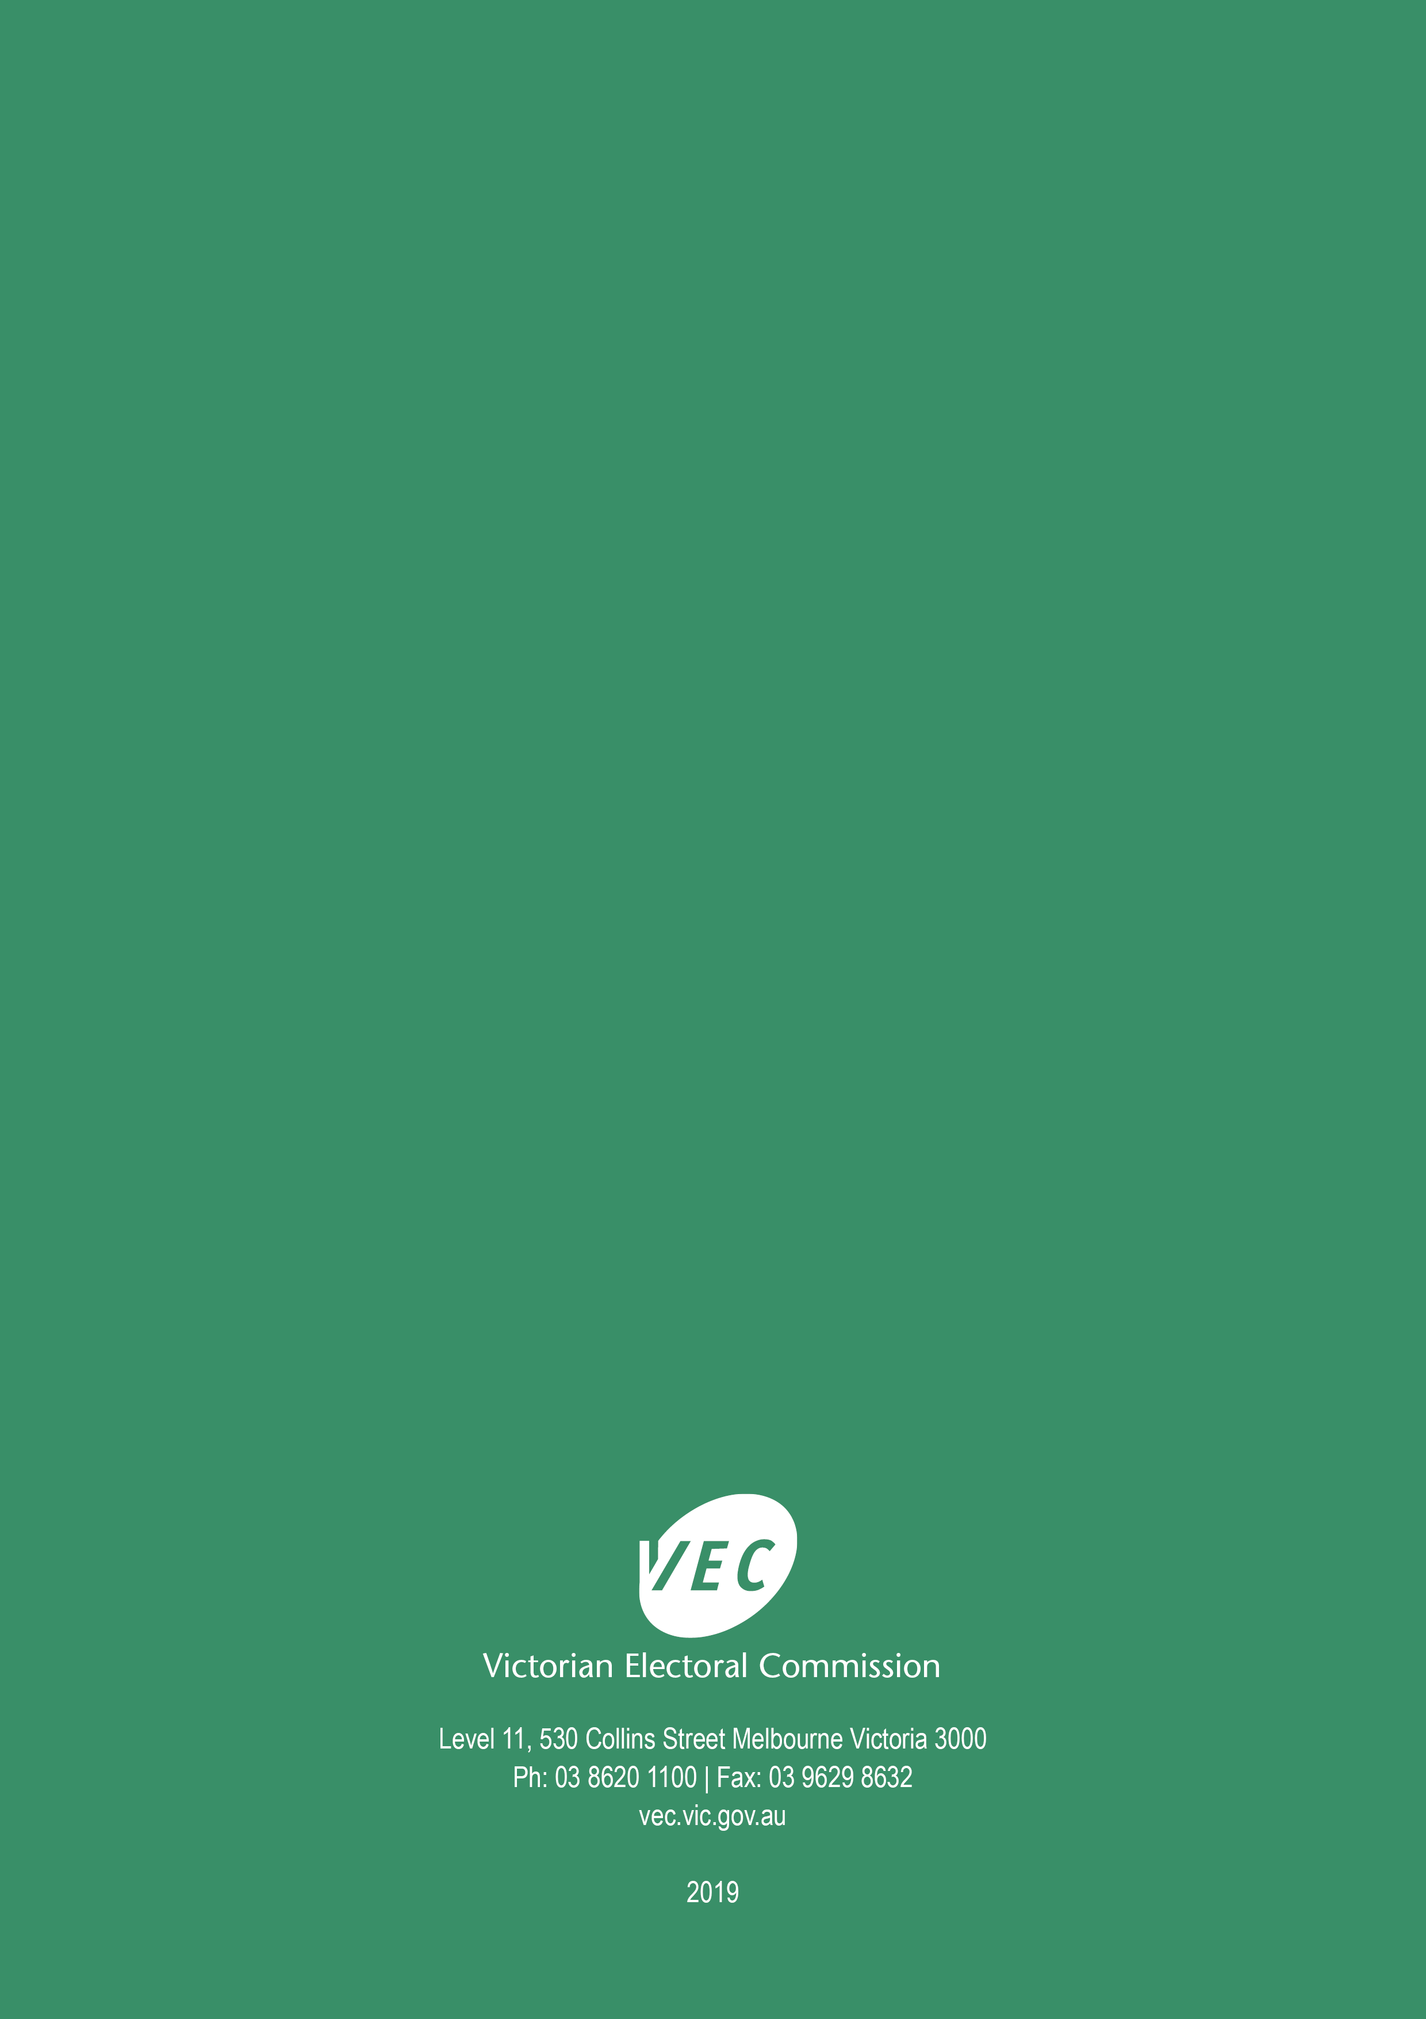

1. Section 219D of the *Local Government Act* *1989.*
2. ibid.
3. .id is a consulting company specialising in population and demographic analysis and prediction information products in most jurisdictions in Australia and New Zealand.
4. Section 5B(1) of the *Local Government Act 1989.*
5. Parks Victoria, ‘Barmah National Park’, Parks Victoria, <https://parkweb.vic.gov.au/explore/parks/barmah-national-park>, accessed 11 April 2019.
6. Parks Victoria, ‘Broken-Boosey State Park’, Parks Victoria, <https://parkweb.vic.gov.au/explore/parks/broken-boosey-state-park>, accessed 11 April 2019.
7. Demographic data compiled from Australian Bureau of Statistics (ABS), ‘Quickstats 2016’ and ABS 2016 Census.
8. SD Planning Strategy and Development, *Major Towns’ Strategy Plan Review (Yarrawonga, Cobram, Numurkah and Nathalia)*, prepared for Moira Shire Council, SD Planning Strategy and Development, June 2018, p. 6; Moira Shire Council, *Council Plan 2013-17*, Moira Shire Council, 2013, p. 1.
9. Rachel Wells, ‘The Town That’s Opening It’s Arms Again’, *Age*, December 4, 2005, <https://www.theage.com.au/national/the-town-thats-opening-its-arms-again-20051204-ge1d3a.html>, accessed 11 April 2019.
10. Victorian Electoral Commission, *Electoral Representation Review, Moorabool Shire Council: Final Report*, 2011, p. 10. Currently, Moorabool Shire Council has a slightly larger population than Moira Shire and it has seven councillors. In Moorabool Shire’s last review (2011), the VEC acknowledged that the number of voters-per-councillor in Moorabool Shire was well above the median for seven-councillor rural councils. The VEC had examined options for more councillors in that review.
11. Councillor Mansfield did not make a response submission but indicated that he wanted to speak at the public hearing in his preliminary submission. He subsequently contacted the VEC before the public hearing to indicate his interest in speaking at the hearing. The VEC generally accepts requests to speak via response submissions but made an exception in this case due to the notification from Councillor Mansfield before the hearing and the availability in the schedule of speakers.
12. This assumes that residents remain within the Shire to access services, which is not always correct. Submitters at the public hearing also spoke of residents accessing services outside the Shire.
13. Moira (LGA) in Department of Environment, Land, Water and Planning (Victoria), ‘Land and Survey Spatial Information (LASSI)’, <https://maps.land.vic.gov.au/lassi/>, accessed 14 May 2019.
14. Some of these challenges were canvassed in the following report commissioned by council. See, SD Planning Strategy and Development, *Major Towns’ Strategy Plan Review (Yarrawonga, Cobram, Numurkah and Nathalia)*, prepared for Moira Shire Council, SD Planning Strategy and Development, June 2018.
15. Department of Environment, Land, Water and Planning (Victoria), *Victoria in Future 2016: population and household projections to 2051*, State Government of Victoria, 2016, p. 1 and 15. The fastest growing local council areas in Victoria’s regions include: Mitchell, Moorabool, Baw Baw, Golden Plains and Surf Coast shire councils.
16. Victorian Electoral Commission, *2016 Local Government Elections Report*, 2017, Figure 9, pp. 26, <https://www.vec.vic.gov.au/files/Report%20on%20the%20conduct%20of%20the%202016%20Local%20Government%20Elections.pdf>