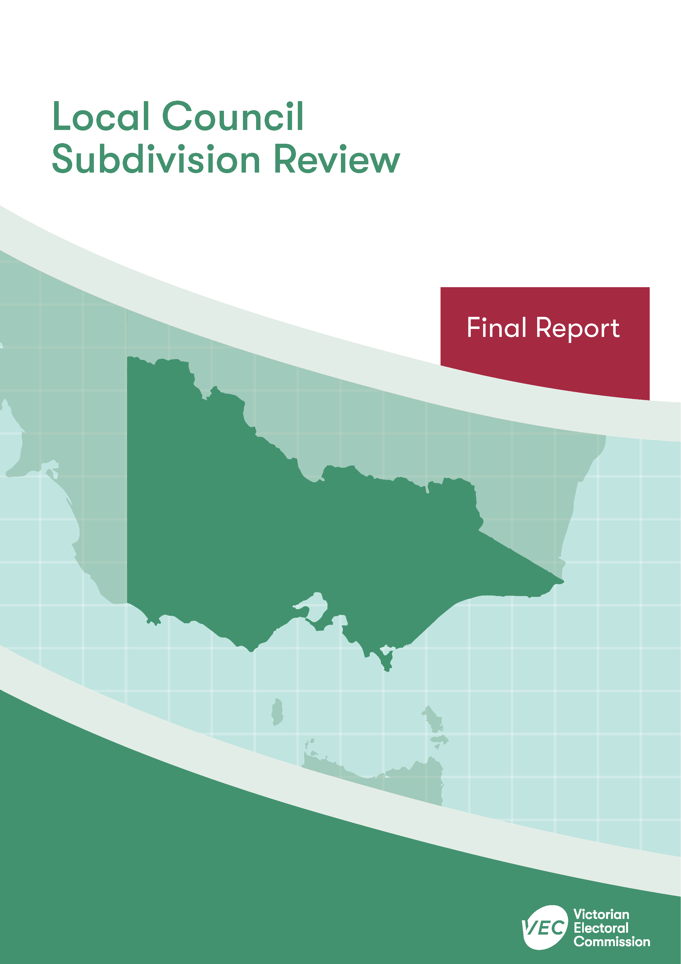



**April 2020**

**Stonnington   
City Council**

Contents

Recommendation 1

Executive summary 2

Background 4

Legislative basis 4

The VEC’s approach 5

Profile of Stonnington City Council 7

Population trends 8

Current number of councillors and electoral structure 8

Current subdivision review 9

Preliminary report 10

Public response 11

Response submissions 11

Public hearing 11

Findings and recommendation 12

The VEC’s findings 12

The VEC’s recommendation 13

Appendix 1: Public involvement 14

Appendix 2: Recommended ward boundaries map 15

Appendix 3: Public information program 17

Recommendation

The Victorian Electoral Commission recommends adjustments to the boundaries of the following wards within Stonnington City Council:

* North Ward
* East Ward

This recommendation is submitted to the Minister for Local Government as required by the *Local Government Act 1989*.

Please see Appendix 2 for a detailed map of the recommended ward boundaries.

Executive summary

The *Local Government Act 1989* (LG Act) requires the Victorian Electoral Commission (VEC) to conduct a subdivision review to ensure the equitable representation of all voters in a local council.[1] The LG Act prescribes that the number of voters per councillor in each ward must be within plus-or-minus 10% of the average number of voters per councillor across the local council. [2] This is known as the ‘equality requirement’.

As population changes affect voter numbers and distribution in subdivided local councils, one or more wards may be unlikely to meet this requirement at the next general election. In such circumstances, the VEC recommends adjustments to internal ward boundaries to ensure that all wards meet the equality requirement before the next election and ideally, until the next scheduled electoral representation review.

Current number of councillors and electoral structure

Stonnington City Council currently comprises nine councillors elected from three three-councillor wards. More information on Stonnington City Council is available on the VEC website at [vec.vic.gov.au](http://vec.vic.gov.au).

In 2018, the VEC notified the Minister for Local Government that one or more wards were unlikely to meet the equality requirement at the 2020 general election. Accordingly, the Minister notified the VEC that a subdivision review of Stonnington City Council was required before the 2020 general election.

Preliminary report

A preliminary report was released on Wednesday 19 February 2020 proposing an adjustment to the boundary between North Ward and East Ward within Stonnington City Council.

Response submissions

The VEC received one submission responding to the preliminary report by the deadline of 5.00 pm on Wednesday 18 March 2020.

Public hearing

The VEC scheduled a public hearing for those wishing to speak about their response submission at 7.00 pm on Tuesday 24 March 2020. There were no requests to speak so the hearing was not held.

Recommendation

The Victorian Electoral Commission recommends adjustments to the boundaries of the following wards within Stonnington City Council:

* North Ward
* East Ward

This recommendation is submitted to the Minister for Local Government as required by the *Local Government Act 1989*.

Please see Appendix 2 for a detailed map of the recommended ward boundaries.

Background

Legislative basis

The *Local Government Act 1989* (LG Act) requires the Victorian Electoral Commission (VEC) to conduct a subdivision review to ensure the equitable representation of all voters in a local council. The LG Act prescribes that the number of voters per councillor in each ward must be within plus-or-minus 10% of the average number of voters per councillor across the local council. [3] This is known as the ‘equality requirement’.

As population changes affect voter numbers and distribution in subdivided local councils, one or more wards may be unlikely to meet this requirement at the next general election. In such circumstances, the VEC recommends adjustments to internal ward boundaries to ensure that all wards meet the equality requirement before the next election and ideally, until the next scheduled electoral representation review.

Subdivision reviews only apply to subdivided councils:

* that are not scheduled for an electoral representation review before the next general election

and

* where, two years before the council is to hold a general election, the VEC considers one or more wards are unlikely to meet the equality requirement at the time of the next general election.

### Scope

A subdivision review only considers the location of ward boundaries. A subdivision review cannot consider changes to the number of councillors or wards.

These changes are considered in a council’s periodic electoral representation review. The next scheduled representation review for Stonnington City Council will be held before the 2024 general election. An earlier review may take place if required.

A subdivision review also cannot change the external boundaries of the local council, divide local councils, or amalgamate local councils. These changes can only be made by an Order in Council.

The VEC’s approach

### Public information program

The VEC conducted a public information program to inform the community of the subdivision review, including:

* a public notice printed in local papers
* a media release announcing the release of the preliminary report
* an information email campaign targeted at known community groups and communities of interest in the local council area
* sponsored social media advertising geo-targeted to users within the local council   
  area
* ongoing information updates and publication of submissions on the VEC website.

More information on the VEC’s public information program for the subdivision review of Stonnington City Council can be found at Appendix 3.

### Public consultation

Public input was encouraged by the VEC via response submissions to the preliminary report.

### Developing recommendations

The VEC bases its recommendations for ward boundaries on:

* internal research specifically relating to the local council under review, including voter statistics from the Victorian electoral roll
* small area forecasts provided by .id[4]
* the VEC’s expertise in mapping, demography and local government
* consideration of all input from the public in written submissions received during the review.

In determining which ward boundaries are most appropriate, the VEC considers the:

* number of voters in each ward, to ensure that each ward meets the equality requirement for the next election
* number of voters affected by the changes, with the aim of affecting as few voters as possible
* communities of interest
* significance of natural and man-made features (such as roads and waterways), to ensure clear and identifiable ward boundaries
* geographic factors, such as size and topography
* longevity of the structure.

### Communities of interest

Each local council contains a number of communities of interest. Where practicable, ward boundaries should be designed to ensure they are fairly represented, and that geographic communities of interest are not split. This allows communities with shared concerns to elect a councillor.

Stonnington City Council

Profile of Stonnington City Council

Stonnington City Council is an inner metropolitan local council located approximately three kilometres south-east of the Melbourne CBD. The local council includes the localities of Armadale, Kooyong, Malvern, Malvern East, Prahran and Toorak, as well as parts of Glen Iris, South Yarra and Windsor.

The City of Stonnington is predominantly residential. Several retail areas are located in the local council area, including Chadstone Shopping Centre and shopping precincts along Chapel and Greville Streets, Glenferrie Road, High Street, Malvern Road and Toorak Road. The local council area also includes many primary, secondary and tertiary education facilities.

The population is largely affluent with relatively low socio-economic disadvantage. The median personal weekly income for the City of Stonnington ($1,042) is much higher than for Greater Melbourne ($673). The unemployment rate for the City of Stonnington (5.2%) is lower than the rates for both Greater Melbourne (6.8%) and Victoria (6.6%),[5] and the City has one of the lowest levels of disadvantage of any Victorian local council. Within the local council area, Kooyong, Toorak and Malvern experience the least disadvantage.[6]

Levels of linguistic and cultural diversity within the City of Stonnington population are similar to or slightly lower than those of Greater Melbourne overall. The proportion of people in the local council that were born in Australia (60.8%) is similar to that of Greater Melbourne (59.8%), though a greater proportion of the City of Stonnington population speak only English at home (69.8% compared to 62%).[7] Other languages spoken at home include Mandarin (4.9%), Greek (3.4%), Cantonese (1.4%), Italian (1.2%) and Spanish (0.9%). Of those born overseas, the largest groups are from China (4.3%), England (3.5%), India (2.5%), New Zealand (2.5%), and Greece (1.6%).[8] Stonnington City Council has a lower proportion of Aboriginal and Torres Strait Islander peoples in the population (0.3%) compared to Greater Melbourne (0.5%). The Boonwurrung and Wurundjeri peoples are the traditional custodians of the land known as the City of Stonnington.[9]

The median age within the local council (35 years) is similar to the median for Greater Melbourne (36 years) and families are predominantly comprised of couples without children (48.6%).[10]

Population trends

At the time of the 2016 Census, the City of Stonnington had a population of 103,832.[11] The population is expected to grow steadily at an average rate of 1.3% per annum from 2018­­–2036, reaching 146,890 by 2036.[12] This rate of growth is below average compared to the projected Greater Melbourne average of 1.9% for the same period.[13]

Within the local council area, the highest level of population growth is expected to occur within South Yarra. This corresponds with the development of new dwellings in this suburb and has led to an imbalance of growth across the local council area.[14]

There are currently an estimated 96,475 registered voters for Stonnington City Council, with an average of 10,719 voters per councillor.

Current number of councillors and electoral structure

Stonnington City Council currently comprises of nine councillors elected from three three-councillor wards. At the last representation review in 2011, the VEC recommended that Stonnington City Council continue with the current electoral structure, which has been in place since the 2005 general election. Prior to the representation review in 2004, Stonnington City Council was comprised of nine single-councillor wards.

Diagram 1 illustrates the current electoral structure and voter statistics by ward as at 17 October 2019.

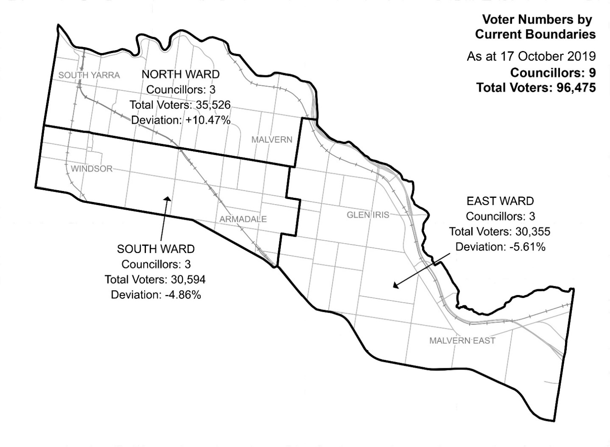

Diagram 1: Stonnington City Council electoral structure and voter statistics.

Current subdivision review

The current subdivision review of Stonnington City Council is required due to the voter-to-councillor ratio in North Ward being more than 10% above the average voter-to-councillor ratio for the local council. Consequently, the North Ward boundary will need to be adjusted so the ward’s enrolment will be within the 10% tolerance at the 2020 general election.

Table 1 (on the next page) shows the number of voters in each ward as at 17 October 2019, ranked by their percentage. This deviates from the average number of voters per councillor for the whole local council.

|  |  |  |  |
| --- | --- | --- | --- |
| Table 1: Voter numbers per ward | | | |
| **Ward** | **Councillors** | **Voters** | **Deviation (%)** |
| North | 3 | 35,526 | +10.47 |
| East | 3 | 30,355 | -5.61 |
| South | 3 | 30,594 | -4.86 |
| **Total for council** | **9** | **96,475** |  |

Preliminary report

The VEC’s subdivision review of Stonnington City Council commenced with the release of a preliminary report on Wednesday 19 February 2020. The report contained proposed ward boundary changes based on analysis of enrolment information and internal research.

The main aim of this subdivision review was to devise a minimal-change adjustment to ward boundaries that would ensure that voter-to-councillor ratios for all wards were within the legislated plus-or-minus 10% tolerance at the time of the 2020 local government elections.

In the preliminary report, the VEC proposed a minor adjustment to the ward boundary between North and East Wards. This proposed adjustment would result in the area of Malvern currently bounded by Malvern Road, Glenferrie Road, Toorak Road and Elizabeth Street being included in East Ward. The adjusted boundary between North and East Wards would follow, from north to south: Toorak Road, Glenferrie Road and Malvern Road.

The proposed ward boundary change would impact 1,261 voters who are currently in North Ward (1.3% of total current enrolment).

Table 2 details the number of voters in each ward as a result of the proposed boundary change.

|  |  |  |  |
| --- | --- | --- | --- |
| Table 2: Voter numbers per ward with proposed boundaries | | | |
| **Ward** | **Councillors** | **Voters** | **Deviation (%)** |
| North | 3 | 34,265 | +6.55 |
| East | 3 | 31,616 | -1.69 |
| South | 3 | 30,594 | -4.86 |
| **Total for council** | **9** | **96,475** |  |

Public response

Response submissions

The VEC accepted submissions responding to the preliminary report from Wednesday 19 February 2020 until 5.00 pm on Wednesday 18 March 2020. The VEC received one response submission. The submitter’s name can be found in Appendix 1.

The response submission was from a resident of Glen Iris who expressed opposition to apartment developments within the local council area. The submission contained no consideration of the proposed ward boundary adjustment and was therefore outside of the scope of the subdivision reviews. The VEC could not take this submission into consideration.

Public hearing

The VEC scheduled a public hearing for those wishing to speak about their response submission at 7.00 pm on Tuesday 24 March 2020 in the Council Chamber, Malvern Town Hall, corner of Glenferrie Road and High Street, Malvern. There were no requests to speak so the hearing was not held.

Findings and recommendation

The VEC’s findings

The VEC notes that the electoral structure in Stonnington City Council has been stable since it was introduced in 2005, with no change to the ward boundaries since this time.

Since the last representation review in 2011, the number of voters within North Ward has increased at a faster rate relative to both South and East Wards, leading to a current deviation of +10.47% in North Ward. As a result, the VEC found that the boundary for North Ward needed to be adjusted. This would bring North Ward’s deviation back within the legislated plus-or-minus 10% tolerance from the average voter-to-councillor ratio in the local council area.

The VEC considered it preferable to maintain the clear ward boundary between North and South Wards, which follows Commercial Road/Malvern Road. Instead, the VEC proposed to adjust the boundary between North and East Wards. This would enable East Ward to absorb voters from North Ward and bring the deviations of both wards closer to the average voter-to-councillor ratio.

At the preliminary stage of the review, the VEC proposed moving the ward boundary so that the area of Malvern currently bounded by Malvern Road, Glenferrie Road, Toorak Road and Elizabeth Street would be included in East Ward. The boundary between North and East Wards would instead follow, from north to south: Toorak Road, Glenferrie Road and Malvern Road.

At the final stage of the review, the VEC considered this minor ward boundary adjustment provided an improved ward boundary that would follow major roads and would be easier to identify for voters in the area. The VEC also considered this change to be favourable for communities of interest in the local council area.

The current boundary of East Ward splits the suburb of Malvern across three wards, while the VEC’s ward boundary adjustment would unite a greater proportion of Malvern within East Ward. Kooyong would remain in North Ward alongside closely associated Toorak, while the boundaries of South Ward would remain entirely unchanged, enabling continuity for voters in that ward.

The VEC received no opposition through community submissions to the proposed ward boundary adjustment during this review.

The ward boundary adjustment would impact 1,261 voters (1.3% of current enrolment) who are currently in North Ward and return North Ward to the legislated plus-or-minus 10% deviation. North Ward would have 34,265 voters (6.55% above the average) and East Ward would have 31,616 voters (1.69% below the average).

The VEC is confident that all wards would remain within the 10% tolerance at least until the October 2020 general election.

The VEC’s recommendation

The Victorian Electoral Commission recommends adjustments to the boundaries of the following wards within Stonnington City Council:

* North Ward
* East Ward

This recommendation is submitted to the Minister for Local Government as required by the *Local Government Act 1989*.

Please see Appendix 2 for a detailed map of the recommended ward boundaries.

# Appendix 1: Public involvement

Response submissions

Response submissions were made by:

Bradley, Hannah

# Appendix 2: Recommended ward boundaries map

The map is provided on the next page.

# Appendix 3: Public information program

Advertising

Public notices of the release of the preliminary report were placed in the following newspapers:

|  |  |
| --- | --- |
| **Newspaper** | **Date of publication** |
| *Stonnington Leader* | Tuesday 18 February 2020 |
| *Herald Sun* | Saturday 15 February 2020 |
| *The Age* | Wednesday 19 February 2020 |

Media releases

A media release was prepared and distributed to local media to promote the publication of the preliminary report on Wednesday 19 February. A final media advisory was circulated on the publication date of this final report.

VEC website

The VEC website delivered up-to-date information to provide transparency and facilitate public participation during the review process. All public submissions were published on the website.

### Online submission tool

An online submission tool was developed and made available during the submission period of the review. The tool allowed people to make a submission from the VEC website.

Email and social media engagement

The VEC delivered an information email campaign targeted at known community groups and communities of interest in the local council area. This included a reminder email at each milestone of the subdivision review process.

The VEC also published sponsored social media advertising that was geo-targeted to users within the local council area. The total reach of these posts was 12,428.

Council communication resources

The VEC provided the Council with a communication pack that included information on the review in various formats. While the council is encouraged to distribute this information and raise awareness about the review, the VEC is an independent reviewer and all communications resources include reference and links to the VEC website and core materials.

|  |
| --- |
| **© State of Victoria**  (Victorian Electoral Commission) **April 2020** |
| This work, Local Council Subdivision Review – Final Report Stonnington City Council 2020,  is licensed under a Creative Commons Attribution 4.0 licence (http://creativecommons.org/ licenses/ by/4.0/). You are free to re-use the work under that licence, on the condition that you credit the State of Victoria (Victorian Electoral Commission) as author, indicate if changes were made and comply with the other licence terms. The licence does not apply to any branding, including government logos. |
|  | |
| Level 11, 530 Collins Street  Melbourne Victoria 3000  T 131 832  info@vec.vic.gov.au  vec.vic.gov.au | |
|  | |



1. Section 219H of the *Local Government Act* *1989.*
2. Section 219L of the *Local Government Act* *1989.*
3. Section 219L of the *Local Government Act* *1989.*
4. .id is a consulting company specialising in population and demographic analysis and prediction information products in most jurisdictions in Australia and New Zealand.
5. Australian Bureau of Statistics, ‘2016 Census QuickStats - Stonnington (C)’, <https://quickstats.censusdata.abs.gov.au/census_services/getproduct/census/2016/quickstat/LGA26350?opendocument>, accessed 24 March 2020.  
   See also: ‘2016 Census QuickStats - Greater Melbourne’.
6. id, ‘City of Stonnington: SEIFA by profile area’, <https://profile.id.com.au/stonnington/seifa-disadvantage>, accessed 24 March 2020.
7. Australian Bureau of Statistics, ‘2016 Census QuickStats - Stonnington (C)’, loc. cit.   
   See also: ‘2016 Census QuickStats – Greater Melbourne’.
8. Australian Bureau of Statistics, ‘2016 Census QuickStats - Stonnington (C)’, loc. cit.
9. City of Stonnington, ‘Reconciliation Action Plan: July 2018–July 2020’, <https://www.stonnington.vic.gov.au/files/assets/public/adl/council-policies/reconciliation-action-plan.pdf>, accessed 24 March 2020.
10. Australian Bureau of Statistics, ‘2016 Census QuickStats - Stonnington (C)’, loc. cit.   
    See also: ‘2016 Census QuickStats – Greater Melbourne’.
11. Ibid.
12. Department of Environment, Land, Water and Planning, ‘Victoria in Future 2019’, <https://www.planning.vic.gov.au/land-use-and-population-research/victoria-in-future>, accessed 24 March 2020.
13. Calculated from VIF2019 Major Regions 2056 data table accompanying: Department of Environment, Land, Water and Planning, ‘Victoria in Future 2019’, <https://www.planning.vic.gov.au/land-use-and-population-research/victoria-in-future>, accessed 24 March 2020.
14. .id, ‘City of Stonnington: Population forecast’, <https://forecast.id.com.au/stonnington>, accessed 24 March 2020.