Strathbogie Shire Council

Local council electoral structure review

March 2023

Preliminary   
Report

Acknowledgement of Country

The electoral representation advisory panel acknowledges the Taungurung and Yorta Yorta peoples as the Traditional Custodians of the lands and waters on which it is holding this review and pays respects to ancestors and Elders past, present and emerging. The panel acknowledges their custodianship for many thousands of years and their continuing living culture.

Document history and version control

|  |  |  |  |
| --- | --- | --- | --- |
| **Version** | **Date approved** | **Approved by** | **Brief description** |
| 1 | 21 March 2023 | Electoral Commissioner | Final version |

Contents

Executive summary 4

Developing electoral structure models 4

Preliminary submissions 4

Electoral structure models 4

Next steps 4

Background 5

About the 2023–24 electoral structure reviews 5

The electoral representation advisory panel 5

Public engagement 6

Developing recommendations 6

About Strathbogie Shire Council 9

Profile 9

Current number of councillors and electoral structure 10

Last electoral structure review 10

Preliminary submissions 11

Number of councillors 11

Electoral structure 12

Preliminary findings and models 13

Number of councillors 13

Electoral structure 14

Models for public feedback 17

Next steps 18

Response submissions 18

Public hearing 19

Final report 19

References 20

Appendix 1: Model maps 21

Appendix 2: Additional models considered 25

Appendix 3: List of preliminary submitters 26

# Executive summary

An independent electoral structure review panel appointed by the Minister for Local Government has reviewed the structure of Strathbogie Shire Council.

The panel looked at:

* whether the council had an appropriate number of councillors
* whether it should be unsubdivided or subdivided.

This report outlines the preliminary models that the panel is presenting for the proposed new electoral structure of Strathbogie Shire Council to meet the requirements of Victoria’s *Local Government Act 2020* (the Act).

More information about the background to the reviews is available on page 5.

## Developing electoral structure models

The panel considered a range of factors when deciding on the models in this report, including:

* research and analysis
* voter growth or decline over time
* public submissions (see below).

More information on the way the panel decided on the models is available on page 6.

## Preliminary submissions

The panel received 6 preliminary submissions. Of these, 2 submissions included maps.

A full analysis of submissions received can be found on page 11.

## Electoral structure models

After considering submissions and research, the panel is presenting the following electoral structure models for further public consultation:

Model 1: an unsubdivided electoral structure with 7 councillors.

Model 2: a subdivided electoral structure with a total of 6 councillors, 2 wards and 3 councillors per ward.

Model 3: a subdivided electoral structure with a total of 6 councillors, 3 wards and 2 councillors per ward.

Details on these models, including maps, are available on Appendix 1.

## Next steps

The panel is now seeking feedback on the electoral structure models. You can make a response submission to these models until Wednesday 12 April 2023. If any response submitters wish to speak at a public hearing, the panel will hold an online public hearing on Wednesday 19 April 2023. Following this, it will present its final recommendation to the Minister by Wednesday 17 May 2023.

More information about the review process is available on the Victorian Electoral Commission (VEC) website at [vec.vic.gov.au](https://www.vec.vic.gov.au/)

# Background

## About the 2023–24 electoral structure reviews

In October 2022, the Minister for Local Government formed 2 electoral representation advisory panels to review the electoral structures of 39 local councils, under section 16 of the *Local Government Act 2020* (the Act). If the minister accepts the electoral structures the panels recommend, they will take effect at the October 2024 elections.

The Act introduced several changes to local government representation, including the types of electoral structures local councils may have. Large and small rural shire councils (including Strathbogie Shire Council) can have one of 3 electoral structures:

* + unsubdivided (entire council area with no wards)
  + single-councillor wards
  + multi-councillor wards with the same number of councillors per ward.

For Strathbogie Shire Council, the electoral representation advisory panel is examining:

* the number of councillors
* whether the council should be subdivided into wards or unsubdivided.

For subdivided structures, it is also examining:

* + the number of wards
  + where the ward boundaries should be
  + the name of each ward
  + how many councillors should be elected for each ward.

The Act requires electoral structures to provide fair and equitable representation and facilitate good governance. For subdivided structures, each ward must have an approximately equal number of voters per councillor (within +/-10% of the average).

## The electoral representation advisory panel

The panel conducting the electoral structure review of Strathbogie Shire Council has 3 members:

* The Honourable Frank Vincent AO KC (Chairperson)
* Ms Liz Williams PSM
* Electoral Commissioner Mr Warwick Gately AM.

The panel is independent of councils and the State government.

Under the Act, the VEC is not responsible for reviewing council electoral structures but must provide administrative and technical support to the panel. The Electoral Commissioner (or their delegate) must be a member of each panel.

## Public engagement

### Public information program

To educate and inform the public about the Strathbogie Shire Council electoral structure review, the VEC began a public information program in mid-December 2022. The VEC:

* + printed public notices in state-wide newspapers
  + held public information sessions to outline the review process and respond to questions from the community
  + sent out media releases to announce the start of the review
  + published information on its social media channels
  + provided updated website content on [vec.vic.gov.au](https://www.vec.vic.gov.au/electoral-boundaries/council-reviews/electoral-structure-reviews), including:
    - information on the review process
    - submission guides and fact sheets for each council under review with background information
    - preliminary submissions from the public.

The VEC will continue to promote the review during the response submissions stage via media releases, the VEC’s social media channels and updated content on the VEC website.

### Public consultation

The panel encouraged public input to the review of Strathbogie Shire Council via preliminary submissions at the start of the review. The panel now invites further input via:

* + response submissions to this preliminary report
  + an online public hearing to provide anyone who makes a response submission the opportunity to expand on their submission.

Public submissions are an important part of the review process but the panel also considers other factors during a review. These are outlined below.

## Developing recommendations

The panel’s electoral structure models presented in this preliminary report comply with the Act and were developed through careful consideration of:

* + research and analysis conducted by the VEC support team, including geospatial and demographic factors
  + rates or patterns of population and voter growth or decline over time, and relevant forecasts of growth or decline based on forecast information provided by .id (informed decisions, a company specialising in demographics and forecasting)
  + input received from the public in written submissions during the preliminary submissions phase.

### Deciding on the number of councillors

The Act allows local councils to have between 5 and 12 councillors, but neither the Act nor the Local Government (Electoral) Regulations 2020 specify how to determine the number of councillors a council needs. Therefore, the models put forward by the panel in this report are guided by the Act’s intention for fairness and equity in voter representation.

In examining the number of councillors Strathbogie Shire Council should have, the panel considered these factors:

* + the population and number of voters in the council area, compared to other councils with a similar population size and number of voters in the same category (for example, metropolitan, interface, regional city, large rural shire, small rural shire)
  + patterns of population change and voter growth or decline in the council area over time
  + the current and past numbers of councillors
  + the representation needs of the communities of interest in the council area
  + if a particular type of electoral structure best suits the council (see ‘Deciding the electoral structure’ below)
  + any matter raised in public submissions not already listed above.

Generally, local councils with a larger number of voters will have a higher number of councillors. Large populations are often more likely to have greater diversity, both in the type and number of communities of interest and issues relating to representation. However, the ideal number of councillors can also be influenced by the particular circumstances of a council, such as the:

* + nature and complexity of services the council provides
  + geographic size and topography of the area
  + forecast population and voter growth or decline
  + social diversity.

### Deciding the electoral structure

The electoral structure of large and small rural shire councils can be:

* + unsubdivided (entire council area with no wards)
  + made up of single-councillor wards

or

* + made up of multi-councillor wards with the same number of councillors per ward.

When developing electoral structure models for Strathbogie Shire Council, the panel considered these main criteria:

* + whether the structure would comply with section 15(2) of the Act (see below), and for how long it would likely comply
  + the appropriate number of councillors, as outlined above
  + whether meaningful and effective ward boundaries can be established and whether these would be easily identifiable to local communities
  + representation of communities of interest
  + the voter distribution and physical features of the area, and the impact these may have on the shape and size of any wards
  + past elections for the council, including:
    - numbers of candidates nominating
    - incidences of uncontested elections
    - rates of informal voting.
  + other matters raised in public submissions not already listed above.

Under section 15(2) of the Act, subdivided structures must aim for an approximately equal number of voters per councillor in each ward. This means the number of voters represented by each councillor in a ward should be within +/-10% of the average number of voters per councillor for all wards.

The panel recommends structures that will comply with section 15(2) at the October 2024 local council elections and uses current voter numbers and forecasts of population and voter change to assess this with as much accuracy as possible. In some cases, population changes and other factors mean it is not possible for a subdivided electoral structure to comply with section 15(2) based on current voter numbers. If this occurs, compliance at the 2024 local government elections will be the priority to ensure each vote has approximately equal value.

# About Strathbogie Shire Council

## Profile

Strathbogie Shire Council is in northern Victoria, approximately 150 km from Melbourne. It covers an area of 3,303 km2 and shares its borders with Campaspe Shire and Greater Shepparton City councils in the north, and Benalla Shire Council in the east. Mansfield, Murrindindi and Mitchell shire councils are to the south and Greater Bendigo City Council is to the west.

The Traditional Custodians of the Strathbogie area are the Taungurung and Yorta Yorta peoples.

### Landscape

The shire is in the Goulburn Valley region of Victoria ‘amidst the picturesque Strathbogie Plateau’ (Department of Planning and Transport, 2022a). It has ‘an abundance of natural attractions’ including the Goulburn River system, Nagambie Lakes, Gooram Falls, Polly McQuinns and ‘unique granite rock formations in the Strathbogie Ranges’ (Strathbogie Shire Council, 2023).

At the 2021 Census, the shire’s population was 11,455 and almost 60% of the population lived in 4 of the shire’s main urban centres – Euroa, Nagambie, Avenel and Violet Town.

Euroa is the largest town in shire and is the main commercial, industrial and administrative centre (Department of Planning and Transport, 2022b). With a population of 3,116 in 2021, it accounted for 27.2% of the shire’s population (ABS, 2021b).

Nagambie, the shire’s second largest town (population 2,036) (ABS, 2021c), is a popular lakeside town and attracts between 4,000 and 5,000 people during peak tourism season (Department of Planning and Transport, 2022b).

Avenel (population 852) (ABS, 2021a) is a small town in the south west of the shire next to the Hume Freeway, known for its rural landscape and floodplains (Department of Planning and Transport, 2022b). Violet Town (population 717) (ABS, 2021d) is in the north east of the shire near the Strathbogie Ranges.

There are 2 major freeways (Goulburn Valley and Hume) connecting major towns in the shire and service centres in other council areas. Strathbogie is serviced by 2 V/Line rail lines – the Shepparton line with a station in Nagambie and the Albury line with stations in Avenel, Euroa and Violet Town.

### Community

The main industries in the shire are agriculture, forestry and fishing, which employed 18.4% of residents in 2021 (.id, 2021). The shire has a rural economic base of wool, grain and cattle production. There are extensive vineyards throughout Nagambie and the Strathbogie Ranges as well as cool-climate horticulture (Department of Planning and Transport, 2022a).

The shire’s population increased from 9,486 in 2011 (ABS, 2011) to 11,455 in 2021 (ABS, 2021e). This trend is expected to continue with an estimated annual growth rate of 1.3%.

The Census showed the shire had an older population than the overall state and regional populations, with approximately 54% of residents aged 50 or older (ABS, 2021e). The largest age group in Strathbogie Shire Council in 2021 was 60-to-69 year olds, who made up 18.9% of the shire (Remplan, 2021). The median age in 2021 was 53, which was higher than the regional Victorian median of 43 (ABS, 2021e).

In 2021, just over 80% of shire residents were born in Australia, and 1.8% identified as Aboriginal and/or Torres Strait Islander people, which is slightly less than the 2% in regional Victoria (ABS, 2021e). English was the only language spoken at home for 87.4% of residents, compared to 86.4% for regional Victoria (ABS, 2021e).

Most people in the shire owned their own home either outright or with a mortgage (77.5%), and the median weekly household income was $1,188 (ABS, 2021e).

## Current number of councillors and electoral structure

Strathbogie Shire Council is currently divided into 5 wards with a total of 7 councillors:

* + 2 wards with 2 councillors each (Lake Nagambie and Seven Creeks wards)
  + 3 wards with one councillor each (Honeysuckle Creek, Hughes Creek and Mount Wombat wards).

There are approximately 10,963 voters in Strathbogie Shire Council, with a ratio of 1,566 voters per councillor.

Visit the VEC website for [more information on Strathbogie Shire Council](https://www.vec.vic.gov.au/electoral-boundaries/local-councils/strathbogie-shire-council).

## Last electoral structure review

The VEC conducted an electoral representation review of Strathbogie Shire Council in 2011. This review was carried out under the *Local Government Act 1989*, which was replaced by the *Local Government Act 2020.*

After conducting the review, the VEC recommended that Strathbogie Shire Council adopt the current structure consisting of 7 councillors elected from 5 wards (2 wards with 2 councillors and 3 wards with one councillor).

Visit the VEC website at [vec.vic.gov.au](https://www.vec.vic.gov.au/electoral-boundaries/local-councils/strathbogie-shire-council) to access a copy of the 2011 representation review final report.

Before the 2011 review, a representation review of Strathbogie Shire Council was completed in 2004. This resulted in a multi-councillor electoral structure of 6 wards with a total of 7 councillors (one ward with 2 councillors and 5 wards with 1 councillor each).

Before the 2004 representation review, Strathbogie Shire Council was comprised of 7 single-councillor wards in 2002, changing from an earlier unsubdivided structure with 5 councillors.

# Preliminary submissions

The panel received 6 preliminary submissions from the public by the deadline of 5 pm on Wednesday 22 February 2023. You can view these submissions on the VEC website at [vec.vic.gov.au/strathbogie](https://www.vec.vic.gov.au/strathbogie) and find a list of people or organisations who made a submission in Appendix 3.

The table below provides an overview of preferences in the preliminary submissions. You can read an analysis of submissions below this table.

|  |  |  |  |  |  |
| --- | --- | --- | --- | --- | --- |
|  | Unsubdivided structure | Single-councillor wards | Multi-councillor wards | Subdivided structure (unspecified) | No comment on structure |
| Fewer councillors | 1 | 1 | - | - | - |
| Maintain current councillor number | - | - | 2 | - | - |
| More councillors | - | - | 2 | - | - |
| No comment on number of councillors | 1 | - | - | 1 | - |

Note: 2 submitters supported more than one option for the total number of councillors

## Number of councillors

Submitters were divided between wanting to reduce the number of councillors to 5 or increase them to 8. One submitter did not provide a preferred number of councillors but reasoned that 2 councillors were insufficient to represent the western communities in Lake Nagambie Ward.

### Maintaining 7 councillors

Two submitters supported maintaining the current number of councillors at 7, although these submitters also suggested 8 councillors would increase representation and enable a multi-councillor ward structure.

### Reducing to 5 councillors

Two submitters suggested 5 councillors would be suitable, due mainly to the shire’s lack of rapid growth and low population numbers. Minimising council costs and providing fair and equitable representation of all communities were also suggested as reasons to reduce councillor numbers.

## Electoral structure

The submissions showed varying support for all 3 types of electoral structures. Two-thirds preferred a subdivided electoral structure, while the remaining submitters preferred an unsubdivided structure.

### Unsubdivided

Two submitters favoured an unsubdivided electoral structure, with one submitter suggesting this would benefit the shire overall and avoid the costs associated with future boundary reviews or by-elections. One submitter also suggested an unsubdivided structure would give voters a broader range and better choice of candidates at election time than a subdivided structure.

### Multi-councillor wards

One submitter who favoured the current ward system said if changes were necessary there should be increased representation. Another submitter who wanted to maintain the current structure suggested the shire should adopt a multi-councillor ward structure of 4 wards with 2 councillors per ward if it had to change.

### Single-councillor wards

One submitter preferred a single-councillor ward structure with 5 councillors. They submitted a map and written description detailing a mix of wards to represent both urban and rural communities. This involved grouping towns, or parts of a town, with farming land evenly across each ward. The submitter suggested this structure would allow residents to communicate directly with their local councillors and believed it important for councillors to have both urban and rural electors in their ward.

### Subdivided

One submitter suggested the need for a subdivided structure but did not specify how many wards or councillors they preferred. They highlighted the potential for smaller communities to be overlooked in other electoral structures, while emphasising that representation should cater to all areas of the shire and not just the larger towns.

# Preliminary findings and models

## Number of councillors

After taking into consideration the requirements of the Act, public submissions and the agreed criteria, the panel found either 6 or 7 councillors to be an appropriate number for Strathbogie Shire Council.

The panel considered the characteristics of the shire in relation to similar rural shire councils, including its size and geography, population and the number and distribution of voters across the shire.

|  |  |  |  |  |  |  |
| --- | --- | --- | --- | --- | --- | --- |
| Similar rural shire councils to Strathbogie Shire Council | | | | | | |
| Local council | Area (km2) | Number of voters at 2022 election | Population (2021 Census) | Current total estimate of voters | Number of councillors | Number of voters per councillor |
| Southern Grampians Shire | 6,654 | 13,058 | 16,588 | 13,151 | 7 | 1,879 |
| Benalla Rural City | 2,353 | 11,755 | 14,528 | 12,022 | 7 | 1,717 |
| Alpine Shire | 4,788 | 11,169 | 13,235 | 11,566 | 7 | 1,652 |
| Central Goldfields Shire* | 1,533 | 11,169 | 13,483 | 11,329 | 7 | 1,618 |
| **Strathbogie Shire\*** | **3,303** | **9,806** | **11,455** | **10,963** | **7** | **1,566** |
| Mansfield Shire | 3,844 | 10,205 | 10,178 | 10,910 | 5 | 2,182 |
| Northern Grampians Shire* | 5,730 | 10,424 | 11,948 | 10,172 | 7 | 1,453 |
| Gannawarra Shire* | 3,738 | 9,129 | 10,683 | 9,449 | 7 | 1,350 |
| Ararat Rural City | 4,211 | 8,955 | 11,880 | 9,002 | 7 | 1,286 |

*This local council is undergoing an electoral structure review during 2023–24.

### Maintaining 7 councillors

The panel supported maintaining the current number of councillors, due mainly to the shire’s voter-to-councillor ratio, which it found compared with other rural councils with 7 councillors. Maintaining 7 councillors was also considered appropriate as it would mean the least amount of change for the community.

### Reducing to 5 councillors

Reducing the number of councillors to 5 was a considerable change and not supported by the panel. While the panel noted some submitters supported this reduction, it found 5 councillors would not provide better representation for the shire’s communities than either 6 or 7 would.

### Reducing to 6 councillors

The panel supported reducing the number of councillors to 6, mainly because this would facilitate a compliant a multi-councillor ward electoral structure.

While acknowledging there were no public submissions in favour of 6 councillors, the panel considered 6 to be a compromise between 5 and 8 councillors that reflected some of the views in the submissions.

The panel also considered how the shire’s voter-to-councillor ratio compared with other rural councils. Taking the shire’s low population growth rate into account, it viewed a reduction to 6 councillors could be justified without significantly impacting councillor workloads and other demands.

### Increasing to 8 councillors

The panel did not support increasing the number of councillors to 8. It considered the population of the shire, its projected growth, its current voter-to-councillor ratio – which compared well with other rural councils – and any special circumstances but did not find evidence to justify an increase.

## Electoral structure

To identify the most appropriate electoral structure, various factors were considered. This included the requirements of the Act, the communities of interest in Strathbogie Shire, public submissions, the appropriateness of ward boundaries and which models best offered fair and equitable representation.

In developing the preliminary models presented in this report, a range of models were considered. The strongest 3 models have been put forward for further public comment.

The panel proposes 3 models for the consideration of the Strathbogie Shire community:

* an unsubdivided electoral structure with 7 councillors ([Model 1](#_Unsubdivided_structure_(Model))
* a subdivided electoral structure of 2 wards with 3 councillors per ward (Model 2)
* a subdivided electoral structure of 3 wards with 2 councillors per ward (Model 3)

Diagrams of the preliminary models are included in Appendix 1.

### Unsubdivided structure (Model 1)

Under this model, Strathbogie Shire Council would adopt an unsubdivided electoral structure, represented by 7 councillors.

The panel considered the merits of an unsubdivided structure alongside the views presented in public submissions.

It found that an unsubdivided structure would remove potential artificial divisions of towns and communities and eliminate the need for future ward boundary changes to balance population change across wards. The model would also enable the shire to maintain 7 councillors.

Consideration was given to the potential drawbacks of an unsubdivided structure, including a perceived loss of local representation or risk of larger towns potentially dominating smaller communities. However, because candidates could appeal to voters from the across the shire, and voters would likely have greater choice in candidates at election time, the panel felt that local representation would not necessarily be compromised in an unsubdivided electoral structure. Under this structure, the quota of votes required to be elected would be the same for all councillors, so candidates with good local support would have a reasonable chance of being elected.

At past elections candidates have been elected from across the shire, not just from the more populous towns, such as Euroa and Nagambie. This indicated candidates wanted to represent their local areas. Therefore, the panel felt voters in all areas of the shire should have a reasonable chance to elect a candidate to represent them from an unsubdivided structure.

### Multi-councillor ward structure of 2 wards, with 3 councillors per ward (Model 2)

Under this model, Strathbogie Shire Council would adopt a 2-ward structure. Each ward would be represented by 3 councillors, in line with the requirement of the *Local Government Act 2020* for there to be the same number of councillors per ward.

In determining the suitability of this model, the panel noted that two-thirds of submitters favoured a subdivided structure. It was therefore reasonable to present a multi-councillor ward structure for public comment, but with an even number of councillors to comply with the Act.

The panel considered the 2 proposed wards captured key communities of interest with clear and recognisable ward boundaries. For example, the boundary running along Pranjip Creek, Creightons Creek and Creightons Creek Road captured the communities of Euroa in the east and Nagambie in the west.

Keeping Nagambie and Euroa communities intact was viewed as a favourable outcome. The panel felt the 2 wards would allow growth in both towns, without the need to further divide either town to balance voter numbers.

It was acknowledged that a 2-ward structure could divide the shire into an eastern and western side, and could mean smaller communities feel overshadowed by the major towns. Nonetheless, the boundary provided for a major population centre and rural area in each ward and thus achieved a balance. The panel also felt 3 councillors per ward would allow the election of councillors with local knowledge of their communities.

The panel also acknowledged that the shire’s communities may identify additional benefits of Model 2 in the response submissions period.

### Multi-councillor ward structure of 3 wards with 2 councillors per ward (Model 3)

Under this model, Strathbogie Shire Council would adopt a 3-ward structure. Each ward would be represented by 2 councillors, in line with the requirement of the *Local Government Act 2020* for there to be the same number of councillors per ward.

This model was considered to provide voters with a greater choice of candidates and the possibility of stronger connections with their local councillor. The panel also considered the proposed boundaries with its use of creeks, railway lines and main roads, would generally be viewed as clear and easily identifiable. The boundaries would keep Euroa and Nagambie in separate wards, with a third ward created to better capture the rural upland communities of the Strathbogie Ranges. This had the advantage of keeping the communities currently in Mount Wombat Ward together. The panel considered most other ward boundaries effective, including using Lambing Gully Road and the Albury railway line as the south boundary of Nagambie and rural surrounds, and Burnt Creek and Pranjip Creek as the eastern boundary.

Potential disadvantages of this model included Avenel township being divided across 2 wards to satisfy the +/- 10% requirement, which may group communities artificially. The same criticism could apply to grouping Violet Town with a large rural area and part of Avenel.

### Models considered but not put forward

#### Multi-councillor ward with 4 wards and 2 councillors in each ward

The panel considered a multi-councillor ward model with 4 wards and 2 councillors in each ward. A positive feature of this structure was that most towns were not divided and remained wholly within their respective wards. However, it was necessary to split Euroa across 3 wards dividing the town along Seven Creeks and the Hume Freeway. A rural part of Mount Wombat Ward was also split along part of Seven Creeks to balance voter numbers.

A multi-councillor ward model of 8 councillors was not considered appropriate for Strathbogie Shire for the reasons addressed above. There was also a risk of non-compliance with the   
+/-10% requirement under this model. See Appendix 2 for a diagram of this model.

#### Single-councillor ward structure with 7 councillors

The panel considered a single-councillor ward model with 7 councillors but found it unfavourable for several reasons, including a lack support for such a structure in public submissions. While one public submission proposed single-councillor wards with 5 councillors, the panel could not support this reduction in councillor numbers because of the size of the shire, its voter population and voter-to-councillor ratio. Instead, the panel modelled and explored a single-councillor ward structure with 7 councillors.

The 7-councillor model preserved existing communities of interest with minimal changes to the current boundaries. However, to create 7 wards, both Nagambie and Euroa had to be divided to meet the voter per councillor requirement. While boundaries were designed to respond to expected growth in Nagambie and Euroa, the panel did not feel these reflected functional communities of interest. On balance, the panel identified too many disadvantages in this model, and these outweighed its benefits. See Appendix 2 for a diagram of this model.

## Models for public feedback

The panel believes that all models outlined below offer fair and equitable representation for voters in Strathbogie Shire Council. Please see Appendix 1 for detailed maps of these models.

### Model 1

Strathbogie Shire Council has an unsubdivided electoral structure with 7 councillors.

### Model 2

Strathbogie Shire Council has 6 councillors and is divided into 2 wards with 3 councillors per ward.

### Model 3

Strathbogie Shire Council has 6 councillors and is divided into 3 wards with 2 councillors per ward.

### Ward names

The panel has suggested ward names to identify the wards in Model 2 and Model 3 and invites comments from the community on these names. These comments can form part of submissions responding to the preliminary report.

# Next steps

## Response submissions

Any person or group, including the local council under review, can make a response submission to the electoral representation advisory panel. In your submission you should address the models proposed by the panel in this preliminary report.

You can make a submission:

|  |  |
| --- | --- |
|  | **Online** Visit [vec.vic.gov.au](http://vec.vic.gov.au/" \o "The VEC website) to make a submission online.  You will need to make an account to use the online public submission tool. You can save a draft submission to finish later. |
|  | **By email** [Strathbogie.ERAPSubmissions@vec.vic.gov.au](mailto:Strathbogie.ERAPSubmissions@vec.vic.gov.au) |
|  | **By post**  Electoral Representation Advisory Panel c/o Victorian Electoral Commission Level 11, 530 Collins St Melbourne VIC 3000 |

The panel must receive all response submissions before 5 pm on Wednesday 12 April 2023. If you post your submission, make sure it has enough time to reach the panel before the deadline. Late submissions will not be accepted.

### Required information

For your submission to be considered, you must include your:

* full name
* contact phone number or email address
* postal or residential address.

The panel will not consider submissions without this information. If you are submitting as a group or organisation, you must include the name of a nominated contact person who is authorised to submit on behalf of your group.

The VEC will handle information provided by submitters in accordance with the privacy policy available at [vec.vic.gov.au/privacy](http://www.vec.vic.gov.au/privacy).

### Public access to submissions

To ensure transparency in the electoral structure review process, your submission will be published on the VEC website at [vec.vic.gov.au](http://www.vec.vic.gov.au/). The VEC will remove your signature and contact details, including residential and postal addresses, from all public copies but must publish your full name (or group name) and locality (suburb or town).

## Public hearing

If you make a response submission, you can also ask to speak at an online public hearing to support your submission and expand on your views.

The online public hearing is scheduled for:

Time: 10 am

Date: Wednesday 19 April 2023

The panel encourages participation in the public hearing. If you wish to speak at the public hearing, you **must** indicate this in your response submission. The public hearing will not be held if there are no requests to speak.

Anyone can attend a public hearing, but you will only be able to speak if you asked to in your response submission. If you ask to speak, the VEC will contact you to arrange a time for you at the hearing. You will have 10 minutes to address the public hearing panel, which will include at least 2 of the review panel members. The members of the public hearing panel may ask you questions.

Visit the VEC website at [vec.vic.gov.au](https://www.vec.vic.gov.au/electoral-boundaries/council-reviews/electoral-structure-reviews/strathbogie) for more information on public hearings.

## Final report

Following the public hearing, the review panel will consider all evidence gathered and publish a final report for the Minister for Local Government containing a recommendation for the number of councillors and the electoral structure for the local council.

The final report is scheduled to be published on Wednesday 17 May 2023. If the recommendation is accepted, any changes will apply at the October 2024 local council elections.

The final report will be available on the VEC website at [vec.vic.gov.au](http://vec.vic.gov.au/) or you can request a printed copy by calling 131 832.

# References

Australian Bureau of Statistics. (2021a). *Census 2021 All persons QuickStats, Avenel*. <https://www.abs.gov.au/census/find-census-data/quickstats/2021/UCL221002> accessed 17 February 2023.

Australian Bureau of Statistics. (2021b). *Census 2021 All persons QuickStats, Euroa*. <https://www.abs.gov.au/census/find-census-data/quickstats/2021/UCL215032> accessed 17 February 2023.

Australian Bureau of Statistics. (2021c). *Census 2021 All persons QuickStats, Nagambie*. <https://www.abs.gov.au/census/find-census-data/quickstats/2021/UCL215061> accessed 17 February 2023.

Australian Bureau of Statistics. (2021d). *Census 2021 All persons QuickStats, Violet Town*. <https://www.abs.gov.au/census/find-census-data/quickstats/2021/UCL221077> accessed 17 February 2023.

Australian Bureau of Statistics. (2021e). *Census 2021 All persons QuickStats, Strathbogie*. <https://www.abs.gov.au/census/find-census-data/quickstats/2021/LGA26430> accessed 13 February 2023.

Australian Bureau of Statistics. (2011). *Census 2011 All persons QuickStats, Strathbogie*. <https://www.abs.gov.au/census/find-census-data/quickstats/2011/LGA26430> accessed 24 February 2023.

Department of Transport and Planning. (2022a). *Strathbogie Planning Scheme, ordinance 02.01.* <https://planning-schemes.app.planning.vic.gov.au/Strathbogie/ordinance/02.01> accessed 24 February 2023.

Department of Transport and Planning. (2022b). *Strathbogie Planning Scheme, ordinance 02.03.* <https://planning-schemes.app.planning.vic.gov.au/Strathbogie/ordinance/02.03> accessed 24 February 2023.

.id informed decisions. (2021). *Strathbogie community profile, Industry sector of employment* <https://profile.id.com.au/strathbogie/industries> accessed 24 February 2023

*Local Government Act 1989* (Vic)

*Local Government Act 2020* (Vic)

Local Government (Electoral) Regulations 2020 (Vic)

Remplan. (2021). *Community profile, Strathbogie population.* <https://app.remplan.com.au/strathbogie/community/population/age?state=PRgPiE!7GY2cV5Z1izeDJ1F64VYZHxTytlLATYu5t2tEuRtV9Q> accessed 24 February 2023.

Strathbogie Shire Council. (2023). *Strathbogie Shire Council, Our Attractions.* <https://www.strathbogie.vic.gov.au/things-to-do/tourism/our-natural-attractions/> accessed 24 February 2023.

# Appendix 1: Model maps

The following maps are included in this report:

|  |  |
| --- | --- |
| Map | Page |
| Model 1 – an unsubdivided electoral structure with 7 councillors | 22 |
| Model 2 – a multi-councillor ward structure with 6 councillors, 2 wards and 3 councillors per ward | 23 |
| Model 3 – a multi-councillor ward structure with 6 councillors, 3 wards and 2 councillors per ward | 24 |

Forecast information in the text of this report is based on forecasts prepared by .id – informed decisions [.id.com.au](https://home.id.com.au/) .id and its licensors are the sole and exclusive owners of all rights, title and interest subsisting in that part of the report content where .id are identified. Some of .id content is a derivative of ABS Data, which can be accessed from the website of the Australian Bureau of Statistics at [abs.gov.au](https://www.abs.gov.au/), and licensed on terms published on the ABS website.

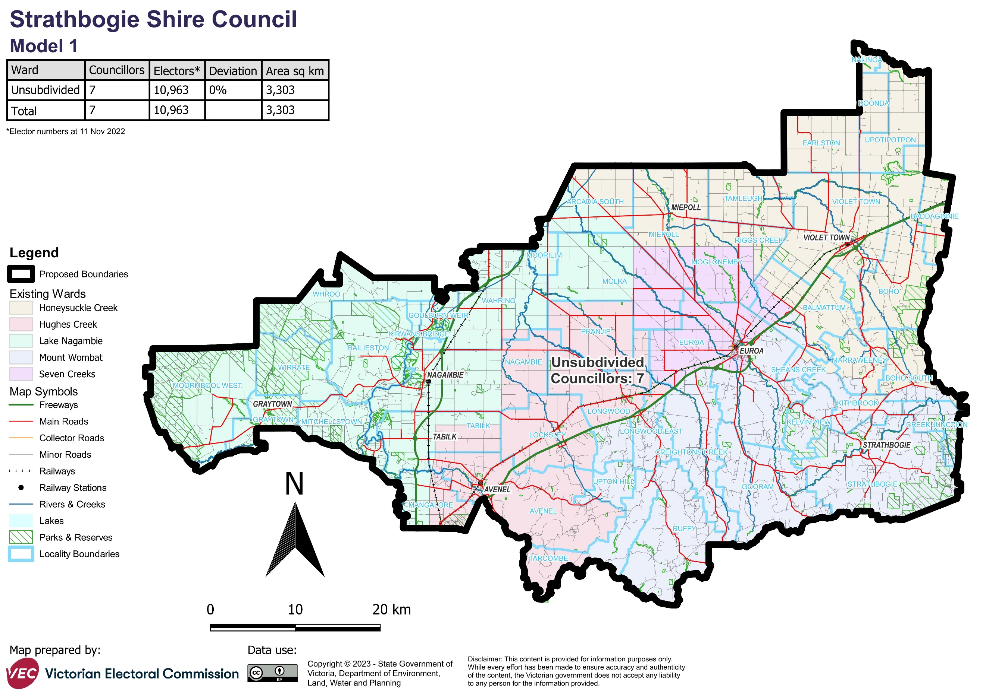

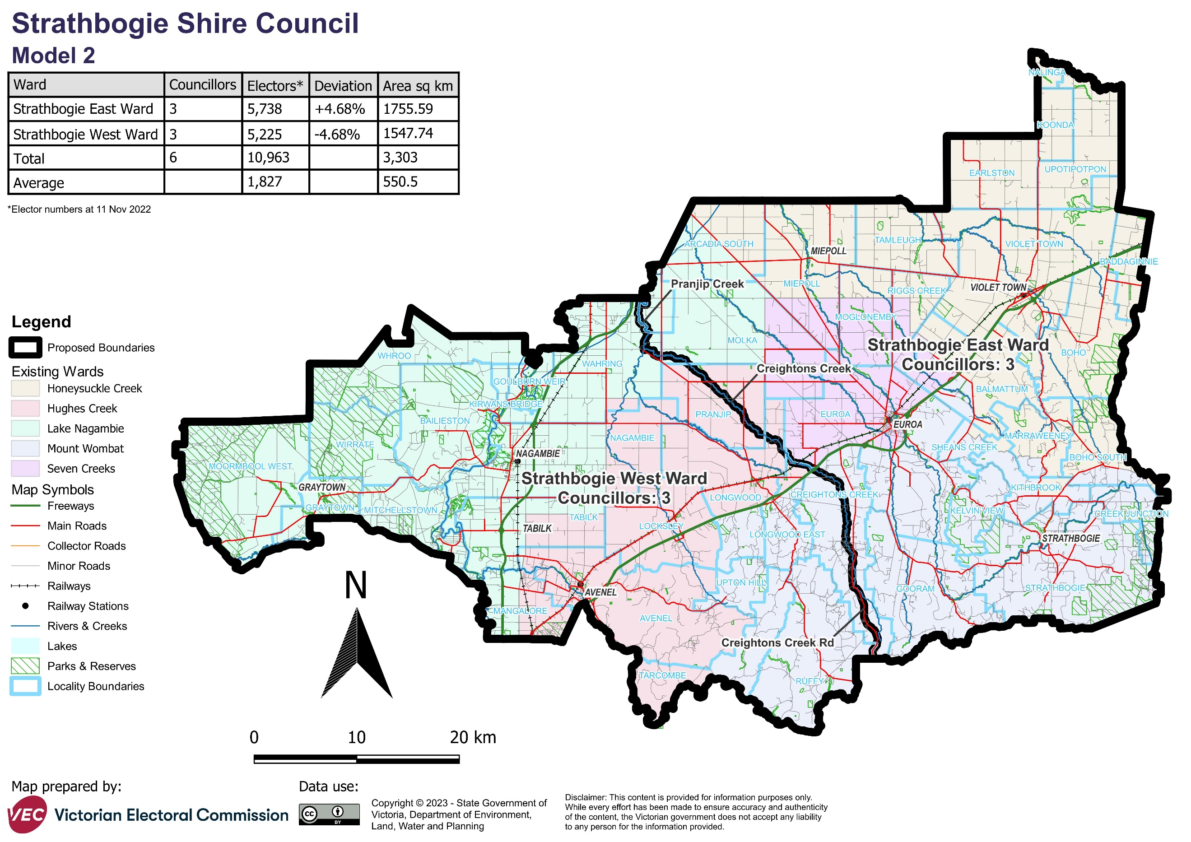

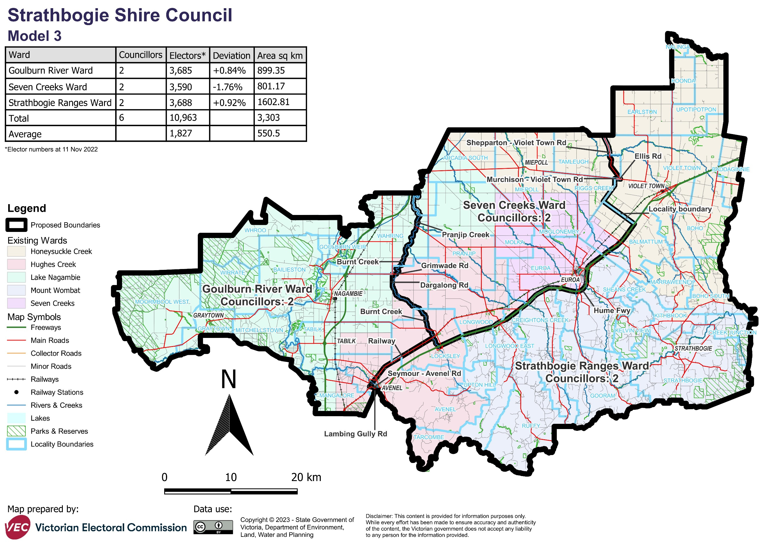

# Appendix 2: Additional models considered

The following models were closely considered by the panel but are not being put forward for further public consultation. See Models considered but not put forward for further information.

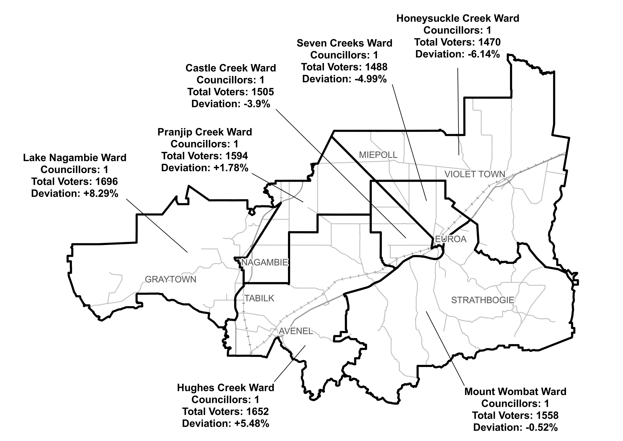Multi-councillor ward structure with 8 councillors

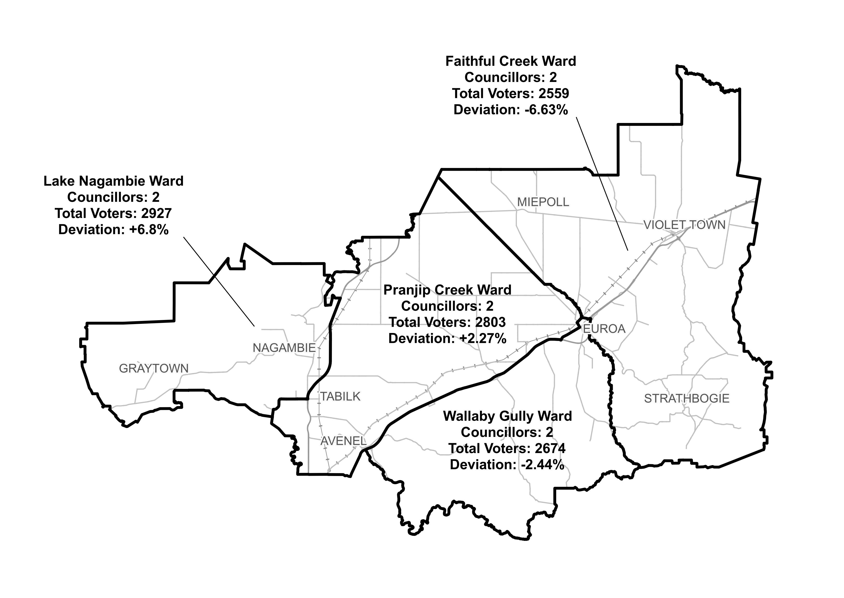

#### Single-councillor ward structure with 7 councillors

# Appendix 3: List of preliminary submitters

The review received 6 preliminary submissions.

Preliminary submissions were made by:

Dickinson, Reg (Councillor)

Hayes-Burke, Sally (Councillor)

Hourigan, Kristy (Councillor)

Raeburn, Christopher (Councillor)

Taylor, Robyn

Tehan, Michael