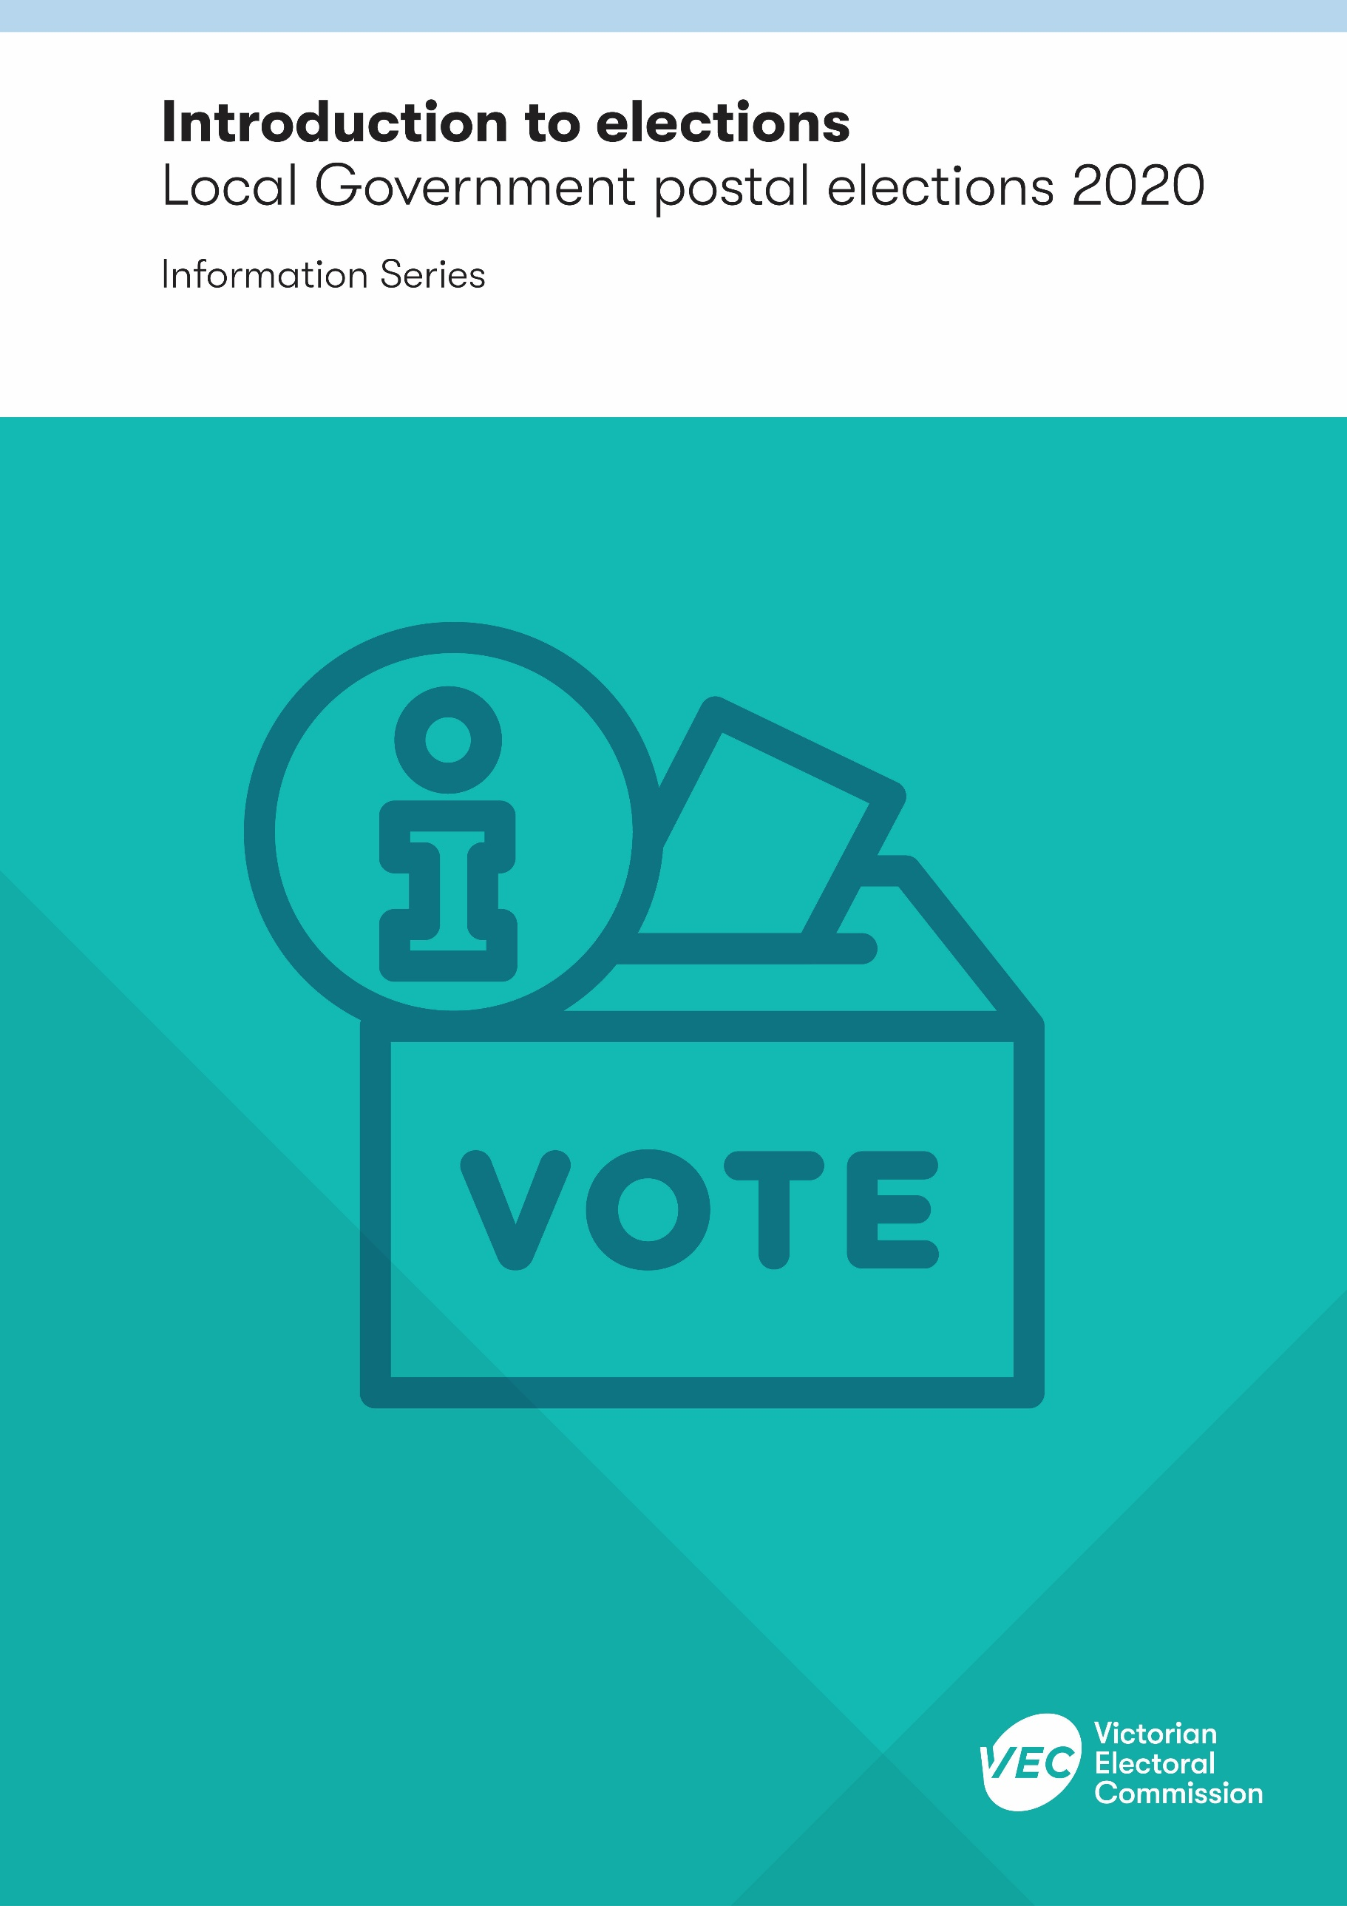

Acknowledgement
of Country
The VEC pays respect to Victoria's traditional owners and their elders past and present who have been custodians of this country for many thousands of years. Their living culture and their role in the life of Victoria is acknowledged by the VEC.

Version history
Subject matter expert | Date received | Date returned
Rose Williams | 18/05/2020 | 19/05/2020

Contents

Introduction 1
COVID-19 safety 1
Who votes in council elections? 2
Is it compulsory to vote? 2
Who can run for election? 3
What is an uncontested election? 4
How do I vote? 4
Important dates 5
Want to work at an election? 6

Introduction
Council elections are held every four years, on the fourth Saturday in October. The Victorian Electoral Commission (VEC) is the statutory election service provider to local councils in the state. This publication provides an overview of council elections being held in October 2020. It is part of the 2020 Local Government Election Information Series on the VEC website.
There are 79 councils in Victoria – 31 in Melbourne and 48 in rural and regional areas. There are council profiles on the VEC website. Each council must have between five and 12 councillors, who are elected by the community to represent them.
In 2020, 76 councils will be going to an election in October.
The South Gippsland Shire Council election has been postponed until October 2021, and the Casey City Council and Whittlesea City Council elections have been postponed until October 2024.
The Minister for Local Government, in consultation with the VEC, determines whether elections are conducted by either postal voting or attendance (in person) voting. All local government elections in 2020 will be postal voting. The 2020 Local Government Elections Service Plan sets out the VEC’s plan to deliver these elections.

COVID-19 safety
The VEC is preparing to deliver safe elections during the extraordinary circumstances of the COVID-19 pandemic.
Our staff are generally working remotely and continue to deliver other electoral services online. You can complete most electoral business online, including updating your enrolment.
However, under the Local Government Act 2020, candidates must nominate in person. Prospective candidates will need to make an appointment with their local Election Manager and follow strict physical distancing and hygiene measures when they go to the office.
Reporting of election results will be slower than usual due to the need to prioritise the health and safety of election officials and scrutineers through physical distancing and strict hygiene measures. The target date for result declarations is Friday 13 November (one week later than anticipated).
We have postponed our face-to-face education and outreach in the community until further notice.

Who votes in council elections?
Two groups of people are eligible to vote in council elections:
- State-enrolled voters in that council area (known as the Electoral Commissioner’s List). This group is automatically enrolled to vote in council elections.
- those who are not State enrolled voters in that council area but pay rates to that council (known as the CEO’s List). This group must apply to council to be included on the roll. It includes:
- non-resident property owners, such as those with holiday houses and investment properties
- directors or company secretaries of corporations that pay rates in that council area but don’t live in the area
- shop tenants who are named on the council’s records to receive the rates notice, or have the written consent of the owner to vote in their place
- non-Australian citizens who live and pay rates in that council area.
These two lists are combined to make the voters’ roll.
The Melbourne City Council voters’ roll has additional categories for corporate representatives. See the Melbourne City Council website for more information.

Is it compulsory to vote?
Voting is compulsory for those on the Electoral Commissioner’s List. It is not compulsory for those on the CEO’s List – except in Melbourne City Council elections where everyone on the voters’ roll is required to vote.
People who do not provide a sufficient excuse for not voting in a council election may be fined. The penalty is half a penalty unit, which is set at $82.61 for the 2020 local government elections.
There are five pieces of relevant legislation for council elections:
- Local Government Act 2020 (the Act)
- City of Melbourne Act 2001 (for Melbourne City Council elections)
- Infringements Act 2006 (in relation to compulsory voting enforcement)
- Fines Reform Act 2014 (also in relation to compulsory voting enforcement).
The procedures for local government elections are detailed in the Local Government (Electoral) Regulations 2020 and, for Melbourne City Council elections, in the City of Melbourne (Electoral) Regulations 2020.

Who can run for election?
To become a candidate in a local council election you must be an Australian citizen (or qualified British subject), be on the voters’ roll in that council area, and have completed the mandatory candidate training. Information about the training is available on the Local Government Victoria (LGV) website or relevant council’s website.
If the council is subdivided into smaller wards, you can run for election in any ward within that council even if you live and are enrolled in a different ward.
The Act lists circumstances which disqualify a person from becoming a councillor or nominating as a candidate. These include if the person:
- is a member of an Australian Parliament, including the Federal Parliament or a Parliament of a State or Territory of the Commonwealth of Australia
- is employed as a Ministerial officer, Parliamentary adviser or an electorate officer (however designated) by a member of an Australian Parliament, including the Federal Parliament or a Parliament of a State or Territory of the Commonwealth of Australia (unless the person has taken leave from that office or position for the election period – see section 256(8) of the Act)
- is a councillor of another council, including interstate councils
- is a member of council staff of the council (unless the person has taken leave from that office or position for the election period – see section 256(8) of the Act)
- is an undischarged bankrupt
- has property that is subject to control under the law relating to bankruptcy
- has been convicted of any of the offences referred to in section 34(2) of the Act, or
- is otherwise incapable of becoming or continuing to be a councillor.
A candidate information session will be made available on the VEC’s website well in advance of nominations opening. Candidate Information Kits are available at the election office. Relevant handbooks and forms can also be downloaded from the VEC website vec.vic.gov.au
There is no public funding for candidates in local government elections.

What is an uncontested election?
An election is uncontested if, at the close of nominations the number of nominations is the same as the number of vacancies. That is, there is no contest. The Election Manager publicly declares the candidates elected; for a general election this will be as soon as practicable on or after election day.
If there are more candidates than vacancies on council, the election is contested and those on the voters’ roll will be required to vote.

How do I vote?
To vote correctly in a local government election (apart from the Melbourne City Council councillor election) you must number every box on the ballot paper in the order of your choice.
Voting in postal elections involves the following steps:
- the VEC sends each voter on the roll at the close of the roll a ballot pack containing candidate statements and photos, ballot paper, ballot paper envelope, and reply-paid envelope
- the voter completes the ballot paper, puts it in the ballot paper envelope and signs the flap on the envelope. This signed declaration is removed before the ballot paper is extracted from the envelope, so the voter’s identity remains private
- the voter puts the ballot paper envelope into a reply-paid return-addressed envelope and posts it to the election office.
When the election office receives the envelope, it is opened, and the ballot paper envelope removed. The ballot paper envelope is scanned to mark the voter as having returned their vote. The scanned envelope is placed in a security box until voting has closed.
All ballot paper envelopes must be in the post or hand-delivered to the election office by 6 pm on the Friday before election day. Local mail clearance times may be earlier than 6 pm and must be considered when votes are being returned by mail. Postal votes may be received by the Election Manager through the post until 12 noon on the fifth working day after election day.

Important dates
Date | Event
Friday 28 August, 4 pm | Close of roll  People must be on the voters’ roll by this date to be eligible to vote at the election.
Thursday 17 September, 9 am | Nominations open  Candidate Information Kits are available at the election office. Nominations must be lodged in person by the candidate.
Tuesday 22 September, 12 noon | Close of nominations and ballot draw  Anyone wishing to stand as a candidate must have nominated by 12 noon.  The ballot draw is held after nominations have all been confirmed. This is usually one hour after the close of nominations, however the precise time may vary.
Tuesday 6 October to Thursday 8 October | Ballot packs are distributed  Ballot packs are distributed via post to every person on the voters’ roll for each election in a random order over three days.
Friday 23 October, 6 pm | Close of voting  In postal elections, ballot papers must be in the mail or in the hands of the Election Manager by 6 pm on the day before election day.
Saturday 24 October | Election day  There is no voting on this day in postal elections.
Friday 30 October | Final day for postal votes  Postal votes must be received by 12 noon to be included. Those signed by the voter after the close of voting will not be admitted.
Friday 13 November | Last day for all results to be declared  Results to be declared by this date. Results are published on the VEC website.

Want to work at an election?
The VEC holds major election events every two years. Registrations are encouraged from people under 25 years, people with a disability, people who speak multiple languages and Aboriginal people.
Previous election experience is not required, and you can register for election work at any time. For more information, see the VEC website.

An exception for the 2020 elections is for non-resident property owners who were on voters’ roll at the last election or by-election for the council. This group will automatically be included on the voters’ roll for the 2020 elections.
A qualified British subject for the electoral roll in Victoria is one who was on an Australian electoral roll between 26 October 1983 and 26 January 1984.

