ELECTORAL REPRESENTATION REVIEW
Yarra City Council
Final Report
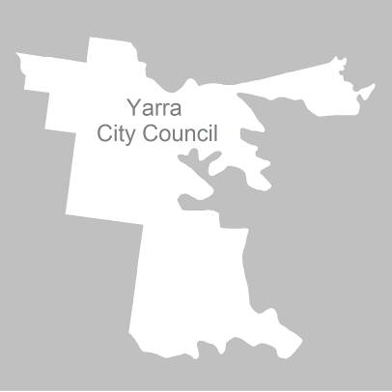

18 May 2011

Contents
Recommendation 3
Background 4
Legislative basis 4
The VEC and Electoral Representation Reviews 4
Profile of the City of Yarra 4
Current electoral structure 5
The electoral representation review process 5
VEC research 6
Public involvement 6
Preliminary report 9
Preliminary submissions 9
Preliminary options 9
Public response 13
Response submissions 13
Analysis of submissions 13
Public hearing 13
Findings and Recommendation 15
Number of councillors 15
Electoral structure 15
Ward boundaries 16
Recommendation 17
Appendix 1: List of submitters 18
Appendix 2: Map 19

Recommendation
The Victorian Electoral Commission (VEC) recommends that the Yarra City Council consist of nine councillors to be elected from three three-councillor wards, with minor changes to the current ward boundaries.

Background

Legislative basis
The Local Government Act 1989 (the Act) requires the VEC to conduct an Electoral Representation Review of each municipality in Victoria at least every 12 years. The Act specifies that the purpose of a representation review is to recommend to the Minister for Local Government the number of councillors and the electoral structure for a municipality, which will provide ‘fair and equitable representation for the persons who are entitled to vote at a general election of the Council’.
The Act requires the VEC, as part of an Electoral Representation Review, to consider:
- the number of councillors in a municipality;
- whether a municipality should be unsubdivided or subdivided;
- if it should be subdivided, whether ward boundaries:
  - provide for fair and equitable division of the municipality;
  - ensure equality of representation through the number of voters being represented by each councillor being within 10 per cent of the average number of voters represented by all councillors; and,
- if it should be subdivided, the number of councillors that should be elected for each ward.

The VEC and Electoral Representation Reviews
The VEC has conducted Electoral Representation Reviews since 2004 on appointment by local councils. The Act was changed in 2010 to define the VEC as the only agency authorised to undertake the reviews.
The VEC drew on its experience in mapping and boundary modelling and also engaged consultants with experience in local government to provide advice on specific local representation issues during the review.

Profile of the City of Yarra
The City of Yarra was formed in 1994 by the amalgamation of the Cities of Collingwood, Fitzroy and Richmond, and part of the City of Northcote. The City of Yarra includes the suburbs of Abbotsford, Burnley, Clifton Hill, Collingwood, Cremorne, Fitzroy, Princes Hill and Richmond, and parts of Alphington, Carlton North, Fairfield and Fitzroy North.
At the 2006 census, the City recorded a population of 69,331 people. Over the next 10 years (2010–2020), the population is projected to grow by 8.33%.

Current electoral structure
The last Electoral Representation Review for Yarra City Council took place in 2004. Following the review, the Minister for Local Government determined that the structure of Yarra City Council would be:
- nine councillors;
- divided into three wards — Langridge Ward, Melba Ward and Nicholls Ward;
- with three councillors from each ward.
The VEC recommended this structure on the basis of the right for residents of the City of Yarra to receive fair and equitable representation during the ensuing terms of council. The VEC determined that there was modest population growth forecast but, with no demonstrable high density residential developments, there were no particular ‘pockets’ of growth within the City. The City of Yarra recorded a high degree of diversity among its residents from its disparate housing indicators, high transient population, a wide range of income levels, and a greater number of people having been born outside Australia. Based on the evidence and with general consensus during the public consultation process, the VEC recommended for the City of Yarra to be subdivided into three wards with three councillors elected by each ward.

The electoral representation review process
The VEC proceeded on the basis of three main principles:
- Ensuring the number of voters represented by each councillor is within 10 per cent of the average number of voters per councillor for that municipality.
Populations are continually changing. Over time these changes can lead to some wards having larger or smaller numbers of voters. As part of the review, the VEC corrected any imbalances and also took into account likely population changes to ensure these boundaries provide equitable representation until the next review.
- Taking a consistent, State-wide approach to the total number of councillors.
The VEC was guided by its comparisons of municipalities of a similar size and category to the council under review. The VEC also considered any special circumstances that may warrant the municipality to have more or fewer councillors than similar municipalities.
- Ensuring communities of interest are as fairly represented as possible.
Each municipality contains a number of communities of interest and, where practicable, the electoral structure should be designed to take these into account. This allows elected councillors to be more effective representatives of the people in their particular municipality or ward.

The recommendation is based on:
- internal research specifically relating to the municipality under review;
- VEC experience from its work with other municipalities and in similar reviews for State elections;
- VEC expertise in mapping, demography and local government;
- careful consideration of all public input in the form of written and verbal submissions received during the review; and,
- advice received from consultants with wide experience in local government.
Public submissions were an important part of the process, but were not the only consideration during the review. The VEC seeks to combine the information gathered through public submissions with its own research and analysis of other factors, such as the need to give representation to communities of interest. The recommendation is not based on a ‘straw poll’ of the number of submissions supporting a particular option.

VEC research
In addition to the information provided in submissions, the VEC created a profile of the municipality based on population trends, development projections and demographic indicators. The VEC used the Australian Bureau of Statistics 2006 census community profiles, the Department of Planning and Community Development projections and voter statistics from the Victorian electoral roll. The VEC also undertook field work to view current and possible boundaries for each of the options presented in the preliminary report to evaluate their effectiveness.

Public involvement
The VEC values the local knowledge and perspectives presented by the public in written submissions. The public were given two opportunities to provide submissions during the review. Their input was considered by the panel in forming the options in the preliminary report and they were also invited to respond to these options. In addition, a public hearing was held to enable people to speak in support of their submissions and supplement them with information.
To ensure transparency in the process, all written submissions were published on the VEC website and all verbal submissions were heard in a public environment.
To raise awareness of the review and encourage the public to engage with the process, a full public information campaign was undertaken.

Advertising
In accordance with sections 219F(4) and 219F(7) of the Act, the VEC ensured public notices were placed in local newspapers.
Notification of the review appeared in the Melbourne Yarra Leader on Monday,
31 January 2011 and the Melbourne Times Weekly on Wednesday, 2 February 2011. The notice detailed the process for the review and called for public submissions. A general notice covering several reviews was printed in The Age and the Herald Sun on Tuesday, 1 February 2011.
Notification of the release of the preliminary report appeared in the Melbourne Yarra Leader on Monday, 21 March 2011 and the Melbourne Times Weekly on Wednesday, 23 March 2011. The notice detailed the options contained in the preliminary report, including a map of each option, instructions on how to access a copy of the preliminary report and how to make a submission in response to the report.

Media release
The VEC produced two media releases for this review. The first release, distributed to local media through the Council, provided information on the review and overall process. A second release, distributed to local media by the VEC, detailed the options in the preliminary report and how to make a submission in response to the report.

Public information session
The VEC held a public information session for people interested in the review process on Thursday, 17 February 2011 at the Richmond Town Hall.

Information brochure and poster
An information brochure was provided to the Council to be distributed to residents through the Council’s network, such as in libraries and service centres. A poster was provided to the Council to be displayed in public spaces.

Helpline
A dedicated helpline was established to assist with public enquiries concerning the review process.

VEC website
The VEC website delivered up-to-date information to provide transparency during the preliminary and response stages of the review process. All submissions were posted on the website and an online submission tool was created to facilitate the submission process. The preliminary report was available for electronic download on the website.

Guide for Submissions
A guide for submissions was developed and distributed to those interested in making submissions. Copies of the guide for submissions were available on the VEC website, in hardcopy on request, and were provided to the Council.

Preliminary report
In accordance with the Act, the VEC produced a preliminary report outlining its proposed options for Yarra City Council. The report was released on 21 March 2011.

Preliminary submissions
By the close of preliminary submissions at 5.00pm on 2 March 2011, the VEC received six submissions.
Five submitters wanted to retain nine councillors, arguing that this number was needed to deal with the diversity of the municipality and the increasing challenges facing it. Three submissions favoured retention of three three-councillor wards, on the grounds that proportional representation produced the best representation of the voters.
Only two submissions mentioned ward boundaries. Mr Stephen Luntz’s submission suggested that an area of Melba Ward west of Lennox Street be moved into Langridge Ward, and the Nicholls Ward boundaries be moved to the south to restore balance. Miss Maria Kolovrat’s submission proposed that each of the three current wards be divided in two to create six wards.
A list of submitters, by name, is available in Appendix 1. Copies of the submissions can be viewed on the VEC website at vec.vic.gov.au

Preliminary options
The key issue in the representation review was the appropriate number of councillors for the Yarra City Council. The VEC considers that similar types of municipalities of a similar size should have the same number of councillors, unless special circumstances justify a variation. In terms of the number of voters, Yarra is the third-smallest municipality in the metropolitan area. Yarra has nine councillors, while other municipalities of a similar size have seven. Consequently, Yarra has the lowest ratio of voters per councillor of any metropolitan council.
In the 2004 electoral representation review, the VEC accepted the argument that special factors affecting the City of Yarra — a mobile population, a high proportion of residents who are not fluent in English, a diverse population including both large numbers of public housing tenants and increasing numbers of highly educated residents, a large business sector, ageing infrastructure and significant social issues — justified Yarra having more councillors than would otherwise be the case, because these factors imposed a greater workload on councillors. This was why the VEC recommended that the City of Yarra retain nine councillors. The question for the current review is whether these factors still apply to the same extent.
Analysis of census information reveals a mixed picture. On the one hand, a large proportion of the residents of Yarra are well educated and affluent. The proportion of Yarra residents with tertiary qualifications is almost twice the metropolitan average. One third of Yarra households earn high incomes compared to a quarter of households in the metropolitan area, while the number of low-income earners is virtually the same as in Melbourne as a whole. Yarra’s median household weekly income is $117 higher than the metropolitan area’s. Over 40% of Yarra residents are professionals (almost twice the proportion for the metropolitan area), and the proportion of managers is higher than the metropolitan figure. Conversely, traditional working class occupations (labourers, machinery operators and drivers, trades workers) are significantly under-represented in Yarra. On the SEIFA Index of Relative Socio-Economic Disadvantage (which derives an index number from a range of indicators of disadvantage), Yarra comes 13th out of 31 metropolitan municipalities, which means that Yarra is far from the most disadvantaged area in Melbourne.
Nevertheless, there are clear signs of special needs in the City of Yarra. Renters comprise 47.7% of households (compared to 24.5% in the metropolitan area), indicating a mobile and transient population. Group households, largely composed of students and other young people, make up 13.6% of households in Yarra — more than three times the proportion for the metropolitan area. Residents who are not proficient in English comprise 22.5% of Yarra’s population compared to 13.9% for Melbourne as a whole. Public housing makes up 10.5% of dwellings in Yarra (the metropolitan figure is 2.7%), and is particularly evident in the tower blocks dotted around the City.
This mixed picture suggests that either nine or seven councillors could be appropriate for the City of Yarra. The VEC’s preferred option was to retain nine councillors, in light of the continuing features of the City that increase the demands on councillors. However, the VEC also put forward an alternative option of seven councillors, reflecting the fact that a large and increasing proportion of Yarra’s population is not disadvantaged.
The number of councillors for a municipality affects the options for electoral structure. A structure that can suit a certain number of councillors may be impossible with a different number. Similarly, ward boundaries may be clear and reflect communities of interest with a certain number of councillors, but not work as well with a different number.
The VEC considers that with nine councillors overall, the current three three-councillor ward structure was the best for the City of Yarra. This structure enables the representation of a range of views, while the odd number per ward ensures that a majority of voters in a ward will elect a majority of councillors. The ward structure coincides with geographic communities of interest, with Melba Ward comprising the whole of Richmond, Langridge Ward based on Collingwood, Abbotsford, Clifton Hill and Alphington, and Nicholls Ward based on North Fitzroy and North Carlton. The ward boundaries — Victoria Street, Johnston Street, Wellington Street and Queens Parade — are easy to identify.
The VEC recommended minor changes to ward boundaries to restore the wards to balance and allow for future population movements. Under this option, a block of Richmond bounded by Lennox Street on the east and Highett Street on the south would be transferred from Melba Ward to Langridge Ward, while part of Fitzroy between Johnston Street and Moor Street would be transferred from Langridge Ward to Nicholls Ward.
The VEC examined a range of possible electoral structures for a seven-councillor municipality. An unsubdivided municipality was rejected because there would probably be so many candidates at an election that many voters would be confused and would vote at random or accidentally vote informally. Single-councillor wards were also rejected, because they would not capture communities of interest and would be vulnerable to population shifts. A model of two two-councillor wards and one three-councillor ward had boundary shortcomings, and would possibly lead to tied election results in the two-councillor wards.
The VEC settled on a model of two three-councillor wards and one single-councillor ward. Under this model, the two three-councillor wards would be equal in size, the three places per ward would allow scope for representation of a range of opinion, and a majority of votes would be translated into majority of seats. The single-councillor ward would be an exception. Under the proposed structure, an expanded Melba Ward would include Richmond and most of Collingwood and Abbotsford, and an expanded Nicholls Ward would include Fitzroy, North Fitzroy and North Carlton. The proposed single-councillor ward would cover Alphington, Fairfield and Clifton Hill. This district is somewhat apart from the rest of the City. The single-councillor ward under the previous electoral structure (Merri Ward) covered the same area. The suggested name for this ward was also Merri — after Merri Creek — which flows through the ward. The proposed structure divided Collingwood and Abbotsford, but otherwise coincided with communities of interest. The proposed boundaries (Johnston Street, Wellington Street and Queens Parade) were very clear.

The preliminary report recommended two options:
Option A (Preferred Option): That the Yarra City Council consist of nine councillors to be elected from three three-councillor wards, with minor changes to the current ward boundaries.
Option B (Alternative Option): That the Yarra City Council consist of seven councillors to be elected from two three-councillor wards and one single-councillor ward.

Public response

Response submissions
Response submissions on the Electoral Representation Review of Yarra City Council opened on 21 March 2011 and closed at 5.00pm on 20 April 2011. Six response submissions were received. Table 1 shows the levels of support for each option based on the preferences expressed in each response submission.
Table 1: Preferences expressed in response submissions for each option
Option A  (Preferred Option) | Option B  (Alternative Option) | Other
5 | 1 | –

Analysis of submissions
All but one submission supported the VEC’s preferred option of retaining three three-councillor wards, with only one submission preferring Option B (for two three-councillor wards and one single-councillor ward) on the ground that Langridge Ward should be shared with other areas of Yarra City.
Most submissions argued that Yarra City Council should retain nine councillors because of special factors affecting the City. These included Yarra’s growing population, its social diversity, its transient population, the challenges presented by the large numbers of local businesses, licensed premises and through traffic, and the strong local tradition of community involvement. The Proportional Representation Society supported the ‘3 x 3’ model because it meant that all voters were on an equal footing.
Most submissions accepted the proposed ward boundaries in Option A. One submitter believed that each ward should include a large public housing estate, and suggested changes to the boundaries to achieve this.
A list of submitters, by name, is available in Appendix 1. Copies of the submissions can be viewed on the VEC website at vec.vic.gov.au.

Public hearing
A public hearing was held at Richmond Town Hall on 27 April 2011. Everyone who made a submission in response to the report was invited to speak to their submissions and two individuals accepted.
Mr Stephen Luntz argued that a growing population and increasing demands on councillors meant that more councillors would be required rather than fewer, and that there should be no reduction in Yarra. When the panel pointed out that by this logic, all growing councils would eventually approach the legislative maximum of 12 councillors, Mr Luntz said that he thought the maximum should be increased, and that in any case there was plenty of room for growth before Yarra would reach the maximum. Queried on the level of representation in the City of Moreland (where Mr Luntz had lived and which has some similarities with Yarra but a higher ratio of voters per councillor), Mr Luntz replied that there was not much difference, and that it was more shaped by the quality of individual councillors. He emphasized that it was important and productive to be able to contact councillors.
Mr Ivan Gilbert (Executive Manager Governance, Yarra City Council) stressed the characteristics of the City of Yarra that increased the demands on Council, particularly the high number of non-electors (largely students who were still enrolled at their family address in other municipalities), the high turnover of population and inner urban issues such as traffic, redevelopment and licensed premises. Mr Gilbert stated that the Council had a strong culture of consultation and public involvement, and that there were very large and passionate attendances at meetings connected with redevelopment issues. When the panel asked whether there had been any change in representation needs since the 2004 review, Mr Gilbert replied that he believed those needs had grown. Gentrification had increased the demands on councillors, as the new residents actively engaged with Council and its activities.
On ward boundaries, Mr Gilbert stated that six options were presented for the Council to consider at its meeting on 19 April 2011. However, the Council decided to endorse the VEC’s Option A.

Findings and Recommendation
The VEC has consulted on the two options in its preliminary report. The VEC now presents its findings for recommendation to the Minister.

Number of councillors
Nearly all responses to the Preliminary Report favoured retaining nine councillors for the City of Yarra. For the VEC, though, strength of argument and evidence carry more weight than numbers supporting one option or another. In the Preliminary Report, the VEC’s preferred option was for nine councillors, but it also put forward an option for seven councillors. The critical question is whether special factors affecting Yarra are still so strong as to justify it having more councillors than other metropolitan councils of a similar size.
The City of Port Phillip is another inner urban municipality. Like the City of Yarra, Port Phillip has a relatively transient population, a high proportion of tenants and severe traffic problems. Yet the City of Port Phillip has only seven councillors, despite having 12,000 more electors than Yarra.
Nevertheless, there are particular features distinguishing the City of Yarra. Its population is more concentrated than that of any other Victorian municipality, and so inner urban issues are more concentrated as well. The number of licensed premises (which involve amenity issues) is second only those in the City of Melbourne. Yarra continues to have substantial numbers of residents who are not fluent in English and a high proportion of public housing, and both these groups require special attention by council. Redevelopment is occurring on a major scale: projects often ignite a strong public reaction, and councillors need to be fully involved. The population growth resulting from redevelopment could lead to Yarra ‘growing into’ a size typical of nine-councillor municipalities.
Although gentrification has increased the number of residents who are in no way disadvantaged, new residents appear to have absorbed the culture of public consultation and contact councillors about numerous issues.
The VEC considers that the characteristics of the City of Yarra justify it continuing to have nine councillors.

Electoral structure
With the number of councillors settled, the electoral structure almost resolves itself. The alternative structure under Option B was the best that the VEC could devise for a seven-councillor municipality, but was not ideal. The ‘3 x 3’ model under Option A puts all voters on the same basis, enables representation of a range of views while ensuring that a majority of voters in a ward will elect a majority of councillors, and effectively captures communities of interest.

Ward boundaries
Ward boundaries need to be adjusted to allow for unequal population growth across the City, with redevelopments pushing faster growth in Melba and Langridge Wards while Nicholls Ward is relatively declining. Currently, enrolments for Melba Ward are 9.18% above the average while those for Nicholls Ward are 6.37% below the average.
Option A proposed to transfer the north-west corner of Richmond from Melba Ward to Langridge Ward, and part of Fitzroy from Langridge Ward to Nicholls Ward. These changes would restore enrolments to balance, with Langridge Ward 4.86% below average, Melba Ward 3.18% above average, and Nicholls Ward 1.89% above. The VEC believes that the proposed boundaries allow for population shifts over the coming decade. The total number of voters switched from one ward to another would be 3,072 — less than 5% of the 65,512 voters for the City of Yarra. Disruption and confusion would be minimised.
Only one response submission suggested alternative ward boundaries. Mr John Cox stated that each of the three wards ‘should include one of the large public housing estates in order to ensure that the most diverse parts of the municipality are represented’. To achieve this, Mr Cox suggested that Nicholls Ward be extended to the south to include all of Fitzroy down to Victoria Parade, while the eastern boundary of Nicholls Ward would be moved west to Smith Street, to include all of Collingwood in Langridge Ward. In the south, the Victoria Street corridor would be included in Langridge Ward, using Elizabeth Street and Buckingham Street as boundaries to Burnley Street.
Mr Cox’s argument that each ward should include one of the large public housing estates is an attractive one, as it would mean that all councillors would represent the full social diversity of the City of Yarra. By including all of Fitzroy in Nicholls Ward and all of Collingwood in Langridge Ward, Mr Cox’s proposals would better fit communities of interest in that part of the municipality. However, under his proposal, the number of voters in Nicholls Ward would be more than 15% above the average. Equality in numbers — keeping ward enrolments within the legislative 10% tolerance — is the paramount consideration in setting ward boundaries, so Mr Cox’s proposal could not be considered further.
The VEC considers that boundaries proposed in Option A provide for fair and equitable representation until the next representation review.

Recommendation
The Victorian Electoral Commission (VEC) recommends that the Yarra City Council consist of nine councillors to be elected from three three-councillor wards, with minor changes to the current ward boundaries.

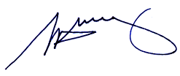
S. H. Tully
Electoral Commissioner

Appendix 1: List of submitters
Preliminary submissions were received from:
Name
Collingwood and Abbotsford Residents’ Association Inc.
Maria Ann Kolovrat
Stephen Luntz
Proportional Representation Society of Australia (Victoria–Tasmania) Inc.
Miriam Robinson
Alan Watkins

Response submissions were received from:
Name
Collingwood and Abbotsford Residents’ Association Inc.
John Cox
Victor Fodor
Stephen Luntz*
Proportional Representation Society of Australia (Victoria–Tasmania) Inc.
Yarra City Council*
* indicates those submitters who spoke in support of their submission at the public hearing on Wednesday, 27 April 2011.

Appendix 2: Map
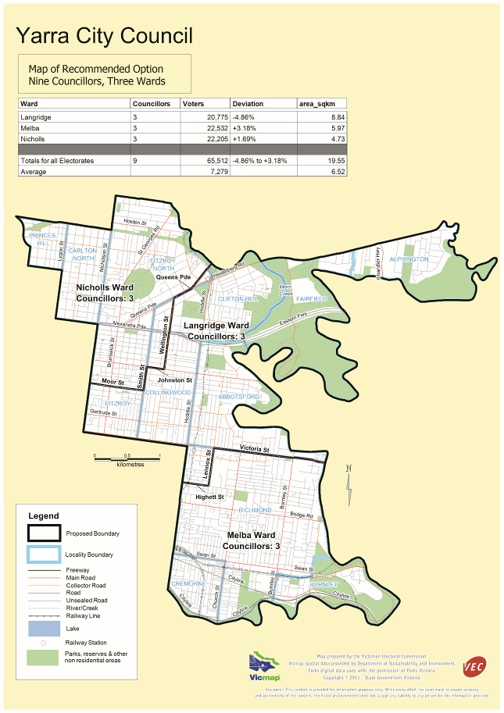

Victorian Electoral Commission
Level 8, 505 Little Collins Street
Melbourne, Vic 3000

131 VEC (131 832)
info@vec.vic.gov.au
vec.vic.gov.au

Section 219D of the Local Government Act 1989.
Victorian Electoral Commission: Final Report, Electoral Representation Review, City of Yarra, 2004, p. 8.
See Yarra City Council — Ordinary Meeting of Council Agenda — Tuesday 19 April 2011.

