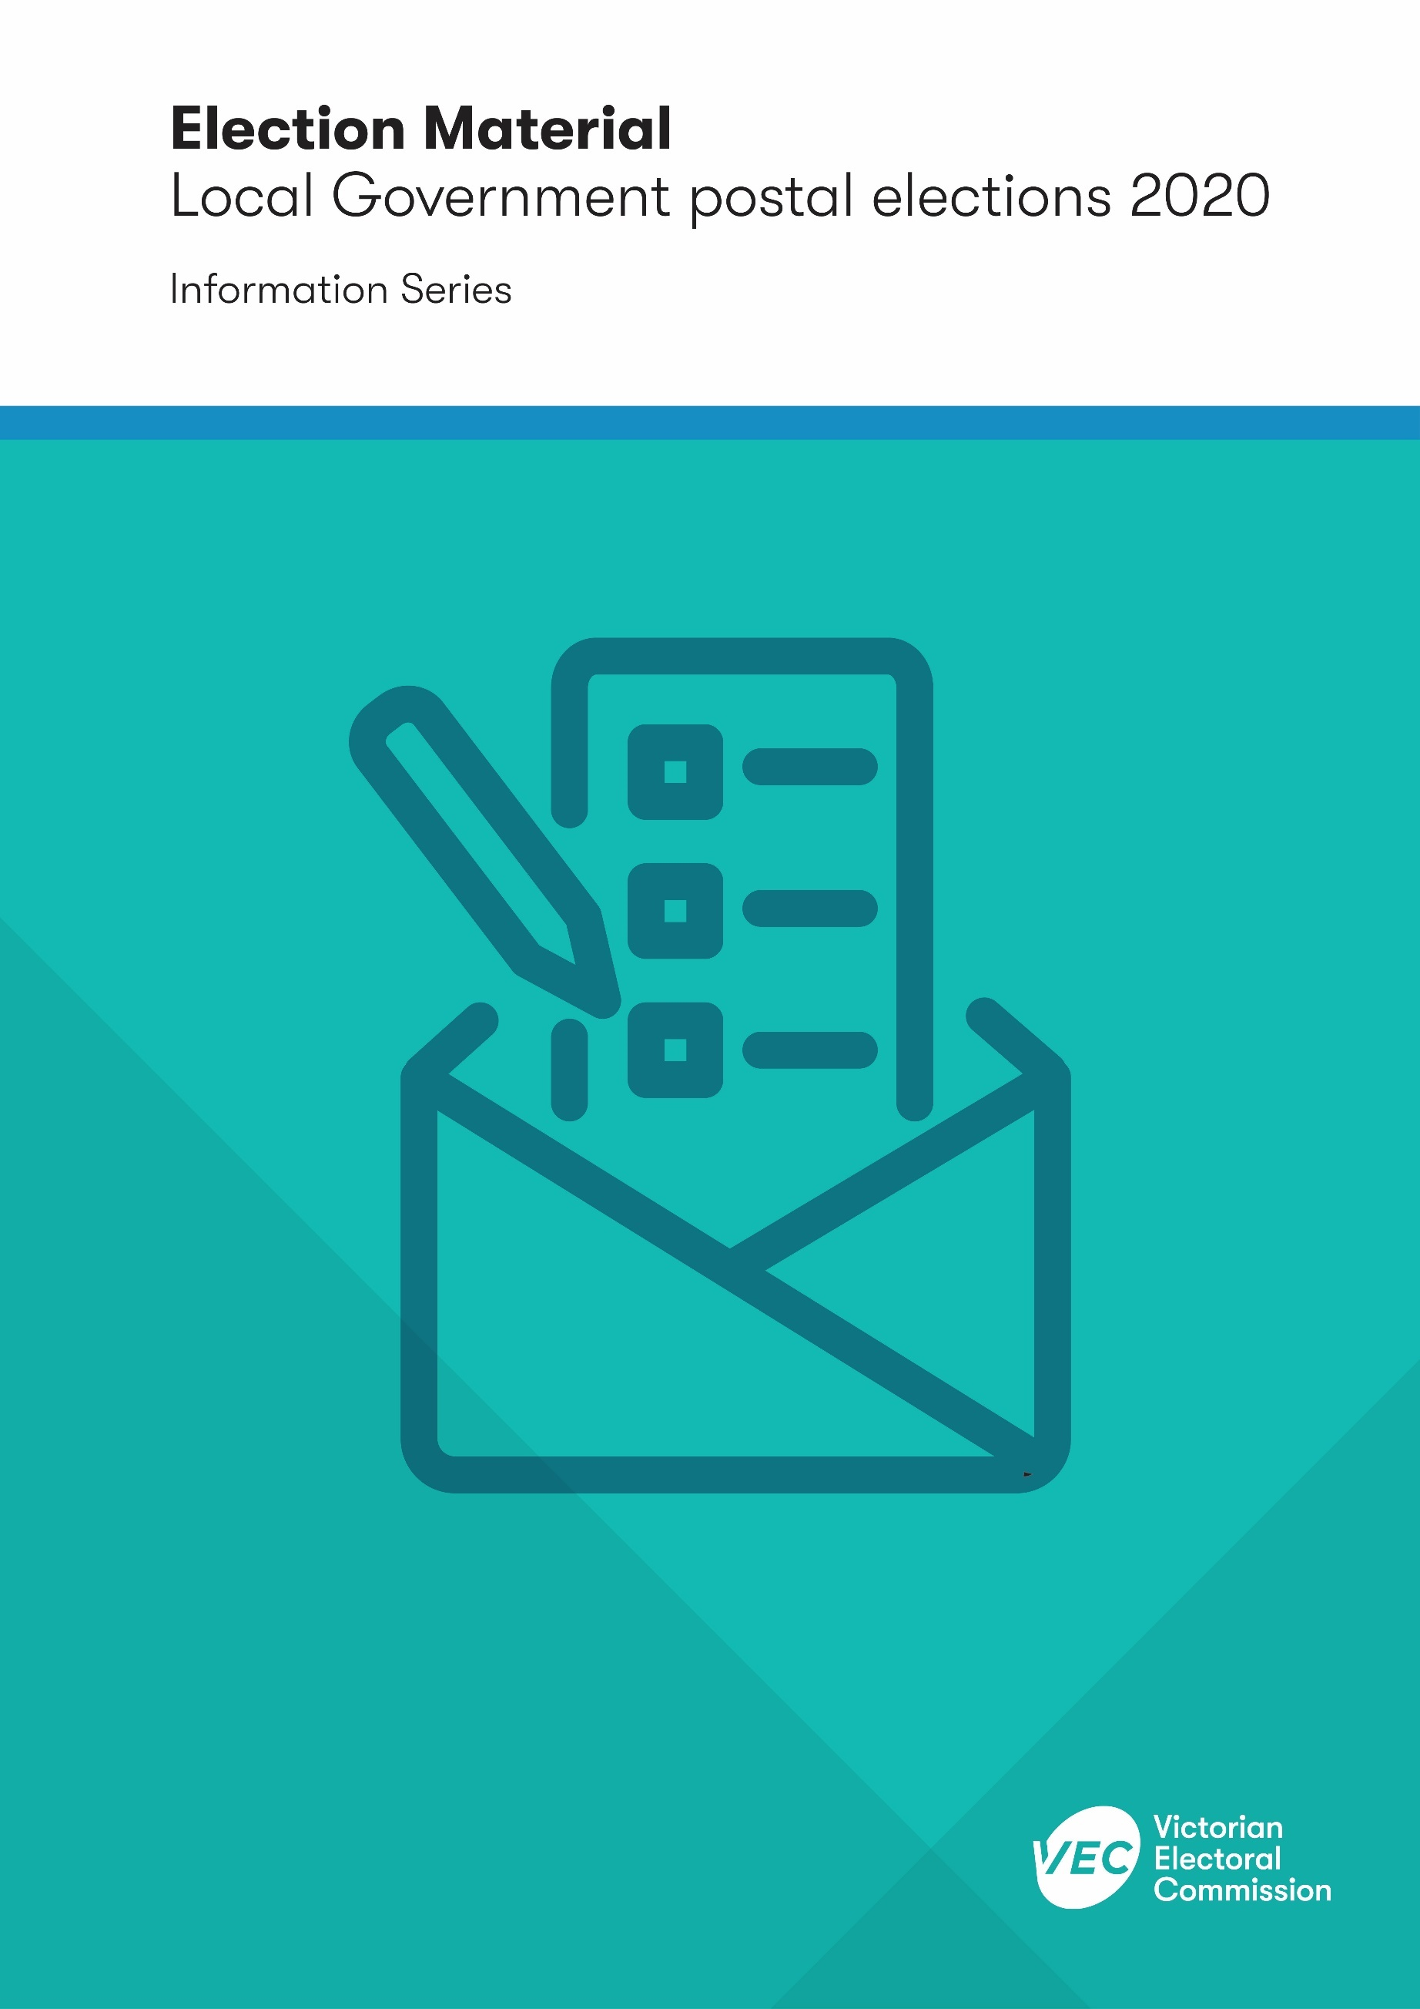

Acknowledgement
of Country
The VEC pays respect to Victoria's traditional owners and their elders past and present who have been custodians of this country for many thousands of years. Their living culture and their role in the life of Victoria is acknowledged by the VEC.

Version history
Subject matter expert | Date received | Date returned
Keegan Bartlett | 20/05/2020 | 26/05/2020

Contents
Introduction 1
Definitions 1
Authorisation of electoral material 1
Social media 2
Leaflets and direct mail 2
Radio and television 2
Posters and billboards 3
Newspapers 3
Misleading or deceptive electoral matter 3
Making a complaint 4
Complaints about electoral material 4

Introduction
This booklet explains the laws related to electoral material at local government elections and what to do if you want to make a complaint about electoral material.
This information is intended for members of the public. Candidates should refer to the Candidate Handbook.

Definitions
The Local Government Act 2020 has specific definitions of ‘electoral material’ and ‘electoral matter’ in the context of local government elections.
These definitions are important for understanding the laws governing this material:
- Electoral material means an advertisement, handbill, pamphlet or notice that contains electoral matter, but does not include an advertisement in a newspaper that is only announcing the holding of a meeting.
- Electoral matter means matter which is intended or likely to affect voting in an election, but does not include any electoral material produced by or on behalf of the election manager for the purposes of conducting an election. Electoral matter is intended or is likely to affect voting in an election if it refers to or comments on:
- the election or
- a candidate in the election or
- an issue submitted to, or otherwise before, the voters in connection with the election.

Authorisation of electoral material
All electoral material must be properly authorised. This ensures the people who produce electoral material are accountable and contactable, and helps prevent the damage to the election or an individual or group involved with the election that may be caused by anonymous electoral material.
The following authorisation statement must be at the end of the electoral material:
“Authorised by [authoriser’s name], [authoriser’s address].”
The authoriser’s address cannot be an email address. Candidates can authorise their own electoral material.
Advertisements and sponsored links published online or through social media are captured by the definition of ‘electoral material’ and must also carry or directly link to an authorisation statement.
Items such as car stickers, clothing, badges, fridge magnets, pens, pencils and balloons are specifically excluded from the authorisation requirement and do not need to carry the authorisation statement.
Authorisation requirements always apply, not just during an election. The penalty for failure to authorise is up to 10 penalty units ($1,652.20 as at 1 July 2020) for a person and up to 50 penalty units ($8,261 as at 1 July 2020) for a body corporate.
Information on how to make a complaint about unauthorised campaign material is found later in this booklet.

Social media
Electoral material published through social media must comply with the terms and conditions of the relevant platform, as well as the requirements of the Local Government Act 2020.
All electoral material posted to social media (including platforms like Facebook, Twitter, blogs, websites, and other social media sites) must carry or directly link to an authorisation statement.
Just like in real life, messages sent through social media that defame, threaten, or harass another person are against the law. Significant penalties apply, including prosecution and imprisonment, for any person convicted of threatning or harassing another person.

Leaflets and direct mail
Leaflets, flyers and other forms of unaddressed mail delivered to households or distributed in public locations must be authorised if they contain electoral matter. Letters or cards that are addressed to individual voters by name do not have to include an authorisation statement, but must clearly identify the name and address of the person who distributed it.
Please note that Australia Post has previously advised that electoral material is included in mail that is exempt from letterboxes marked ‘No Junk Mail’. Producers and distributors should be aware of other Australia Post rules relating to handling and delivering unaddressed direct mail. For further information, contact Australia Post directly.
Any person intending to distribute electoral material in public locations should check with the local council for the area in respect to any local laws on distributing advertising material at the location. Similarly, railway stations, bus stops, and tram stops are also public locations and are administered by the Department of Transport.

Radio and television
All electoral material broadcast on radio or television, including election advertisements, must comply with the requirements set out in Schedule 2 of the Broadcasting Services Act 1992 (Commonwealth).

The VEC cannot offer any advice regarding Commonwealth legislation. Any enquiries about the Commonwealth Act should be directed to:
Australian Communications and Media Authority
Level 32, Melbourne Central Tower
360 Elizabeth Street
Melbourne
PO Box 13112
Law Courts
Melbourne Vic 8010
Tel: 1300 850 115
Email: info@acma.gov.au
Online: acma.gov.au/contact-us

Posters and billboards
All posters and billboards containing electoral matter must be authorised.
People producing, distributing and displaying posters and billboards should check with:
- The owner and, if relevant, resident of any private property or business where the poster or billboard is intended to be displayed
- The relevant local council about any local laws that may apply to the display of electoral material (includes public and private property)
- the Department of Transport (now including VicRoads and Public Transport Victoria) for regulations and rules that apply to the display of electoral material on and alongside freeways, highways and major road corridors, and at public transport locations (buses, bus stops, trains, train stations, trams, and tram stops)
- The Department of Education and Training in relation to the display of electoral material on government-owned schools.

Newspapers
Election advertisements in newspapers must be authorised.
Newspaper proprietors must also print the word “advertisement” as a headline in at least 10 point size on each article or paragraph printed in the newspaper containing electoral matter which is paid for or otherwise compensated.
All articles or letters in a newspaper that contain electoral matter must include the author’s name and their suburb or locality at the end. This requirement does not apply to leading articles or articles solely reporting on a meeting.

Misleading or deceptive electoral matter
Section 288 of the Local Government Act 2020 prohibits matter that is likely to mislead or deceive a voter in relation to the casting of the vote of the voter (emphasis added).
The term ‘misleading’ in this context has been narrowly defined by the courts as relating to the voter’s understanding of the effect of their vote. For example, electoral material suggesting numbering the candidates on a ballot paper in a particular order would be a vote for a particular candidate when, in fact, that order would result in the candidate getting the last preference would likely be considered misleading. Whereas electoral material putting forward a perspective on an issue that can be freely contested by electoral material putting forward a different or opposing view on the issue is not, by itself, going be misleading.

Making a complaint
The VEC can only accept complaints made in writing, except where adjustments are required. The VEC has an online submission form, which allows you to submit your complaint directly.
You are encouraged to include any evidence or supplementary information (e.g. photographs or screenshots) with your complaint.
Complaints to the VEC can be made:
Online: vec.vic.gov.au
Email: complaints@vec.vic.gov.au
Post:
Complaints Team
Victorian Electoral Commission
Level 11, 530 Collins Street
Melbourne VIC 3000

If you are unable to make a complaint in writing, you can:
- contact us through the National Relay Service and ask for 03 8620 1100
- contact us through an interpreter
- ask us for other types of assistance.
The VEC’s policy is that it will treat your information respectfully and in confidence. The VEC will not discuss individual complaints with the media. This includes confirming or denying that a complaint has been received.

Complaints about electoral material
The VEC is not the regulator for alleged offences under the Local Government Act 2020, including the requirements governing electoral material for local government elections. Complaints alleging a breach of the Local Government Act 2020 are referred to the Local Government Inspectorate (LGI).
Each local council is responsible for enforcing local laws and codes of conduct where they apply. Complaints that relate to local law matters will be referred to the relevant local council. Examples include the placement of campaign posters or signs on public property and use of council resources for campaigning purposes.
If the VEC has referred your complaint externally, we will advise you that the matter has been referred.

