Local council electoral structure review

## About the review

Under Victoria’s *Local Government Act 2020*, Casey City Council must now have a single-councillor ward electoral structure.

The Minister for Local Government has appointed an electoral representation advisory panel to review the electoral structure of Casey City Council and advise on the most appropriate single-councillor ward structure.

The panel is looking at:

* the appropriate number of councillors and wards
* the location of ward boundaries
* appropriate ward names.

Electoral structure reviews are an important part of democracy and your input is valuable. As a local, you know your council area better than anyone. This is your chance to tell the panel your thoughts about the single-councillor ward structure you believe would best provide representation for your community.

You can have your say:

1. in a response submission to the preliminary report
2. at an online public hearing, if you ask to speak in your response submission.

About Casey City Council

The Traditional Custodians of the land in Casey City Council are the Bunurong people.

Casey City Council is located on the south-eastern fringe of the Greater Melbourne metropolitan area and covers 397 km2.

It has grown significantly since 2001, from 175,505 people to over 365,000, making it Victoria’s most populous council. Growth is expected to continue to nearly 450,000 by 2028 and 550,00 by 2041.

The council area includes the Dandenong Ranges foothills, established residential and commercial areas, farming and coastal towns.

Residential settlement in the post-war years began in the north-west and continued east and south following major transport corridors. More recently the Narre Warren, Berwick, and Cranbourne areas have developed into major population centres.

The council is typified by family households and large separate dwellings, many with 4 or more bedrooms. The rate of housing growth has led to high numbers of homeowners with a mortgage, well above the overall rate for Greater Melbourne.

The population of the council area is diverse, with a large percentage of people from India and Sri Lanka. A significant number of people from Afghanistan also live in Casey.

## Current structure

Casey City Council is divided into 6 wards with a total of 11 councillors:

* 5 wards with 2 councillors each
* one ward with one councillor

## Last review

The VEC conducted an electoral representation review of Casey City Council in 2020.

Visit the VEC website at [vec.vic.gov.au](https://www.vec.vic.gov.au/) to access a copy of the 2020 review final report.

Review process

Monday 30 and Tuesday 31 October

### Information sessions

Session 1: 12 noon, Monday 30 October

Session 2: 6 pm, Tuesday 31 October

These sessions will give you more information about the review process. You will be able to register for a session on the VEC website.

Wednesday 1 November

### Preliminary report

The panel will release a preliminary report with one or more options for the electoral structure on Wednesday 1 November.

**You can make a response submission from this date.**

Wednesday 22 November

### Response submissions

The panel must receive your submission by   
5 pm on Wednesday 22 November.

The panel will not accept late submissions.

Tuesday 28 November

### Public hearing

The panel will hold an online public hearing if anyone asks to speak about their response submission at 2 pm Tuesday 28 November.

The public hearing will not be held if no one asks to speak.

Wednesday 24 January 2024

### Final report

The panel will submit a final report to the Minister for Local Government including its advice for the electoral structure on Wednesday 24 January 2024.

The Minister will consider the panel’s advice before recommending a change to the electoral structure. Any change is expected to apply at the next local council general election.

## Submission guide

You can download a submission guide from the VEC website at [vec.vic.gov.au](http://vec.vic.gov.au/)

## How to make a submission Untitled-1

On the VEC website at [vec.vic.gov.au](http://vec.vic.gov.au/)

By email to:

[Casey.ERAPSubmissions@ vec.vic.gov.au](mailto:Casey.ERAPSubmissions@%20vec.vic.gov.au)

LetterBy post to:

Electoral representation advisory panel  
c/o Victorian Electoral Commission  
Level 11, 530 Collins St  
Melbourne VIC 3000

Submissions must include your:

* full name
* contact phone number or email address
* residential or postal address.

Your submission will be published on the VEC website, including your name and suburb or town but not your full address or contact details. See the submission guide or VEC website at [vec.vic.gov.au/privacy](https://www.vec.vic.gov.au/privacy) for privacy information.

## One vote, one value

The ‘one vote, one value’ democratic principle is enshrined in the *Local Government Act 2020*. This means every person’s vote counts equally.

When a local council is subdivided into wards, the number of voters each councillor represents in each ward must be plus-or-minus 10% of the average number of voters per councillor for all wards.

The map below includes the current number of voters in each ward and the ward’s current deviation from the average. The panel will consider likely population and voter changes to ensure the structure remains equitable.

If you make a submission online, you can use a mapping tool to build your preferred electoral structure. The tool uses current voter numbers to tell you the deviations of the wards you make. This will help you propose a structure that meets the requirements of the Act.

Current electoral structure

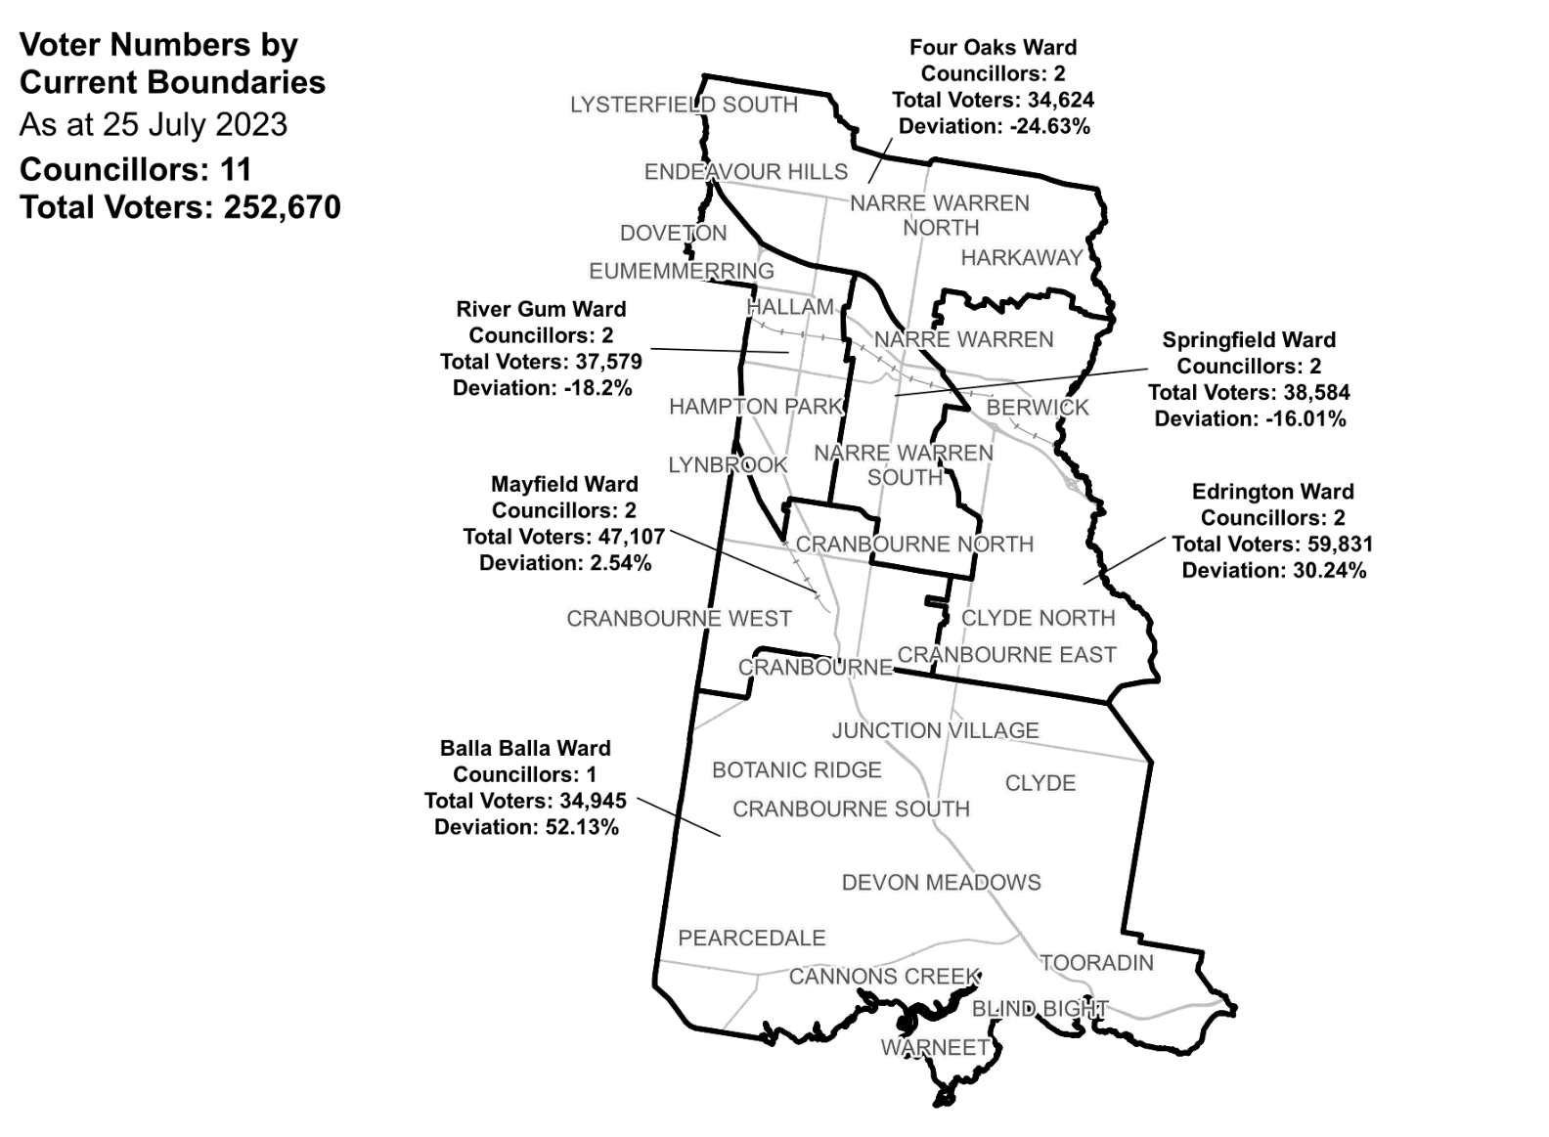

|  |  |  |  |
| --- | --- | --- | --- |
| Ward | Councillors | Voters | Deviation |
| Balla Balla Ward | 1 | 34,945 | +52.13% |
| Edrington Ward | 2 | 59,831 | +30.24% |
| Four Oaks Ward | 2 | 34,624 | -24.63% |
| Mayfield Ward | 2 | 47,107 | +2.54% |
| River Gum Ward | 2 | 37,579 | -18.2% |
| Springfield Ward | 2 | 38,584 | -16.01% |

## Statistics

Area (km2) 397

Voters

### Voters per square km

636

### Average voters per councillor

22,970

Population

### Current population

365,239

### Forecast population growth

2.8% p.a.

More Census statistics available at [abs.gov.au](https://www.abs.gov.au/census/find-census-data/search-by-area)

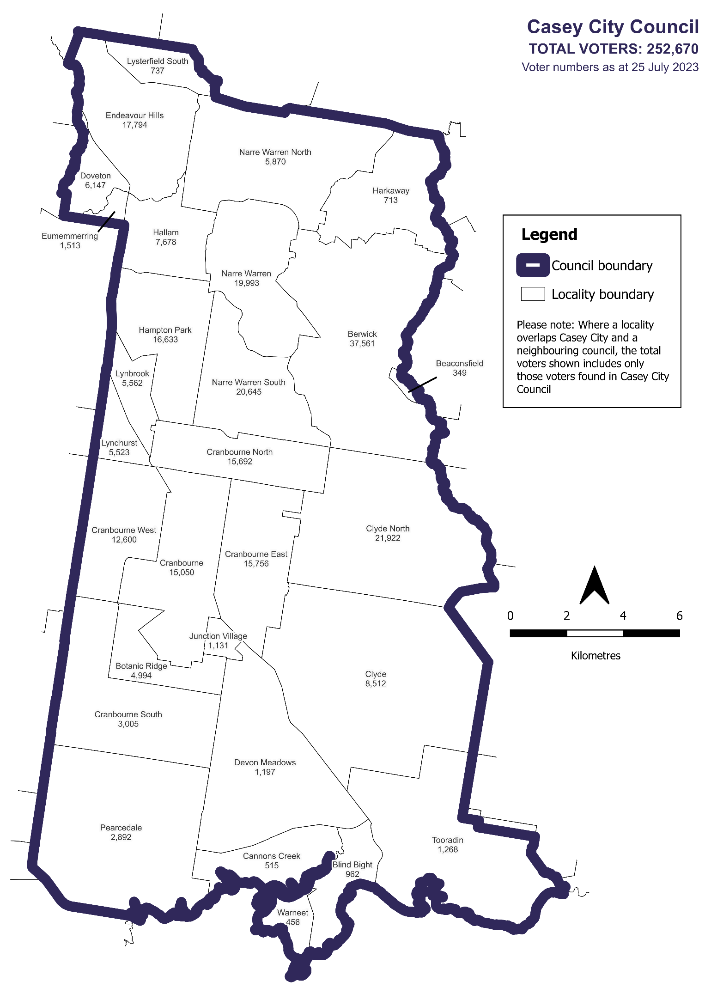Voter numbers by locality (map)

Voter numbers by locality (table)

## Casey City Council voter numbers at 25 July 2023

|  |  |
| --- | --- |
| Locality | Voters |
| Beaconsfield | 349 |
| Berwick | 37,561 |
| Blind Bight | 962 |
| Botanic Ridge | 4,994 |
| Cannons Creek | 515 |
| Clyde | 8,512 |
| Clyde North | 21922 |
| Cranbourne | 15,050 |
| Cranbourne East | 15,756 |
| Cranbourne North | 15,692 |
| Cranbourne South | 3,005 |
| Cranbourne West | 12,600 |
| Devon Meadows | 1,197 |
| Doveton | 6,147 |
| Endeavour Hills | 17,794 |
| Eumemmerring | 1,513 |
| Hallam | 7,678 |
| Hampton Park | 16,633 |
| Harkaway | 713 |
| Junction Village | 1,131 |
| Lynbrook | 5,562 |

|  |  |
| --- | --- |
| Locality | Voters |
| Lyndhurst | 5,523 |
| Lysterfield South | 737 |
| Narre Warren | 19,993 |
| Narre Warren North | 5,870 |
| Narre Warren South | 20,645 |
| Pearcedale | 2,892 |
| Tooradin | 1,268 |
| Warneet | 456 |