Local council electoral structure review

## About the review

Under Victoria’s *Local Government Act 2020*, Moonee Valley City Council must now have a single-councillor ward structure.

The Minister for Local Government has appointed an electoral representation advisory panel to review the electoral structure of Moonee Valley City Council and advise on the most appropriate single-councillor ward structure.

The panel is looking at:

* the appropriate number of councillors and wards
* the location of ward boundaries
* appropriate ward names.

Electoral structure reviews are an important part of democracy and your input is valuable. As a local, you know your council area better than anyone. This is your chance to tell the panel your thoughts about the single-councillor ward structure you believe would best provide representation for your community.

You can have your say:

1. in a submission to the preliminary report
2. at an online public hearing, if you ask to speak in your response submission.

About Moonee Valley City Council

The Traditional Custodians of the land in Moonee Valley City Council are the Wurundjeri people.

Moonee Valley is located 10 kilometres north-west of Melbourne and covers an area of approximately 43 km2. It has a population of about 122,000 people, which is expected to reach 166,143 by 2041. The highest population growth is expected in Moonee Ponds.

Major suburbs include Essendon, Moonee Ponds, Ascot Vale and Keilor East and around two-thirds of the council area is residential. High density living is prominent mainly in the south-east of the council area and along major transport routes. Essendon Fields, which includes the airport and commercial services, takes up a large section of the north of the council area.

Moonee Valley is culturally diverse, with nearly a third of the population born overseas and more than a third speaking a language other than English at home. After English, the most common languages spoken are Italian, Greek and Vietnamese.

Income and education levels are significantly higher than the averages for Greater Melbourne and Victoria.

Features of significance in the council area include the Maribyrnong River, Moonee Ponds Creek, the Calder and Tullamarine Freeways, Moonee Valley Racecourse and Essendon Airport.

## Current electoral structure

Moonee Valley City Council is divided into 3 wards with a total of 9 councillors:

* 3 wards with 3 councillors each

## Last review

The VEC conducted an electoral representation review of Moonee Valley City Council in 2015.

Visit the VEC website at [vec.vic.gov.au](https://www.vec.vic.gov.au/) to access a copy of the 2015 review final report.

Review process

Monday 16 and Tuesday 17 October

### Information sessions

Session 1: 12 noon, Monday 16 October

Session 2: 6 pm, Tuesday 17 October

These sessions will give you more information about the review process. You will be able to register for a session on the VEC website.

Wednesday 18 October

### Preliminary report

The panel will release a preliminary report with one or more options for the electoral structure on Wednesday 18 October.

**You can make a response submission from this date.**

Wednesday 8 November

### Response submissions

The panel must receive your submission by   
5 pm on Wednesday 8 November 2023.

The panel will not accept late submissions.

Tuesday 14 November

### Public hearing

The panel will hold an online public hearing if anyone asks to speak about their response submission at 2 pm Tuesday 14 November.

The public hearing will not be held if no one asks to speak.

Wednesday 13 December

### Final report

The panel will submit a final report to the Minister for Local Government including its advice for the electoral structure on Wednesday 13 December.

The minister will consider the panel’s advice before recommending a change to the electoral structure. Any change is expected to apply at the next local council general election.

## Submission guide

You can download a submission guide from the VEC website at [vec.vic.gov.au](http://vec.vic.gov.au/)

## How to make a submission Untitled-1

On the VEC website at [vec.vic.gov.au](http://vec.vic.gov.au/)

By email to:

[MooneeValley.ERAPSubmissions@ vec.vic.gov.au](mailto:MooneeValley.ERAPSubmissions@vec.vic.gov.au)

LetterBy post to:

Electoral representation advisory panel  
c/o Victorian Electoral Commission  
Level 11, 530 Collins St  
Melbourne VIC 3000

Submissions must include your:

* full name
* contact phone number or email address
* residential or postal address.

Your submission will be published on the VEC website, including your name and suburb or town but not your full address or contact details. See the submission guide or VEC website at [vec.vic.gov.au/privacy](https://www.vec.vic.gov.au/privacy) for privacy information.

## One vote, one value

The ‘one vote, one value’ democratic principle is enshrined in the *Local Government Act 2020*. This means every person’s vote counts equally.

When a local council is subdivided into wards, the number of voters each councillor represents in each ward must be plus-or-minus 10% of the average number of voters per councillor for all wards.

The map below includes the current number of voters in each ward and the ward’s current deviation from the average. The panel will consider likely population and voter changes to ensure the structure remains equitable.

If you make a submission online, you can use a mapping tool to build your preferred electoral structure. The tool uses current voter numbers to tell you the deviations of the wards you make. This will help you propose a structure that meets the requirements of the Act.

Current electoral structure

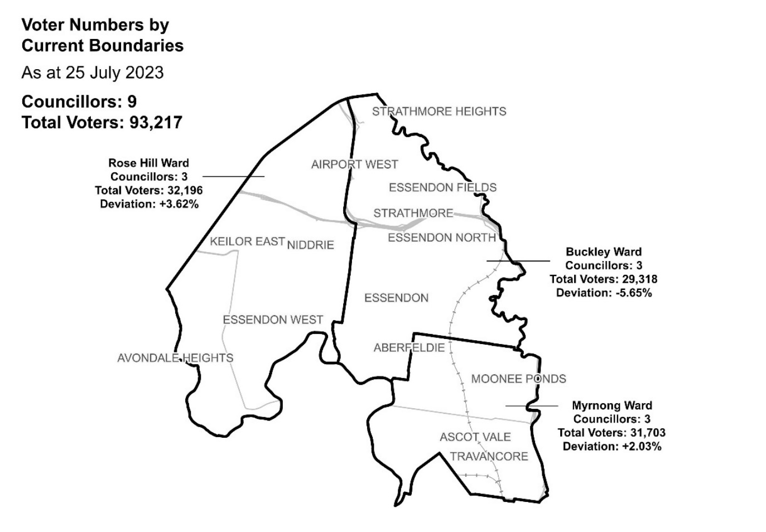

|  |  |  |  |
| --- | --- | --- | --- |
| Ward | Councillors | Voters | Deviation |
| Buckley Ward | 3 | 29,318 | -5.65% |
| Myrnong Ward | 3 | 31,703 | +2.03% |
| Rose Hill Ward | 3 | 32,196 | +3.62% |

## Statistics

Area (km2) 43

Voters

### Voters per square km

2,168

### Average voters per councillor

10,357

Population

### Current population

121,851

### Forecast population growth

1.5% p.a.

More Census statistics available at [abs.gov.au](https://www.abs.gov.au/census/find-census-data/search-by-area)

Voter numbers by locality (map)

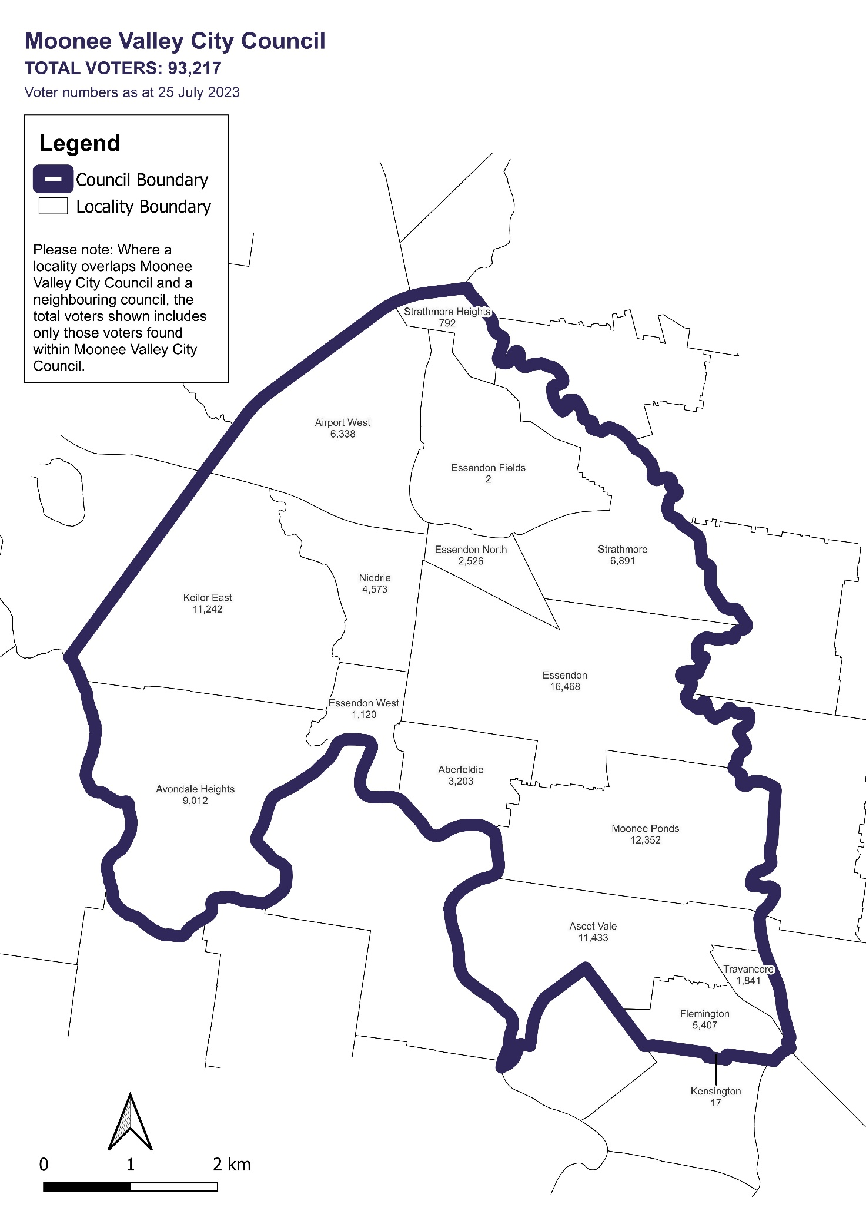

Voter numbers by locality (table)

|  |  |
| --- | --- |
| Locality | Voters |
| Aberfeldie | 3,203 |
| Airport West | 6,338 |
| Ascot Vale | 11,433 |
| Avondale Heights | 9,012 |
| Essendon | 16,468 |
| Essendon Fields | 2 |
| Essendon North | 2,526 |
| Essendon West | 1,120 |
| Flemington | 5,407 |
| Keilor East | 11,242 |
| Kensington | 17 |
| Moonee Ponds | 12,352 |
| Niddrie | 4,573 |
| Strathmore | 6,891 |
| Strathmore Heights | 792 |
| Travancore | 1,841 |

## Moonee Valley City Council voter numbers at 25 July 2023