Local council electoral structure review

March 2023

Buloke Shire Council

Preliminary   
Report

Acknowledgement of Country

The electoral representation advisory panel acknowledges the Wotjobaluk, Jaadwa, Jadawadjali, Wergaia, Jupagalk and Dja Dja Wurrung peoples as the Traditional Custodians of the lands and waters on which it is holding this review and pays respects to ancestors and Elders past, present and emerging. The panel acknowledges their custodianship for many thousands of years and their continuing living culture.

Document history and version control

|  |  |  |  |
| --- | --- | --- | --- |
| **Version** | **Date approved** | **Approved for publication by** | **Brief description** |
| 1 | 14 March 2023 | Electoral Commissioner | Final version |
| 2 | 27 March 2023 | Electoral Commissioner | Removed incorrect attribution of submission to Mayor of Buloke Shire Council. |

# Contents

Contents 3

Executive summary 4

Developing electoral structure models 4

Preliminary submissions 4

Electoral structure models for public feedback 4

Next steps 4

Background 5

About the 2023–24 electoral structure reviews 5

The electoral representation advisory panel 5

Public engagement 6

Developing recommendations 6

About Buloke Shire Council 9

Profile 9

Current number of councillors and electoral structure 10

Last electoral structure review 10

Preliminary submissions 11

Number of councillors 11

Electoral structure 12

Preliminary findings and options 14

Number of councillors 14

Electoral structure 15

Models for public feedback 18

Next steps 19

Response submissions 19

Public hearing 20

Final report 20

References 21

Appendix 1: Model maps 22

Appendix 2: Additional models considered 25

Appendix 3: List of preliminary submitters 26

# Executive summary

An independent electoral structure review panel appointed by the Minister for Local Government has reviewed the structure of Buloke Shire Council.

The panel looked at:

* whether the council had an appropriate number of councillors
* whether it should be unsubdivided or subdivided.

This report outlines the preliminary models that the panel is presenting for the proposed new electoral structure of Buloke Shire Council to meet the requirements of the *Local Government Act 2020*.

More information about the background to the reviews is available on page 5.

## Developing electoral structure models

The panel considered a range of factors when deciding on the models in this report, including:

* research and analysis
* voter growth or decline over time
* public submissions (see below).

More information on the way the panel decided on the models is available on page 6.

## Preliminary submissions

The panel received 4 preliminary submissions. Of these, one submission included a map.

A full analysis of submissions received can be found on page 11.

## Electoral structure models for public feedback

After considering submissions and research, the panel is presenting the following electoral structure models for further public consultation:

Model 1: an unsubdivided electoral structure with 7 councillors.

Model 2: a subdivided electoral structure with a total of 6 councillors, 3 wards and 2 councillors per ward.

Details on these models, including maps, are available in Appendix 1.

## Next steps

The panel is now seeking feedback on the electoral structure models. You can make a response submission to these models until Wednesday 5 April 2023. If any response submitters wish to speak at a public hearing, the panel will hold an online public hearing on Wednesday 12 April 2023. Following this, it will present its final recommendation to the Minister by Wednesday 10 May 2023. More information about the review process is available on the Victorian Electoral Commission (VEC) website at [vec.vic.gov.au](https://www.vec.vic.gov.au).

# Background

## About the 2023–24 electoral structure reviews

In October 2022, the Minister for Local Government formed 2 electoral representation advisory panels to review the electoral structures of 39 local councils, under section 16 of the *Local Government Act 2020* (the Act). If the Minister accepts the electoral structures the panels recommend, they will take effect at the October 2024 elections.

The Act introduced several changes to local government representation, including the types of electoral structures local councils may have. Large and small rural shire councils (including Buloke Shire Council) can have one of 3 electoral structures:

* + unsubdivided (entire council area with no wards)
  + single-councillor wards
  + multi-councillor wards with the same number of councillors per ward.

For Buloke Shire Council, the electoral representation advisory panel is examining:

* the number of councillors
* whether the council should be subdivided into wards or unsubdivided.

For subdivided structures, it is also examining:

* + the number of wards
  + where the ward boundaries should be
  + the name of each ward
  + how many councillors should be elected for each ward.

The Act requires electoral structures to provide fair and equitable representation and facilitate good governance. For subdivided structures, each ward must have an approximately equal number of voters per councillor (within +/-10% of the average).

## The electoral representation advisory panel

The panel conducting the electoral structure review of Buloke Shire Council has 3 members:

* The Honourable Frank Vincent AO KC (Chairperson)
* Ms Liz Williams PSM
* Electoral Commissioner, Mr Warwick Gately AM.

The panel is independent of councils and the State government.

Under the Act, the VEC is not responsible for reviewing council electoral structures but must provide administrative and technical support to the panel. The Electoral Commissioner (or their delegate) must be a member of each panel.

## Public engagement

### Public information program

To educate and inform the public about the Buloke Shire Council electoral structure review, the VEC began a public information program in mid-December 2022. The VEC:

* + printed public notices in state-wide newspapers
  + held public information sessions to outline the review process and respond to questions from the community
  + sent out media releases to announce the start of the review
  + published information on its social media channels
  + provided updated website content on vec.vic.gov.au, including:
    - information on the review process
    - submission guides and fact sheets for each council under review with background information
    - preliminary submissions from the public.

The VEC will continue to promote the review during the response submissions stage via media releases, the VEC’s social media channels and updated content on the VEC website.

### Public consultation

The panel encouraged public input to the review of Buloke Shire Council via preliminary submissions at the start of the review. The panel now invites further input via:

* + response submissions to this preliminary report
  + an online public hearing to provide anyone who makes a response submission the opportunity to expand on their submission.

Public submissions are an important part of the review process, but the panel also considers other factors during a review. These are outlined below.

## Developing recommendations

The panel’s electoral structure models presented in this preliminary report comply with the Act and were developed through careful consideration of:

* + research and analysis conducted by the VEC support team, including geospatial and demographic factors
  + rates or patterns of population and voter growth or decline over time, and relevant forecasts of growth or decline based on forecast information provided by .id (informed decisions, a company specialising in demographics and forecasting)
  + input received from the public in written submissions during the preliminary submissions phase.

### Deciding on the number of councillors

The Act allows local councils to have between 5 and 12 councillors, but neither the Act nor the Local Government (Electoral) Regulations 2020 specify how to determine the number of councillors a council needs. Therefore, the options put forward by the panel in this report are guided by the Act’s intention for fairness and equity in voter representation.

In examining the number of councillors Buloke Shire Council should have, the panel considered these factors:

* + the population and number of voters in the council area, compared to other councils with a similar population size and number of voters in the same category (for example, metropolitan, interface, regional city, large rural shire, small rural shire)
  + patterns of population change and voter growth or decline in the council area over time
  + the current and past numbers of councillors
  + the representation needs of the communities of interest in the council area
  + if a particular type of electoral structure best suits the council (see ‘Deciding the electoral structure’ below)
  + any matter raised in public submissions not already listed above.

Generally, local councils with a larger number of voters will have a higher number of councillors. Large populations are often more likely to have greater diversity, both in the type and number of communities of interest and issues relating to representation. However, the ideal number of councillors can also be influenced by the particular circumstances of a council, such as the:

* + nature and complexity of services the council provides
  + geographic size and topography of the area
  + forecast population and voter growth or decline
  + social diversity.

### Deciding the electoral structure

The electoral structure of large and small rural shire councils can be:

* + unsubdivided (entire council area with no wards)
  + made up of single-councillor wards

or

* + made up of multi-councillor wards with the same number of councillors per ward.

When developing electoral structure models for Buloke Shire Council, the panel considered these main criteria:

* + whether the structure would comply with section 15(2) of the Act (see below), and for how long it would likely comply
  + the appropriate number of councillors, as outlined above
  + whether meaningful and effective ward boundaries can be established and whether these would be easily identifiable to local communities
  + representation of communities of interest
  + the voter distribution and physical features of the area, and the impact these may have on the shape and size of any wards
  + past elections for the council, including:
    - numbers of candidates nominating
    - incidences of uncontested elections
    - rates of informal voting.
  + other matters raised in public submissions not already listed above.

Under section 15(2) of the Act, subdivided structures must aim for an approximately equal number of voters per councillor in each ward. This means the number of voters represented by each councillor in a ward should be within +/-10% of the average number of voters per councillor for all wards.

The panel recommends structures that will comply with section 15(2) at the October 2024 local government elections and uses current voter numbers and forecasts of population and voter change to assess this with as much accuracy as possible. In some cases, population changes and other factors mean it is not possible for a subdivided electoral structure to comply with section 15(2) based on current voter numbers. If this occurs, compliance at the 2024 local government elections will be the priority to ensure each vote has approximately equal value.

# About Buloke Shire Council

## Profile

Buloke Shire Council is located in the Murray-Mallee region of Victoria, approximately 300 kilometres north-west of Melbourne and 180 kilometres south-east of Mildura. The shire covers an area of 7,998 km2, spanning about 200km from north to south. It shares borders with Mildura and Swan Hill Rural City Councils to the north, Gannawarra and Loddon Shire Councils to the east, Northern Grampians Shire Council to the south and Yarriambiack Shire Council to the west.

The Traditional Custodians of the land in Buloke Shire are the Wotjobaluk, Jaadwa, Jadawadjali, Wergaia, Jupagalk and Dja Dja Wurrung people.

**Landscape**

Buloke Shire Council comprises mostly farming land, but also important natural features, such as the Richardson and Avoca rivers and the significant wetlands of Lake Buloke, Lake Tyrrell and the Wooroonook Lakes (Department of Transport and Planning, 2022).

The Calder Highway and the Sunraysia Highway run north-south through the shire. They form part of an extensive road network, connecting the shire to Mildura and Swan Hill to the north and east, and to major regional centres south.

The shire has a population of 6,178 (ABS, 2021a), with the major towns of Birchip, Charlton, Donald, Sea Lake and Wycheproof comprising approximately 70%. The population is also distributed across smaller townships and on farms located throughout rural districts.

**Community**

Agriculture is a major industry in the shire, comprising 27% of total economic output for the council area (REMPLAN, 2023) and 30% of employment (ABS, 2021a). The main agricultural outputs include grain, such as wheat, oats and barley, and sheep grazing (REMPLAN, 2023). Health care and social assistance, education and training, retail and construction are other important industries of employment (REMPLAN, 2023).

Buloke Shire has an older age profile compared to regional Victoria. With a median age of 52, just over half of the population (53.2%) is aged over 50 years (ABS, 2021a), whereas for regional Victoria the median age is 43 years (ABS, 2021c). The shire’s population declined modestly by approximately 4% between 2011 and 2021 (ABS, 2021c), with forecast population growth expected to be 0.7% annually from 2022 to 2028.

Of the population, 83.7% were born in Australia and 88.1% use only English at home (ABS, 2021a). Aboriginal and Torres Strait Islander people represent 1.5% of the population. Countries where most people were born overseas include England, New Zealand and the Philippines. Languages other than English most commonly spoken at home include Malayalam, Mandarin and Tagalog.

There is a high rate of home ownership amongst residents, as well as a high proportion of single person households. The median weekly household income of $1,088 is lower than the average rate for regional Victoria of $1,386 (ABS, 2021a; ABS, 2021c).

## Current number of councillors and electoral structure

Buloke Shire Council is currently divided into 3 wards with a total of 7 councillors:

* one ward with 3 councillors (Mount Jeffcott)
* 2 wards with 2 councillors each (Mallee and Lower Avoca).

There are currently approximately 5,249 voters in Buloke Shire Council, equating to a ratio of 750 voters per councillor.

Visit the VEC website at [vec.vic.gov.au](http://www.vec.vic.gov.au/) for more information on the current electoral structure of Buloke Shire Council.

## Last electoral structure review

The VEC conducted an electoral representation review of Buloke Shire Council in 2019. This representation review was carried out in accordance with the requirements of the *Local Government Act 1989*, which was replaced by the *Local Government Act 2020*.

After conducting the review, the VEC recommended that Buloke Shire Council continue to consist of 7 councillors elected from 3 wards (2 wards with 2 councillors and one ward with 3 councillors).

Visit the VEC website at [vec.vic.gov.au](http://www.vec.vic.gov.au/) to access a copy of the 2019 representation review final report.

Prior to the 2019 review, a representation review of Buloke Shire Council was completed in 2007. This review resulted in the current electoral structure being implemented. Prior to the 2007 representation review, Buloke Shire Council was comprised of 9 councillors elected from 3 wards, each with 3 councillors.

# Preliminary submissions

The panel received 4 preliminary submissions from the public by the deadline of 5 pm on Wednesday 15 February 2023. You can view these submissions on the VEC website at [vec.vic.gov.au](https://www.vec.vic.gov.au/) and find a list of people or organisations who made a submission in Appendix 3.

The table below provides an overview of preferences in the preliminary submissions. You can read an analysis of submissions below this table.

|  |  |  |  |  |  |
| --- | --- | --- | --- | --- | --- |
|  | Unsubdivided structure | Single-councillor wards | Multi-councillor wards | Subdivided structure (unspecified) | No comment on structure |
| Decreased number of councillors | - | - | 2 | - | - |
| Maintain current councillor number | 2 | - | - | - | - |
| Increased number of councillors | - | - | 1 | - | - |
| No comment on number of councillors | - | - | - | - | - |

Note: 1 submitter supported more than one option for the total number of councillors

## Number of councillors

The number of councillors proposed in submissions was greatly influenced by the preferred electoral structure. Submissions in favour of an unsubdivided electoral structure proposed maintaining 7 councillors, whereas those in favour of a maintaining a subdivided electoral structure proposed 6 councillors and acknowledged the requirement of the new *Local Government Act 2020* for multi-councillor wards to have the same number of councillors per ward. Valid arguments were presented on the need for either 6 or 7 councillors.

### Maintaining 7 councillors

Those in favour of maintaining the current number of councillors proposed that 7 councillors allowed for a better and more sustainable balance of councillor workloads. They highlighted the demands on councillors to represent constituents, while also managing infrastructure, other assets and service delivery, over large geographic areas.

One submitter proposed that 7 councillors would reduce the likelihood of tied votes and situations where the mayor casts a deciding vote, reasoning that this would make council decision-making more consistent and equitable.

Another submitter suggested there was no justification for increasing the number of councillors for Buloke Shire Council and therefore the shire should retain 7 councillors. Citing the previous review conducted by the VEC in 2019, the submitter offered that there had since been no change to the special circumstances faced by the shire that would justify a change to the number of councillors.

In terms of fair and equitable representation, one submitter stated that 7 councillors provided the best opportunity for voters to elect at least one ‘local’ candidate from the shire’s main population centres.

### Reducing to 6 councillors

2 submissions were in favour of 6 councillors. One submission stated that an even number of councillors would provide a better balance of power across the shire, particularly between the more populous south and the sparsely populated north.

The other submitter in favour of 6 councillors contended that an even number of councillors would not be an issue for council decision making, as the mayor can cast the deciding vote in the event of a tie.

2 submissions were against reducing the number of councillors to 6. These submissions stated that this would increase the councillor workloads, and could undermine the quality of electoral representation, as well as the quality of the connection between councillor and community. These submissions also argued that an even number of councillors would present issues in council decision-making where a tied vote could require the mayor to cast the deciding vote.

One submission included suggestions regarding councillor numbers that were beyond the scope of the present review process.

## Electoral structure

Of the 4 preliminary submissions received, 2 were for an unsubdivided electoral structure and 2 were for a subdivided structure consisting of 3 wards with 2 councillors in each ward.

### Unsubdivided

Those in favour of an unsubdivided electoral structure stated it would provide strong, local representation. The Buloke Shire Council submission suggested this electoral structure would provide appropriate and equitable representation for the Buloke community. In a separate submission, Dr Alan Kelvin Getley proposed that with enough candidates standing for election, each of the shire’s main population centres can still elect a ‘local’ candidate to represent them and their interests.

Submissions in favour of an unsubdivided electoral structure also stated that, as this structure retains the current councillor number of 7, councillors can continue to manage a sustainable workload with responsibility over a large geographical area.

These submissions also argued that an unsubdivided structure would enhance electoral representation by increasing the likelihood of contested elections, thus providing choice for voters. For example, Dr Getley’s submission highlighted recent uncontested elections in Mallee Ward and Mount Jeffcott Ward, where residents did not have the opportunity to cast a vote. The submission suggested that this would not be the case in an unsubdivided structure. Buloke Shire Council stated that participation in local government elections would improve as voters could vote for candidates from across the shire rather than only from their local area.

Some submissions proposed that an unsubdivided electoral structure could hinder electoral representation. Councillor Bernadette Hogan put forth that as voters are more numerous and concentrated in the shire’s southern towns, such a structure could reduce representation for residents in the shire’s north and lead to uneven distribution of council resources. Martin Duke stated that an unsubdivided electoral structure would not be appropriate for equitable representation of the shire’s different communities of interests and their specific needs.

### Multi-councillor wards

Submissions in favour of this electoral structure argued that the current 3-ward structure has served the shire well. Councillor Hogan stated that the current structure allows better representation for the less populated towns and communities in the rural north of the shire, as well as for communities of interest linked to these towns sharing common interests. Martin Duke proposed a 3-ward structure to ensure local representation, and to better facilitate good flow of information between the community and council through local representation.

Martin Duke stated that councillor workloads would be better balanced and equitable through the type of local representation provided by a 3-ward electoral structure. Similarly, the distances councillors were required to travel to connect with communities, attend forums and meetings is manageable under such an electoral structure.

Councillor Hogan argued that only minor adjustments to the current structure are required to make a structure with 3 wards and 2 councillors per ward compliant. Councillor Hogan submitted a map to illustrate this. This submission was incorporated into Model 2 proposed in this preliminary report.

Submissions against this electoral structure were opposed to the reduction in councillor numbers from 7 to 6 required by the new *Local Government Act 2020*, under which multi-councillor wards must have the same number of councillors per ward. They stated this would increase councillor workloads and undermine strong local representation, as fewer councillors would be available to represent voters located across a large geographic area impacting infrastructure and service coverage.

# Preliminary findings and options

## Number of councillors

After taking into consideration the requirements of the Act, public submissions and the agreed criteria, the panel found either 6 or 7 councillors to be an appropriate number for Buloke Shire Council.

The panel considered the characteristics of the shire in relation to similar rural shire councils, including its size and geography, population and the number and distribution of voters across the shire.

|  |  |  |  |  |  |  |
| --- | --- | --- | --- | --- | --- | --- |
| Similar rural shire councils to Buloke Shire Council | | | | | | |
| Local council | Area (km2) | Number of voters at 2020 election | Population (2021 Census) | Current total estimate of voters | Number of councillors | Number of voters per councillor |
| Pyrenees Shire | 3,435 | 7,063 | 7,671 | 7,233 | 5 | 1,447 |
| Loddon Shire | 6,696 | 7,072 | 7,759 | 7,146 | 5 | 1,429 |
| Yarriambiack Shire* | 7,326 | 5,703 | 6,556 | 5,594 | 7 | 799 |
| Towong Shire | 6,675 | 5,264 | 6,223 | 5,305 | 5 | 1,061 |
| **Buloke Shire\*** | **7,998** | 5,404 | **6,178** | **5,249** | **7** | **750** |
| Hindmarsh Shire | 7,524 | 4,695 | 5,698 | 4,673 | 6 | 779 |
| Queenscliffe Borough | 9 | 4,143 | 3,276 | 4,337 | 5 | 867 |
| West Wimmera Shire | 9,109 | 3,477 | 4,006 | 3,453 | 5 | 691 |

*This local council is undergoing an electoral structure review during 2023–24.

### Maintaining 7 councillors

Buloke Shire has the lowest number of voters per councillor of any rural shire with 7 councillors, at 750. Many similar rural shires, including those with a similar number of voters per councillor, have lower councillor numbers of 6 or 5.

It is important to also note that Buloke Shire has a large geographic area which requires councillors to travel over long distances to attend meetings and community events. Submissions to this review and previous representation reviews highlight the already high councillor workloads, considering the extensive infrastructure and service coverage they oversee, travel times, and special circumstances. There were two public submissions in support of maintaining seven councillors

The shire has similar features and special circumstances to other rural shires with 7 councillors. Yarriambiack Shire, neighbouring Buloke Shire to the west, also has 7 councillors and is similar to Buloke Shire in terms of its area, population, voter numbers and voters per councillor. It also shares many of the same special circumstances as Buloke, which previous representation reviews have found justified 7 councillors as an appropriate number.

Considering these factors, the panel considered 7 to be an appropriate number of councillors for Buloke Shire.

### Reducing to 6 councillors

However, the panel considered 6 councillors to be an appropriate number of councillors, but only for a subdivided structure consisting of 3 wards and 2 councillors per ward. This was supported by both submissions made in favour of this type of subdivided structure.

Hindmarsh Shire Council serves as an example of a similar rural shire with 6 councillors. Located to the west of Buloke Shire, Hindmarsh Shire Council is currently represented by 6 councillors across 3 wards, with 2 councillors per ward. The shire is similar in terms of its area, population, number of voters and number of voters per councillor. It also shares some special circumstances with Buloke Shire, such as a large geographic size and strong communities of interest. Recent representation reviews of Hindmarsh Shire Council recommended that the shire retain 6 councillors, noting that 6 was a stable number of councillors which facilitated good discussion and decision-making, and that the mayoral casting vote was rarely used.

It was considered that the drawbacks of having one less councillor could be balanced by the benefits in retaining a subdivided electoral structure.

## Electoral structure

To identify the most appropriate electoral structure, various factors were considered. This included the requirements of the Act, the communities of interest in Buloke Shire, public submissions, the appropriateness of ward boundaries and which models best offered fair and equitable representation.

In developing the preliminary models presented in this report, a range of models were considered. The strongest 2 models have been put forward for further public comment.

The panel proposes 2 models for the consideration of the Buloke Shire community:

* an unsubdivided electoral structure ([Model 1](bookmark://_An_unsubdivided_model))
* a subdivided electoral structure of 3 wards, with 2 councillors per ward ([Model 2](bookmark://_A_multi-councillor_ward)).

Diagrams of the preliminary models are included in Appendix 1.

### Unsubdivided structure (Model 1)

Under this model, Buloke Shire Council would adopt an unsubdivided electoral structure, represented by 7 councillors.

This model was considered to have several strengths. Model 1 allows the council to retain 7 councillors and wouldn’t significantly impact councillor workloads. This model also had support in public submissions. The panel considered an unsubdivided electoral structure would provide voters increased choice in candidates at election, potentially reducing the possibility of uncontested elections. Given the shire would not be divided into wards, geographic communities or communities of interest would not be split by boundaries and there would be no need to make boundary adjustments to account for population change. An unsubdivided structure may also foster a shire-wide approach to representation and to council business.

The panel also considered some drawbacks of the model. Given the uneven distribution of the population throughout the shire, there is the potential for the more populous areas and towns in the south to gain greater representation through more people in those areas voting for local candidates. This may result in reduced local representation for the towns and regions in the shire’s north. However, it was noted that candidates were elected unopposed in 2 out of the 3 recent elections in the Mallee Ward, and that neither candidate elected in the ward’s most recent election resided within it. An unsubdivided structure may reduce the risk of uncontested elections.

An unsubdivided structure has the benefit of proportional representation, where a candidate must achieve a quota of votes to be elected. In many cases, this quota may be a lower threshold to entry than if they were to nominate in a ward structure. This means that a sufficiently strong candidate from the shire’s rural areas, smaller communities or non-geographic communities of interest areas may have a reasonable chance of achieving representation on the Council.

Given the large geographic area of the shire, councillors may have to travel long distances to connect with voters and attend council meetings and events. Submissions linked these factors to higher councillor workloads and a weaker connection between councillors and the community. However, much larger rural shires function well with an unsubdivided electoral structure. Councillors in East Gippsland Shire Council represent voters and coordinate services spanning a large area of 20,940 km2. The panel also considered that candidates could stand and campaign on local issues, and that voters have more choice at elections, including voting for local candidates representing their interests.

### Multi-councillor ward structure (Model 2)

Under this model, Buloke Shire Council would maintain its current 3-ward structure. Each ward would be represented by 2 councillors, in line with the requirement of the *Local Government Act 2020* (Vic) for there to be the same number of councillors per ward.

Aside from a reduction in councillors, the panel considered Model 2 to be reasonably consistent with the current structure and thus may be supported by submitters proposing to maintain the current electoral structure.

This model captures communities of interest well. Donald and the surrounding communities continue to be captured within Mount Jeffcott Ward, while Charlton and Wycheproof continue to be captured within Lower Avoca Ward, along with surrounding connected communities. Northern towns such as Sea Lake and Berriwillock continue to be captured within Mallee Ward with surrounding rural communities.

This model provides for fair and equitable representation for the separate geographic communities and communities of interest in the shire with the same number of councillors representing the northern Mallee Ward as the 2 southern wards.

Under Model 2, the boundary between Mallee Ward and Mount Jeffcott Ward has been moved south, following main roads and localities. As a result, the town of Birchip is contained within the redrawn boundaries of Mallee Ward. To the east, the boundary between Mallee Ward and Lower Avoca Ward is adjusted north to encompass mostly agricultural land, following main roads and localities. The boundary between Mount Jeffcott Ward and Lower Avoca Ward moves west to encompass mostly agricultural land, again following main roads and localities.

These changes to ward boundaries ensure that the electoral structure meets the requirement to be within +/-10% of the average number of voters per councillor for all wards through to the 2024 Local Government election.

Model 2 reduces the number of councillors for the shire from 7 to 6, which the panel considered to have drawbacks, such as the possibility of increased councillor workloads. This model may also divide communities with strong links to one another. For example, moving Birchip from the Mount Jeffcott Ward to the Mallee Ward away from Donald may divide the community. The towns are close to one another, with strong connections and community ties between them.

The drawbacks of reducing councillors, however, is balanced by the continuation of a subdivided model similar to the current structure.

### Models considered but not put forward

The panel considered 2 single-councillor ward models. After careful consideration, it was found that these models were unlikely to provide good representation for communities due to the following weaknesses:

* the models poorly captured communities of interest, splitting main towns such as Donald, Charlton and Wycheproof
* there may be an increased likelihood of uncontested elections given the history of low candidate numbers and uncontested elections in the Mallee and Mount Jeffcott wards
* the models would be sensitive to minor changes in number of voters, with changes of 7-to-9 voters in a given ward resulting in a 1% change in deviation and leading to uncertainty around the longevity of the electoral structure
* no preliminary submissions were made in support of single-councillor wards in this review, or in the previous representation review for Buloke Shire Council in 2019.

These models have not been put forward for further consultation. These modes are shown in Appendix 2.

## Models for public feedback

The panel considers all models outlined below to offer fair and equitable representation for voters in Buloke Shire Council. Please see Appendix 1 for detailed maps of these models.

### Model 1

Buloke Shire Council has an unsubdivided electoral structure with 7 councillors.

### Model 2

Buloke Shire Council has 6 councillors and is divided into 3 wards with 2 councillors per ward.

### Ward names

The panel has suggested that current ward names be retained for Model 2. The panel invites comments from the community on these names as part of submissions responding to the preliminary report.

# Next steps

## Response submissions

Any person or group, including the local council under review, can make a response submission to the electoral representation advisory panel. In your submission, you should address the options proposed by the panel in this preliminary report.

You can make a submission:

|  |  |
| --- | --- |
|  | **Online** Visit [vec.vic.gov.au](http://vec.vic.gov.au/) to make a submission online.  You will need to make an account to use the online Public Submission Tool and can save a draft submission to finish later. |
|  | **By email** [Buloke.ERAPSubmissions@vec.vic.gov.au](mailto:Buloke.ERAPSubmissions@vec.vic.gov.au) |
|  | **By post**  Electoral Representation Advisory Panel c/o Victorian Electoral Commission Level 11, 530 Collins St Melbourne VIC 3000 |

The panel must receive all response submissions before 5 pm on Wednesday 5 April 2023. If you post your submission, make sure it has enough time to reach the panel before the deadline. Late submissions will not be accepted.

### Required information

For your submission to be considered, you must include your:

* full name
* contact phone number or email address
* postal or residential address.

The panel will not consider submissions without this information. If you are submitting as a group or organisation, you must include the name of a nominated contact person who is authorised to submit on behalf of your group.

The VEC will handle information provided by submitters in accordance with the privacy policy available at [www.vec.vic.gov.au/privacy](http://www.vec.vic.gov.au/privacy).

### Public access to submissions

To ensure transparency in the electoral structure review process, your submission will be published on the VEC website at [vec.vic.gov.au](http://www.vec.vic.gov.au/). The VEC will remove your signature and contact details, including residential and postal addresses, from all public copies but must publish your full name (or group name) and locality (suburb or town).

## Public hearing

If you make a response submission, you can also ask to speak at an online public hearing to support your submission and expand on your views.

The online public hearing is scheduled for:

Time: 10 am

Date: Wednesday 12 April 2023

The panel encourages participation in the public hearing. If you wish to speak at the public hearing, you **must** indicate this in your response submission. The public hearing will not be held if there are no requests to speak.

Anyone can attend a public hearing, but you will only be able to speak if you asked to in your response submission. If you ask to speak, the VEC will contact you to arrange a time for you at the hearing. You will have 10 minutes to address the public hearing panel, which will include at least 2 of the review panel members. The members of the public hearing panel may ask you questions.

Visit the VEC website at [vec.vic.gov.au](http://vec.vic.gov.au/) for more information on public hearings.

## Final report

Following the public hearing, the review panel will consider all evidence gathered and publish a final report for the Minister for Local Government containing a recommendation for the number of councillors and the electoral structure for the local council.

The final report is scheduled to be published on 10 May 2023. If the recommendation is accepted, any changes will apply at the October 2024 local council elections.

The final report will be available on the VEC website at [vec.vic.gov.au](http://vec.vic.gov.au/) or you can request a printed copy by calling 131 832.

# References

Australian Bureau of Statistics. (2021a). *2021 Census Community Profiles, Buloke.* <https://abs.gov.au/census/find-census-data/community-profiles/2021/LGA21270> accessed 28 February 2023.

Australian Bureau of Statistics. (2021b). ' Time Series Profile' [time series spreadsheet] *Census 2021 Quick Stats, Buloke.* <https://www.abs.gov.au/census/find-census-data/quickstats/2021/LGA21270> accessed 28 February 2023.

Australian Bureau of Statistics. (2021c). *2021 Census All persons QuickStats, Rest of Vic.* <https://abs.gov.au/census/find-census-data/quickstats/2021/2RVIC> accessed 28 February 2023.

Department of Transport and Planning*.* (2022). *Planning Scheme, Buloke.* <https://planning-schemes.app.planning.vic.gov.au/Buloke/ordinance> accessed 28 February 2023.

*Local Government Act 1989* (Vic)

*Local Government Act 2020* (Vic)

Local Government (Electoral) Regulations 2020 (Vic)

REMPLAN, 2023. Economy, Jobs and Business Insights, Buloke. <https://app.remplan.com.au/buloke/economy/industries/employment?state=Om4YTv!kEbGcGOEJFJRPr1SKPq73HXiVHWedsJlylPSbLPLxHaH0XSgHkU33EBTxkE> accessed 28 February 2023.

# Appendix 1: Model maps

The following maps are included in this report:

|  |  |
| --- | --- |
| Map | Page |
| Model 1 – An unsubdivided electoral structure with 7 councillors | 23 |
| Model 2 – A multi-councillor ward structure with 6 councillors, 3 wards and 2 councillors per ward | 24 |

Forecast information in the text of this report is based on forecasts prepared by .id – informed decisions [id.com.au](http://www.id.com.au) .id and its licensors are the sole and exclusive owners of all rights, title and interest subsisting in that part of the report content where .id are identified. Some of .id content is a derivative of ABS Data, which can be accessed from the website of the Australian Bureau of Statistics at [abs.gov.au](http://www.abs.gov.au), and licensed on terms published on the ABS website.

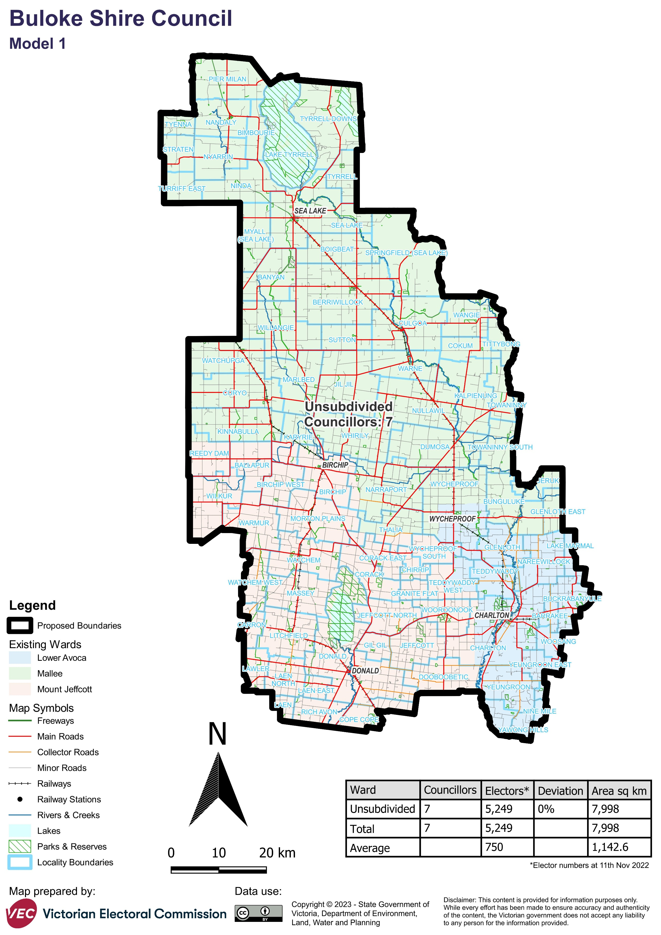

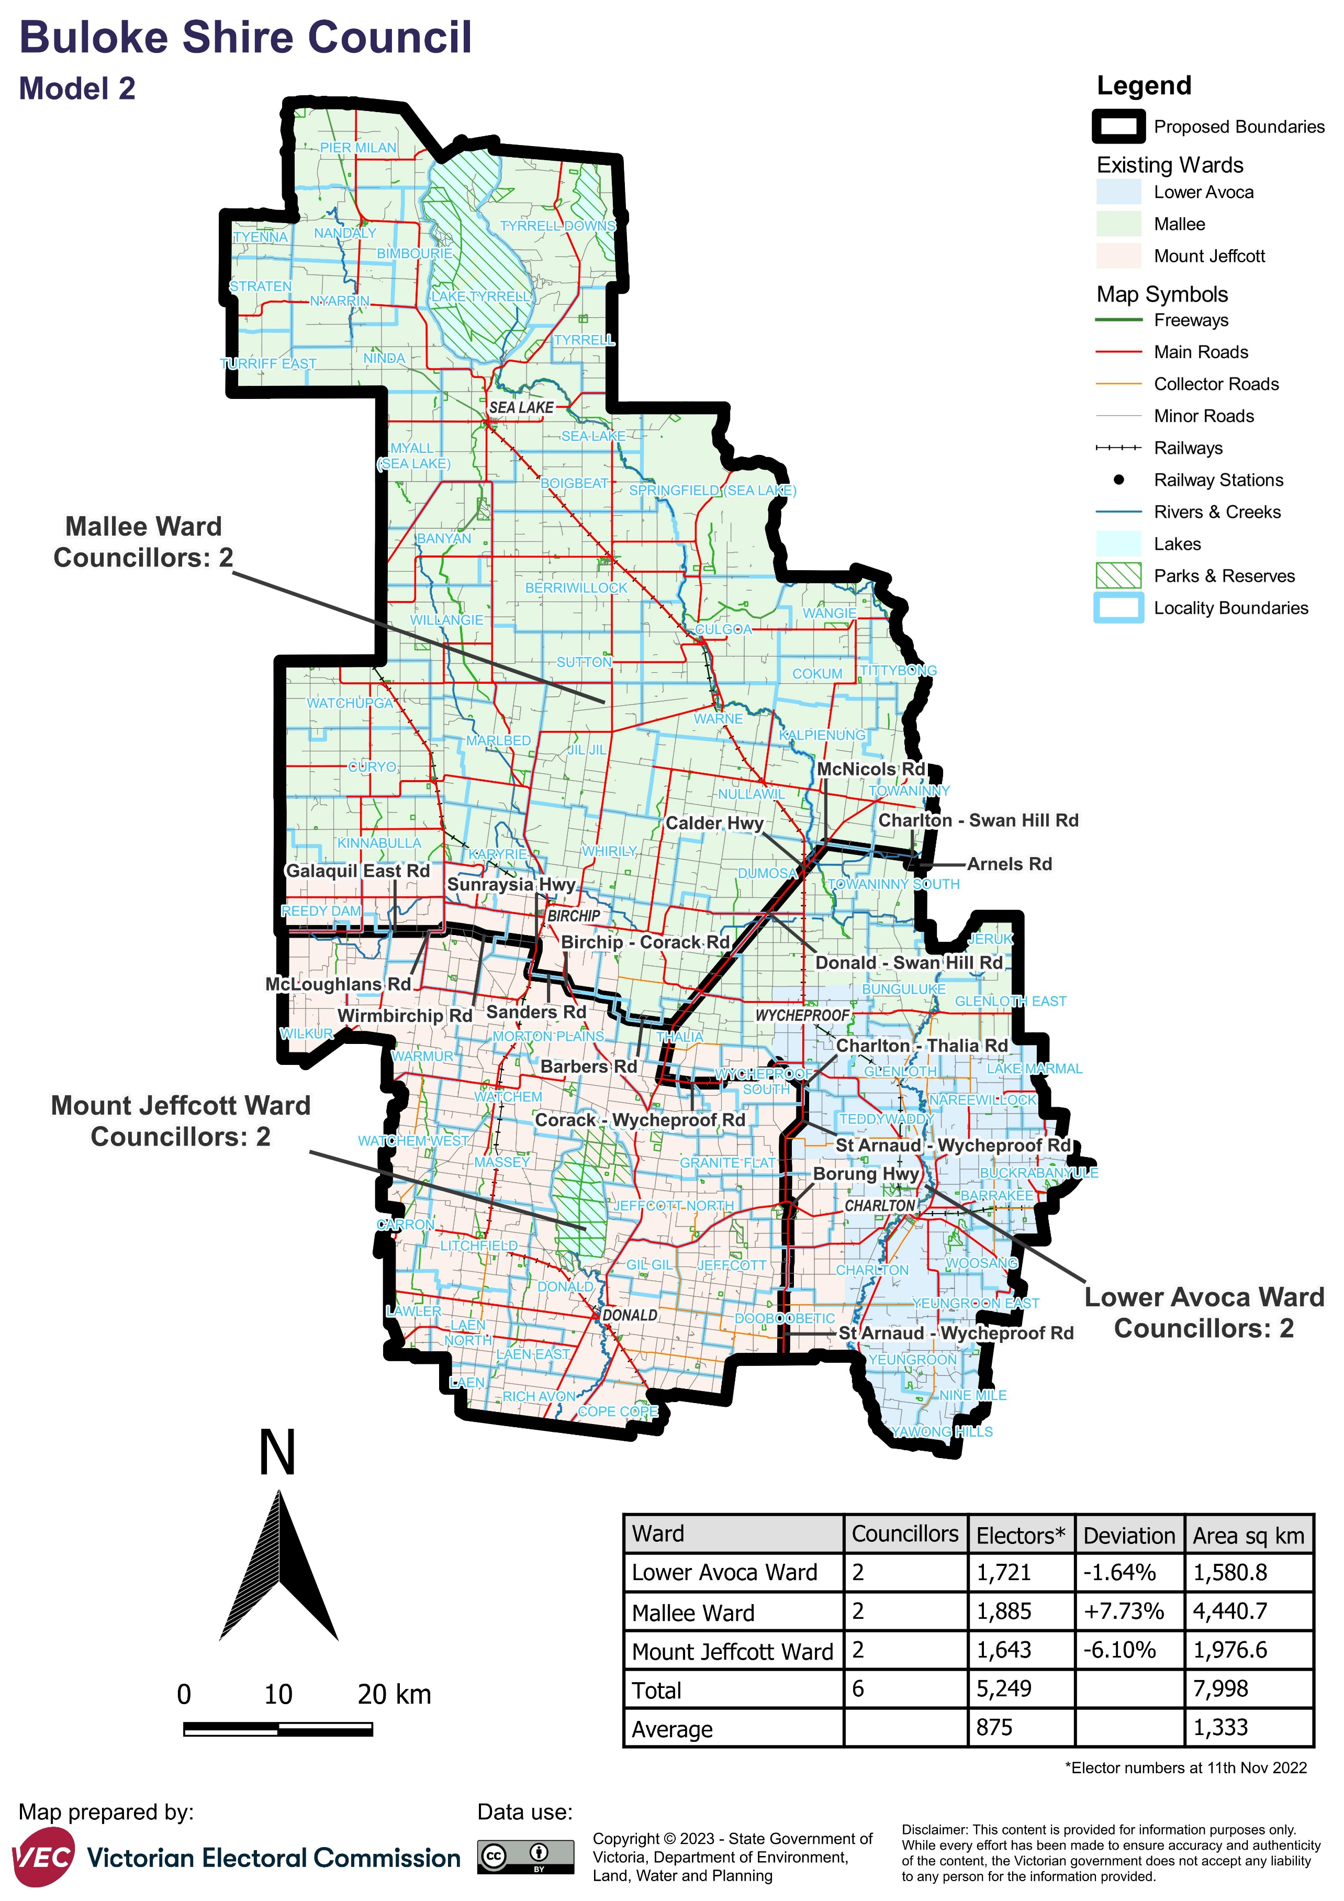

# Appendix 2: Additional models considered

The following models were closely considered by the panel but are not being put forward for further public consultation.   
See Models considered but not put forward for further information.

*A subdivided electoral structure comprising 7 single-councillor wards*

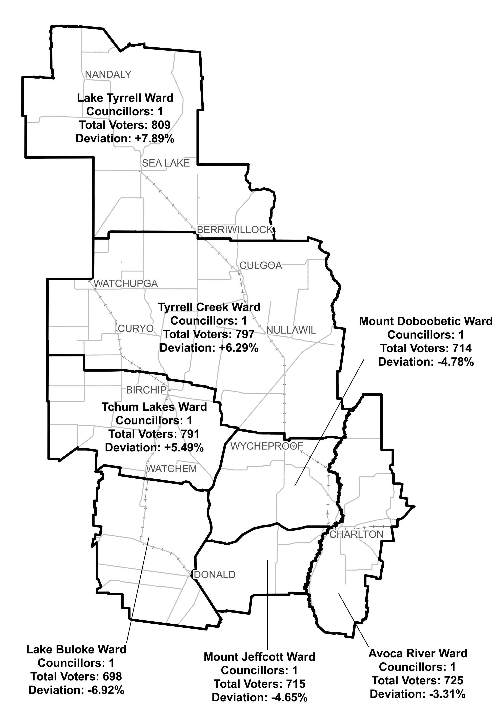

*A subdivided electoral structure comprising 5 single-councillor wards*

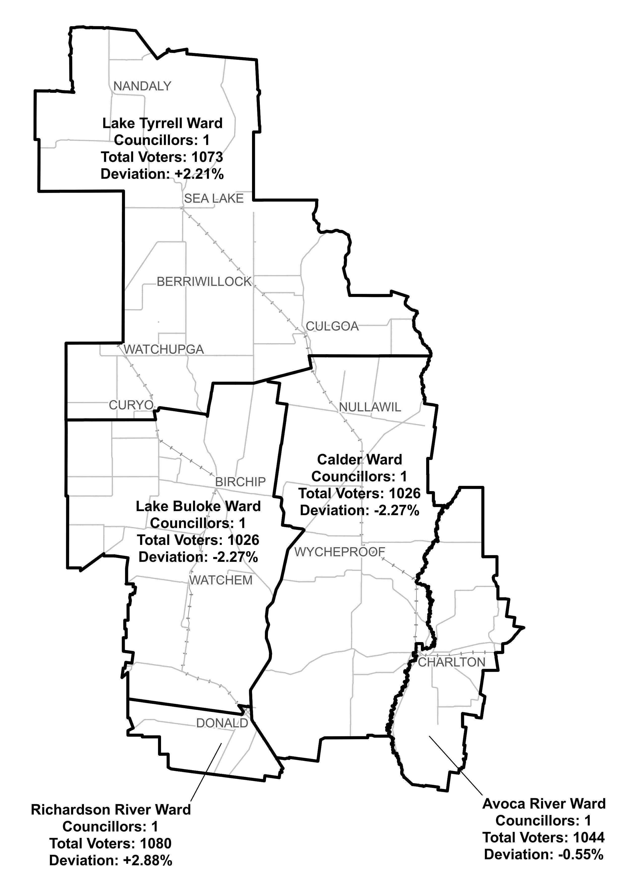

# Appendix 3: List of preliminary submitters

The review received 4 preliminary submissions.

Preliminary submissions were made by:

Buloke Shire Council

Duke, Martin

Getley, Dr Alan Kelvin

Hogan, Bernadette (Councillor, Buloke Shire Council)