October 2023

Moonee Valley City Council

Local council electoral structure review

Preliminary   
Report

Acknowledgement of Country

The electoral representation advisory panel acknowledges the Wurundjeri People as the Traditional Custodians of the lands and waters for which it is holding this review and pays respects to ancestors and Elders past, present and emerging. The panel acknowledges their custodianship for many thousands of years and their continuing living culture.

Report approval

|  |  |  |
| --- | --- | --- |
| **Version** | **Date approved** | **Approved by** |
| 1 | 11 October 2023 | Ms Julie Eisenbise |
| 1 | 11 October 2023 | Mr Tim Presnell |
| 1 | 10 October 2023 | Ms Dana Fleming |

Version approval

|  |  |  |  |
| --- | --- | --- | --- |
| **Version** | **Date approved** | **Approved by** | **Brief description** |
| 1 | 13 October 2023 | Program Sponsor | Final proofread and confirmed for publication |

Contents

Executive summary 4

Developing electoral structure models 4

Electoral structure models 4

Next steps 4

Background 6

About the 2023–24 electoral structure reviews 6

The electoral representation advisory panel 6

Public engagement 6

Developing recommendations 7

About Moonee Valley City Council 11

Profile 11

Current number of councillors and electoral structure 12

Last electoral structure review 12

Preliminary findings and models 13

Number of councillors 13

Electoral structure 13

Models for public feedback 16

Ward names 16

Next steps 18

Response submissions 18

Public hearing 19

Final report 19

References 20

Appendix 1: Model maps 21

# Executive summary

An electoral structure review panel appointed by the Minister for Local Government is reviewing the electoral structure of Moonee Valley City Council.

The purpose of the review is to advise the Minister on the appropriate number of councillors and electoral structure, including ward names, for the council.

Under Victoria’s *Local Government Act 2020* (the Act), Moonee Valley City Council must now have a single-councillor ward electoral structure.

The panel is looking at:

* + the appropriate number of councillors and wards for the council
  + the location of ward boundaries
  + appropriate ward names.

This report outlines the preliminary models the panel is presenting for public consultation for the proposed new electoral structure of Moonee Valley City Council to meet the requirements of the Act.

More information about the background to the review is available on page 6.

## Developing electoral structure models

The panel considered a range of factors when deciding on the models in this report, including:

* + research and analysis
  + voter growth or decline over time.

More information on the way the panel decided the models is available on page 14.

## Electoral structure models

After considering research and the requirements of the Act, the panel is presenting the following electoral structure models for public consultation:

* Model 1: a subdivided electoral structure with a total of 9 councillors – 9 wards with one councillor per ward.
* Model 2: a subdivided electoral structure with a total of 9 councillors – 9 wards with one councillor per ward, with different ward boundaries to Model 1.

Details on these models, including maps, are available in Appendix 1.

## Next steps

The panel is now seeking feedback on the preliminary electoral structure models. You can make a response submission to the preliminary models until 5 pm Wednesday 8 November 2023. If any response submitters wish to speak at a public hearing, the panel will hold an online public hearing on Tuesday 14 November 2023. Following this, the panel will present its final recommendation to the Minister on Wednesday 13 December 2023.

More information about the review process is available on the Victorian Electoral Commission (VEC) website at [vec.vic.gov.au](https://www.vec.vic.gov.au/electoral-boundaries/council-reviews/electoral-structure-reviews/councils-under-review).

# Background

## About the 2023–24 electoral structure reviews

In October 2022, the Minister for Local Government formed 2 electoral representation advisory panels to review and provide advice on the electoral structures of 39 local councils, under section 16 of the Act. If the Minister accepts the electoral structure recommended by the panel, any changes are expected to take effect at the October 2024 local council elections.

The Act introduced several changes to local government representation, including the types of electoral structures local councils may have. All metropolitan, interface and regional city councils (including Moonee Valley City Council) must now have single-councillor ward electoral structures.

For Moonee Valley City Council, the panel is examining:

* the number of councillors and wards
  + where the ward boundaries should be
  + the name of each ward.

The Act requires electoral structures to provide fair and equitable representation and facilitate good governance. Each ward must have an approximately equal number of voters per councillor (within +/-10% of the average). While conducting the review, the panel also notes the role of a councillor as specified under section 28 of the Act.

## The electoral representation advisory panel

The panel conducting the electoral structure review of Moonee Valley City Council has 3 members:

* Ms Julie Eisenbise (Chairperson)
* Mr Tim Presnell
* Deputy Electoral Commissioner Ms Dana Fleming.

The purpose of the review is to advise the Minister on the appropriate number of councillors and electoral structure, including ward names, for the council. The panel is independent of councils and the VEC.

Under the Act, the VEC is not responsible for reviewing council electoral structures but must provide administrative and technical support to the panel. The Electoral Commissioner (or their nominated representative) must be a member of each panel.

## Public engagement

### Public information program

On behalf of the panel, the VEC conducts a public information and awareness program to inform the public about the Moonee Valley City Council electoral structure review. This includes:

* + printed public notices in state-wide newspapers
  + public information sessions to outline the review process and respond to questions from the community
  + a media release to announce the start of the review
  + information on social media channels
  + website content on [vec.vic.gov.au](https://www.vec.vic.gov.au/electoral-boundaries/council-reviews/electoral-structure-reviews/councils-under-review), including:
    - current information on the review process
    - fact sheets for each council under review and a submission guide.

Moonee Valley City Council was also offered and took up the first but not the second of the following 2 optional methods to promote the reviews:

* + social media advertisements targeted at the council area
  + notifying voters in the council area subscribed to the VEC’s VoterAlert service about the start of the review and release of the preliminary report.

### Public consultation

The panel now invites input to the electoral structure review of Moonee Valley City Council via:

* + response submissions to this preliminary report
  + an online public hearing for anyone who makes a response submission to speak to the panel and expand on their submission.

Public submissions are an important part of the review process and are considered alongside other factors addressed during the review. These are outlined below.

## Developing recommendations

The electoral structure models the panel is presenting in this preliminary report comply with the Act and were developed through careful consideration of:

* + research and analysis conducted by the VEC support team, including geospatial and demographic data
  + rates or patterns of population and voter change over time, and relevant forecasts of growth or decline based on forecast information provided by .id (informed decisions, a company specialising in demographics and forecasting).

### Deciding on the number of councillors

The Act allows local councils to have between 5 and 12 councillors, but neither the Act nor the Local Government (Electoral) Regulations 2020 specify how to determine the appropriate number of councillors. Therefore, the models put forward by the panel in this report are guided by the Act’s intention for fairness and equity in voter representation.

In examining the appropriate number of councillors for Moonee Valley City Council, the panel considered the following criteria:

* + the population and number of voters in the council area, compared to other councils with a similar population size and number of voters in the same category (for example, other comparable metropolitan, interface or regional city councils)
  + patterns of population change and voter growth or decline in the council area over time
  + the current and past numbers of councillors
  + the representation needs of the communities of interest in the council area.

The panel’s final recommendation will also consider any matters raised in public response submissions not already listed above.

Local councils with a larger number of voters will often have more councillors. Large populations generally have greater diversity, both in the type and number of communities of interest and issues relating to representation. However, the ideal number of councillors can also be influenced by the circumstances of each council, such as the:

* + nature and complexity of services the council provides
  + geographic size and topography of the area
  + forecast population and voter growth or decline
  + social diversity.

### Deciding the electoral structure

Under the Act, regional city, metropolitan and interface councils must now have single-councillor ward electoral structures.

When developing single-councillor ward models for Moonee Valley City Council, the panel considered these criteria:

* + whether the structure would comply with section 15(2) of the Act (see below), and for how long it would likely comply
  + the appropriate number of councillors, as outlined above
  + whether meaningful and effective ward boundaries could be established and whether these would be easily identifiable to local communities
  + the representation of communities of interest
  + the voter distribution and physical features of the area, and the impact these may have on the shape and size of wards
  + past elections for the council, including:
    - numbers of candidates nominating
    - incidences of uncontested elections
    - rates of informal voting.

The panel’s final recommendation will also consider any matters raised in public response submissions not already listed above.

Under section 15(2) of the Act, subdivided structures must aim for an approximately equal number of voters per councillor in each ward. This means the number of voters represented by each councillor in a ward should be within +/-10% of the average number of voters per councillor for all wards.

During this review, the panel aims to recommend a structure that will comply with section 15(2) at the time of the 2024 local council elections and, if possible, also comply based on voter numbers at the time the review is conducted. The panel uses forecasts of population and voter change to assess compliance at the 2024 elections with as much accuracy as possible. In some cases, population change and other factors impacting voter numbers mean it is not possible to create compliant subdivided structures based both on voter numbers that were current at the time of the review and forecast voter numbers. In these instances, the panel prioritises compliance at the 2024 local government elections to ensure each vote will have approximately equal value at the 2024 election.

One of the factors that may impact compliance with section 15(2) is the number of current and forecast voters with ratepayer-based voting entitlements, also known as council-enrolled electors. Voters’ rolls include both state-enrolled electors (the majority of the roll) and a smaller number of council-enrolled electors. The Act introduced changes to ratepayer-based entitlement categories, which come into full effect at the 2024 local council elections. The panel will take this change to the makeup of voters’ rolls, and therefore compliance with section 15(2) of the Act, into consideration during this review.

### Deciding on ward names

The panel takes the following approach to naming wards:

1. The panel retains existing ward names if these are still relevant to the area covered by the ward.
2. When a new name is required, the panel bases this on features such as:
   * + places (registered under the *Geographic Place Names Act 1998*) in the ward
     + compass directions
     + native flora or fauna.

### Use of Aboriginal language

The panel recognises that there should be meaningful consultation with local Aboriginal communities and groups before a ward is named using Aboriginal language. Meaningful consultation is a significant process that the panel is not able to undertake within the timeframes of the current review program.

The panel also recognises that many of the place names in current use across Victoria are based on Aboriginal language. As such, the panel may put forward new ward names using Aboriginal language if:

* it is the name of a place within a ward
* it is currently in common use

and

* the name is registered under the *Geographic Place Names Act 1998*.

Unregistered names using Aboriginal language have not been put forward by the panel as new ward names. While the panel supports the adoption of names based on Aboriginal language, this requires appropriate consultation.

Accordingly, for the panel to consider an Aboriginal language ward name that is suggested in a public submission to the review, the name submitted needs to comply with the above guidelines.

# About Moonee Valley City Council

## Profile

The City of Moonee Valley is located 4 to 13 kilometres northwest of the Melbourne CBD and covers an area of approximately 43km2. It shares its eastern boundary along Moonee Ponds Creek with Merri-bek City Council and part of Flemington with Melbourne City Council. The Maribyrnong River forms the southern boundary with Maribyrnong City Council and to the west it is separated from Brimbank City Council by roads, rail and natural features.

The Traditional Custodians of the land are the Wurundjeri People of the Kulin Nation.

### Landscape

About two-thirds of the council area is dedicated to residential housing. With the exception of Keilor East on the western side, the most populated suburbs – Essendon, Keilor East, Moonee Ponds and Ascot Vale – are located in the southeast. They contain the highest proportion of medium to high density housing in the area. The council area has multiple commercial centres, mainly in the southeast. The largest is in Moonee Ponds.

Essendon Fields is in the northeast. It takes up a large area and is a commercial precinct. In the northeast, the Calder and Tullamarine Freeways provide important transport beyond the boundaries of the council area. Moonee Valley Racecourse is in the southeast. In Flemington, there is high rise public housing in the southeast corner of Racecourse Road and Crown Street. There are several train lines and tram services in the council area, mostly in the south and east. The Maribyrnong River is on the southern boundary and adjacent parkland is used for recreational activities.

### Population and community

In 2021, the population of the council area was about 122,000 (ABS 2022). Between 2022 and 2028 the population is estimated to grow at a rate of 1.5% per year and is expected to reach 166,143 by 2041. The highest population growth has been forecast in Moonee Ponds and its surrounds, where further housing developments are planned.

High-density living is more common in the council area than for Greater Melbourne overall; apartments make up 23% of all dwellings compared with 15.6% in Greater Melbourne (ABS 2022). Most high-density housing is concentrated in the southeast of the council area, from Travancore up through to Essendon, whereas in the west, in Keilor East and Avondale Heights, houses predominate (ABS 2022).

The municipality is culturally diverse, with nearly one-third of the population born overseas and over a third speaking a language other than English at home (ABS 2022). After English, the most common languages spoken are Italian, Greek and Vietnamese (ABS 2022). The proportion of the population identifying as Aboriginal and/or Torres Strait Islander is 0.5%, similar to the Greater Melbourne average of 0.7% (ABS 2022).

The median weekly household income ($2,011) is higher than that of Greater Melbourne ($1,901) (ABS 2022). The overall rate of home ownership in the council area is similar to that of Greater Melbourne, though a higher proportion of homes is owned outright (34.2% compared to 29.7% in Greater Melbourne) (ABS 2022).

## Current number of councillors and electoral structure

The municipality is currently divided into 3 wards with a total of 9 councillors:

* one ward with 3 councillors (Buckley)
* one ward with 3 councillors (Myrnong)
* one ward with 3 councillors (Rose Hill)

***Diagram of Moonee Valley City Council showing the current electoral structure showing three wards with three councillors each. Ward names are Rose Hill Ward, Buckley Ward and Myrnong Ward. 
***

***Figure 1:*** *Diagram of current electoral structure of Moonee Valley City Council*

There are approximately 93,217 voters in Moonee Valley City Council, with an approximate ratio of 10,357 voters per councillor.

Visit the VEC website at [vec.vic.gov.au](https://www.vec.vic.gov.au/electoral-boundaries/council-reviews/electoral-structure-reviews) for more information on Moonee Valley City Council.

## Last electoral structure review

The VEC conducted an electoral representation review of Moonee Valley City Council in 2015. This review was carried out under the *Local Government Act 1989* (Vic), which was replaced by the *Local Government Act 2020* (Vic).

After conducting the review, the VEC recommended that Moonee Valley City Council continue to consist of 9 councillors elected from 3 wards, but with minor variations to the ward boundaries.

Visit the VEC website at [vec.vic.gov.au](https://www.vec.vic.gov.au/electoral-boundaries/council-reviews/electoral-structure-reviews) to access a copy of the final report of the 2015 electoral representation review.

# Preliminary findings and models

## Number of councillors

After taking into consideration the requirements of the Act and the agreed criteria, the panel found 9 councillors to be an appropriate number for Moonee Valley City Council.

The panel considered the characteristics of the Moonee Valley City Council in relation to similar councils, including its population, the number and distribution of voters, and the size and geography of the council.

|  |  |  |  |  |  |  |
| --- | --- | --- | --- | --- | --- | --- |
| Similar metropolitan councils to Moonee Valley City Council | | | | | | |
| Local council | Area (km2) | Number of voters at 2020 election | Population (2021 Census) | Current total estimate of voters | Number of councillors | Number of voters per councillor |
| Glen Eira City* | 39 | 105,230 | 148,908 | 106,181 | 9 | 11,797 |
| Greater Dandenong City | 130 | 99,768 | 158,208 | 100,580 | 11 | 9,144 |
| Port Phillip City* | 21 | 88,268 | 101,942 | 97,755 | 9 | 10,861 |
| Banyule City | 63 | 95,510 | 126,236 | 95,151 | 9 | 10,572 |
| Moonee Valley City* | 43 | 93,923 | 121,851 | 93,217 | 9 | 10,357 |
| Manningham City | 113 | 87,255 | 124,700 | 87,278 | 9 | 9,698 |
| Stonnington City* | 26 | 89,600 | 104,703 | 86,821 | 9 | 9,646 |
| Maroondah City | 61 | 85,275 | 115,043 | 85,033 | 9 | 9,448 |

*These local councils are undergoing an electoral structure review in 2023–24.

### Maintaining 9 councillors

The panel considered it appropriate to maintain the current number of councillors (9) because metropolitan councils with a similar number of voters have 9 councillors. Only modest population growth (1.5% pa) is forecast for the municipality and there are no special circumstances, such as a high level of social disadvantage or a high level of cultural diversity.

## Electoral structure

To identify the most appropriate electoral structure, various factors were considered. This included the requirements of the Act, the communities of interest in Moonee Valley City Council, the appropriateness of ward boundaries and which models offered the best potential for fair and equitable representation and consequently facilitate good governance.

In developing the preliminary models presented in this report, the panel considered a range of models. The strongest 2 models have been put forward for further public comment.

The panel proposes 2 models for the consideration of the Moonee Valley City Council community:

* a subdivided electoral structure of 9 single-councillor wards (Model 1)
* a subdivided electoral structure of 9 single-councillor wards, with different ward boundaries to Model 1 (Model 2)

Diagrams of the preliminary models are included in Appendix 1.

### A single-councillor ward structure with 9 councillors (Model 1)

### Model 1 is a single-councillor ward structure with 9 councillors.

Under this model, Moonee Valley City Council would adopt a 9-ward electoral structure. Each ward would be represented by one councillor, in line with the requirements of the Act.

Model 1 largely divides the 3 current multi-councillor wards into 9 single-councillor wards. Due to the greater number of voters in Windy Hill Ward, a section of Essendon had to be placed in the proposed Queens Lake Ward.

The panel supported submitting Model 1 for public consultation because, with the exception of Queens Lake, it mostly maintained each suburb within a single ward. The panel also considered that the division of the 3 current wards into 9 single-councillor wards might provide electoral boundaries that are more familiar to voters. The panel further considered that Model 1 balances the areas of disadvantage in Avondale Heights and Keilor East in the west and Ascot Vale, Flemington and Moonee Ponds to the southeast, across wards. Keeping Puckle Street, Moonee Ponds within a single ward was also considered to be a benefit of Model 1.

The drawbacks of Model 1 were identified to be some irregularly shaped wards and a rail line dividing the proposed Fairbairn, Myrnong, Queens Lake and Windy Hill Wards. Given the need to divide the more densely populated area in the southeast of the council area across 2 to 3 wards, the panel is particularly interested to receive feedback on the approach adopted for this area in Model 1, including the use of Mount Alexander Road as a ward boundary.

### A single-councillor ward structure with 9 councillors (alternative version) (Model 2)

Under this model, Moonee Valley City Council would adopt a 9-ward structure. Each ward would be represented by one councillor, in line with the requirements of the Act.

Model 2 uses infrastructure and natural features including main roads, rail lines and waterways as ward boundaries. The panel considered that Model 2 may be better than Model 1 at keeping suburbs together because the use of main roads, rail lines and waterways as boundaries means that those features do not separate suburbs within wards.

The drawbacks of Model 2 are that it is less stable than Model 1, with larger deviations projected for 2024. The panel considered that the shape and size of wards in Model 2 were less uniform and compact than the wards in Model 1 and that having disadvantaged areas largely contained in the proposed Milleara and Walter Wards might not be favoured by local communities. Again, the panel is interested in receiving public feedback, particularly with respect to the proposed division of the area in the southeast, including whether the rail line would provide a better boundary between Myrnong and Walter Wards.

### Summary

In summary, introducing single-councillor wards represents a large electoral structure change for Moonee Valley City Council. Achieving models that divide communities into appropriate wards while also accounting for population growth and ensuring they comply with the +/-10% requirement can be challenging.

Balancing the densely populated areas in the southeast of the council area with the more evenly spread suburbs in the west and the large area covered by Essendon Airport in the north to create 9 single-councillor wards proved particularly difficult.

Model 1 uses suburb boundaries where possible to create 3 wards of similar size in the west and a large ward in the north capturing the suburbs of Essendon Fields, Essendon North and Strathmore. The large suburb of Essendon is captured across two wards, one of which also includes the smaller suburb of Aberfeldie. The southeast is divided into 3 wards capturing the 3 main areas of Moonee Ponds, Ascot Vale and Flemington-Travancore. The use of suburb boundaries ensures that most suburbs are kept within a single ward, especially in the north and west of the council area. In the southeast, it was not possible to maintain suburb boundaries to the same extent, and some suburbs are split between wards, which may divide communities and major commercial centres.

In Model 2, the use of infrastructure and natural features resulted in the division of more suburbs between wards than is the case for Model 1. Calder and Tullamarine Freeways are used to clearly demarcate the north ward to capture Essendon Fields and Airport West. The west is divided into 3 wards using main roads and Steele Creek to create 3 similarly sized north-south oriented wards. In the east and southeast, the rail line is adopted as a continuous boundary. Further north, a ward is created to capture part of Essendon and the suburbs south of Essendon Fields Airport. While strong ward boundaries are adopted throughout, some suburbs are divided between wards and the use of a rail line as a ward boundary results in some awkwardly shaped wards and the division of commercial activities in the southeast across 4 wards.

## Models for public feedback

The panel considers all models outlined below to be the single-councillor ward electoral structures with the best potential to offer fair and equitable representation for voters in Moonee Valley City Council and consequently facilitate good governance. Please see Appendix 1 for detailed maps of these models.

### Model 1

Moonee Valley City Council has 9 councillors and is divided into 9 wards with one councillor per ward.

Ward names: Buckley Ward, Canning Ward, Essendon Fields Ward, Fairbairn Ward, Myrnong Ward, Queens Lake Ward, Roberts Ward, Rosehill Ward, Windy Hill Ward.

### Model 2

Moonee Valley City Council has 9 councillors and is divided into 9 wards with one councillor per ward.

Ward names: Aberfeldie Park Ward, Airport Ward, Buckley Ward, Milleara Ward, Myrnong Ward, Napier Ward, Queens Lake Ward, Rosehill Ward, Walter Ward.

## Ward names

The panel has suggested ward names to identify the wards in each model and invites comments from the community on these names as part of submissions responding to the preliminary report. The basis of the ward name recommendations for each model are described below.

### Model 1

The ward names Canning, Essendon Fields, Fairbairn, Roberts, Rosehill and Windy Hill are new and are based on natural features, built features, roads, rivers, creeks, lakes or localities found within each ward.

The ward names Buckley and Myrnong are the names of 2 existing wards under the current electoral structure.

### Model 2

The ward names Aberfeldie Park, Airport, Milleara, Napier, Queens Lake, Rosehill and Walter are new and are based on natural features, built features, roads, rivers, creeks, lakes or localities found within each ward.

The ward names Buckley and Myrnong are the names of 2 existing wards under the current electoral structure.

The panel will review ward name suggestions received during the response submission stage when forming the final advice to the Minister for Local Government on the electoral structure of the council. Suggested ward names should comply with the panel’s approach to naming wards (see Deciding on ward names and Use of Aboriginal language). All ward name suggestions received during the response submission stage will be provided to the Minister for consideration at the conclusion of the electoral structure review.

# Next steps

## Response submissions

Any person or group, including the local council under review, can make a response submission to the electoral representation advisory panel. In your submission you should address the models proposed by the panel in this preliminary report.

You can make a submission:

|  |  |
| --- | --- |
|  | **Online** Visit [vec.vic.gov.au](https://www.vec.vic.gov.au/electoral-boundaries/council-reviews/electoral-structure-reviews/councils-under-review) to make a submission online.  You will need to make an account to use the online Public Submission Tool and can save a draft submission to finish later. |
|  | **By email** mooneevalley.erapsubmissions@vec.vic.gov.au |
|  | **By post**  Electoral Representation Advisory Panel c/o Victorian Electoral Commission Level 11, 530 Collins St Melbourne VIC 3000 |

The panel must receive all response submissions before 5 pm on Wednesday 8 November 2023. If you post your submission, make sure it has enough time to reach the panel before the deadline. Late submissions will not be accepted.

### Required information

For your submission to be considered, you must include your:

* full name
* contact phone number or email address
* postal or residential address.

To protect the integrity and transparency of the review process, the panel will not consider submissions without this information. If you are submitting as a group or organisation, you must include the name of a nominated contact person who is authorised to submit on behalf of your group.

On behalf of the panel, the VEC will handle information provided by submitters in accordance with the privacy policy available at [vec.vic.gov.au/privacy](http://vec.vic.gov.au/privacy)

### Public access to submissions

To ensure transparency in the electoral structure review process, your submission will be published on the VEC website at [vec.vic.gov.au](https://www.vec.vic.gov.au/electoral-boundaries/council-reviews/electoral-structure-reviews/councils-under-review). The VEC will remove your signature and contact details, including residential and postal addresses, from all public copies but must publish your full name (or group name) and locality (suburb or town).

Please note that any submission content that is potentially defamatory, offensive, obscene or that includes the personal information of people or organisations who are not a party to the submission may also be redacted before publication.

## Public hearing

If you make a response submission, you can also ask to speak at an online public hearing to support your submission and expand on your views.

The online public hearing is scheduled for:

Time: 2 pm

Date: Tuesday 14 November 2023

The panel encourages participation in the public hearing. If you wish to speak at the public hearing, you **must** indicate this in your response submission. The public hearing will not be held if there are no requests to speak.

Anyone can attend a public hearing, but you will only be able to speak if you asked to in your response submission. If you ask to speak, the VEC will contact you to arrange a time for you to speak at the hearing. You will have 10 minutes to address the public hearing panel, which will include at least 2 of the review panel members. The members of the public hearing panel may ask you questions.

Visit the VEC website at [vec.vic.gov.au](https://www.vec.vic.gov.au/electoral-boundaries/council-reviews/electoral-structure-reviews/councils-under-review) for more information on public hearings.

## Final report

Following the public hearing, the review panel will consider all evidence gathered and prepare a final report for the Minister for Local Government containing a recommendation for the number of councillors and the electoral structure for the local council.

The final report is scheduled to be provided to the Minister on Wednesday 13 December 2023. The Minister will consider the final reports, including any determination to make the reports publicly available. Any change to the electoral structure of Moonee Valley City Council following on from this review is expected to apply at the October 2024 local council elections. Under the Act, the final council electoral structure will be set by an Order in Council published in the Victoria Government Gazette.

# References

*Geographic Place Names Act 1998* (Vic)

*Local Government Act 1989* (Vic)

*Local Government Act 2020* (Vic)

*Local Government (Electoral) Regulations 2020* (Vic)

ABS (Australian Bureau of Statistics) (2022) [*2021 Moonee Valley, Census All persons QuickStats*,](https://abs.gov.au/census/find-census-data/quickstats/2021/LGA25060) ABS, accessed 1 September 2023

# Appendix 1: Model maps

The following maps are included in this report:

|  |  |
| --- | --- |
| Map | Page |
| Model 1 – a single-councillor ward structure with 9 councillors – 9 wards with one councillor per ward. | 22 |
| Model 2 – a single-councillor ward structure with 9 councillors – 9 wards with one councillor per ward (with boundaries different to Model 1). | 24 |

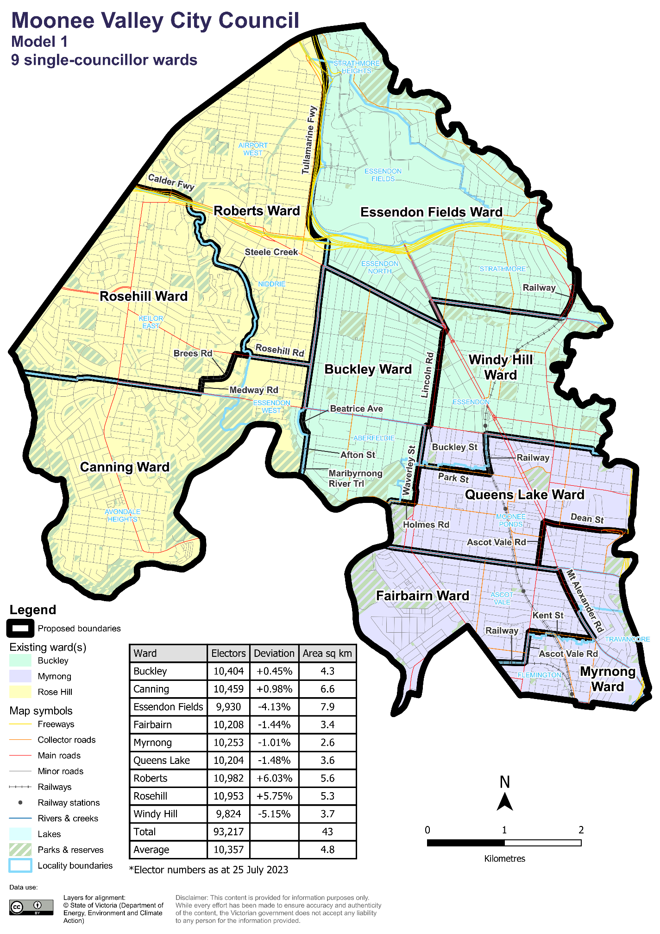

#### Data for Model 1

|  |  |  |  |
| --- | --- | --- | --- |
| Ward | Electors* | Deviation | Area# (square km) |
| Buckley Ward | 10,404 | +2.43% | 4.3 |
| Canning Ward | 10,459 | +1.89% | 6.6 |
| Essendon Fields Ward | 9,930 | -5.30% | 7.9 |
| Fairbairn Ward | 10,208 | +0.88% | 3.4 |
| Myrnong Ward | 10,253 | -4.85% | 2.6 |
| Queens Lake Ward | 10,204 | -1.48% | 3.6 |
| Roberts Ward | 10,982 | +6.52% | 5.6 |
| Rosehill Ward | 10,953 | +6.22% | 5.3 |
| Windy Hill Ward | 9,824 | -7.51% | 3.7 |
| **Total** | 93,483 | **n/a** | 43 |
| **Average** | 10,387 | **n/a** | 4.8 |

*Elector numbers as at 25 July 2023

#Ward area (square km) and total council area is measured at level of accuracy required for electoral boundaries. This may vary slightly from other data sources (e.g. ABS).

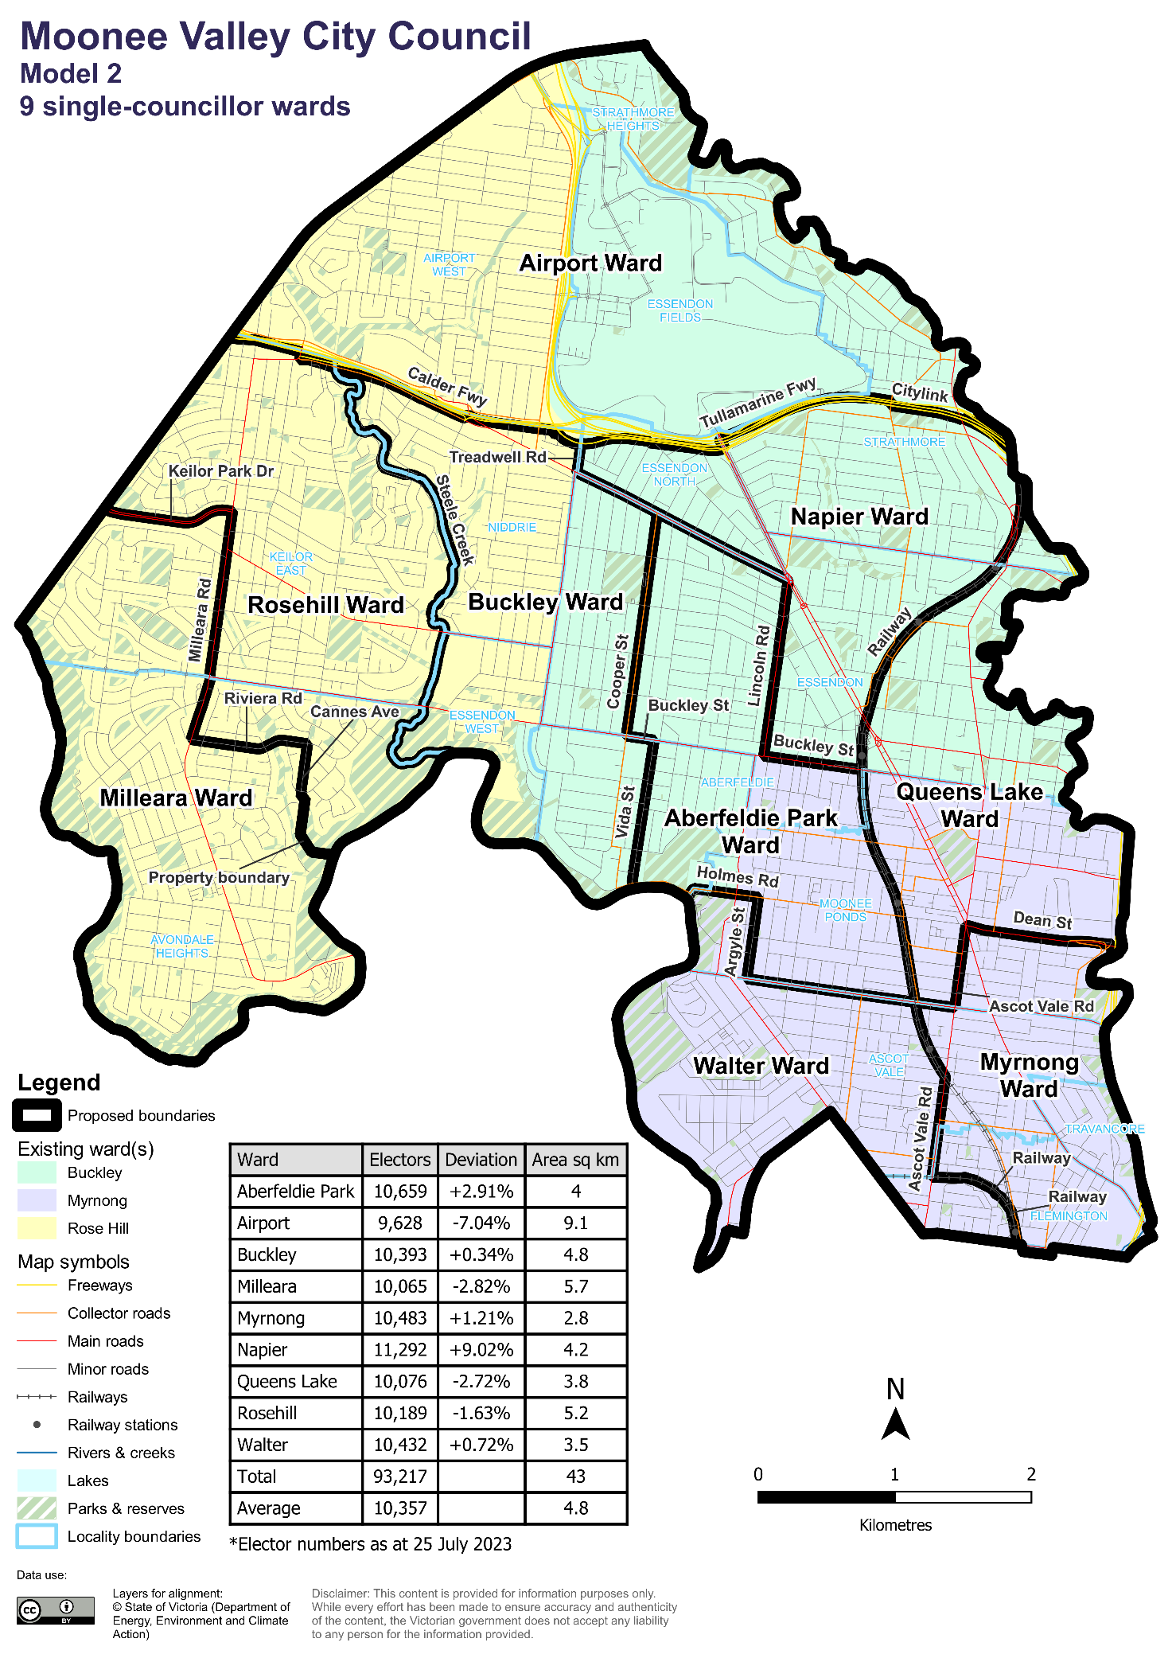

#### Data for Model 2

|  |  |  |  |
| --- | --- | --- | --- |
| Ward | Electors* | Deviation | Area# (square km) |
| Aberfeldie Park Ward | 10,659 | +4.05% | 4 |
| Airport Ward | 9,628 | -6.08% | 9.1 |
| Buckley Ward | 10,659 | +4.05% | 4.8 |
| Milleara Ward | 10,065 | -2.04% | 5.7 |
| Myrnong Ward | 10,483 | -3.04% | 2.8 |
| Napier Ward | 11,292 | +5.86% | 4.2 |
| Queens Lake Ward | 10,076 | -3.02% | 3.8 |
| Rosehill Ward | 10,189 | -1.15% | 5.2 |
| Walter Ward | 10,432 | +3.53% | 3.5 |
| **Total** | 93,483 | **n/a** | 43 |
| **Average** | 10,387 | **n/a** | 4.8 |

*Elector numbers as at 25 July 2023

#Ward area (square km) and total council area is measured at level of accuracy required for electoral boundaries. This may vary slightly from other data sources (e.g. ABS).

Forecast information referred to in the text of this report is based on forecasts prepared by .id – informed decisions [id.com.au](http://id.com.au) .id and its licensors are the sole and exclusive owners of all rights, title and interest subsisting in that part of the report content where .id are identified. Some of .id content is a derivative of ABS Data, which can be accessed from the website of the Australian Bureau of Statistics at [abs.gov.au](http://abs.gov.au), and licensed on terms published on the ABS website.