South Gippsland Shire Council Election
Voter education guidebook
(Easy English)
October 2021

The Victorian Electoral Commission (V.E.C) has created this guidebook to help people who may have limited ability to read and/or understand written English to participate in the October 2021 South Gippsland Shire Council election.
The guidebook is designed as a co-read product and is best implemented by a supporter who can read through the information and relate it to the matching pictures, to support a person in their learning.
The worksheets are designed to introduce people to voting, and how to make their vote count in Victoria.

More information
There are Easy English booklets about
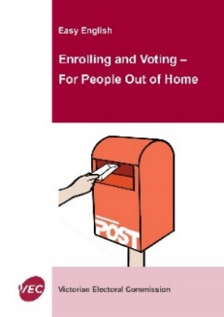

- People Out of home

- What happens if I do not vote?

Contact the V.E.C
You can get more information from the Victorian Electoral Commission (the V.E.C).
Phone 131 832
Website vec.vic.gov.au
Email info@vec.vic.gov.au

About this election

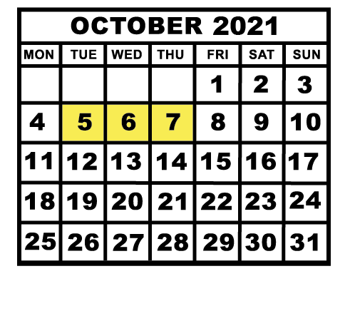
South Gippsland Shire Council will be having an election in October this year.
The election will be a postal election.
This means you will get a ballot pack in the mail. Ballot packs will be mailed between Tuesday 5 and Thursday 7 October 2021.
The Victorian Electoral Commission run the election.

A local council election is when you choose people who will make decisions about services and activities where you live.
These people are called councillors.

What councillors do
Your councillors make decisions about
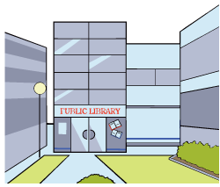
- parks and sporting grounds
- community services
- libraries
- roads and footpaths
- rubbish and recycling
- public buildings and halls
- building and construction
- dog and cat registration.

How are councillors chosen?

For local council elections, some people in the local area say they want to be a councillor.
You choose the people you think will make the best decisions about your local area.

Worksheet 1, Enrolment
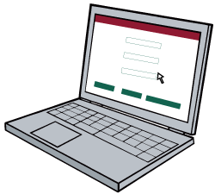
Before you vote you must get on the roll.
The roll is a list of people who can vote in the election.
To get on the roll you must enrol.

Who can enrol

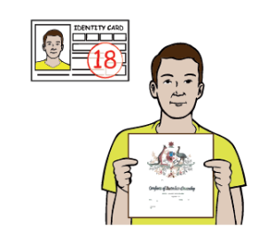
Every Australian citizen aged 18 years of age and over must enrol to vote.
Even if you cannot read or write English, you must still enrol.
You can get help from others to enrol and to vote.

You may also be able to enrol if you pay rates to another local council (from where you live) where you have a property.
Speak to your local council for more information.

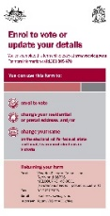
How to enrol

Enrolling means that you fill in an enrolment form with your name and details. Your details are then added to the list of people allowed to vote in an election.
You can contact us and we will send a form to you
or
you can look for the form online vec.vic.gov.au
Sign your name to show you understand the form
or get help to sign it if you need it.
Post this form to the V.E.C.
For the South Gippsland Shire Council election, the VEC must receive your enrolment form before 4 pm on Friday 27 August 2021.
We must fill this form out any time we

- move house
- change our name.

Activity 1.

Practice answering questions:
Write your first name ________________________________________
Write your last name ________________________________________
Write your date of birth _______________________________________
Write your address __________________________________________
Practice signing your name ___________________________________
Great work, you are ready to fill in an enrolment form now

Worksheet 2, Voting

What is voting?
Voting is a way for people to make a choice.
Voting is about everyone being heard.
Voting is about us all being a part of decision making in the community.

Voting is when we write our choices on a ballot paper.
We need to put our choices in an order.
We use numbers to show the order we want.
We write a different number against every person’s name.

We can get someone to help us to learn about the different people before we choose.
We need to make the choice for ourselves when we write our numbers down.

We make choices every day.

Activity 1.
What did you choose to eat today when you had breakfast?
(circle the items you had)
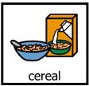  Cereal | Muffin | Coffee
Toast | Tea | Eggs
Fruit | Oats | Nothing

Activity 2.
What do you want to do today?
(circle your choice)
Sleep/ relax | 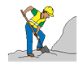  Go to work | Talk to my friend
Go shopping | Go to school | 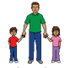  Look after family
Go to prayer | Go to gym | Watch TV

How to fill out ballot papers
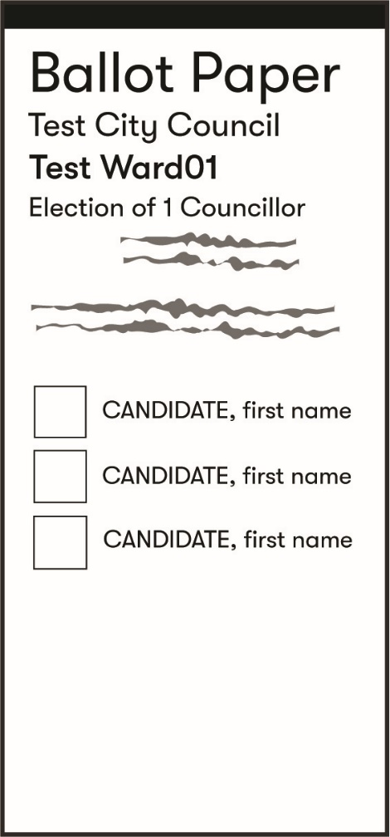
This is an example of a ballot paper.
You must write a number in each box on the ballot paper
- write 1 in the box next to the person who you want to win
- write 2 in the box next to your second choice
- keep numbering until every box has a number
- use numbers only.

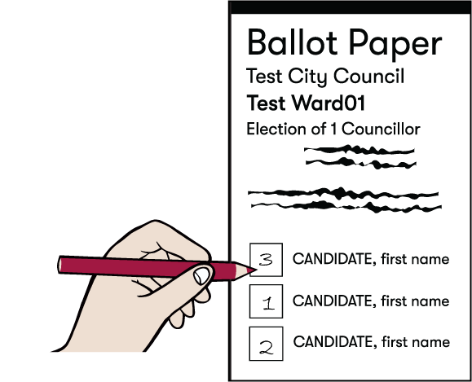
Every ballot paper can be different, so get help to read the instructions before you start.
Do not leave any box empty.

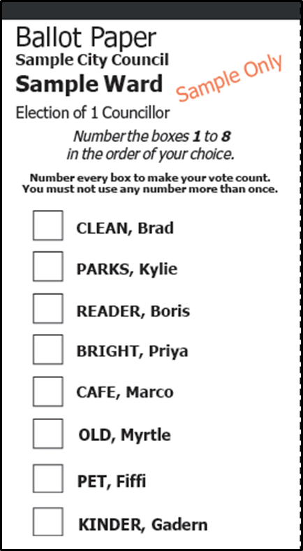
Write your numbers in order of your choice, from 1 to 8.

Make sure that you put your finished ballot paper in the return envelope and mail it before 6 pm on Friday 29 October.
Results from the election will be available by Friday 12 November 2021 at the latest.

Who can help you to vote

If voting is hard for you to do by yourself, you can get someone to help you.

You can get your family, friends or supporters to help you.
They can help you to read and understand the instructions.
They can also help you to write out your voting choices.
But YOU are the one who decides how to vote.

A helper cannot make the choices for you.
It is important to know you can get help, but you must make the choices for yourself.

Activity 3.

Who would you ask to help you to enrol and vote?

Write their name here________________________________________

How do I become a candidate?

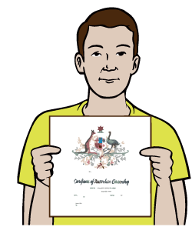
- you must be an Australian citizen
- you must be enrolled for this election.
You must fill out a form. Ask the V.E.C for the form that says you want to be a candidate.
You must pay $250. You get this money back if you win or get enough votes.
Provide your completed form and payment to the Election Manager at the V.E.C.
Some people cannot be a candidate.
Ask the V.E.C for more information.

