Local council electoral structure review

## About the review

Under Victoria’s *Local Government Act 2020*, Mildura Rural City Council must now have a single-councillor ward electoral structure.

The Minister for Local Government has appointed an electoral representation advisory panel to conduct an electoral structure review of the council. The panel will advise the Minister on the most appropriate single-councillor ward structure for Mildura Rural City Council.

The panel is looking at:

* the appropriate number of councillors and wards
* the location of ward boundaries
* appropriate ward names.

Electoral structure reviews are an important part of democracy, and your input is valuable. As a local, you know your local council area better than anyone. This is your chance to let the panel know your thoughts about the single-councillor ward electoral structure that you believe would best provide representation for your community.

There are 2 opportunities for you to have your say on the electoral structure of the council:

1. in a response submission to the preliminary report
2. at an online public hearing, if you request to speak in your response submission.

About Mildura Rural City Council

The Traditional Custodians of the land in Mildura Rural City Council are the First Peoples of the Millewa-Mallee, being Latji Latji and Ngintait Traditional Owners and the Wotjobaluk, Jaadwa, Jadawadjali, Wergaia and Jupagalk peoples.

Located in the Mallee region about 550 km north-west of Melbourne, Mildura Rural City Council is the largest municipality in Victoria, covering an area of 22,082 km².

The Murray River forms the northern boundary of the council. More than half of the council area is covered by parkland, including the Hattah-Kulkyne, Murray-Sunset and Wyperfeld national parks. Much of the remaining land within the council is used for primary production, primarily of fruit, nuts and grain.

Major roads including the Sturt, Mallee, and Calder highways service the council area, as well as Mildura Airport – the state’s largest and busiest regional airport.

Health care, agriculture, manufacturing and construction are major industries, both in terms of employment and economic output.

The council had a population of 56,972 in the 2021 Census and this is forecast to grow at an annual rate of 0.8% from 2022 to 2028. The median age of the population in 2021 was 40 years, lower than the median age for the whole of rural and regional Victoria, which is 43 years.

Mildura is culturally diverse, with approximately 14% of the population born overseas and approximately 12% speaking a language other than English at home in 2021. Aboriginal or Torres Strait Islander people comprised 4.5% of the population in 2021, higher than for rural and regional Victoria overall (2%).

## Current structure

Mildura Rural City Council is an unsubdivided municipality with a total of 9 councillors.

## Last review

The VEC conducted an electoral representation review of Mildura Rural City Council in 2015.

Visit the VEC website at [vec.vic.gov.au](https://www.vec.vic.gov.au/) to access a copy of the 2015 review final report.

Review process

Monday 26 and Tuesday 27 June

### Information sessions

Session 1: 12 noon, Monday 26 June

Session 2: 6 pm, Tuesday 27 June

Information sessions are for anyone wanting to find out more about the review process. Links to register for an information session will be available on the VEC website.

Wednesday 28 June

### Preliminary report

The panel will release a preliminary report including one or more options for the electoral structure on Wednesday 28 June.

**Response submissions open from this date.**

Wednesday 19 July

### Response submissions close

The panel must receive all submissions by 5 pm on Wednesday 19 July.

Late submissions will not be accepted.

Wednesday 26 July

### Public hearing

The panel will hold an online public hearing if anyone requests to speak about their response submission at 2 pm on Wednesday 26 July.

The public hearing will not be held if there are no requests to speak.

Wednesday 23 August

### Final report

The panel will submit a final report to the Minister for Local Government including its advice on the electoral structure on Wednesday 23 August.

The Minister will then consider the panel’s advice before recommending a change to the electoral structure. Any change to the electoral structure of the council following the review is expected to apply at the next local council elections.

## Untitled-1How to make a submission

On the VEC website at [vec.vic.gov.au](http://vec.vic.gov.au/)

By email to

[Mildura.ERAPSubmissions  
@vec.vic.gov.au](mailto:Mildura.ERAPSubmissions@vec.vic.gov.au?subject=Mildura%20Rural%20City%20Council%20Electoral%20Structure%20Review)

LetterBy post to

Electoral representation advisory panel  
c/o Victorian Electoral Commission  
Level 11, 530 Collins Street  
Melbourne VIC 3000

Submissions must include your:

* full name
* contact phone number or email address
* residential or postal address.

All submissions will be published on the VEC website. Your name and locality (suburb or town) will be published, but your full address and contact details will be removed. See the submission guide and VEC website at [vec.vic.gov.au/privacy](https://www.vec.vic.gov.au/privacy) for privacy information.

## Submission guide

Download the submission guide from the VEC website at [vec.vic.gov.au](http://vec.vic.gov.au/) for more information on the review process and making a submission.

## One vote, one value

The ‘one vote, one value’ democratic principle is enshrined in the *Local Government Act 2020*. This means that every person’s vote counts equally.

When a local council area is subdivided into wards, the number of voters each councillor represents in each ward must be within plus-or-minus 10% of the of the average number of voters per councillor for all the wards.

The map below includes the current number of voters in each ward and the ward’s current deviation from the average. The panel will consider likely population and voter changes to ensure the structure remains equitable.

If you make a submission online, you can use a mapping tool to build your preferred electoral structure. The tool uses current voter numbers to tell you the deviations of the wards you make. This will help you propose a structure that meets the requirements of the Act.

Current electoral structure

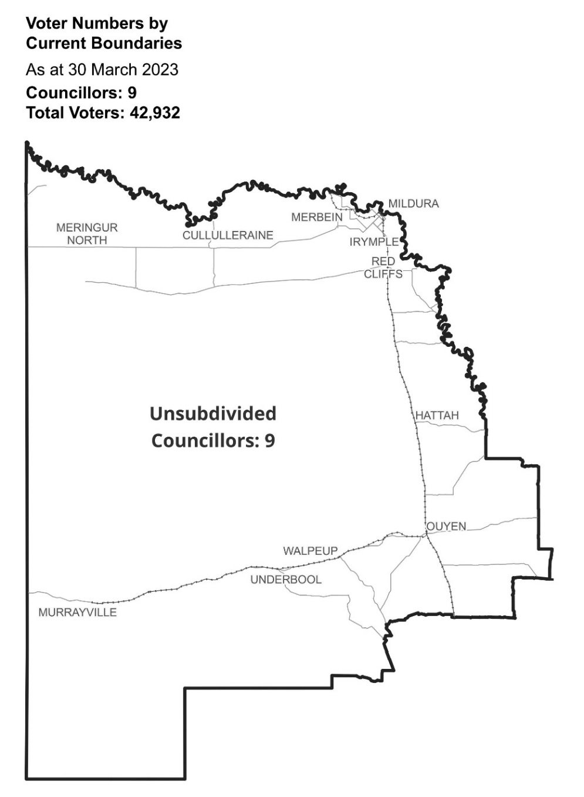

|  |  |  |  |
| --- | --- | --- | --- |
| Ward | Councillors | Voters | Deviation |
| Unsubdivided | 9 | 42,932 | n/a |

## Statistics

Area (km2) 22,082

Voters

### Voters per square km

1.9

### Average voters per councillor

4,770

Population

### Current population

56,972

### Forecast population growth

0.8% p.a.

Further census statistics available at [abs.gov.au](https://abs.gov.au/)

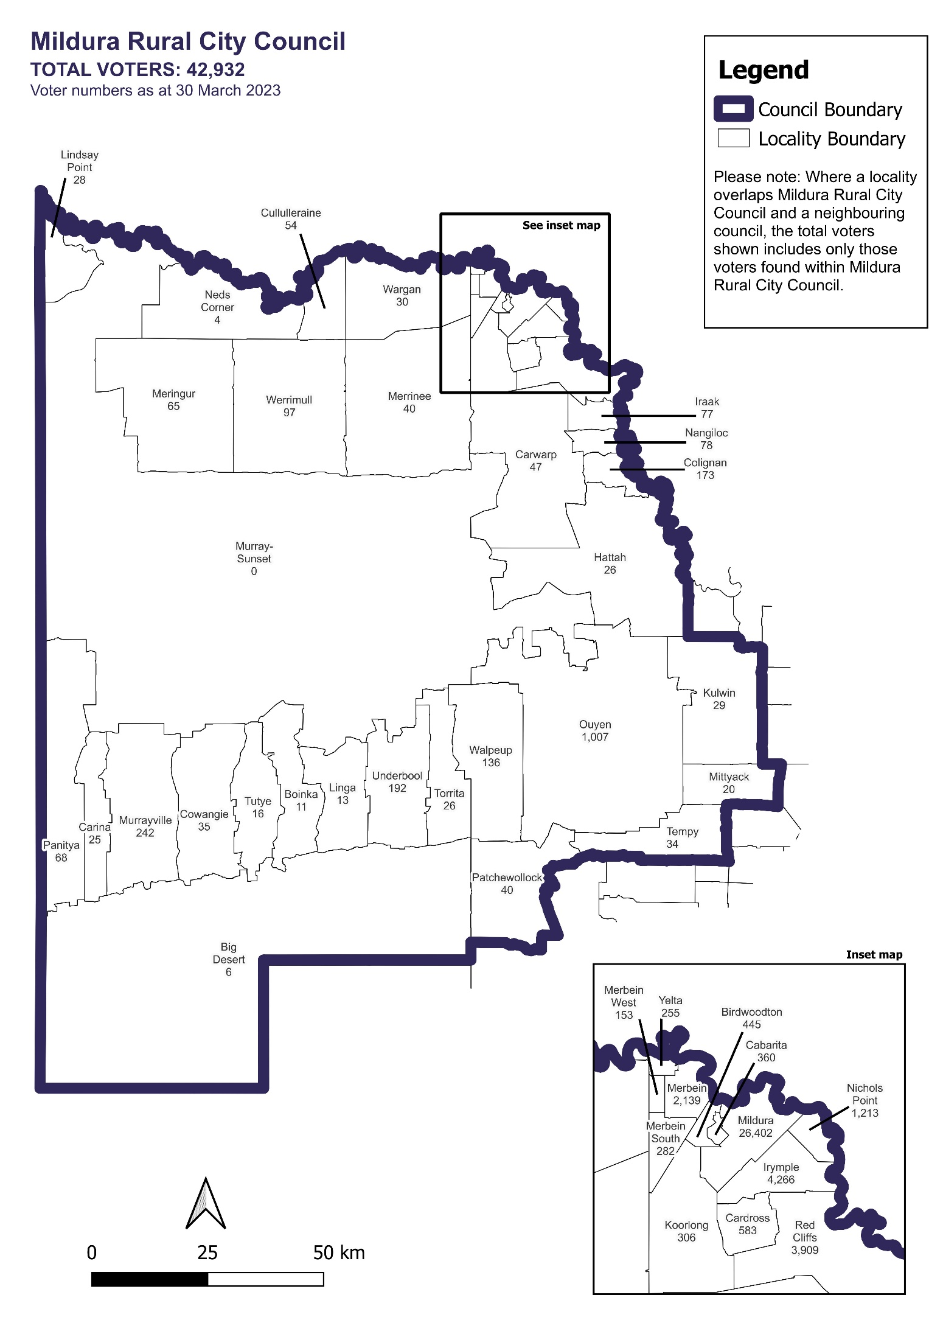Voter numbers by locality (map)

Voter numbers by locality (table)

## Mildura Rural City Council voter numbers at 30 March 2023

|  |  |
| --- | --- |
| Locality | Voters |
| Big Desert | 6 |
| Birdwoodton | 445 |
| Boinka | 11 |
| Cabarita | 360 |
| Cardross | 583 |
| Carina | 25 |
| Carwarp | 47 |
| Colignan | 173 |
| Cowangie | 35 |
| Cullulleraine | 54 |
| Hattah | 26 |
| Iraak | 77 |
| Irymple | 4,266 |
| Koorlong | 306 |
| Kulwin | 29 |
| Lindsay Point | 28 |
| Linga | 13 |
| Merbein | 2,139 |
| Merbein South | 282 |
| Merbein West | 153 |
| Meringur | 65 |
| Merrinee | 40 |

|  |  |
| --- | --- |
| Locality | Voters |
| Mildura | 26,402 |
| Mittyack | 20 |
| Murray-Sunset | 0 |
| Murrayville | 242 |
| Nangiloc | 78 |
| Neds Corner | 4 |
| Nichols Point | 1,213 |
| Ouyen | 1,007 |
| Panitya | 68 |
| Patchewollock | 40 |
| Red Cliffs | 3,909 |
| Tempy | 34 |
| Torrita | 26 |
| Tutye | 16 |
| Underbool | 192 |
| Walpeup | 136 |
| Wargan | 30 |
| Werrimull | 97 |
| Yelta | 255 |