

July 2023

Port Phillip City Council

Local council electoral structure review

Preliminary   
Report

Acknowledgement of Country

The electoral representation advisory panel acknowledges the Bunurong and Wurundjeri peoples as the Traditional Custodians of the lands and waters for which it is holding this review and pays respects to ancestors and Elders past, present and emerging. The panel acknowledges their custodianship for many thousands of years and their continuing living culture.

Document history and version control

|  |  |  |  |
| --- | --- | --- | --- |
| **Version** | **Date approved** | **Submission approved by** | **Brief description** |
| 1 | 14 July 2023 | Strategic Advisor, Enrolment | Final version for publication |

Contents

Executive summary 4

Developing electoral structure models 4

Electoral structure models 4

Next steps 4

Background 6

About the 2023–24 electoral structure reviews 6

The electoral representation advisory panel 6

Public engagement 7

Developing recommendations 7

About Port Phillip City Council 11

Profile 11

Current number of councillors and electoral structure 13

Last electoral structure review 13

Preliminary findings and models 14

Number of councillors 14

Electoral structure 15

Models for public feedback 20

Ward names 20

Next steps 22

Response submissions 22

Public hearing 23

Final report 23

References 24

Appendix 1: Model maps 25

# Executive summary

An independent electoral structure review panel appointed by the Minister for Local Government is reviewing the electoral structure of Port Phillip City Council.

The purpose of the review is to advise the Minister on the appropriate number of councillors and electoral structure, including ward names, for the council.

Under Victoria’s *Local Government Act 2020* (the Act), Port Phillip City Council must now have a single-councillor ward electoral structure.

The panel is looking at:

* + the appropriate number of councillors and wards for the council
  + the location of ward boundaries
  + appropriate ward names.

This report outlines the preliminary models the panel is presenting for public consultation, for the proposed new electoral structure of Port Phillip City Council to meet the requirements of the Act.

More information about the background to the review is available on page 6.

## Developing electoral structure models

The panel considered a range of factors when deciding on the models in this report, including:

* + research and analysis
  + voter growth or decline over time.

More information on the way the panel decided on the models is available on page 7.

## Electoral structure models

After considering research and the requirements of the Act, the panel is presenting the following electoral structure models for public consultation:

* Model 1: a subdivided electoral structure with a total of 9 councillors – 9 wards with one councillor per ward.
* Model 2: a subdivided electoral structure with a total of 9 councillors – 9 wards with one councillor per ward, with different ward boundaries to Model 1.
* Model 3: a subdivided electoral structure with a total of 9 councillors – 9 wards with one councillor per ward, with different ward boundaries to Models 1 and 2.

Details on these models, including maps, are available in Appendix 1.

## Next steps

The panel is now seeking feedback on the preliminary electoral structure models. You can make a response submission to the preliminary models until 5 pm Wednesday 9 August. If any response submitters wish to speak at a public hearing, the panel will hold an online public hearing on Tuesday 15 August. Following this, the panel will present its final recommendation to the Minister on Wednesday 13 September 2023.

More information about the review process is available on the Victorian Electoral Commission (VEC) website at [vec.vic.gov.au](https://www.vec.vic.gov.au)

# Background

## About the 2023–24 electoral structure reviews

In October 2022, the Minister for Local Government formed 2 electoral representation advisory panels to review and provide advice on the electoral structures of 39 local councils, under section 16 of the Act. If the Minister accepts the electoral structure recommended by the panel, any changes will take effect at the October 2024 local council elections.

The Act introduced several changes to local government representation, including the types of electoral structures local councils may have. All metropolitan, interface and regional city councils (including Port Phillip City Council) must now have single-councillor ward electoral structures.

For Port Phillip City Council, the electoral representation advisory panel is examining:

* the number of councillors and wards
  + where the ward boundaries should be
  + the name of each ward.

The Act requires electoral structures to provide fair and equitable representation and facilitate good governance. Each ward must have an approximately equal number of voters per councillor (within +/-10% of the average). While conducting the review, the panel also notes the role of a councillor as specified under section 28 of the Act.

## The electoral representation advisory panel

The panel conducting the electoral structure review of Port Phillip City Council has 3 members:

* The Honourable Frank Vincent AO KC (Chairperson*)
* Ms Janet Dore
* Acting Deputy Electoral Commissioner Ms Máiréad Doyle.

*Please note that during the preliminary report preparation of this review, Ms Máiréad Doyle sat as Acting Chairperson while The Honourable Frank Vincent took a period of leave.

The purpose of the review is to advise the Minister on the appropriate number of councillors and electoral structure, including ward names, for the council. The panel is independent of councils and the Victorian State government.

Under the Act, the VEC is not responsible for reviewing council electoral structures but must provide administrative and technical support to the panel. The Electoral Commissioner (or their delegate) must be a member of each panel.

## Public engagement

### Public information program

On behalf of the panel, the VEC has conducted a public information and awareness program to inform the public about the Port Phillip City Council electoral structure review. This has included:

* + printed public notices in state-wide newspapers
  + public information sessions to outline the review process and respond to questions from the community
  + media releases to announce the start of the review
  + information on social media channels
  + updated website content on [vec.vic.gov.au](https://www.vec.vic.gov.au/), including:
    - current information on the review process
    - submission guide and fact sheets for each council under review with background information.

The VEC will continue to promote the review on behalf of the panel during the response submission stage via media releases, the VEC’s social media channels and the VEC website.

### Public consultation

The panel now invites input to the electoral structure review of Port Phillip City Council via:

* + response submissions to this preliminary report
  + an online public hearing for anyone who makes a response submission to speak to the panel and expand on their submission.

Public submissions are an important part of the review process and are considered alongside other factors addressed during the review. These are outlined below.

## Developing recommendations

The electoral structure models the panel is presenting in this preliminary report comply with the Act and were developed through careful consideration of:

* + research and analysis conducted by the VEC support team, including geospatial and demographic data
  + rates or patterns of population and voter change over time, and relevant forecasts of growth or decline based on forecast information provided by .id (informed decisions, a company specialising in demographics and forecasting).

### Deciding on the number of councillors

The Act allows local councils to have between 5 and 12 councillors, but neither the Act nor the Local Government (Electoral) Regulations 2020 specify how the number of councillors is to be determined. Therefore, the models put forward by the panel in this report are guided by the Act’s intention for fairness and equity in voter representation.

In examining the appropriate number of councillors for Port Phillip City Council, the panel considered the following criteria:

* + the population and number of voters in the council area, compared to other councils with a similar population size and number of voters in the same category (for example, other comparable metropolitan, interface or regional city councils)
  + patterns of population change and voter growth or decline in the council area over time
  + the current and past numbers of councillors
  + the representation needs of the communities of interest in the council area.

The panel’s final recommendation will also consider any matters raised in public response submissions not already listed above.

Local councils with a larger number of voters will often have more councillors. Large populations generally have greater diversity, both in the type and number of communities of interest and issues relating to representation. However, the ideal number of councillors can also be influenced by the circumstances of each council, such as the:

* + nature and complexity of services the council provides
  + geographic size and topography of the area
  + forecast population and voter growth or decline
  + social diversity.

### Deciding the electoral structure

Under the Act, regional city, metropolitan and interface councils must now have single-councillor ward electoral structures.

When developing single-councillor ward models for Port Phillip City Council, the panel considered these criteria:

* + whether the structure would comply with section 15(2) of the Act (see below), and for how long it would likely comply
  + the appropriate number of councillors, as outlined above
  + whether meaningful and effective ward boundaries could be established and whether these would be easily identifiable to local communities
  + the representation of communities of interest
  + the voter distribution and physical features of the area, and the impact these may have on the shape and size of wards
  + past elections for the council, including:
    - numbers of candidates nominating
    - incidences of uncontested elections
    - rates of informal voting.

The panel’s final recommendation will also consider any matters raised in public response submissions not already listed above.

Under section 15(2) of the Act, subdivided structures must aim for an approximately equal number of voters per councillor in each ward. This means the number of voters represented by each councillor in a ward should be within +/-10% of the average number of voters per councillor for all wards.

During this review, the panel aims to recommend a structure that will comply with section 15(2) at the time of the 2024 local council elections and, if possible, also comply based on voter numbers at the time the review is conducted. The panel uses forecasts of population and voter change to assess compliance at the 2024 elections with as much accuracy as possible. In some cases, population change and other factors impacting voter numbers mean it is not possible to create compliant subdivided structures based both on voter numbers that were current at the time of the review and forecast voter numbers. In these instances, the panel prioritises compliance at the 2024 local government elections to ensure each vote will have approximately equal value at the 2024 election.

One of the factors that may impact compliance with section 15(2) is the number of current and forecast voters with ratepayer-based voting entitlements, also known as council-enrolled electors. Voters’ rolls include both state-enrolled electors (the majority of the roll) and a smaller number of council-enrolled electors. The Act introduced changes to ratepayer-based entitlement categories, which come into full effect at the 2024 local council elections. The panel will take this change to the makeup of voters’ rolls, and therefore compliance with section 15(2) of the Act, into consideration during this review.

### Deciding on ward names

The panel has taken the following approach to naming wards.

1. Retaining existing ward names if these are still relevant to the area covered by the ward.
2. When a new name is required, the panel bases this on features such as:
   * + places (registered under the *Geographic Place Names Act 1998*) in the ward
     + compass directions
     + native flora or fauna.

### Use of Aboriginal language

The panel recognises that there should first be meaningful consultation with local Aboriginal communities and groups before a ward is named using Aboriginal language. Meaningful consultation is a significant process that the panel is not able to undertake within the timeframes of the current review program.

The panel also recognises that many of the place names in current use across Victoria are based on Aboriginal language. As such, the panel may put forward new ward names using Aboriginal language if:

* it is the name of a place within a ward
* it is currently in common use

and

* the name is registered under the *Geographic Place Names Act 1998*.

Unregistered names using Aboriginal language have not been put forward by the panel as new ward names. While the panel supports the adoption of names based on Aboriginal language, this requires appropriate consultation.

Accordingly, for the panel to consider an Aboriginal language ward name that is suggested in a public submission to the review, the name submitted needs to comply with the above guidelines.

# About Port Phillip City Council

## Profile

Port Phillip City Council is located to the south of Melbourne’s CBD, along the coast of Port Phillip Bay. It covers an area of 21 km2, stretching from Port Melbourne in the north to Elwood in the south. The council area shares its borders with Melbourne and Stonnington city councils in the north, Glen Eira City Council in the east, Bayside City Council in the south, and Port Phillip Bay in the west.

The Traditional Custodians of the lands in Port Phillip City Council are the Bunurong and Wurundjeri peoples.

### Landscape

Port Phillip City Council is the most densely populated council in Victoria, at a rate twice the metropolitan Melbourne average (DTP 2023). While highly urbanised, the council supports a range of land uses and patterns, including high-density and apartment living, reclaimed industrial areas, large commercial and retail centres, and significant coastal and park lands.

The council area includes the suburbs of South Melbourne and parts of Port Melbourne, Southbank, and Melbourne to the north, Albert Park, Middle Park, and St Kilda West in the centre, and St Kilda, Balaclava, Ripponlea, Elwood, and parts of Windsor and St Kilda East in the south (.id 2022a). Its neighbourhoods are distinct and serviced by several retail areas and shopping precincts along Bay Street in Port Melbourne, Carlisle Street in Balaclava, Clarendon Street in South Melbourne, and Fitzroy and Acland streets in St Kilda (.id 2022a).

Compared with neighbouring councils, Port Phillip City Council has a significantly larger proportion of its land dedicated to public and open space, including the foreshore, and Albert Park reserve and lake (Port Phillip City Council 2023). The south and east of the council area are mostly residential, while commercial and retail activities are more prominent in its north and west alongside high-density and apartment living (.id 2022a). Other major features in the council area include Catani Gardens, Gasworks Art Park, the Jewish Museum of Australia, Luna Park, and the Palais Theatre (.id 2022a).

The council area is serviced by an extensive public transport network including the Sandringham train line, St Kilda and Port Melbourne light rails, and multiple tram and bus routes. Major arterial roads, such as St Kilda and Brighton roads, run along its eastern boundary and through its south, while Canterbury Road runs through its centre.

### Community

The population in the council area increased from 100,863 in 2016 to 101,942 in 2021 (ABS 2016, ABS 2022a). Beginning in the 1960s rapid growth and development changed the industrial character of its north, and throughout the 1980s and 90s much land was converted from commercial to residential (.id 2022a). Recent growth overall has been more modest and is expected to continue at an annual rate of around 1.1% until 2028. However, the Fishermans Bend Urban Renewal Area will experience significant rates of growth, mainly in Montague and Wirraway growth precincts, until 2041 (DTP 2023). For example, growth in Fishermans Bend is expected to grow over 800% in this time and the area around the Domain will increase at nearly 80%. Along an area of St Kilda Road and in South Melbourne growth is expected to be 20–25% (.id 2022b).

The median age of residents in the council area was 38 in 2021, with the largest age group 30–34 years (11.7%) (ABS 2022a). Overall, 33.1% of the population was born overseas compared with 35.7% for Greater Melbourne overall (.id 2022a). Residents who identified as Aboriginal and/or Torres Strait Islander people accounted for 0.5% of the council’s population, which is slightly less than the 0.7% across Greater Melbourne (ABS 2022a, ABS 2022b). English was the only language spoken at home for 72.5% of residents and 21% of people used a language other than English at home (.id 2022a).

Over 52% of housing was high density (DTP 2023) and just under 49% of residents were renting in 2021 (.id 2022a), at a median weekly rate of $420 (ABS 2022a). Port Phillip City Council residents have significantly higher mortgage repayments and rental costs compared with average housing costs for Greater Melbourne overall (DTP 2023).

## Current number of councillors and electoral structure

Port Phillip City Council is currently divided into 3 wards with a total of 9 councillors:

* 3 wards with 3 councillors each (Canal, Gateway, and Lake wards)

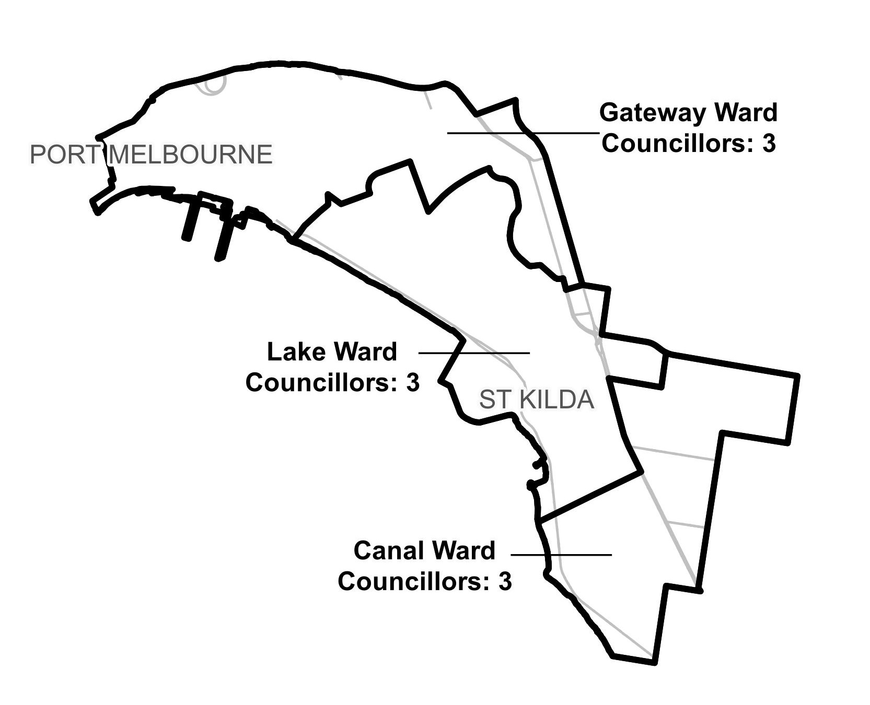

**Figure 1:** Diagram of current electoral structure of Port Phillip City Council.

There are an estimated 97,755 voters in Port Phillip City Council, with an estimated ratio of 10,861 voters per councillor.

Visit the VEC website at [vec.vic.gov.au](https://www.vec.vic.gov.au/electoral-boundaries/local-councils/port-phillip-city-council) for more information on Port Phillip City Council.

## Last electoral structure review

The VEC conducted an electoral representation review of Port Phillip City Council in 2015. This review was carried out under the *Local Government Act 1989* (Vic), which was replaced by the *Local Government Act 2020* (Vic).

After conducting the review, the VEC recommended that Port Phillip City Council adopt a structure of 9 councillors elected from 3 wards (3 wards with 3 councillors each).

Visit the VEC website at [vec.vic.gov.au](https://www.vec.vic.gov.au/electoral-boundaries/local-councils/port-phillip-city-council) to access a copy of the 2015 representation review final report.

# Preliminary findings and models

A significant challenge in this review has been to develop electoral structure models that meet the requirement for all wards to have roughly equal numbers of voters, deviating no more than +/-10% of the average number of voters per councillor overall. The challenge is due in part to uneven rates of growth occurring throughout the council area, impacting some suburbs, such as Port Melbourne, South Melbourne and Windsor. The difficulty in developing electoral structures for Port Phillip City Council that meet the requirements of the Act is intensified by the large numbers of rental properties, businesses and commercial properties in the council area. These features of the council, which do not impact other metropolitan councils to the same degree, means there is a large and disproportionate number of council-enrolled voters entitled to vote at elections. While changes to the number of state-enrolled voters can be predicted with reasonable certainty, this is not the case for other voter entitlements.

Because of this, the panel has proposed models with some wards that deviate more than   
+/-10% of the overall average of voters per councillor based on current voter numbers. This will ensure all models can accommodate various future growth and change calculations and comply with section 15(2) of the Act at the time of the 2024 local council elections. The models will ensure there are approximately equal numbers of voters per ward, not deviating more than   
+/-10% of the average number of voters per councillor for the whole council.

## Number of councillors

After taking into consideration the requirements of the Act and the agreed criteria, the panel found 9 councillors to be an appropriate number for Port Phillip City Council.

The panel considered the characteristics of Port Phillip City Council in relation to similar metropolitan councils, including its population, the number and distribution of voters, and the size and geography of the council.

|  |  |  |  |  |  |  |
| --- | --- | --- | --- | --- | --- | --- |
| Similar metropolitan councils to Port Phillip City Council | | | | | | |
| Local council | Area (km2) | Number of voters at 2020 election | Population (2021 Census) | Current total estimate of voters | Number of councillors | Number of voters per councillor |
| Whitehorse City Council | 64 | 112,640 | 169,346 | 113,214 | 11 | 10,292 |
| Frankston City Council* | 130 | 107,216 | 139,281 | 106,376 | 9 | 11,819 |
| Glen Eira City Council* | 39 | 105,230 | 148,908 | 106,181 | 9 | 11,797 |
| Greater Dandenong City Council | 130 | 99,768 | 158,208 | 100,580 | 11 | 9,143 |
| Port Phillip City Council | 21 | 88,268 | 101,942 | 97,755 | 9 | 10,861 |
| Banyule City Council | 63 | 95,510 | 126,236 | 95,151 | 9 | 10,572 |
| Moonee Valley City Council* | 43 | 93,923 | 121,851 | 93,530 | 9 | 10,392 |
| Manningham City Council | 113 | 87,255 | 124,700 | 87,278 | 9 | 9,697 |
| Stonnington City Council* | 26 | 89,600 | 104,703 | 86,821 | 9 | 9,646 |

*These local councils are undergoing an electoral structure review during 2023–24.

### Maintaining 9 councillors

Port Phillip City Council currently has 97,755 voters represented by 9 councillors. The council covers an area of 21 km2. Other metropolitan councils with a similar number of voters usually also have 9 councillors. While forecasts indicate modest population growth across the whole council area, some areas anticipate rapid and significant growth. Nonetheless, the panel considers it appropriate for the total number of councillors to remain unchanged but notes this may need to be reviewed in future.

## Electoral structure

To identify the most appropriate electoral structure, various factors were considered. This included the requirements of the Act, the communities of interest in Port Phillip City Council, the appropriateness of ward boundaries and which models best offered fair and equitable representation and consequently facilitated good governance.

In developing the preliminary models presented in this report, the panel considered a range of models. The strongest 3 models have been put forward for further public comment.

The panel proposes 3 models for the consideration of the Port Phillip City Council community:

* a subdivided electoral structure of 9 single-councillor wards (Model 1)
* a subdivided electoral structure of 9 single-councillor wards, with different ward boundaries to Model 1 (Model 2)
* a subdivided electoral structure of 9 single-councillor wards, with different ward boundaries to Models 1 and 2 (Model 3).

Diagrams of the preliminary models are included in Appendix 1.

### A single-councillor ward structure with 9 councillors (Model 1)

Under this model, Port Phillip City Council would adopt a 9-ward structure. Each ward would be represented by one councillor, in line with the requirements of the Act.

Model 1 takes a minimal change approach, using the current 3-ward structure to divide each ward into 3 single-councillor wards. Canal Ward in the south is divided to create Canal Central, Canal North, and Canal South wards. Lake Ward in the centre of the council area is divided to form Lake Central, Lake South, and Lake West wards. Gateway Ward in the north is divided into Gateway Central, Gateway East, and Gateway West wards.

The 9 new wards in Model 1 are as follows:

* + Canal Central Ward includes the suburbs of Ripponlea, Balaclava, part of Elwood (east of Tennyson Street), and part of St Kilda (east of St Kilda Road).
  + Canal North Ward takes in the suburb of St Kilda East and part of the suburb of St Kilda that is east of St Kilda Road (with Alma Road and Inkerman Street as boundaries).
  + Canal South Ward includes most of Elwood from the coastline to Tennyson Street.
  + Gateway Central Ward includes most of South Melbourne, the council’s share of Southbank and part of Port Melbourne (east of Graham and Liardet streets in Port Melbourne).
  + Gateway East Ward captures an area east of Lakeside Drive to include the residential strip running along the council area’s eastern boundary and part of South Melbourne up to Park Street.
  + Gateway West Ward includes Port Melbourne up to Graham and Liardet streets.
  + Lake Central Ward captures Albert Park reserve and lake and its surrounding residential areas in parts of St Kilda West, St Kilda and a small area Middle Park.
  + Lake South Ward takes in part of St Kilda west, and a significant area of the coastline including the pier and marina, as well as a large part of St Kilda bounded by Gurner, Grey, and Fitzroy streets and St Kilda Road. It also includes a small area of Middle Park.
  + Lake West Ward extends from McGregor Street in the south to the current Gateway–Lake ward boundary in the north and uses Canterbury Road as its eastern boundary to include most of Middle Park and Albert Park.

Based on the current structure, the boundaries of Model 1 are likely to be easily identifiable for residents, which may help with the change from 3 multi-councillor wards to 9 single-councillor wards. The panel felt each ward broadly captured the council activity areas, and aligned reasonably well with communities and the services they access.

A challenge in creating ward boundaries was balancing uneven growth anticipated in the council, as well as an uneven and unpredictable distribution of voter types. The difficulty in predicting voter numbers for council elections in 2024 and creating wards with equal numbers of voters restricted the options for ward boundaries, particularly in areas with high growth in Port Melbourne, South Melbourne, and Windsor. Nonetheless, the boundaries of Model 1 accommodate population growth and voter distribution to create stability and comply with predicted voter-to-councillor ratios. The panel considered this a major strength of Model 1, along with the benefits of using existing ward boundaries.

Overall, the panel viewed the minimal-change approach of Model 1 favourably. However, it acknowledged that the necessary division of some suburbs to balance population distribution and growth may split communities of interest. The panel therefore seeks feedback and public input on the suitability of the proposed boundaries.

### A single-councillor ward structure with 9 councillors (alternative version) (Model 2)

Under this model, Port Phillip City Council would adopt a 9-ward structure. Each ward would be represented by one councillor, in line with the requirements of the Act.

Model 2 was based on a public submission made under a previous electoral representation review, with modified boundaries to accommodate recent population change and projected growth. It aimed to provide a more even division and spread of wards across the council area.

The 9 new wards proposed in Model 2 are as follows:

* + Balaclava Ward takes in Balaclava and Ripponlea, some of Elwood (east of Tennyson Street), and part of St Kilda (east of Brighton Road).
  + Catani Ward includes St Kilda West, Middle Park, some of Albert Park (south of Richardson Street and east of Kerferd Road) and a small part of St Kilda.
  + Elwood Ward captures most of Elwood, from the foreshore to Tennyson and Southey streets.
  + Kirrip Park Ward includes Southbank, most of Port Melbourne (north of Williamstown Road and east of Graham and Liardet streets), some of South Melbourne, and a small part of Albert Park (between Richardson Street and Victoria Avenue).
  + Lakeside Ward takes in Windsor, the suburb of Melbourne (east of Lakeside Drive), the parkland area of Albert Park north of Canterbury Road, and some of St Kilda (west of Crimea Street).
  + Port Melbourne Ward takes in part of Port Melbourne from the foreshore to Williamstown Road, Graham Street and Pickles Street.
  + South Melbourne Ward includes most of South Melbourne and the residential area of Albert Park (between Kerferd Road and Merton Street).
  + St Kilda East Ward includes St Kilda East and some of St Kilda (between Crimea and Inkerman streets).
  + St Kilda Ward takes in about half of St Kilda (between Fitzroy and Dickens streets, and the foreshore and Brighton Road).

Model 2 effectively manages the uneven rate of growth through a more even spread of wards and distribution of growth areas between wards. For instance, the proposed ward boundaries in Kirrip Park, South Melbourne, and Lakeside wards balance growth hotspots and accommodate the uneven distribution of voters, while maintaining communities of interest.

St Kilda Junction is kept in one ward (Lakeside Ward), and Port Phillip foreshore is spread across 4 wards (Port Melbourne, Catani, St Kilda, and Elwood wards). This connects foreshore communities and shared interests.

Overall, the panel felt the boundaries of Model 2 were identifiable and effectively balanced uneven voter distribution and projected growth. The panel acknowledged splitting the suburb of Port Melbourne between Port Melbourne Ward and Kirrip Park Ward might divide communities and felt it was not ideal to use Bay Street as part of the ward boundary. For these reasons the panel seeks community feedback on the proposed boundaries.

### A single-councillor ward structure with 9 councillors (alternative version) (Model 3)

Under this model, Port Phillip City Council would adopt a 9-ward structure. Each ward would be represented by one councillor, in line with the requirements of the Act.

The boundaries of Model 3 aim to reflect local suburban identities and communities of interest, and broadly resembles the single-councillor ward structure in place for Port Phillip City Council from 2008 until 2015.

The 9 new wards proposed in Model 3 have the following arrangement:

* + Alma Ward includes St Kilda East and some of St Kilda (between Chapel Street, St Kilda Road and Charnwood Road).
  + Botanical Ward takes in most of St Kilda and some of Elwood (between Dickens Street and the Elster Canal Path).
  + Carlisle Ward takes in Balaclava, Ripponlea, and some of St Kilda (between St Kilda Road and Chapel Street).
  + Catani Ward includes St Kilda West, Middle Park, and part of St Kilda (between Lower Esplanade, Carlisle Street, and Grey Street).
  + Gasworks Ward includes just under half of Albert Park, and part of Port Melbourne (between the foreshore, Graham Street, and Rouse Street).
  + Kirrip Park Ward takes in Southbank and most of South Melbourne, using Raglan Street as a boundary.
  + Lakeside Ward includes Melbourne and Windsor, about half of the suburb of Albert Park (between Canterbury Road and Lakeside Drive), part of St Kilda and part of South Melbourne (south of Raglan Street).
  + Ormond Ward includes most of Elwood, between Brighton Road, the foreshore and part of Elster Canal Path.
  + Sandridge Ward takes in most of Port Melbourne between Ingles, Pickles, and Graham and Rouse streets.

Model 3 was also developed using a public submission made under a previous electoral representation review. As in Model 2, the ward boundaries of Model 3 have been adjusted to accommodate population change, voter distribution and projected growth. The model uses Ingles Street to divide the suburb of Port Melbourne, as well as Sandridge and Kirrip Park wards. Lakeside Ward encompasses Albert Park reserve and lake, and the population along St Kilda Road and in Windsor. Anticipated growth and voter distribution is balanced across multiple wards by separating these areas from Southbank and South Melbourne.

The panel felt Model 3 captures Albert Park reserve and lake neatly and accounts for growth in the suburbs of Melbourne and Windsor. The proposed boundaries offer a different division of the south-eastern suburbs using St Kilda Junction as a divergence point creating 4 wards: Alma, Botanical, Carlisle, and Ormond. The panel also felt the use of Brighton and St Kilda roads created a clear and easily recognisable boundary. Overall, the panel believed Model 3 mostly kept communities of interest together using identifiable boundaries. It seeks feedback and public input on the proposed boundaries of Model 3.

### Summary

In summary, introducing single-councillor wards represents a significant change for Port Phillip City Council though this electoral structure was in place relatively recently, prior to 2015. Nonetheless, achieving models that divide communities into appropriate wards while also accounting for population growth and ensuring they comply with the +/-10% requirement can be challenging. The 3 models presented for public feedback each address the challenges in a different way.

Model 1 uses the current electoral structure, dividing each ward into 3 to create 9 single-councillor wards.

Model 2 is based on a public submission from a previous electoral structure review and seeks to create 9 wards more evenly spread across the council area. The result is a clear separation between the foreshore and inland wards.

Model 3 also uses a public submission from a previous electoral structure review, with a focus on keeping suburban identities and communities of interest together in wards.

All of the models accommodate the uneven rates of growth and population expected for the council and generally use familiar features as ward boundaries where possible.

Each of the 3 models have attributes that residents will have different perspectives on, and the panel is interested in these perspectives.

## Models for public feedback

The panel considers all models outlined below to be the single-councillor ward electoral structures with the best potential to offer fair and equitable representation for voters in Port Phillip City Council and consequently facilitate good governance. Please see Appendix 1 for detailed maps of these models.

### Model 1

Port Phillip City Council has 9 councillors and is divided into 9 wards with one councillor per ward.

Ward names: Canal Central Ward, Canal North Ward, Canal South Ward, Gateway Central Ward, Gateway East Ward, Gateway West Ward, Lake Central Ward, Lake South Ward, Lake West Ward.

### Model 2

Port Phillip City Council has 9 councillors and is divided into 9 wards with one councillor per ward.

Ward names: Balaclava Ward, Catani Ward, Elwood Ward, Kirrip Park Ward, Lakeside Ward, Port Melbourne Ward, South Melbourne Ward, St Kilda Ward, St Kilda East Ward.

### Model 3

Port Phillip City Council has 9 councillors and is divided into 9 wards with one councillor per ward.

Ward names: Alma Ward, Botanical Ward, Carlisle Ward, Catani Ward, Gasworks Ward, Kirrip Park Ward, Lakeside Ward, Ormond Ward, Sandridge Ward.

## Ward names

The panel has suggested ward names to identify the wards in each model and invites comments from the community on these names as part of submissions responding to the preliminary report. The basis of the ward name recommendations for each model are described below.

### Model 1

Canal Central, Canal South, Gateway Central, Gateway East, Gateway West, Lake Central, Lake South, and Lake West ward names are new and based on the existing ward names under the current electoral structure with a compass descriptor.

### Model 2

Balaclava, Elwood, Kirrip Park, Lakeside, Port Melbourne, and South Melbourne ward names are new and are based on natural features, localities, built features or registered places found within each ward.

Catani, St Kilda and St Kilda East ward names are based on ward names used under previous electoral structures.

### Model 3

Botanical, Gasworks, Kirrip Park, Lakeside ward names are new and are based on natural features, built features or registered places found within each ward.

Alma, Carlisle, Catani, Ormond and Sandridge ward names are based on ward names used under previous electoral structures.

The panel will review ward name suggestions received during the response submission stage when forming the final advice to the Minister for Local Government on the electoral structure of the council. Suggested ward names should comply with the panel’s approach to naming wards (see Deciding on ward names and Use of Aboriginal language). All ward name suggestions received during the response submission stage will be provided to the Minister for consideration at the conclusion of the electoral structure review.

# Next steps

## Response submissions

Any person or group, including the local council under review, can make a response submission to the electoral representation advisory panel. In your submission you should address the models proposed by the panel in this preliminary report.

You can make a submission:

|  |  |
| --- | --- |
| P374C1T3#yIS1 | **Online** Visit [vec.vic.gov.au](http://vec.vic.gov.au/) to make a submission online.  You will need to make an account to use the online Public Submission Tool and can save a draft submission to finish later. |
| P377C3T3#yIS1 | **By email** [PortPhillip.ERAPSubmissions@vec.vic.gov.au](mailto:PortPhillip.ERAPSubmissions@vec.vic.gov.au) |
| P380C5T3#yIS1 | **By post**  Electoral Representation Advisory Panel c/o Victorian Electoral Commission Level 11, 530 Collins St Melbourne VIC 3000 |

The panel must receive all response submissions before 5 pm on Wednesday 9 August 2023. If you post your submission, make sure it has enough time to reach the panel before the deadline. Late submissions will not be accepted.

### Required information

For your submission to be considered, you must include your:

* full name
* contact phone number or email address
* postal or residential address.

To protect the integrity and transparency of the review process, the panel will not consider submissions without this information. If you are submitting as a group or organisation, you must include the name of a nominated contact person who is authorised to submit on behalf of your group.

On behalf of the panel, the VEC will handle information provided by submitters in accordance with the privacy policy available at [vec.vic.gov.au/privacy](http://vec.vic.gov.au/privacy)

### Public access to submissions

To ensure transparency in the electoral structure review process, your submission will be published on the VEC website at [vec.vic.gov.au](http://www.vec.vic.gov.au/). The VEC will remove your signature and contact details, including residential and postal addresses, from all public copies but must publish your full name (or group name) and locality (suburb or town).

Please note that any submission content that is potentially defamatory, offensive, obscene or that includes the personal information of people or organisations who are not a party to the submission may also be redacted before publication.

## Public hearing

If you make a response submission, you can also ask to speak at an online public hearing to support your submission and expand on your views.

The online public hearing is scheduled for:

Time: 2 pm

Date: Tuesday 15 August 2023

The panel encourages participation in the public hearing. If you wish to speak at the public hearing, you **must** indicate this in your response submission. The public hearing will not be held if there are no requests to speak.

Anyone can attend a public hearing, but you will only be able to speak if you asked to in your response submission. If you ask to speak, the VEC will contact you to arrange a time for you to speak at the hearing. You will have 10 minutes to address the public hearing panel, which will include at least 2 of the review panel members. The members of the public hearing panel may ask you questions.

Visit the VEC website at [vec.vic.gov.au](http://vec.vic.gov.au/) for more information on public hearings.

## Final report

Following the public hearing, the review panel will consider all evidence gathered and prepare a final report for the Minister for Local Government containing a recommendation for the number of councillors and the electoral structure for the local council.

The final report is scheduled to be provided to the Minister on Wednesday 13 September 2023. The Minister will consider the final reports, including any determination to make the reports publicly available. Any change to the electoral structure of Port Phillip City Council following on from this review is expected to apply at the October 2024 local council elections. Under the Act, the final council electoral structure will be set by an Order in Council published in the Victoria Government Gazette.

# References

ABS (Australian Bureau of Statistics) (2022a) [*2021 Census All Person QuickStats, Port Phillip (LGA)*,](https://www.abs.gov.au/census/find-census-data/quickstats/2021/LGA25900)ABS website, accessed 24 May 2023.

——(2022b) [*Region summary: Greater Melbourne*](https://dbr.abs.gov.au/region.html?lyr=gccsa&rgn=2GMEL), ABS website, accessed 24 May 2023.

——(2016) [*2016 Census All Person QuickStats, Port Phillip (LGA)*,](https://www.abs.gov.au/census/find-census-data/quickstats/2016/LGA25900)ABS website, accessed 24 May 2023.

DTP (Department of Transport and Planning) (2023) [*Port Phillip planning scheme*](https://planning-schemes.app.planning.vic.gov.au/Port%20Phillip/ordinance?_ga=2.233889117.2135433062.1684882435-1766048721.1683691332), DTP website, accessed 14 June 2023.

Electoral Act 2002 (Vic)

.id (informed decisions) (2022a) [*Welcome to City of Port Phillip Community Profile*](https://profile.id.com.au/port-phillip), .id website, accessed 24 May 2023.

—— (2022b) [*Welcome to the City of Port Phillip population forecasts*](https://forecast.id.com.au/port-phillip), .id website, accessed 24 May 2023.

Geographic Place Names Act 1998 (Vic)

Local Government Act 1989 (Vic)

Local Government Act 2020 (Vic)

Local Government (Electoral) Regulations 2020 (Vic)

Port Phillip City Council (2023*)* [*Who lives in our City – Demographics – Health Profiles*](https://www.portphillip.vic.gov.au/people-and-community/who-lives-in-our-city/demographics), Port Phillip City Council website, accessed 14 June 2023.

# Appendix 1: Model maps

The following maps are included in this report:

|  |  |
| --- | --- |
| Map | Page |
| Model 1 – a single-councillor ward structure with 9 councillors – 9 wards with one councillor per ward. | 26 |
| Model 2 – a single-councillor ward structure with 9 councillors – 9 wards with one councillor per ward (with boundaries different to Model 1). | 27 |
| Model 3 – a single-councillor ward structure with 9 councillors – 9 wards with one councillor per ward (with boundaries different to Models 1 and 2). | 28 |

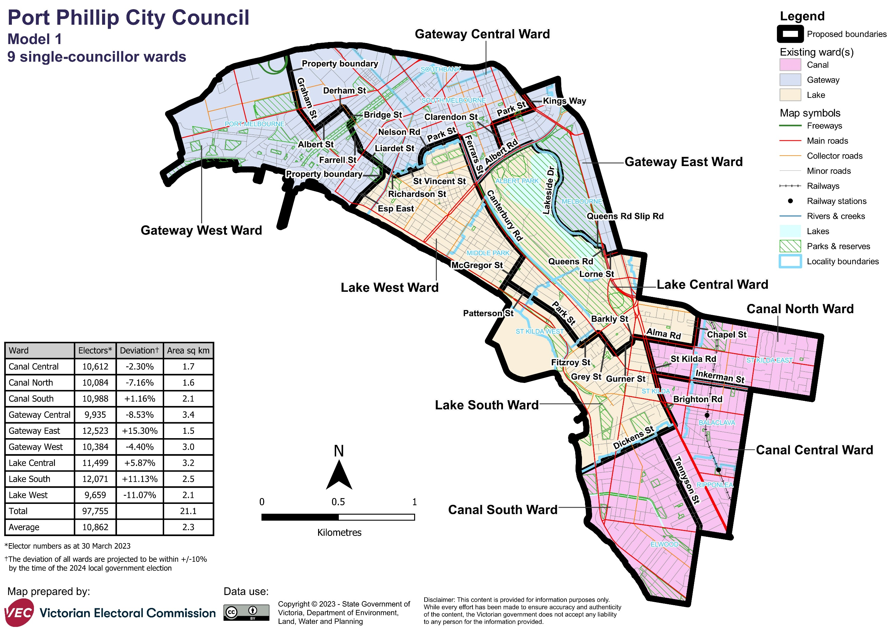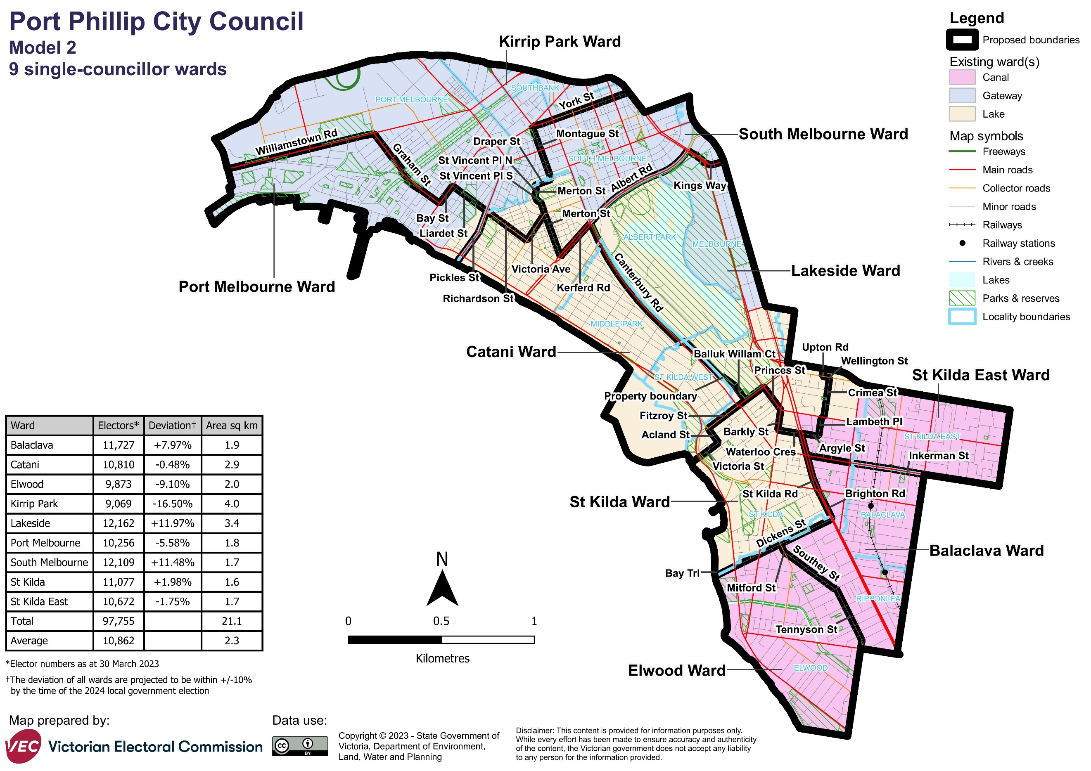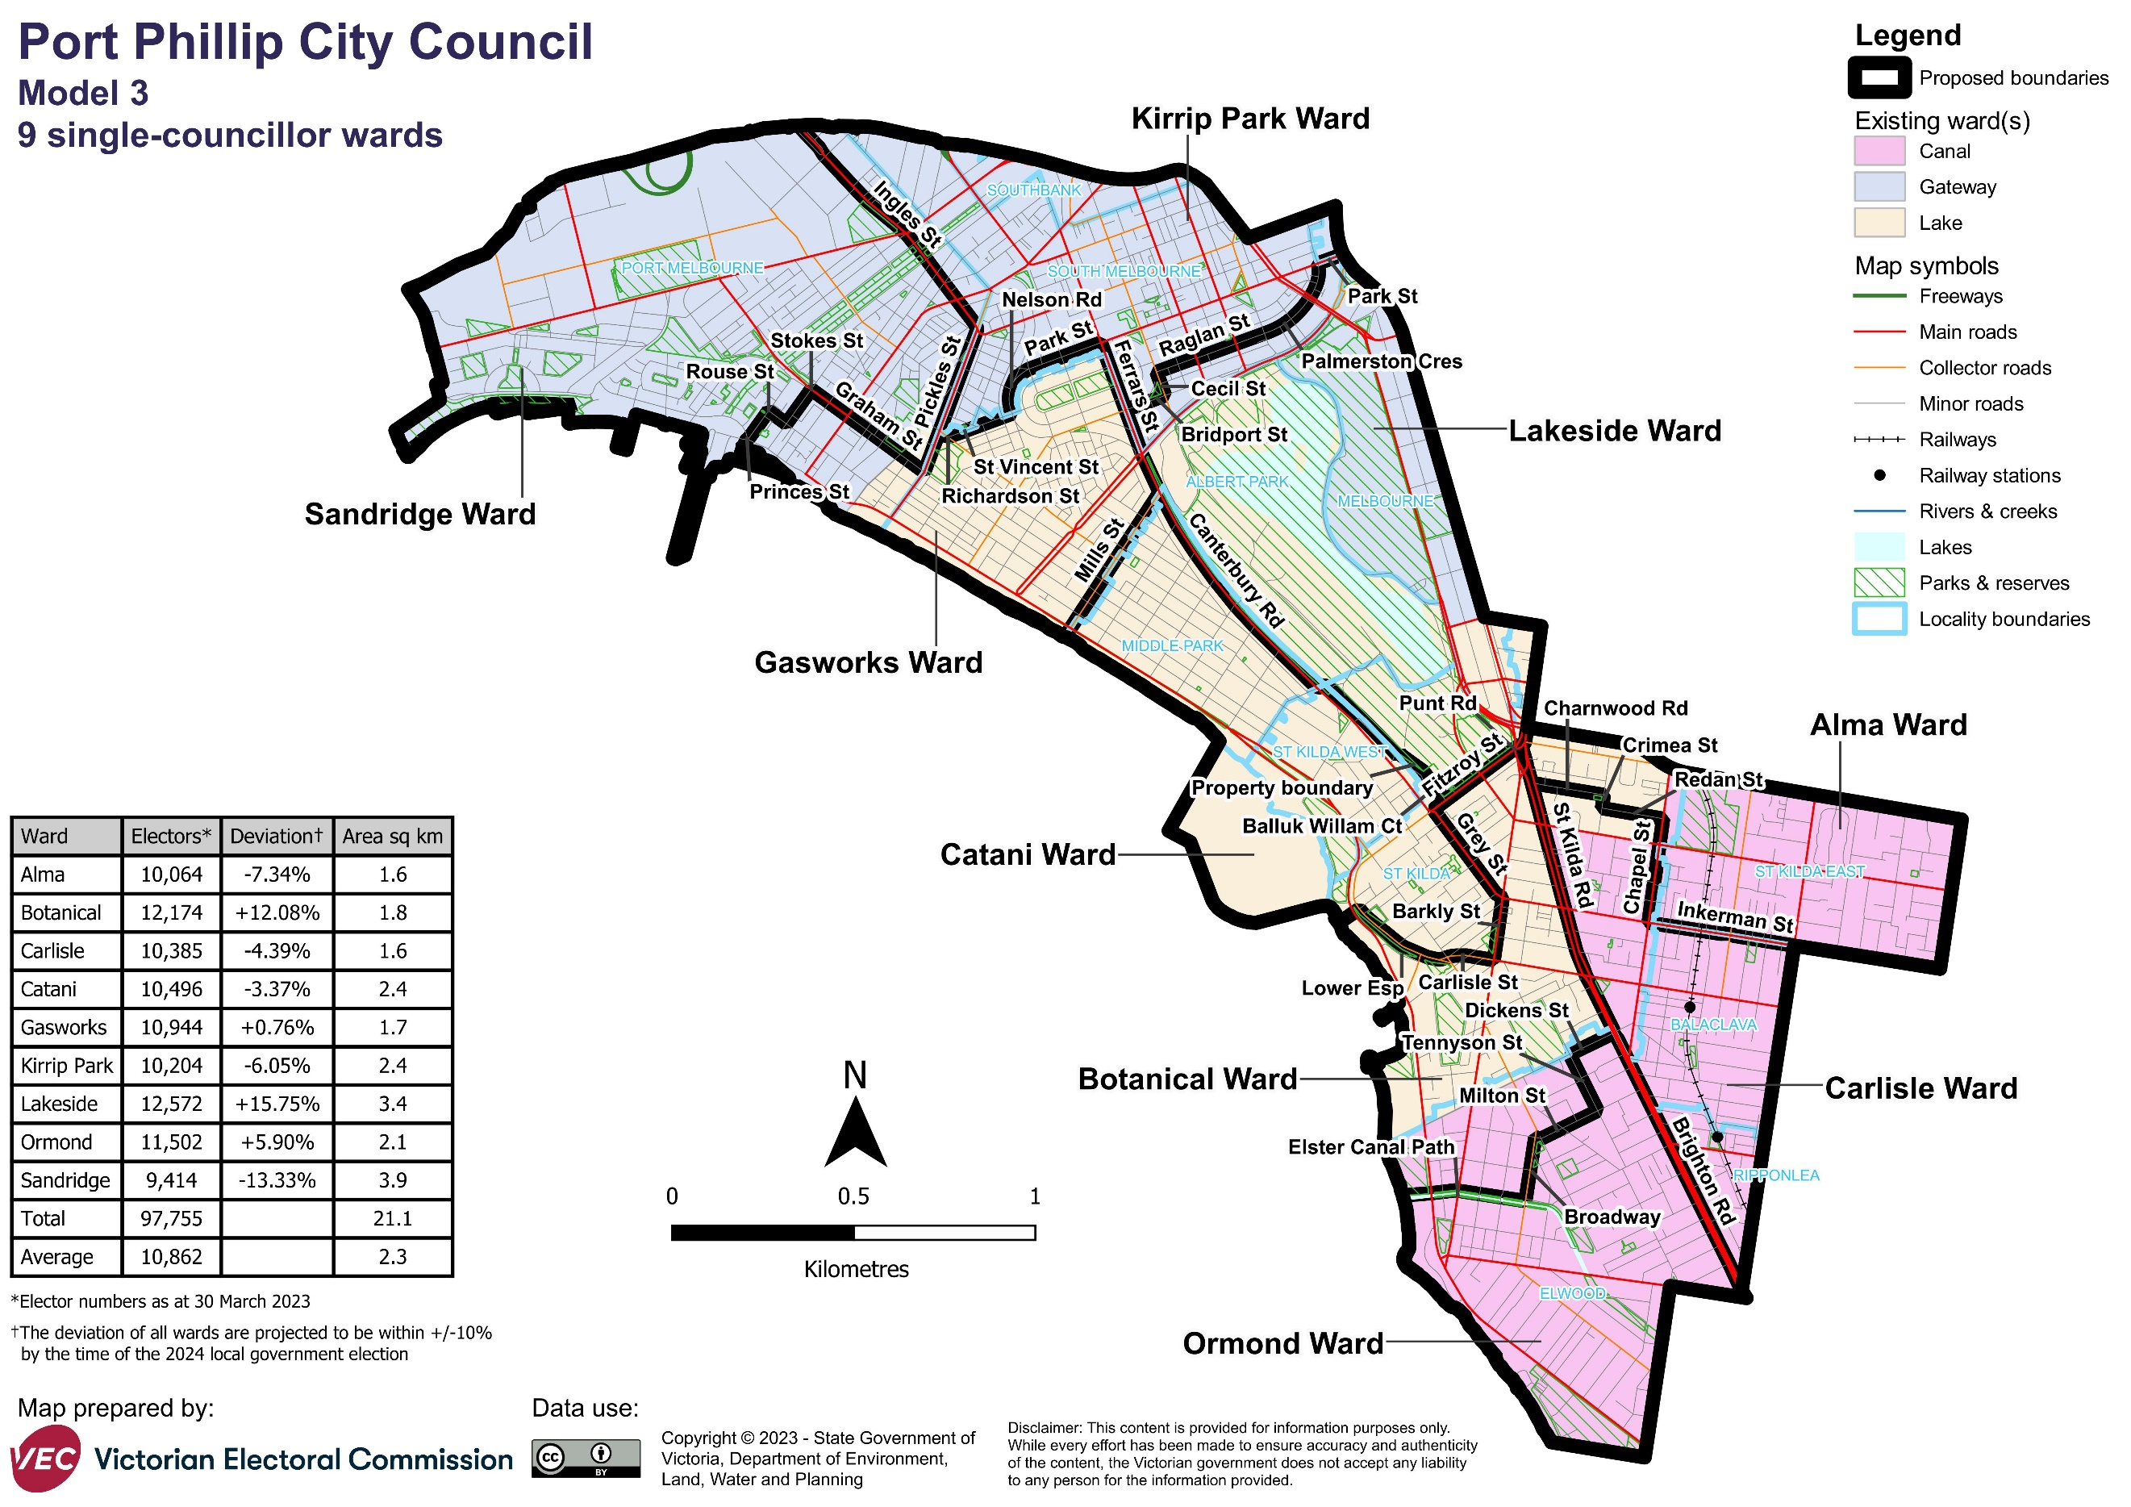

Forecast information referred to in the text of this report is based on forecasts prepared by .id – informed decisions [id.com.au](http://id.com.au) .id and its licensors are the sole and exclusive owners of all rights, title and interest subsisting in that part of the report content where .id are identified. Some of .id content is a derivative of ABS Data, which can be accessed from the website of the Australian Bureau of Statistics at [abs.gov.au](http://abs.gov.au), and licensed on terms published on the ABS website.