Local council electoral structure review

About the review
Under Victoria’s Local Government Act 2020, Warrnambool City Council must now have a single-councillor ward electoral structure.
The Minister for Local Government has appointed an electoral representation advisory panel to conduct an electoral structure review of the council. The panel will advise the Minister on the most appropriate single-councillor ward structure for Warrnambool City Council.
The panel is looking at:
- the appropriate number of councillors and wards
- the location of ward boundaries
- appropriate ward names.
Electoral structure reviews are an important part of democracy, and your input is valuable. As a local, you know your local council area better than anyone. This is your chance to let the panel know your thoughts about the single-councillor ward electoral structure that you believe would best provide representation for your community.
There are 2 opportunities for you to have your say on the electoral structure of the council:
- in a response submission to the preliminary report
- in an online public hearing, if you request to speak in your response submission.

About Warrnambool City Council
The Traditional Custodians of the land in Warrnambool City Council are the Eastern Maar people.
Warrnambool City Council is about 260 km west of Melbourne, with a population of 35,406 in 2021 and a forecast annual growth rate of 1.1%.
Covering an area of 121 km², the council area includes urban centres of Allansford, Bushfield-Woodford, and Warrnambool.
Warrnambool City Council is bordered by Moyne Shire Council and the Southern Ocean. The coastal landscape of the area includes the ancient dune systems of Thunder and Pickering points and the Merri and Hopkins river estuaries. Logans Beach is a well-known site for southern right whales.
Major roads service the area including the Princes and Hopkins highways and the Great Ocean Road.
Agriculture is an important part of the economy with the Warrnambool area producing 25% of Australia’s milk and 30% of Victoria’s beef and lamb. Health care and social assistance was the largest industry sector in 2021 employing 23% of residents.
The median age in 2021 was 42, which was slightly lower than the overall rural and regional Victorian median of 43.
In 2021, most people in the municipality (68.9%) owned their own home either outright or with a mortgage, and the median weekly household income was $1,396.

Current structure
Warrnambool City Council is unsubdivided with a total of 7 councillors.
Last review
The VEC conducted an electoral representation review of Warrnambool City Council in 2015.
Visit the VEC website at vec.vic.gov.au to access a copy of the 2015 review final report.

Review process

Monday 3 and Tuesday 4 July

Information sessions
Session 1: 12 noon, Monday 3 July
Session 2: 6 pm, Tuesday 4 July
Information sessions are for anyone wanting to find out more about the review process. Links to register for an information session will be available on the VEC website.

Wednesday 5 July

Preliminary report
The panel will release a preliminary report including one or more options for the electoral structure on Wednesday 5 July.
Response submissions open from this date.

Wednesday 26 July

Response submission close
The panel must receive all submissions by 5 pm on Wednesday 26 July.
Late submissions will not be accepted.

Wednesday 2 August

Public hearing
The panel will hold an online public hearing if anyone requests to speak about their response submission at 10 am on Wednesday 2 August.
The public hearing will not be held if there are no requests to speak.

Wednesday 30 August

Final report
The panel will submit a final report to the Minister for Local Government including its advice on the electoral structure on Wednesday 30 August.
The Minister will then consider the panel’s advice before recommending a change to the electoral structure. Any change to the electoral structure of the council following the review is expected to apply at the next local council elections.
How to make a submission

On the VEC website at vec.vic.gov.au
By email to
Warrnambool.ERAPSubmissions
@vec.vic.gov.au
By post to
Electoral representation advisory panel
c/o Victorian Electoral Commission
Level 11, 530 Collins Street
Melbourne VIC 3000
Submissions must include your:
- full name
- contact phone number or email address
- residential or postal address.
All submissions will be published on the VEC website. Your name and locality (suburb or town) will be published, but your full address and contact details will be removed. See the submission guide and VEC website at vec.vic.gov.au/privacy for privacy information.

Submission guide
Download the submission guide from the VEC website at vec.vic.gov.au for more information on the review process and making a submission.

One vote, one value
The ‘one vote, one value’ democratic principle is enshrined in the Local Government Act 2020. This means that every person’s vote counts equally.
When a local council area is subdivided into wards, the number of voters each councillor represents in each ward must be within plus-or-minus 10% of the of the average number of voters per councillor for all the wards.
The map below includes the current number of voters in each ward and the ward’s current deviation from the average. The panel will consider likely population and voter changes to ensure the structure remains equitable.
If you make a submission online, you can use a mapping tool to build your preferred electoral structure. The tool uses current voter numbers to tell you the deviations of the wards you make. This will help you propose a structure that meets the requirements of the Act.

Current electoral structure
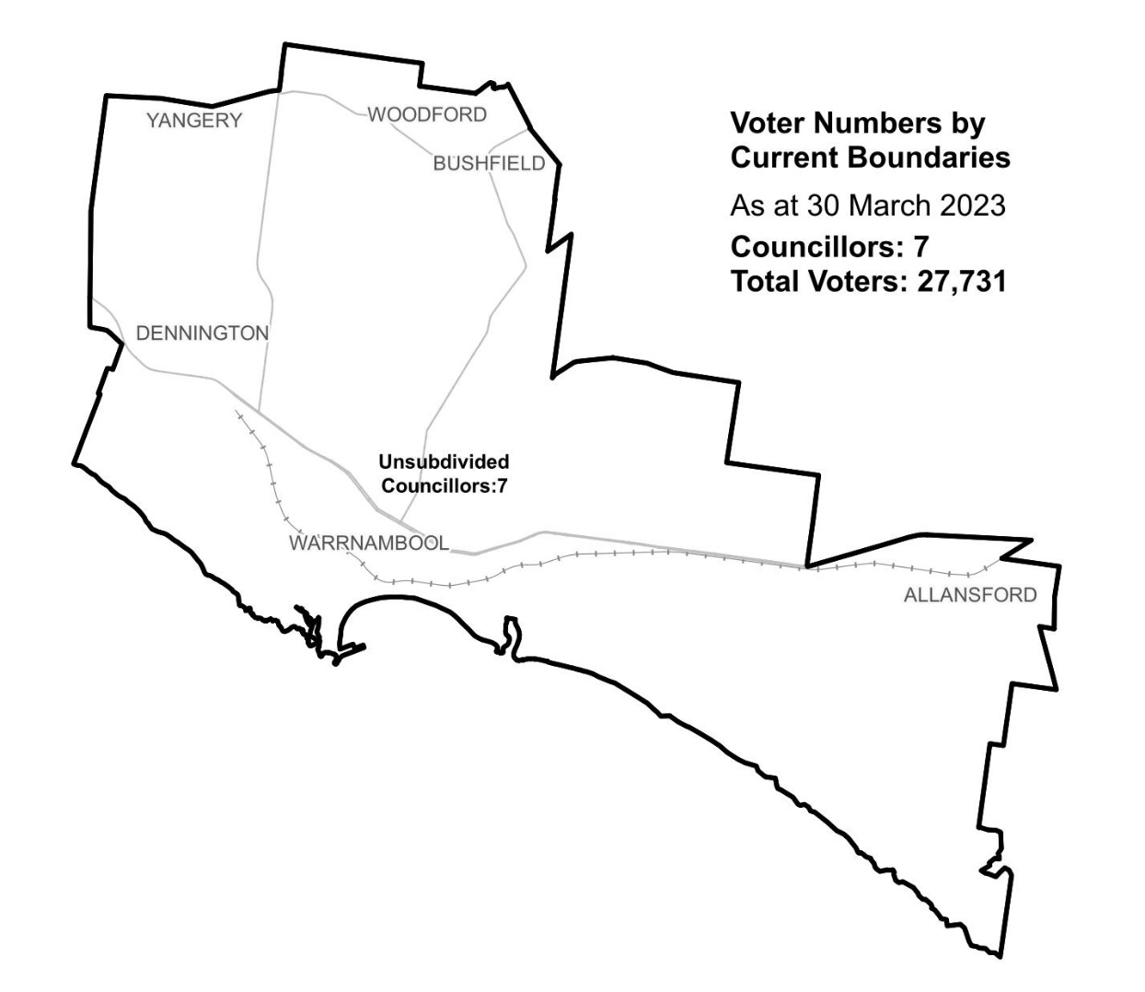
Ward | Councillors | Voters | Deviation
Unsubdivided | 7 | 27,731 | n/a

Statistics
Area (km²) 121

Voters

Voters per square km
229.2

Average voters per councillor
3,961

Population

Current population
35,406

Forecast population growth
1.1% p.a.

Further census statistics available at abs.gov.au

Voter numbers by locality (map)
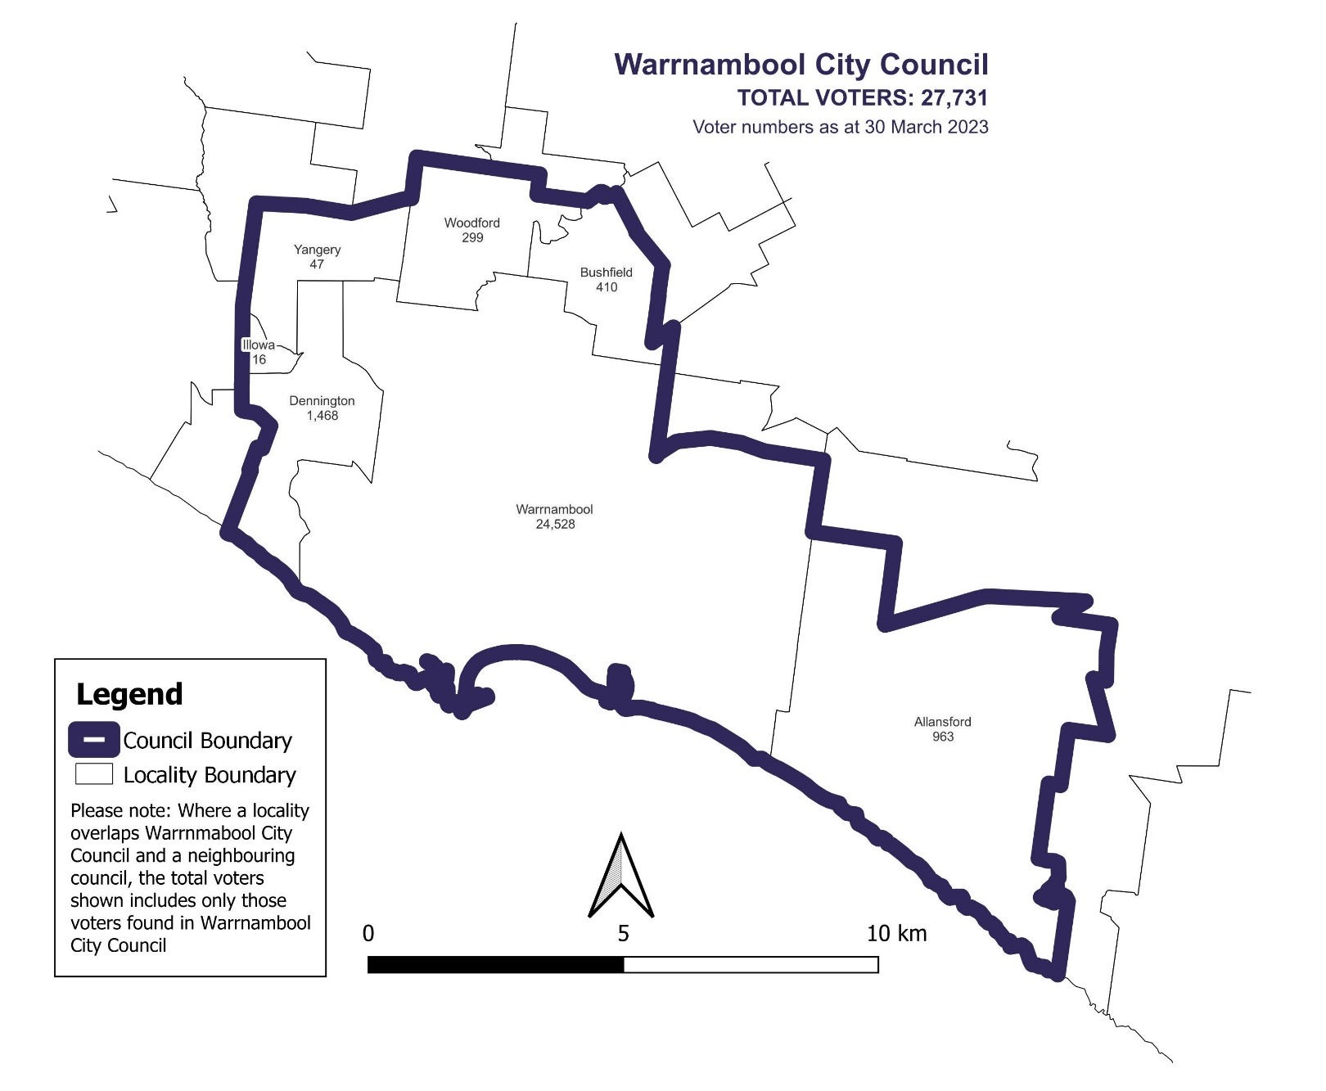

Voter numbers by locality (table)

Warrnambool City Council voter numbers at 30 March 2023

Locality | Voters
Allansford | 963
Bushfield | 410
Dennington | 1,468
Illowa | 16
Warrnambool | 24,528
Woodford | 299
Yangery | 47

