Victorian Electoral Commission

Multicultural Inclusion Plan 2020 – 2023
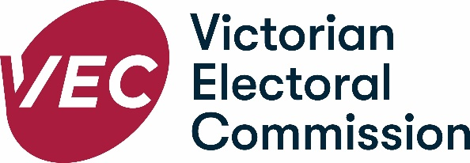

Cover image: Patel, Anuradha, Eternal Spiral, 2020, Digital Print.
Anuradha Patel is an Indian born artist based in Australia with a professional practice of over 40 years. Her practice includes public art as well as studio-based works in paper, metal and print.

Foreword
I am proud to present the Victorian Electoral Commission’s first Multicultural Inclusion Plan 2020–2023 (MIP).
The MIP is a key part of the VEC’s vision of all Victorians actively participating in their democracy. The MIP builds on the VEC’s existing work with Culturally and Linguistically Diverse (CALD) communities to ensure that the VEC continues to deliver culturally competent, responsive services for CALD voters.
At the heart of the VEC’s work is social inclusion. The VEC aims to be proactive in identifying and removing any existing barriers to full and effective participation in democracy. For more than a decade, the VEC has been an Australian leader in building CALD communities’ electoral skills and knowledge through the delivery of voter education, in partnership with key stakeholders. My gratitude goes to the VEC CALD Advisory Group members who have been strong and constant contributors to our successes.
Australia is one of the most multicultural countries in the world, and Victoria is one of our most culturally diverse states. At the time of the 2016 Census and in terms of Victoria’s total population - 49.1% were born overseas or born in Australia with at least one parent born overseas and 26% spoke a language other than English at home. Last year, a further 82,113 people who were born overseas chose to call Victoria home.
Given that enrolling and voting is compulsory for Australian citizens, there is a responsibility upon the VEC to ensure that all eligible voters can access the communication and services it provides. This responsibility is taken seriously and as such this plan has both an internal and external focus. The VEC aims to increase the electoral participation of all voters and this plan aims to address the needs of Victoria’s ever-growing population of CALD voters.
The MIP also has an internal focus, ensuring that the VEC workforce is reflective of, and responsive to, the community we serve. It aims to build the VEC’s internal cultural competency to not only meet the growing needs of CALD communities, but also contributing to greater social cohesion through development of understanding and respect for other cultures.
The MIP has been developed following extensive internal and external consultations with VEC staff, the VEC's CALD Advisory Group, the Electoral Access Advisory Group, the Homelessness Advisory Group, English as an Additional Language teachers, young CALD people, CALD people from the VEC’s Democracy Ambassador program, the Victorian Multicultural Commission and, especially, CALD voters with low English language proficiency.
Electoral accessibility is about removing barriers and increasing peoples’ confidence to enrol and vote. I look forward to implementing this plan over the next three years, knowing that the actions will contribute to people from CALD backgrounds feeling empowered and enthusiastic about engaging in Victoria's democracy.

Warwick Gately AM
Electoral Commissioner

Acknowledgement of Country
The Victorian Electoral Commission (VEC) acknowledges the Aboriginal and Torres Strait Islander people of this nation, as the traditional custodians of the lands on which the VEC works and where we conduct our business.
We pay our respects to ancestors and Elders, past, present and emerging. The Commission is committed to honouring Aboriginal and Torres Strait Islander peoples’ unique cultural and spiritual relationships to the land, waters and seas and their rich contribution to society.

Contents
Foreword 3
Acknowledgement of Country 5
About the Victorian Electoral Commission 7
Our primary responsibilities include: 8
Our values are: 8
Purpose 9
VEC Diversity and Inclusion Framework and Statement 9
Strategy 2023 10
The VEC’s Multicultural Inclusion Plan 2020 – 2023 11
Key priority areas and actions 12
Access 12
Employment 13
Community 13
Capability 14
Reporting and Governance 14
Feedback 15

About the Victorian Electoral Commission
Our vision – all Victorians actively participating in their democracy.
The purpose of the Victorian Electoral Commission (VEC) is to deliver high quality, accessible electoral services with innovation, integrity and independence.
The VEC is an independent and impartial statutory authority established under Victoria’s Electoral Act 2002. It operates under the auspices of the Department of Premier and Cabinet, within the portfolio of the Minister for Government Services. However, the VEC is not subject to the direction or control of the Minister in respect to the performance of its responsibilities and functions and the exercise of its power.
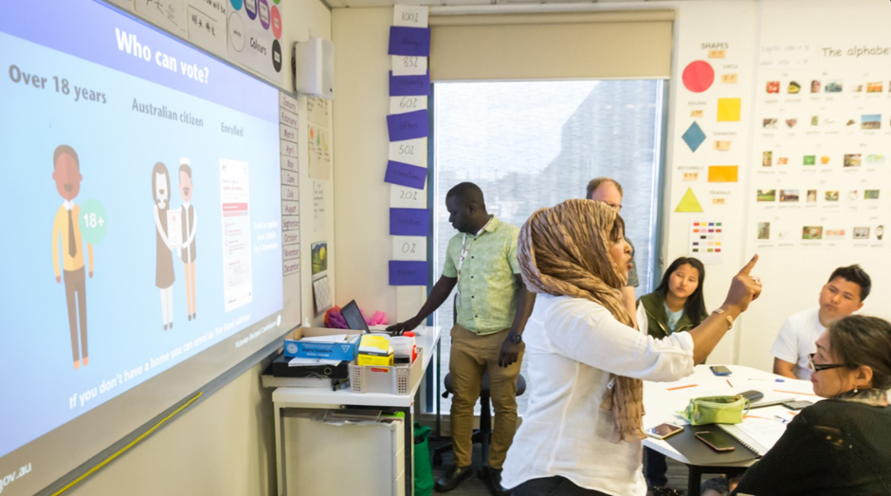
VEC Community Educator Etimad Jaffer speaking at an education session in Yarraville, VIC

Our primary responsibilities include:
- conducting State, local government and certain statutory elections
- maintaining the register of Victorian electors
- conducting electoral boundary reviews
- administering political funding and donation disclosure laws
- conducting research in the public interest
- promoting public awareness and understanding of electoral issues.

Our values are:
- Independence - acting with impartiality and integrity
- Accountability - transparent reporting and effective stewardship of resources
- Innovation - shaping our future through creativity and leadership
- Respect - consideration of self, others and the environment
- Collaboration - working as a team with partners and communities.
The VEC has three active community advisory groups: Culturally and Linguistically Diverse (CALD) Advisory Group; Electoral Access Advisory Group (EAAG) and Homelessness Advisory Group.
The CALD Advisory Group consists of 12 members of ethno-specific service providers, State and Federal government departmental representatives and persons with lived experience of multiculturalism. The CALD Advisory Group provides the VEC with community advice, feedback and ideas for achieving better CALD elector engagement.
VEC Democracy Ambassador Ebrima Sarr assisting at an education session in Yarraville, VIC

Purpose
The purpose of the Multicultural Inclusion Plan (MIP) is to increase the formal electoral participation of CALD communities by addressing known barriers. The MIP will help VEC staff see their engagement, enrolment and voting services from the perspective of the CALD community. Leading from this, the MIP prescribes the actions, tools, skills and knowledge that will enable VEC staff to create and deliver accessible services and information that are both culturally inclusive, and responsive to CALD communities’ electoral needs.

VEC Diversity and Inclusion Framework and Statement
The VEC Diversity and Inclusion Framework was launched in June 2020 and builds on the VEC Diversity and Inclusion Statement (2017). These documents build confidence and trust by recognising and celebrating diversity both within our organisation and the communities we serve. We recognise that our differences span across gender, race, ability, age, sexual orientation, income, faith, socio-economic background and living situation. We need to represent the richness of all people, all backgrounds, and all perspectives, and recognise the overlapping nature of these communities. The VEC is committed to diversity and inclusion in our workplaces with the people we employ and those we work with, and at the ballot box with the people we serve. The VEC Diversity and Inclusion Framework outlines our Guiding Principles for Diversity and Inclusion as:
- Recruit – Our workforce reflects the diversity of the community we serve
- Include – Our culture fosters accessibility and inclusion
- Develop – We provide opportunity for our people to grow
- Lead – Our leaders feel secure and are empowered to be creative/innovative
- Enable – We build the capability of individuals, support workers, teachers and community to facilitate electoral participation and candidature
- Access – Our relationships with communities help us to learn about opportunities and challenges.

Strategy 2023
The VEC works to remove all possible barriers to participation and strives to ensure all eligible Victorians are engaged with the democratic process. The VEC’s Strategy 2023 provides an overarching five-year goal for the VEC to be change-ready and ensure there are people, systems and relationships in place to make the most of opportunities.
The Strategy has four focus areas for overall implementation including: people; technology; decision making; and relationships. Extensive internal consultation on the MIP ensures strategic alignment with Strategy 2023. Our aim is to learn from others outside the VEC about opportunities and challenges. By seeking advice and knowledge from all our networks when planning how to improve our services, we continually change with the times.
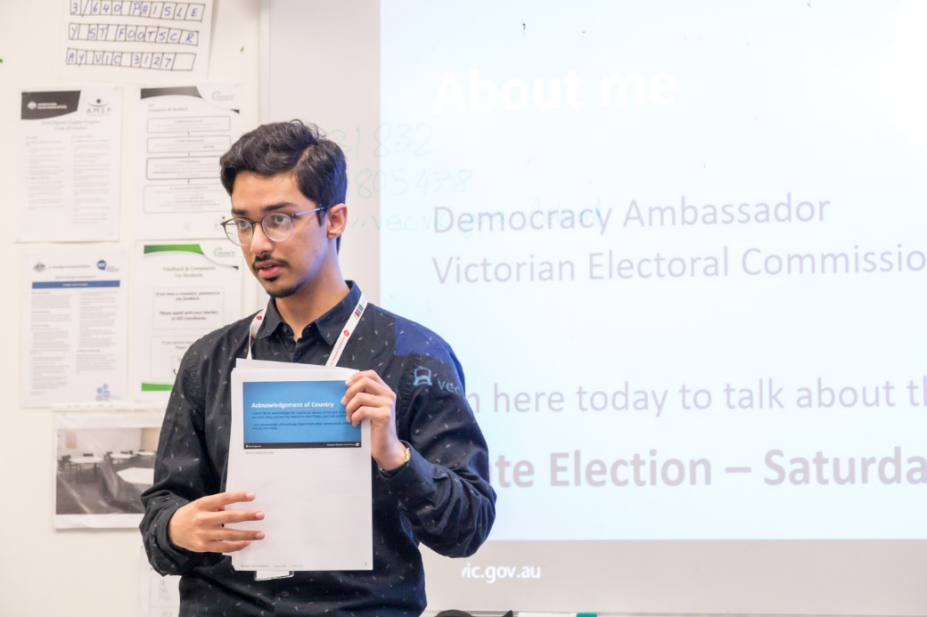
VEC Democracy Ambassador Mofiz Ul Haq at an education session for the 2018 State election

The VEC’s Multicultural Inclusion Plan 2020 – 2023
The VEC has a proud reputation as an Australian leader in CALD community electoral participation, and in the delivery of voter education and inclusion programs. These include the Democracy Ambassador Program (an Australian-first), delivery of active citizenship workshops and the development of the Talking Democracy Kit - a resource designed specifically for English as an Additional Language (EAL) teachers to be used in English classrooms.
To build on this work, it is timely that the VEC develops and implements a comprehensive action plan to meet the electoral needs of the growing population of CALD voters in Victoria.
The MIP actions are grouped into key priority areas:
- access – to culturally responsive information and services
- employment – staff recruitment and retention
- community – engagement, skill development, collaboration and partnerships
- capability – building staff skills to provide culturally responsive information and services.

Key priority areas and actions
Access – culturally responsive information and services
We commit to providing culturally accessible information and services to CALD communities in Victoria.
To achieve this, we will:
- have multilingual and culturally competent staff working during elections
- have staff from CALD communities delivering electoral education activities, and promoting online translated enrolment forms and the VoterAlert service to support enrolling and voting
- ensure that interpreter services are offered at public facing events and education sessions, where appropriate
- provide translated information for all significant electoral events.

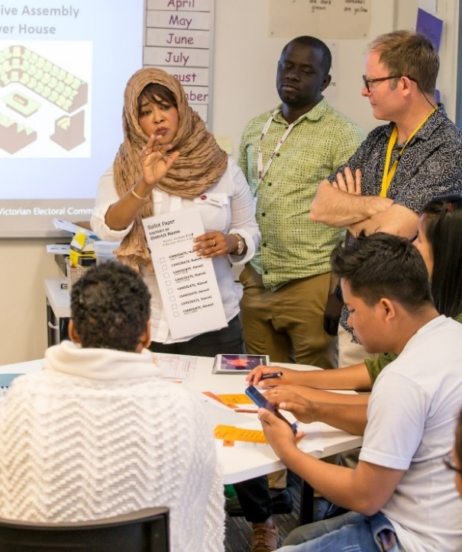
VEC Community Educator Etimad and Democracy Ambassador Ebrima

Employment – staff recruitment and retention
Our workforce expands up to 20,000 people during State elections. We aim to employ and retain a diverse workforce that is representative of the community we serve.
To achieve this, we will:
- ensure our recruitment practices are inclusive and attract candidates from CALD communities
- ensure that the election official appointment process includes clear guidelines to support the appointment of people with multilingual skills and people from diverse cultures (including women)
- provide at least one internship or mentorship program for a student from a culturally diverse background.
Community – engagement, skill development, collaboration and partnerships
We will work in partnership with culturally diverse service providers and communities to support electoral participation.
To achieve this, we will:
- ensure the membership of the CALD Advisory Group reflects the constantly changing CALD community
- work with the CALD Advisory Group, key stakeholders and people with lived experience, to assist in the development and implementation of education programs and resources
- initiate a partnership with an English as an Additional Language (EAL) teacher training provider to embed electoral education into their training
- partner with an organisation with a view to delivering an electoral skill development workshop to young CALD people
- continue to promote and provide culturally responsive education sessions and community outreach activities

- increase our community engagement among CALD communities across Victoria throughout the year
- continue to collaborate and partner with leadership programs to deliver active citizenship workshops to CALD community leaders across Victoria
- develop a checklist to ensure internal and external publications and information includes images which reflect the diversity within the community.
Capability – build staff skills to provide culturally responsive information and services
We will have highly-trained and committed staff to meet the electoral participation needs of CALD communities.
To achieve this, we will:
- review this Plan annually and make amendments to ensure actions match changes in the broader community
- continue to build our workforce’s cultural knowledge and skills
- complete research on the barriers and enablers to electoral participation among CALD people.

Reporting and Governance
The Electoral Commissioner and the VEC Executive Management Group are responsible for ensuring the actions of the Multicultural Inclusion Plan 2020 – 2023 are achieved.
The VEC will maintain a progress report for the Multicultural Inclusion Plan and invite feedback twice a year from the CALD Advisory Group.
An annual progress summary will be reported in the VEC Annual Report.

Feedback
If you have any feedback or suggestions about this Plan, you can:
Email us at info@vec.vic.gov.au
Call us on (03) 8620 1100

If you require interpreter services, you can contact us on
9209 0112.

If you are deaf, hard of hearing or need communication support, you can contact us on 133 677 or through the National Relay Service 1800 555 600.

Write to us at:
Victorian Electoral Commission
Level 11
530 Collins Street
Melbourne VIC 3000.

