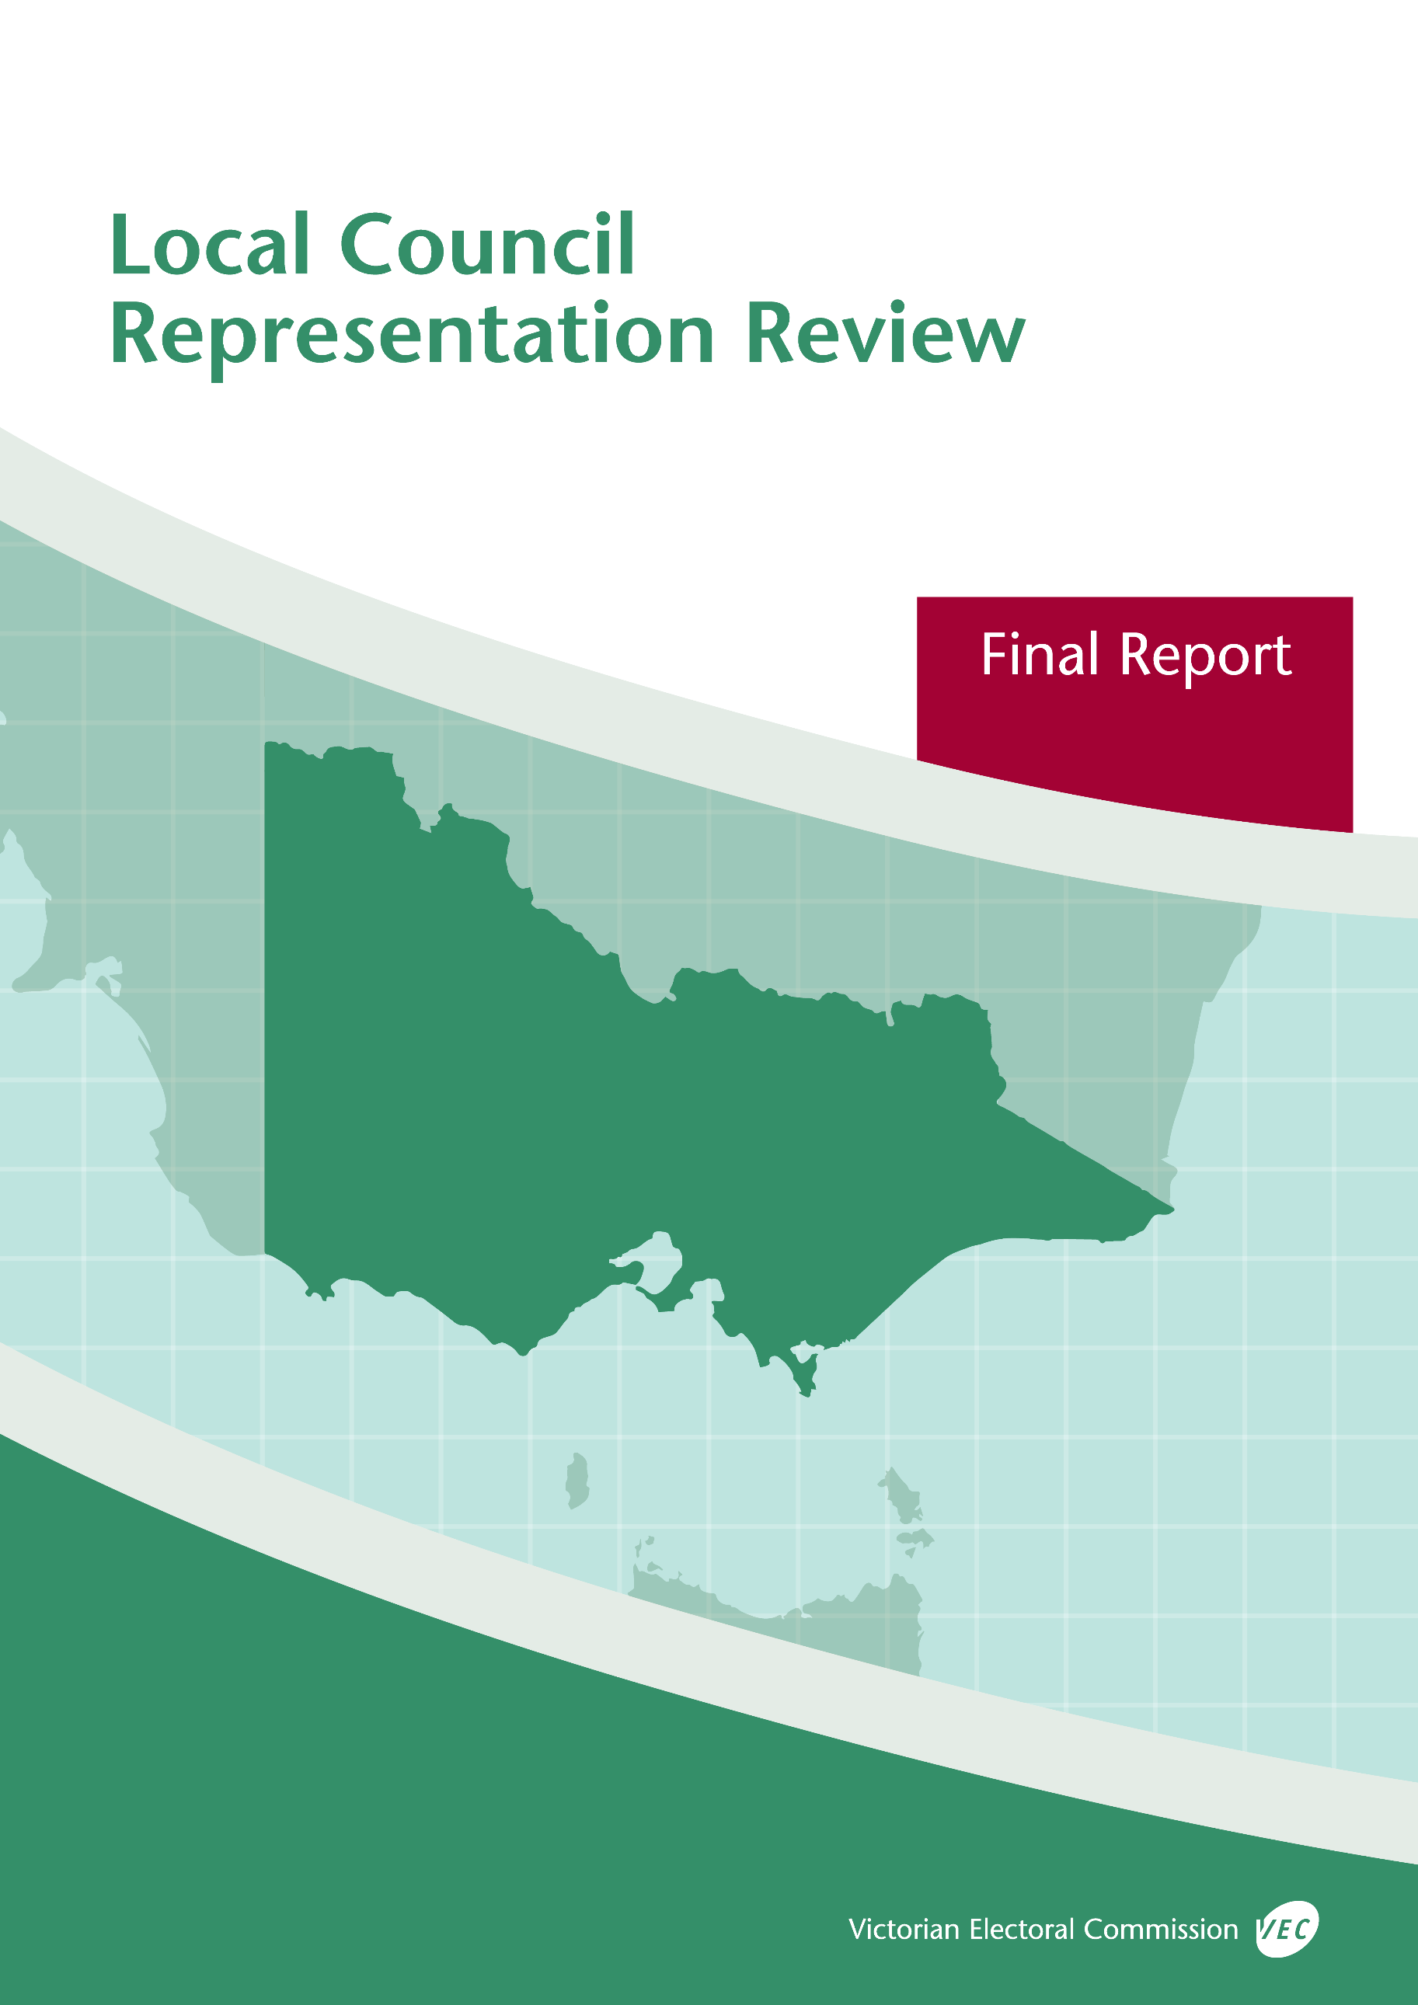



**October 2019**

**Kingston City Council**

© State of Victoria (Victorian Electoral Commission)   
Wednesday 9 October 2019

Version 1  
  
cid:image001.png@01D4D431.F774F3F0

This work, Local Council Representation Review Final Report – Kingston City Council, is licensed under a Creative Commons Attribution 4.0 licence [<http://creativecommons.org/licenses/by/4.0/>]. You are free to share this work under that licence, on the condition that you do not change any content and you credit the State of Victoria (Victorian Electoral Commission) as author and comply with the other licence terms. The licence does not apply to any branding, including Government logos.

Contents

Recommendation 1

Executive summary 2

Background 4

Legislative basis 4

Public engagement 4

The VEC’s principles 5

Developing recommendations 6

Kingston City Council representation review 8

Profile of Kingston City Council 8

Current electoral structure 9

Preliminary submissions 10

Preliminary report 11

Public response 15

Response submissions 15

Public hearing 18

Findings and recommendation 20

The VEC’s findings 20

The VEC’s recommendation 22

Appendix 1: Public involvement 23

Appendix 2: Map 25

Appendix 3: Public information program 27

Recommendation

The Victorian Electoral Commission recommends that Kingston City Council consist of 11 councillors elected from three wards (two four-councillor wards and one three-councillor ward).

This recommendation is submitted to the Minister for Local Government as required by the *Local Government Act 1989*.

Please see Appendix 2 for a detailed map of this recommended structure.

Executive summary

The *Local Government Act 1989* (the Act) requires the Victorian Electoral Commission (VEC) to conduct an electoral representation review of each municipality in Victoria before every third council general election.

The purpose of an electoral representation review is to recommend an electoral structure that provides ‘fair and equitable representation for the persons who are entitled to vote at a general election of the Council.’[1] The matters considered by a review are:

* the number of councillors
* the electoral structure of the council (whether the council should be unsubdivided or divided into wards and, if subdivided, the details of the ward boundaries and the number of councillors per ward).

The VEC conducts all reviews based on three main principles:

1. taking a consistent, State-wide approach to the total number of councillors
2. if subdivided, ensuring the number of voters represented by each councillor is within   
   plus-or-minus 10% of the average number of voters per councillor for that local   
   council
3. ensuring communities of interest are as fairly represented as possible.

Current electoral structure

Kingston City Council currently comprises nine councillors elected from three three-councillor wards. More information on Kingston City Council and the current electoral structure is available in the council fact sheet on the VEC website at [vec.vic.gov.au](http://vec.vic.gov.au).

Prior to the last representation review in 2007, Kingston City Council was comprised of seven councillors elected from seven single-councillor wards. Visit the VEC website at [vec.vic.gov.au](http://www.vec.vic.gov.au/) to access a copy of the 2007 review final report.

Preliminary submissions

Preliminary submissions opened at the commencement of the current review on Wednesday   
19 June 2019. The VEC received 15 submissions for the representation review of Kingston City Council by the deadline at 5.00 pm on Wednesday 17 July 2019.

Preliminary report

A preliminary report was released on Wednesday 14 August 2019 with the following options for consideration:

* Option A (preferred option)  
  **Kingston City Council consist of nine councillors elected from three three‑councillor wards with adjustments to the current ward boundaries.**
* Option B (alternative option)  
  **Kingston City Council consist of eleven councillors elected from three wards (two four-councillor wards and one three-councillor ward).**

Response submissions

The VEC received 32 submissions responding to the preliminary report by the deadline at   
5.00 pm on Wednesday 11 September 2019.

Public hearing

The VEC conducted a public hearing for those wishing to speak about their response submission at 6.00 pm on Thursday 19 September 2019. Three people spoke at the hearing.

Recommendation

**The Victorian Electoral Commission recommends that Kingston City Council consist of 11 councillors elected from three wards (two four-councillor wards and one three-councillor ward).**

This electoral structure was designated as Option B in the preliminary report. Please see Appendix 2 for a detailed map of this recommended structure.

Background

Legislative basis

The Act requires the VEC to conduct a representation review of each local council in Victoria before every third general council election, or earlier if gazetted by the Minister for Local Government.

The Act states that the purpose of a representation review is to recommend the number of councillors and the electoral structure that provides ‘fair and equitable representation for the persons who are entitled to vote at a general election of the Council.’[2]

The Act requires the VEC to consider:

* the number of councillors in a local council
* whether a local council should be unsubdivided or subdivided.

If a local council is subdivided, the VEC must ensure that the number of voters represented by each councillor is within plus-or-minus 10% of the average number of voters per councillor for that local council.[3] On this basis, the review must consider the:

* number of wards
* ward boundaries
* number of councillors that should be elected for each ward.

Public engagement

### Public information program

The VEC conducted a public information program to inform the community of the representation review, including:

* public notices printed in local and State-wide papers
* public information session to outline the review process and respond to questions from the community
* media releases announcing the commencement of the review and the release of the preliminary report
* a submission guide to explain the review process and provide background information on the scope of the review
* an information email campaign targeted at known community groups and communities of interest in the local council area
* sponsored social media advertising geo-targeted to users within the local council   
  area
* ongoing information updates and publication of submissions on the VEC website.

More information on the VEC’s public information program for the representation review of Kingston City Council can be found at Appendix 3.

### Public consultation

Public input was accepted by the VEC via:

* preliminary submissions at the start of the review
* response submissions to the preliminary report
* a public hearing that provided an opportunity for people who had made a response submission to expand on their submission.

Public submissions are an important part of the review process but are not the only consideration. The VEC ensures its recommendations comply with the Act and are formed through careful consideration of public submissions, independent research, and analysis of all relevant factors.

The VEC’s principles

Three main principles underlie all the VEC’s work on representation reviews:

1. **Taking a consistent, State-wide approach to the total number of councillors.**

The VEC is guided by its comparisons of local councils of a similar size and category to the council under review. The VEC also considers any special circumstances that may warrant the local council having more or fewer councillors than similar local councils.

1. **If subdivided, ensuring the number of voters represented by each councillor is within plus-or-minus 10% of the average number of voters per councillor for that local council.**

This is the principle of ‘one vote, one value’, which is enshrined in the Act. This means that every person’s vote counts equally.

1. **Ensuring communities of interest are as fairly represented as possible.**

Each local council contains a number of communities of interest. Where practicable, the electoral structure should be designed to ensure they are fairly represented, and that geographic communities of interest are not split by ward boundaries. This allows elected councillors to be more effective representatives of the people and interests in their particular local council or ward.

Developing recommendations

The VEC bases its recommendations for particular electoral structures on the following information:

* internal research specifically relating to the local council under review, including data from the Australian Bureau of Statistics and .id[4]; voter statistics from the Victorian electoral roll; and other State and local government data sets
* small area forecasts provided by .id for relevant local council areas
* the VEC’s experience conducting previous electoral representation reviews of local councils and similar reviews for State elections
* the VEC’s expertise in mapping, demography and local government
* careful consideration of all input from the public in written submissions received during the review and via oral submissions at the public hearing
* advice from consultants with extensive experience in local government.

### Deciding on the number of councillors

The Act allows for a local council to have between five and 12 councillors but does not specify how to decide the appropriate number.[5] In considering the number of councillors for a local council, the VEC is guided by the Victorian Parliament’s intention for fairness and equity in the local representation of voters under the Act.

The starting point in deciding the appropriate number of councillors for a local council is comparing the local council under review to other local councils of a similar size and type (Principle 1). Generally, local councils that have a larger number of voters will have a higher number of councillors. Often large populations are more likely to be diverse, both in the nature and number of their communities of interest and the issues of representation.

However, the VEC also considers the particular circumstances of each local council which could justify fewer or more councillors, such as:

* the nature and complexity of services provided by the Council
* geographic size and topography
* population growth or decline
* the social diversity of the local council.

### Deciding the electoral structure

The Act allows for a local council ward structure to be unsubdivided—with all councillors elected ‘at-large’ by all voters—or subdivided into a number of wards.

If the local council is to be subdivided into wards, there are three options available:

1. single-councillor wards
2. multi-councillor wards
3. a combination of single-councillor and multi-councillor wards.

A subdivided electoral structure must be developed with internal ward boundaries that provide for a fair and equitable division of the local council.

The Act allows for wards with different numbers of councillors, as long as the number of voters represented by each councillor is within plus-or-minus 10% of the average number of voters per councillor for that local council (Principle 2). For example, a local council may have one   
three-councillor ward with 15,000 voters and two single-councillor wards each with 5,000 voters. In this case, the average number of voters per councillor would be 5,000.

Over time, population changes can lead to some wards in subdivided local councils having larger or smaller numbers of voters. As part of the review, the VEC corrects any imbalances and considers likely population changes to ensure ward boundaries provide equitable representation for as long as possible.

In considering which electoral structure is most appropriate, the VEC considers the following matters:

* the VEC’s recommendation at the previous representation review and the reasons for that recommendation
* the longevity of the structure, with the aim of keeping voter numbers per councillor within the 10% tolerance for as long as possible (Principle 2)
* communities of interest, consisting of people who share a range of common concerns, such as geographic, economic or cultural associations (Principle 3)
* the number of candidates in previous elections, as outcomes from previous elections indicate that large numbers of candidates can lead to an increase in the number of informal (invalid) votes
* geographic factors, such as size and topography
* clear ward boundaries.

Kingston City Council representation review

Profile of Kingston City Council

Kingston City Council is located on the eastern side of Port Phillip Bay, approximately   
15 kilometres south of Melbourne CBD. The local council area covers 91 square kilometres and includes a long stretch of coastline, important waterways and catchment areas, and part of the south-eastern regional green wedge. There is a range of land uses through the local council area, including residential, industrial, commercial, agricultural, parklands and open space.

The City of Kingston contains a large section of sparsely populated land extending through the centre of the local council area. It takes in the main industrial precincts, including Moorabbin Airport, some agricultural land and parts of Melbourne’s south-eastern green wedge. Much of this land is not suited for residential development.

The population is concentrated in established suburbs along the coast and major transport routes (Nepean Highway and Frankston railway line). Some suburbs, such as Clayton and Clarinda in the north-east and the relatively self-contained areas of Dingley Village and Waterways along the eastern boundary are close to major service centres outside the City of Kingston, and likely connect with these centres as well as those contained in the council area.

The City of Kingston includes various commercial and shopping districts, such as Southland Shopping Centre. The City is a major employment centre and one of the most concentrated manufacturing regions in metropolitan Melbourne.[6] In 2017-18, there were 1,230 manufacturing businesses employing about 18,000 people, making this industry the largest in the local council area.[7] Since 2006, however, manufacturing has gone from the top employer of the City’s own residents to the fifth, and currently sits behind social care and assistance, retail, education and training, and construction, all of which have grown substantially.[8]

Cultural and ethnic diversity has increased in the City of Kingston. In the 2006-16 period, the proportion of people in the City born overseas grew from 28.28% to 31.21%.[9] This equates to an additional 9,173 individuals born overseas, over half of whom were born in either China (2,738) or India (2,244).[10] Some suburbs, such as Clarinda and Clayton South have over 50% of the population born overseas.[11]

On average, residents of the City of Kingston report higher personal and family incomes than both the State and Greater Melbourne averages[12], and overall the local council area rates well on measures of relative social advantage and disadvantage.[13] However, some suburbs, such as Clarinda and Clayton South in the north, and parts of Chelsea and Carrum in the south, sit well below the City’s average on these measures.[14]

Kingston City Council faces challenges in relation to development. Since 2006, medium-density dwellings increased from 31.2% of the City’s total housing stock to 37.6%, and high-density dwellings from 0.7% to 3.1%.[15] These rates will continue to increase, particularly in areas such as Highett, Cheltenham and parts of Moorabbin.[16] Alongside other development planned for the local council area, growth will put pressure on the Council’s planning, policy-making, services and facilities.

The City of Kingston has experienced sustained population growth, with the population increasing from 134,623 in 2006 to 151,389 in 2016.[17] The population is projected to continue to grow by about 1.2% per year to be 190,599 by 2031.[18]

Current electoral structure

Kingston City Council currently comprises nine councillors elected from three three-councillor wards. More information on Kingston City Council and the current electoral structure is available in the council fact sheet on the VEC website at [vec.vic.gov.au](http://vec.vic.gov.au).

Prior to the last representation review in 2007, Kingston City Council was comprised of seven councillors elected from seven single-councillor wards. Visit the VEC website at [vec.vic.gov.au](http://www.vec.vic.gov.au/) to access a copy of the 2007 review final report.

Preliminary submissions

At the close of submissions on Wednesday 17 July 2019, the VEC had received 15 submissions for the representation review of Kingston City Council. A list of people who made a preliminary submission can be found in Appendix 1.

### Number of councillors

The number of councillors was not a major concern in preliminary submissions. Most submitters felt the current number of nine councillors provided fair and equitable representation. One submission argued for increasing the number of councillors to 11 to enable Kingston City Council to better manage the pressures associated with growth and development and the likely impact these pressures would have on Council services and planning considerations. The submission also argued against 10 councillors, as an even number of councillors could result in deadlocked Council votes.

### Electoral structure

**Unsubdivided**

Two submitters proposed an unsubdivided electoral structure, one of whom suggested it was not fair for councillors in one ward to be contributing towards decisions in another ward. Another submitter suggested an unsubdivided electoral structure was the most democratic as it would help facilitate the election of independent candidates and those not affiliated with the major political parties. The same submitter also argued that an unsubdivided electoral structure would encourage a whole-of-council approach, provide residents with more options when connecting with their councillors and avoid the need to define and name wards.

**Single-councillor wards**

Three submitters preferred a single-councillor ward structure. One of these referred to the suburb of Dingley Village to suggest the area was under-represented at present, that councillor workloads were not being shared effectively and that smaller, single-councillor wards would improve representation for the area. Another submitter argued that a single-councillor electoral structure would be more democratic because they felt the current multi-councillor ward structure provided no direct accountability to voters, was confusing for voters familiar with the State and Federal single-member electorates and lacked transparency.

**Multi-councillor wards**

Eight out of 15 submitters proposed retaining the current multi-councillor ward structure and suggested that this structure had worked well to date. Some submitters argued the current electoral structure facilitated good access to councillors and allowed councillors to share workloads effectively; others thought the current structure enabled councillors to develop a good understanding of local issues.

Numerous submitters felt the current electoral structure reflected and represented the diversity of the local council area. Some argued that it provided fair representation by not allowing political parties or vested interests to dominate elections.

The Proportional Representation Society of Australia (Victoria-Tasmania) Inc. (PRSA) supported the current electoral structure as it preferred an odd number of councillors and multi-councillor wards comprising an equal number of councillors to maximise the benefits of proportional representation and ensure parity across the different wards. It also suggested that due to the number of candidates in the past three elections, an unsubdivided electoral structure would ‘clutter’ the ballot paper, which would not benefit voters.

Two submitters did not specify a preferred electoral structure, emphasising instead issues specific to their wards. One of these requested the three-councillor North Ward be retained. The other proposed that the suburb of Heatherton, which is currently split between North and Central Wards, be contained fully in North Ward.

Preliminary report

A preliminary report was released on Wednesday 14 August 2019. The VEC considered public submissions and research findings when formulating the options presented in the preliminary report.

### Number of councillors

When considering the appropriate number of councillors for the City of Kingston, the VEC assessed population data, communities of interests and any special circumstances, such as population growth and development that might warrant increasing or decreasing councillor numbers.

Demographic data for Kingston City Council indicated the local council area has experienced sustained population growth for the period 2006-16, increasing from 134,623 to 151,389.[19] It also indicated that the population would continue to increase at a projected rate of about 1.2% per year, so that by 2031 (around the time of the next scheduled representation review) the population would number 190,599.[20]

On current and projected population and voter numbers, comparisons with similar Melbourne Metropolitan local councils and the VEC’s own research and analysis, two options for the number of councillors were proposed.

The VEC determined that Kingston City Council did not face significant social challenges, which might justify increasing councillor numbers and noted the majority of support in preliminary submissions for retaining nine councillors. For these reasons the VEC considered a nine‑councillor electoral structure to be appropriate for fair and equitable representation.

The VEC reported that Kingston City Council had the highest voter-to-councillor ratio among Metropolitan Melbourne local councils with nine councillors and that population growth and development would place pressure on councillor workloads and the City’s planning and policy processes. In response to these factors, the VEC proposed increasing the number of councillors to 11, which was also considered to provide fair and equitable representation.

### Electoral structure

While most preliminary submissions argued for retaining multi-councillor wards, there was some support for both an unsubdivided electoral structure and single-councillor wards. The VEC assessed all these options, as well as suitable variations, as summarised below.

The VEC acknowledged the arguments in favour of an unsubdivided electoral structure. However, in each of the past three elections, there had been between 45 and 53 candidates across the three wards and this number of candidates on one ballot paper would likely confuse some voters and contribute to a higher rate of informal votes.[21]

In response to some support in preliminary submissions, the VEC modelled two single-councillor electoral structures—one for nine councillors and one for 11 councillors. While the VEC considered the merits of the arguments in favour of this electoral structure, it found that uneven population distribution, projected population growth, and the spread of communities of interest across the City of Kingston meant creating sustainable and equally-sized single-councillor wards with clear and logical ward boundaries was not possible. For these reasons, the VEC determined that both the nine and 11 single-councillor ward models were unsatisfactory in providing fair and equitable representation and therefore did not progress these options for further consultation.

On the basis of preliminary submissions, the VEC’s own research and detailed modelling of various electoral structures, the VEC considered that a multi-councillor ward structure would provide the best option for fair and equitable representation.

The current electoral structure (with a minor boundary adjustment) was proposed as Option A and was put forward for public consultation in the preliminary report in response to strong support in preliminary submissions for retaining the current electoral structure of three three-councillor wards. It also satisfied the legislated requirement that all wards are within plus-or-minus 10% of the average number of voters per councillor, used familiar ward boundaries and involved minimal disruption to voters and residents.

In this option the ward boundary between South and Central Wards remained unchanged. A minor ward boundary adjustment was proposed so that all of Heatherton would be contained within North Ward. This change impacted approximately 1,200 voters (0.98% of total voters) and was considered an improvement to the current boundaries.

The VEC reported the advantages of a three three-councillor ward structure as maintaining parity between the different wards, providing voters with a good degree of choice at elections, facilitating diversity of representation and enabling councillor workloads to be shared.

The VEC determined that Option A effectively contained geographic communities of interest and would not split communities or activity centres to a significant degree. The wards proposed in Option A had a relatively even share of the City’s development pressures and a good mix of land uses in each, which the VEC considered would reasonably distribute the challenges faced by the City across the three wards.

The VEC determined Option B, comprising four councillors each in North and South Wards and three councillors for Central Ward, to be the most appropriate 11 councillor electoral structure for Kingston City Council. Of all modelled subdivided electoral structures consisting of 11 councillors, the VEC determined that Option B was the best at keeping communities of interest together.

In developing Option B, the VEC considered two important factors—the potential representation needs of each ward and suitable boundaries—to determine the best model for accommodating two extra councillors. The proposed North and South Wards, which each had an additional councillor in this option, were found to contain the greatest levels of social diversity and disadvantage and the VEC determined that these factors were likely to add to councillor workloads. On these grounds, it was reasonable for North and South Wards to each have the additional councillor. It was also determined that this electoral structure would enable greater use of main roads as ward boundaries providing boundaries that are more easily identified and may be more familiar to residents.

The VEC considered Option B had similar advantages to Option A, including an appropriate degree of choice for voters at election time, the ability to provide diversity of representation for voters in each ward and fair representation for the City’s communities of interest. The difference between the two options was that in order to ensure all wards remained within plus-or-minus 10% of the average number of voters per councillor, the proposed Central Ward would be slightly smaller than the current electoral structure. Nonetheless, it was considered that there was a good mix of land uses and a reasonable spread of the City’s development pressures across each ward.

Like Option A, in this option the ward boundaries between South and Central Wards remained unchanged from the current electoral structure. The VEC considered the ward boundaries proposed in Option B would be clearer and more easily identifiable that those suggested in Option A. In particular, the use of Centre Dandenong Road as a boundary between North and Central Wards was considered to be an improvement on the current boundary.

The most significant difference between the options was that Option B did not have an equal number of councillors in each of the three wards and this might lead to a perception of unequal representation.

The VEC concluded both Option A and Option B would be appropriate electoral structures to ensure fair and equitable representation for the voters of Kingston City Council and that both responded to the key considerations and principles used by the VEC when conducting representation reviews. Option A retained the current electoral structure (apart from the minor change in Heatherton), creating the least disruption to voters. However, the VEC considered Option B an appropriate response to anticipated population changes.

### Options

After careful consideration, the VEC put forward the following options:

* Option A (preferred option)  
  **Kingston City Council consist of nine councillors elected from three three‑councillor wards, with adjustments to the current ward boundaries.**
* Option B (alternative option)  
  **Kingston City Council consist of eleven councillors elected from three wards (two four-councillor wards and one three-councillor ward).**

Public response

Response submissions

The VEC accepted submissions responding to the preliminary report from Wednesday 14 August 2019 until 5.00 pm on Wednesday 11 September 2019. The VEC received 32 response submissions. A list of people who made a response submission can be found in Appendix 1. Table 1 indicates the level of support for each option.

|  |  |  |
| --- | --- | --- |
| Preferences expressed in response submissions | | |
| **Option A** | **Option B** | **Other** |
| 7 | 23 | 2 |

Overall, there was general satisfaction with the three-ward electoral structure, with most submitters agreeing that the current structure had served the community well. There were, however, three submissions that argued in favour of single-councillor wards but, given the choice between the two options in the preliminary report, ultimately preferred Option B.

One submitter argued against the current multi-councillor electoral structure claiming that it worked against fair and equitable representation. The submitter felt that only councillors whose wards were affected by a particular issue should have a say or a vote on it and only issues common across all wards should be voted on by all elected councillors; they suggested that this was not the case under the current multi-councillor ward structure.

Of the 32 response submissions, seven supported Option A (nine councillors), 23 supported Option B (11 councillors), and two did not specify a preference for either option. Of those in favour of Option B, seven of these were identical pro forma email submissions and three were almost identical. One submitter suggested that the responsibilities of councillors were increasing and residents were expecting more from the Council, though they did not explicitly state a preference for either option.

### Option A (nine councillors elected from three wards)

Many of the submitters in support of retaining nine councillors suggested the current structure was working well and provided a good balance of representation between the three wards. Paul Cahir argued the current structure of three three-councillor wards provided balanced and fair representation and that most residents were satisfied with the current arrangements and did not therefore favour an increase in councillor numbers. Claire Houston suggested the current electoral structure was logical and practical and did not require ward boundary adjustments.

John Cumming felt that the current structure of nine councillors was sufficient and that 11 councillors would require a larger majority of councillors to make Council decisions. This, he suggested, would slow down decision-making. James Harding also argued that more than nine councillors was unnecessary and would impede decision-making. Mr Harding suggested the current structure provided balanced representation, especially when compared with an unsubdivided electoral structure, which he argued would lack a local representation focus, or a single‑councillor ward structure, which he thought would encourage parochialism.

The PRSA supported Option A to maintain parity between the wards and argued proportional representation worked best when all wards had the same number of councillors. It suggested that in Option B a lower quota of votes would be required for electing councillors in the four‑councillor wards and this would result in lopsided and inequitable representation.

Other submitters in support of Option A argued that an increase in councillor numbers would be an unnecessary cost to the Council and ratepayers. Ms Houston argued there was no need for more councillors, that more councillors would be a financial burden on ratepayers and would not change the Council’s outcomes. Mr Cumming similarly suggested that two more councillors would be a burden on the City’s finances with no increased benefit. Alun Stevens argued that more councillors would increase costs and reduce accountability.

The Dingley Village Community Association Inc. (DVCA) supported Option A, but also indicated it would accept Option B. The DVCA argued the current electoral structure had worked well to date and both options would ensure voters were fairly represented. The DVCA suggested that the three‑ward structure enabled adequate access to councillors and facilitated constructive council decision-making.

No submitter opposed the proposed ward boundary changes in Option A, and one submitter specifically agreed that the boundary changes were appropriate.

### Option B (11 councillors elected from three wards)

Submitters in support of Option B argued for increasing the number of councillors to 11 to address population growth and related pressures, such as increased councillor workloads, higher density living and greater planning requirements.

Juliana Michealides suggested that Option B was the most appropriate 11–councillor electoral structure for the City of Kingston. Leslie C Williams OAM argued that under the current electoral structure the number of councillors and their connection with the community was inadequate, and supported Option B to address these concerns. Hamish Taylor suggested Option B would provide a suitable number of councillors for the voting population and retaining nine councillors would result in a high voter-to-councillor ratio when compared with similar local councils. Brian and Nina Earl favoured Option B and argued that increasing the number of councillors to   
11 would assist with the increasing volume of matters coming before the Council.

In their respective submissions, Wayne Imlich and Alison Yates both argued that 11 councillors were needed to address increased councillor workloads resulting from population growth, housing development and other pressures. Natalie Roberts felt nine councillors would be insufficient to address growth and development pressures, and that 11 councillors would ensure her interests and those of her neighbours and local community were better represented.

Alex Breskin was of the view that increasing the number of councillors would benefit the City, provide residents with more options when connecting with councillors and help to more effectively distribute councillor workloads.

Many submitters felt that having four councillors in North and South Wards was appropriate for the growth and diversity of these areas and, according to Corey Baker, would enable more views and interests to be represented. Brian Douglas suggested an extra councillor in South Ward would better represent its growing number of residents. Ms Michaelides felt the four-councillor wards would improve diversity of representation. Mr Taylor was of the view that four councillors in North and South Wards would provide appropriate representation for the diverse communities located in these areas. Mr Breskin suggested four councillors in North Ward was appropriate for its diversity, population density and commercial interests. Mr Breskin also argued that Option B provided a more even distribution of commercial interests across the three wards, and unlike the current structure, did not have most of the commercial interests concentrated in Central Ward.

Many submitters suggested Option B provided better ward boundaries than Option A. Mr Taylor argued the proposed boundaries, particularly the use of Centre Dandenong Road to separate North and Central Wards, were comprised mainly of main roads and major landmarks, would be well-known to residents and would effectively separate communities of interest. Ms Michaelides also felt the ward boundaries proposed in Option B would be familiar to residents and would reflect the City’s communities of interest. Ms Michaelides added that the use of Centre Dandenong Road was an improvement on the current boundary and that maintaining the area currently contained within South Ward would be an advantage. Mr Breskin argued that   
Option B provided clearer ward boundaries for Central Ward than is currently the case.

Three submitters stated a preference for a single-councillor ward structure, but favoured   
Option B of the two options presented in the preliminary report. Martin Campbell argued that single-councillor wards would better support the different land-uses within the local council area but opted for Option B as it provided more councillors across the larger wards. In their respective submissions Melanie Hill and Jan Murnane suggested single-councillor wards would improve representation and accountability, yet preferred Option B as 11 councillors was comparable with similar local councils, would improve the distribution of councillor workloads and would provide a greater level of experience in councillors to draw on Council decision-making.

Five pro forma email response submissions were received by the VEC from different submitters, which stated: ‘I would prefer 11 councillors to increase representation on issues and distribute the workload over the large, diverse wards.’ Two other pro forma submissions stated: ‘To better distribute the workload over the large wards and providing (sic) improved representation, I support Option B for a total of 11 councillors, which comparable cities have in place.’

Additionally, three almost identical email submissions were received. These submissions claimed that 11 councillors are what similar local councils have in place, would provide better representation over the diverse wards, improve representation for diverse community expectations and interests, improve the distribution of councillor workloads and (in relation to the four-councillor wards) provide a better chance that the submitter’s views would be considered.

Brian and Nina Earl’s submission argued in support of Option B but suggested that the ward boundary between North and Central Wards should not split Cheltenham.

Many submitters also raised matters that were out-of-scope for this review. These matters were not considered as part of the representation review.

Public hearing

The VEC conducted a public hearing for those wishing to speak about their response submission at 6.00 pm on Thursday 19 September 2019 in the Council Chambers, City of Kingston Municipal Offices, 1230 Nepean Highway, Cheltenham. Three people spoke at the public hearing: Brian and Nina Earl (who spoke to the one submission) and Juliana Michaelides.

Mr and Mrs Earl argued that the ward boundaries in Option B were clear, easily identifiable and superior to those proposed in Option A. As such, they were no longer concerned about Centre Dandenong Road splitting Cheltenham as initially suggested in their response submission.

Mr and Mrs Earl argued that increasing the number of councillors under Option B was appropriate for population growth. They suggested 11 councillors would help the Council better deal with the increasing number of issues coming before it, particularly as a result of major housing and other developments.

Mr and Mrs Earl felt that not having the same number of councillors in each ward was an advantage as it could encourage greater levels of cooperation between councillors. They also felt that having two four-councillor wards and one three-councillor ward would help residents connect with councillors from across the whole council area and not just those elected from their ward.

Ms Michaelides argued that residents required more representation due to population growth and that 11 councillors would be appropriate for this purpose. Ms Michaelides also suggested that 11 councillors would provide for greater diversity among elected representatives.

Findings and recommendation

The VEC’s findings

The VEC considered a range of views expressed in submissions and conducted its own internal research to inform its final recommendations regarding the appropriate number of councillors and electoral structure for Kingston City Council. In coming to these recommendations, the VEC first considered whether increasing the number of councillors was warranted, and following this, determined which of the options would provide the most appropriate structure for fair and equitable representation.

### Number of councillors

In recommending the appropriate number of councillors for the City of Kingston, the VEC considered current and projected population growth and the City’s voter-to-councillor ratio.

At 13,592 voters, the City of Kingston currently has the highest voter-to-councillor ratio of all nine-councillor Metropolitan Melbourne local councils. On current voter numbers, increasing the number of councillors would reduce this ratio to 11,121. This would give Kingston City Council the lowest voter-to-councillor when compared with other 11-councillor Metropolitan Melbourne local councils. This was assessed in the context of population growth, which will be significant in the years to come; the population is projected to increase by almost 40,000 people, to 190,599 by 2031. This growth will be accompanied by ongoing development and other pressures, such as increased rates of medium- and high-density dwellings across the local council area. The VEC considered that such growth will likely place pressure on councillor workloads, as well as the Council’s policy and planning processes.

Increasing the number of councillors to 11, while receiving minimal support in preliminary submissions, was the preference among response submissions by a clear majority. Most of these submissions also emphasised continued population growth and related pressures to support increasing the number of councillors.

For these reasons the VEC considered there was a compelling case to increase the number of councillors to 11. However, the VEC considered both options would provide fair and equitable representation for the voters of Kingston City Council. While Option A involves minimal change and the current electoral structure received significant support in preliminary submissions,   
Option B was supported by a large majority of response submitters and represents an appropriate response to the current enrolment and the City’s projected population changes. On balance, 11 councillors was determined to be the most appropriate number of councillors for the voters of Kingston City Council.

### Electoral structure

In determining the most appropriate electoral structure for fair and equitable representation, the VEC considered the City’s communities of interest, the ward boundaries in each option and the arguments for having two four-councillor wards in Option B as opposed to three councillors in each ward under Option A.

The VEC considered both options would perform well with regard to the City’s communities of interest. Neither option splits communities of interest or commercial centres to a significant degree and both maintain the self-contained communities, such as Dingley Village and Waterways, within a ward. Both options keep all of Heatherton in North Ward, as preferred in a preliminary submission.

As the ward boundaries separating Central and South Wards were the same in both options, the VEC concentrated on the differences to the boundary between North and Central Wards. In Option A the boundary uses local streets, a locality boundary, the proposed Mordialloc Freeway and parts of major roads (Centre Dandenong Road and Lower Dandenong Road). While these boundaries would be recognisable and familiar to residents, the more extensive use of Centre Dandenong Road in Option B provides a more solid and continuous ward boundary.

The VEC responded to one response submitter’s concern about a ward boundary in Option B splitting Cheltenham by modelling two alternatives. The first model involved shifting all of Cheltenham into Central Ward and was not viable due to current and projected voter numbers. The second model involved moving Cheltenham into North Ward and was only possible if the whole of Dingley Village was transferred from North Ward to Central Ward. Such a change would affect 14,187 voters (8,123 voters in Dingley Village being moved from North to Central Ward and 6,064 from a section of Cheltenham being shifted from Central to North Ward); the impact caused by this disruption did not outweigh the overall benefits of Option B.

The VEC determined that providing one more councillor in North and South Wards was justified on account of the social and cultural diversity of these areas. It also considered the challenges associated with representing areas of social disadvantage, which are slightly greater in North and South Wards, and population growth, particularly in the north-west suburbs of Highett and Moorabbin.

The VEC considered that having an equal number of councillors in each of the wards was not a major concern among submitters. Moreover, the VEC determined that the benefits of an additional councillor in North and South Wards, such as more choice for voters and improved representation for the diverse communities contained within each, would likely outweigh the concerns raised about a lack of parity between the wards.

While not a major concern, the VEC also considered Option B would provide a good distribution of commercial interests and major activity centres across the three wards. Under Option A and the current electoral structure, Central Ward has a greater share of major activity centres than the other wards.

In conclusion, the VEC determined there was sufficient evidence to warrant increasing the number of councillors for Kingston City Council to 11. In relation to communities of interest and ward boundaries, it also determined that, on balance, Option B provided a better electoral structure for fair and equitable representation.

The VEC’s recommendation

**The Victorian Electoral Commission recommends that Kingston City Council consist of 11 councillors elected from three wards (two four-councillor wards and one three-councillor ward).**

This recommendation is submitted to the Minister for Local Government as required by the *Local Government Act 1989*. The model was designated as Option B in the VEC’s preliminary report for this review.

Please see Appendix 2 for a detailed map of this recommended structure.

# Appendix 1: Public involvement

Preliminary submissions

Preliminary submissions were made by:

Breskin, Alex

Campbell, Martin

Collison, David

D’Souza, Nigel

DeWever, Shirley

Douglas, Brian

Earl, Brian & Nina

Greskie, Juliette

Hardham, Simone

Houston, Claire

Pompei, Leon

Proportional Representation Society of Australia (Victoria-Tasmania) Inc.

Rimington, Mary

Roxas, Feliciano

Taylor, Hamish

Response submissions

Response submissions were made by:

Baker, Corey

Breskin, Alex

Bridger, Belinda

Bridger, Justin

Cahir, Paul

Campbell, Martin

Cleaver, Paul

Costelow, Vern

Cumming, John

Dingley Village Community Association

Douglas, Brian

Earl, Brian & Nina

Ellis, Lisa

Fritze, Karen

Harding, James

Hill, Melanie

Houston, Claire

Imlach, Wayne

Kemp, Andrea

Kemp, Richard

McWilliam, Mitchell

Michaelides, Juliana

Murnane, Jan

O’Shannessy, Lyndel

Phillip, Jenny

Proportional Representation Society of Australia (Victoria-Tasmania) Inc.

Rella, Cindy

Roberts, Natalie

Stevens, Alun

Taylor, Hamish

Williams, Leslie C (OAM)

Yates, Alison

Public hearing

The following individuals spoke at the public hearing:

Earl, Brian & Nina

Michaelides, Juliana

# Appendix 2: Map

The map is provided on the next page.

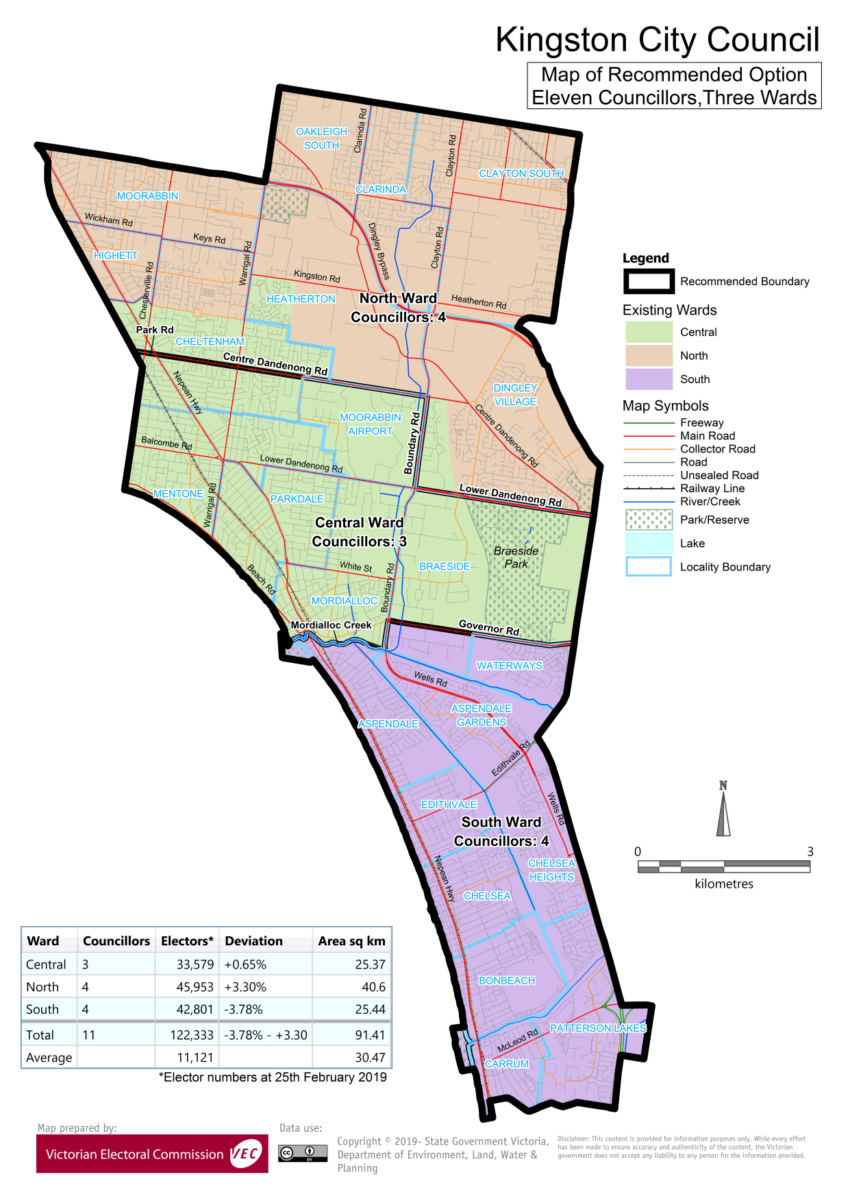

# Appendix 3: Public information program

Advertising

In accordance with the Act, public notices of the review and the release of the preliminary report were placed in the following newspapers:

|  |  |  |
| --- | --- | --- |
| **Newspaper** | **Notice of review** | **Notice of preliminary report** |
| *Herald Sun* | Thursday 6 June | Wednesday 7 August |
| *Moorabbin Leader* | Wednesday 19 June | Wednesday 14 August |
| *Mordialloc Chelsea Leader* | Monday 17 June | Monday 12 August |
| *Chelsea Mordialloc Mentone News* | Wednesday 19 June | Wednesday 14 August |

Media releases

A media release was prepared and distributed to local media to promote the commencement of the review. A further release was distributed with the publication of the preliminary report. A final media advisory was circulated on the publication date of this final report.

Public information session

A public information session for people interested in the review process was held on Thursday 20 June 2019 in the Council Chambers, City of Kingston Municipal Offices, 1230 Nepean Highway, Cheltenham.

Submissions guide

A submission guide was developed and made available on the VEC website, or in hardcopy on request, throughout the review timeline. The submission guide provided information about the review, the review timeline and how to make submissions to the review.

Online submission tool

An online submission tool was developed and made available during the submission periods of the review. The tool allowed people to make a submission from the VEC website. During the preliminary submission stage, users also had the opportunity to map out their preferred subdivisions through the online submission tool using Boundary Builder. Boundary Builder included real elector numbers so that users could see if their preferred structures and numbers of councillors met the plus-or-minus 10% rule.

VEC website

The VEC website delivered up-to-date information to provide transparency and facilitate public participation during the review process. All public submissions were published on the website.

Email and social media engagement

The VEC delivered an information email campaign targeted at known community groups and communities of interest in the local council area. This included a reminder email at each milestone of the representation review process.

The VEC also published sponsored social media advertising that was geo-targeted to users within the local council area. This included advertising at both the preliminary submission and response submission stages. The total reach of these posts was 9,948 during the preliminary submission stage and 9,034 during the response submission stage.

Council communication resources

The VEC provided the Council with a communication pack that included information on the review in various formats. While the council is encouraged to distribute this information and raise awareness about the review, the VEC is an independent reviewer and all communications resources include reference and links to the VEC website and core materials.

This page has been left intentionally blank

This page has been left intentionally blank

This page has been left intentionally blank



1. Section 219D of the *Local Government Act* *1989.*
2. Section 219D of the *Local Government Act* *1989.*
3. Ibid.
4. .id is a consulting company specialising in population and demographic analysis and prediction information products in most jurisdictions in Australia and New Zealand.
5. Section 5B(1) of the *Local Government Act 1989.*
6. Department of Environment, Land, Water and Planning (DELWP), Planning Schemes Online, Kingston Planning Scheme. See: <http://planning-schemes.delwp.vic.gov.au/schemes/kingston>
7. .id, ‘City of Kingston: economic profile’, <https://economy.id.com.au/kingston>, accessed, 21 August 2019.
8. Australian Bureau of Statistics (ABS), *Census of population and housing: time series profile, Australia, 2016,* 2003.0, 2017.
9. Ibid.
10. Ibid.
11. City of Kingston, *Multicultural Profile: City of Kingston,* October 2018. Available at: <https://www.kingston.vic.gov.au/About-Us/City-of-Kingston/City-Demographics-and-History>
12. ABS, ‘2016 Quickstats: Kingston (C)’, <https://quickstats.censusdata.abs.gov.au/census_services/getproduct/census/2016/quickstat/LGA23430?opendocument>
13. ABS, *Census of Population and Housing: Socio-Economic Indexes for Areas (SEIFA), Australia, 2016*, 2033.0.55.001. Socio-Economic Indexes for Areas (SEIFA) is developed by the Australian Bureau of Statistics (ABS) to rank areas in Australia according to relative socio-economic advantage and disadvantage. The rankings use variables, such as income, education, employment, occupation and housing, derived from Census data to indicate relative socio-economic advantage and disadvantage for particular areas, including Local Government Areas. Available at: <https://www.abs.gov.au/ausstats/abs@.nsf/mf/2033.0.55.001>
14. .id, ‘City of Kingston: community profile’, <https://profile.id.com.au/kingston>
15. Ibid.
16. .id, ‘City of Kingston: population forecast’, <https://forecast.id.com.au/kingston> See also City of Kingston, *Kingston Housing Strategy & Neighbourhood Character Study: Final Draft Report, March — 2019.* Available at: <https://www.yourkingstonyoursay.com.au/HSNCS>
17. Australian Bureau of Statistics (ABS), *Census of population and housing: time series profile, Australia, 2016,* 2003.0, 2017.
18. Department of Environment, Land, Water and Planning (DELWP), *Victoria in Future 2019,* 2019. Available at <https://www.planning.vic.gov.au/land-use-and-population-research/victoria-in-future>
19. Australian Bureau of Statistics (ABS), *Census of population and housing: time series profile, Australia, 2016,* 2003.0, 2017.
20. Department of Environment, Land, Water and Planning (DELWP), *Victoria in Future 2019,* 2019. Available at <https://www.planning.vic.gov.au/land-use-and-population-research/victoria-in-future>
21. The VEC has generally observed that informal voting increases as more candidates are listed on the ballot paper. See State of Victoria (Victorian Electoral Commission), *2016 Local Government Elections Report,* 2017, <https://www.vec.vic.gov.au/Publications/CouncilElectionReports.html>, accessed 26 September 2019.