VEC Disclosures user guide:
submitting an annual return
Registered political parties

Acknowledgement
of Country
The VEC pays respect to Victoria's traditional owners and their elders past and present who have been custodians of this country for many thousands of years. Their living culture and their role in the life of Victoria is acknowledged by the VEC.

Disclaimer
The information in this user guide is specific to Victorian funding and disclosure laws and does not take into account the laws of other Australian jurisdictions. The information is also general in nature and does not consider your individual circumstances. If in doubt, you should seek professional advice.

More information
More information about funding and disclosure obligations can be found at vec.vic.gov.au/disclosures.
For further queries please contact the VEC Funding and Disclosure Unit:
T: (03) 8260 1100 or 131 832
E: disclosures@vec.vic.gov.au

Version control
Version | Date Effective | Approved by | Amendment
0.1 | 17/09/2019 | Program Manager, Funding and Disclosure | Nil
1.0 | 11/10/2019 | Director, Electoral Integrity and Regulation | Nil
2.0 | 30/06/2020 | Program Manager, Funding and Disclosure | financial year values;  system enhancements
3.0 | 30/06/2021 | Director, Electoral Integrity and Regulation | financial year values;  system enhancements

Contents
Disclaimer 2
More information 2
Definitions 4
Annual return for a registered political party 5
General information 5
Required documents 5
Annual return due date 5
Offences 5
VEC Disclosures 6
More information 6
Annual return process 7
Complete annual return 7
Screen 1 - Key information 8
Screen 2 – Transaction details 12
Submit annual return 18
View and export an annual return 20
Request an amendment 21

Definitions

Annual return
An annual return is provided to the Victorian Electoral Commission (VEC) by the Registered Officer of the registered political party, via VEC Disclosures. The annual return summarises political donations, amounts received, expenditure and debts incurred during a financial year.

Nominated entity
A nominated entity is an organisation appointed by a registered political party as its nominated entity. A party cannot have more than one nominated entity.

Recipient
A recipient is a person or organisation that receives a political donation. Recipients include a registered political party, a candidate, a group of candidates, an elected member, an associated entity, a third-party campaigner or a nominated entity.

Registered Officer
A Registered Officer is a person nominated by a registered political party to be their responsible officer. The Registered Officer is the person shown on the Register of Political Parties as the Registered Officer of that party. They are appointed either during the party registration process or at a later date when the previous Registered Officer ceases to be the Registered Officer.
The Registered Officer is responsible for the funding and disclosure obligations of the registered political party. This includes submitting an annual return on behalf of the registered political party, its nominated entity, and any endorsed candidates and elected members.

Registered political party
A registered political party is a political party that has been registered under Part 4 of the Electoral Act 2002.

State campaign account
The Registered Officer must keep a State campaign account for the purposes of State elections. Public funding and all donations must be paid into the State campaign account.

Disclosure threshold
The disclosure threshold for the 2020-21 financial year was $1,040.

Annual return for a registered political party
This guide is intended to assist Registered Officers to complete an annual return for your registered political party via VEC Disclosures. This is a requirement under Part 12 of the Electoral Act 2002.

General information
The reporting period for the 2020-21 financial year annual return is from Wednesday 1 July 2020 to Wednesday 30 June 2021.

Required documents
You must submit the following mandatory documentation with your annual return:
- An audit certificate from a registered company auditor within the meaning of the Corporations Act 2001 of the Commonwealth.
As stipulated within section 209(3) of the Electoral Act 2002, the audit certificate must state that the auditor:
  - was given full and free access, at all reasonable times, to all accounts, records, documents and papers relating directly or indirectly to any matter required to be specified in the statement
  - examined the material referred to in paragraph (a) for the purpose of giving the certificate
  - received all information and explanations requested in respect of any matter required to be specified in the statement
  - has no reason to believe that any matter stated in the statement is not correct.
Download the VEC audit certificate template.

Annual return due date
Annual returns must be completed no later than 16 weeks of the end of financial year and are due by 20 October each year.
The 2020-21 financial year annual return is due by 11.59 pm Wednesday 20 October 2021 via VEC Disclosures.
Annual returns will be published via VEC Disclosures within six months of the end of the relevant financial year.

Offences
Offences include (but are not limited to) failing to submit on time (200 penalty units) and providing false or misleading information (300 penalty units and/or 2 years imprisonment). A full list of fees and penalties can be found on the Department of Treasury and Finance website: Indexation of fees and penalties | Department of Treasury and Finance Victoria (dtf.vic.gov.au).

VEC Disclosures
You can complete an annual return in multiple sessions. VEC Disclosures allows you to save your progress and come back to complete it at a later time (see Edit and submit an annual return in another session for more information).
Please note that VEC Disclosures is best viewed in Google Chrome. If you receive an error message that your browser is not compatible, follow the prompts to download and install Google Chrome.
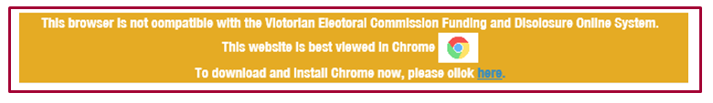

More information
For further information about annual returns and your legislative obligations, refer to Determination No. 2 of 2019 under the Electoral Act 2002.
If you have any questions or need further clarification about an annual return, please contact us. Email: disclosures@vec.vic.gov.au
Phone: (03) 8620 1100 or 131 832.

Annual return process

Complete annual return
- To access VEC Disclosures, visit disclosures.vec.vic.gov.au.
- From VEC Disclosures home page, select ‘Sign in’ from the top menu.
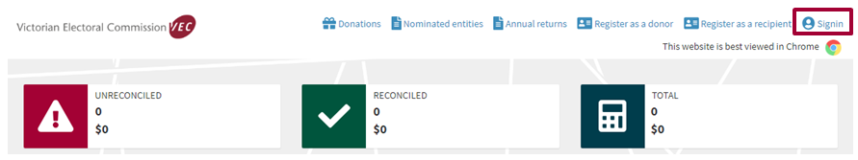
- Enter your ‘User name’ and ‘Password’ and select ‘Sign in’.
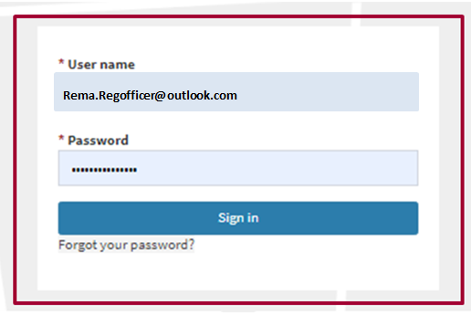
- From the Dashboard, select ‘Annual returns’ from the left-hand menu.
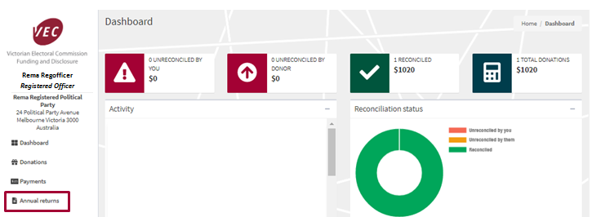

- Select ‘Lodge annual return’.
*Note: An entity can only have one active annual return per financial year.
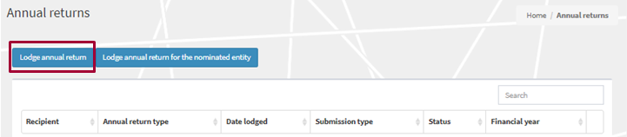

Screen 1 - Key information
- Ensure that you read and understand the key information at the top of the page before you progress through the annual return form.
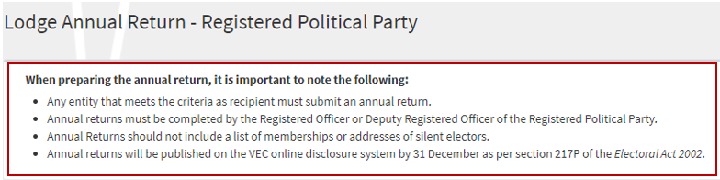
- Financial year details are for the current financial reporting period only and cannot be edited.
- The registered political party details will auto-populate. These details are locked and cannot be edited.
- The ‘Registered Officer’ section will auto-populate. These details are locked and cannot be edited.
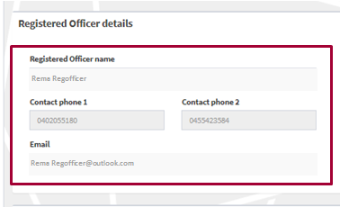
- The ‘Submitted by’ section will auto-populate with your details, as the current system user logged in. The details are locked and cannot be edited.
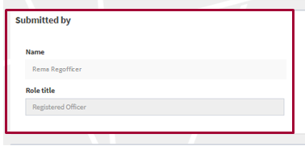

Income for financial year
All fields marked with a red Asterisk (*) must be populated even if the amount is zero (except auto-populated fields).
- The ‘Total income (inc. GST)’ field will auto-populate for the 2020-21 financial year and cannot be edited. This figure is the total amount received by, or on behalf of, the registered political party for the 2020-21 financial year.
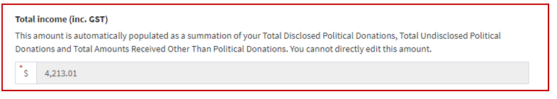
- The ‘Total disclosed political donations (inc. GST)’ field will auto-populate for the 2020-21 financial year and cannot be edited. The figure is the total disclosed political donations for the 2020-21 financial year, previously disclosed in VEC Disclosures.
The auto-populated ‘Total disclosed political donations (inc. GST)’ amounts will also appear within the line items in Table 1 – disclosed political donations at the bottom of the screen.
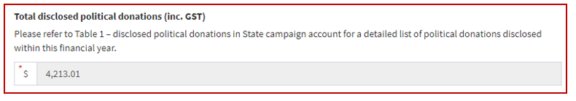
- Enter the ‘Total undisclosed political donations (inc. GST)’ received for the 2020-21 financial year. This will include any donations received under the $1,040 disclosure threshold that were not previously disclosed via VEC Disclosures.
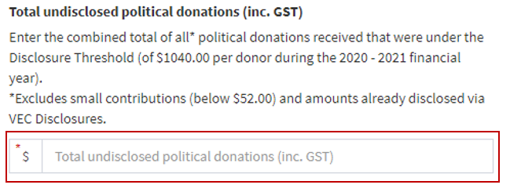
- Enter the total ‘Number of donors for undisclosed political donations’ that have contributed to the total undisclosed political donations for the 2020-21 financial year.
- Enter the ‘Total amounts received other than political donations (inc. GST)’* for the 2020-21 financial year.
After you select ‘Save and Continue’, you will be prompted to provide details for each amount exceeding the disclosure threshold (including in aggregate) received from a single person or entity during the previous financial year. Two or more amounts received from one person or entity can be consolidated into one line.
*Note: this field was previously referred to as ‘non-political donations’.
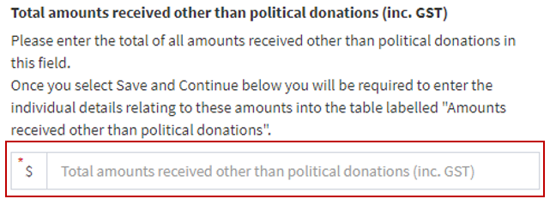
*Note: Further details of these amounts must be added in Table 3 – Amounts received other than political donations.

Expenses for financial year
- Enter the ‘Total expenditure (inc. GST)’ incurred by, or on behalf of, the registered political party for the 2020-21 financial year.
- Enter the ‘Total outstanding debts (inc. GST) incurred by, or on behalf of, the registered political party as at the end of the 2020-21 financial year.
*Note: Further details of these debts must be added in Table 2 – outstanding debt details.
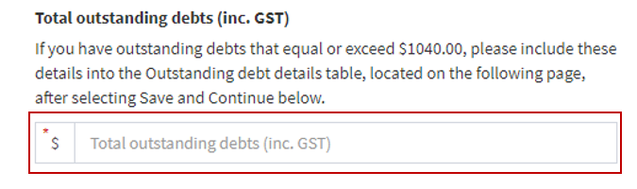

Table 1 – disclosed political donations
- Review the pre-populated table: ‘Table 1 - disclosed political donations in State campaign account’.
If there are any discrepancies between this record and your own records, email us at disclosures@vec.vic.gov.au.
If accurate, select ‘Save and Continue’. This will save a draft version of the annual return.
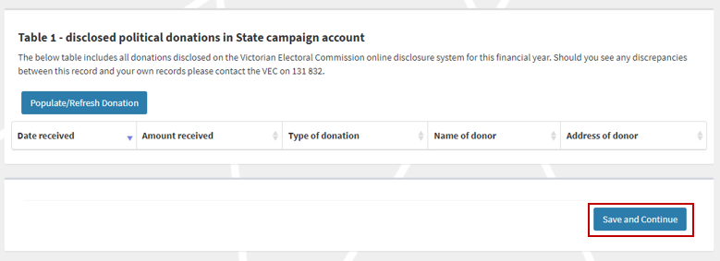

Screen 2 – Transaction details

Table 2 – outstanding debt details
- Select ‘Add’ to populate the ‘Outstanding debt details’ table with any debts owed to a person or entity at the end of the financial year that exceed the disclosure threshold.
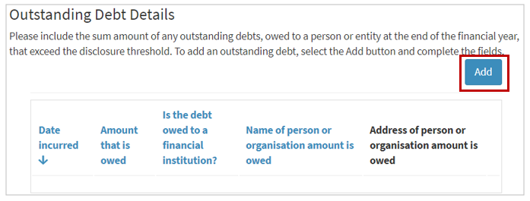
- Complete all fields in the ‘Outstanding debt details’ section.
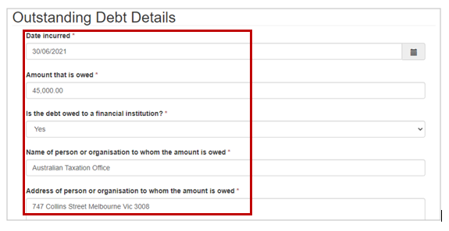
- Once complete, select ‘Submit’ and repeat steps above to add more line entries.
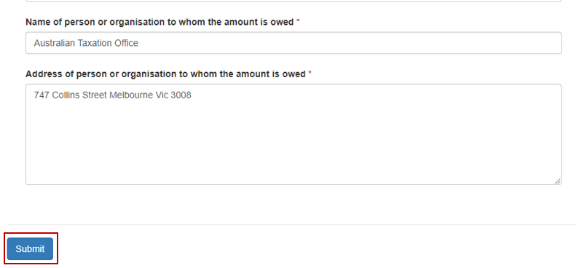
- To edit or delete any line entries, select the drop-down arrow next to the entry and select ‘Edit’ or ‘Delete’.
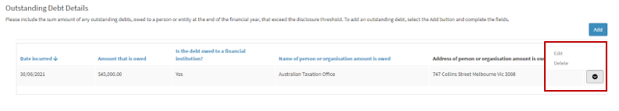
- When the details match your records, select ‘Save and Continue’. This will save a draft version of the annual return.

Table 3 – Amounts received other than political donations
- Select ‘Add’ to populate the table with any amounts received, other than political donations, from a single person or entity during the financial year that exceed the disclosure threshold, including in aggregate.
*Note: Two or more amounts received from one person or entity can be consolidated into one line entry.
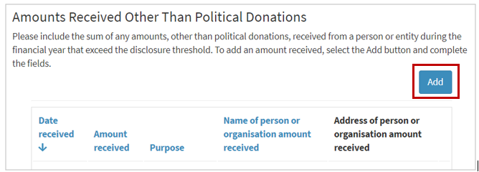

- Complete all fields in the ‘Amounts received other than political donations’ section.
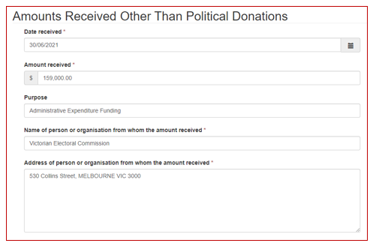
- Once complete, select ‘Submit’ and repeat steps above to add any further line entries.
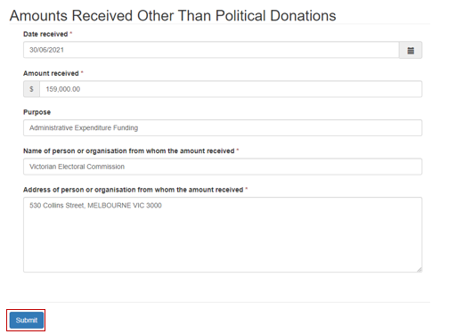
- To edit or delete line entries, select the drop-down arrow next to the relevant entry and select ‘Edit’ or ‘Delete’.
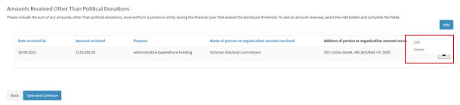
- Review the line entries and when the details match your records, select ‘Save and Continue’. Alternatively, select ‘Back’ to return to the previous screen.
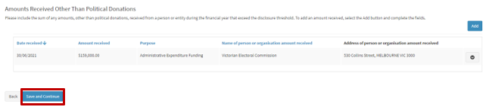

Upload audit certificate
- Download the VEC registered company auditor template or access it through VEC Disclosures.
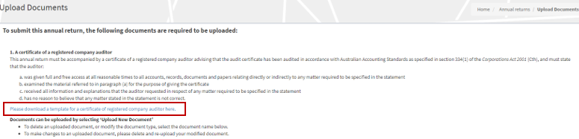
- You must upload a certificate from a registered company auditor advising that the annual return has been audited in accordance within the meaning of the Corporations Act 2001 (Cth).
As stipulated within section 209(3) of the Electoral Act 2002, the audit certificate must state that the auditor:
- was given full and free access at all reasonable times to all accounts, records, documents and papers relating directly or indirectly to any matter required to be specified in the statement
- examined the material referred to in paragraph (a) for the purpose of giving the certificate
- received all information and explanations that the auditor requested in respect of any matter required to be specified in the statement
- has no reason to believe that any matter stated in the statement is not correct.

- To upload the audit certificate, select ‘Upload New Document’*.
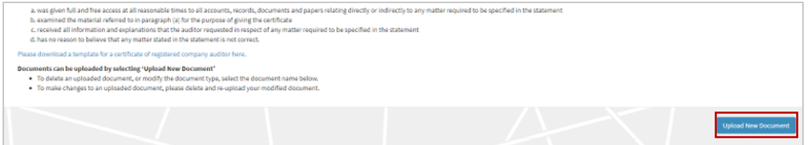
*Note: The maximum file size for a document is five megabytes (5MB). Larger files must be emailed directly to the VEC Funding and Disclosure Unit at disclosures@vec.vic.gov.au
- A pop-up window will prompt you to select the document type from the drop-down list. You can also include a description of the document beneath.
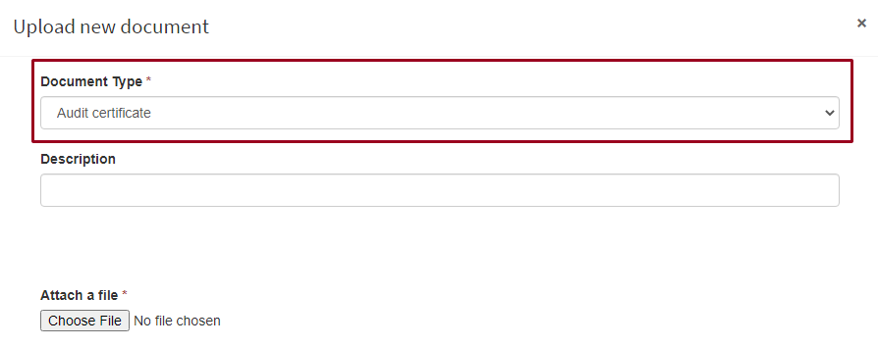
- Select ‘Choose File’.

- In the window that pops-up, navigate to your document, select it, and then select ‘Open’.
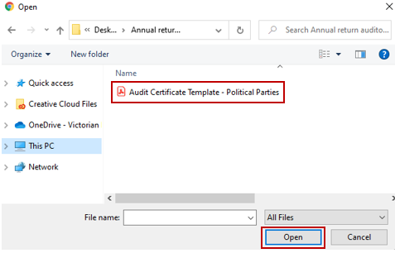
*Note: The pop-up window may vary depending on your computer’s operating system.
- The name of the file you chose will appear next to the ‘Choose file’ button. Once you’ve confirmed this is the correct file name, select ‘Upload’.
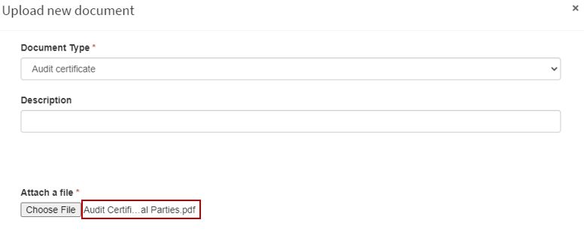
- The document will appear as a line item. Any document that appears here are saved to your annual return and you will not lose them if you navigate away from this page.
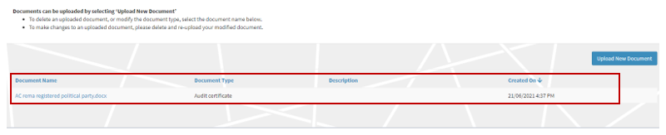
* Note: To delete or modify a document in this list, click on the Document name.

Submit annual return
- When you have completed your annual return, review and tick to confirm you’ve read the acknowledgements, then select ‘Submit’.
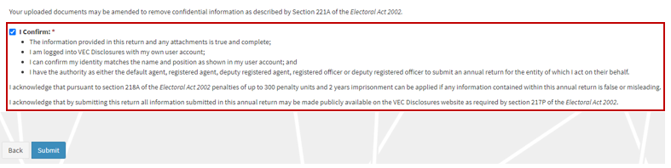
*Note: if you have any questions about the acknowledgments, contact the Funding and Disclosure Unit via email at disclosures@vec.vic.gov.au.
- You will see a submission confirmation screen. We will review the annual return and contact you if any further information is required.
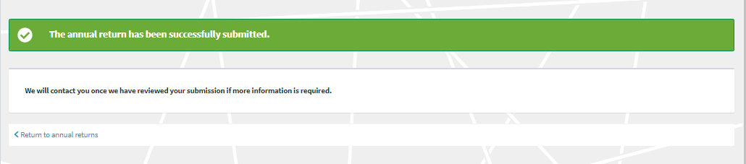

Edit and submit an annual return in another session
- You can complete your annual return in multiple sessions. VEC Disclosures allows you to save your progress and come back to complete it at a later time. Make sure you select the ‘Save and continue’ button if you wish to exit and come back later.
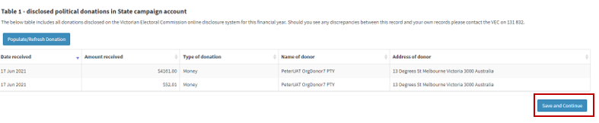

- To go back to the previous screen, select ‘Back’. Make sure you save and continue if you wish to exit and return later.
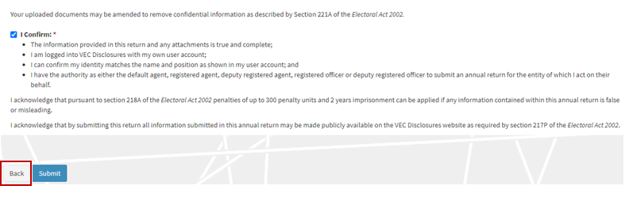
- To finalise and submit an annual return that you have previously started, log in to VEC Disclosures and go to the annual returns page. Your annual return will be listed as a line item with a status of ‘Unsubmitted’. Select ‘Edit’ to continue with your annual return.
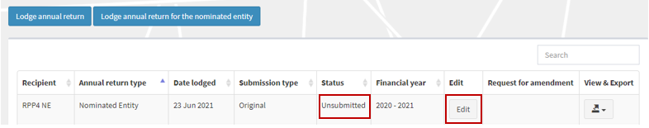
- When you have completed your annual return, review and tick to confirm you’ve read the acknowledgments, then select ‘Submit’.
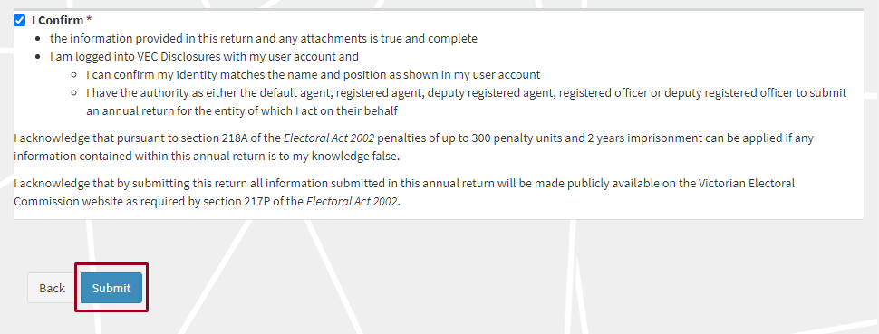

- The annual return will appear as ‘Submitted’ on the ‘Annual returns’ page.
Important: If you need to amend an annual return after you’ve submitted it, refer to the Request an amendment section or email disclosures@vec.vic.gov.au.
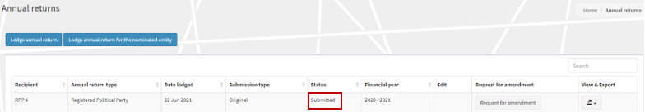

View and export an annual return
- Users can now view and export their annual return. Click on the ‘View & export’ button and select PDF.
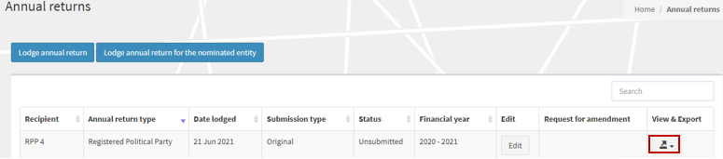
- Select the ‘Export’ button to download a copy of the PDF.
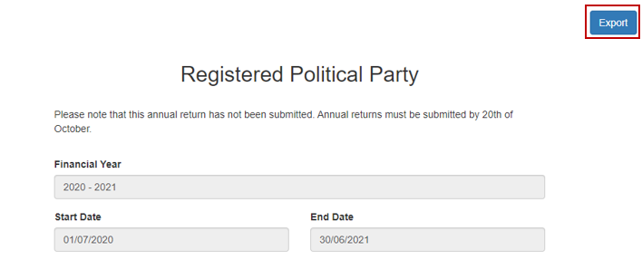

- To return to the annual returns page, click on the grey ‘X’.
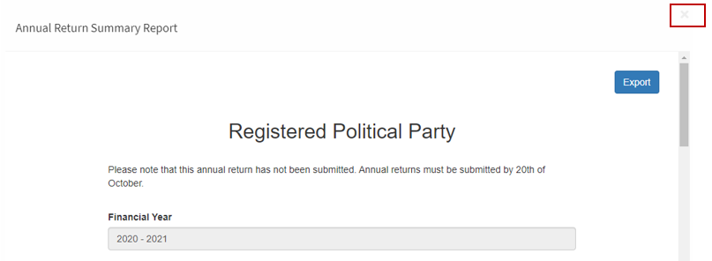

Request an amendment
- If you need to amend an annual return after submitting it, you can request an amendment through VEC Disclosures. Select ‘Request for amendment’.
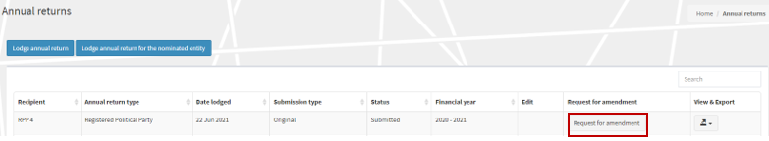
- Input the details for your amendment in the ‘Amendment Reason’ field and then select ‘Submit’.
Important: The details provided in the fields below will be published on VEC Disclosures. We recommend that you do not include any personal information.
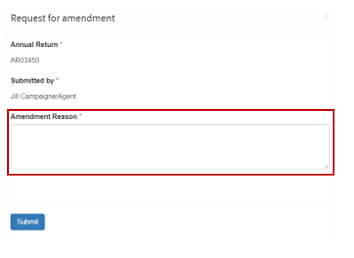

- Your request will be considered, and you may be contacted for additional information.
