Local council electoral structure review

## About the review

Under Victoria’s *Local Government Act 2020*, Maribyrnong City Council must now have a single-councillor ward electoral structure.

The Minister for Local Government has appointed an electoral representation advisory panel to review the electoral structure of Maribyrnong City Council and advise on the most appropriate single-councillor ward structure.

The panel is looking at:

* the appropriate number of councillors and wards
* the location of ward boundaries
* appropriate ward names.

Electoral structure reviews are an important part of democracy and your input is valuable. As a local, you know your council area better than anyone. This is your chance to tell the panel your thoughts about the single-councillor ward structure you believe would best provide representation for your community.

You can have your say:

1. in a response submission to the preliminary report
2. at an online public hearing, if you ask to speak in your response submission.

About Maribyrnong City Council

The Traditional Custodians of the land in the Maribyrnong City Council area are the Bunurong and Wurundjeri peoples.

The council area is located on the Maribyrnong River, 4 km west of central Melbourne. It comprises the suburbs of Braybrook, Footscray, Kingsville, Maidstone, Maribyrnong, Seddon, West Footscray, Tottenham and Yarraville. Covering an area of 31 km2, it was home to 85,209 people in 2021, with the population forecast to grow to over 135,000 by 2041.

The council area features major transport routes and is close to the port and airports. Parts of the council area that were previously industrial are being redeveloped for residential and other uses.

New housing will also be provided in and around the network of existing activity centres, with Footscray a focal point for new development and investment.

The municipality is culturally diverse. In 2021, 38% of residents were born overseas, from over 100 countries. This includes 9% born in Vietnam and 3.4% in India. Over 40% of residents speak a language other than English at home, with the most common languages being Vietnamese (11.7% in 2021) and Cantonese (2.8% in 2021). Over 30 religions are represented with Catholicism, Buddhism (8%), Islam (4%) and Hinduism (3.1%) having the largest communities.

## Current structure

Maribyrnong City Council is divided into 3 wards with a total of 7 councillors:

* one ward with 3 councillors
* 2 wards with 2 councillors each.

## Last review

The VEC conducted an electoral representation review of Maribyrnong City Council in 2011.

Visit the VEC website at [vec.vic.gov.au](https://www.vec.vic.gov.au/) to access a copy of the 2011 review final report.

Review process

Monday 23 and Tuesday 24 October

### Information sessions

Session 1: 12 noon, Monday 23 October

Session 2: 6 pm, Tuesday 24 October

These sessions will give you more information about the review process. You will be able to register for a session on the VEC website.

Wednesday 25 October

### Preliminary report

The panel will release a preliminary report with one or more options for the electoral structure on Wednesday 25 October.

**You can make a response submission from this date.**

Wednesday 15 November

### Response submissions

The panel must receive your submission by   
5 pm on Wednesday 15 November.

The panel will not accept late submissions.

Tuesday 21 November

### Public hearing

The panel will hold an online public hearing if anyone asks to speak about their response submission at 10 am on Tuesday 21 November.

The public hearing will not be held if no one asks to speak.

Wednesday 20 December

### Final report

The panel will submit a final report to the Minister for Local Government including its advice for the electoral structure on Wednesday 20 December.

The minister will consider the panel’s advice before recommending a change to the electoral structure. Any change is expected to apply at the next local council general election.

## Submission guide

You can download a submission guide from the VEC website at [vec.vic.gov.au](http://vec.vic.gov.au/)

## How to make a submission Untitled-1

On the VEC website at [vec.vic.gov.au](http://vec.vic.gov.au/)

By email to:

[Maribyrnong.ERAPSubmissions@ vec.vic.gov.au](mailto:Maribyrnong.ERAPSubmissions@vec.vic.gov.au)

LetterBy post to:

Electoral representation advisory panel  
c/o Victorian Electoral Commission  
Level 11, 530 Collins St  
Melbourne VIC 3000

Submissions must include your:

* full name
* contact phone number or email address
* residential or postal address.

Your submission will be published on the VEC website, including your name and suburb or town but not your full address or contact details. See the submission guide or VEC website at [vec.vic.gov.au/privacy](https://www.vec.vic.gov.au/privacy) for privacy information.

## One vote, one value

The ‘one vote, one value’ democratic principle is enshrined in the *Local Government Act 2020*. This means every person’s vote counts equally.

When a local council is subdivided into wards, the number of voters each councillor represents in each ward must be plus-or-minus 10% of the average number of voters per councillor for all wards.

The map below includes the current number of voters in each ward and the ward’s current deviation from the average. The panel will consider likely population and voter changes to ensure the structure remains equitable.

If you make a submission online, you can use a mapping tool to build your preferred electoral structure. The tool uses current voter numbers to tell you the deviations of the wards you make. This will help you propose a structure that meets the requirements of the Act.

Current electoral structure

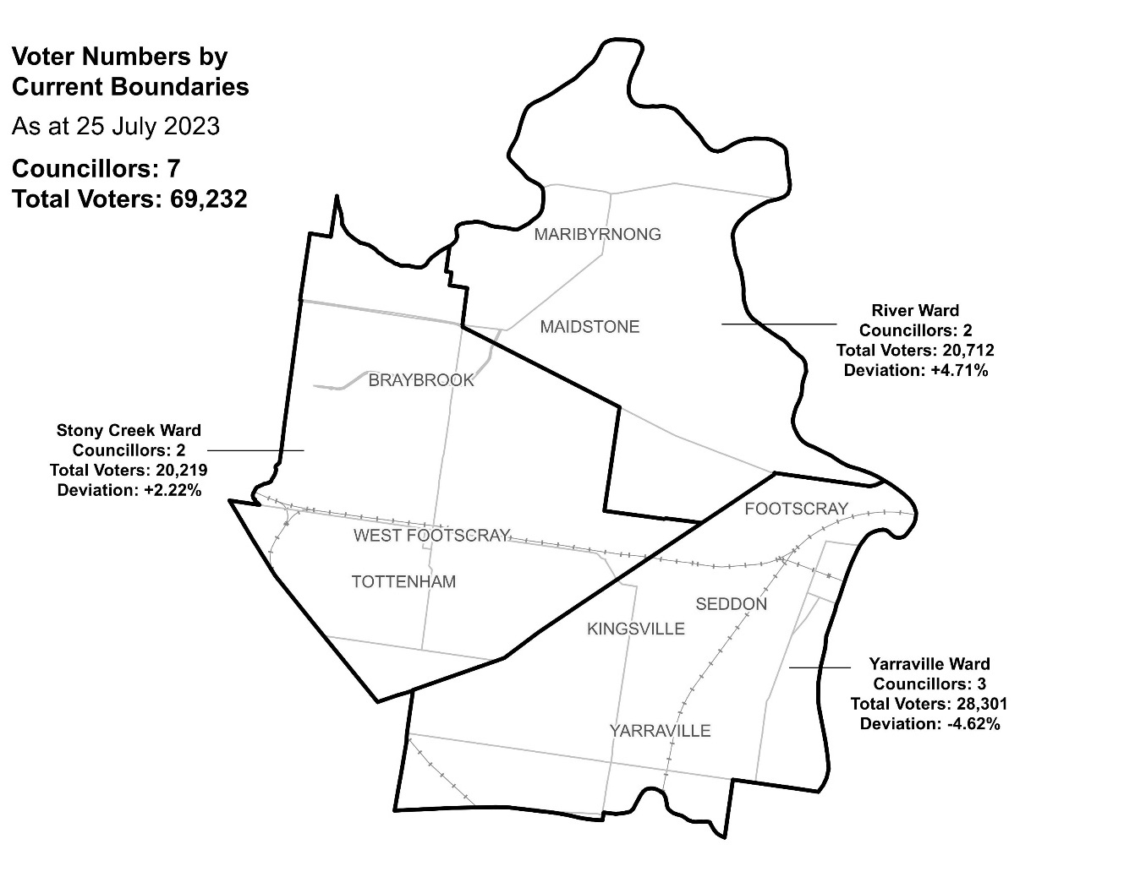

|  |  |  |  |
| --- | --- | --- | --- |
| Ward | Councillors | Voters | Deviation |
| River Ward | 2 | 20,712 | + 4.71% |
| Stony Creek Ward | 2 | 20,219 | + 2.22% |
| Yarraville Ward | 3 | 28,301 | - 4.62% |

## Statistics

Area (km2) 31

Voters

### Voters per square km

2,233.3

### Average voters per councillor

9,890

Population

### Current population

85,209

### Forecast population growth

1.9% p.a.

More Census statistics available at [abs.gov.au](https://www.abs.gov.au/census/find-census-data/search-by-area)

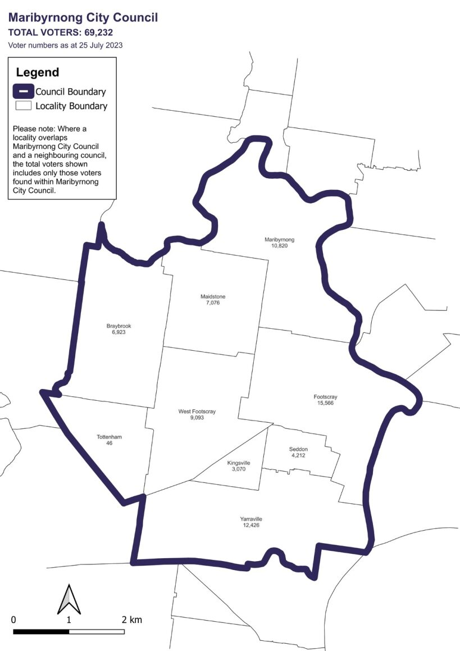Voter numbers by locality (map)

Voter numbers by locality (table)

## Maribyrnong City Council voter numbers at 25 July 2023

|  |  |
| --- | --- |
| Locality | Voters |
| Braybrook | 6,923 |
| Footscray | 15,566 |
| Kingsville | 3,070 |
| Maidstone | 7,076 |
| Maribyrnong | 10,820 |
| Seddon | 4,212 |
| Tottenham | 46 |
| West Footscray | 9,093 |
| Yarraville | 12,426 |