Local council electoral structure review

March 2023

Gannawarra Shire Council

Preliminary   
Report

Acknowledgement of Country

The electoral representation advisory panel acknowledges the Barapa Barapa, Wamba Wamba, and Yorta Yorta people as the Traditional Custodians of the lands and waters on which it is holding this review and pays respects to ancestors and Elders past, present and emerging. The panel acknowledges their custodianship for many thousands of years and their continuing living culture.

Document history and version control

|  |  |  |  |
| --- | --- | --- | --- |
| **Version** | **Date approved** | **Approved by** | **Brief description** |
| 1 | 14 March 2023 | Electoral Commissioner | Final version |

# Contents

Executive summary 4

Developing electoral structure models 4

Preliminary submissions 4

Electoral structure models for public feedback 4

Next steps 4

Background 5

About the 2023–24 electoral structure reviews 5

The electoral representation advisory panel 5

Public engagement 6

Developing recommendations 6

About Gannawarra Shire Council 9

Profile 9

Current number of councillors and electoral structure 10

Last electoral structure review 10

Preliminary submissions 11

Number of councillors 11

Electoral structure 12

Preliminary findings and models 13

Number of councillors 13

Electoral structure 15

Models for public feedback 18

Next steps 19

Response submissions 19

Public hearing 20

Final report 20

References 21

Appendix 1: Model maps 22

Appendix 2: Additional models considered 25

Appendix 3: List of preliminary submitters 26

# Executive summary

An independent electoral structure review panel appointed by the Minister for Local Government has reviewed the structure of Gannawarra Shire Council.

The panel looked at:

* whether the council had an appropriate number of councillors
* whether it should be unsubdivided or subdivided.

This report outlines the preliminary models that the panel is presenting for the proposed new electoral structure of Gannawarra Shire Council in order to meet the requirements of the *Local Government Act 2020* (Vic) (The Act).

More information about the background to the reviews is available on page 5.

## Developing electoral structure models

The panel considered a range of factors when deciding on the models in this report, including:

* research and analysis
* voter growth or decline over time
* public submissions (see below).

More information on the way the panel decided on the models is available on page 6.

## Preliminary submissions

The panel received 4 preliminary submissions. Of these, one submission included a map.

A full analysis of submissions received can be found on page 11.

## Electoral structure models for public feedback

After considering submissions and research, the panel is presenting the following electoral structure models for further public consultation:

Model 1: an unsubdivided electoral structure with 7 councillors

Model 2: a subdivided electoral structure with a total of 6 councillors, 2 wards and 3 councillors per ward.

Details on these models, including maps, are available on page 22.

## Next steps

The panel is now seeking feedback on the electoral structure models. You can make a response submission to these models until Wednesday 5 April 2023. If any response submitters wish to speak at a public hearing, the panel will hold an online public hearing on Thursday 13 April 2023. Following this, it will present its final recommendation to the Minister by Wednesday 10 May 2023.

More information about the review process is available on the Victorian Electoral Commission (VEC) website at [vec.vic.gov.au](https://www.vec.vic.gov.au/electoral-boundaries/council-reviews/electoral-structure-reviews)

# Background

## About the 2023–24 electoral structure reviews

In October 2022, the Minister for Local Government formed 2 electoral representation advisory panels to review the electoral structures of 39 local councils, under section 16 of the *Local Government Act 1989* (Vic) (The Act). If the Minister accepts the electoral structures the panels recommend, they will take effect at the October 2024 elections.

The Act introduced several changes to local government representation, including the types of electoral structures local councils may have. Large and small rural shire councils (including Gannawarra Shire Council) can have one of 3 electoral structures:

* + unsubdivided (entire council area with no wards)
  + single-councillor wards
  + multi-councillor wards with the same number of councillors per ward.

For Gannawarra Shire Council, the electoral representation advisory panel is examining:

* the number of councillors
* whether the council should be subdivided into wards or unsubdivided.

For subdivided structures, it is also examining:

* + the number of wards
  + where the ward boundaries should be
  + the name of each ward
  + how many councillors should be elected for each ward.

The Act requires electoral structures to provide fair and equitable representation and facilitate good governance. For subdivided structures, each ward must have an approximately equal number of voters per councillor (within +/-10% of the average).

## The electoral representation advisory panel

The panel conducting the electoral structure review of Gannawarra Shire Council has   
3 members:

* The Honourable Frank Vincent AO KC (Chairperson)
* Ms Liz Williams PSM
* Electoral Commissioner Mr Warwick Gately AM.

The panel is independent of councils and the State government.

Under the Act, the VEC is not responsible for reviewing council electoral structures but must provide administrative and technical support to the panel. The Electoral Commissioner (or their delegate) must be a member of each panel.

## Public engagement

### Public information program

To educate and inform the public about the Gannawarra Shire Council electoral structure review, the VEC began a public information program in mid-December 2022. The VEC:

* + printed public notices in state-wide newspapers
  + held public information sessions to outline the review process and respond to questions from the community
  + sent out media releases to announce the start of the review
  + published information on its social media channels
  + provided updated website content on [vec.vic.gov.au](https://www.vec.vic.gov.au/electoral-boundaries/council-reviews/electoral-structure-reviews), including:
    - information on the review process
    - submission guides and fact sheets for each council under review with background information
    - preliminary submissions from the public.

The VEC will continue to promote the review during the response submissions stage via media releases, the VEC’s social media channels and updated content on the VEC website.

### Public consultation

The panel encouraged public input to the review of Gannawarra Shire Council via preliminary submissions at the start of the review. The panel now invites further input via:

* + response submissions to this preliminary report
  + an online public hearing to provide anyone who makes a response submission the opportunity to expand on their submission.

Public submissions are an important part of the review process but the panel also considers other factors during a review. These are outlined below.

## Developing recommendations

The panel’s electoral structure models presented in this preliminary report comply with the Act and were developed through careful consideration of:

* + research and analysis conducted by the VEC support team, including geospatial and demographic factors
  + rates or patterns of population and voter growth or decline over time, and relevant forecasts of growth or decline based on forecast information provided by .id (informed decisions, a company specialising in demographics and forecasting)
  + input received from the public in written submissions during the preliminary submissions phase.

### Deciding on the number of councillors

The Act allows local councils to have between 5 and 12 councillors, but neither the Act nor the Local Government (Electoral) Regulations 2020 specify how to determine the number of councillors a council needs. Therefore, the models put forward by the panel in this report are guided by the Act’s intention for fairness and equity in voter representation.

In examining the number of councillors Gannawarra Shire Council should have, the panel considered these factors:

* + the population and number of voters in the council area, compared to other councils with a similar population size and number of voters in the same category (for example, metropolitan, interface, regional city, large rural shire, small rural shire)
  + patterns of population change and voter growth or decline in the council area over time
  + the current and past numbers of councillors
  + the representation needs of the communities of interest in the council area
  + if a particular type of electoral structure best suits the council (see ‘Deciding the electoral structure’ below)
  + any matter raised in public submissions not already listed above.

Generally, local councils with a larger number of voters will have a higher number of councillors. Large populations are often more likely to have greater diversity, both in the type and number of communities of interest and issues relating to representation. However, the ideal number of councillors can also be influenced by the particular circumstances of a council, such as the:

* + nature and complexity of services the council provides
  + geographic size and topography of the area
  + forecast population and voter growth or decline
  + social diversity.

### Deciding the electoral structure

The electoral structure of large and small rural shire councils can be:

* + unsubdivided (entire council area with no wards)
  + made up of single-councillor wards

or

* + made up of multi-councillor wards with the same number of councillors per ward.

When developing electoral structure models for Gannawarra Shire council, the panel considered these main criteria:

* + whether the structure would comply with section 15(2) of the Act (see below), and for how long it would likely comply
  + the appropriate number of councillors, as outlined above
  + whether meaningful and effective ward boundaries can be established and whether these would be easily identifiable to local communities
  + representation of communities of interest
  + the voter distribution and physical features of the area, and the impact these may have on the shape and size of any wards
  + past elections for the council, including:
    - numbers of candidates nominating
    - incidences of uncontested elections
    - rates of informal voting.
  + other matters raised in public submissions not already listed above.

Under section 15(2) of the Act, subdivided structures must aim for an approximately equal number of voters per councillor in each ward. This means the number of voters represented by each councillor in a ward should be within +/-10% of the average number of voters per councillor for all wards.

The panel recommends structures that will comply with section 15(2) at the October 2024 local government elections and uses current voter numbers and forecasts of population and voter change to assess this with as much accuracy as possible. In some cases, population changes and other factors mean it is not possible for a subdivided electoral structure to comply with section 15(2) based on current voter numbers. If this occurs, compliance at the 2024 local government elections will be the priority to ensure each vote has approximately equal value.

# About Gannawarra Shire Council

## Profile

Gannawarra Shire Council is in north-western Victoria and has an area of 3,738 km2. It is bounded by Swan Hill Rural City Council in the north, Campaspe Shire Council and Loddon Shire Council in the south, Buloke Shire Council in the west, and the Murray River in the north-east.

The Traditional Custodians of the Gannawarra area are the Barapa Barapa, Wamba Wamba, and Yorta Yorta people.

### Landscape

Major geographic features of the shire are the Loddon River, which runs north to south, the Murray River, Gunbower Creek, Gunbower National Park, and the Kerang wetlands.

Gannawarra Shire is serviced by the Murray Valley Highway and the Loddon Valley Highway. In addition, 2 railway lines pass through the shire, moving freight (Robinvale and Swan Hill lines) and passengers (Swan Hill line).

Gannawarra Shire has 2 major service towns. Located on the Loddon River, Kerang operates as the main retail and administrative hub for the shire and caters for the farming and rural west. Cohuna operates as an agricultural and livestock service town in the north-east and services Gunbower Creek and Murray River tourism activities. Smaller settlements of Koondrook, Leitchville, Murrabit and Quambatook make up the remaining urban population.

### Community

At the 2021 census, the shire’s population was 10,683 (ABS, 2021a), an increase of 317 over the past decade (ABS, 2011). From 2022 to 2028, the shire’s population is projected to decline slightly at a rate of -0.3% per year. The shire’s median age is 51, higher than the median of 43 found in regional Victoria (ABS, 2021b).

Of the population, 85.7% were born in Australia, and 89.59% speak only English at home. This is compared to 81% and 86.4% respectively for regional Victoria (ABS, 2021b). The number of indigenous and Torres strait islander people at the 2021 census was 268 or 2.6%, slightly more than the 2% in regional Victoria (ABS, 2021b).

The major industry in Gannawarra Shire is agriculture, with the western half of the shire dominated by dryland farming, and the eastern by irrigated agriculture and dairy farming (Department of Transport and Planning, 2022). Dairy and cropping are the most prominent agricultural activities, consisting of 39% and 38% of the industry respectively, while other major agricultural uses in the shire are livestock (13%) and horticulture (10%) (Gannawarra Shire Council, 2021). Agriculture, forestry and fishing made up 22.2% of employment, with health care and social assistance (12.1%), retail trade (9.5%), construction (8.2%), and manufacturing (6.7%) representing other major areas of employment in the shire (ABS, 2021a).

Home ownership is common in Gannawarra, with 51.3% owning their property outright, and a further 24.8% owning with a mortgage. This contrasts to the regional Victoria rate of 39.3% outright ownership, and 33.2% owned with a mortgage, with fewer people renting (18%) in Gannawarra than in regional and rural Victoria (23.6%) (ABS, 2021b).

The weekly median income of Gannawarra shire is $1,071, less than the weekly median of $1,386 for regional Victoria (ABS, 2021b).

## Current number of councillors and electoral structure

Gannawarra Shire Council is currently divided into 4 wards with a total of 7 councillors:

* + One ward with 3 councillors (Patchell)
  + One ward with 2 councillors (Yarran)
  + 2 wards with one councillor each (Murray and Avoca)

There are currently approximately 9,449 voters in Gannawarra Shire Council, with a ratio of 1,350 voters per councillor.

Visit the VEC website at [vec.vic.gov.au](https://www.vec.vic.gov.au/electoral-boundaries/local-councils/gannawarra-shire-council) for more information on Gannawarra Shire Council.

## Last electoral structure review

The VEC conducted an electoral representation review of Gannawarra Shire Council in 2015. This representation review complied with the *Local Government Act 1989* (Vic)*,* which was replaced by the *Local Government Act 2020* (Vic).

After conducting the review, the VEC recommended that Gannawarra Shire Council continue to consist of 7 councillors elected from 4 wards (2 wards with 1 councillor each, 1 ward with 2 councillors and 1 ward with 3 councillors).

The VEC recommended continuing with the same ward and councillor structure by the following considerations:

* + 7 councillors were a suitable number due to the size and population of Gannawarra Shire Council relative to comparable councils.
  + There were distinct communities of interest to warrant continuing with a multi-ward structure, with particular emphasis put on the separate communities of Kerang, Cohuna, and the agricultural dryland west.
  + The ward boundaries adhered to the +/-10% threshold.

Visit the VEC website at [vec.vic.gov.au](https://www.vec.vic.gov.au/electoral-boundaries/local-councils/gannawarra-shire-council) to access a copy of the 2015 representation review final report.

# Preliminary submissions

The panel received 4 preliminary submissions from the public by the deadline of 5 pm on Wednesday 15 February 2023. You can view these submissions on the VEC website at [vec.vic.gov.au](https://www.vec.vic.gov.au/electoral-boundaries/council-reviews/electoral-structure-reviews/gannawarra/preliminary-submissions) and find a list of people or organisations who made a submission in Appendix 3.

The table below provides an overview of preferences in the preliminary submissions. You can read an analysis of submissions below this table.

|  |  |  |  |  |  |
| --- | --- | --- | --- | --- | --- |
|  | Unsubdivided structure | Single-councillor wards | Multi-councillor wards | Subdivided structure (unspecified) | No comment on structure |
| Decreased number of councillors | - | 2 | - | - | - |
| Maintain current councillor number | 1 | 1 | - | - | - |
| Increased number of councillors | - | - | - | - | - |
| No comment on number of councillors | - | - | - | - | - |

## Number of councillors

All 4 public submissions proposed a view on the preferred number of councillors for Gannawarra Shire Council. They were split evenly between wanting to retain the current 7, or to reduce to 5.

**Reducing to 5 councillors**

A common theme within submissions was that the major population centre of Kerang dominated council decision-making, and that this dynamic was problematic for the rest of the shire. Anthony Troy from Cohuna suggested that reducing to 5 councillors would be a good way to increase the representation of smaller communities.

The Leitchville and District Progress Associationalso advocated for 5 councillors. It argued that councillors from Kerang ‘time and again out-voted the councillors from other wards, despite them having very sound proposals/arguments’. It argued that having a 5-councillor single ward structure ‘would give a greater say to the smaller towns in our Shire, with the members from the larger towns having to accommodate the needs of their neighbours to achieve their goals.’

Anthony Troy also believed having fewer councillors would save on costs, suggesting that any saved money could be put into infrastructure.

**Maintaining 7 councillors**

Laura O’Dwyer saw larger town dominance as a problem too, suggesting that 7 councillors with an unsubdivided structure was the answer to reaching better shire-wide representation. O’Dwyer came to this conclusion by stating that 5 councillors would increase the likelihood of residents from the more populated centres of Kerang, Cohuna and Koondrook outvoting candidates from small towns or rural areas.

Another advocate for 7 councillors was current councillor for Patchell ward, Jane Ogden. Councillor Ogden submitted that 7 councillors was appropriate considering the largearea of Gannawarra Shire. Councillor Ogden also argued that large travel distances was an important factor to consider as it affects both workload and candidate numbers nominating at elections.

## Electoral structure

There were differing opinions in the public submissions regarding how Gannawarra Shire Council should be structured. Submissions were split between advocating for single-councillor wards or an unsubdivided structure.

### Unsubdivided

Laura O’Dwyer advocated for an unsubdivided structure as the best way to combat high levels of parochialism amongst councillors, arguing that this divided council business between the interests of the major town centres of Kerang and Cohuna to the detriment of the whole council. O’Dwyer stated: ‘Councillors need to remember that they represent the entire Gannawarra Council not just the town that they come from’ and that adopting an unsubdivided structure would better serve the shire and foster a shire-wide perspective.

Councillor Ogden stated that if a subdivided structure was not possible under the legislative requirements that an unsubdivided structure with 7 councillors would be the next best model.

### Single-councillor wards

Anthony Troy proposed a single-councillor ward structure with 5 councillors, reasoning that this would work toward giving better representation to the rural areas of Gannawarra Shire. The Leitchville and District Progress Association also proposed a structure of 5 councillors elected from single-councillor wards as this would give greater representation to rural communities.

Councillor Ogden proposed a single-councillor ward structure, but with 7 councillors. The councillor contended that single-councillor wards would cater to communities of interest, and that more localised representatives were better placed to understand the needs of the communities they represented.

# Preliminary findings and models

## Number of councillors

After taking into consideration the requirements of the Act, public submissions and the agreed criteria, the panel found 6 or 7 councillors to be an appropriate number for Gannawarra Shire Council.

The panel considered the characteristics of the Gannawarra Shire Council in relation to similar rural shire councils, including its size and geography, population and the number and distribution of voters across the shire.

|  |  |  |  |  |  |  |
| --- | --- | --- | --- | --- | --- | --- |
| Similar rural shire councils to Gannawarra Shire Council | | | | | | |
| Local council | Area (km2) | Number of voters at 2020 election | Population (2021 Census) | Current total estimate of voters | Number of councillors | Number of voters per councillor |
| Central Goldfields Shire* | 1,533 | 11,169 | 13,483 | 11,329 | 7 | 1,618 |
| Strathbogie Shire* | 3,303 | 9,806 | 11,455 | 10,963 | 7 | 1,566 |
| Mansfield Shire | 3,844 | 10,205 | 10,178 | 10,910 | 5 | 2,182 |
| Northern Grampians Shire* | 5,730 | 10,424 | 11,948 | 10,172 | 7 | 1,453 |
| **Gannawarra Shire** | **3,738** | 9,129 | **10,683** | **9,449** | **7** | **1,350** |
| Pyrenees Shire | 3,435 | 7,063 | 7,671 | 7,233 | 5 | 1,447 |
| Loddon Shire | 6,696 | 7,072 | 7,759 | 7,146 | 5 | 1,429 |
| Yarriambiack Shire* | 7,326 | 5,703 | 6,556 | 5,594 | 7 | 799 |
| Towong Shire | 6,675 | 5,264 | 6,223 | 5,305 | 5 | 1,061 |

*This local council is undergoing an electoral structure review during 2023–24.

### Maintaining 7 councillors

The panel considered maintaining 7 councillors to be a viable option for the following reasons:

* there was support for 7 councillors in the public submissions
* it involves the least amount of change
* 7 councillors is appropriate for the large area of Gannawarra Shire, considering councillor workloads and travel times.

### Increasing councillor numbers

The panel considered that increasing councillor numbers was not warranted given the lack of public interest and the relative population of Gannawarra Shire Council compared to other councils with 7 councillors. As shown in the table above, Gannawarra Shire Council sits on the low end of 7-councillor shires and has a voter‑to‑councillor ratio of 1,350. The shire’s population is gradually decreasing, and increasing councillor numbers would require additional resourcing and costs without a compelling reason. As there are no special circumstances to justify an increase to councillor numbers, the panel ruled out any such increase.

### Reducing to 6 councillors

The panel considered a reduction in councillor numbers to 6 to be a viable option due to the smaller population of Gannawarra Shire Council compared to other councils, and importantly, the requirement that any subdivided electoral structure must have an equal number of councillors in each ward. The panel also considered 6 councillors to be a reasonable compromise between 5 and 7, both of which had received support in public submissions.

Gannawarra Shire Council is on the low end of 7-councillor shires when considering total voter numbers, meaning there is a compelling reason to consider a decrease in councillors. A key principle applied when deciding on the appropriate number of councillors is a ‘consistent, state-wide approach’. This means that councillor numbers should be broadly in line with other councils with similar population sizes. Considering the position of Gannawarra Shire Council when compared to other rural shires, the panel found it reasonable to propose an electoral structure of 6 councillors.

In addition, the Act requires electoral structures with multi-councillor wards to have an equal number of councillors elected from each. As such, the panel acknowledges the need to consider reducing or increasing councillor numbers to accommodate a viable multi‑councillor ward structure. As the panel must consider communities of interest when developing viable and robust ward structures, the drawbacks of reducing councillor numbers or proposing an even number should be balanced with the benefits of a particular ward structure. Considering the distinct communities of interest in Gannawarra Shire Council, the panel believes 6 councillors can be justified on the basis that it provides for an appropriate multi‑councillor ward electoral structure.

### Reducing to 5 councillors

The panel found that reducing to 5 councillors could not be justified. It made this decision based on the relative population of Gannawarra Shire compared to other rural councils, the large area of the shire and the lack of any favourable 5-councillor ward structure that would comply with new legislative requirements. As such, the panel considered there to be no special or compelling reasons for Gannawarra Shire Council to reduce to 5 councillors.

## Electoral structure

To identify the most appropriate electoral structure, various factors were considered. This included the requirements of the Act, the communities of interest in Gannawarra Shire Council, public submissions, the appropriateness of ward boundaries and which models best offered fair and equitable representation.

In developing the preliminary models presented in this report, a range of models were considered. The strongest 2 models have been put forward for further public comment.

The panel proposes 2 models for the consideration of the Gannawarra Shire Council community:

* an unsubdivided electoral structure (Model 1).
* a subdivided electoral structure of 2 wards, with 3 councillors per ward (Model 2).

Diagrams of the preliminary models are included in Appendix 1.

### An unsubdivided structure (Model 1)

Under this model, Gannawarra Shire Council would adopt an unsubdivided electoral structure, represented by 7 councillors.

This model maintains the current number of councillors, had support in public submissions, would not involve arbitrarily dividing towns and communities, and would not require considerations about the +/-10% requirement. It might also potentially foster a shire-wide perspective in council business.

The panel gave serious consideration to major communities of interest in Gannawarra Shire, namely Kerang, Cohuna, the dryland west, and irrigated east. However, it felt that an unsubdivided structure could still adequately provide representation for these communities, as well as smaller towns and localities. Furthermore, there was a strong sense in the public submissions that parochialism was an issue within the shire. An unsubdivided structure could help to remedy this and foster a stronger shire-wide outlook. As such, the panel was interested in gauging the public response to such a proposal.

While unsubdivided structures may realise an increase in voter informality where there are large numbers of candidates, Gannawarra Shire Council has had relatively low voter informality at past elections, and the panel was not concerned that this would increase. Gannawarra has historically had few candidates nominating for council positions, so the correlation between particularly high numbers of candidates on the ballot paper and high informal voting rates was not a major consideration.

In acknowledging concerns that an unsubdivided structure could lead to a concentration of candidates in major towns the panel noted firstly, in an unsubdivided structure, elections are held using the proportional representation system. This means that there is a ‘quota’ of votes that a candidate needs to meet to be elected. A sufficiently strong candidate (or candidates) from the shire’s rural areas would only need to achieve this vote quota to be elected. Secondly, a candidate does not need to live in the ward they are nominating for. At the last election, 8 of the 15 candidates shire-wide resided in Kerang. This includes the mayor and incumbent councillor for Avoca Ward, Charlie Gillingham. Similarly, a current councillor for Murray Ward resides in the town of Cohuna (which is in Yarran Ward). Therefore, having subdivided wards does not necessarily guarantee local representation.

### A multi-councillor ward structure (Model 2)

Under this model, Gannawarra Shire Council would adopt a 2-ward structure. Each ward would be represented by 3 councillors, in line with the requirement of the Act for there to be the same number of councillors per ward.

The panel considered the model to have several benefits: it neatly captures the 2 major populations centres of Kerang and Cohuna in their own wards; roughly separates the dryland cropping west and irrigated farming east; uses natural and recognisable boundaries of the Loddon River and Pyramid Creek; and serves as a reasonable compromise between 5 and 7 councillors.

It was noted that multi-councillor ward structures have worked well for councils in the past. However, the new Act now restricts multi-councillor wards to having the same number of councillors in each ward, which in this model of 2 wards requires each ward to have 3 councillors. One of the panel’s main principles is the consideration of communities of interest. The proposed multi-councillor ward structure captures the distinct communities of Kerang and Cohuna in separate wards, and roughly captures the irrigated farming in the east and dryland farming in the west in separate wards. As such, the panel was interested in further public comment on this model.

### Models considered but not put forward

#### A multi-councillor ward model with 6 councillors

The panel considered a model of 6 councillors consisting of 3 wards with 2 councillors each (see Appendix 2). While the prospect of having 3 equal wards was attractive, the panel had concerns about the ward structures, and whether the wards adequately captured communities of interest. To achieve 3 wards that fell within the +/-10% threshold, one of the proposed wards needed to consist of the entire current Avoca Ward but also ‘wrap around’ the north of Kerang and include the town of Koondrook.

Considering the diverse farming communities found in the east and west of the shire, the absence of public support for this structure, the large geographic area councillors would need to travel, and on communities of interest grounds, the panel decided this model was not favourable for the shire.

#### A single-councillor ward model with 7 councillors

The panel considered a model of 7 councillors with single-councillor wards (see Appendix 2). This model was considered as it followed similar boundaries to the current structure, it had support in public submissions, and it appeared to capture sensible communities of interest. However, this model divided Kerang into 3 wards, and Cohuna was divided in 2 in order to satisfy the +/-10% requirement. The arbitrary division of these main towns was not satisfactory. In this model, Kerang was split into 2 urban wards and a third ward containing the south-eastern quarter of the town and the rest of the current Patchell Ward. Similarly, the current Yarran Ward was split in 2, with Cohuna split down the centre.

It was decided therefore that splitting the main towns made this model unviable. The towns of Kerang and Cohuna present as sensible and obvious communities of interest, which this model did not provide for.

## Models for public feedback

The panel considers all models outlined below to offer fair and equitable representation for voters in Gannawarra Shire Council. Please see Appendix 1 for detailed maps of these models.

### Model 1

Gannawarra Shire Council has 7 councillors and an unsubdivided electoral structure.

### Model 2

Gannawarra Shire Council has 6 councillors and is divided into 2 wards with 3 councillors per ward.

### Ward names

The panel has suggested ward names to identify the wards in Model 2 and invites comments from the community on these names as part of submissions responding to the preliminary report.

# Next steps

## Response submissions

Any person or group, including the local council under review, can make a response submission to the electoral representation advisory panel. In your submission, you should address the options proposed by the panel in this preliminary report.

You can make a submission:

|  |  |
| --- | --- |
|  | **Online** Visit [vec.vic.gov.au](http://vec.vic.gov.au/" \o "The VEC website) to make a submission online.  You will need to make an account to use the online Public Submission Tool and can save a draft submission to finish later. |
|  | **By email** [Gannawarra.ERAPSubmissions@vec.vic.gov.au](mailto:Gannawarra.ERAPSubmissions@vec.vic.gov.au) |
|  | **By post**  Electoral Representation Advisory Panel c/o Victorian Electoral Commission Level 11, 530 Collins St Melbourne VIC 3000 |

The panel must receive all response submissions before 5 pm on Wednesday 5 April 2023. If you post your submission, make sure it has enough time to reach the panel before the deadline. Late submissions will not be accepted.

### Required information

For your submission to be considered, you must include your:

* full name
* contact phone number or email address
* postal or residential address.

The panel will not consider submissions without this information. If you are submitting as a group or organisation, you must include the name of a nominated contact person who is authorised to submit on behalf of your group.

The VEC will handle information provided by submitters in accordance with the privacy policy available at [vec.vic.gov.au/privacy](http://www.vec.vic.gov.au/privacy).

### Public access to submissions

To ensure transparency in the electoral structure review process, your submission will be published on the VEC website at [vec.vic.gov.au](https://www.vec.vic.gov.au/electoral-boundaries/council-reviews/electoral-structure-reviews/gannawarra/preliminary-submissions). The VEC will remove your signature and contact details, including residential and postal addresses, from all public copies but must publish your full name (or group name) and locality (suburb or town).

## Public hearing

If you make a response submission, you can also ask to speak at an online public hearing to support your submission and expand on your views.

The online public hearing is scheduled for:

Time: 10 am

Date: Thursday 13 April 2023

The panel encourages participation in the public hearing. If you wish to speak at the public hearing, you **must** indicate this in your response submission. The public hearing will not be held if there are no requests to speak.

Anyone can attend a public hearing, but you will only be able to speak if you asked to in your response submission. If you ask to speak, the VEC will contact you to arrange a time for you at the hearing. You will have 10 minutes to address the public hearing panel, which will include at least 2 of the review panel members. The members of the public hearing panel may ask you questions.

Visit the VEC website at [vec.vic.gov.au](https://www.vec.vic.gov.au/electoral-boundaries/council-reviews/electoral-structure-reviews/gannawarra/preliminary-submissions) for more information on public hearings.

## Final report

Following the public hearing, the review panel will consider all evidence gathered and publish a final report for the Minister for Local Government containing a recommendation for the number of councillors and the electoral structure for the local council.

The final report is scheduled to be published on Wednesday 10 May 2023. If the recommendation is accepted, any changes will apply at the October 2024 local council elections.

The final report will be available on the VEC website at [vec.vic.gov.au](https://www.vec.vic.gov.au/electoral-boundaries/council-reviews/electoral-structure-reviews/gannawarra/preliminary-submissions) or you can request a printed copy by calling 131 832.

# References

Australian Bureau of Statistics. (2021a). *Census 2021 Quick Stats, Gannawarra.* <https://www.abs.gov.au/census/find-census-data/quickstats/2021/LGA22250> accessed 28 February 2023.

Australian Bureau of Statistics. (2021b). *Census 2021 Quick Stats, Rest of Vic.* [*https://www.abs.gov.au/census/find-census-data/quickstats/2021/2RVIC*](https://www.abs.gov.au/census/find-census-data/quickstats/2021/2RVIC)accessed 28 February 2023.

Australian Bureau of Statistics. (2016). *Census 2016 Quick Stats, Gannawarra.* <https://www.abs.gov.au/census/find-census-data/quickstats/2016/LGA22250>accessed 28 February 2023.

Australian Bureau of Statistics. (2011). *Census 2011 Quick Stats, Gannawarra.* <https://www.abs.gov.au/census/find-census-data/quickstats/2011/LGA22250> accessed 28 February 2023.

Department of Transport and Planning*.* (2022). *Gannawarra Planning Scheme.* <https://planning-schemes.app.planning.vic.gov.au/static/1671128853611/pdf/2668437.pdf> accessed 28 February 2023.

Gannawarra Shire Council. (2021). *Growing* *Gannawarra Council Plan 2021-2025.* <https://www.gannawarra.vic.gov.au/files/assets/public/document-resources/council-plan-2021-2025/final_council-plan-2021-2025.pdf>accessed 28 February 2023.

*Local Government Act 1989* (Vic)

*Local Government Act 2020* (Vic)

*Local Government (Electoral) Regulations 2020* (Vic)

# Appendix 1: Model maps

The following maps are included in this report:

|  |  |
| --- | --- |
| Map | Page |
| Model 1 – an unsubdivided electoral structure with 7 councillors | 23 |
| Model 2 – a multi-councillor ward structure with 6 councillors — 2 wards and 3 councillors per ward | 24 |

Forecast information in the text of this report is based on forecasts prepared by .id – informed decisions [id.com.au](http://www.id.com.au/) .id and its licensors are the sole and exclusive owners of all rights, title and interest subsisting in that part of the report content where .id are identified. Some of .id content is a derivative of ABS Data, which can be accessed from the website of the Australian Bureau of Statistics at [abs.gov.au](http://www.abs.gov.au/), and licensed on terms published on the ABS website

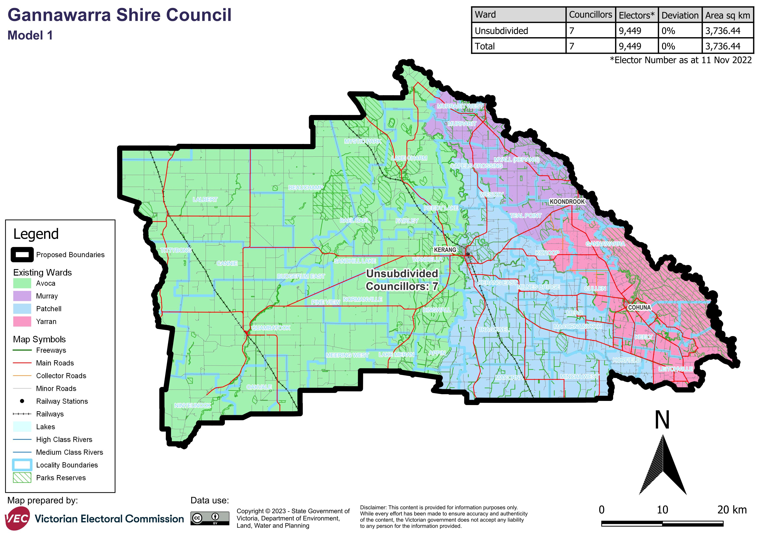

Model 2 is a multi-councillor ward structure with 2 wards and 3 councillors in each ward. This model has a western Wandella Ward, and an eastern Gunbower Ward . Please contact the VEC if you require the content of this map in an alternative format.


# Appendix 2: Additional models considered

The following models were closely considered by the panel but are not being put forward for further public consultation. See Models considered but not put forward for further information.

#### A multi-councillor ward model with 6 councillors

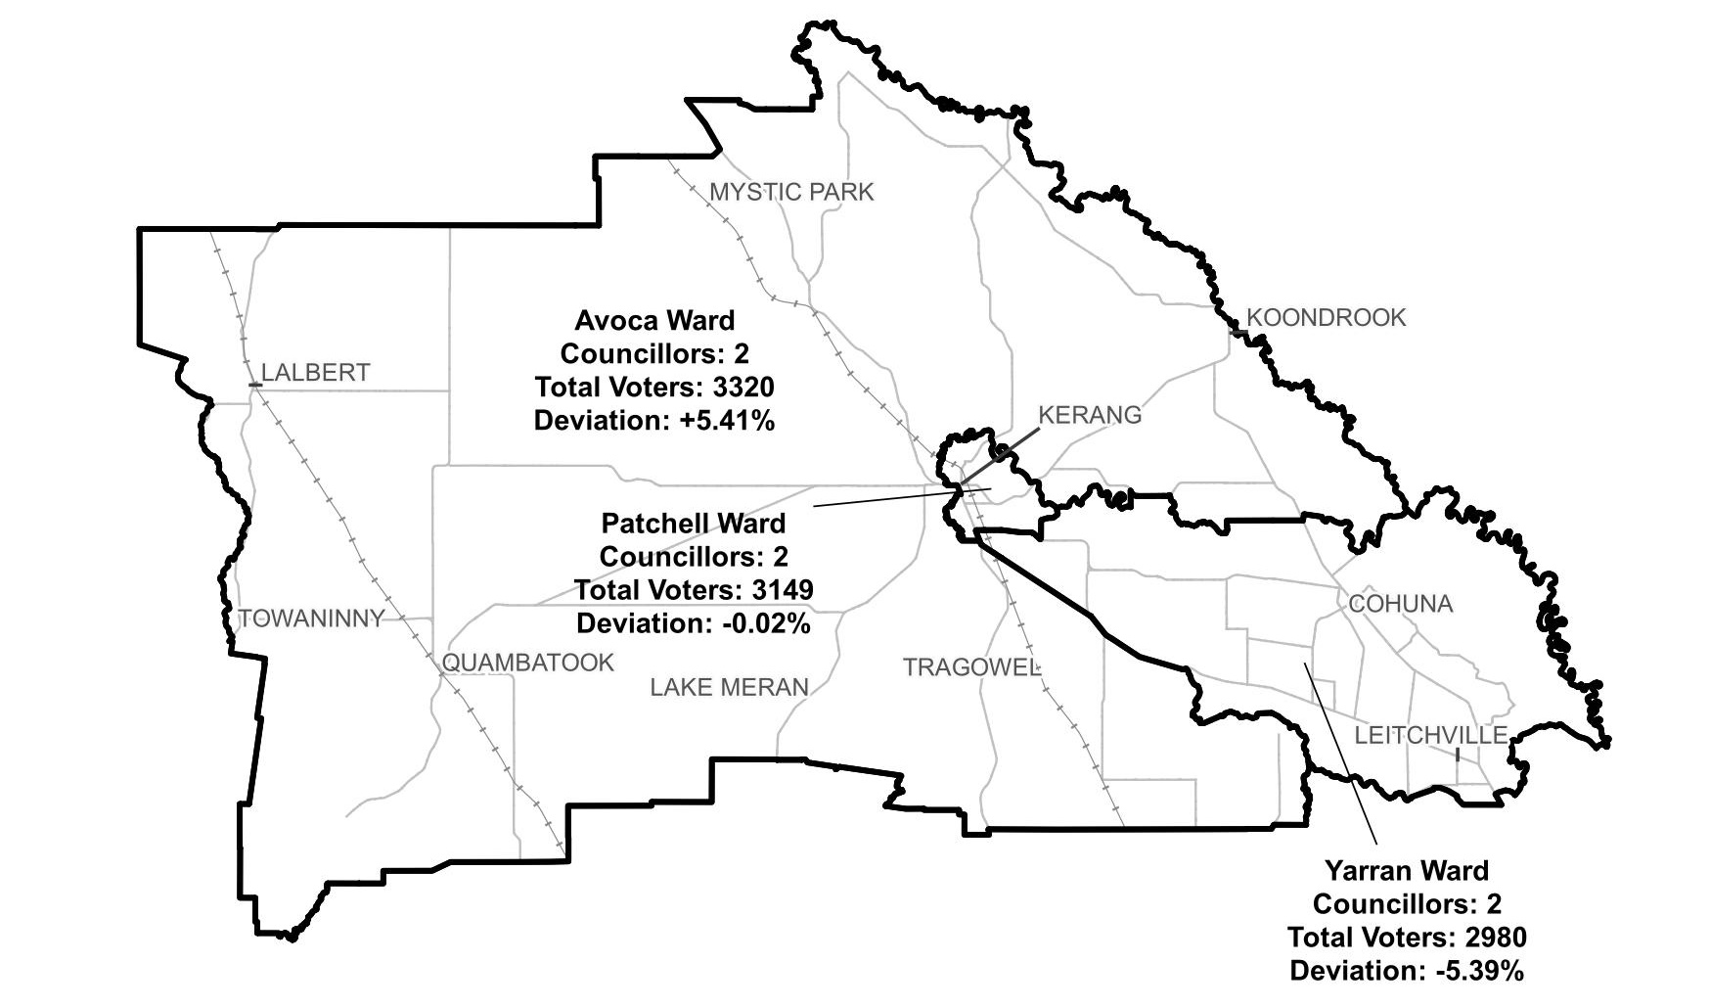

#### A single-councillor ward model with 7 councillors

This model was a single-councillor ward structure with 7 councillors. This model had the follow minds: Avoca Ward, Patchell Ward, Wandella Ward, Murray Ward, Yarran Ward, Pyramid Creek Ward, Gunbower Ward
Please contact the VEC if you require the content of this diagram in an alternative format.

# Appendix 3: List of preliminary submitters

The review received 4 preliminary submissions.

Preliminary submissions were made by:

Leitchville and District Progress Association

O’Dwyer, Laura

Ogden, Jane (Councillor, Gannawarra Shire Council)

Troy, Anthony