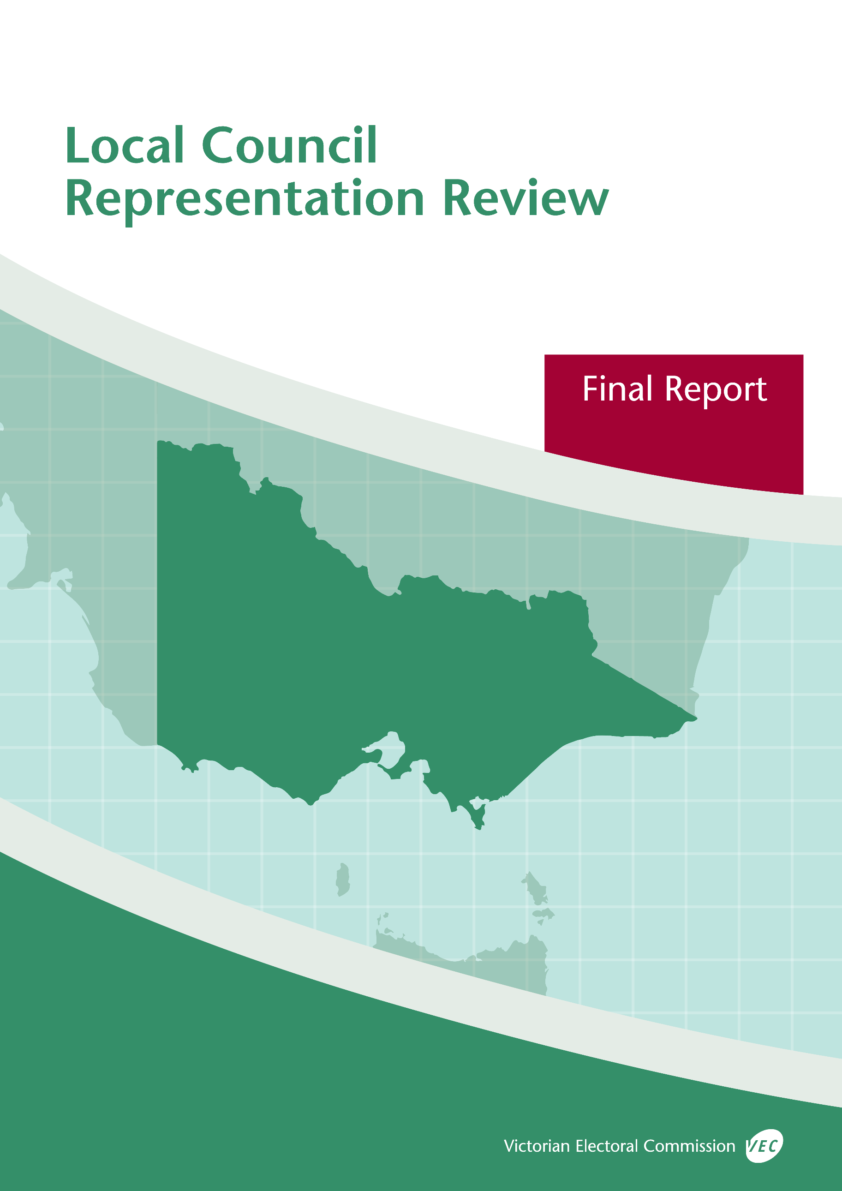



**May 2019**

**Moyne Shire Council**

© State of Victoria (Victorian Electoral Commission)   
Wednesday 15 May 2019

Version 1  
  
cid:image001.png@01D4D431.F774F3F0

This work, Local Council Representation Review Final Report – Moyne Shire Council, is licensed under a Creative Commons Attribution 4.0 licence [<http://creativecommons.org/licenses/by/4.0/>]. You are free to share this work under that licence, on the condition that you do not change any content and you credit the State of Victoria (Victorian Electoral Commission) as author and comply with the other licence terms. The licence does not apply to any branding, including Government logos.

Contents

Recommendation 1

Executive summary 2

Background 4

Legislative basis 4

Public engagement 4

The VEC’s principles 5

Developing recommendations 6

Moyne Shire Council representation review 8

Profile of Moyne Shire Council 8

Current electoral structure 9

Preliminary submissions 9

Preliminary report 10

Public response 14

Response submissions 14

Public hearing 17

Findings and recommendation 18

The VEC’s findings 18

The VEC’s recommendation 20

Appendix 1: Public involvement 21

Appendix 2: Map 23

Appendix 3: Public information program 25

Recommendation

The Victorian Electoral Commission recommends that Moyne Shire Council continue to consist of seven councillors elected from an unsubdivided electoral structure.

This recommendation is submitted to the Minister for Local Government as required by the *Local Government Act 1989*.

Please see Appendix 2 for a map of this recommended structure.

Executive summary

The *Local Government Act 1989* (the Act) requires the Victorian Electoral Commission (VEC) to conduct an electoral representation review of each municipality in Victoria before every third council general election.

The purpose of an electoral representation review is to recommend an electoral structure that provides fair and equitable representation for people who are entitled to vote at a general election of the council. The matters considered by a review are:

* the number of councillors
* the electoral structure of the council (whether the council should be unsubdivided or divided into wards and, if subdivided, the ward boundaries and the number of councillors per ward).

The VEC conducts all reviews based on three main principles:

1. taking a consistent, State-wide approach to the total number of councillors
2. if subdivided, ensuring the number of voters represented by each councillor is within   
   plus-or-minus 10% of the average number of voters per councillor for that local   
   council
3. ensuring communities of interest are as fairly represented as possible.

Current electoral structure

Moyne Shire Council currently comprises seven councillors elected from an unsubdivided electoral structure. Prior to the last representation review in 2007, Moyne Shire Council was comprised of 10 councillors elected from five two-councillor wards.

Visit the VEC website at [vec.vic.gov.au](http://www.vec.vic.gov.au) to access a copy of the 2007 review final report.

Preliminary submissions

Preliminary submissions opened at the commencement of the review on Wednesday 23 January 2019. The VEC received 12 submissions for the representation review of Moyne Shire Council by the deadline at 5.00 pm on Wednesday 20 February 2019.

Preliminary report

A preliminary report was released on Wednesday 20 March 2019 with the following options for consideration:

* Option A (preferred option)  
  **Moyne Shire Council consist of seven councillors elected from an unsubdivided electoral structure.**
* Option B (alternative option)  
  **Moyne Shire Council consist of** **seven councillors elected from five wards (two two-councillor wards and three single-councillor wards).**
* Option C (alternative option)  
  **Moyne Shire Council consist of** **seven councillors elected from three wards (two two-councillor wards and one three-councillor ward).**

Response submissions

The VEC received 15 submissions responding to the preliminary report by the deadline at   
5.00 pm on Wednesday 17 April 2019.

Public hearing

The VEC conducted a public hearing for those wishing to speak about their response submission at 4.00 pm on Wednesday 24 April 2019. Two people spoke at the hearing.

Recommendation

**The Victorian Electoral Commission recommends that Moyne Shire Council continue to consist of seven councillors elected from an unsubdivided electoral structure.**

This electoral structure was designated as Option A in the preliminary report. Please see Appendix 2 for a map of this recommended structure.

Background

Legislative basis

The Act requires the VEC to conduct a representation review of each local council in Victoria before every third general council election, or earlier if gazetted by the Minister for Local Government.

The Act states that the purpose of a representation review is to recommend the number of councillors and the electoral structure that provides ‘fair and equitable representation for the persons who are entitled to vote at a general election of the Council.’[1]

The Act requires the VEC to consider:

* the number of councillors in a local council
* whether a local council should be unsubdivided or subdivided.

If a local council is subdivided, the VEC must ensure that the number of voters represented by each councillor is within plus-or-minus 10% of the average number of voters per councillor for that local council.[2] On this basis, the review must consider the:

* number of wards
* ward boundaries
* number of councillors that should be elected for each ward.

Public engagement

### Public information program

The VEC conducted a public information program to inform the community of the representation review, including:

* public notices printed in local and state-wide papers
* public information sessions to outline the review process and respond to questions from the community
* a media release announcing the commencement of the review and the release of the preliminary report
* a submission guide to explain the review process and provide background information on the scope of the review
* an information email campaign targeted at known community groups and communities of interest in the local council area
* sponsored social media advertising geo-targeted to users within the local council   
  area
* ongoing information updates and publication of submissions on the VEC website.

More information on the VEC’s public information program for the representation review of Moyne Shire Council can be found at Appendix 3.

### Public consultation

Public input was accepted by the VEC via:

* preliminary submissions at the start of the review
* response submissions to the preliminary report
* a public hearing that provided an opportunity for people who had made a response submission to expand on their submission.

Public submissions are an important part of the review process but are not the only consideration. The VEC ensures its recommendations comply with the Act and are formed through careful consideration of public submissions, independent research, and analysis of all relevant factors.

The VEC’s principles

Three main principles underlie all the VEC’s work on representation reviews:

1. **Taking a consistent, State-wide approach to the total number of councillors.**

The VEC is guided by its comparisons of local councils of a similar size and category to the council under review. The VEC also considers any special circumstances that may warrant the local council having more or fewer councillors than similar local councils.

1. **If subdivided, ensuring the number of voters represented by each councillor is within plus-or-minus 10% of the average number of voters per councillor for that local council.**

This is the principle of ‘one vote, one value’, which is enshrined in the Act. This means that every person’s vote counts equally.

1. **Ensuring communities of interest are as fairly represented as possible.**

Each local council contains a number of communities of interest. Where practicable, the electoral structure should be designed to ensure they are fairly represented, and that geographic communities of interest are not split by ward boundaries. This allows elected councillors to be more effective representatives of the people and interests in their particular local council or ward.

Developing recommendations

The VEC bases its recommendations for particular electoral structures on the following information:

* internal research specifically relating to the local council under review, including data from the Australian Bureau of Statistics and .id[3]; voter statistics from the Victorian electoral roll; and other State and local government data sets
* the VEC’s experience conducting previous electoral representation reviews of local councils and similar reviews for State elections
* the VEC’s expertise in mapping, demography and local government
* careful consideration of all input from the public in written submissions received during the review and via oral submissions at the public hearing
* advice from consultants with extensive experience in local government.

### Deciding on the number of councillors

The Act allows for a local council to have between five and 12 councillors but does not specify how to decide the appropriate number.[4] In considering the number of councillors for a local council, the VEC is guided by the Victorian Parliament’s intention for fairness and equity in the local representation of voters under the Act.

The starting point in deciding the appropriate number of councillors for a local council is comparing the local council under review to other local councils of a similar size and type (Principle 1). Generally, local councils that have a larger number of voters will have a higher number of councillors. Often large populations are more likely to be diverse, both in the nature and number of their communities of interest and the issues of representation.

However, the VEC also considers the particular circumstances of each local council which could justify fewer or more councillors, such as:

* the nature and complexity of services provided by the Council
* geographic size and topography
* population growth or decline
* the social diversity of the local council.

### Deciding the electoral structure

The Act allows for a local council ward structure to be unsubdivided—with all councillors elected ‘at-large’ by all voters—or subdivided into a number of wards.

If the local council is to be subdivided into wards, there are three options available:

1. single-councillor wards
2. multi-councillor wards
3. a combination of single-councillor and multi-councillor wards.

A subdivided electoral structure must have internal ward boundaries that provide for a fair and equitable division of the local council.

The Act allows for wards with different numbers of councillors, as long as the number of voters represented by each councillor is within plus-or-minus 10% of the average number of voters per councillor for that local council (Principle 2). For example, a local council may have one   
three-councillor ward with 15,000 voters and two single-councillor wards each with 5,000 voters. In this case, the average number of voters per councillor would be 5,000.

Over time, population changes can lead to some wards in subdivided local councils having larger or smaller numbers of voters. As part of the review, the VEC corrects any imbalances and considers likely population changes to ensure ward boundaries provide equitable representation for as long as possible.

In considering which electoral structure is most appropriate, the VEC considers the following matters:

* the VEC’s recommendation at the previous representation review and the reasons for that recommendation
* the longevity of the structure, with the aim of keeping voter numbers per councillor within the 10% tolerance for as long as possible (Principle 2)
* communities of interest, consisting of people who share a range of common concerns, such as geographic, economic or cultural associations (Principle 3)
* the number of candidates in previous elections, as large numbers of candidates can lead to an increase in the number of informal (invalid) votes
* geographic factors, such as size and topography
* clear ward boundaries.

Moyne Shire Council representation review

Profile of Moyne Shire Council

Moyne Shire Council is located on Victoria’s south-west coast and forms part of the Barwon South West Region. It incorporates pastoral areas in the north and stretches of the Shipwreck coastline to the South.

The Gunditjmara, Girai Wurrung and Djab Wurrung people are the traditional custodians of the land.

The Shire covers an area of 5,478 square kilometres. The current population is 16,495 – just over half of whom reside outside of the major towns of Port Fairy and Koroit in the south, and Macarthur, Woolsthorpe and Mortlake in the north. The Shire is expected to experience a modest rate of population growth at 0.5% per year in the period 2011-2031, much of which will take place in the south and in Port Fairy, Koroit and surrounds.

Agriculture plays an important role in the local economy. Large cattle and sheep farms are prominent in the north, while dairying and crop production are more common towards the south and along the coastal areas. Manufacturing is based heavily on agricultural products and there is a growing aquaculture industry. Tourism is growing, particularly along the coast and in Port Fairy, and major energy projects such as windfarms are either in operation or being planned. While there are differences between the north and south areas of the Shire and between the country and urban districts, there are some mutual economic interests, such as those between tourism and agriculture.

The unemployment rate is comparatively low at 3.7% and the main industry of employment is agriculture (26.1%) followed by health care and social assistance (12.1%). Residents generally have a higher than average weekly income and are less likely to be on low incomes when compared to the average for regional Victoria.

Although the Shire as a whole ranks well on the SEIFA index[5], some areas of the Shire, such as Mortlake and Macarthur, are considered to experience high levels of social and economic disadvantage. The Shire’s population is largely linguistically and culturally homogenous, with a high proportion of the population born in Australia.

Current electoral structure

Moyne Shire Council currently comprises seven councillors elected from an unsubdivided electoral structure.

Preliminary submissions

The VEC received 12 preliminary submissions by the deadline for submissions at 5.00 pm on Wednesday 20 February 2019. Submissions were received from community members, the Moyne Shire Council and the Proportional Representation Society of Australia (Victoria‑Tasmania) Inc.

Most of the submissions came from community members residing outside of the major towns of the Shire’s south and were primarily concerned about fair and equitable representation for voters in the country and northern areas. Many of these submissions identified a strong preference for increasing the number of councillors and subdividing the council with the view that this would provide and improve local representation.

Three submissions, including that provided by Moyne Shire Council, wanted ‘no change’ to the present electoral structure. One submission commented on Council support services and was deemed out of scope. The submissions were made available on the VEC website.

### Number of councillors

Seven submissions suggested increasing the number of councillors to either eight, nine or ten, with one of these proposing either nine or ten councillors. Most of these submissions felt that increasing the number of councillors would provide greater representation for country voters and those living outside of Port Fairy and would allow for a subdivided electoral structure for the same reasons.

The submissions advocating retaining seven councillors were of the view that the current electoral structure was working well, was comparable with similar sized rural councils and was consistent with the projected rate of population growth.

### Electoral structure

The majority of preliminary submissions suggested a subdivided electoral structure, with most of these preferencing single-councillor wards. One submission suggested an electoral structure of eight councillors elected from four two-councillor wards, while another proposed a seven-councillor model consisting of two two-councillor wards and one three-councillor ward. Another wanted a return to the subdivided structure in place prior to the 2007 representation review.

The chief concern amongst those proposing subdivided electoral structures was the need to represent the mainly geographical communities of interest located throughout the north and in the Shire’s country districts. There was a view that these interests had been neglected by Council, which some claimed was dominated by candidates from the more populated areas in the south and urban-based communities of interest. Various submissions supporting a subdivided structure also suggested that a rural-urban divide prevented fair and equitable representation.

Three of the preliminary submissions argued for retaining the current unsubdivided model. They were generally of the view that the current electoral structure was working well, represented multiple communities of interest, including the interests of rural voters, and promoted a whole of council approach. In its submission Moyne Shire Council argued that there had been a reasonable spread of candidates and elected councillors from across the Shire in recent elections.

A list of people who made a preliminary submission can be found in Appendix 1.

Preliminary report

A preliminary report was released on Wednesday 20 March 2019. The VEC considered public submissions and research findings when formulating the options presented in the preliminary report.

### Number of councillors

When considering the appropriate number of councillors for Moyne Shire Council, the VEC assessed population data and other factors which could warrant an increase or decrease in the number of councillors, such as projected population growth or special circumstances relating to distinct communities of interest. The analysis of demographic data for Moyne Shire Council showed a modest rate of population growth, and critically, a fairly even distribution of the resident and voting populations throughout the Shire. The Shire was considered consistent with similar seven-councillor country Victorian councils in relation to both the voter-to-councillor ratio and its geographical size.

The VEC was also of the view that Moyne Shire Council did not face significant social issues, such as high levels of social disadvantage, which might warrant increasing the number of councillors.

While many of the submissions argued that most councillors had come from Port Fairy and surrounds, historical election data showed that there has been a good spread of candidates and elected councillors from across the Shire. The only exception to this is the lack of candidates and elected councillors from the north-west. The VEC did not believe that increasing the number of councillors would necessarily translate to more candidates and elected councillors from the rural districts in the north, especially the north-west. As the diagram opposite shows, there is currently a reasonable spread of councillors from across the Shire.

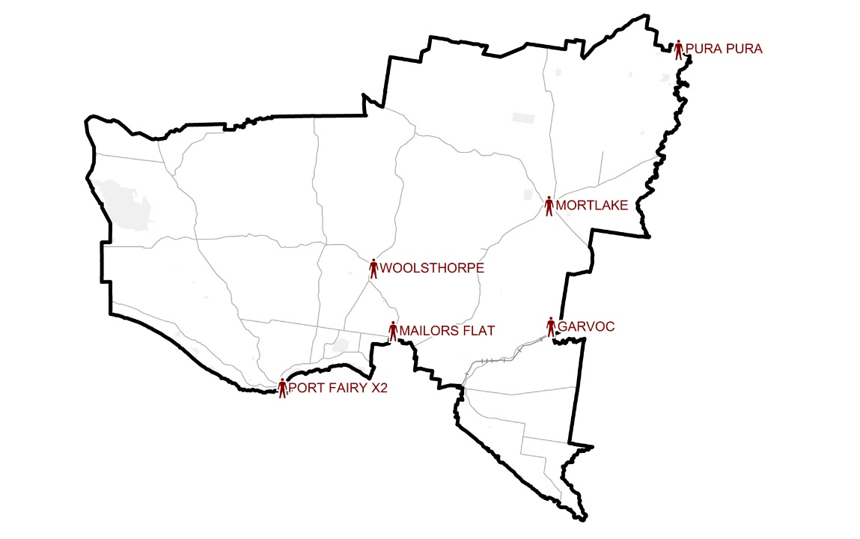

**Diagram 1: Location of current councillors**

The VEC therefore recommended no change be made to the current number of seven councillors.

### Electoral structure

In its preliminary report, the VEC recommended that an unsubdivided structure effectively provided for fair and equitable representation of the voters of Moyne Shire Council.

The VEC found a reasonable distribution of candidates and elected councillors in the past three elections, which meant that the current electoral structure provided a good opportunity for most areas of the Shire to have local representation. This finding was given additional weight by the even distribution of voters throughout the Shire, albeit with higher concentrations in the major population centres of the south and in some towns across the north. Thus, under an unsubdivided structure candidates appealing to specific geographic areas or smaller communities of interest and with a moderate level of support would have a good chance of being elected. In the past three elections, no candidates from the far north-west of the Shire had nominated for election. While this may have meant that some voters in the area felt unrepresented, it also raised the prospect of uncontested or failed elections in wards encompassing this area under a subdivided electoral structure.

The VEC believed that an unsubdivided model would benefit electors particularly non‑geographical communities of interest, such as those concerned about windfarms, which are located throughout the Shire, the interests associated with regional development, tourism and growing concerns about the environment. Mutual interests, such as those between tourism and agriculture, were also identified.

The unsubdivided option would allow voters to select from all candidates at election time and for those residing in country areas to have a say on all candidates, including candidates coming from the more populated areas in the south of the Shire, particularly Port Fairy.

In response to submissions, the VEC considered and proposed two subdivided electoral structures as alternative options. Option B consisted of seven councillors elected from five wards (two two‑councillor wards and three single-councillor wards) and Option C consisted of seven councillors elected from three wards (one three-councillor ward and two two-councillor wards).

Both options reflected geographical communities of interest and in response to public submissions provided the opportunity for local representation for these distinct areas.

Option B provided two single-councillor northern wards to effectively capture the broadscale agriculture and country interests prominent across the north of the Shire and to ensure a good chance that representation would be provided for voters in the north-east and north-west. The three southern two-councillor wards were also based on geographical communities of interest and to some degree distinct land use patterns. The south-east ward included significant dairying lands and a major part of the Shire’s coastline; the central ward contained major population and urban centres and smaller scale farming ventures; and the south-west ward included the major town of Port Fairy, some farming land and a sparsely populated coastal area.

Option C provided a broader view of the Shire’s geography by including the whole of the north in one ward and drawing the central and south-east areas together. Proportional vote counting would apply in all wards, meaning that candidates would be elected based on the proportion of their support in the community. This was seen as an advantage for voters when compared to Option B, particularly for those in the north.

The subdivided options provided local representation for major geographical communities of interest, and the VEC was of the view that this provided a good opportunity for elected councillors to be more knowledgeable of and responsive to local issues.

However, the VEC identified important drawbacks in both alternative options. They effectively capped local representation for the northern communities of interest at two elected councillors. Uncontested or failed elections were more likely in Option B, and the large geographical areas covered by the northern wards in both options, in particular Option C, would likely impact councillor workloads and travel times. The potential for ward boundaries to divide communities of interest and the bringing together of very different communities in, for example, the South East Central Ward of Option C, were also issues of concern. Moreover, the VEC was of the view that the alternative options did not necessarily guarantee local representation for the northern areas: Option B did provide a good chance of providing local representation for the north-east and the north-west, yet it did not guarantee local representation for the far north-west; Option C provided for two councillors to represent the whole of the north with a high risk that some parts of the ward, especially the north-west, could be left without a local representative. Finally, the VEC felt that subdividing the Shire might exacerbate the country-urban, north-south divide expressed by submitters.

### Options

After careful consideration, the VEC put forward the following options:

* Option A (preferred option)  
  **Moyne Shire Council consist of seven councillors elected from an unsubdivided electoral structure.**
* Option B (alternative option)  
  **Moyne Shire Council consist of seven councillors elected from five wards (two two-councillor wards and three single-councillor wards).**
* Option C (alternative option)  
  **Moyne Shire Council consist of seven councillors elected from three wards (two two-councillor wards and one three-councillor ward).**

Public response

Response submissions

The VEC accepted submissions responding to the preliminary report from Wednesday 20 March 2019 until 5.00 pm on Wednesday 17 April 2019. The VEC received 15 response submissions. A list of people who made a response submission can be found in Appendix 1. Table 1 indicates the level of support for each option.

|  |  |  |  |  |
| --- | --- | --- | --- | --- |
| Table 1: Preferences expressed in response submissions | | | | |
| **Option A** | **Option B** | **Option C** | **Other** | **Out of scope** |
| 6 | 6 | 1 | 1 | 1 |

### Number of councillors

All options put forward by the VEC in its preliminary report consisted of seven councillors in total. While preliminary submissions evidenced a mix of views on the preferred number of councillors, with a majority suggesting an increase was needed to improve local representation, the number of councillors attracted little interest in the response submissions. While a number of these submissions suggested that seven councillors was suitable for the Shire, most did not mention councillor numbers at all.

Of those response submissions that did comment on the number of councillors, seven was considered appropriate to provide fair representation for Moyne and consistent with the modest level of population growth predicted in future years. In its submission, Moyne Shire Council did not believe that increasing the number of councillors would provide broader representation, which was a point of particular concern for those advocating an increase to councillor numbers in preliminary submissions.

### Electoral structure

Response submissions focused on whether the Shire should be subdivided or not. As Table 1 indicates, there was an even split between support for the unsubdivided model of Option A and the alternative subdivided model of Option B. One submission argued for Option C, while another did not specify a preferred option, and one was considered out of scope.

There was an evident geographical divide between supporters of the unsubdivided option and those arguing for Option B or C.

* Of the submitters supporting Option A, two were based in Port Fairy, including Moyne Shire Council, two were from locations in the south-east and two were from outside the Shire.
* Five out of the seven submissions supporting a subdivided electoral structure were from individuals residing outside the main town and population centres located in the south of the Shire.

This divide reveals the push for local representation of voters located in the northern and country areas.

#### Local representation

A subdivided structure was seen as the best way to guarantee local representation for a number of submitters, particularly for geographical communities of interest in the north of the Shire. Many felt that the election of a candidate from their local area in the north would improve accountability, and councillors familiar with and knowledgeable of local issues would enhance the representation of country and farming interests. Some believed that voters would have a stronger connection with councillors elected from their local area. These arguments were particularly important for some submitters who felt that areas of the north had not been adequately represented to date.

However, those supporting Option A, including Moyne Shire Council, suggested that these areas are currently and have in the past been represented by locally elected councillors, and that it was important for there to be a whole of council approach to decision-making rather than an issue- or geographical-based approach to such matters. Other submissions supporting Option A suggested that the ability of voters to have a say on all candidates at election time and the requirement that councillors act for the Shire as a whole, provided appropriate representation to all voters. Some suggested that proportional representation applied across the entire Shire would give candidates with a sizeable level of community support a good chance of being elected, with one adding that under Option A, geographical communities of interest were just as likely to be represented as they would be in a subdivided electoral structure. Another submitter suggested that voters in single-councillor wards would be discriminated against compared to those in multi-councillor wards, as single-councillor wards require a higher proportion of voters to elect a councillor.

#### The dominance of Port Fairy

Many of those in support of a subdivided structure suggested that Port Fairy was currently over‑represented on the Council and argued, in turn, that councillors were not able to represent the Shire as a whole and its many geographical communities of interest. One submission in particular was of the view that the current unsubdivided structure skewed voting and representation towards the major population centres. Others felt that there was a ‘Port Fairy versus the rest of the Shire’ mentality, which they believed a subdivided structure would remedy. One submitter suggested that Port Fairy being a major holiday destination and therefore containing a high number of unoccupied dwellings did not require the same level of representation as other areas of the Shire. Some of those supporting the subdivided options felt that Port Fairy had more in common with Warrnambool than it did with the country areas and should therefore be included as part of the City of Warrnambool.

In its support for Option A, Moyne Shire Council was of the view that there is currently and has been a reasonable spread of candidates and elected councillors from most areas of the Shire, and that the current electoral structure has provided local representation for all areas of the Shire.

#### The geographical size of the Shire

Many of those supporting a subdivided electoral structure referred to the large geographical size covered by the Shire and the diversity of interests contained within it to suggest that a subdivided electoral structure would guarantee a spread of elected councillors and provide the best structure to represent locally-based interests. On account of the large geographical size of some wards, one submission proposed increasing the number of councillors to two in each of the northern wards and reducing to one the number of councillors in the three southern wards. In support of Option A, one submitter thought that current technology and the Council’s engagement programs made geographical size less relevant than it once was and less difficult for smaller communities to access elected councillors.

Some submissions thought that Option B would reduce councillor travel times and workloads. Geographical size was also why some submissions supported Option B over Option C due to the very large northern ward in Option C, which would impact on councillor workloads and travel times and could potentially result in parts of the ward being unrepresented.

#### Political considerations and electoral outcomes

Many of those supporting Option B felt that an unsubdivided electoral structure encouraged preference deals. One submitter in particular felt that both subdivided options minimised voting blocks and the potential for some individuals and groups to be excluded from elections.

The submitter in support of Option C preferred this subdivided model as he thought that Option B, which closely resembled the electoral structure in place prior to the 2007 representation review would resurrect old problems. He was of the view that Option C, having a large multi-councillor ward in the north would improve the quality of candidates standing, provide voters in this ward with more choice and avoid the possibility of uncontested elections as in the single-councillor wards of Option B.

Some supporters of the subdivided options did not feel that uncontested elections would be a major issue. One submitter believed there would be no risk of too few candidates in the single-councillor wards of Option B, and the other in support of Option C argued that the large northern ward would allow for a greater number of candidates and less chance of uncontested elections.

Public hearing

The VEC conducted a public hearing for those wishing to speak about their response submission at 4.00 pm on Wednesday 24 April 2019 at the Port Fairy Community Services Centre 16 Atkinson Street, Port Fairy. A list of people who spoke at the hearing can be found in Appendix 1.

Two speakers chose to attend and both spoke in support of Option B.

### Support for Option B: seven councillors elected from five wards

Each speaker presented similar arguments in support of the subdivided electoral structure. They argued that local representation was needed for voters and residents in the north of the Shire and that the current unsubdivided structure had resulted in geographical communities of interest in the north being unfairly or inadequately represented. John B Howard in particular felt that Option B would improve the accountability of councillors and the governance processes of Council and argued strongly that the current unsubdivided structure meant that councillors were not accountable to some areas and groups of people. Both felt that large geographical areas, such as those contained within the northern wards, required more councillors and therefore proposed that these wards be provided with two councillors each, while the south-east, central and south-west wards should each have one councillor. This proposal was further supported by suggesting that the holiday destination of Port Fairy, which contained a number of dwellings unoccupied for parts of the year, did not place the same demands on councillors as other, mainly country areas.

Terry Rowbottom, representing the Moyne Residents and Ratepayers Action Group, felt that most councillors came from or focused too heavily on the southern regions of the Shire, particularly Port Fairy, and that the Council had a much greater presence in these areas than in the north. In regard to why candidates from the north-west had not stood as candidates at elections, Mr Rowbottom was of the belief that this was because voters in this area were disgruntled with how they had been treated by Council in recent times.

According to Mr Howard, local representation for the northern and more country areas was needed because it was in these areas that the most contentious issues facing Council were located, including windfarms and blue gum plantations. He preferred Option B over Option C on account of the very large northern ward of the latter. Most significantly, Mr Howard stated that people in the north have no real connection to Port Fairy and are more connected to Warrnambool because of the location of key businesses and services. He added that many residents, particularly those in the north, were more likely to connect with major towns outside of the Shire.

Findings and recommendation

The VEC’s findings

The VEC considered a range of views expressed in submissions and conducted its own internal research to make its final recommendations regarding the appropriate number of councillors and the electoral structure for Moyne Shire Council.

### Number of councillors

The VEC put forward three electoral structure options in its preliminary report, all of which consisted of seven councillors. While many submitters during the preliminary submission stage proposed increasing the number of councillors, mainly to provide representation to a broader range of geographical communities of interest, an increase was not considered appropriate.

The VEC proposed seven councillors as appropriate for fair and equitable representation due to the size of the Shire, the current voter-to-councillor ratio, which was comparative to similar councils, and the modest rate of population growth expected in future years. The VEC considered that the Shire as a whole did not face significant social issues which might warrant an increase to the number of councillors. Moreover, the VEC did not feel that increasing the number of councillors would necessarily provide broader or more effective representation. For these reasons and in line with the options put forward in the preliminary report, the VEC recommends that Moyne Shire Council continue to consist of seven councillors.

### Electoral structure

The electoral structure attracted significant interest throughout the review process. Most preliminary submissions supported a subdivided electoral structure, including a number that proposed Moyne Shire be divided into single-councillor wards, ranging between seven to ten wards. The VEC did not consider that single-councillor wards would effectively capture communities of interest, could potentially divide some communities, and – due to the Shire’s population distribution and the concentration of population in Port Fairy and surrounds – it would be difficult to provide a single-councillor ward model that provided and sustained sensible ward boundaries.

The VEC proposed three options in the preliminary report, all of which were considered to provide fair and equitable representation. Option A, an unsubdivided electoral structure, reflected the status quo; Option B was a subdivided electoral structure consisting of a combination of single- and multi-councillor wards; and Option C was also a subdivided electoral structure, consisting of three multi-councillor wards. There was an even split during the response submission stage between Options A and B, with minimal support for Option C.

A strong argument was presented throughout the review process on the need for local representation, and this was the main argument presented in support of a subdivided electoral structure. However, the VEC came to the view that local representation would not necessarily be improved under either Option B or C. There is currently and has been in the past a reasonable distribution of candidates and elected councillors from across the Shire. This has provided most areas of the Shire with local representation. The VEC is not of the view that the spread of councillors would necessarily change under a subdivided electoral structure, and notes that the locations of current councillors (see Diagram 1 on page 11) roughly corresponds to the ward structure proposed in Option B, although with some important differences: the area contained under the proposed north-east ward in Option B currently has two elected representatives; the area of the suggested central ward has one councillor and there is a councillor located on the border of what would be the north-east and south-east wards. The only area not to have candidates or elected councillors in the past three elections is the far north-west. However, given that the north-west ward proposed in Option B contains the town of Woolsthorpe, which has consistently had councillors elected, a subdivided structure would by no means assure local representation for the far north-west.

The notion that the Council is focused too heavily on Port Fairy featured prominently throughout the submissions and was also put forward at the public hearing. This perspective may be anticipated, to some degree, given that Moyne Shire Council’s main offices are located in Port Fairy and there exists, what some submitters refer to as, a ‘Port Fairy versus the rest of the Shire’ mentality. However, this mentality would be unlikely to change under either of the subdivided options put forward and would potentially be exacerbated given the cap on local representation for those areas outside of the south and Port Fairy. This would be particularly so for voters in the single-councillor wards of the north, who could be disadvantaged in instances where one councillor may not sufficiently reflect community concerns or where choosing to vote in favour of a councillor that better reflects their issues is not always a viable option in a smaller ward election.

The proposal to increase the number of councillors in the two northern wards to two each and reduce the number of councillors in the remaining wards to one each, as presented in a response submission and by both speakers at the public hearing, was not a viable option and could not be considered by the VEC. While the VEC understood that the proposal intended to address what some submitters felt was an imbalance in the representation needs of those in the north and country areas and made a case for councillor numbers to be determined by geographical area, such an approach would not comply with the Act. The Act specifies that the number of councillors per ward in a subdivided electoral structure is to be determined by the voting population where the number of voters represented by each councillor has to be within plus-or-minus 10% of the average number of voters per councillor.

Responding to concerns presented by submitters regarding the prevalence of preference deals and voting blocks under an unsubdivided electoral structure, the VEC notes that these practices can occur under any electoral structure and if occurring will not necessarily be reduced by changing to a ward structure.

Finally, the VEC is not convinced that a subdivided structure is necessarily the solution to many of the issues raised throughout the review process, particularly those relating to planning issues, personal dealings with the Council or its current performance. Nor is the VEC of the view that a subdivided electoral structure will resolve the dissatisfaction towards Council performance that many submitters expressed. The VEC determined that given the reasonable spread of councillors from across the Shire and the fairly even distribution of the population throughout, the solution to community discontent and expressions of under-representation is not necessarily a subdivided structure. Rather, there is a need for more candidates from those areas feeling unrepresented to stand for election. Under an unsubdivided structure and with a reasonable level of support candidates running for election on local issues would stand a good chance of being elected. Furthermore, an unsubdivided electoral structure would not place a limit on how many councillors could represent a particular area.

### Summary

The VEC found that the advantages offered by a subdivided electoral structure would not necessarily resolve the problems with the current electoral structure that were identified by submitters to the review. The unsubdivided electoral structure appears to be returning a fairly good spread of local representatives from across the Shire.

Therefore, and on balance, the VEC recommends retaining the current electoral structure as this allows all voters to choose from all candidates at an election. The VEC has found that the current electoral structure provides the most fair and equitable representation for Moyne Shire Council.

The VEC’s recommendation

**The Victorian Electoral Commission recommends that Moyne Shire Council continue to consist of seven councillors elected from an unsubdivided electoral structure.**

This recommendation is submitted to the Minister for Local Government as required by the *Local Government Act 1989*. The model was designated as Option A in the VEC’s preliminary report for this review. Please see Appendix 2 for a map of this recommended structure.

# Appendix 1: Public involvement

Preliminary submissions

Preliminary submissions were received from:

Bucci, Paul

Cumming, Hamish

Cumming, Lachlan

Gardner, Ann & Andrew

Goodall, Kelvin

Hicks, Heather

Howard, John B

Humble, Geoffrey

Jelbart, Christine

Lewis, Paul

Moyne Shire Council

Proportional Representation Society of Australia (Victoria-Tasmania) Inc.

Response submissions

Response submissions were received from:

Bucci, Paul

Carr, Melissa

Cumming, Hamish

Cumming, Lachlan (Lachie)

Curtis, Chris

Daly, Michael

Howard, John B

Huglin, Frank

Lodge, David

Moyne Residents and Ratepayers Action Group

Moyne Shire Council

Murray, Denise

Parker, Jill

Proportional Representation Society of Australia (Victoria-Tasmania) Inc.

Sault, James

Public hearing

The following individuals spoke at the public hearing:

Howard, John B

Rowbottom, Terry (President) for Moyne Residents and Ratepayers Action Group

# Appendix 2: Map

The map is provided on the next page.

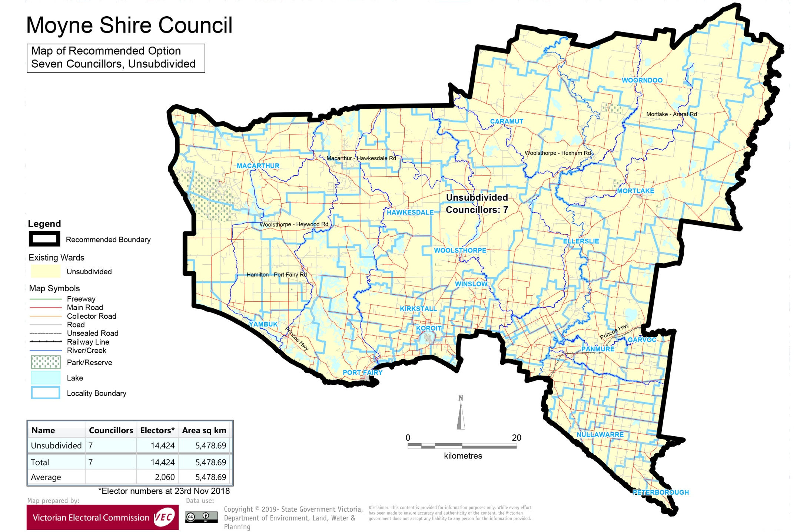

# Appendix 3: Public information program

Advertising

In accordance with the Act, public notices of the review and the release of the preliminary report were placed in the following newspapers:

|  |  |  |
| --- | --- | --- |
| **Newspaper** | **Notice of review** | **Notice of preliminary report** |
| *Herald Sun* | Thursday 17 January 2019 | Wednesday 20 March 2019 |
| *Mortlake Dispatch* | Thursday 17 January 2019 | Thursday 21 March 2019 |
| *Moyne Gazette* | Thursday 17 January 2019 | Thursday 21 March 2019 |
| *The Warrnambool Standard* | Thursday 17 January 2019 | Thursday 21 March 2019 |
| *Hamilton Spectator* | Thursday 17 January 2019 | Tuesday 19 March 2019 |

Media releases

A media release was prepared and distributed to local media to promote the commencement of the review on Wednesday 23 January 2019. A further release was distributed with the publication of the preliminary report on Wednesday 20 March 2019. A final media advisory was circulated on the publication date of this final report.

Public information sessions

Public information sessions for people interested in the review process were held on:

* Monday 21 January 2019 in the Mortlake Municipal Offices Council Chambers,   
  1 Jamieson Avenue, Mortlake.
* Monday 21 January 2019 at the Port Fairy Community Services Centre, 16 Atkinson Street, Port Fairy.

Submissions guide

A submission guide was developed and made available on the VEC website, or in hardcopy on request, throughout the review timeline. The submission guide provided information about the review, the review timeline and how to make submissions to the review.

Online submission tool

An online submission tool was developed and made available during the submission periods of the review. The tool allowed people to make a submission from the VEC website. During the preliminary submission stage, users also had the opportunity to map out their preferred subdivisions through the online submission tool using Boundary Builder. Boundary Builder included real elector numbers so that users could see if their preferred structures and numbers of councillors met the plus-or-minus 10% rule.

VEC website

The VEC website delivered up-to-date information to provide transparency and facilitate public participation during the review process. All public submissions were published on the website.

Email and social media engagement

The VEC delivered an information email campaign targeted at known community groups and communities of interest in the local council area. This included a reminder email at each milestone of the representation review process.

The VEC also published sponsored social media advertising that was geo-targeted to users within the local council area. This included advertising at both the preliminary submission and response submission stages. The total approximate reach of these posts was 7,326 users.

Council communication resources

The VEC provided the Council with a communication pack that included information on the review in various formats. While the Council is encouraged to distribute this information and raise awareness about the review, the VEC is an independent reviewer and all communications resources include reference and links to the VEC website and core materials.

This page has been left intentionally blank



1. Section 219D of the *Local Government Act* *1989.*
2. ibid.
3. .id is a consulting company specialising in population and demographic analysis and prediction information products in most jurisdictions in Australia and New Zealand.
4. Section 5B(1) of the *Local Government Act 1989.*
5. Socio-Economic Indexes for Areas (SEIFA) is developed by the Australian Bureau of Statistics (ABS) to rank areas in Australia according to relative socio-economic advantage and disadvantage. The rankings use variables, such as income, education, employment, occupation and housing, derived from Census data to indicate relative socio-economic advantage and disadvantage for particular areas, including Local Government Areas. See: <https://www.abs.gov.au/websitedbs/censushome.nsf/home/seifa>