July 2023

Glen Eira City Council

Local council electoral structure review

Preliminary   
Report

Acknowledgement of Country

The electoral representation advisory panel acknowledges the Bunurong and Wurundjeri peoples as the Traditional Custodians of the lands and waters for which it is holding this review and pays respects to ancestors and Elders past, present and emerging. The panel acknowledges their custodianship for many thousands of years and their continuing living culture.

Document history and version control

|  |  |  |  |
| --- | --- | --- | --- |
| **Version** | **Date approved** | **Submission approved by** | **Brief description** |
| 1 | 14 July 2023 | Strategic Advisor, Enrolment | Final version for publication |

Contents

Executive summary 4

Developing electoral structure models 4

Electoral structure models 4

Next steps 4

Background 6

About the 2023–24 electoral structure reviews 6

The electoral representation advisory panel 6

Public engagement 7

Developing recommendations 7

About Glen Eira City Council 11

Profile 11

Current number of councillors and electoral structure 13

Last electoral structure review 13

Preliminary findings and models 14

Number of councillors 14

Electoral structure 15

Models for public feedback 19

Ward names 19

Next steps 21

Response submissions 21

Public hearing 22

Final report 22

References 23

Appendix 1: Model maps 24

# Executive summary

An independent electoral structure review panel appointed by the Minister for Local Government is reviewing the electoral structure of Glen Eira City Council.

The purpose of the review is to advise the Minister on the appropriate number of councillors and electoral structure, including ward names, for the council.

Under Victoria’s *Local Government Act 2020* (the Act), Glen Eira City Council must now have a single-councillor ward electoral structure.

The panel is looking at:

* + the appropriate number of councillors and wards for the council
  + the location of ward boundaries
  + appropriate ward names.

This report outlines the preliminary models the panel is presenting for public consultation, for the proposed new electoral structure of Glen Eira City Council to meet the requirements of the Act.

More information about the background to the review is available on page 6.

## Developing electoral structure models

The panel considered a range of factors when deciding on the models in this report, including:

* + research and analysis
  + voter growth or decline over time.

More information on the way the panel decided on the models is available on page 7.

## Electoral structure models

After considering research and the requirements of the Act, the panel is presenting the following electoral structure models for public consultation:

* Model 1: a subdivided electoral structure with a total of 9 councillors – 9 wards with one councillor per ward
* Model 2: a subdivided electoral structure with a total of 9 councillors – 9 wards with one councillor per ward, with different ward boundaries to Model 1
* Model 3: a subdivided electoral structure with a total of 9 councillors – 9 wards with one councillor per ward, with different ward boundaries to Model 1 and Model 2

Details on these models, including maps, are available in Appendix 1.

## Next steps

The panel is now seeking feedback on the preliminary electoral structure models. You can make a response submission to the preliminary models until 5 pm Wednesday 9 August 2023. If any response submitters wish to speak at a public hearing, the panel will hold an online public hearing on Wednesday 16 August 2023. Following this, the panel will present its final recommendation to the Minister on Wednesday 13 September 2023.

More information about the review process is available on the Victorian Electoral Commission (VEC) website at [vec.vic.gov.au](https://www.vec.vic.gov.au/electoral-boundaries/council-reviews/electoral-structure-reviews)

# Background

## About the 2023–24 electoral structure reviews

In October 2022, the Minister for Local Government formed 2 electoral representation advisory panels to review and provide advice on the electoral structures of 39 local councils, under section 16 of the Act. If the Minister accepts the electoral structure recommended by the panel, any changes will take effect at the October 2024 local council elections.

The Act introduced several changes to local government representation, including the types of electoral structures local councils may have. All metropolitan, interface and regional city councils (including Glen Eira City Council) must now have single-councillor ward electoral structures.

For Glen Eira City Council, the electoral representation advisory panel is examining:

* the number of councillors and wards
  + where the ward boundaries should be
  + the name of each ward.

The Act requires electoral structures to provide fair and equitable representation and facilitate good governance. Each ward must have an approximately equal number of voters per councillor (within +/-10% of the average). While conducting the review, the panel also notes the role of a councillor as specified under section 28 of the Act.

## The electoral representation advisory panel

The panel conducting the electoral structure review of Glen Eira City Council has 3 members:

* The Honourable Frank Vincent AO KC (Chairperson*)
* Ms Janet Dore
* Acting Deputy Electoral Commissioner Ms Máiréad Doyle.

*Please note that during the preliminary report preparation of this review, Ms Máiréad Doyle sat as Acting Chairperson while The Honourable Frank Vincent took a period of leave.

The purpose of the review is to advise the Minister on the appropriate number of councillors and electoral structure, including ward names, for the council. The panel is independent of councils and the Victorian State government.

Under the Act, the VEC is not responsible for reviewing council electoral structures but must provide administrative and technical support to the panel. The Electoral Commissioner (or their delegate) must be a member of each panel.

## Public engagement

### Public information program

On behalf of the panel, the VEC has conducted a public information and awareness program to inform the public about the Glen Eira City Council electoral structure review. This has included:

* + printed public notices in state-wide newspapers
  + public information sessions to outline the review process and respond to questions from the community
  + media releases to announce the start of the review
  + information on social media channels
  + updated website content on [vec.vic.gov.au](https://www.vec.vic.gov.au/), including:
    - current information on the review process
    - submission guide and fact sheets for each council under review with background information.

The VEC will continue to promote the review on behalf of the panel during the response submission stage via media releases, the VEC’s social media channels and the VEC website.

### Public consultation

The panel now invites input to the electoral structure review of Glen Eira City Council via:

* + response submissions to this preliminary report
  + an online public hearing for anyone who makes a response submission to speak to the panel and expand on their submission.

Public submissions are an important part of the review process and are considered alongside other factors addressed during the review. These are outlined below.

## Developing recommendations

The electoral structure models the panel is presenting in this preliminary report comply with the Act and were developed through careful consideration of:

* + research and analysis conducted by the VEC support team, including geospatial and demographic data
  + rates or patterns of population and voter change over time, and relevant forecasts of growth or decline based on forecast information provided by .id (informed decisions, a company specialising in demographics and forecasting).

### Deciding on the number of councillors

The Act allows local councils to have between 5 and 12 councillors, but neither the Act nor the Local Government (Electoral) Regulations 2020 specify how the number of councillors is to be determined. Therefore, the models put forward by the panel in this report are guided by the Act’s intention for fairness and equity in voter representation.

In examining the appropriate number of councillors for Glen Eira City Council, the panel considered the following criteria:

* + the population and number of voters in the council area, compared to other councils with a similar population size and number of voters in the same category (for example, other comparable metropolitan, interface or regional city councils)
  + patterns of population change and voter growth or decline in the council area over time
  + the current and past numbers of councillors
  + the representation needs of the communities of interest in the council area.

The panel’s final recommendation will also consider any matters raised in public response submissions not already listed above.

Local councils with a larger number of voters will often have more councillors. Large populations generally have greater diversity, both in the type and number of communities of interest and issues relating to representation. However, the ideal number of councillors can also be influenced by the circumstances of each council, such as the:

* + nature and complexity of services the council provides
  + geographic size and topography of the area
  + forecast population and voter growth or decline
  + social diversity.

### Deciding the electoral structure

Under the Act, regional city, metropolitan and interface councils must now have single-councillor ward electoral structures.

When developing single-councillor ward models for Glen Eira City Council, the panel considered these criteria:

* + whether the structure would comply with section 15(2) of the Act (see below), and for how long it would likely comply
  + the appropriate number of councillors, as outlined above
  + whether meaningful and effective ward boundaries could be established and whether these would be easily identifiable to local communities
  + the representation of communities of interest
  + the voter distribution and physical features of the area, and the impact these may have on the shape and size of wards
  + past elections for the council, including:
    - numbers of candidates nominating
    - incidences of uncontested elections
    - rates of informal voting.

The panel’s final recommendation will also consider any matters raised in public response submissions not already listed above.

Under section 15(2) of the Act, subdivided structures must aim for an approximately equal number of voters per councillor in each ward. This means the number of voters represented by each councillor in a ward should be within +/-10% of the average number of voters per councillor for all wards.

During this review, the panel aims to recommend a structure that will comply with section 15(2) at the time of the 2024 local council elections and, if possible, also comply based on voter numbers at the time the review is conducted. The panel uses forecasts of population and voter change to assess compliance at the 2024 elections with as much accuracy as possible. In some cases, population change and other factors impacting voter numbers mean it is not possible to create compliant subdivided structures based both on voter numbers that were current at the time of the review and forecast voter numbers. In these instances, the panel prioritises compliance at the 2024 local government elections to ensure each vote will have approximately equal value at the 2024 election.

One of the factors that may impact compliance with section 15(2) is the number of current and forecast voters with ratepayer-based voting entitlements, also known as council-enrolled electors. Voters’ rolls include both state-enrolled electors (the majority of the roll) and a smaller number of council-enrolled electors. The Act introduced changes to ratepayer-based entitlement categories, which come into full effect at the 2024 local council elections. The panel will take this change to the makeup of voters’ rolls, and therefore compliance with section 15(2) of the Act, into consideration during this review.

### Deciding on ward names

The panel has taken the following approach to naming wards.

1. Retaining existing ward names if these are still relevant to the area covered by the ward.
2. When a new name is required, the panel bases this on features such as:
   * + places (registered under the *Geographic Place Names Act 1998*) in the ward
     + compass directions
     + native flora or fauna.

### Use of Aboriginal language

The panel recognises that there should first be meaningful consultation with local Aboriginal communities and groups before a ward is named using Aboriginal language. Meaningful consultation is a significant process that the panel is not able to undertake within the timeframes of the current review program.

The panel also recognises that many of the place names in current use across Victoria are based on Aboriginal language. As such, the panel may put forward new ward names using Aboriginal language if:

* it is the name of a place within a ward
* it is currently in common use

and

* the name is registered under the *Geographic Place Names Act 1998*.

Unregistered names using Aboriginal language have not been put forward by the panel as new ward names. While the panel supports the adoption of names based on Aboriginal language, this requires appropriate consultation.

Accordingly, for the panel to consider an Aboriginal language ward name that is suggested in a public submission to the review, the name submitted needs to comply with the above guidelines.

# About Glen Eira City Council

## Profile

Glen Eira City Council is located in the inner south-east of metropolitan Melbourne, around   
10 km from the CBD. The council covers an area of 38 km2 and is bordered by Stonnington City Council to the north, Kingston City Council to the south, Monash City Council to the east and Port Phillip and Bayside councils to the west.

The Traditional Custodians of the lands in Glen Eira City Council are the Bunurong and Wurundjeri peoples (FPSR 2023).

### Landscape

The council area is heavily urbanised, featuring a strong grid pattern of residential streets and numerous shopping strips along main transport routes (DTP 2023, Glen Eira City Council 2020). The council covers suburbs including Caulfield North, Elsternwick and St Kilda East in the north-west and Carnegie and Murrumbeena further to the east. Glen Huntly, the most densely populated suburb (.id 2023b), is in the centre along with Caulfield, McKinnon, and Ormond. Bentleigh East, the largest suburb by both population and area, and Bentleigh are located in the south (.id 2023a).

A defining feature of the council area and council planning are the many commercial and activity centres, which serve as important social and business hubs (Glen Eira City Council 2020). Located next to train stations and along tram routes, these centres provide a range of commercial, retail, entertainment and community services for residents and attract large numbers of visitors to the council area.

Additionally, there are around 30 parks and recreation reserves spread throughout, the largest of which is historic Caulfield Park, located in Caulfield North.

The council area is well serviced by major roads and public transport routes. The Princes Highway forms its northern boundary, while the Nepean Highway forms parts of its southern boundary. The Sandringham, Frankston and Cranbourne-Pakenham train lines pass through the council, as well as 5 tram routes and several bus services.

### Community

The population of Glen Eira City Council was 148,908 in 2021 (ABS 2022a), an increase of nearly 18,000 people over the past decade. Its population is forecast to grow modestly at an average of about 1% per year, with the greatest growth forecast to occur in Caulfield North, Caulfield East and Carnegie (.id 2023a).

Aboriginal and Torres Strait Islander people make up 0.3% of the population (ABS 2022a), lower than the average of 0.7% for greater Melbourne (ABS 2022b). Almost 40% of Glen Eira City Council residents were born overseas, with 4.5% born in China and 4.4% born in India (ABS 2022a). Nearly 36% of the population speaks a language other than English at home, including Mandarin (5.6%), Greek (3.6%), Russian (2.1%), Hebrew (2.1%) and Hindi (1.2%) (ABS 2022a).

The council area is home to a large Jewish community, mainly in the north-east in suburbs including St Kilda East, Caulfield North, Caulfield and Elsternwick (.id 2023c). Judaism is the largest religious group comprising 17.6% of the population (ABS 2022a), followed by Catholic (16.1%) and Eastern Orthodox (5.8%) religious groups (ABS 2022a).

The median weekly household income was $2,133 in 2021, higher than the average of $1,901 for greater Melbourne (ABS 2022a, ABS 2022b). Around 31.5% of homes are owned outright and almost 34% of households rent (ABS 2022a, ABS 2022b).

Glen Eira City Council has a vibrant economy, with more than 17,252 local businesses that employ over 45,000 people (.id 2023d). Health care and social assistance is a major industry, accounting for 20.7% of employment and 10.6% of economic output in the council (REMPLAN 2023). Other major industries by employment include education (16.3%) and retail (11.2%) (REMPLAN 2023).

## Current number of councillors and electoral structure

Glen Eira City Council is currently divided into 3 wards with 3 councillors each, with a total of   
9 councillors.

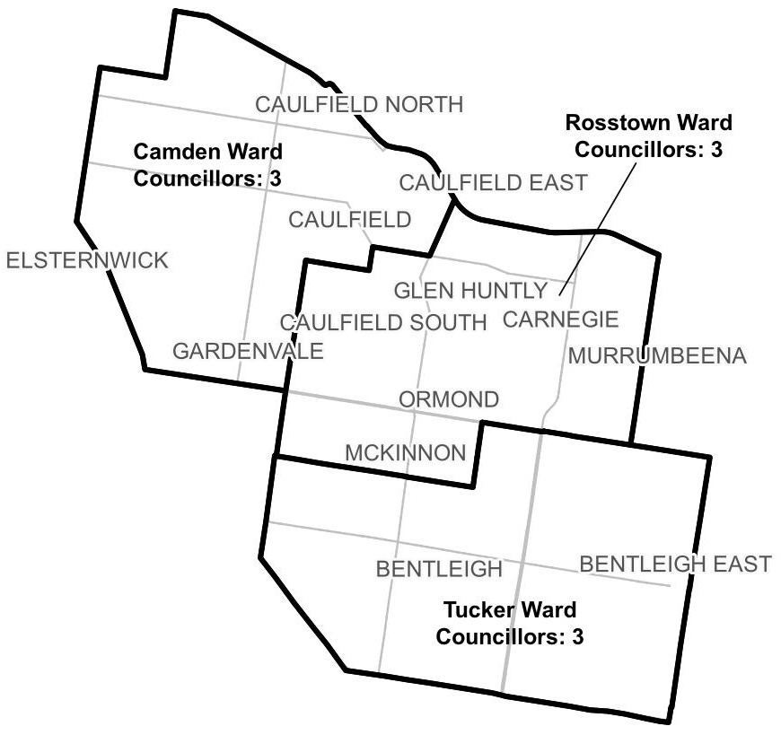

**Figure 1:** Diagram of current electoral structure of Glen Eira City Council.

There are an estimated 106,181 voters in Glen Eira City Council, with an estimated ratio of 11,797 voters per councillor.

Visit the VEC website at [vec.vic.gov.au](https://www.vec.vic.gov.au/electoral-boundaries/local-councils/glen-eira-city-council) for more information on Glen Eira City Council.

## Last electoral structure review

The VEC conducted an electoral representation review of Glen Eira City Council in 2011. This review was carried out under the *Local Government Act 1989* (Vic), which was replaced by the *Local Government Act 2020* (Vic).

After conducting the review, the VEC recommended that Glen Eira City Council continue to consist of 9 councillors elected from 3 wards, with minimal changes to ward boundaries.

Visit the VEC website at [vec.vic.gov.au](https://www.vec.vic.gov.au/electoral-boundaries/local-councils/glen-eira-city-council) to access a copy of the 2011 representation review final report.

# Preliminary findings and models

## Number of councillors

After taking into consideration the requirements of the Act and the agreed criteria, the panel found 9 councillors to be an appropriate number for Glen Eira City Council.

The panel considered the characteristics of Glen Eira City Council in relation to similar metropolitan councils, including its population, the number and distribution of voters, and the size and geography of the council.

|  |  |  |  |  |  |  |
| --- | --- | --- | --- | --- | --- | --- |
| Similar metropolitan councils to Glen Eira City Council | | | | | | |
| Local council | Area (km2) | Number of voters at 2020 election | Population (2021 Census) | Current total estimate of voters | Number of councillors | Number of voters per councillor |
| Knox City | 114 | 117,363 | 159,103 | 116,282 | 9 | 12,920 |
| Darebin City | 54 | 114,106 | 148,570 | 114,358 | 9 | 12,706 |
| Whitehorse City | 64 | 112,640 | 169,346 | 113,214 | 11 | 10,292 |
| Frankston City* | 130 | 107,216 | 139,281 | 106,376 | 9 | 11,819 |
| Glen Eira City* | 39 | 105,230 | 148,908 | 106,181 | 9 | 11,797 |
| Greater Dandenong City* | 130 | 99,768 | 158,208 | 100,580 | 11 | 9,143 |
| Port Phillip City* | 21 | 88,268 | 101,942 | 97,755 | 9 | 10,861 |
| Banyule City | 63 | 95,510 | 126,236 | 95,151 | 9 | 10,572 |
| Moonee Valley City* | 43 | 93,923 | 121,851 | 93,530 | 9 | 10,392 |

*These local councils are undergoing an electoral structure review during 2023–24.

### Maintaining 9 councillors

Glen Eira City Council currently has 106,181 voters represented by 9 councillors and covers an area of 39 km2. Other metropolitan councils with a similar number of voters usually also have 9 councillors. As forecasts indicate only modest population change is expected for the council, the panel considers it appropriate for the total number of councillors to remain unchanged.

## Electoral structure

To identify the most appropriate electoral structure, various factors were considered. This included the requirements of the Act, the communities of interest in Glen Eira City Council, the appropriateness of ward boundaries and which models best offered fair and equitable representation and consequently facilitate good governance.

In developing the preliminary models presented in this report, the panel considered a range of models. The strongest 3 models have been put forward for further public comment.

The panel proposes 3 models for the consideration of the Glen Eira City Council community:

* a subdivided electoral structure of 9 single-councillor wards (Model 1)
* a subdivided electoral structure of 9 single-councillor wards, with different ward boundaries to Model 1 (Model 2)
* a subdivided electoral structure of 9 single-councillor wards, with different ward boundaries to Models 1 and 2 (Model 3).

Diagrams of the preliminary models are included in Appendix 1.

### A single-councillor ward structure with 9 councillors (Model 1)

Under this model, Glen Eira City Council would adopt a 9-ward structure. Each ward would be represented by one councillor, in line with the requirements of the Act.

Model 1 uses the boundaries of the 3 wards in the current electoral structure as its basis, further dividing each of these wards into 3 to create 9 new wards.

Camden Ward in the north-west of the council area is divided into Caulfield Park Ward, Gardenvale Ward and Greenmeadows Ward. The boundaries separating these wards follow major roads including Kooyong Road, Glen Eira Road and Glen Huntly Road. The proposed Gardenvale Ward extends north across Glen Huntly Road into a part of Caulfield south of Glen Eira Road and east of Hawthorn Road to ensure the numbers of voters in each ward are within +/-10% deviation of the average.

Rosstown Ward is divided into Koornang Ward, Mallanbool Ward and Wattle Grove Ward. The boundaries separating these wards follow a mix of major roads, minor roads, residential streets and locality boundaries. The boundary between Koornang Ward and Wattle Grove Ward follows the route of the Rosstown Rail Trail.

Tucker Ward is divided into Coatesville Ward, Elster Creek Ward and Tucker Ward. The boundaries separating these wards follow major roads including Jasper, Tucker and Centre Roads, as well as residential streets and property boundaries.

As Model 1 retains the ward boundaries of the current structure, the wards are compact and roughly even in shape and size. The division of each current ward into 3 single-councillor wards means the level of representation for the same geographic area is unchanged.

Moreover, residents would likely be familiar with the current boundaries, making it somewhat easier to adapt to a new structure. Wards in Model 1 capture communities of interest and suburbs reasonably well, using major roads where possible to create clear ward boundaries.

There are some potential drawbacks of this model, however. Some boundaries split suburbs across 2 or more wards, which may not align with the areas that communities identify with. Moreover, some ward boundaries split major shopping strips, such as those located along Glen Huntly Road in Elsternwick and Centre Road in Bentleigh East. To satisfy the requirement that each ward has a roughly equal number of voters, some boundaries follow minor streets and property boundaries, which may not be clear or familiar to residents. Finally, the ward boundaries continue to divide areas making up the former councils of Caulfield and Moorabbin, which was presented as unfavourable in submissions to previous representation reviews.

### A single-councillor ward structure with 9 councillors (alternative version) (Model 2)

Under this model, Glen Eira City Council would adopt a 9-ward structure. Each ward would be represented by one councillor, in line with the requirements of the Act.

Model 2 uses locality boundaries to divide the council into 9 wards, with entire suburbs for the most part contained in wards. This reflects the community’s strong identification with suburbs and neighbourhoods. For example:

* Greenmeadows Ward unites the suburbs of Elsternwick and Gardenvale with part of St Kilda East, where community connections are possibly stronger than east towards Caulfield South.
* Rosstown Ward captures Caulfield and Caulfield South, similarly recognising the community connections these localities share.
* Wattle Grove Ward unites the suburbs of McKinnon and Ormond, which have common demographic characteristics.

Ward boundaries deviate from locality boundaries in some instances, mainly to meet the requirement to have roughly equal numbers of voters in each ward (within a +/- 10% deviation of the average). For example, it was not possible to contain all of Bentleigh East in the one ward. Due to the number of voters in the suburb it was necessary to divide it in half between Mallanbool and Moorleigh wards. This has the knock-on effect of pushing Mallanbool Ward north to take in a small part of Murrumbeena.

The main benefits of Model 2 are:

* the creation of wards capturing communities of interest reasonably well, particularly those based on suburb and neighbourhood identities
* the merging of wards to unite suburbs, such as McKinnon and Caulfield South, which are divided under the current structure
* compact wards with recognisable features in major roads forming ward boundaries
* boundaries that keep most local shopping centres within a single ward.

The potential drawbacks of Model 2 are mainly due to the compromises required to ensure an equal number of voters in each ward. Not all suburbs could be contained within the one ward which may divide communities. For example, Carnegie has been divided between the proposed Koornang Park and Murrumbeena wards. Additionally, some local shopping strips and activity centres are split between wards, such as shopping centres on Koornang Road in Carnegie and Centre Road in Bentleigh East. This could also be considered a benefit, however, by the possibility of having 2 councillors represent the same area and the interests of the local community.

### A single-councillor ward structure with 9 councillors (Model 3)

Under this model, Glen Eira City Council would adopt a 9-ward structure. Each ward would be represented by one councillor, in line with the requirements of the Act.

Model 3 follows a similar approach to Model 2 in using localities as the basis for wards, but with modified ward boundaries to better accommodate local activity centres and surrounding communities. These shopping centres are an important social and economic feature of Glen Eira.

Most boundaries in Models 2 and 3 are the same, with the key difference being boundary adjustments to follow minor residential streets and property boundaries to avoid dividing local shopping strips and activity centres. These adjustments include the following:

* The boundary between Murrumbeena and Koornang wards is moved east to capture the major activity centre on Koornang Road in Carnegie within Koornang Ward.
* The boundary between Greenmeadows and Rosstown wards is moved west to capture the activity centre along Glen Huntly Road within Rosstown Ward.
* The boundary between Greenmeadows and Caulfield Park wards is moved north and east to capture the local shopping centre on the corner of Glen Eira and Orrong roads in Caulfield North within Caulfield Park Ward.
* The boundary between Wattle Grove and Jasper wards is moved north to capture the major activity centre on Centre Road in Bentleigh within Jasper Ward.
* The boundary between Moorleigh and Waratah wards is moved north to capture the activity centre on Centre Road in Bentleigh East within Moorleigh Ward.

With these minor adjustments to ward boundaries, Model 3 better captures shopping and activity centres within single wards. Each ward in Model 3 contains at least one major activity centre, except for Waratah Ward, which contains several smaller local centres. Model 3 may therefore better reflect the interests that develop around shopping and activity centres.

A potential drawback of Model 3 is that strong ward boundaries are compromised in some areas to keep shopping strips together. Some ward boundaries are less clear and distinct as they follow back streets and property boundaries, rather than following major roads.

**Summary**

In summary, introducing single-councillor wards represents a large electoral change for Glen Eira City Council. Achieving models that divide communities into appropriate wards while also accounting for population growth and ensuring they comply with the +/-10% requirement can be challenging.

Model 1 represents minimal change from the current electoral structure. The boundaries of the 3 wards of the current structure have been maintained, and each of these 3 wards has been divided in 3 to create 9 single-councillor wards. Under Model 1, the level of representation for the same geographic area is unchanged, and wards are considered to capture communities of interest and suburbs reasonably well, using major roads to create clear ward boundaries.

Model 2 uses locality boundaries to create 9 new wards. By capturing entire suburbs in a single ward where possible, this approach reflects the community’s strong identification with their suburb and local community.

Model 3 builds on the locality-based approach for Model 2 and makes minor adjustments to ward boundaries to capture activity centres and shopping strips across the municipality within single wards. Model 3 is considered to better capture communities of interest based on suburb and neighbourhood identities.

Each model has strengths and potential drawbacks. The panel now welcomes feedback and suggestions for improvement from the public through response submissions.

## Models for public feedback

The panel considers all models outlined below to be the single-councillor ward electoral structures with the best potential to offer fair and equitable representation for voters in Glen Eira City Council and consequently facilitate good governance.

Please see Appendix 1 for detailed maps of these models.

### Model 1

Glen Eira City Council has 9 councillors and is divided into 9 wards with one councillor per ward.

Ward names: Caulfield Park Ward, Coatesville Ward, Elster Creek Ward, Gardenvale Ward, Greenmeadows Ward, Koornang Ward, Mallanbool Ward, Tucker Ward, Wattle Grove Ward.

### Model 2

Glen Eira City Council has 9 councillors and is divided into 9 wards with one councillor per ward.

Ward names: Caulfield Park Ward, Greenmeadows Ward, Jasper Ward, Koornang Ward, Mallanbool Ward, Moorleigh Ward, Murrumbeena Ward, Rosstown Ward, Wattle Grove Ward.

### Model 3

Glen Eira City Council has 9 councillors and is divided into 9 wards with one councillor per ward.

Ward names: Caulfield Park Ward, Greenmeadows Ward, Jasper Ward, Koornang Ward, Moorleigh Ward, Murrumbeena Ward, Rosstown Ward, Waratah Ward, Wattle Grove Ward.

## Ward names

The panel has suggested ward names to identify the wards in each model and invites comments from the community on these names as part of submissions responding to the preliminary report. The basis of the ward name recommendations for each model are described below.

### Model 1

Caulfield Park, Elster Creek, Gardenvale, Greenmeadows, Koornang, Mallanbool and Wattle Grove ward names are new and are based on the registered names of parks, natural features or localities found within each ward.

The Coatesville ward name is based on the registered name of the neighbourhood and primary school, as well as the name of a former locality, within that ward.

The Tucker ward name is the existing name of a ward under the current electoral structure.

### Model 2

The Murrumbeena ward name is new and based on the locality within that ward.

Caulfield Park, Greenmeadows, Koornang, Mallanbool and Wattle Grove ward names: as above.

The Moorleigh ward name is new and is based on the registered name of a secondary college as well as the Moorleigh Community Village in that ward.

The Rosstown ward name is the existing name of a ward under the current electoral structure.

The Jasper ward name is the former name of a ward in the City of Glen Eira prior to 2005, based on the registered name of Jasper Road in that ward.

### Model 3

The Waratah ward name is new and is based on the registered name of a park found within that ward.

Caulfield Park, Greenmeadows, Jasper, Koornang, Moorleigh, Murrumbeena, Rosstown and Wattle Grove ward names: as above.

The panel will review ward name suggestions received during the response submission stage when forming the final advice to the Minister for Local Government on the electoral structure of the council. Suggested ward names should comply with the panel’s approach to naming wards (see Deciding on ward names and Use of Aboriginal language). All ward name suggestions received during the response submission stage will be provided to the Minister for consideration at the conclusion of the electoral structure review.

# Next steps

## Response submissions

Any person or group, including the local council under review, can make a response submission to the electoral representation advisory panel. In your submission you should address the models proposed by the panel in this preliminary report.

You can make a submission:

|  |  |
| --- | --- |
|  | **Online** Visit [vec.vic.gov.au](https://www.vec.vic.gov.au/electoral-boundaries/council-reviews/electoral-structure-reviews" \o "Electoral structure reviews page on the VEC website) to make a submission online.  You will need to make an account to use the online Public Submission Tool and can save a draft submission to finish later. |
|  | **By email** [GlenEira.ERAPSubmissions@vec.vic.gov.au](mailto:GlenEira.ERAPSubmissions@vec.vic.gov.au?subject=Glen%20Eira%20City%20Council%20electoral%20structure%20review) |
|  | **By post**  Electoral Representation Advisory Panel c/o Victorian Electoral Commission Level 11, 530 Collins St Melbourne VIC 3000 |

The panel must receive all response submissions before 5 pm on Wednesday 9 August 2023. If you post your submission, make sure it has enough time to reach the panel before the deadline. Late submissions will not be accepted.

### Required information

For your submission to be considered, you must include your:

* full name
* contact phone number or email address
* postal or residential address.

To protect the integrity and transparency of the review process, the panel will not consider submissions without this information. If you are submitting as a group or organisation, you must include the name of a nominated contact person who is authorised to submit on behalf of your group.

On behalf of the panel, the VEC will handle information provided by submitters in accordance with the privacy policy available at [vec.vic.gov.au/privacy](http://vec.vic.gov.au/privacy)

### Public access to submissions

To ensure transparency in the electoral structure review process, your submission will be published on the VEC website at [vec.vic.gov.au](http://www.vec.vic.gov.au/). The VEC will remove your signature and contact details, including residential and postal addresses, from all public copies but must publish your full name (or group name) and locality (suburb or town).

Please note that any submission content that is potentially defamatory, offensive, obscene or that includes the personal information of people or organisations who are not a party to the submission may also be redacted before publication.

## Public hearing

If you make a response submission, you can also ask to speak at an online public hearing to support your submission and expand on your views.

The online public hearing is scheduled for:

Time: 2 pm

Date: Wednesday 16 August 2023

The panel encourages participation in the public hearing. If you wish to speak at the public hearing, you **must** indicate this in your response submission. The public hearing will not be held if there are no requests to speak.

Anyone can attend a public hearing, but you will only be able to speak if you asked to in your response submission. If you ask to speak, the VEC will contact you to arrange a time for you to speak at the hearing. You will have 10 minutes to address the public hearing panel, which will include at least 2 of the review panel members. The members of the public hearing panel may ask you questions.

Visit the VEC website at [vec.vic.gov.au](https://www.vec.vic.gov.au/electoral-boundaries/council-reviews/electoral-structure-reviews) for more information on public hearings.

## Final report

Following the public hearing, the review panel will consider all evidence gathered and prepare a final report for the Minister for Local Government containing a recommendation for the number of councillors and the electoral structure for the local council.

The final report is scheduled to be provided to the Minister on Wednesday 13 September 2023. The Minister will consider the final reports, including any determination to make the reports publicly available. Any change to the electoral structure of Glen Eira City Council following on from this review is expected to apply at the October 2024 local council elections. Under the Act, the final council electoral structure will be set by an Order in Council published in the Victoria Government Gazette.

# References

ABS (Australian Bureau of Statistics) (2022a) [*2021 Census All Person QuickStats, Glen Eira (LGA)*](https://abs.gov.au/census/find-census-data/quickstats/2021/LGA22310), ABS, accessed 12 May 2023.

⸺—(2022b) [*2021 Census All Persons QuickStats, Greater Melbourne*](https://www.abs.gov.au/census/find-census-data/quickstats/2021/2GMEL), ABS, accessed 12 May 2023.

DTP (Department of Transport and Planning) (2023) [*Glen Eira Planning Scheme,*](https://planning-schemes.app.planning.vic.gov.au/Glen%20Eira/ordinance) DTP, accessed 10 May 2023.

Electoral Act 2002 (Vic)

FPSR (First Peoples State Relations) (2023) [*Acknowledgement of Traditional Owners*](https://www.firstpeoplesrelations.vic.gov.au/acknowledgement-traditional-owners)*,* First Peoples State Relations website, accessed 12 May 2023.

Geographic Place Names Act 1998 (Vic)

Glen Eira City Council (2020) [*Glen Eira City Plan*](https://www.gleneira.vic.gov.au/our-city/planning-for-the-future/from-project-to-policy/our-city-plan)*,* Glen Eira City Council, accessed 9 May 2023.

.id (Informed Decisions) (2023a) [*City of Glen Eira population forecast*](https://forecast.id.com.au/glen-eira)*,* .id, accessed 10 May 2023

⸺—(2023b) [*City of Glen Eira social atlas*](https://atlas.id.com.au/glen-eira)*,* .id, accessed 10 May 2023

⸺—(2023c) [*City of Glen Eira religion (community profile)*](https://atlas.id.com.au/glen-eira)*,* .id, accessed 10 May 2023

⸺—(2023c) [*City of Glen Eira economic profile*](https://economy.id.com.au/glen-eira)*, .*id, accessed 10 May 2023

Local Government Act 1989 (Vic)

Local Government Act 2020 (Vic)

Local Government (Electoral) Regulations 2020 (Vic)

REMPLAN (2022) [*Economy, Jobs and Business Insights (Glen Eira)*](https://app.remplan.com.au/gleneira-lga/economy/summary)*,* REMPLAN website, accessed 11 May 2023.

# Appendix 1: Model maps

The following maps are included in this report:

|  |  |
| --- | --- |
| Map | Page |
| Model 1 – a single-councillor ward structure with 9 councillors – 9 wards with one councillor per ward. | 25 |
| Model 2 – a single-councillor ward structure with 9 councillors – 9 wards with one councillor per ward (with boundaries different to Model 1). | 26 |
| Model 3 – a single-councillor ward structure with 9 councillors – 9 wards with one councillor per ward (with boundaries different to Models 1 and 2). | 27 |

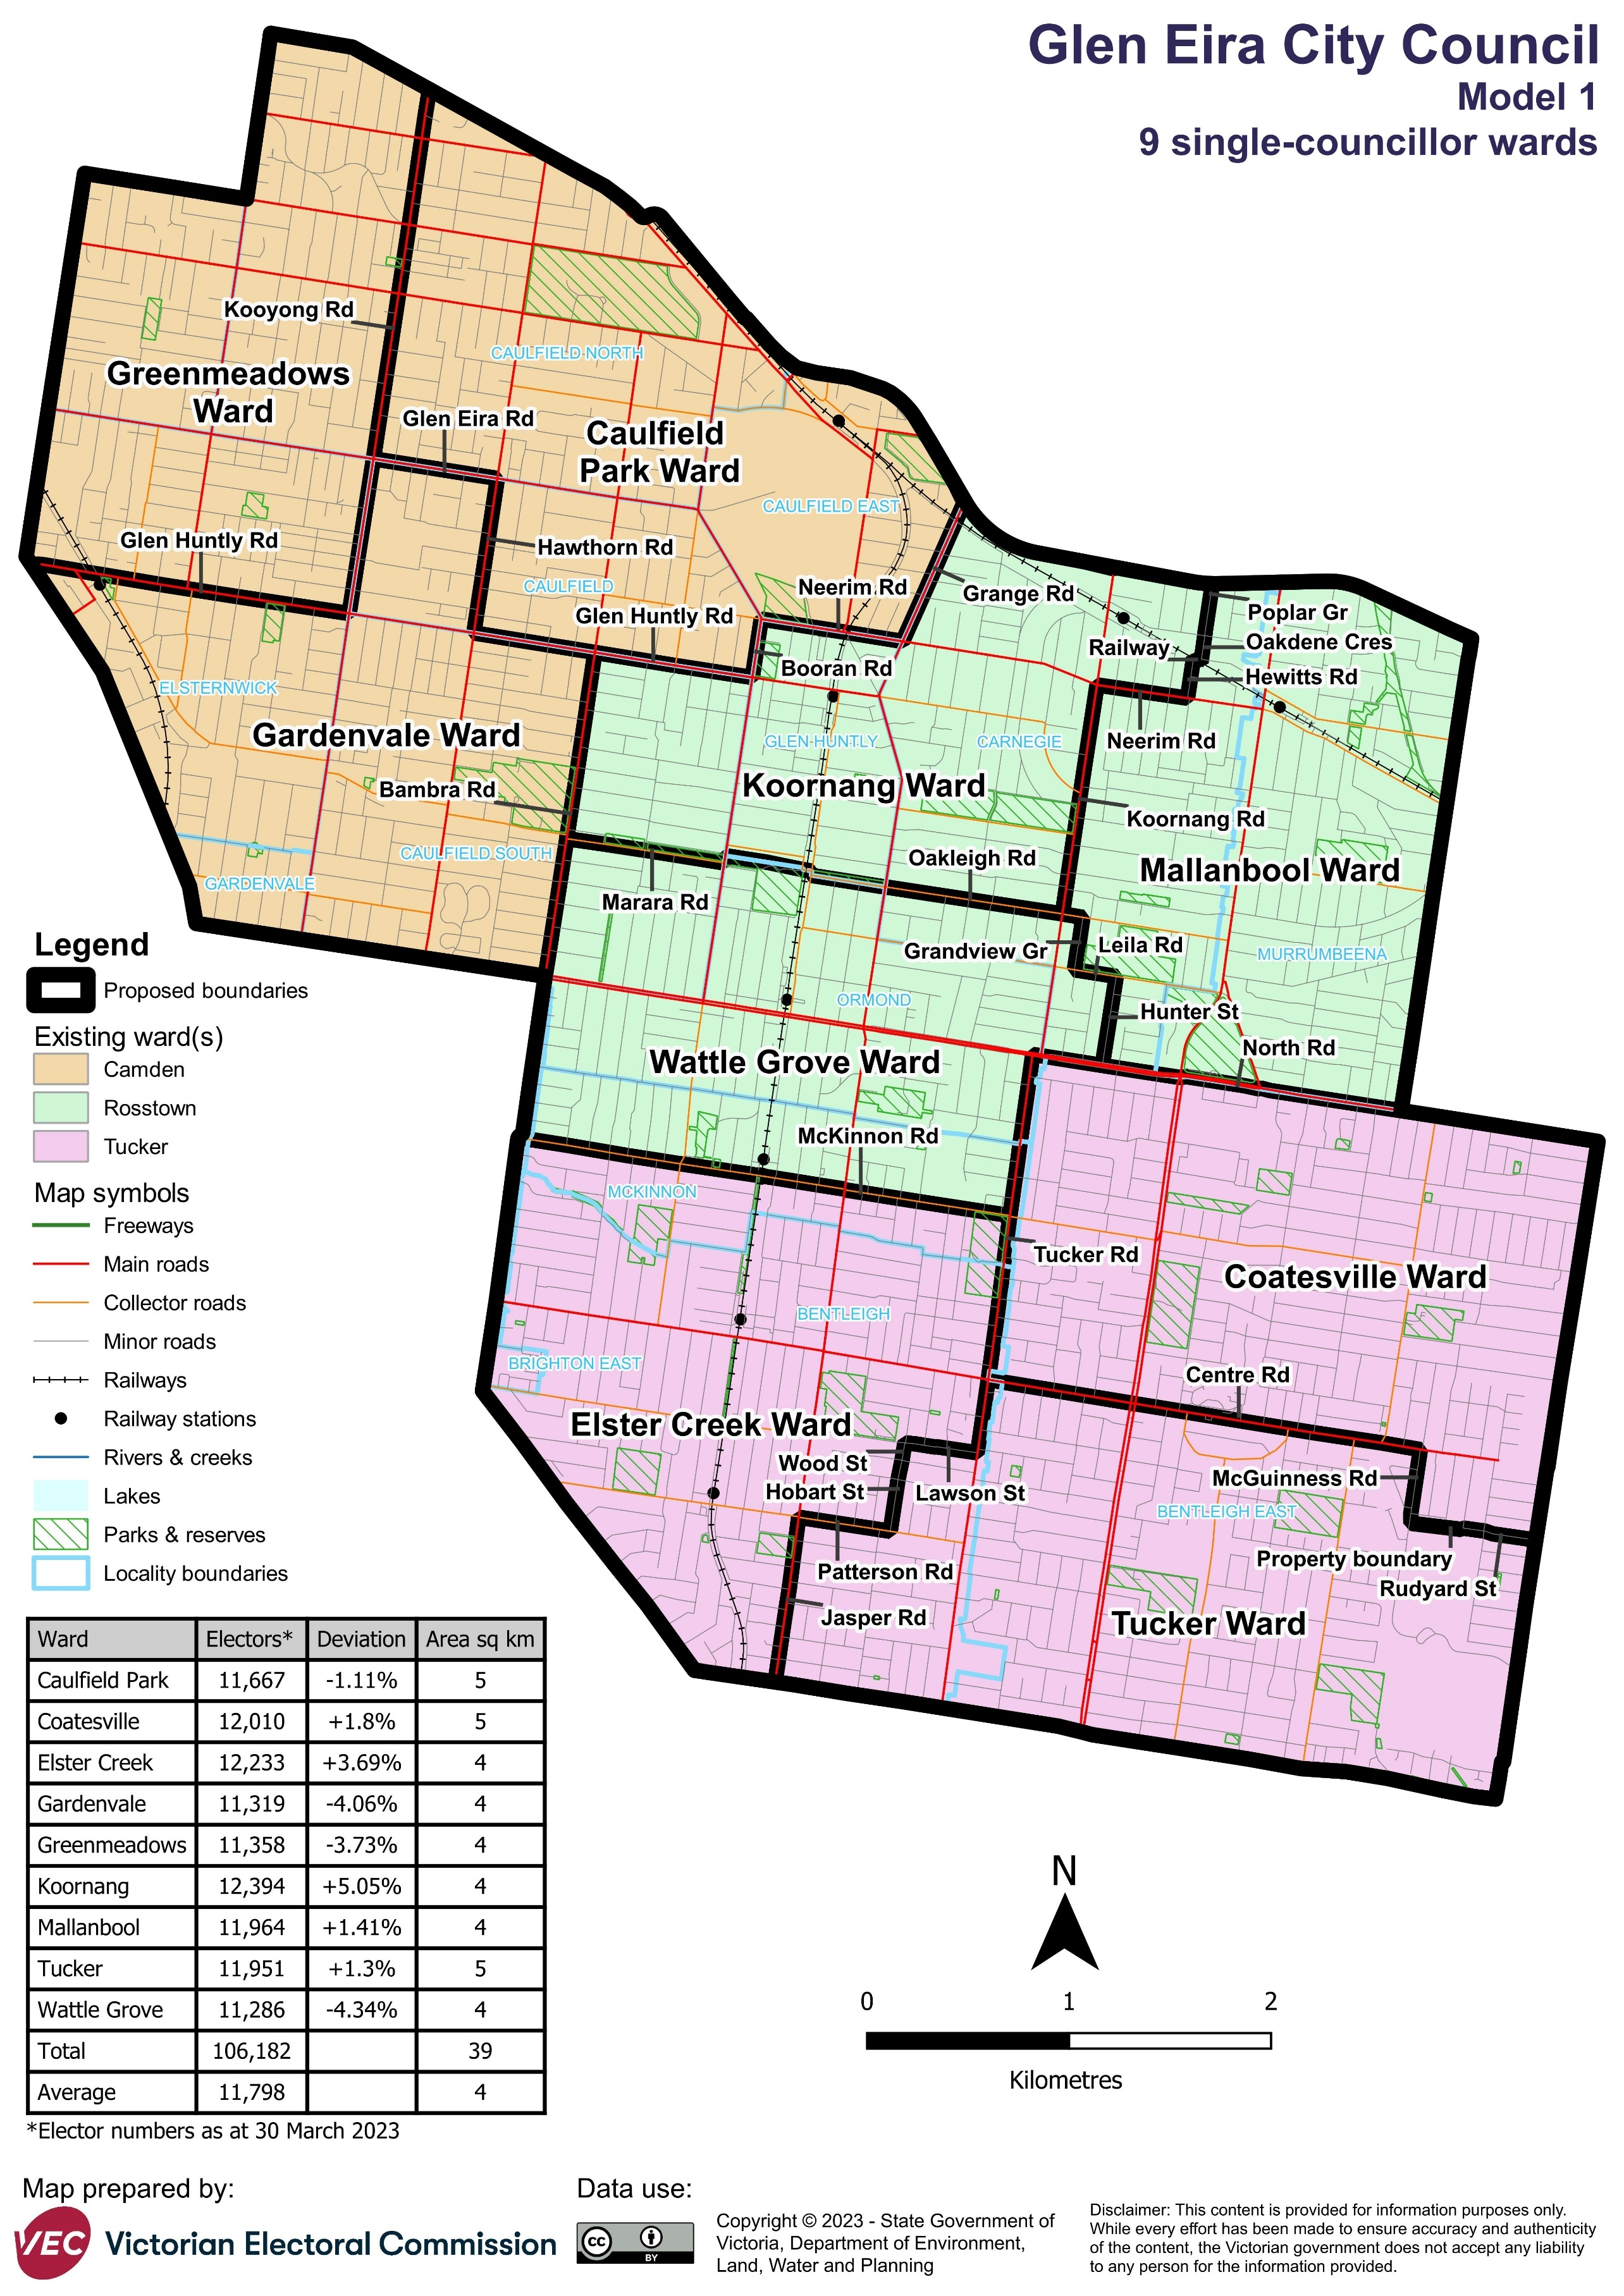

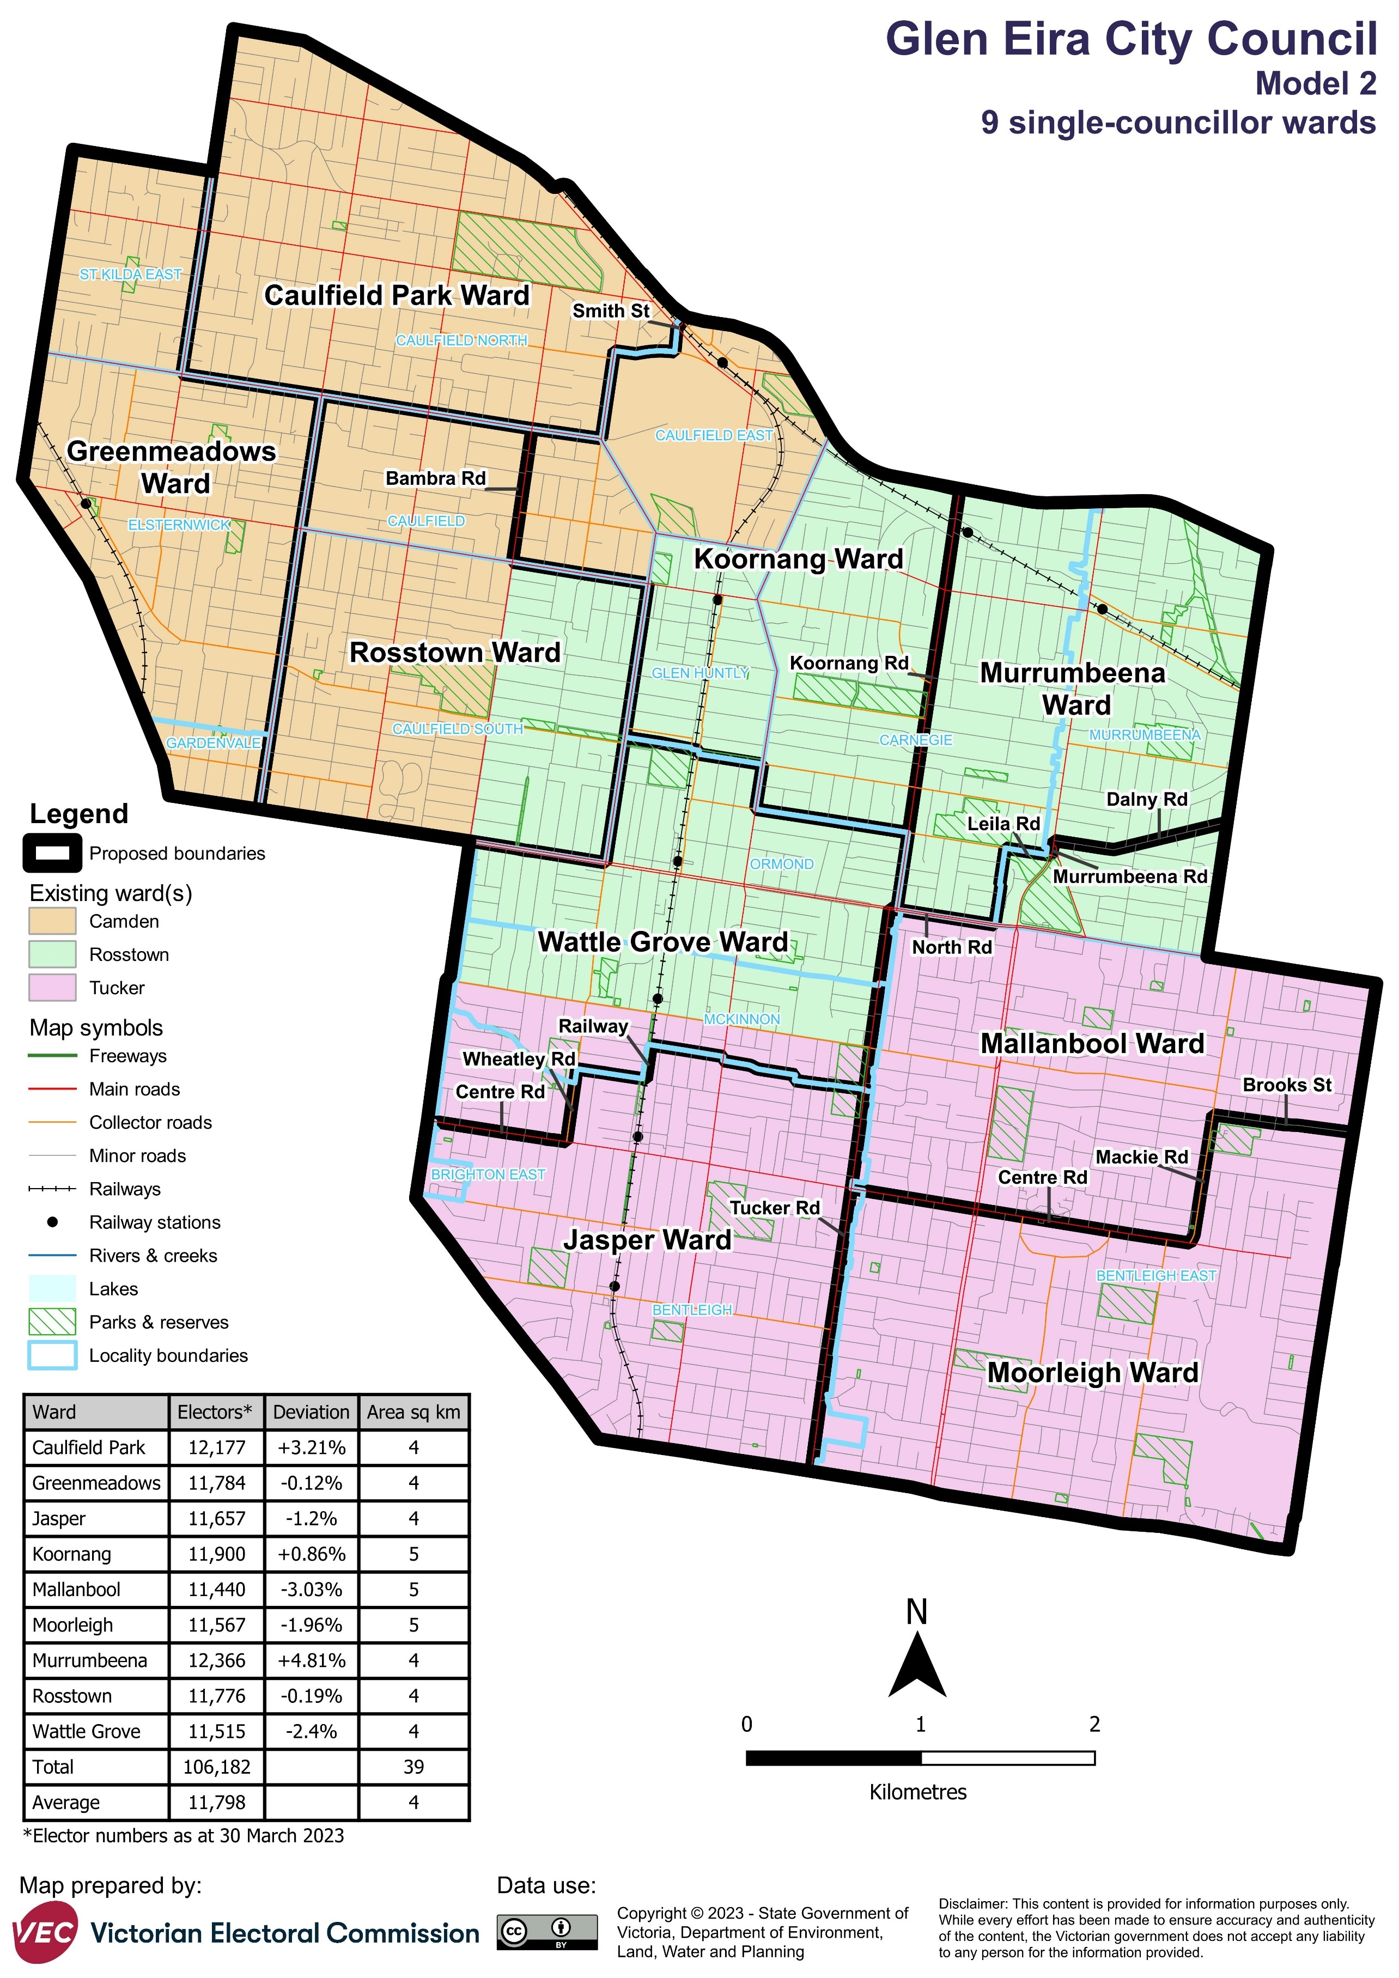

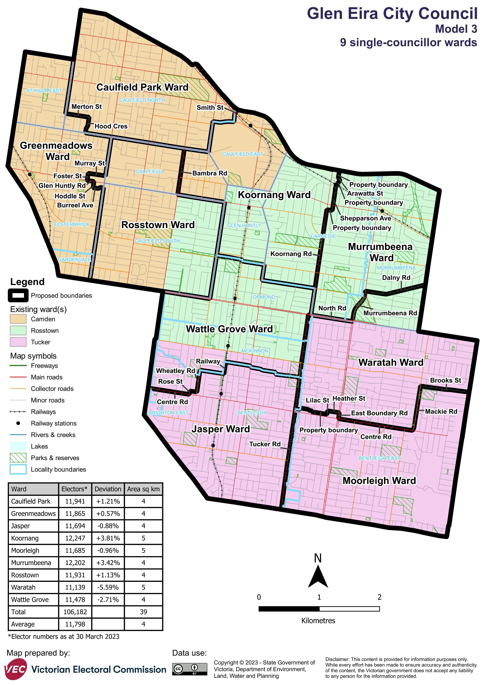

Forecast information referred to in the text of this report is based on forecasts prepared by .id – informed decisions [id.com.au](http://id.com.au/) .id and its licensors are the sole and exclusive owners of all rights, title and interest subsisting in that part of the report content where .id are identified. Some of .id content is a derivative of ABS Data, which can be accessed from the website of the Australian Bureau of Statistics at [abs.gov.au](http://abs.gov.au/), and licensed on terms published on the ABS website.