July 2023

Stonnington City Council

Local council electoral structure review

Preliminary   
Report

Acknowledgement of Country

The electoral representation advisory panel acknowledges the Wurundjeri and Bunurong peoples as the Traditional Custodians of the lands and waters for which it is holding this review and pays respects to ancestors and Elders past, present and emerging. The panel acknowledges their custodianship for many thousands of years and their continuing living culture.

Document history and version control

|  |  |  |  |
| --- | --- | --- | --- |
| **Version** | **Date approved** | **Submission approved by** | **Brief description** |
| 1 | 14 July 2023 | Strategic Advisor, Enrolment | Final version for publication |

Contents

Executive summary 4

Developing electoral structure models 4

Electoral structure models 4

Next steps 4

Background 6

About the 2023–24 electoral structure reviews 6

The electoral representation advisory panel 6

Public engagement 6

Developing recommendations 7

About Stonnington City Council 11

Profile 11

Current number of councillors and electoral structure 12

Last electoral structure review 12

Preliminary findings and models 14

Number of councillors 14

Electoral structure 15

Models for public feedback 19

Ward names 19

Next steps 20

Response submissions 20

Public hearing 21

Final report 21

References 22

Appendix 1: Model maps 23

# Executive summary

An independent electoral structure review panel appointed by the Minister for Local Government is reviewing the electoral structure of Stonnington City Council.

The purpose of the review is to advise the Minister on the appropriate number of councillors and electoral structure, including ward names, for the council.

Under Victoria’s *Local Government Act 2020* (the Act), Stonnington City Council must now have a single-councillor ward electoral structure.

The panel is looking at:

* + the appropriate number of councillors and wards for the council
  + the location of ward boundaries
  + appropriate ward names.

This report outlines the preliminary models the panel is presenting for public consultation, for the proposed new electoral structure of Stonnington City Council to meet the requirements of the Act.

More information about the background to the review is available on page 6.

## Developing electoral structure models

The panel considered a range of factors when deciding on the models in this report, including:

* + research and analysis
  + voter growth or decline over time.

More information on the way the panel decided on the models is available on page 7.

## Electoral structure models

After considering research and the requirements of the Act, the panel is presenting the following electoral structure models for public consultation:

* Model 1: a subdivided electoral structure with a total of 9 councillors – 9 wards with one councillor per ward.
* Model 2: a subdivided electoral structure with a total of 9 councillors – 9 wards with one councillor per ward, with different ward boundaries than Model 1.
* Model 3: a subdivided electoral structure with a total of 9 councillors – 9 wards with one councillor per ward, with different ward boundaries than Model 1 and 2.

Details on these models, including maps, are available in Appendix 1.

## Next steps

The panel is now seeking feedback on the preliminary electoral structure models. You can make a response submission to the preliminary models until 5 pm Wednesday 9 August. If any response submitters wish to speak at a public hearing, the panel will hold an online public hearing on Tuesday 15 August. Following this, the panel will present its final recommendation to the Minister on Wednesday 13 September 2023.

More information about the review process is available on the Victorian Electoral Commission (VEC) website at [vec.vic.gov.au](https://www.vec.vic.gov.au)

# Background

## About the 2023–24 electoral structure reviews

In October 2022, the Minister for Local Government formed 2 electoral representation advisory panels to review and provide advice on the electoral structures of 39 local councils, under section 16 of the Act. If the Minister accepts the electoral structure recommended by the panel, any changes will take effect at the October 2024 local council elections.

The Act introduced several changes to local government representation, including the types of electoral structures local councils may have. All metropolitan, interface and regional city councils (including Stonnington City Council) must now have single-councillor ward electoral structures.

For Stonnington City Council, the electoral representation advisory panel is examining:

* the number of councillors and wards
  + where the ward boundaries should be
  + the name of each ward.

The Act requires electoral structures to provide fair and equitable representation and facilitate good governance. Each ward must have an approximately equal number of voters per councillor (within +/-10% of the average). While conducting the review, the panel also notes the role of a councillor as specified under section 28 of the Act.

## The electoral representation advisory panel

The panel conducting the electoral structure review of Stonnington City Council has 3 members:

* Ms Julie Eisenbise (Chairperson)
* Mr Tim Presnell
* Acting Electoral Commissioner Ms Dana Fleming.

The purpose of the review is to advise the Minister on the appropriate number of councillors and electoral structure, including ward names, for the council. The panel is independent of councils and the Victorian State government.

Under the Act, the VEC is not responsible for reviewing council electoral structures but must provide administrative and technical support to the panel. The Electoral Commissioner (or their delegate) must be a member of each panel.

## Public engagement

### Public information program

On behalf of the panel, the VEC has conducted a public information and awareness program to inform the public about the Stonnington City Council electoral structure review. This has included:

* + printed public notices in state-wide newspapers
  + public information sessions to outline the review process and respond to questions from the community
  + media releases to announce the start of the review
  + information on social media channels
  + notified voters in the council area who are subscribed to the VEC’s [VoterAlert](https://vec.vic.gov.au/voteralert) service of the release of the preliminary report and opening of response submissions
  + updated website content on [vec.vic.gov.au](https://www.vec.vic.gov.au/), including:
    - current information on the review process
    - submission guide and fact sheets for each council under review with background information.

The VEC will continue to promote the review on behalf of the panel during the response submission stage via media releases, the VEC’s social media channels and the VEC website.

### Public consultation

The panel now invites input to the electoral structure review of Stonnington City Council via:

* + response submissions to this preliminary report
  + an online public hearing for anyone who makes a response submission to speak to the panel and expand on their submission.

Public submissions are an important part of the review process and are considered alongside other factors addressed during the review. These are outlined below.

## Developing recommendations

The electoral structure models the panel is presenting in this preliminary report comply with the Act and were developed through careful consideration of:

* + research and analysis conducted by the VEC support team, including geospatial and demographic data
  + rates or patterns of population and voter change over time, and relevant forecasts of growth or decline based on forecast information provided by .id (informed decisions, a company specialising in demographics and forecasting).

### Deciding on the number of councillors

The Act allows local councils to have between 5 and 12 councillors, but neither the Act nor the Local Government (Electoral) Regulations 2020 specify how the number of councillors is to be determined. Therefore, the models put forward by the panel in this report are guided by the Act’s intention for fairness and equity in voter representation.

In examining the appropriate number of councillors for Stonnington City Council, the panel considered the following criteria:

* + the population and number of voters in the council area, compared to other councils with a similar population size and number of voters in the same category (for example, other comparable metropolitan, interface or regional city councils)
  + patterns of population change and voter growth or decline in the council area over time
  + the current and past numbers of councillors
  + the representation needs of the communities of interest in the council area.

The panel’s final recommendation will also consider any matters raised in public response submissions not already listed above.

Local councils with a larger number of voters will often have more councillors. Large populations generally have greater diversity, both in the type and number of communities of interest and issues relating to representation. However, the ideal number of councillors can also be influenced by the circumstances of each council, such as the:

* + nature and complexity of services the council provides
  + geographic size and topography of the area
  + forecast population and voter growth or decline
  + social diversity.

### Deciding the electoral structure

Under the Act, regional city, metropolitan and interface councils must now have single-councillor ward electoral structures.

When developing single-councillor ward models for Stonnington City Council, the panel considered these criteria:

* + whether the structure would comply with section 15(2) of the Act (see below), and for how long it would likely comply
  + the appropriate number of councillors, as outlined above
  + whether meaningful and effective ward boundaries could be established and whether these would be easily identifiable to local communities
  + the representation of communities of interest
  + the voter distribution and physical features of the area, and the impact these may have on the shape and size of wards
  + past elections for the council, including:
    - numbers of candidates nominating
    - incidences of uncontested elections
    - rates of informal voting.
  + other matters raised in public submissions not already listed above.

Under section 15(2) of the Act, subdivided structures must aim for an approximately equal number of voters per councillor in each ward. This means the number of voters represented by each councillor in a ward should be within +/-10% of the average number of voters per councillor for all wards.

During this review, the panel aims to recommend a structure that will comply with section 15(2) at the time of the 2024 local council elections and, if possible, also comply based on voter numbers at the time the review is conducted. The panel uses forecasts of population and voter change to assess compliance at the 2024 elections with as much accuracy as possible. In some cases, population change and other factors impacting voter numbers mean it is not possible to create compliant subdivided structures based both on voter numbers that were current at the time of the review and forecast voter numbers. In these instances, the panel prioritises compliance at the 2024 local government elections to ensure each vote will have approximately equal value at the 2024 election.

One of the factors that may impact compliance with section 15(2) is the number of current and forecast voters with ratepayer-based voting entitlements, also known as council-enrolled electors. Voters’ rolls include both state-enrolled electors (the majority of the roll) and a smaller number of council-enrolled electors. The Act introduced changes to ratepayer-based entitlement categories, which come into full effect at the 2024 local council elections. The panel will take this change to the makeup of voters’ rolls, and therefore compliance with section 15(2) of the Act, into consideration during this review.

### Deciding on ward names

The panel has taken the following approach to naming wards.

1. Retaining existing ward names if these are still relevant to the area covered by the ward.
2. When a new name is required, the panel bases this on features such as:
   * + places (registered under the *Geographic Place Names Act 1998*) in the ward
     + compass directions
     + native flora or fauna.

### Use of Aboriginal language

The panel recognises that there should first be meaningful consultation with local Aboriginal communities and groups before a ward is named using Aboriginal language. Meaningful consultation is a significant process that the panel is not able to undertake within the timeframes of the current review program.

The panel also recognises that many of the place names in current use across Victoria are based on Aboriginal language. As such, the panel may put forward new ward names using Aboriginal language if:

* it is the name of a place within a ward
* it is currently in common use

and

* the name is registered under the *Geographic Place Names Act 1998*.

Unregistered names using Aboriginal language have not been put forward by the panel as new ward names. While the panel supports the adoption of names based on Aboriginal language, this requires appropriate consultation.

Accordingly, for the panel to consider an Aboriginal language ward name that is suggested in a public submission to the review, the name submitted needs to comply with the above guidelines.

# About Stonnington City Council

## Profile

Stonnington City Council covers an area of 26 km2 and is in inner eastern Melbourne, about 5 to 10 km from the city centre. It is bordered by the City of Melbourne in the west, Boroondara and Yarra City councils in the north, Monash City Council in the east, and Glen Eira and Port Phillip City councils in the south. The Traditional Custodians of the Stonnington area are the Wurundjeri and Bunurong peoples.

**Landscape**

Stonnington City Council has many distinct and culturally important localities. In the west of the council, South Yarra, Prahran, and Windsor centre broadly around the Chapel Street commercial and cultural precinct, with the former the site of significant high-rise development. The council’s centre consists of the affluent suburbs of Armadale, Kooyong, Malvern, and Toorak. Glen Iris and Malvern East make up the eastern part of the council.

The Yarra River and Gardiners Creek form most of the council’s northern boundary, with surrounding parklands providing major natural geographic features. Other parks within the council’s boundaries include Victoria Gardens, Malvern Public Gardens, Central Park, Hedgeley Dene Gardens, and Princes Gardens.

Stonnington City Council is well serviced by public transport, with connections to the Sandringham, Glen Waverley, Frankston, Cranbourne, and Pakenham railway lines, as well as numerous tram services, which run down most main roads in the council area. The Monash Freeway runs across the council’s northern boundary, connecting the eastern suburbs with the Melbourne city centre, and is one of the busiest roads in the state.

**Community**

At the 2021 census, the council’s population was 104,703 (ABS 2022c). In 2016, it was 103,832 and in 2011 it was 93,145 (ABS 2011, 2016). It is projected to undergo a modest increase of 1% per year to reach about 111,110 by 2028. The median age of residents is 37, the same as for Greater Melbourne (ABS 2022b, 2022d).

Of the population, 63.9% were born in Australia, and 73.1% speak only English at home. This is higher than the 59.9% and 61.1% respective rates for Greater Melbourne (ABS 2022a, ABS 2022b). The percentage of Aboriginal and Torres Strait Islander identifying people in Stonnington City Council at the 2021 census was 0.3%, less than half the 0.7% who live in Greater Melbourne (ABS 2022a, ABS 2022b).

At 15.9%, the largest employment category by economic output is construction. Other major employment sectors include professional, scientific and technical services (14.7%), rental, hiring and real estate services (14.1%), health care and social assistance (9.5%), and retail trade (9.4%) (.id 2023a).

Home ownership, at 52.4%, is lower than the Greater Melbourne rate of 66.8% (owned outright and with a mortgage), while the proportion of households renting is significantly higher (44.9% compared with 30.2%) (ABS 2022a, ABS 2022b).

The weekly median household income is $2,210, which is over $300 more than the median for Greater Melbourne (ABS 2022a, ABS 2022b). Stonnington City Council is one of the most socioeconomically advantaged councils in Victoria, with more than 1 in 3 households classed as high income (.id 2023b). Despite this advantage, small areas of extreme disadvantage exist, particularly around the large public housing complexes found in South Yarra and Prahran.

## Current number of councillors and electoral structure

Stonnington City Council is currently divided into 3 wards with a total of 9 councillors:

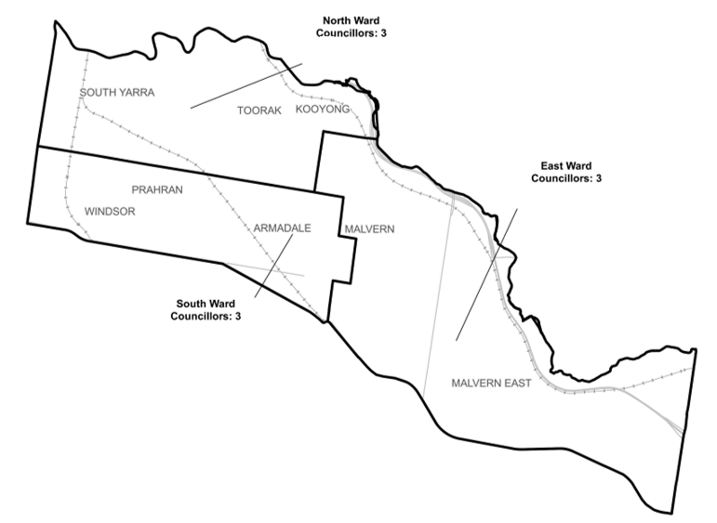

**Figure 1:** Diagram of current electoral structure of Stonnington City Council.

There are approximately 86,821 voters in Stonnington City Council, with an approximate ratio of 9,646 voters per councillor.

Visit the VEC website at [vec.vic.gov.au](https://www.vec.vic.gov.au/electoral-boundaries/local-councils/stonnington-city-council) for more information on Stonnington City Council.

## Last electoral structure review

The VEC conducted an electoral representation review of Stonnington City Council in 2011. This review was carried out under the *Local Government Act 1989* (Vic), which was replaced by the *Local Government Act 2020* (Vic).

After conducting the review, the VEC recommended that Stonnington City Council continue to consist of 9 councillors elected from 3 wards (3 wards with 3 councillors in each)

### Subdivision review

Since the 2011 representation review, the VEC also conducted a subdivision review of Stonnington City Council in 2020.

Subdivision reviews conducted under the *Local Government Act 1989* (Vic) adjusted the internal ward boundaries of a council but did not change the electoral structure or number of councillors. Subdivision reviews were conducted in situations where the voter-to-councillor ratios in one or more wards of a council were forecast to move outside the legislated +/-10% tolerance before the council’s next election and aimed to ensure voter-to-councillor ratios for all wards were within tolerance at the election.

The 2020 review of Stonnington City Council aimed to return the North and East wards to within the permitted +/-10% tolerance before the 2020 local council elections. Visit the Stonnington City Council [profile page](https://www.vec.vic.gov.au/electoral-boundaries/local-councils/stonnington-city-council) on the VEC website to access a copy of the 2020 subdivision review final report.

# Preliminary findings and models

## Number of councillors

After taking into consideration the requirements of the Act and the agreed criteria, the panel found 9 councillors to be an appropriate number for Stonnington City Council.

The panel considered the characteristics of Stonnington City Council in relation to similar metropolitan councils, including its population, the number and distribution of voters, and the size and geography of the council.

|  |  |  |  |  |  |  |
| --- | --- | --- | --- | --- | --- | --- |
| Similar metropolitan councils to Stonnington City Council | | | | | | |
| Local council | Area (km2) | Number of voters at 2020 election | Population (2021 Census) | Current total estimate of voters | Number of councillors | Number of voters per councillor |
| Port Phillip City* | 21 | 88,268 | 101,942 | 97,755 | 9 | 10,861 |
| Banyule City | 63 | 95,510 | 126,236 | 95,151 | 9 | 10,572 |
| Moonee Valley City* | 43 | 93,923 | 121,851 | 93,530 | 9 | 10,392 |
| Manningham City | 113 | 87,255 | 124,700 | 87,278 | 9 | 9,698 |
| Stonnington City* | 26 | 89,600 | 104,703 | 86,821 | 9 | 9,646 |
| Maroondah City | 61 | 85,275 | 115,043 | 85,033 | 9 | 9,448 |
| Yarra City* | 20 | 78,793 | 90,114 | 83,253 | 9 | 9,250 |
| Bayside City | 37 | 76,020 | 101,306 | 76,043 | 7 | 10,863 |
| Hobsons Bay City | 64 | 68,321 | 91,322 | 67,693 | 7 | 9,670 |

*These local councils are undergoing an electoral structure review during 2023–24.

### Maintaining 9 councillors

Stonnington City Council currently has 86,821 voters represented by 9 councillors and covers an area of 26 km2. Other inner city metropolitan councils with a similar number of voters and social profile usually also have 9 councillors, such as Yarra City Council and Port Phillip City Council. As forecasts indicate only modest population change is expected for the council, and 9 councillors is consistent with other inner-city councils, the panel considers it appropriate for the total number of councillors to remain at 9.

## Electoral structure

To identify the most appropriate electoral structure, various factors were considered. This included the requirements of the Act, the communities of interest in Stonnington City Council, the appropriateness of ward boundaries and which models best offered fair and equitable representation and consequently facilitate good governance.

In developing the preliminary models presented in this report, the panel considered a range of models. The strongest 3 models have been put forward for further public comment.

The panel proposes 3 models for the consideration of the Stonnington City Council community:

* a subdivided electoral structure of 9 single-councillor wards (Model 1)
* a subdivided electoral structure of 9 single-councillor wards, with different ward boundaries to Model 1 (Model 2)
* a subdivided electoral structure of 9 single-councillor wards, with different ward boundaries to Models 1 and 2 (Model 3).

Diagrams of the preliminary models are included in Appendix 1.

### A single-councillor ward structure with 9 councillors (Model 1)

Under this model, Stonnington City Council would adopt a 9-ward structure. Each ward would be represented by one councillor, in line with the requirements of the Act.

The approach in developing this model was to keep localities together as much as possible while using main roads as recognisable boundaries. This was not always possible given an uneven voter distribution across the council and the requirement to keep each ward within a +/-10% voter count of each other ward. South Yarra in particular has a large concentration of high-rise residential development, posing a considerable challenge in modelling sensible ward boundaries.

The western part of the council is covered by 3 wards: Como Ward, Greville Ward and Princes Gardens Ward:

* Como Ward includes the northern half of South Yarra, the most densely populated area within the council, and a small part of Toorak.
* Greville Ward and Princes Gardens Ward are divided by Chapel, High and Hornby streets. They share the southern half of South Yarra and parts of Windsor and Prahran, with the latter ward capturing the public housing high-rise units found around Little Chapel Street and Malvern Road.

Together these wards share the representation of the large commercial area centred around Chapel Street, and the heavy concentration of high-rise buildings found in the South Yarra area. These wards try to use main roads as boundaries, particularly along Chapel Street, Toorak Road, and Williams Road, occasionally needing to deviate from these main roads to adhere to the +/-10% requirement.

The middle of the council is covered by 3 wards: Toorak, Orrong and Kooyong wards:

* Toorak Ward focuses on the suburb of Toorak, capturing most of it by using Kooyong and Malvern roads as the eastern and southern boundaries. The northern boundary follows minor roads.
* Orrong Ward captures half of Prahran and Armadale and is centred around Orrong Road and High Street. It uses Kooyong, Williams, and Malvern roads as recognisable boundaries.
* Kooyong Ward captures the entirety of Kooyong, as well as half of Malvern and Armadale, and a small part of Toorak. It is centred around Glenferrie Road, but also incorporates parts of the Malvern Road and High Street commercial strips and uses Kooyong Road and High Street to form recognisable boundaries.

The eastern part of the council is captured in 3 wards:

* Wattletree Ward is centred around Wattletree and Tooronga roads and captures the section of Malvern south of High Street, as well as parts of Malvern East, Armadale, and Glen Iris. It uses High Street and Burke Road as recognisable boundaries.
* Hedgeley Dene Ward captures parts of Glen Iris and Malvern East using Glen Waverley Road, Tooronga Road, and Burke Road as solid borders.
* Malvern Valley Ward covers the remaining eastern part of the council, including the Chadstone shopping precinct. It is made up entirely of Malvern East, using parts of Darling Road and Waverley Road as identifiable western boundaries.

### A single-councillor ward structure with 9 councillors (alternative version) (Model 2)

Under this model, Stonnington City Council would adopt a 9-ward structure. Each ward would be represented by one councillor, in line with the requirements of the Act.

This model takes guidance from the current electoral structure, attempting to divide each of the current wards into 3 single-councillor wards and effecting the least amount of change to the current boundaries. This is largely achieved through the adoption of Malvern Road currently separating North Ward and South Ward, and with minor variations to the boundaries dividing South Ward and East Ward. Unlike in Model 1, the large public housing complexes found in Prahran and South Yarra are captured in two wards (Darling and Greville).

The main benefit of Model 2 is that it more closely resembles the current structure, which might make it more familiar to voters. A potential drawback might be that simply dividing the current wards into 3 does not provide fair and equitable representation.

The current North Ward is split into 3 wards, all north of Commercial and Malvern roads:

* Darling and Como wards capture most of South Yarra. Much like Model 1, these wards provide and share representation for the considerable commercial and cultural precincts around Chapel Street using it as a strong boundary between the two.
* Toorak Ward then centres on the suburb of Toorak, while also capturing small parts of Kooyong and Malvern. It largely centres around the main arterial of Toorak Road.

The current South Ward is split into 3 wards, to the south of Commercial and Malvern roads:

* Greville Ward captures Windsor and about half of Prahran, providing representation for the Chapel Street commercial precinct south of Commercial Road.
* Orrong Ward captures the remainder of Windsor and Prahran, with part of Armadale, using the Frankston/Cranbourne/Pakenham railway line and Sutherland Road as an eastern boundary.
* Wattletree Ward captures most of Armadale, half of Malvern and small parts of Glen Iris and Malvern East. It centres around Wattletree Road, Glenferrie Road and High Street shopping strips, while using Tooronga Road, Malvern Road, and High Street west of Glenferrie Road as recognisable boundaries

The eastern part of the council is then made up of 3 wards, essentially splitting the current East Ward into 3.

* Tooronga Ward captures Kooyong, a small part of Glen Iris and about half of Malvern, centring on Tooronga Road and the Malvern Road retail strip. Kooyong Road and High Street are used as strong, identifiable boundaries.
* Hedgeley Dene Ward takes in about a third of Malvern East, with a small part of Glen Iris and Malvern also captured. It centres on Wattletree Road and Burke Road, while using Waverley Road, Darling Road, High Street and Tooronga Road as major boundaries.
* Malvern Valley Ward, which is almost the same as in Model 1, and takes in the remainder of Malvern East centred around Waverley Road. It also includes the Chadstone shopping precinct.

### A single-councillor ward structure with 9 councillors (alternative version) (Model 3)

Under this model, Stonnington City Council would adopt a 9-ward structure. Each ward would be represented by one councillor, in line with the requirements of the Act.

Model 3 takes the approach of keeping certain major roads in the centre of each ward and avoiding using major roads as boundaries where possible. The panel considered the benefit of this approach was that major commercial strips would be contained in one ward as whole communities of interest, instead of being split on each side of the road, with an awareness that major roads can often unite communities rather than divide them. This approach worked better in the centre and east of the council and is achieved, for the most part, along Orrong Road, Glenferrie Road, Tooronga Road, and Burke Road. To adhere to the +/-10% requirement, the Chapel Street precinct is divided into two wards, with Darling Ward in the north, and Chapel Ward in the south.

Centring wards on major roads means the use of smaller, less recognisable roads as boundaries, which may be considered a drawback. Additionally, splitting the commercial precincts that run along major roads, as occurs in Model 1 and 2, may be of benefit to these communities with the prospect of being able to appeal and receive representation from 2 councillors instead of one.

The western part of the council is covered broadly by 5 wards:

* Darling and Chapel Wards are centred around the Chapel Street commercial precinct, with Darling Ward in the north capturing more of the South Yarra area north of Argo and Fitzgerald streets, while Chapel Ward in the south captures more of the Prahran and Windsor area, including all the South Yarra and Prahran public housing units as in Model 1.
* Como Ward captures the rest of South Yarra, with some of Toorak and Prahran, and is largely centred around Williams Road, as well as the Prahran commercial strip on Malvern Road.
* Orrong Ward centres around Orrong Road and takes in about two-thirds of Toorak, including the Toorak Road commercial precinct, with parts of Armadale and Prahran also captured.
* Lumley Gardens Ward then centres around Williams Street south of Murray Street, and captures about a third each of Prahran, Armadale, and Windsor, including the Armadale commercial precinct south of High Street and west of Kooyong Road.

The 3 middle wards all centre on major roads, and their commercial precincts, capturing each centred road north to south within the council:

* Glenferrie Ward centres on Glenferrie Road, Tooronga Ward centres on Tooronga Road, and Burke Ward centres on Burke Road. These wards capture the suburbs of Kooyong, Armadale, Malvern, the remainder of Toorak, and part of Malvern East.

The final ward is Malvern Valley Ward, which captures the remainder of Malvern East including the Chadstone shopping precinct. It differs from Model 1 and 2 by using MacGregor Street and Ash Grove as part of its western boundary.

### Summary

In summary, introducing single-councillor wards represents a large electoral change for Stonnington City Council. Achieving models that divide communities into appropriate wards while also accounting for population growth and ensuring they comply with the +/-10% requirement can be challenging.

Each model presented in this report attempts to achieve appropriate wards in a different way. Model 1 tries to use main roads as boundaries and, where possible, keep localities grouped together. Model 2 attempts to use the current ward structure and divide each current ward into 3. Model 3 looks to focus the centre of wards on major roads and commercial strips, using minor roads as boundaries more often. All models have advantages and drawbacks and will appeal to different interests. The panel now welcomes public feedback on the 3 models presented in this report.

## Models for public feedback

The panel considers all models outlined below to be the single-councillor ward electoral structures with the best potential to offer fair and equitable representation for voters in Stonnington City Council and consequently facilitate good governance. Please see Appendix 1 for detailed maps of these models.

### Model 1

Stonnington City Council has 9 councillors and is divided into 9 wards with one councillor per ward.

Ward names: Como Ward, Greville Ward, Hedgeley Dene Ward, Kooyong Ward, Malvern Valley Ward, Princes Gardens Ward, Orrong Ward, Toorak Ward, Wattletree Ward.

### Model 2

Stonnington City Council has 9 councillors and is divided into 9 wards with one councillor per ward.

Ward names: Como Ward, Darling Ward, Greville Ward, Hedgeley Dene Ward, Malvern Valley Ward, Orrong Ward, Toorak Ward, Tooronga Ward, Wattletree Ward.

### Model 3

Stonnington City Council has 9 councillors and is divided into 9 wards with one councillor per ward.

Ward names: Burke Ward, Chapel Ward, Como Ward, Darling Ward, Glenferrie Ward, Lumley Gardens Ward, Malvern Valley Ward, Orrong Ward, Tooronga Ward.

## Ward names

The panel has suggested ward names to identify the wards in each model and invites comments from the community on these names as part of submissions responding to the preliminary report. The basis of the ward name recommendations for each model are described below.

All ward names are new and are based on natural features, built features, or localities found within each ward.

The panel will review ward name suggestions received during the response submission stage when forming the final advice to the Minister for Local Government on the electoral structure of the council. Suggested ward names should comply with the panel’s approach to naming wards (see Deciding on ward names and Use of Aboriginal language). All ward name suggestions received during the response submission stage will be provided to the Minister for consideration at the conclusion of the electoral structure review.

# Next steps

## Response submissions

Any person or group, including the local council under review, can make a response submission to the electoral representation advisory panel. In your submission you should address the models proposed by the panel in this preliminary report.

You can make a submission:

|  |  |
| --- | --- |
|  | **Online** Visit [vec.vic.gov.au](http://vec.vic.gov.au/" \o "The VEC website homepage) to make a submission online.  You will need to make an account to use the online Public Submission Tool and can save a draft submission to finish later. |
|  | **By email** [Stonnington.ERAPSubmissions@vec.vic.gov.au](mailto:Stonnington.ERAPSubmissions@vec.vic.gov.au) |
|  | **By post**  Electoral Representation Advisory Panel c/o Victorian Electoral Commission Level 11, 530 Collins St Melbourne VIC 3000 |

The panel must receive all response submissions before 5 pm on Wednesday 9 August 2023. If you post your submission, make sure it has enough time to reach the panel before the deadline. Late submissions will not be accepted.

### Required information

For your submission to be considered, you must include your:

* full name
* contact phone number or email address
* postal or residential address.

To protect the integrity and transparency of the review process, the panel will not consider submissions without this information. If you are submitting as a group or organisation, you must include the name of a nominated contact person who is authorised to submit on behalf of your group.

On behalf of the panel, the VEC will handle information provided by submitters in accordance with the privacy policy available at [vec.vic.gov.au/privacy](http://vec.vic.gov.au/privacy)

### Public access to submissions

To ensure transparency in the electoral structure review process, your submission will be published on the VEC website at [vec.vic.gov.au](http://www.vec.vic.gov.au/). The VEC will remove your signature and contact details, including residential and postal addresses, from all public copies but must publish your full name (or group name) and locality (suburb or town).

Please note that any submission content that is potentially defamatory, offensive, obscene or that includes the personal information of people or organisations who are not a party to the submission may also be redacted before publication.

## Public hearing

If you make a response submission, you can also ask to speak at an online public hearing to support your submission and expand on your views.

The online public hearing is scheduled for:

Time: 10 am

Date: Tuesday 15 August 2023

The panel encourages participation in the public hearing. If you wish to speak at the public hearing, you **must** indicate this in your response submission. The public hearing will not be held if there are no requests to speak.

Anyone can attend a public hearing, but you will only be able to speak if you asked to in your response submission. If you ask to speak, the VEC will contact you to arrange a time for you to speak at the hearing. You will have 10 minutes to address the public hearing panel, which will include at least 2 of the review panel members. The members of the public hearing panel may ask you questions.

Visit the VEC website at [vec.vic.gov.au](http://vec.vic.gov.au/) for more information on public hearings.

## Final report

Following the public hearing, the review panel will consider all evidence gathered and prepare a final report for the Minister for Local Government containing a recommendation for the number of councillors and the electoral structure for the local council.

The final report is scheduled to be provided to the Minister on Wednesday 13 September 2023. The Minister will consider the final reports, including any determination to make the reports publicly available. Any change to the electoral structure of Stonnington City Council following on from this review is expected to apply at the October 2024 local council elections. Under the Act, the final council electoral structure will be set by an Order in Council published in the Victoria Government Gazette.

# References

.id (2023a) [*Stonnington City Council, Industry sector of employment*](https://profile.id.com.au/stonnington/industries), .id website, accessed 3 July 2023.

—— (2023b) [*Stonnington City Council, SEIFA by Local Government Area*](https://profile.id.com.au/stonnington/seifa-disadvantage)*,* .id website, accessed 3 July 2023.

ABS (Australian Bureau of Statistics) (2022a) [*2021 Census All Person Quickstats, Stonnington*](https://abs.gov.au/census/find-census-data/quickstats/2021/LGA26350)*,* ABS website, accessed 28 June 2023.

—— (2022b) [*2021 Census All Person Quickstats, Greater Melbourne*](https://abs.gov.au/census/find-census-data/quickstats/2021/2GMEL)*,* ABS website, accessed 28 June 2023.

—— (2016) [*2016 Census All Person Quickstats, Stonnington*](https://abs.gov.au/census/find-census-data/quickstats/2016/LGA26350)*,* ABS website, accessed 28 June 2023.  
—— (2011) [*2011 Census All Person Quickstats, Stonnington*](https://abs.gov.au/census/find-census-data/quickstats/2016/LGA26350)*,* ABS website, accessed 28 June 2023.

Geographic Place Names Act 1998 (Vic)

Local Government Act 1989 (Vic)

Local Government Act 2020 (Vic)

Local Government (Electoral) Regulations 2020 (Vic)

# Appendix 1: Model maps

The following maps are included in this report:

|  |  |
| --- | --- |
| Map | Page |
| Model 1 – a single-councillor ward structure with 9 councillors – 9 wards with one councillor per ward. | 24 |
| Model 2 – a single-councillor ward structure with 9 councillors – 9 wards with one councillor per ward (with boundaries different to Model 1). | 25 |
| Model 3 – a single-councillor ward structure with 9 councillors – 9 wards with one councillor per ward (with boundaries different to Model 1 and Model 2). | 26 |

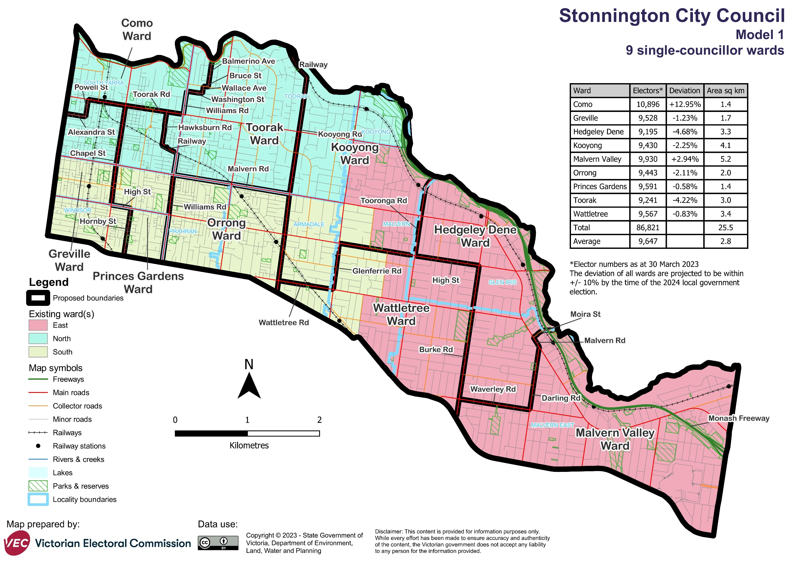

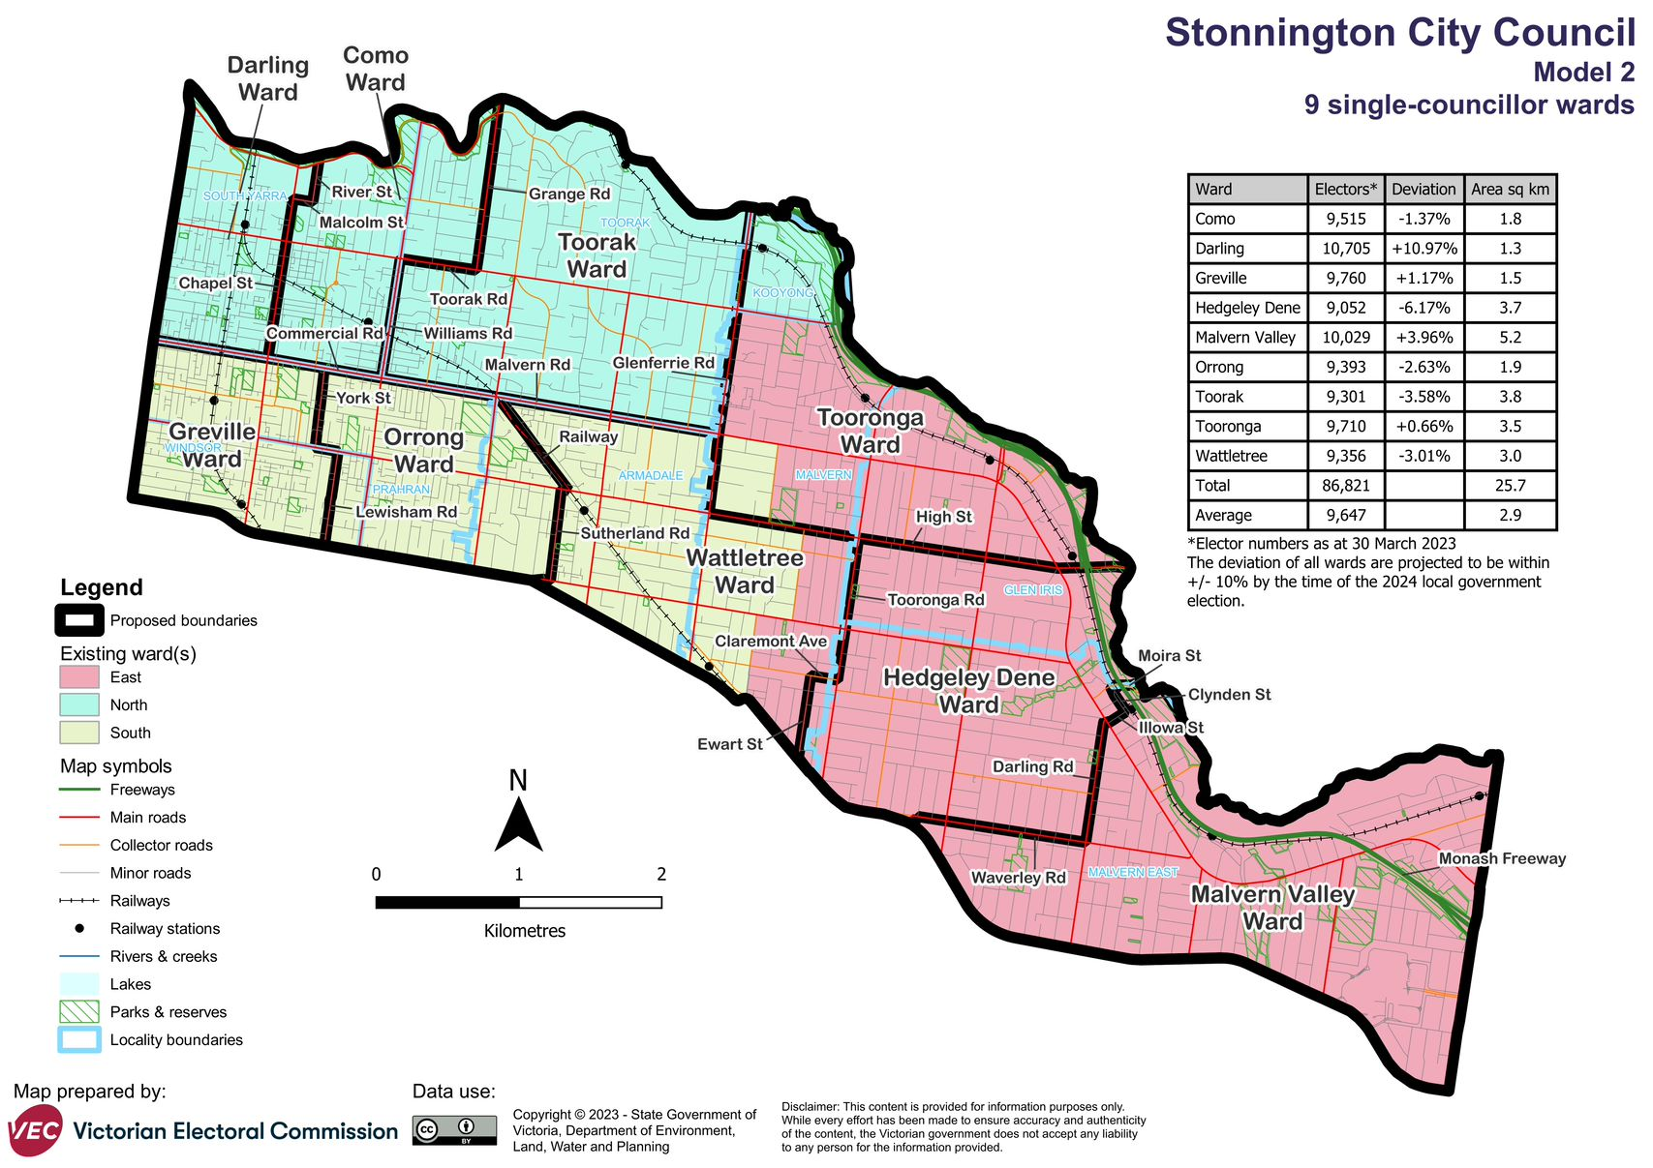

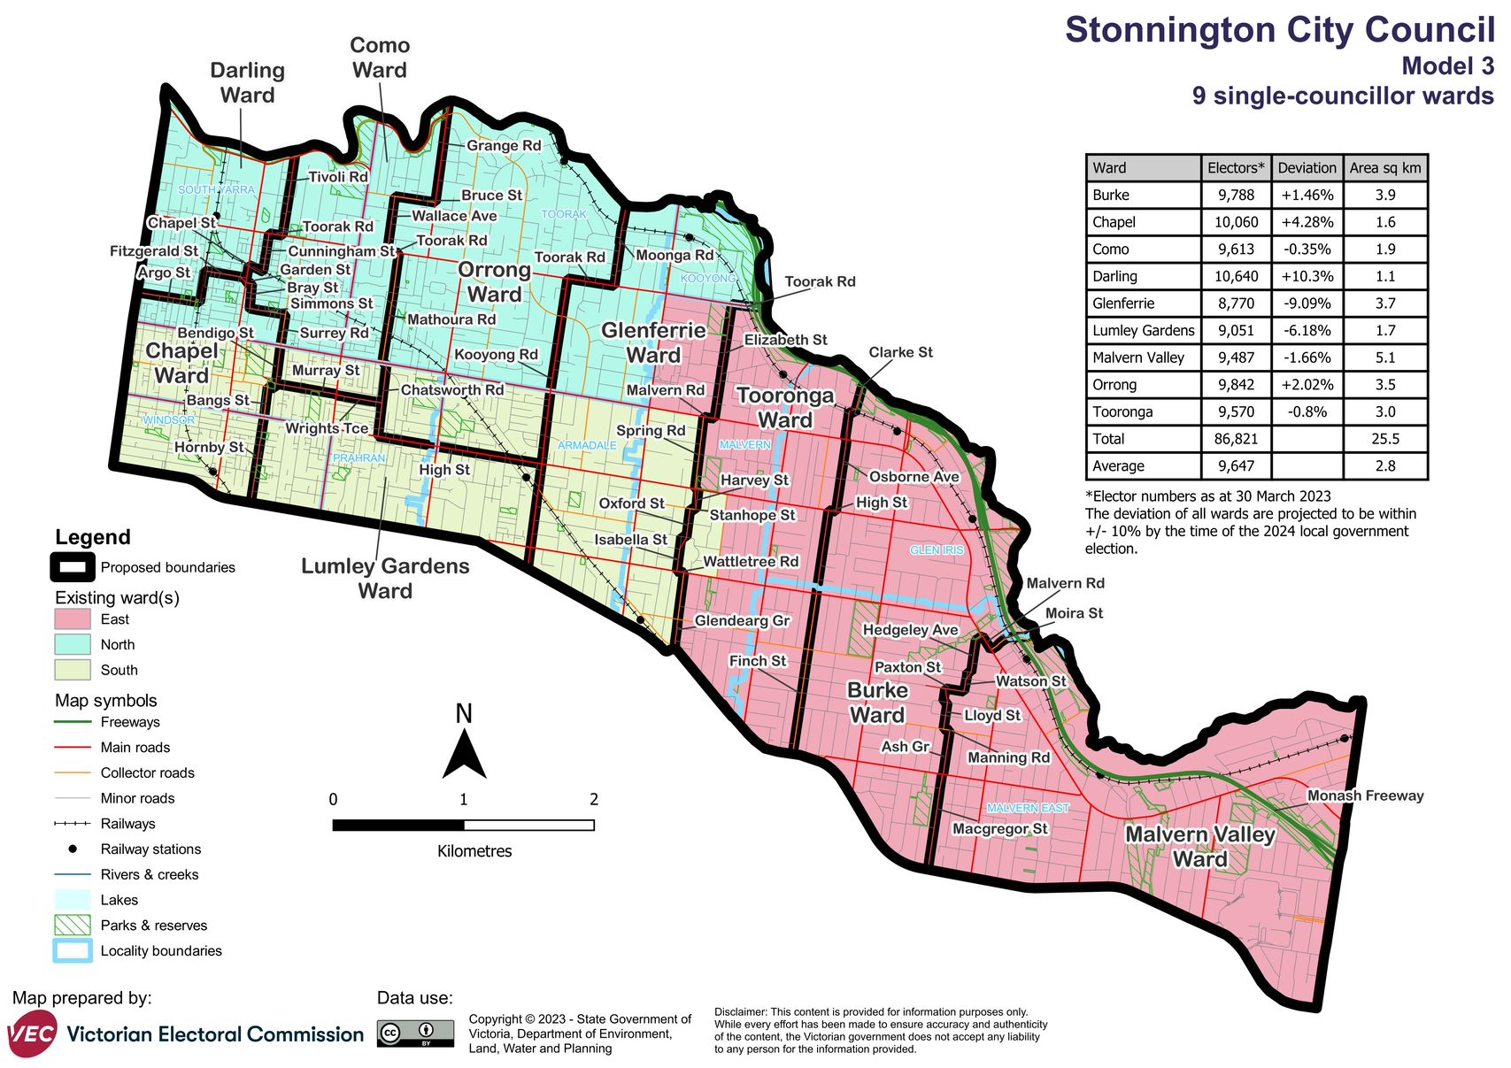

Forecast information referred to in the text of this report is based on forecasts prepared by .id – informed decisions [id.com.au](http://id.com.au/) .id and its licensors are the sole and exclusive owners of all rights, title and interest subsisting in that part of the report content where .id are identified. Some of .id content is a derivative of ABS Data, which can be accessed from the website of the Australian Bureau of Statistics at [abs.gov.au](http://abs.gov.au/), and licensed on terms published on the ABS website.