Local council electoral structure review

## About the review

Under Victoria’s *Local Government Act 2020*, Greater Geelong City Council must now have a single-councillor ward electoral structure.

The Minister for Local Government has appointed an electoral representation advisory panel to conduct an electoral structure review of the council. The panel will advise the Minister on the most appropriate single-councillor ward structure for Greater Geelong City Council.

The panel is looking at:

* the appropriate number of councillors and wards
* the location of ward boundaries
* appropriate ward names.

Electoral structure reviews are an important part of democracy, and your input is valuable. As a local, you know your local council area better than anyone. This is your chance to let the panel know your thoughts about the single-councillor ward electoral structure that you believe would best provide representation for your community.

There are 2 opportunities for you to have your say on the electoral structure of the council:

1. in a response submission to the preliminary report
2. in an online public hearing, if you request to speak in your response submission.

About Greater Geelong City Council

The Traditional Custodians of the land in Greater Geelong City Council are the Wadawurrung People.

Greater Geelong City Council is about 70 km south-west of central Melbourne. Covering an area of 1,248 km2 it is home to 271,057 people. It is the most populated of Victoria’s regional cities and is the third most populated local council in the state. It has a fast-growing population and is forecast to reach about 400,000 people by 2041.

Greater Geelong has a history of industrial manufacturing and has Victoria’s second largest seaport and airport.

Geelong is the main town, with a population of about 180,000 people. Other large settlements in the council area are Ocean Grove, Barwon Heads, Drysdale, Clifton Springs, Lara and Leopold. The overall rural population is about 9,000 people.

Prominent natural features of the council area include the Bellarine Peninsula, the Brisbane Ranges National Park, the You Yangs Regional Park, and the Barwon River.

The median age in the council is 39. This is slightly younger than the median of 43 years for regional Victoria but similar to the overall Victorian median of 38. The median weekly household income is $1,592, compared to $1,386 for regional Victoria and $1,759 for Victoria overall. The proportion of the population who identify as Aboriginal and/or Torres Strait Islander peoples is 1.3%, slightly higher than for Victoria overall (1%).

## Current structure

Greater Geelong City Council is divided into 4 wards with a total of 11 councillors:

* one ward with 2 councillors
* 3 wards with 3 councillors each

## Last review

The VEC conducted an electoral representation review of Greater Geelong City Council in 2015–16.

Visit the VEC website at [vec.vic.gov.au](https://www.vec.vic.gov.au/) to access a copy of the 2015–16 review final report.

Review process

Monday 3 and Tuesday 4 July

### Information sessions

Session 1: 12 noon, Monday 3 July

Session 2: 6 pm, Tuesday 4 July

Information sessions are for anyone wanting to find out more about the review process. Links to register for an information session will be available on the VEC website.

Wednesday 5 July

### Preliminary report

The panel will release a preliminary report including one or more options for the electoral structure on Wednesday 5 July.

**Response submissions open from this date.**

Wednesday 26 July

### Response submission close

The panel must receive all submissions by 5 pm on Wednesday 26 July.

Late submissions will not be accepted.

Tuesday 1 August

### Public hearing

The panel will hold an online public hearing if anyone requests to speak about their response submission at 10 am on Tuesday   
1 August.

The public hearing will not be held if there are no requests to speak.

Wednesday 30 August

### Final report

The panel will submit a final report to the Minister for Local Government, including its advice on the electoral structure, on Wednesday 30 August.

The Minister will then consider the panel’s advice before recommending a change to the electoral structure. Any change to the electoral structure of the council following the review is expected to apply at the next local council elections.

## Untitled-1How to make a submission

On the VEC website at [vec.vic.gov.au](http://vec.vic.gov.au/)

By email to

[GreaterGeelong.ERAPSubmissions  
@vec.vic.gov.au](mailto:GreaterGeelong.ERAPSubmissions@vec.vic.gov.au)

LetterBy post to

Electoral representation advisory panel  
c/o Victorian Electoral Commission  
Level 11, 530 Collins Street  
Melbourne VIC 3000

Submissions must include your:

* full name
* contact phone number or email address
* residential or postal address.

All submissions will be published on the VEC website. Your name and locality (suburb or town) will be published, but your full address and contact details will be removed. See the submission guide and VEC website at [vec.vic.gov.au/privacy](https://www.vec.vic.gov.au/privacy) for privacy information.

## Submission guide

Download the submission guide from the VEC website at [vec.vic.gov.au](http://vec.vic.gov.au/) for more information on the review process and making a submission.

## One vote, one value

The ‘one vote, one value’ democratic principle is enshrined in the *Local Government Act 2020*. This means that every person’s vote counts equally.

When a local council area is subdivided into wards, the number of voters each councillor represents in each ward must be within plus-or-minus 10% of the of the average number of voters per councillor for all the wards.

The map below includes the current number of voters in each ward and the ward’s current deviation from the average. The panel will consider likely population and voter changes to ensure the structure remains equitable.

If you make a submission online, you can use a mapping tool to build your preferred electoral structure. The tool uses current voter numbers to tell you the deviations of the wards you make. This will help you propose a structure that meets the requirements of the Act.

Current electoral structure

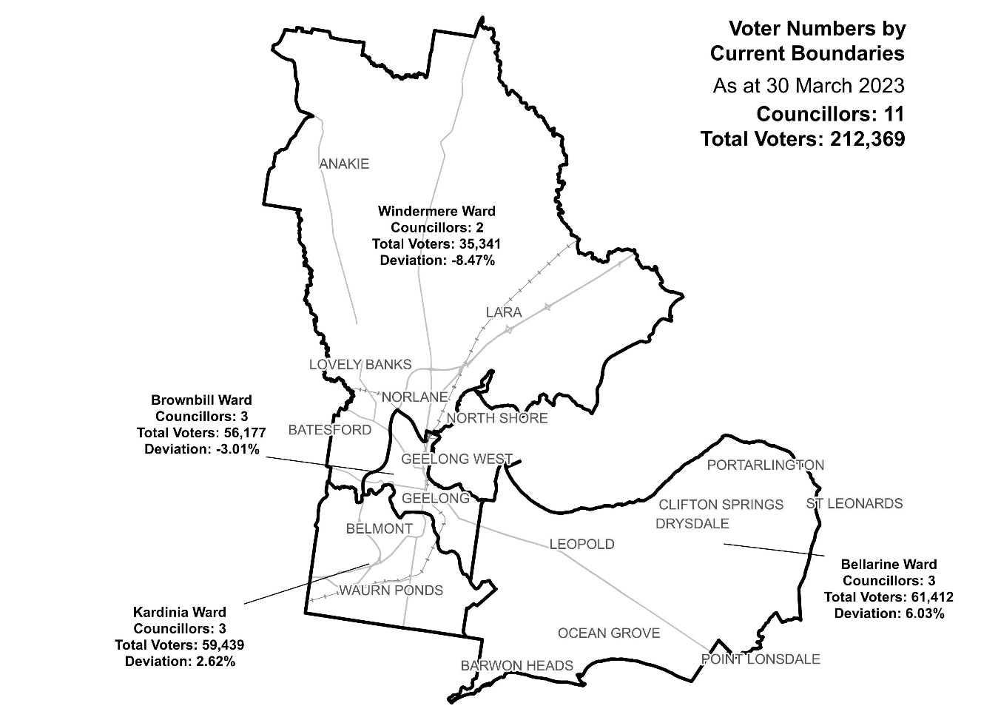

|  |  |  |  |
| --- | --- | --- | --- |
| Ward | Councillors | Voters | Deviation |
| Bellarine Ward | 3 | 61,412 | +6.03% |
| Brownbill Ward | 3 | 56,177 | -3.01% |
| Kardinia Ward | 3 | 59,439 | +2.62% |
| Windemere Ward | 2 | 35,341 | -8.47% |

## Statistics

Area (km2) 1,248 km2

Voters

### Voters per square km

170.2

### Average voters per councillor

19,306

Population

### Current population

271,057

### Forecast population growth

2.1% p.a.

Further census statistics available at [abs.gov.au](https://abs.gov.au)

Voter numbers by locality (map)

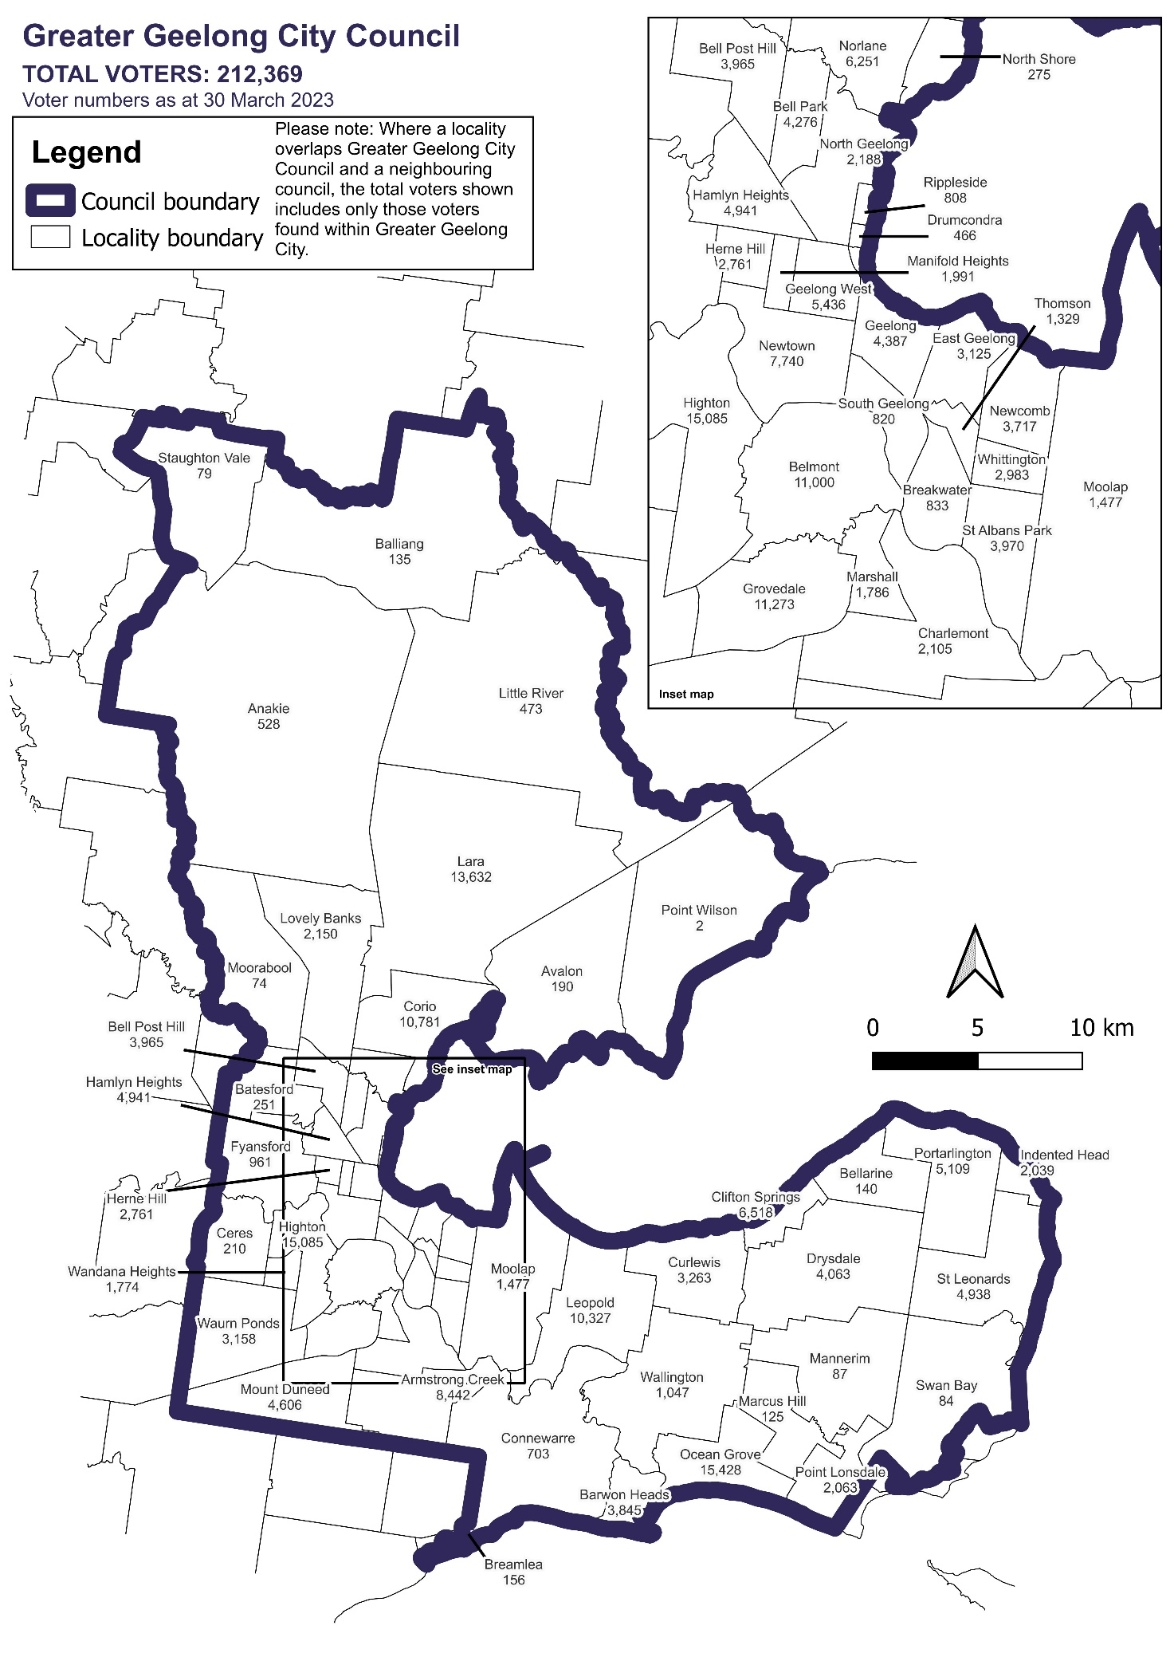

Voter numbers by locality (table)

## Greater Geelong City Council voter numbers at 30 March 2023

|  |  |
| --- | --- |
| Locality | Voters |
| Anakie | 528 |
| Armstrong Creek | 8,442 |
| Avalon | 190 |
| Balliang | 135 |
| Barwon Heads | 3,845 |
| Batesford | 251 |
| Bell Park | 4,276 |
| Bell Post Hill | 3,965 |
| Bellarine | 140 |
| Belmont | 11,000 |
| Breakwater | 833 |
| Breamlea | 156 |
| Ceres | 210 |
| Charlemont | 2,105 |
| Clifton Springs | 6,518 |
| Connewarre | 703 |
| Corio | 10,781 |
| Curlewis | 3,263 |
| Drumcondra | 466 |
| Drysdale | 4,063 |
| East Geelong | 3,125 |
| Fyansford | 961 |

|  |  |
| --- | --- |
| Locality | Voters |
| Geelong | 4,387 |
| Geelong West | 5,436 |
| Grovedale | 11,273 |
| Hamlyn Heights | 4,941 |
| Herne Hill | 2,761 |
| Highton | 15,085 |
| Indented Head | 2,039 |
| Lara | 13,632 |
| Leopold | 10,327 |
| Little River | 473 |
| Lovely Banks | 2,150 |
| Manifold Heights | 1,991 |
| Mannerim | 87 |
| Marcus Hill | 125 |
| Marshall | 1,786 |
| Moolap | 1,477 |
| Moorabool | 74 |
| Mount Duneed | 4,606 |
| Newcomb | 3,717 |
| Newtown | 7,740 |
| Norlane | 6,251 |
| North Geelong | 2,188 |

|  |  |
| --- | --- |
| Locality | Voters |
| North Shore | 275 |
| Ocean Grove | 15,428 |
| Point Lonsdale | 2,063 |
| Point Wilson | 2 |
| Portarlington | 5,109 |
| Rippleside | 808 |
| South Geelong | 820 |
| St Albans Park | 3,970 |
| St Leonards | 4,938 |
| Staughton Vale | 79 |
| Swan Bay | 84 |
| Thomson | 1,329 |
| Wallington | 1,047 |
| Wandana Heights | 1,774 |
| Waurn Ponds | 3,158 |
| Whittington | 2,983 |