Local council electoral structure review

## About the review

Under Victoria’s *Local Government Act 2020*, Horsham Rural City Council must now have a single-councillor ward electoral structure.

The Minister for Local Government has appointed an electoral representation advisory panel to conduct an electoral structure review of the council. The panel will advise the Minister on the most appropriate single-councillor ward structure for Horsham Rural City Council.

The panel is looking at:

* the appropriate number of councillors and wards
* the location of ward boundaries
* appropriate ward names.

Electoral structure reviews are an important part of democracy, and your input is valuable. As a local, you know your local council area better than anyone. This is your chance to let the panel know your thoughts about the single-councillor ward electoral structure that you believe would best provide representation for your community.

There are 2 opportunities for you to have your say on the electoral structure of the council:

1. in a response submission to the preliminary report
2. in an online public hearing, if you request to speak in your response submission.

About Horsham Rural City Council

The formally recognised Traditional Custodians of the land in Horsham Rural City Council are the Wotjobaluk, Wergaia, Jupagalk, Jaadwa and Jadawadjali peoples.

Horsham Rural City Council is in western Victoria, approximately 300 km north-west of Melbourne. It covers 4,267 km2 and is home to 20,429 people.

Nearly three quarters of the population live in the main town Horsham. Natimuk is the second largest town, with 421 people. Horsham Rural City Council also has about 25 small settlements with less than 200 residents.

Horsham township provides goods, services, arts and cultural activities to the wider region. It serves as an important centre for the surrounding agricultural communities.

About 70% of the area supports dryland broadacre cropping and 27% of the area is covered by native vegetation and waterways.

The main farm industries are cropping, sheep wool and meat production, wheat, barley, canola and lentils. Oats, chickpeas and other pulses are produced to a lesser extent.

Distinct natural features are Dyurrite (Mount Arapiles) and Burrunj (Black Range State Park), the Wimmera and Mackenzie rivers, Burnt Creek, and the Natimuk-Douglas Saline Wetland Depression.

The median age is 41 years old. The percentage of the population aged 20 to 54 years is lower than that for Victoria overall, and a greater percentage is aged 55 years and over. Australia is the country of birth for 87% of residents, compared to 65% for Victoria overall.

## Current structure

Horsham Rural City Council is unsubdivided with a total of 7 councillors.

## Last review

The VEC conducted an electoral representation review of Horsham Rural City Council in 2015.

Visit the VEC website at [vec.vic.gov.au](https://www.vec.vic.gov.au/) to access a copy of the 2015 review final report.

Review process

Monday 26 and Tuesday 27 June

### Information sessions

Session 1: 12 noon, Monday 26 June

Session 2: 6 pm, Tuesday 27 June

Information sessions are for anyone wanting to find out more about the review process. Links to register for an information session will be available on the VEC website.

Wednesday 28 June

### Preliminary report

The panel will release a preliminary report including one or more options for the electoral structure on Wednesday 28 June.

**Response submissions open from this date.**

Wednesday 19 July

### Response submission close

The panel must receive all submissions by 5 pm on Wednesday 19 July.

Late submissions will not be accepted.

Wednesday 26 July

### Public hearing

The panel will hold an online public hearing if anyone requests to speak about their response submission at 10 am on Wednesday 26 July.

The public hearing will not be held if there are no requests to speak.

Wednesday 23 August

### Final report

The panel will submit a final report to the Minister for Local Government, including its advice for the electoral structure, on Wednesday 23 August.

The Minister will then consider the panel’s advice before recommending a change to the electoral structure. Any change to the electoral structure of the council following the review is expected to apply at the next local council elections.

## Untitled-1How to make a submission

On the VEC website at [vec.vic.gov.au](http://vec.vic.gov.au/)

By email to

[Horsham.ERAPSubmissions@  
vec.vic.gov.au](mailto:Horsham.ERAPSubmissions@vec.vic.gov.au)

LetterBy post to

Electoral representation advisory panel  
c/o Victorian Electoral Commission  
Level 11, 530 Collins Street  
Melbourne VIC 3000

Submissions must include your:

* full name
* contact phone number or email address
* residential or postal address.

All submissions will be published on the VEC website. Your name and locality (suburb or town) will be published, but your full address and contact details will be removed. See the submission guide and VEC website at [vec.vic.gov.au/privacy](https://www.vec.vic.gov.au/privacy) for privacy information.

## Submission guide

Download the submission guide from the VEC website at [vec.vic.gov.au](http://vec.vic.gov.au/) for more information on the review process and making a submission.

## One vote, one value

The ‘one vote, one value’ democratic principle is enshrined in the *Local Government Act 2020*. This means that every person’s vote counts equally.

When a local council area is subdivided into wards, the number of voters each councillor represents in each ward must be within plus-or-minus 10% of the of the average number of voters per councillor for all the wards.

The map below includes the current number of voters in each ward and the ward’s current deviation from the average. The panel will consider likely population and voter changes to ensure the structure remains equitable.

If you make a submission online, you can use a mapping tool to build your preferred electoral structure. The tool uses current voter numbers to tell you the deviations of the wards you make. This will help you propose a structure that meets the requirements of the Act.

Current electoral structure

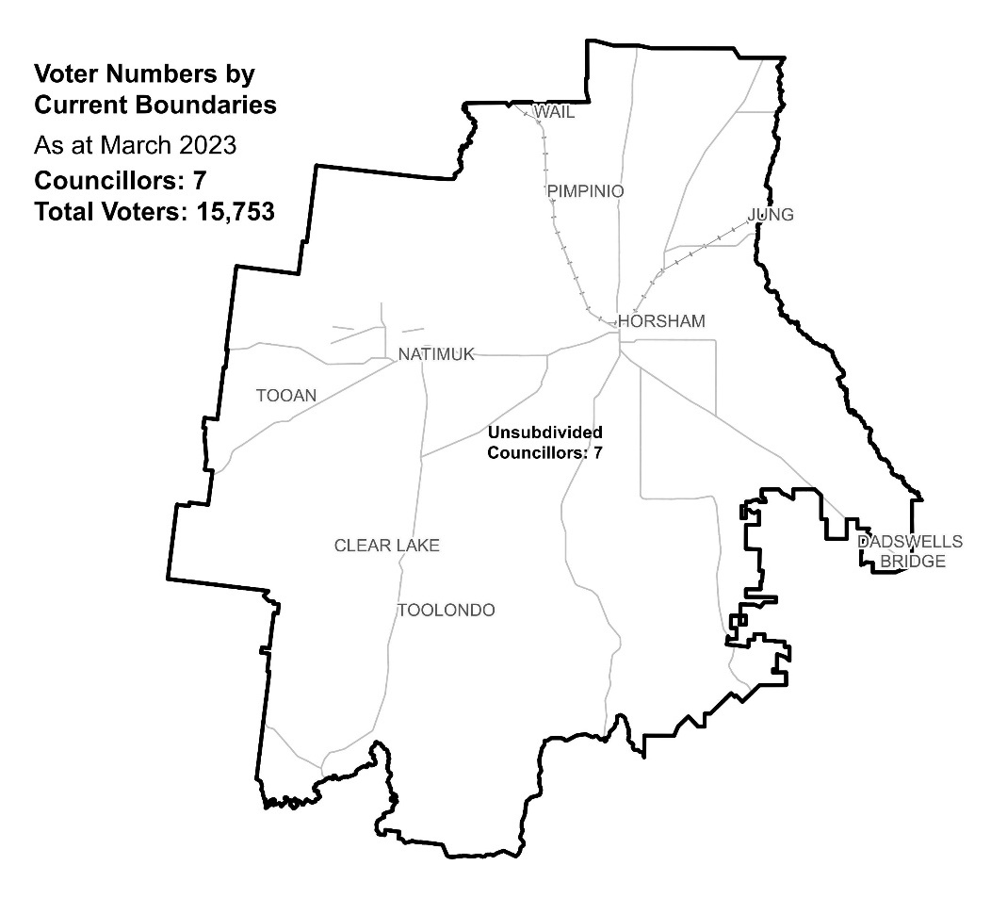

|  |  |  |  |
| --- | --- | --- | --- |
| Ward | Councillors | Voters | Deviation |
| Unsubdivided | 7 | 15,753 | n/a |

## Statistics

Area (km2) 4,267

Voters

### Voters per square km

3.7

### Average voters per councillor

2,250

Population

### Current population

20,429

### Forecast population growth

0.6% p.a.

Further census statistics available at [abs.gov.au](https://abs.gov.au)

Voter numbers by locality (map)

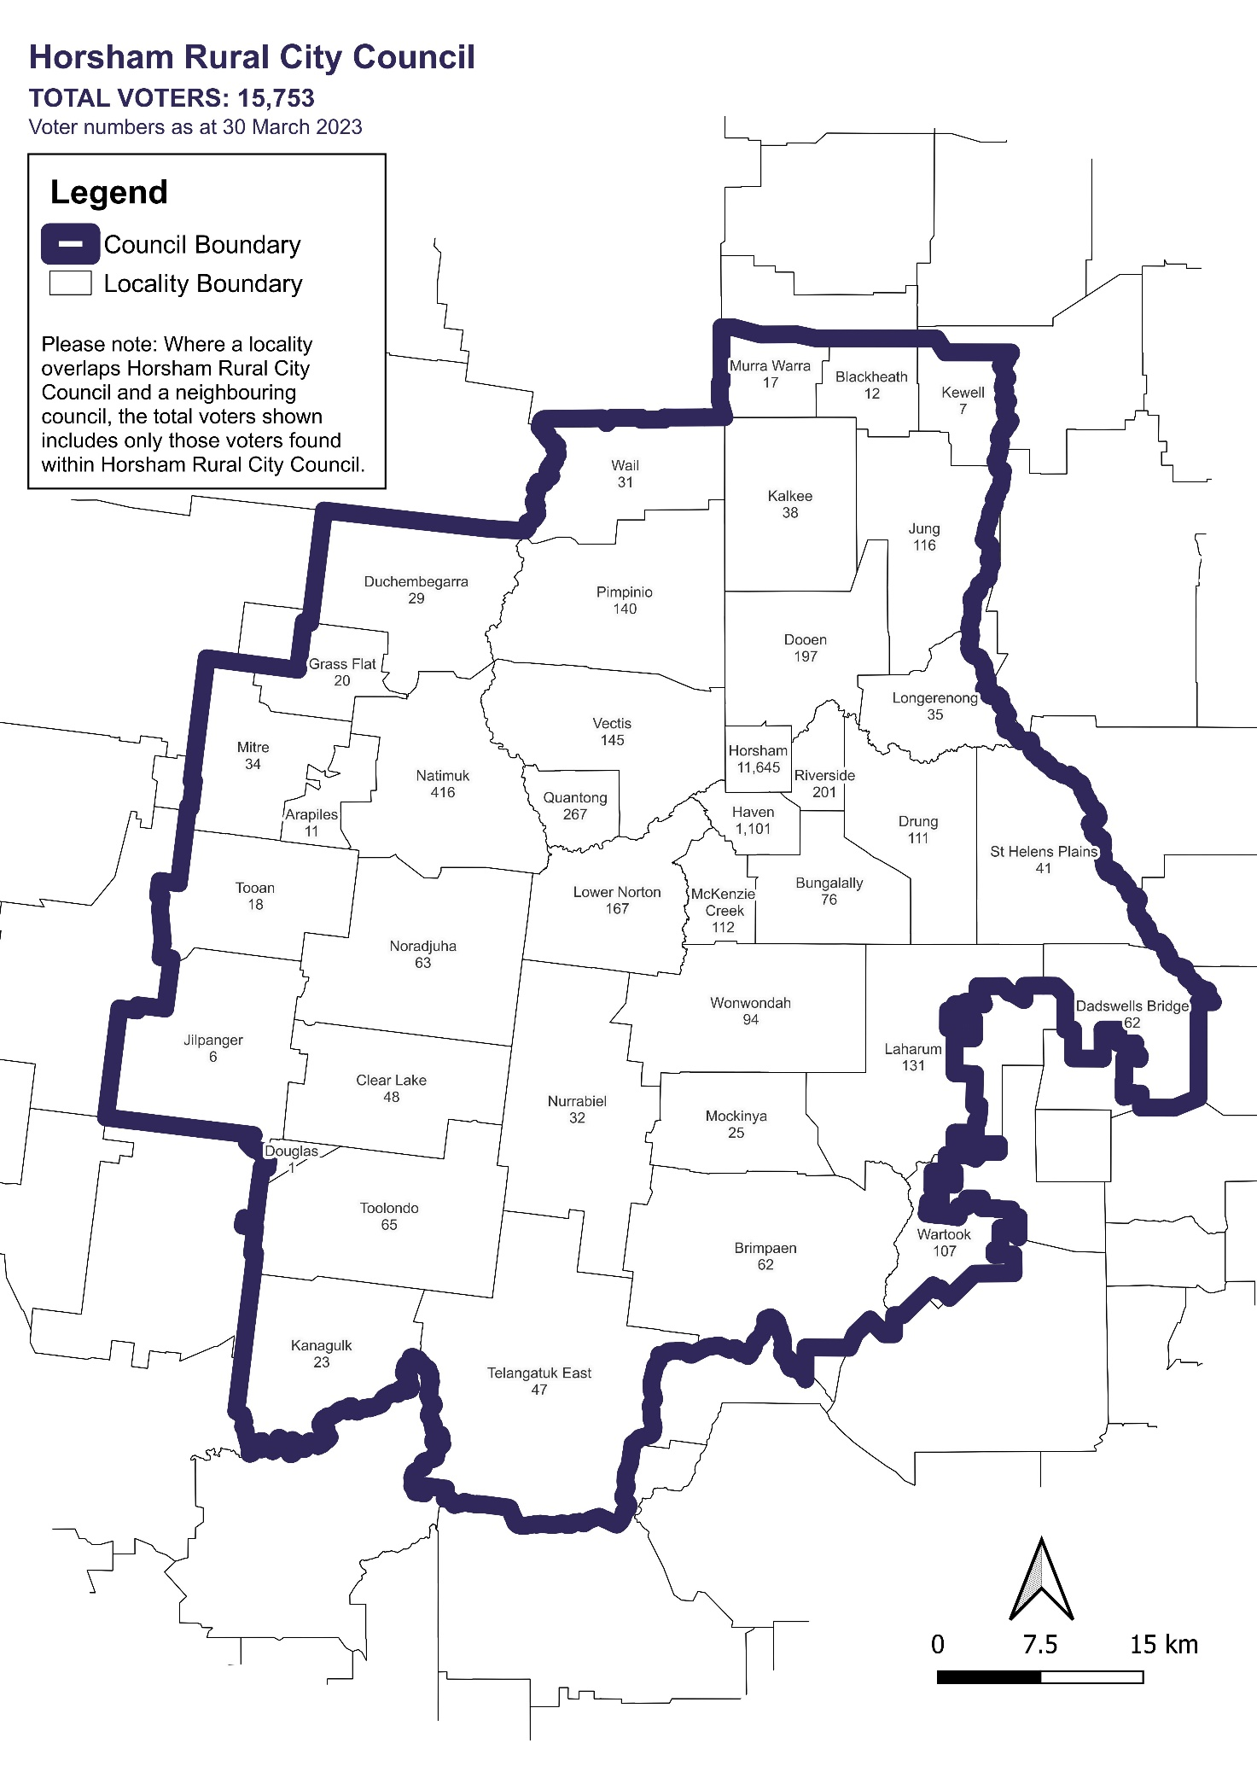

Voter numbers by locality (table)

## Horsham Rural City Council voter numbers at 30 March 2023

|  |  |
| --- | --- |
| Locality | Voters |
| Arapiles | 11 |
| Blackheath | 12 |
| Brimpaen | 62 |
| Bungalally | 76 |
| Clear Lake | 48 |
| Dadswells Bridge | 62 |
| Dooen | 197 |
| Douglas | 1 |
| Drung | 111 |
| Duchembegarra | 29 |
| Grass Flat | 20 |
| Haven | 1,101 |
| Horsham | 11,645 |
| Jilpanger | 6 |
| Jung | 116 |
| Kalkee | 38 |
| Kanagulk | 23 |
| Kewell | 7 |
| Laharum | 131 |
| Longerenong | 35 |
| Lower Norton | 167 |
| McKenzie Creek | 112 |

|  |  |
| --- | --- |
| Locality | Voters |
| Mitre | 34 |
| Mockinya | 25 |
| Murra Warra | 17 |
| Natimuk | 416 |
| Noradjuha | 63 |
| Nurrabiel | 32 |
| Pimpinio | 140 |
| Quantong | 267 |
| Riverside | 201 |
| St Helens Plains | 41 |
| Telangatuk East | 47 |
| Tooan | 18 |
| Toolondo | 65 |
| Vectis | 145 |
| Wail | 31 |
| Wartook | 107 |
| Wonwondah | 94 |