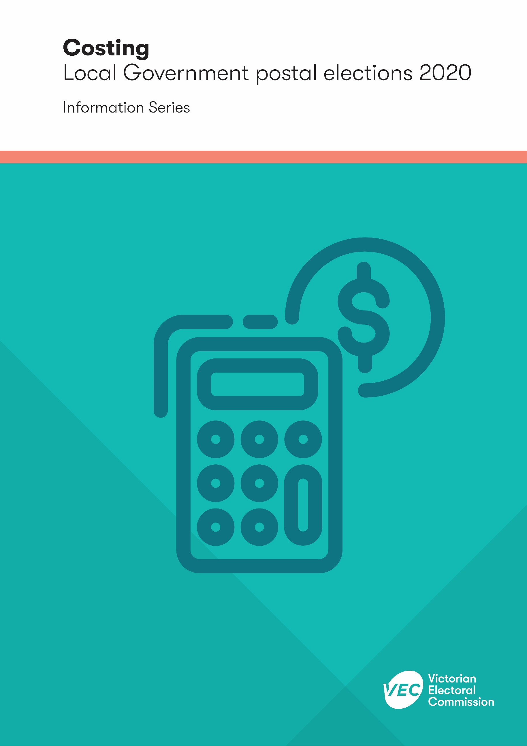
Acknowledgement
of Country
The VEC pays respect to Victoria's traditional owners and their elders past and present who have been custodians of this country for many thousands of years. Their living culture and their role in the life of Victoria is acknowledged by the VEC.

Version history
Subject matter expert | Date received | Date returned
Katrina Collins | 11/05/2020 | 25/05/2020

Contents

Introduction 1
Costing model 1
Cost management 2
Core costs 3
Marginal costs 3
Costing review 4
Service delivery responsibilities 4
Estimates & quotes 5
Election service agreement 5
Parameters and variations 5
Audit and quality assurance 6

Introduction
The Victorian Electoral Commission (VEC) is the statutory election service provider to local councils in the state. This publication outlines the process for costing local council general elections in 2020. It is part of the 2020 Election Information Series, available on the VEC website.
Since commencing its local council election program in the 1990s, the VEC has worked closely with Victoria’s local government sector, including councils and council officers, to identify and refine its costing process. The VEC became the statutory provider of electoral services in 2015, following changes to the then Local Government Act 1989, however councils are still required to pay for these services.
This document explains the VEC’s costing model and how it is administered, the key parameters that largely determine the costs, and the costing process that was followed in preparation for the 2020 local council general elections. It is not the aim of this document to provide a list of the prices and rates, time and motion analyses, and complex formulae that are used by the VEC to finally determine a cost, as these can vary significantly by the parameters applying to a particular council.
Local council elections may be conducted either by full postal voting or attendance voting. The Local Government Act 2020 enables the Local Government Minister to determine the voting method for local council general elections. For 2020 the Local Government Minister has determined that all elections will be conducted by post.

Costing model
The cost of conducting local council elections includes core costs and marginal costs. This breakdown is explained in more detail in the following sections.
The VEC does not pass on core costs to councils as part of its cost recovery model. Marginal costs are passed to councils and are allocated or apportioned using two methods:
1 | Direct costs: The cost is based on a price per unit (e.g. per voter) or a quote from a supplier and applies specifically to the council.
2 | Apportioned Cost — State wide: The overall cost is apportioned across Victoria by the number of councils and/or by the number of voters in each council.

These cost allocation methods and the costing application used by the VEC have been independently audited.

The VEC accompanies its cost quotations with a list of defined variations with discrete areas where the cost would be likely to change if the assumed parameters are not held. The variations provide for an increase or decrease in the:
- number of voters
- voter turnout
- number of candidates
- number of uncontested elections
- size and length of the counting operation
- unanticipated rate changes within existing suppliers.
These variations are provided with the quotation and incorporated in the costing information included in the election service agreement with each council.

Cost management
The costing process for each council’s election is administered by the VEC’s client liaison team. The client liaison officers are responsible for:
- preparing the estimate, quote, and election service agreement for each council’s election
- managing the VEC’s day-to-day relationship with each council
- preparing invoices in accordance with the election service agreement
- supervising the delivery of the election services and ensuring compliance with the Local Government Act 2020
- providing formal and informal feedback and reports to councils at critical points during the election timeline
- preparing the final election report.
The client liaison officers are the key contact point for each council during the election period and work closely with other VEC staff and the VEC’s local election manager to deliver each council’s elections.

Core costs
The VEC does not pass on core costs to councils as part of its cost recovery model. The VEC defines core costs as those that would normally be incurred by the VEC as part of delivering its electoral services for the Victorian State Parliament, State Government and certain statutory elections. These costs include:
- core staff payroll
- core system development, including applications that are widely, but not exclusively, used for local council elections (e.g. the VEC’s election management system and computer count applications)
- ongoing support for maintaining the voters’ roll
- recruiting and generic training for the pool of election officials across Victoria
- equipment used for all VEC election activity
- the VEC’s head office and warehouse accommodations.

Marginal costs
The VEC’s costing model includes only the additional work undertaken to provide council electoral services. The marginal costs are related to:
- council-specific advertising and voter information products
- the preparation and placement of statutory notices for each council’s election
- the election manager, assistant election manager(s), and election office staffing
- establishing, maintaining and decommissioning an election office, including setting up, installing and de-installing connections, equipment and machinery, as well as their consumables
- printing ballot papers and collating and dispatching postal ballot packs
- establishing counting venues, including computer count venues, and appointing and training counting team leaders and counting or data entry staff
- following up with apparent non-voters through the dispatch and processing of apparent failure to vote notices, infringement notices and penalty reminder notices
- receiving payments and reviewing excuses or requests in relation to compulsory voting enforcement
- prosecuting residual non-voters who failed to satisfactorily respond to the enforcement notices, or requested for their offence to be referred to the Court
- a proportion of additional head office support staff and other administrative costs necessary to support the increased levels of activity.

Costing review
The VEC comprehensively reviews its costing allocation before each event and looks for opportunities to share costs between the core and marginal cost categories. For example, election managers and assistant election managers for local council elections are recruited from the VEC’s existing pool of senior election officials. Although specific training on local council elections is necessary, there are significant benefits to the VEC that are external to its local council electoral responsibilities. Consequently, the costs for election managers and assistant election managers to attend local council election training in advance of their appointments has been removed from the costing application and will not be recovered from local councils.
Similarly, the VEC also regularly reviews the apportionment of head office support costs, as these arrangements are necessary for the VEC to successfully deliver its local council electoral responsibilities, regardless of how many councils are involved in a particular electoral event.

Service delivery responsibilities
In addition to the core and marginal costs, there are several other costs that the VEC budgets for as part of its council elections program. These additional costs are not passed on to councils and include:
- professional advice to build capacity and electoral knowledge within the VEC, Victoria or Australia
- public and products liability insurance
- remedial action for any at-fault errors or omissions.

Estimates & quotes
In December 2019, the VEC provided each council with estimates for conducting their elections and compulsory voting enforcement.
The estimates were provided to assist councils with forward budgeting and were guided by the VEC’s experience delivering the 2016 local council elections, adjusted for the 2020 local government election service plan. The VEC continued to refine the costing application and negotiate with key suppliers after the estimates were dispatched.
Further quotes were produced for councils whose voting method changed from attendance to postal and those councils affected by changes to their electoral structure and number of councillors.

Election service agreement
Following the preparation of the estimates, in early 2020 the VEC liaised with each council to confirm and update the relevant costing parameters. These final parameters were used as the basis for preparing the formal quotation and election service agreement.
The election service agreement establishes the relationship between the VEC and each council. The agreement responds to the statutory function of the VEC to prepare the voters’ roll and conduct the election and non-voter follow up for each council’s election. It also incorporates arrangements for countbacks, by-elections and other contingency electoral services that may need to be performed by the VEC during the 2020-24 council term.
The quotation for each council’s general elections is included in Schedules 1 and 2 of the election service agreement with that council. Costing arrangements that apply for the other services, should they be required, are outlined in Schedule 3.
For the 2020 local council elections, electoral service agreements were dispatched to councils in March 2020.

Parameters and variations
All estimates and quotations prepared by the VEC are subject to several key parameters and a defined list of variations.
The VEC uses these parameters to gauge the cost of an election based on the number of voters, number of candidates, voter turnout and whether election office accommodation is provided by the Council or if the VEC is required to secure a commercial lease. Generally, the VEC either uses parameters provided by councils themselves or looks at what information already exists. All parameters are disclosed through the costing details incorporated in the electoral service agreements for general elections or attached to the contingency service quotation for by-elections and countbacks.

The VEC’s defined list of variations identifies areas where the VEC may need to vary the cost if a parameter changes. For example, if the enrolment in a local council increases or decreases from the number used to prepare the electoral service agreement, the variations identify a cost per voter that will be added to or deducted from the cost. These variations are applied during invoicing and are disclosed as an attachment to the invoice. There are also some variations which cover global changes to service requirements, such as taxes and levies, changes to legislation and movements in the cost of election staff rates of pay.

Audit and quality assurance
All estimates, quotations and invoices prepared are put through a stringent quality assurance process, including peer review and reviews by the Local Government Program Manager and the VEC’s Executive Management. Formal quotations are approved by the Electoral Commissioner or Deputy Electoral Commissioner before they are provided to each council.
The VEC has an independent audit and risk committee responsible for monitoring its finance operations. In addition to reporting on costing arrangements internally, regular audits are conducted by suitably qualified, independent auditors, which look particularly at the accuracy and effectiveness of the VEC’s costing application, identify any errors or irregularities, and focus on the fairness of the costing methodology.
The VEC’s most recent audit of its local council costing application was completed in May 2020.

