VEC Disclosures user guide:
submitting an annual return
Individual third-party campaigner

Acknowledgement
of Country
The VEC pays respect to Victoria's traditional owners and their elders past and present who have been custodians of this country for many thousands of years. Their living culture and their role in the life of Victoria is acknowledged by the VEC.

Disclaimer
The information in this user guide is specific to Victorian funding and disclosure laws and does not take into account the laws of other Australian jurisdictions. The information is also general in nature and does not consider your individual circumstances. If in doubt, you should seek professional advice.

More information
More information about funding and disclosure obligations can be found at vec.vic.gov.au/disclosures.
For further queries please contact the VEC Funding and Disclosure Unit:
T: (03) 8260 1100 or 131 832
E: disclosures@vec.vic.gov.au

Version control
Version | Date Effective | Approved by | Amendment
0.1 | 17/09/2019 | Program Manager, Funding and Disclosure | Zero
1.0 | 11/10/2019 | Director, Electoral Integrity and Regulation | Zero
2.0 | 30/06/2020 | Program Manager, Funding and Disclosure | financial year values;  system enhancements
3.0 | 30/06/2021 | Director, Electoral Integrity and Regulation | financial year values;  system enhancements

Contents
Disclaimer 2
More information 2
Definitions 4
Annual return for an individual third-party campaigner 5
General information 5
Required documents 5
Annual return due date 5
Offences 6
VEC Disclosures 6
More information 6
Annual return process 7
Complete annual return 7
Screen 1 – Key information 8
Screen 2 – Transaction details 12
Submit annual return 17

Definitions

Agent
A third-party campaigner may appoint a person as an agent. The agent is the person responsible for disclosing all donations a recipient receives via VEC Disclosures, maintaining the State campaign account, and submitting the recipient’s annual return. If an agent is not appointed, the financial controller is the default agent.

Financial controller (default agent)
The financial controller of the third-party campaigner is the agent, if no agent has been appointed. If the third-party campaigner is a corporation, the secretary of the corporation is the financial controller. If the third-party campaigner is a trust, the trustee is the financial controller. If it is neither a corporation or a trust, the person responsible for keeping the financial records of the third-party campaigner is the financial controller.

Candidate
A candidate is a person who has been selected by a political party to be a candidate in an election, or a person, other than a member of a political party, who has publicly announced an intention to be a candidate in an election.

Elected member
An elected member is a person who is a member of the Legislative Council or the Legislative Assembly of the Victorian Parliament.

Recipient
A recipient is a person or organisation that receives a political donation, being a registered political party, a candidate, an elected member, an associated entity, a third-party campaigner or a nominated entity.

Third-party campaigner
A third-party campaigner is a person or organisation that:
- receives political donations or incurs political expenditure of more than $4,160 per financial year, and
- is not a registered political party, candidate at an election, an elected member, an associated entity, or a nominated entity of a registered political party.

State campaign account
The registered agent or financial controller must keep a State campaign account for the purposes of State elections. All donations must be paid into the State campaign account.

Annual return for an individual third-party campaigner
This guide is intended to assist individual third-party campaigners, or their registered agent, to complete an annual return via VEC Disclosures, as provisioned under Part 12 of the Electoral Act 2002.
Important: If an individual third-party campaigner didn’t receive any political donations or incur political expenditure which exceeded a total of $4,160 in the 2020-21 financial year, an annual return is not required to be submitted.
If you are not required to submit an annual return, you are still required to email a declaration to confirm you did not receive any political donations or incur political expenditure exceeding $4,160 during the 2020-21 financial year. The declaration can be emailed to disclosures@vec.vic.gov.au.

General information
The reporting period for the 2020-21 financial year annual return is from Wednesday 1 July 2020 to Wednesday 30 June 2021.

Required documents
You must submit the following mandatory documentation with your annual return:
- An audit certificate from an independent auditor advising that the statement has been audited in accordance with Australian Accounting Standards as specified in Section 334(1) of the Corporations Act 2001 (Cth).
As stipulated within section 209(3) of the Electoral Act 2002, the audit certificate must state that the auditor:
- was given full and free access at all reasonable times to all accounts, records, documents and papers relating directly or indirectly to any matter required to be specified in the statement
- examined the material referred to in paragraph (a) for the purpose of giving the certificate
- received all information and explanations that the auditor requested in respect of any matter required to be specified in the statement
- has no reason to believe that any matter stated in the statement is not correct.
Download the VEC audit certificate template.

Annual return due date
Annual returns must be completed within 16 weeks after the end of financial year and are due by 20 October each year.
The 2020-21 financial year annual return is due by 11.59 pm Wednesday 20 October 2021 via VEC Disclosures.
Annual returns will be published via VEC Disclosures within six months of the end of the relevant financial year.

Offences
Offences include (but are not limited to) failing to submit on time (200 penalty units) and providing false or misleading information (300 penalty units and/or 2 years imprisonment). A full list of fees and penalties can be found on the Department of Treasury and Finance website: Indexation of fees and penalties | Department of Treasury and Finance Victoria (dtf.vic.gov.au).

VEC Disclosures
Annual returns can be completed over more than one session. VEC Disclosures allows a user to ‘Save and Continue’ and return in a separate session (for further information see Edit and submit an annual return in another session).
Please note that VEC Disclosures is best viewed in Google Chrome. If you receive an error message that your browser is not compatible, follow the prompts to download and install Google Chrome.
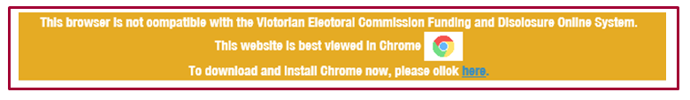

More information
For further information about annual returns and your legislative obligations, refer to Determination No. 2 of 2019 under the Electoral Act 2002.
If you have any questions or need further clarification about an annual return, please contact us.
Email: disclosures@vec.vic.gov.au
Phone: (03) 8620 1100 or 131 832.

Annual return process

Complete annual return
- To access VEC Disclosures, visit disclosures.vec.vic.gov.au
- From the VEC Disclosures home page, select ‘Sign in’ from the top menu.
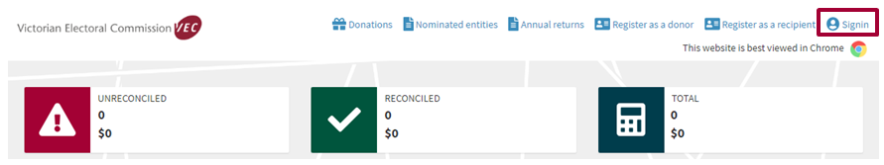
- Enter your user name and password and select ‘Sign in’.
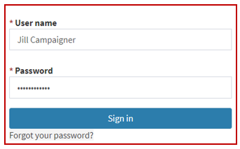
- From the Dashboard, select ‘Annual returns’ from the left-hand menu.
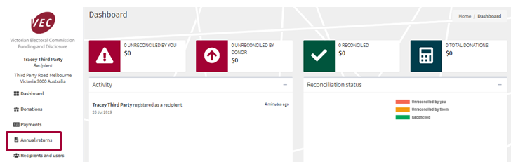
- Select ‘Lodge annual return’.
*Note: An entity can only have one active annual return per financial year.
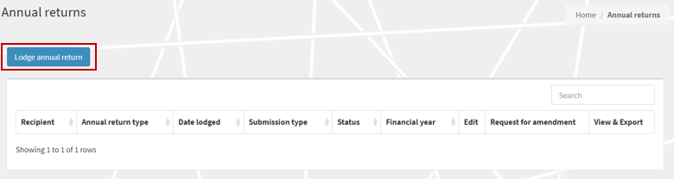

Screen 1 – Key information
- Ensure that you read and understand the key information at the top of this page prior to progressing through the annual return form.
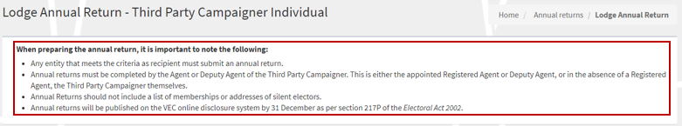
- ‘Financial year’ details are for the current financial reporting period only, and you cannot edit them.
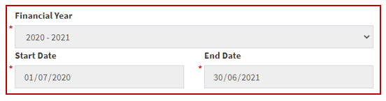
- The ‘Personal details’ and ‘Agent details’ will auto-populate. These details are locked and cannot be edited.
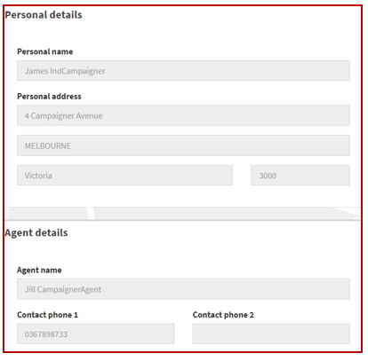
- The ‘Submitted by’ section will auto-populate with your details, as the current system user logged in. These details are locked and you cannot edit them.
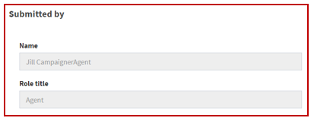

State campaign account income for financial year
All fields marked with a red asterisk (*) must be populated even if the amount is zero (except auto-populated fields).
- The ‘Total income (inc. GST)’ will auto-populate for the 2020-21 financial year and cannot be edited.
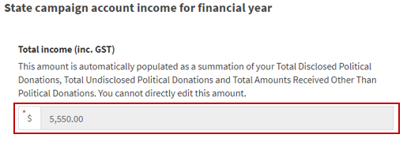
- The ‘Total disclosed political donations (inc. GST)’ field will auto-populate for the 2020-21 financial year. This field cannot be edited. This figure is the total disclosed political donations for the 2020-21 financial year.
*Note: The auto-populated ‘Total disclosed political donations (inc. GST)’ amounts will also appear as a line item in Table 1 – disclosed political donations at the bottom of the screen.
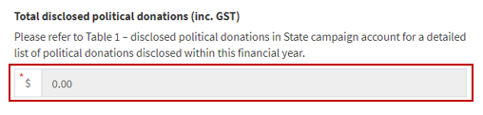
- Enter the ‘Total undisclosed political donations (inc. GST)’ received for the 2020-21 financial year.
This will include donations received by the campaigner under the $1,040 disclosure threshold that were not previously disclosed in VEC Disclosures.
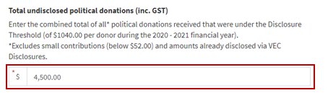
- Enter the total number of donors that have contributed to the total undisclosed political donations for the 2020-21 financial year.
- Enter the ‘Total amounts received other than political donations (inc. GST)’* for the 2020-21 financial year.
After you select ‘Save and Continue’, you will be prompted to provide details for each amount exceeding the disclosure threshold (including in aggregate) received from a single person or entity during the financial year. Two or more amounts received from one person or entity can be consolidated into one line.
*Note: this field was previously referred to as ‘non-political donations’.
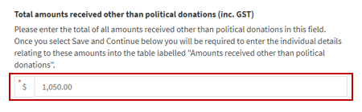
*Note: Further details of these amounts must be added in Table 3 – Amounts received other than political donations.

State campaign account expenses for financial year
- Enter the ‘Total expenditure (inc GST)’ incurred by, or on behalf of, the campaigner for the 2020-21 financial year.
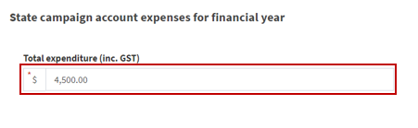
- Enter the ‘Total outstanding debts (inc GST)’ incurred by, or on behalf of, the campaigner as at the end of the 2020-21 financial year.
*Note: Further details of these debts must be added in Table 2 – outstanding debt details.
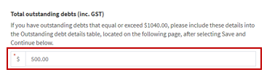

Table 1 – disclosed political donations in State campaign account
- Review the pre-populated table: ‘Table 1 - disclosed political donations in State campaign account’. If accurate, select ‘Save and Continue’. This will save a draft version of the annual return.
If there are any discrepancies between this record and your own records, email disclosures@vec.vic.gov.au.
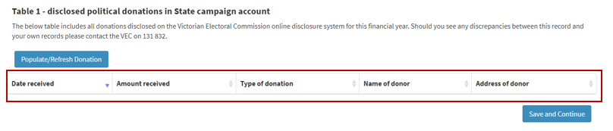

Screen 2 – Transaction details

Table 2 – outstanding debt details
- Select ‘Add’ to populate the ‘Outstanding debt details’ table with any debts owed to a person or entity at the end of the financial year that exceed the disclosure threshold.
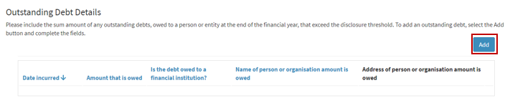

- Complete all fields in the ‘Outstanding debt details’ form.
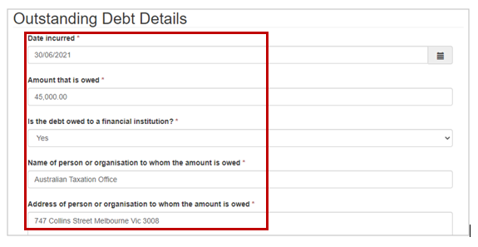
- Once complete, select ‘Submit’ and repeat steps above to add any further line entries.
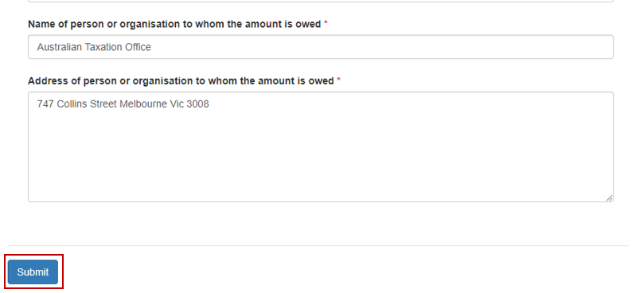
- To edit or delete any line entries, select the drop-down arrow next to the relevant entry and select ‘Edit’ or ‘Delete’.
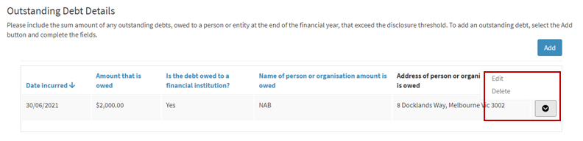
- When the details you enter into the required fields and the prepopulated fields match your records, select ‘Save and Continue’. This will save a draft version of the annual return.

Table 3 – Amounts received other than political donations
- Select ‘Add’ to populate the ‘Amounts received other than political donations’ table with any amounts received, other than political donations, from a single person or entity during the financial year that exceed the disclosure threshold, including in aggregate.
*Note: Two or more amounts received from one person or entity can be consolidated into one line entry.
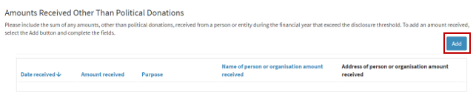
- Once complete, select ‘Submit’ and repeat steps above to add any further line entries.
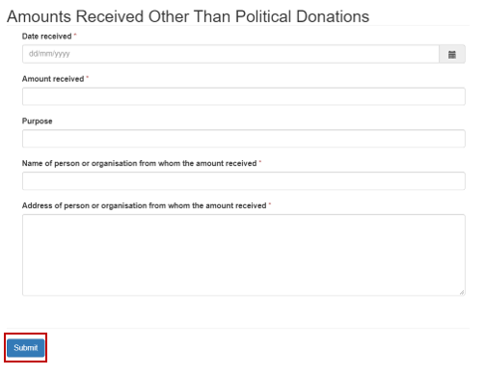
- To edit or delete any line entries, select the drop-down arrow next to the relevant entry and select ‘Edit’ or ‘Delete’.
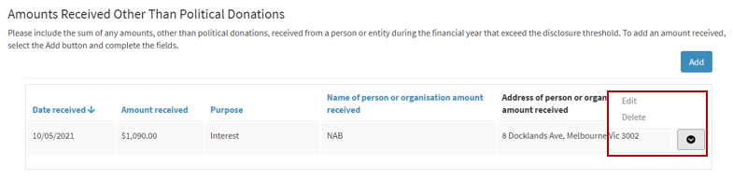
- When the details you enter into the required fields and the prepopulated fields match your records, select ‘Save and Continue’. This will save a draft version of the annual return. Alternatively, select ‘Back’ to return to the previous screen.
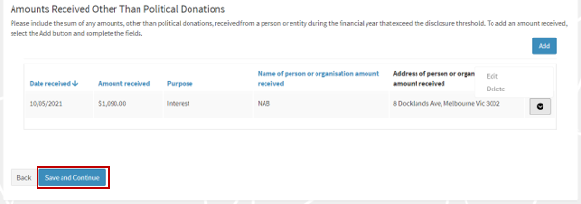

Upload Audit Certificate
- Download the VEC independent auditor template or access it through VEC Disclosures.
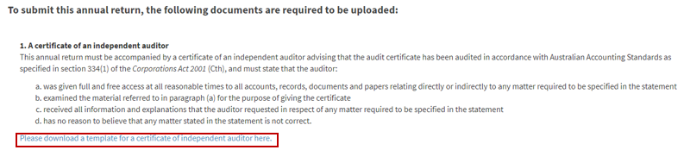
- You must upload a certificate from an independent auditor advising that the annual return has been audited in accordance with Australian Accounting Standards as specified in Section 334(1) of the Corporations Act 2001 (Cth).
As stipulated within section 209(3) of the Electoral Act 2002, the audit certificate must state that the auditor:
  - was given full and free access at all reasonable times to all accounts, records, documents and papers relating directly or indirectly to any matter required to be specified in the statement
  - examined the material referred to in paragraph (a) for the purpose of giving the certificate
  - received all information and explanations that the auditor requested in respect of any matter required to be specified in the statement
  - has no reason to believe that any matter stated in the statement is not correct.
- To upload the audit certificate, select ‘Upload New Document’.
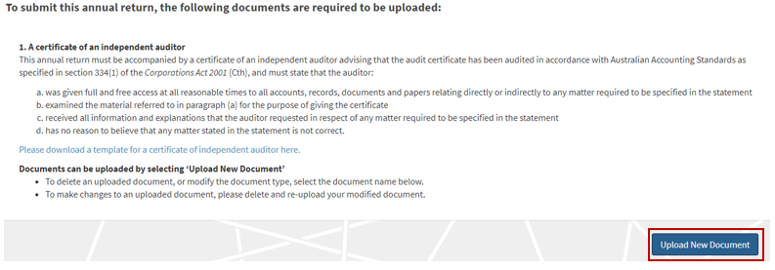
*Note: The maximum file size for a document is five megabytes (5MB). Larger files must be emailed directly to the Funding and Disclosure Unit at disclosures@vec.vic.gov.au.
- A pop-up window will prompt you to select the document type from the drop-down list, you can include a description of the document.
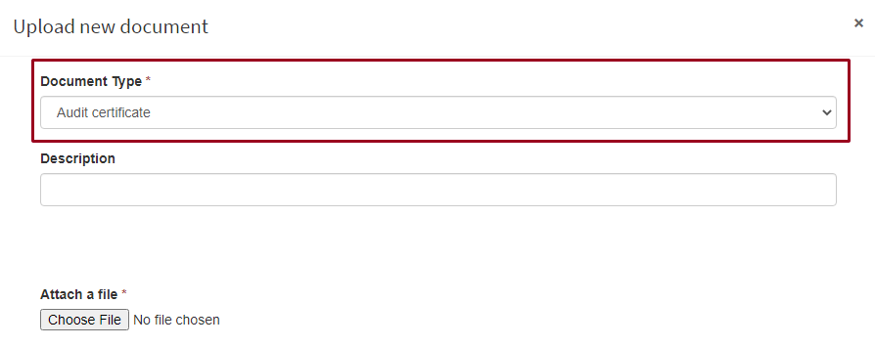
- Select ‘Choose File’.
- In the window that pops up, navigate to your document, select it and then select ‘Open’.
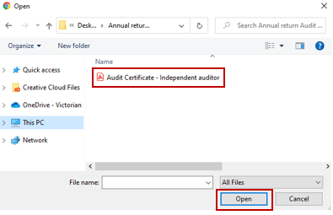
*Note: The pop-up window may vary depending on your computer’s operating system.

- The name of the file you chose will appear next to the ‘Choose file’ button.
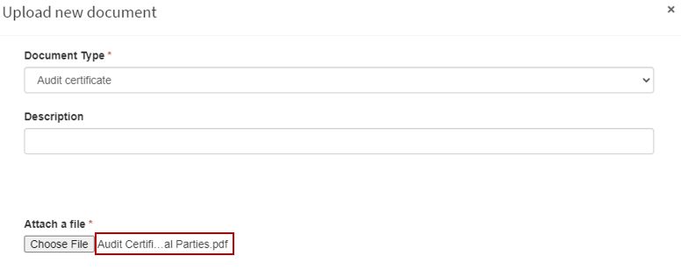
- Once you’ve confirmed this is the correct file, select ‘Upload’.
- The document will appear as a line item. Any document that appears here are saved to your annual return and will not be lost if you navigate away from this page.
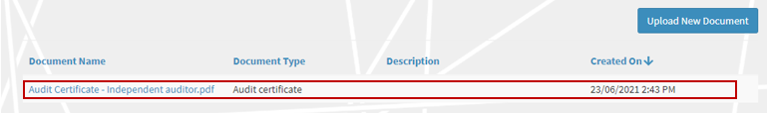
*Note: To delete or modify a document in this list, click on the Document name.

Submit annual return
- When you have uploaded the audit certificate, review the acknowledgements and select the ‘I confirm’ checkboxes.
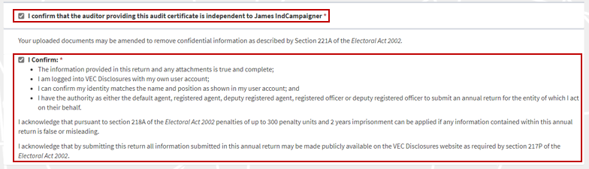
*Note: if you have any questions about the acknowledgments, contact the Funding and Disclosure Unit via email at disclosures@vec.vic.gov.au.
- You can submit your annual return once you have completed all the necessary fields and uploaded the completed audit certificate.
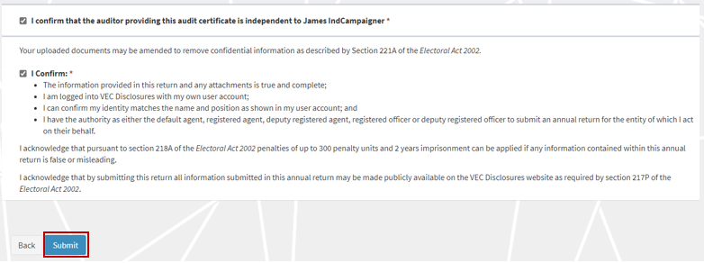
- You will see a submission confirmation screen. We will review the annual return and contact you if any further information is required.
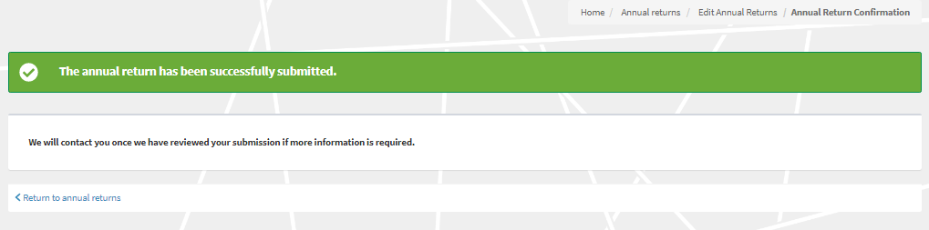

Edit and submit an annual return in another session
- You can complete an annual return in multiple sessions. VEC Disclosures allows you to save your progress and come back to complete it at a later time. Make sure you save and continue if you wish to exit and come back later.
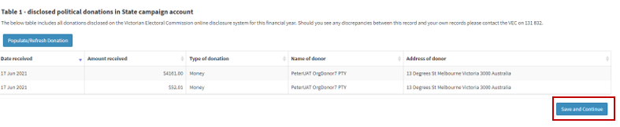
- To finalise and submit an annual return that you have previously started, log in to VEC Disclosures and go to the annual returns page. Your annual return will be listed as a line item with a status of ‘Unsubmitted’. Select ‘Edit’ to continue with your annual return.
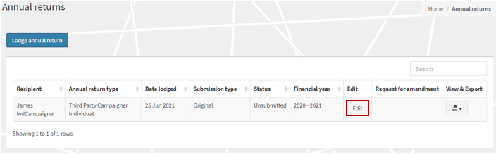
- When you have completed your annual return, review and tick to confirm you’ve read the acknowledgments, then select ‘Submit’.
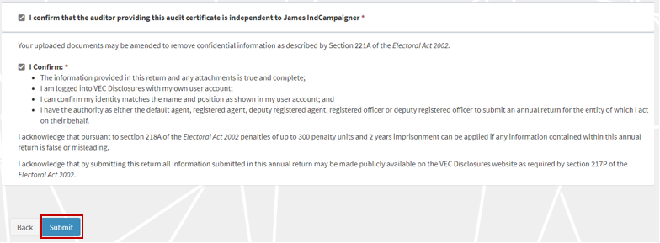
- The annual return will appear as ‘Submitted’ on the ‘Annual returns’ page.
Important: If you need to amend the annual return after you have submitted it, refer to the ‘Request an amendment’ section or email disclosures@vec.vic.gov.au.
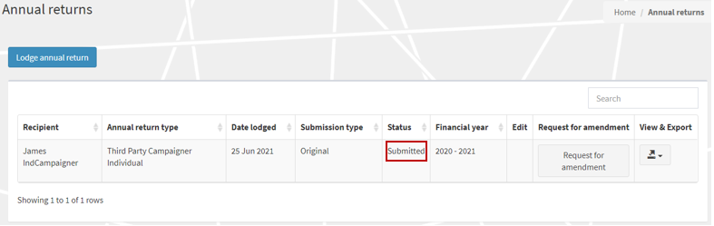

View and Export annual return
- You can now view and export a copy of your annual return. Click on the ‘View & Export’ button and then select ‘PDF’.
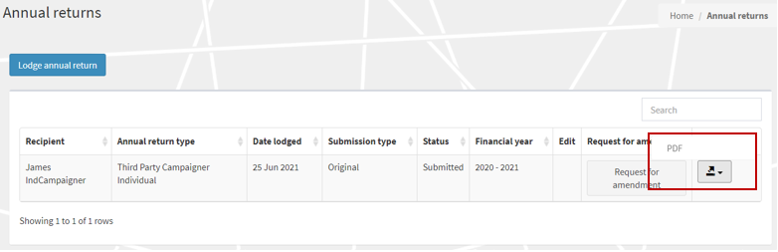
- Select the ‘Export’ button to download a copy of the PDF.
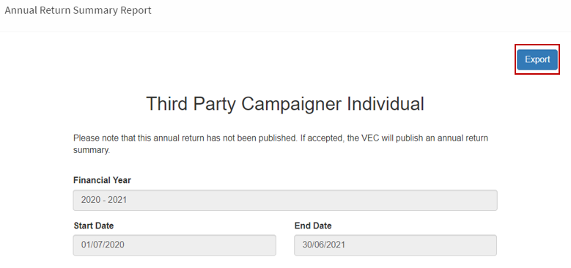
- To return to the annual returns page, click on the grey ‘X’.
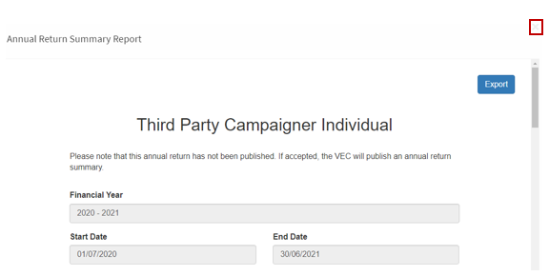

Request an amendment
- If you need to amend your annual return after submitting it, you can request an amendment through VEC Disclosures. Select ‘Request for amendment’.
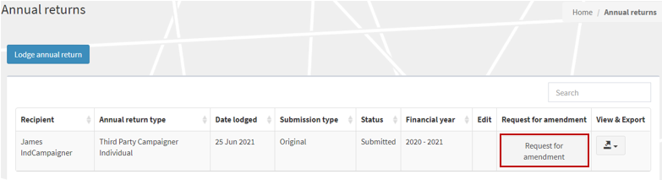
- Input the details of your amendment in the ‘Amendment Reason’ field and select ‘Submit’.
Important: The details provided in the fields below will be published on VEC Disclosures. We recommend that you do not include any personal information.
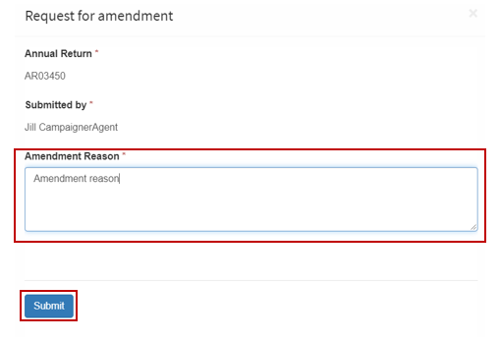
- Your request will be considered, and you may be contacted for additional information.
