



**The rules to tell the V.E.C.**

**what you think.**

**We call this our Feedback Policy.**

August 2020

This information is from the

Victorian Electoral Commission.

We will write **V.E.C.** when we talk about us.

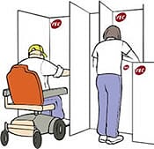The V.E.C. run elections for

* local council
* Victoria.

The V.E.C. can also help run

community elections.

**The rules to tell the V.E.C.**



**what you think**



You can tell the V.E.C. what you think.

We listen to what you say.



Your ideas can make it better for everyone.

You can tell us about any thing we do. Like

* how you learn about **how** to vote
* how to enrol to vote
* how we include all people in Victoria.

**What must we do?**



Our rules say we must

* tell you we have your information



* listen to what you say



* tell you what we will do.

**Your rights**

You have the right to



* tell us what you think



* know we follow these rules.

You also have the right to

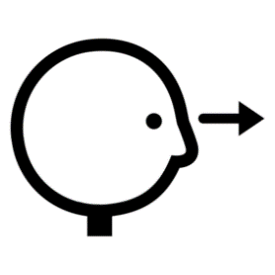

* ask the V.E.C. to look at your problem again.

You do **not** think it was fixed.



* take away your complaint. You do **not** want

the V.E.C. to look at it any more.

**You must**

* listen to our staff
* be polite to our staff



* tell us the truth.

**V.E.C. rights and responsibilities**

We must

* check you have the help you need
* only tell the people who need to know about your feedback



* tell you we have your feedback.

We only look at things about the V.E.C.. Like





* you tell us about how we talk to you

* you think we broke these rules.



You want to give us feedback.

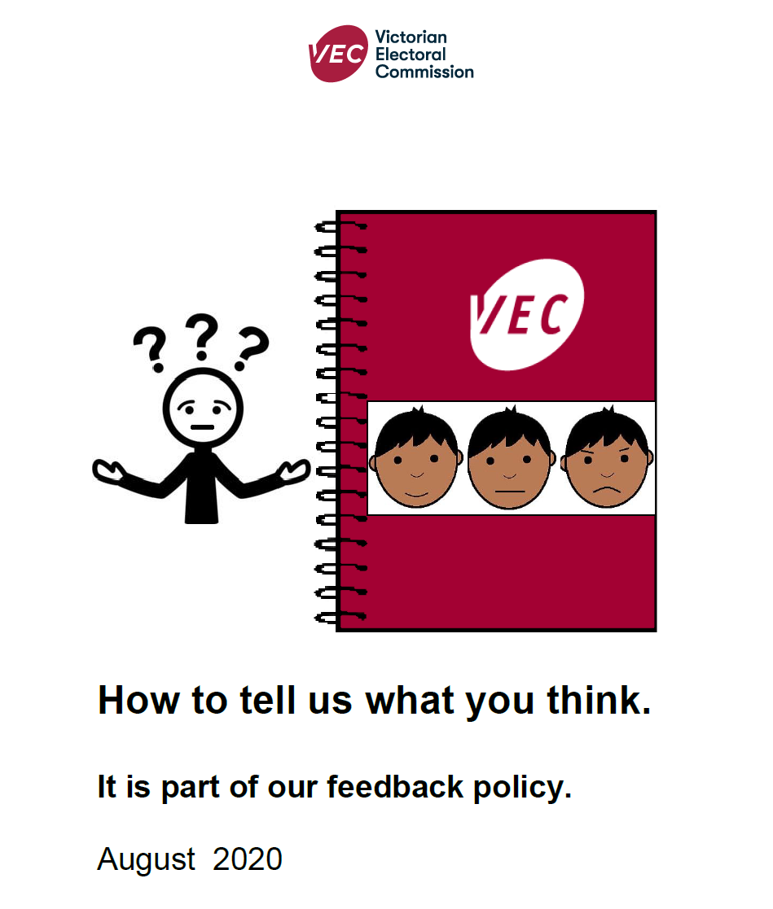

Read about this in our book

**How to tell us what you think**.

**We may stop talking to you**



Like you are happy with what we say now.

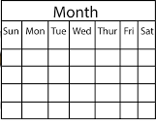

You can **not** contact us for 4 weeks.

**Or**

You want to talk to the V.E.C.



**But**



You make lots of calls. Like you make

more than 10 calls every day.

**Or**

You say you will hurt



* your self
* our staff
* other people.

**Or**

You hurt our staff. Like

* you hit staff



* you use swear words to staff
* do **not** tell the truth.

**Or**

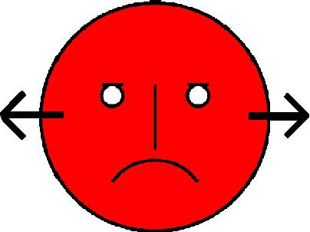You do **not** like what we said.

You can **not** tell us why you do **not** like it.

**Or**

You ask us to look at the information



* again

**and**

* again

**and**

* again.



We do **not** understand the problem.

You do **not** try to help us understand.

**We write a report.**

**It is about what you tell us**

Only the staff who look at feedback can read it.

It is private.



The report helps us be better.

**More information**

Call us 131 832.

Email complaints@V.E.C..vic.gov.au

Website www.V.E.C..vic.gov.au

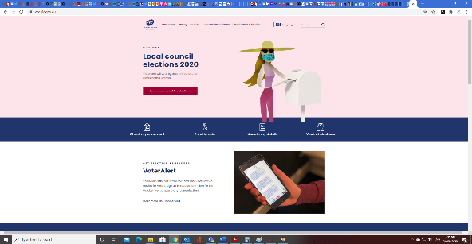

Write a letter. Post to

Complaints Victorian Electoral Commission

Level 11. 530 Collins Street

Melbourne. Victoria. 3000.



National Relay Service 8620 1100.

Interpreter 9209 0112.

**Images**

****We have used images from

* V.E.C. images
* 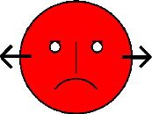ChangePeople
* COMPIC
* Inspired Services
* Picto-Selector
* SocialBuzz
* TheNounProject
* Tobii-Dynavox.

# This fact sheet is based on the V.E.C. Customer Feedback Policy. July 2020.

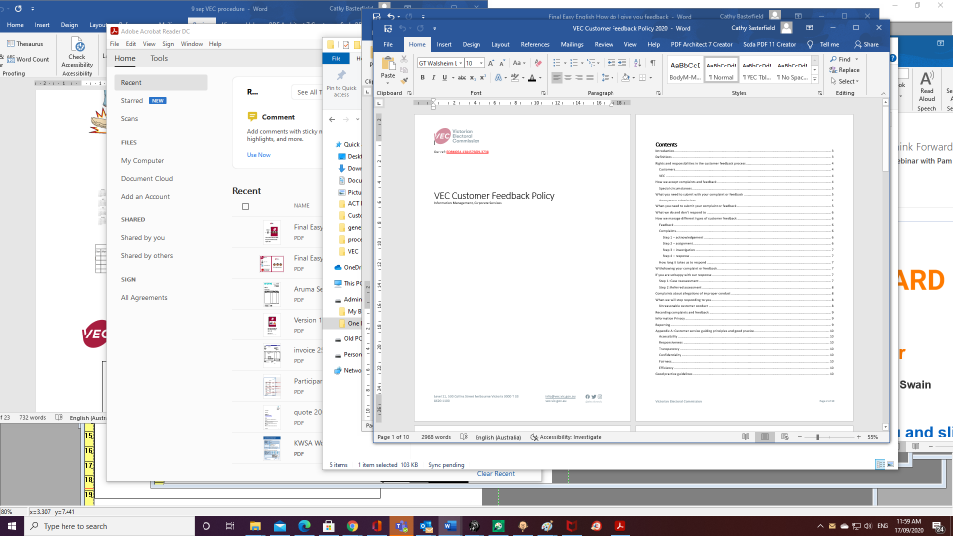

Access Easy English wrote the Easy English.

August 2020.