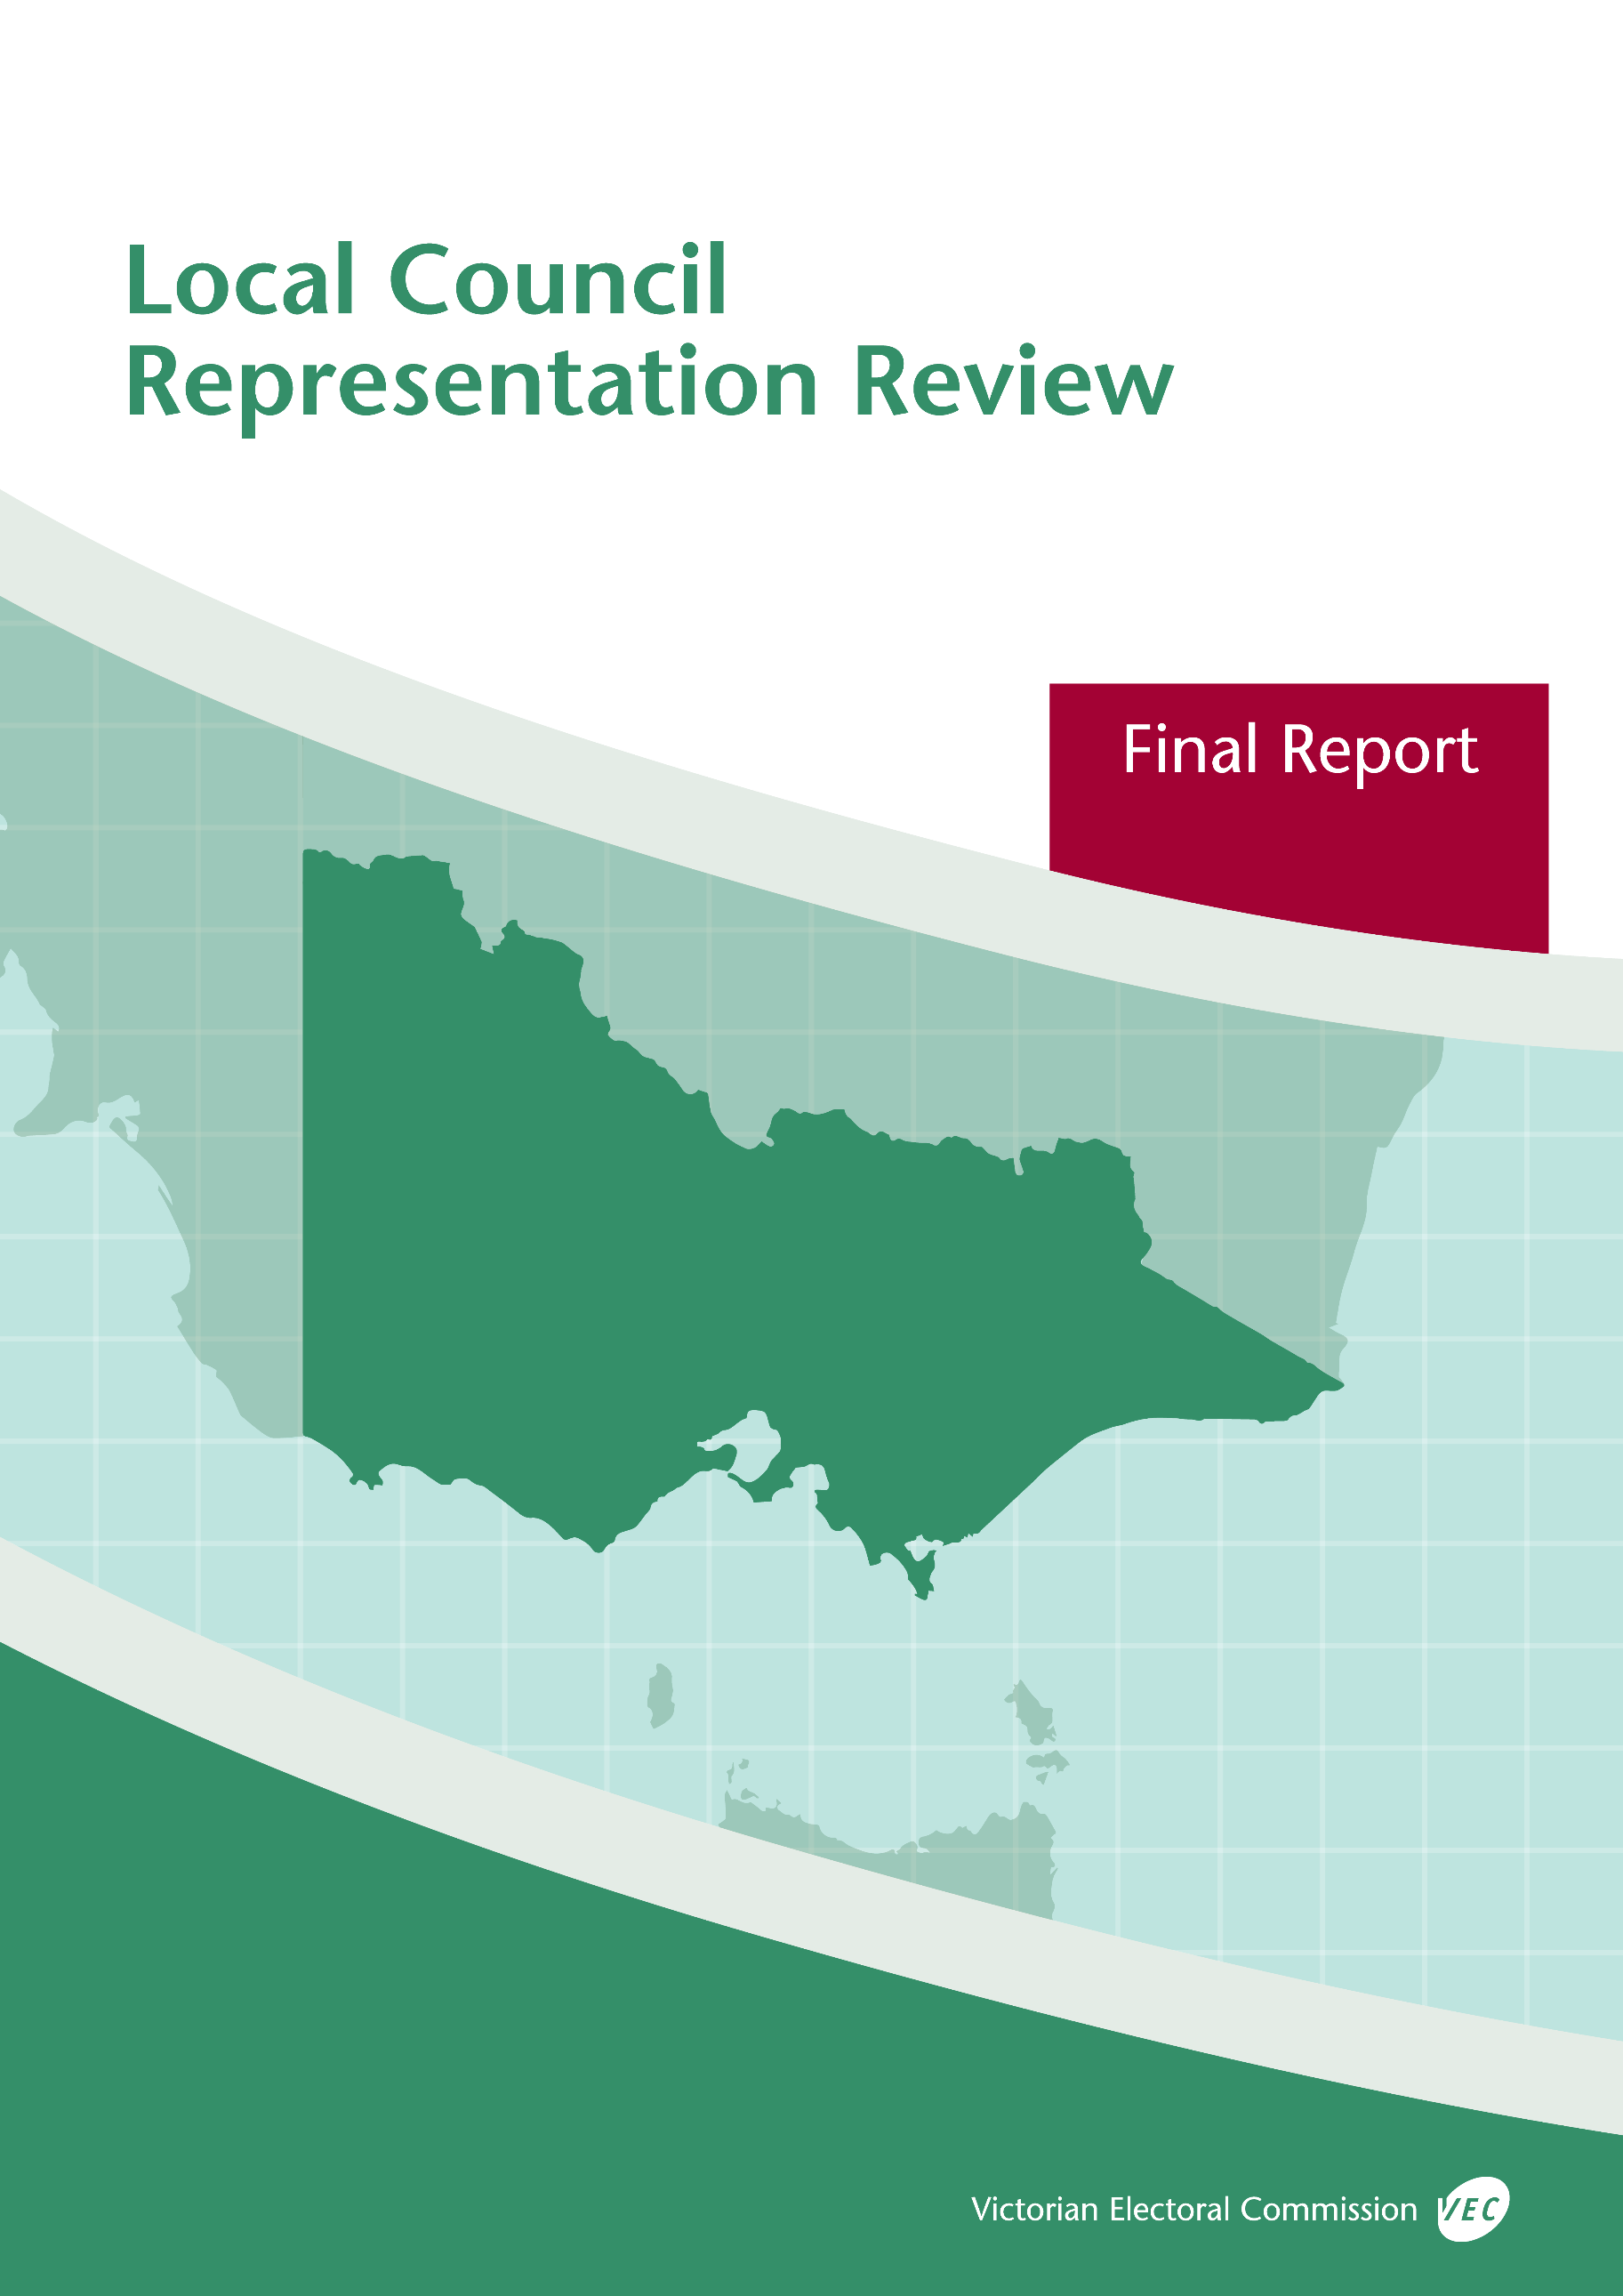



**Southern Grampians**

**Shire Council**

**May 2019**

© State of Victoria (Victorian Electoral Commission)   
Wednesday 15 May 2019

Version 1  
  
image001

This work, Local Council Representation Review Final Report – Southern Grampians Shire Council, is licensed under a Creative Commons Attribution 4.0 licence [<http://creativecommons.org/licenses/by/4.0/>]. You are free to share this work under that licence, on the condition that you do not change any content and you credit the State of Victoria (Victorian Electoral Commission) as author and comply with the other licence terms. The licence does not apply to any branding, including Government logos.

Contents

Recommendation 1

Executive summary 2

Background 4

Legislative basis 4

Public engagement 4

The VEC’s principles 5

Developing recommendations 6

Southern Grampians Shire Council representation review 8

Profile of Southern Grampians Shire Council 8

Current electoral structure 9

Preliminary submissions 9

Preliminary report 10

Public response 12

Response submissions 12

Public hearing 14

Findings and recommendation 15

The VEC’s findings 15

The VEC’s recommendation 17

Appendix 1: Public involvement 18

Appendix 2: Map 19

Appendix 3: Public information program 21

Recommendation

The Victorian Electoral Commission recommends that Southern Grampians Shire Council continue to consist of seven councillors elected from an unsubdivided electoral structure.

This recommendation is submitted to the Minister for Local Government as required by the *Local Government Act 1989*.

Please see Appendix 2 for a map of this recommended structure.

Executive summary

The *Local Government Act 1989* (the Act) requires the Victorian Electoral Commission (VEC) to conduct an electoral representation review of each municipality in Victoria before every third council general election.

The purpose of an electoral representation review is to recommend an electoral structure that provides fair and equitable representation for people who are entitled to vote at a general election of the council. The matters considered by a review are:

* the number of councillors
* the electoral structure of the council (whether the council should be unsubdivided or divided into wards and, if subdivided, the ward boundaries and the number of councillors per ward).

The VEC conducts all reviews based on three main principles:

1. taking a consistent, State-wide approach to the total number of councillors
2. if subdivided, ensuring the number of voters represented by each councillor is within   
   plus-or-minus 10% of the average number of voters per councillor for that local   
   council
3. ensuring communities of interest are as fairly represented as possible.

Current electoral structure

Southern Grampians Shire Council currently comprises seven councillors elected from an unsubdivided electoral structure. The electoral structure was last reviewed in 2007, which made a ‘no change’ recommendation.

Visit the VEC website at [vec.vic.gov.au](http://www.vec.vic.gov.au/) to access a copy of the 2007 review final report.

Preliminary submissions

Preliminary submissions opened at the commencement of the current review on Wednesday   
23 January 2019. The VEC received two submissions for the representation review of Southern Grampians Shire Council by the deadline at 5.00 pm on Wednesday 20 February 2019.

Preliminary report

A preliminary report was released on Wednesday 20 March 2019 with the following options for consideration:

* Option A (preferred option)  
  **Southern Grampians Shire Council consist of seven councillors elected from an unsubdivided electoral structure.**
* Option B (alternative option)  
  **Southern Grampians Shire Council consist of seven councillors elected from four wards (one four-councillor ward and three single-councillor wards).**

Response submissions

The VEC received eight submissions responding to the preliminary report by the deadline at   
5.00 pm on Wednesday 17 April 2019.

Public hearing

The VEC scheduled a public hearing for those wishing to speak about their response submission at 6.00 pm on Tuesday 23 April 2019. There were no requests to speak so the hearing was not held.

Recommendation

**The Victorian Electoral Commission recommends that Southern Grampians Shire Council continue to consist of seven councillors elected from an unsubdivided electoral structure.**

This electoral structure was designated as Option A in the preliminary report. Please see Appendix 2 for a map of this recommended structure.

Background

Legislative basis

The Act requires the VEC to conduct a representation review of each local council in Victoria before every third general council election, or earlier if gazetted by the Minister for Local Government.

The Act states that the purpose of a representation review is to recommend the number of councillors and the electoral structure that provides ‘fair and equitable representation for the persons who are entitled to vote at a general election of the Council.’[1]

The Act requires the VEC to consider:

* the number of councillors in a local council
* whether a local council should be unsubdivided or subdivided.

If a local council is subdivided, the VEC must ensure that the number of voters represented by each councillor is within plus-or-minus 10% of the average number of voters per councillor for that local council.[2] On this basis, the review must consider the:

* number of wards
* ward boundaries
* number of councillors that should be elected for each ward.

Public engagement

### Public information program

The VEC conducted a public information program to inform the community of the representation review, including:

* public notices printed in local and state-wide papers
* a public information session to outline the review process and respond to questions from the community
* media releases announcing the commencement of the review and the release of the preliminary report
* a submission guide to explain the review process and provide background information on the scope of the review
* an information email campaign targeted at known community groups and communities of interest in the local council area
* sponsored social media advertising geo-targeted to users within the local council   
  area
* ongoing information updates and publication of submissions on the VEC website.

More information on the VEC’s public information program for the representation review of Southern Grampians Shire Council can be found at Appendix 3.

### Public consultation

Public input was accepted by the VEC via:

* preliminary submissions at the start of the review
* response submissions to the preliminary report.

Public submissions are an important part of the review process but are not the only consideration. The VEC ensures its recommendations comply with the Act and are formed through careful consideration of public submissions, independent research, and analysis of all relevant factors.

The VEC’s principles

Three main principles underlie all the VEC’s work on representation reviews:

1. **Taking a consistent, State-wide approach to the total number of councillors.**

The VEC is guided by its comparisons of local councils of a similar size and category to the council under review. The VEC also considers any special circumstances that may warrant the local council having more or fewer councillors than similar local councils.

1. **If subdivided, ensuring the number of voters represented by each councillor is within plus-or-minus 10% of the average number of voters per councillor for that local council.**

This is the principle of ‘one vote, one value’, which is enshrined in the Act. This means that every person’s vote counts equally.

1. **Ensuring communities of interest are as fairly represented as possible.**

Each local council contains a number of communities of interest. Where practicable, the electoral structure should be designed to ensure they are fairly represented, and that geographic communities of interest are not split by ward boundaries. This allows elected councillors to be more effective representatives of the people and interests in their particular local council or ward.

Developing recommendations

The VEC bases its recommendations for particular electoral structures on the following information:

* internal research specifically relating to the local council under review, including data from the Australian Bureau of Statistics and .id[3]; voter statistics from the Victorian electoral roll; and other State and local government data sets
* the VEC’s experience conducting previous electoral representation reviews of local councils and similar reviews for State elections
* the VEC’s expertise in mapping, demography and local government
* careful consideration of all input from the public in written submissions received during the review
* advice from consultants with extensive experience in local government.

### Deciding on the number of councillors

The Act allows for a local council to have between five and 12 councillors but does not specify how to decide the appropriate number.[4] In considering the number of councillors for a local council, the VEC is guided by the Victorian Parliament’s intention for fairness and equity in the local representation of voters under the Act.

The starting point in deciding the appropriate number of councillors for a local council is comparing the local council under review to other local councils of a similar size and type (Principle 1). Generally, local councils that have a larger number of voters will have a higher number of councillors. Often, large populations are more likely to be diverse, both in the nature and number of their communities of interest and the issues of representation.

However, the VEC also considers the particular circumstances of each local council which could justify fewer or more councillors, such as:

* the nature and complexity of services provided by the Council
* geographic size and topography
* population growth or decline
* the social diversity of the local council.

### Deciding the electoral structure

The Act allows for a local council ward structure to be unsubdivided—with all councillors elected ‘at-large’ by all voters—or subdivided into a number of wards.

If the local council is to be subdivided into wards, there are three options available:

1. single-councillor wards
2. multi-councillor wards
3. a combination of single-councillor and multi-councillor wards.

A subdivided electoral structure must have internal ward boundaries that provide for a fair and equitable division of the local council.

The Act allows for wards with different numbers of councillors, as long as the number of voters represented by each councillor is within plus-or-minus 10% of the average number of voters per councillor for that local council (Principle 2). For example, a local council may have one   
three-councillor ward with 15,000 voters and two single-councillor wards each with 5,000 voters. In this case, the average number of voters per councillor would be 5,000.

Over time, population changes can lead to some wards in subdivided local councils having larger or smaller numbers of voters. As part of the review, the VEC corrects any imbalances and considers likely population changes to ensure ward boundaries provide equitable representation for as long as possible.

In considering which electoral structure is most appropriate, the VEC considers the following matters:

* the VEC’s recommendation at the previous representation review and the reasons for that recommendation
* the longevity of the structure, with the aim of keeping voter numbers per councillor within the 10% tolerance for as long as possible (Principle 2)
* communities of interest, consisting of people who share a range of common concerns, such as geographic, economic or cultural associations (Principle 3)
* the number of candidates in previous elections, as large numbers of candidates can lead to an increase in the number of informal (invalid) votes
* geographic factors, such as size and topography
* clear ward boundaries.

Southern Grampians Shire Council representation review

Profile of Southern Grampians Shire Council

Southern Grampians Shire Council is a predominantly rural local council area located in Victoria’s Western District. At the 2016 Census, Southern Grampians Shire had a total population of 15,944. The Shire is projected to experience a steady decline in its population at a rate of -0.4% from 2021 to 2031.[5]

More than half of the Shire’s population reside in the main town of Hamilton. At the 2016 Census, Hamilton registered a population of 9,974. The next largest towns were Coleraine with a population of 1,029, followed by Dunkeld (678), Penshurst (622) and Branxholme (351). Numerous other small rural towns are located across the Shire.[6]

Southern Grampians Shire’s natural features include several major parks, with the most well‑known being the Grampians National Park. Its natural features also include the Wannon and Glenelg rivers, Rocklands Reservoir, Lake Linlithgow and Mount Napier.

The traditional custodians include the Gunditjmara, Eastern Maar and the Djab Wurrung people.

Much of the land in the Shire is focused on rural activities, which includes the husbandry of livestock (sheep grazing) and grain production. The Shire is well known for its wool growing and produces 15% of Australia’s wool clip.[7] Other important employment sectors include health and aged care services, education, tourism, retail, manufacturing, research and development, meat and food processing, and engineering. Wind farms have recently been built in Glenthompson, located in the south-east of the Shire in line with similar developments across the south-west coast of Victoria.[8]

Approximately 20% of the Shire’s residents are employed in the agriculture, forestry and fishing sector, followed by health care and social assistance (15%) and retail trade (9.7%). While the Shire’s median household weekly income is slightly below the average for rural and regional Victoria, its unemployment rate at 4.4% compares favourably with rural and regional Victoria which has an average unemployment rate of 6.6%.

Southern Grampians Shire Council has a larger proportion of residents in older age groups (65+) compared to the average for rural and regional Victoria. People aged 65+ comprised 23% of the Shire’s population. The Shire also has more couples without children (46%) compared to couples with children (39%). The percentage of older lone persons in the Shire (15.4%) is greater than the average for rural and regional Victoria (12.1%).

The Shire has a small number of residents who speak a language other than English at home (3%) and a small number of residents who were born overseas (approximately 7%). People identifying as Aboriginal and or Torres Strait Islander in the Shire comprise 1.5% of the population, which reflects the average for rural and regional Victoria (1.6%).

Current electoral structure

Southern Grampians Shire Council currently comprises seven councillors elected from an unsubdivided electoral structure. The electoral structure was last reviewed in 2007, which made a ‘no change’ recommendation.

Preliminary submissions

At the close of submissions on Wednesday 20 February 2019, the VEC had received two submissions for the representation review of Southern Grampians Shire Council. A list of people who made a preliminary submission can be found in Appendix 1.

### Number of councillors

Submissions were received from the Proportional Representation Society of Australia (Victoria‑Tasmania) (PRSA) and a resident from Hamilton, John Trevor Stone.

Mr Stone and the PRSA’s submissions identified seven as the most appropriate number of councillors for Southern Grampians Shire Council. Mr Stone argued that there was limited population growth in the Shire to warrant more councillors and that it was appropriate for Southern Grampians Shire Council to continue with seven councillors.

The PRSA supported the present number of councillors. According to the PRSA, the proportional representation system works best in an unsubdivided electoral structure with an odd number of councillors. The PRSA also suggested that the number of councillors could be reduced to five, if the community deemed the smaller number acceptable.

### Electoral structure

The preliminary submissions expressed different views about the electoral structure. Mr Stone’s submission expressed a desire to introduce a subdivided electoral structure. He proposed a two‑ward structure, consisting of a four-councillor ward encompassing the main town of Hamilton and a three-councillor ward representing the rest of the Shire.

The PRSA’s submission stated that it preferred an unsubdivided structure because the structure allows for the proportional representation system to apply ‘in a symmetrical even‑handed manner’ with all candidates needing to reach the same quota of votes to be elected. The PRSA argued that the proportional representation system is the fairest system because under an unsubdivided structure it maximises the number of effective votes. The PRSA opposed single‑councillor wards on principle, arguing that electoral structures with single-councillor wards produced wasted votes, reduced choice for voters and led to unrepresentative results.

Preliminary report

A preliminary report was released on Wednesday 20 March 2019. The VEC considered public submissions and research findings when formulating the options presented in the preliminary report.

### Number of councillors

When considering the appropriate number of councillors for a municipality, the VEC assesses population data and other factors which may warrant an increase or decrease in the number of councillors, such as projected population growth or special circumstances relating to distinct communities of interest.

The VEC’s analysis of demographic data for Southern Grampians Shire Council suggested that seven councillors would continue to be appropriate. Current population projections indicate that Southern Grampians Shire will continue to experience a decline in population to 2031 but the rate of decline will be slow.[9] Southern Grampians Shire also fits comfortably within the range of seven-councillor local council areas in rural Victoria, in the VEC’s grouping of comparable local council areas.

The VEC find no compelling reason to justify more councillors and considered the number of councillors in the Shire to be appropriate based on the number of voters-to-councillors, council’s management of a regional centre and a large rural area, the needs of the community and an ageing population.

### Electoral structure

In its preliminary report, the VEC noted that an unsubdivided electoral structure has been in place in Southern Grampians Shire for over 20 years. In the previous representation review, the VEC found that Southern Grampians Shire lends itself well to an unsubdivided electoral structure as there is a ‘significant degree of interdependence’ between the smaller towns and the main service centre of Hamilton.

The VEC also considered election statistics from the last three general elections (2008, 2012 and 2016) to assess whether the current electoral structure has been working well. These results included the percentage of informal votes in the Shire, the percentage of voters that participated in the elections and the location and spread of elected candidates. These results generally indicated that there has been fair and equitable representation in Southern Grampians Shire.

Given the small number of preliminary submissions and the preference for a subdivided electoral structure in one of the submissions, the VEC developed a subdivided electoral structure for further consideration by the community. The VEC initially modelled Mr Stone’s suggestion of a structure of two wards that would differentiate Hamilton from the surrounding rural communities. While Mr Stone’s proposed model would reduce the possibility of uncontested single-councillor rural wards during elections, the VEC was concerned that the two-ward structure could create or entrench a rural-urban divide in the Shire.

During the previous representation review in 2007, the VEC put forward an alternative option of seven councillors elected from four wards. The option contained a Hamilton-based ward with four councillors and three single-councillor wards for the rural areas surrounding Hamilton. The VEC returned to this option in this review. With some adjustments to the internal ward boundaries, it found that this model would provide representation of the Shire’s geographic communities of interest. Each ward in the subdivided model is based on a substantial town and complies with the legislative equality requirement. The option differed from Mr Stone’s model by splitting the multi‑councillor rural ward into three single-councillor wards. This four-ward option was presented as Option B in the preliminary report.

### Options

After careful consideration, the VEC put forward the following options:

* Option A (preferred option)  
  **Southern Grampians Shire Council consist of seven councillors elected from an unsubdivided electoral structure.**
* Option B (alternative option)  
  **Southern Grampians Shire Council consist of seven councillors elected from four wards (one four-councillor ward and three single-councillor wards).**

Public response

Response submissions

The VEC accepted submissions responding to the preliminary report from Wednesday 20 March 2019 until 5.00 pm on Wednesday 17 April 2019. The VEC received eight response submissions. A list of people who made a response submission can be found in Appendix 1. Table 1 indicates the level of support for each option.

|  |  |
| --- | --- |
| Table 1: Preferences expressed in response submissions | |
| **Option A** | **Option B** |
| 5 | 3 |

### Number of councillors

Both options put forward by the VEC consisted of seven councillors. Most of the response submissions focused on the electoral structure and did not comment on the number of councillors, likely indicating that the number of councillors was not a point of contention. Three submissions provided reasons for supporting the current number of councillors.

Southern Grampians Shire Council commented that the current number of seven councillors is the ‘best option to provide fair and equitable representation and allows for appropriate accessibility to the community and efficient decision-making’. Reiterating their preliminary submission, the Proportional Representation Society of Australia (Victoria-Tasmania) (PRSA) noted that an odd number of councillors in an unsubdivided electoral structure is fairest and most effective in relation to the proportional representation system. Chris Curtis writing from outside the Shire also supported the current number of councillors based on similar reasons to the PRSA.

### Electoral structure

As outlined in Table 1, there were five submissions supporting the current unsubdivided electoral structure (Option A) with three submissions supporting Option B.

### Support for Option A

Five response submitters supported the current unsubdivided electoral structure. They commented that in the current structure there has been a reasonable spread of councillors elected from the small rural towns outside of Hamilton as well as from within Hamilton. This seems to indicate that the main urban centre and its specific interests are not dominating Council at the expense of the smaller rural communities and their interests in the Shire. Another submitter commented that the current electoral structure provides the greatest choice of candidates for voters, has returned more diverse representatives and is generally more ‘transparent’ for the Shire’s voters.

Southern Grampians Shire Council was one of the response submitters supporting Option A. Council added that there is a ‘strong sense of community’ under the current unsubdivided electoral structure ‘which benefits the entire municipality’. Council noted that in an unsubdivided structure, councillors generally ‘take an active interest in matters across the Shire and focus on the best outcome for the municipality overall’. It argued that the alternative option (Option B) could lead to councillors being elected on minor issues, result in a narrow view of councillor responsibilities and encourage sectional interests to develop on Council. Changing to Option B could also contribute to a rural-urban division in the Shire, divide existing communities of interest and restrict the number of candidates for voters across the local council area.

Reiterating their preliminary submission, the PRSA preferred Option A because it would ensure most councillors are elected by the affirmative votes of an absolute majority of voters over the entire local council area. The PRSA strongly opposed Option B as it argued single‑councillor wards maximised the number and percentage of ineffective or ‘wasted’ votes, increased the chance of uncontested elections and facilitated unopposed succession when councillors retire in single-councillor wards. The PRSA also opposed Option B because proportional representation works best with an odd number of councillors and Option B contains one multi-councillor ward with an even number of four councillors.

Similar to the PRSA’s contention, Mr Curtis advocated for Option A because Option A would give the greatest number of voters a vote that counts and the least number of ‘wasted’ votes.   
Option B was not favoured because the mix of multi and single-councillor wards would result in different vote counting systems and candidates needing to reach different quotas for election across the wards, which Mr Curtis considered to be inherently unfair.

### Support for Option B

Three submitters preferred Option B. They included John Trevor Stone of Hamilton who made a preliminary submission and two new submitters from Glenthompson and Coleraine.

In his response submission, Mr Stone expressed concern that the ‘constant (negative) prediction’ regarding the Shire’s forecasted population growth ‘will influence community attitudes and result in its likely coming true’. In his response submission, Mr Stone commented that Option A had not failed the Shire in any way, but a different electoral structure could generate useful change in a ‘conservative rural shire’. He supported Option B because a different electoral structure could ‘provide greater activity and progress’ in the Shire.

A submitter from Glenthompson commented that in the current unsubdivided electoral structure, Hamilton’s needs were ‘the only ones given any real consideration’. This submitter indicated that changing to the subdivided electoral structure presented as Option B could redress an imbalance in the representation of the smaller towns in the Shire

The third submitter from Coleraine supported Option B without detailing the reasons for this support.

Public hearing

The VEC scheduled a public hearing for those wishing to speak about their response submission at 6.00 pm on Tuesday 23 April 2019 in the Ted Kenna Room, Hamilton Performing Arts Centre, Brown Street Hamilton. There were no requests to speak so the hearing was not held.

Findings and recommendation

The VEC’s findings

The VEC considered the key themes expressed in the submissions to the representation review, as well as internal research and analysis to develop its final recommendation. The recommendation complies with the legislative equality requirement, recognises communities of interest and was supported in several submissions.

### Number of councillors

The VEC’s final recommendation on the number of councillors for the Shire is consistent with the findings of its preliminary report. It recommends retaining the existing number of seven councillors on the basis that no increase or decrease is warranted based on population trends and the absence of significant special circumstances relating to distinct communities of interest in the Shire.

The VEC’s analysis of demographic data indicated that seven councillors would be appropriate for Southern Grampians Shire Council. The Shire is not forecasted to experience significant population growth and the existing trend indicates that the population will remain relatively static until the next representation review in 2031. According to the Victorian Department of Environment, Land, Water and Planning, Southern Grampians Shire is forecasted to experience a small decline in population from 2021 to 2031 at a rate of -0.4%.[10] Comparing the Shire with other rural local council areas, the VEC found that the average number of voters-per-councillor in Southern Grampians Shire is consistent with other similar sized local council areas along the south-west coast including Corangamite, Moyne and Glenelg Shire councils, which also have seven councillors each.

### Electoral structure

The VEC put forward two electoral structures in its preliminary report: the existing structure (Option A) and a subdivided model (Option B). Both options were considered to facilitate fair and equitable representation. Based on the response submissions and the VEC’s research and analysis, the VEC considers Option A to be, on balance, more favourable than Option B.

The VEC received one response submission commenting that in the current structure Hamilton’s interests are the only ones given ‘any real consideration’. In a local council area such as Southern Grampians Shire where there is one large town centre and 60% of the total population residing in the main town, the VEC acknowledges that there can be a perceived or actual imbalance in council decision-making and planning. Overall, however, the submissions did not indicate a strong feeling of lack of representation for the smaller towns in the current structure that would warrant changing the electoral structure.

Moreover, during the last representation review of Southern Grampians Shire Council in 2007, the VEC found that there was a ‘significant degree of interdependence between the urban and rural areas’, which still appears to be the case. Hamilton remains the largest town and the major service centre in the Shire. Its central location means it is accessible for the surrounding smaller communities. The VEC’s research suggested that while there are some differences in local economic drivers across the various towns, the Shire continues to have a rural focus, with Agriculture, Forestry and Fishing being the main employment sectors and Health and Social Services being the second largest sector of employment for Shire residents. Across the towns of Southern Grampians Shire, there are also a range of agribusinesses, health and education services as well as tourism and the arts that support the rural nature of the Shire and draw from this main characteristic.[11]

When considering the location and spread of candidates in the three recent general elections for Southern Grampians Shire Council (2008, 2012 and 2016) the VEC observed that the smaller communities of the Shire have been able to elect representatives. In fact, there has been a trend towards a gradual increase in the number of candidates and councillors from the smaller communities outside of Hamilton over the recent elections.[12] This indicates that in the current unsubdivided electoral structure, candidates from the smaller communities outside of Hamilton have been able to appeal to voters across the Shire and be successfully elected.

There are other relevant election statistics that can provide an indication of whether democratic principles are thriving in local government elections. Over the past three Southern Grampians Shire Council elections, the VEC observed that there have been 10 to 13 candidates standing for election, which has provided voters with a choice in candidates. The percentage of informal votes has not been high, averaging 3.7% across these elections. Voters have also been turning out to vote in high numbers. On average 83% of the Shire’s voters turned out to vote in the past three elections, which the VEC considers to be a reasonably high percentage for a rural council area.[13] Moreover, the current ratio of four Hamilton-based councillors to three councillors from towns outside of Hamilton generally represents the rural and urban communities in proportion to the ‘urban’ and ‘rural’ populations in the Shire.

The VEC developed Option B to provide the community with an alternative to consider. While acknowledging the three submissions that supported Option B, overall the response submissions did not provide substantial arguments for changing the electoral structure. The VEC’s research into the Shire also did not suggest that there are significant issues with local representation, which would warrant changing the electoral structure. The small number of submissions received during this review particularly in the preliminary stage, may indicate that there is general community satisfaction with the electoral structure.

Southern Grampians Shire Council has had the current unsubdivided electoral structure for over 20 years. There are continued benefits for fair and equitable representation in Southern Grampians Shire with the current unsubdivided electoral structure. An unsubdivided structure would continue to provide voters with the widest choice of candidates and councillors. The characteristics of the Shire also suggest that there is a degree of shared interest across the Shire.

Considering whether there is a need to change the electoral structure, the VEC also observed the following in regard to Option B:

* the model proposed would mean that rural voters in the Shire would not have a say over electing urban councillors, and vice versa.
* it could create and or entrench an urban-rural divide in the Shire.
* the single-councillor rural wards surrounding Hamilton may be uncontested if there is insufficient interest in these areas to stand for election.

For these reasons, the VEC listed Option A as the preferred option in the preliminary report and recommends Option A in this final stage of the review. While a different electoral structure may offer new approaches to local representation, on balance the VEC considers continuing with the current electoral structure as the most appropriate option for Southern Grampians Shire until the next representation review.

The VEC’s recommendation

**The Victorian Electoral Commission recommends that Southern Grampians Shire Council continue to consist of seven councillors elected from an unsubdivided electoral structure.**

This recommendation is submitted to the Minister for Local Government as required by the *Local Government Act 1989*. The model was designated as Option A in the preliminary report. Please see Appendix 2 for a detailed map of this recommended structure.

# Appendix 1: Public involvement

Preliminary submissions

Preliminary submissions were received from:

Stone, John Trevor

Proportional Representation Society Australia (Victoria-Tasmania) Inc.

Response submissions

Response submissions were received from:

Curtis, Chris

Potatau-Wright, Tracey

Proportional Representation Society of Australia (Victoria-Tasmania) Inc.

Southern Grampians Shire Council

Stone, John Trevor

Turner, Hilary

Waddington, Margaret

Zollinger, Reto

Public hearing

There were no requests to speak at the public hearing and so a public hearing was not held for this review.

# Appendix 2: Map

The map is provided on the next page.

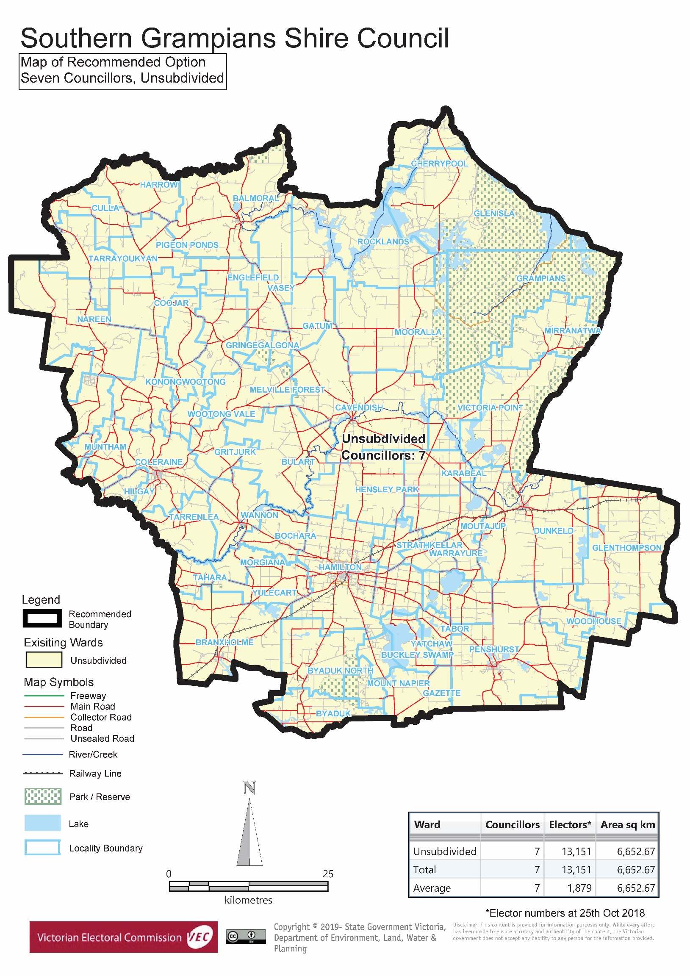{insert the final recommendation map/s – if more than one map, references to Appendix 2 above will need to be rewritten}

# Appendix 3: Public information program

Advertising

In accordance with the Act, public notices of the review and the release of the preliminary report were placed in the following newspapers:

|  |  |  |
| --- | --- | --- |
| **Newspaper** | **Notice of review** | **Notice of preliminary report** |
| *Herald Sun* | Thursday 17 January | Wednesday 20 March |
| *Hamilton Spectator* | Thursday 17 January | Tuesday 19 March |

Media releases

A media release was prepared and distributed to local media to promote the commencement of the review on Wednesday 23 January 2019. A further release was distributed with the publication of the preliminary report on Wednesday 20 March 2019. A final media advisory was circulated on the publication date of this final report.

Public information session

A public information session for people interested in the review process was held on Thursday 24 January 2019 in the Martin J Hynes Auditorium, Market Place, Hamilton.

Submissions guide

A submission guide was developed and made available on the VEC website, or in hardcopy on request, throughout the review timeline. The submission guide provided information about the review, the review timeline and how to make submissions to the review.

Online submission tool

An online submission tool was developed and made available during the submission periods of the review. The tool allowed people to make a submission from the VEC website. During the preliminary submission stage, users also had the opportunity to map out their preferred subdivisions through the online submission tool using Boundary Builder. Boundary Builder included real elector numbers so that users could see if their preferred structures and numbers of councillors met the plus-or-minus 10% rule.

VEC website

The VEC website delivered up-to-date information to provide transparency and facilitate public participation during the review process. All public submissions were published on the website.

Email and social media engagement

The VEC delivered an information email campaign targeted at known community groups and communities of interest in the local council area. This included a reminder email at each milestone of the representation review process.

The VEC also published sponsored social media advertising that was geo-targeted to users within the local council area. This included advertising at both the preliminary submission and response submission stages. The total approximate reach of these posts was 8,171 users.

Council communication resources

The VEC provided the Council with a communication pack that included information on the review in various formats. While the Council is encouraged to distribute this information and raise awareness about the review, the VEC is an independent reviewer and all communications resources include reference and links to the VEC website and core materials.

This page has been left intentionally blank

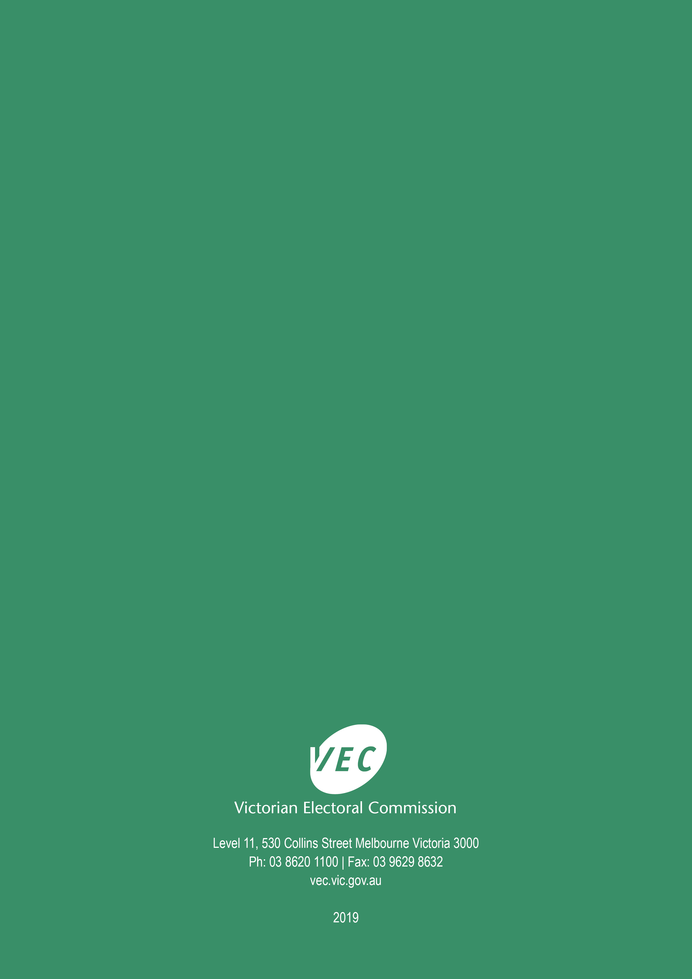

1. Section 219D of the *Local Government Act* *1989.*
2. ibid.
3. .id is a consulting company specialising in population and demographic analysis and prediction information products in most jurisdictions in Australia and New Zealand.
4. Section 5B(1) of the *Local Government Act 1989.*
5. Department of Environment, Land, Water and Planning (Victoria), *Victoria in Future: population and household projections to 2051*, Melbourne: State Government of Victoria, 2016, p. 15.
6. Demographic information compiled from Australian Bureau of Statistics (ABS), ‘Quickstats 2016’ and ABS, 2016 Census.
7. Know your council, ‘Southern Grampians Shire’, State Government of Victoria, <http://knowyourcouncil.vic.gov.au/councils/southern-grampians>, accessed 30 April 2019.
8. Southern Grampians Shire Council, *Council Plan 2017 – 2021*, Southern Grampians Shire Council, Greater Hamilton, 2017, p. 4; Southern Grampians Shire Council, *Economic Development Strategy 2011-2021*, Southern Grampians Shire Council, p. 11.
9. Department of Environment, Land, Water and Planning (Victoria), *Victoria in Future: population and household projections to 2051*, Melbourne: State Government of Victoria, 2016, p. 15.
10. Department of Environment, Land, Water and Planning (Victoria), *Victoria in Future: population and household projections to 2051*, Melbourne: State Government of Victoria, 2016, p. 15.
11. Individual profiles of the industries in Hamilton (total), Coleraine – Rural West, Rural North and Rural East, and an overall industry profile in the Shire can be accessed at: .id, ‘Southern Grampians Shire: industry sector of employment’, <https://profile.id.com.au/southern-grampians/industries?WebID=10>, accessed 30 April 2019. See also, Southern Grampians Shire Council, *Economic Development Strategy 2011-2021*, Southern Grampians Shire Council, p. 11.
12. The VEC drew on its records of councillor and candidate locations in local council areas.
13. General election statistics are available at: Victorian Electoral Commission (VEC), ‘Southern Grampians Shire Council Profile’, <https://www.vec.vic.gov.au/ElectoralBoundaries/SouthernGrampiansProfile.html>, 30 April 2019.