VEC Disclosures user guide:
submitting an annual return
Independent candidates and independent elected members

Acknowledgement
of Country
The VEC pays respect to Victoria's traditional owners and their elders past and present who have been custodians of this country for many thousands of years. Their living culture and their role in the life of Victoria is acknowledged by the VEC.

Disclaimer
The information in this user guide is specific to Victorian funding and disclosure laws and does not take into account the laws of other Australian jurisdictions. The information is also general in nature and does not consider your individual circumstances. If in doubt, you should seek professional advice.

More information
More information about funding and disclosure obligations can be found at vec.vic.gov.au/disclosures.
For further queries please contact the VEC Funding and Disclosure Unit:
T: (03) 8260 1100 or 131 832
E: disclosures@vec.vic.gov.au

Version control
Version | Date Effective | Approved by | Amendment
0.1 | 17/09/2019 | Program Manager, Funding and Disclosure | Zero
1.0 | 11/10/2019 | Director, Electoral Integrity and Regulation | Zero
2.0 | 30/06/2020 | Program Manager, Funding and Disclosure | financial year values;  system enhancements
3.0 | 30/06/2021 | Director, Electoral Integrity and Regulation | financial year values;  system enhancements

Contents
Disclaimer 2
More information 2
Definitions 4
Annual return for an independent candidate or independent elected member 5
General information 5
Documentation 5
Annual return due date 5
VEC Disclosures 6
More information 6
Offences 6
Annual return process 7
Complete annual return 7
Screen 1 – Key information 8
Income for financial year 9
Screen 2 – Upload Documents 11
Submit annual return 14

Definitions

Agent
An independent candidate or independent elected member may appoint a person as an agent. The agent will act on their behalf in relation to all funding and disclosure obligations, including reconciling political donations, maintaining the State campaign account, and submitting an annual return.

Annual return
An annual return for an independent candidate or independent elected member summarises political donations that, when aggregated, are equal to or greater than the donation threshold incurred during a financial year.

Candidate
A candidate is a person who has been selected by a political party to be a candidate in an election, or a person who is not a member of a political party that has publicly announced an intention to be a candidate in an election.

Elected member
An elected member is a person who is a member of the Legislative Council or the Legislative Assembly of the Victorian Parliament.

Recipient
A recipient is a person or organisation that receives a political donation, being a registered political party, a candidate, an elected member, an associated entity, a third-party campaigner or a nominated entity.

State campaign account
The independent candidate or independent elected member (or their registered agent) must keep a State campaign account for the purposes of State elections. All donations must be paid into the State campaign account.

Disclosure threshold
Disclosure of donations is subject to a minimum threshold below which disclosure is not required. The disclosure threshold for the 2020-21 financial year was $1,040.

Annual return for an independent candidate or independent elected member
This guide is intended to assist independent candidates and independent elected members, or their registered agent, to complete an annual return using VEC Disclosures, as provisioned under Part 12 of the Electoral Act 2002.
Important: If you didn’t receive any political donations (from any single person or entity) that, when aggregated, are equal to or greater than the disclosure threshold within the financial year, you are not required to submit an annual return.
If you are not required to submit an annual return, you are still required to email a declaration to confirm you did not receive any donations exceeding the disclosure threshold during the financial year. This declaration can be emailed to disclosures@vec.vic.gov.au.

General information
The reporting period for the 2020-21 financial year annual return is from Wednesday 1 July 2020 to Wednesday 30 June 2021.

Documentation
There is no mandatory documentation required for an annual return for an independent candidate and independent elected member, according to sections 209 and 217M of the Electoral Act 2002.
If an audit certificate is provided, it is suggested that it comes from an independent auditor and advises that the statement has been audited in accordance with Australian Accounting Standards as specified in section 334(1) of the Corporations Act 2001 (Cth). The audit certificate should state that the auditor:
- was given full and free access at all reasonable times to all accounts, records, documents and papers relating directly or indirectly to any matter required to be specified in the statement
- examined the material referred to in paragraph (a) for the purpose of giving the certificate
- received all information and explanations that the auditor requested in respect of any matter required to be specified in the statement
- has no reason to believe that any matter stated in the statement is not correct.
Download the VEC audit certificate template.

Annual return due date
Annual returns must be completed within 16 weeks after the end of financial year and are due by 20 October each year.
The 2020-21 financial year annual return is due by 11.59 pm Wednesday 20 October 2021 via VEC Disclosures.
Annual returns will be published via VEC Disclosures within six months of the end of the relevant financial year.

VEC Disclosures
Annual returns can be completed over more than one session. VEC Disclosures allows a user to ‘Save and Continue’ and return in a separate session (for further information see Edit and submit in another session.
Please note that VEC Disclosures is best viewed in Google Chrome. If you receive an error message that your browser is not compatible, follow the prompts to download and install Google Chrome.
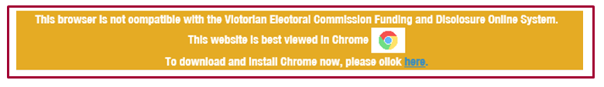

More information
For further information about annual returns and your legislative obligations, refer to Determination No. 2 of 2019 under the Electoral Act 2002.
If you have any questions or need further clarification about an annual return, please contact us.
Email: disclosures@vec.vic.gov.au
Phone: (03) 8620 1100 or 131 832.

Offences
Offences include (but are not limited to) failing to submit on time (200 penalty units) and providing false or misleading information (300 penalty units and/or 2 years imprisonment). A full list of fees and penalties can be found on the Department of Treasury and Finance website: Indexation of fees and penalties | Department of Treasury and Finance Victoria (dtf.vic.gov.au).

Annual return process

Complete annual return
- To access VEC Disclosures, visit disclosures.vec.vic.gov.au
- From the VEC Disclosures home page, select ‘Sign in’ from the top menu.
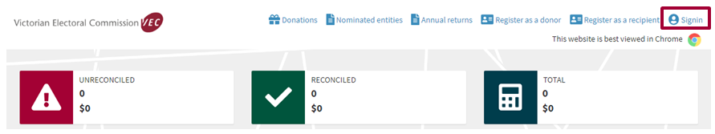
- Enter your ‘User name’ and ‘Password’ and select ‘Sign in’.
- From the dashboard, select ‘Annual returns’ from the left-hand menu.
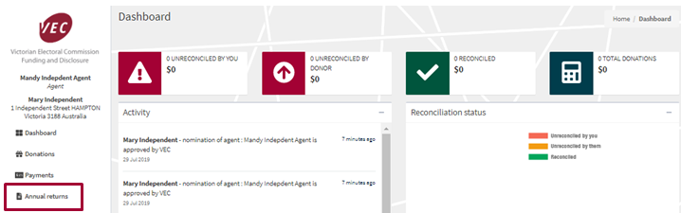

- Select ‘Lodge annual return’.
*Note: Entities can only have one active annual return per financial year.
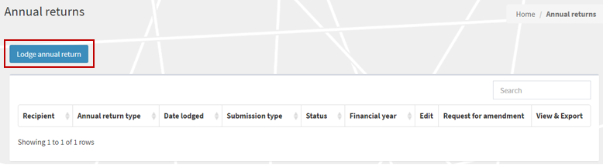

Screen 1 – Key information
- Ensure that you read and understand the key information at the top of this page before you progress through the annual return form.
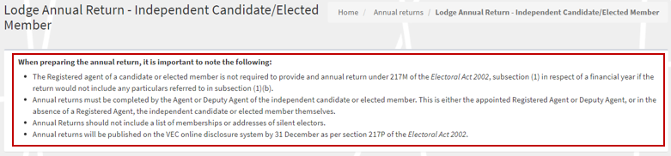
- ‘Financial year’ details are for the current financial reporting period only, and you cannot edit them.
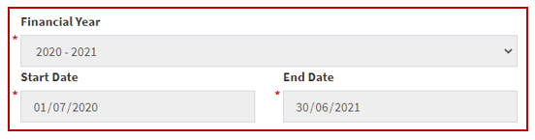

- The independent candidate or independent elected member and Agent details will auto-populate and cannot be edited.
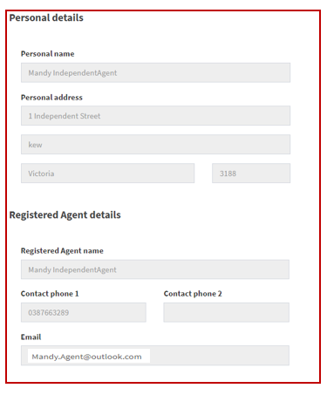
- The ‘Submitted by’ section will auto-populate with your details, as the current system user logged in. These details are locked and you cannot edit them.
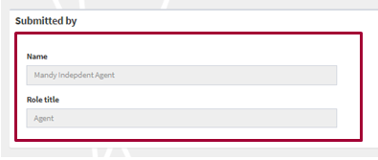

Income for financial year
All fields marked with a red asterisk (*) must be populated even if the amount is ZERO (except auto-populated fields).
- The ‘Total income (inc. GST)’ field will auto-populate for the 2020-21 financial year and cannot be edited. This figure is the total amount of disclosed political donations and total undisclosed political donations received for the 2020-21 financial year.
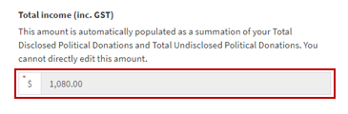
- The ‘Total disclosed political donations (inc. GST)’ field will auto-populate for the 2020-21 financial year and cannot be edited. This figure is the total disclosed political donations for the 2020-21 financial year, as previously disclosed in VEC Disclosures.
Note: This figure will also appear as a line item in ‘Table 1 – disclosed political donations’ at the bottom of the screen.
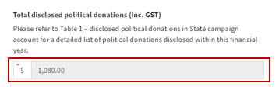
- Enter the ‘Total undisclosed political donations’ received for the 2020-21 financial year. This will include any donations received under the $1,040 disclosure threshold that were not previously disclosed in VEC Disclosures.
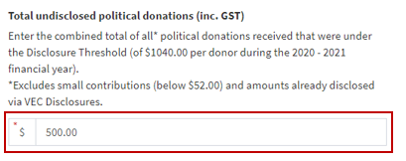
- Enter the total number of donors that have contributed to the total undisclosed political donations for the 2020-21 financial year.

Table 1 – disclosed political donations in State campaign account
- Review the pre-populated table: ‘Table 1 - disclosed political donations in State campaign account’.
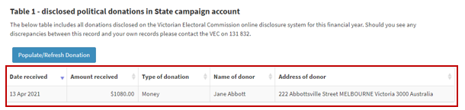
If there are any discrepancies between this record and your own records, email disclosures@vec.vic.gov.au.
If accurate, select ‘Save and Continue’. This will save a draft version of the annual return.
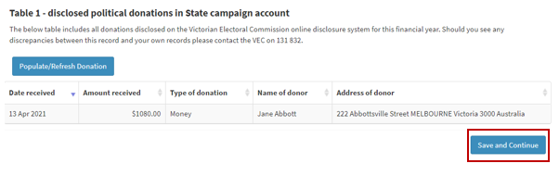
Note: You can navigate away or log out of VEC Disclosures and come back to it later.

Screen 2 – Upload Documents
- If you are an independent candidate or independent elected member, there are no mandatory annual return documents to upload.
If you wish, you may upload an audit certificate from an independent auditor advising that the annual return has been audited in accordance with Australian Accounting Standards as specified in Section 334(1) of the Corporations Act 2001 (Cth).
Download the VEC independent auditor template or access it through VEC Disclosures.
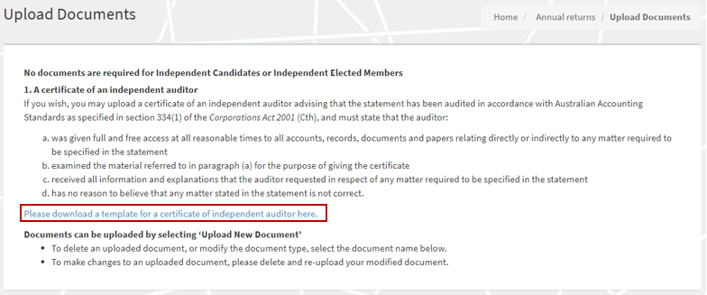
If an audit certificate is provided, the audit certificate must state that the auditor:
  - was given full and free access at all reasonable times to all accounts, records, documents and papers relating directly or indirectly to any matter required to be specified in the statement
  - examined the material referred to in paragraph (a) for the purpose of giving the certificate
  - received all information and explanations that the auditor requested in respect of any matter required to be specified in the statement
  - has no reason to believe that any matter stated in the statement is not correct.
- To upload the audit certificate, select ‘Upload New Document’.
Note: The maximum file size for a document is five megabytes (5MB). Larger files must be emailed directly to the Funding and Disclosure Unit at disclosures@vec.vic.gov.au.
- A pop-up window will prompt you to select the ‘Document Type’ from the drop-down list. You can also include a description of the document beneath.
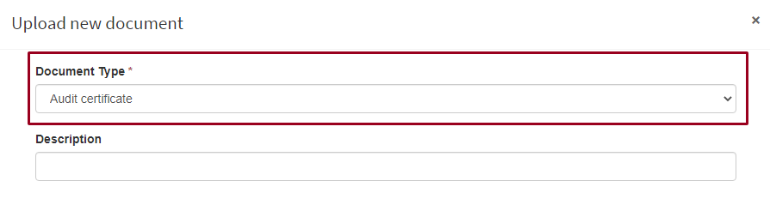

- Select ‘Choose File’.
- In the window that pops-up, navigate to your document, select it, and then select ‘Open’.
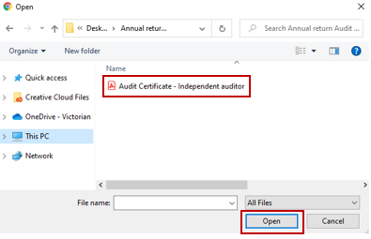
Note: The pop-up window may vary depending on your computer’s operating system.
- The name of the file you chose will appear next to the ‘Choose file’ button. Once you’ve confirmed this is the correct file name, select ‘Upload’.
- The document will appear as a line item. Any documents that appear here are saved to your annual return and will not be lost if you navigate away from this page.
*Note: To delete or modify a document in this list, click on the Document name.

- Review the acknowledgements and select the ‘I Confirm’ checkbox before submitting your annual return.
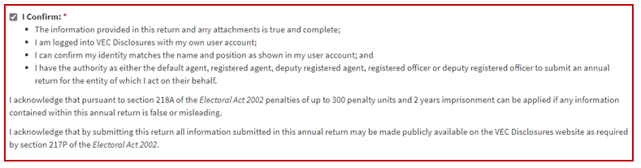
*Note: if you have any questions about the acknowledgments, contact the Funding and Disclosure Unit via email at disclosures@vec.vic.gov.au.

Submit annual return
- When you have completed your annual return, review and tick to confirm you’ve read the acknowledgments, then select ‘Submit’.
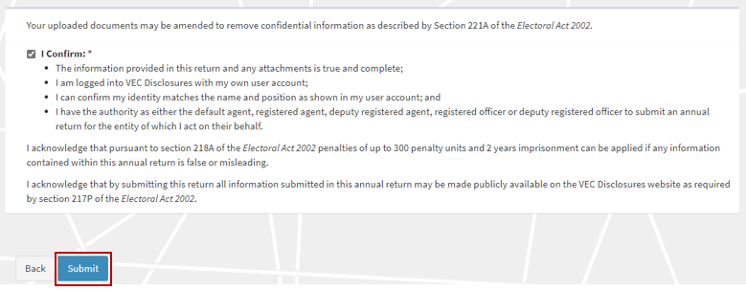
- You will see a submission confirmation screen. We will review the annual return and contact you if any further information is required.
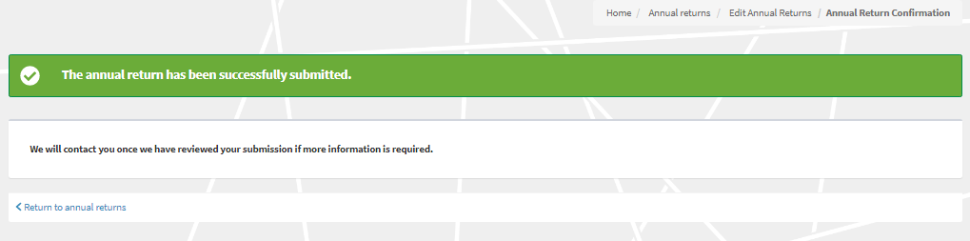

Edit and submit an annual return in another session
You can complete an annual return in multiple sessions. VEC Disclosures allows you to save your progress and come back to complete it at a later time. Make sure you save and continue if you wish to exit and come back later.
- To finalise and submit an annual return that you have previously started, log in to VEC Disclosures and go to the annual returns page. Your annual return will be listed as a line item with a status of ‘Unsubmitted’. Select ‘Edit’ to continue with your annual return.
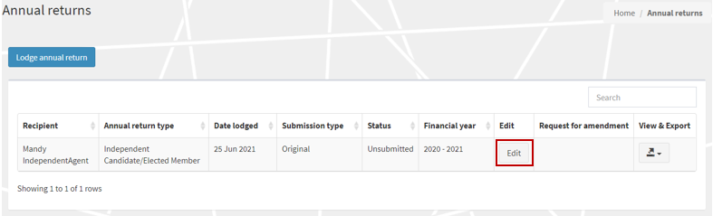
- When you have completed your annual return, review and tick to confirm you’ve read the acknowledgments, then select ‘Submit’.
- The annual return will appear as ‘Submitted’ on the Annual returns page.
Important: If you need to amend an annual return after you’ve submitted it, refer to Request an amendment or email disclosures@vec.vic.gov.au.
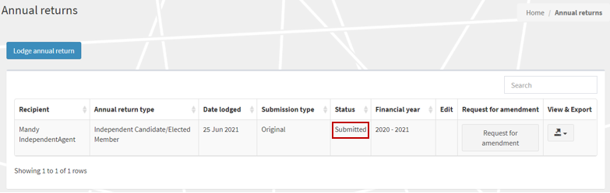

View and Export annual return
- You can now view and export a copy of your annual return. Click on the ‘View & Export’ button and then select ‘PDF’.
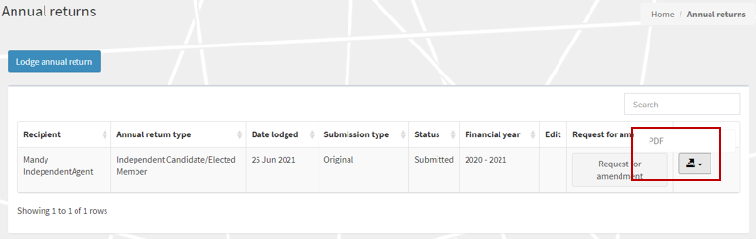
- Select the ‘Export’ button to download a copy of the PDF.
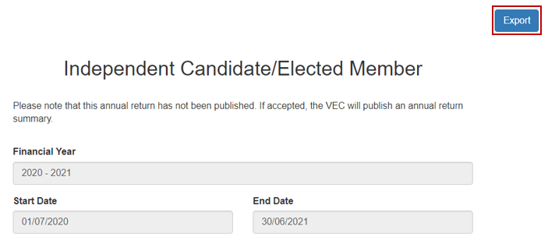
- To return back to the annual returns page, click on the grey ‘X’.

Request an amendment
- If you need to amend your annual return after submitting it, you can request an amendment through VEC Disclosures. Select ‘Request for amendment’.
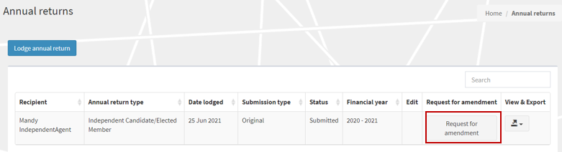
- Input the details of your amendment in the ‘Amendment Reason’ field and then select ‘Submit’.
Important: The details provided in the fields below will be published on VEC Disclosures. We recommend that you do not include any personal information.
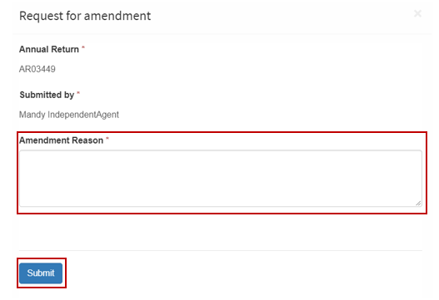
- Your request will be considered, and you may be contacted for additional information.
