Local council electoral structure review

## About the review

Under Victoria’s *Local Government Act 2020*, Monash City Council must now have a single-councillor ward electoral structure.

The Minister for Local Government has appointed an electoral representation advisory panel to conduct an electoral structure review of the council. The panel will advise the Minister on the most appropriate single-councillor ward structure for Monash City Council.

The panel is looking at:

* the appropriate number of councillors and wards
* the location of ward boundaries
* appropriate ward names.

Electoral structure reviews are an important part of democracy, and your input is valuable. As a local, you know your local council area better than anyone. This is your chance to let the panel know your thoughts about the single-councillor ward electoral structure that you believe would best provide representation for your community.

There are 2 opportunities for you to have your say on the electoral structure of the council:

1. in a response submission to the preliminary report
2. in an online public hearing, if you request to speak in your response submission.

About Monash City Council

The Traditional Custodians of the land in Monash City Council are the Wurundjeri and Bunurong peoples.

Monash City Council is in the eastern suburbs of Melbourne, approximately 20 kms from the city centre. With a population of over 190,000 at the 2021 Census, the city covers an area of 82 km².

The city is serviced by the Monash Freeway, Princes Highway, and Ferntree Gully and Springvale roads, along with the Glen Waverly, Pakenham, and Cranbourne train lines.

Suburbs in Monash City Council include Mount Waverley, Glen Waverley, Wheelers Hill, Oakleigh and Clayton.

The top employment sectors in 2021 were health care and social assistance, professional, scientific, and technical services, with professionals and managers accounting for over 45% of occupations. Unemployment, at 5.8%, was marginally higher than for Greater Melbourne overall (5.5%).

Between 2016 and 2021, the population grew by 4.3% to 190,397, especially in the suburbs of Chadstone, Oakleigh, and Oakleigh South. The median age of the population in 2021 was 38 years, marginally higher than greater Melbourne (37 years).

The city is very culturally diverse. Over 50% of residents were born overseas, with many of these from China, India, and Sri Lanka. In 56.7% of households, a non-English language is used at home, with Mandarin, Greek and Cantonese the main languages.

The weekly median household income in Monash City Council is $1,901, mirroring the greater Melbourne median.

## Current structure

Monash City Council is divided into 4 wards with a total of 11 councillors:

* 3 wards with 3 councillors each
* One ward with 2 councillors.

## Last review

The VEC conducted an electoral representation review of Monash City Council in 2011.

Review process

17 and 18 July

### Information sessions

Session 1: 12 noon, Monday 17 July

Session 2: 6 pm, Tuesday 18 July

Information sessions are for anyone wanting to find out more about the review process. Links to register for an information session will be available on the VEC website.

Wednesday 19 July

### Preliminary report

The panel will release a preliminary report including one or more options for the electoral structure on Wednesday 19 July.

**Response submissions open from this date.**

Wednesday 9 August

### Response submission close

The panel must receive all submissions by 5 pm on Wednesday 9 August.

Late submissions will not be accepted.

Wednesday 16 August

### Public hearing

The panel will hold an online public hearing if anyone requests to speak about their response submission at 10 am on Wednesday 16 August.

The public hearing will not be held if there are no requests to speak.

Wednesday 13 September

### Final report

The panel will submit a final report to the Minister for Local Government including its advice on the electoral structure on Wednesday 13 September.

The Minister will then consider the panel’s advice before recommending a change to the electoral structure. Any change to the electoral structure of the council following the review is expected to apply at the next local council elections.

## Untitled-1How to make a submission

On the VEC website at [vec.vic.gov.au](http://vec.vic.gov.au/)

By email to

[Monash.ERAPSubmissions  
@vec.vic.gov.au](mailto:Monash.ERAPSubmissions@vec.vic.gov.au)

LetterBy post to

Electoral representation advisory panel  
c/o Victorian Electoral Commission  
Level 11, 530 Collins Street  
Melbourne VIC 3000

Submissions must include your:

* full name
* contact phone number or email address
* residential or postal address.

All submissions will be published on the VEC website. Your name and locality (suburb or town) will be published, but your full address and contact details will be removed. See the submission guide and VEC website at [vec.vic.gov.au/privacy](https://www.vec.vic.gov.au/privacy) for privacy information.

## Submission guide

Download the submission guide from the VEC website at [vec.vic.gov.au](http://vec.vic.gov.au/) for more information on the review process and making a submission.

## One vote, one value

The ‘one vote, one value’ democratic principle is enshrined in the *Local Government Act 2020*. This means that every person’s vote counts equally.

When a local council area is subdivided into wards, the number of voters each councillor represents in each ward must be plus-or-minus 10% of the of the average number of voters per councillor for all the wards.

The map below includes the current number of voters in each ward and the ward’s current deviation from the average. The panel will consider likely population and voter changes to ensure the structure remains equitable.

If you make a submission online, you can use a mapping tool to build your preferred electoral structure. The tool uses current voter numbers to tell you the deviations of the wards you make. This will help you propose a structure that meets the requirements of the Act.

Current electoral structure

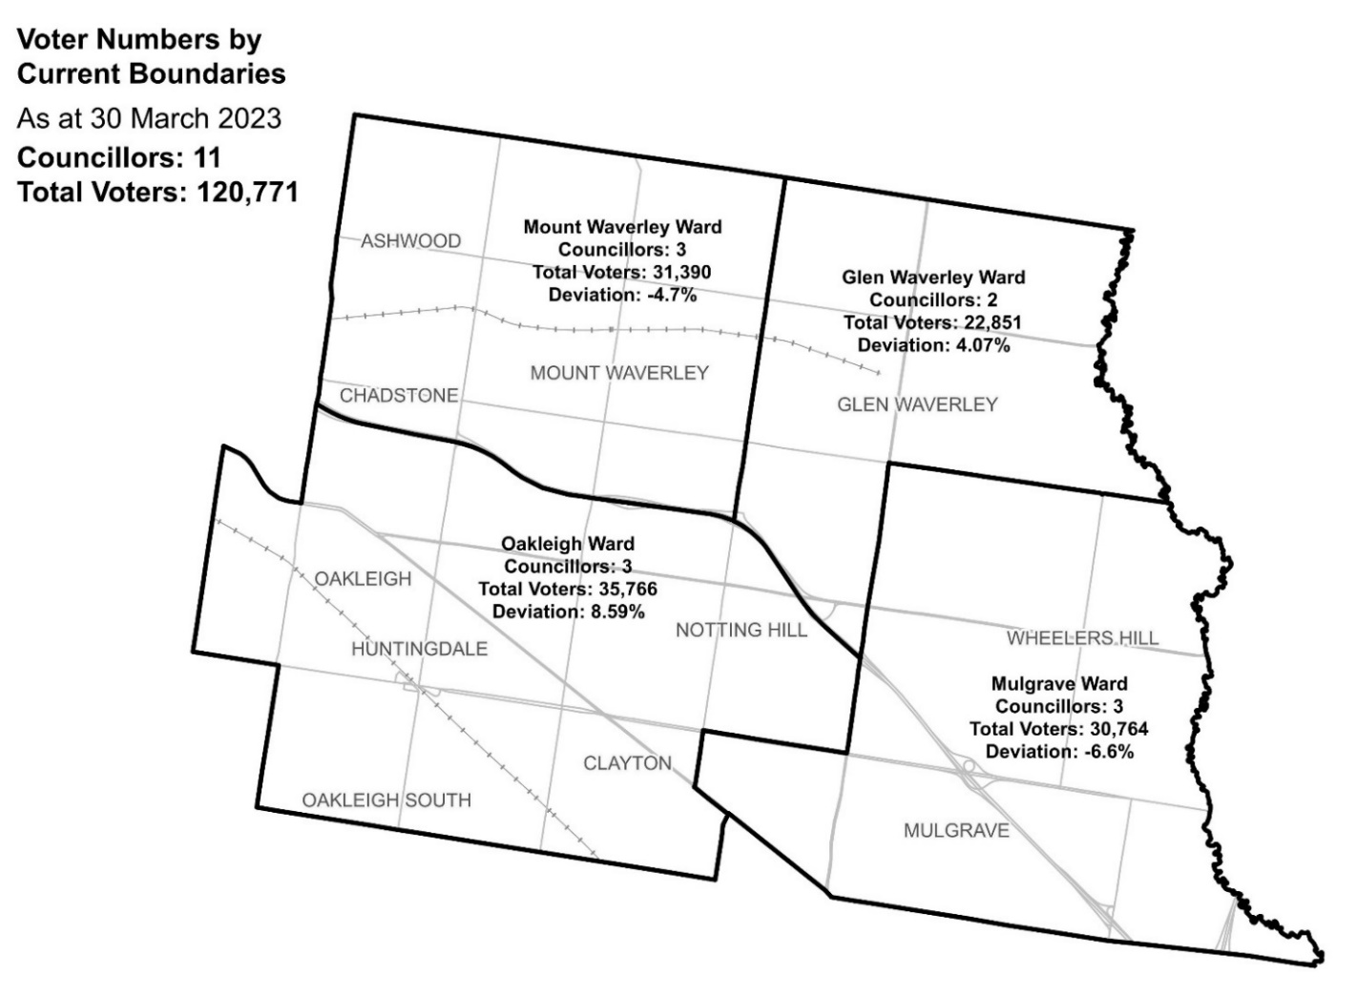

|  |  |  |  |
| --- | --- | --- | --- |
| Ward | Councillors | Voters | Deviation |
| Glen Waverley Ward | 2 | 22,851 | +4.07% |
| Mount Waverley Ward | 3 | 31,390 | -4.70% |
| Mulgrave Ward | 3 | 30,764 | -6.60% |
| Oakleigh Ward | 3 | 35,766 | +8.59% |

## Statistics

Area (km2) 82

Voters

### Voter per square km

1,472.8

### Average voters per councillor

10,979

Population

### Current population

190,397

### Forecast population growth

0.6% p.a.

Further census statistics available at [abs.gov.au](http://www.abs.gov.au/)

Voter numbers by locality (map)

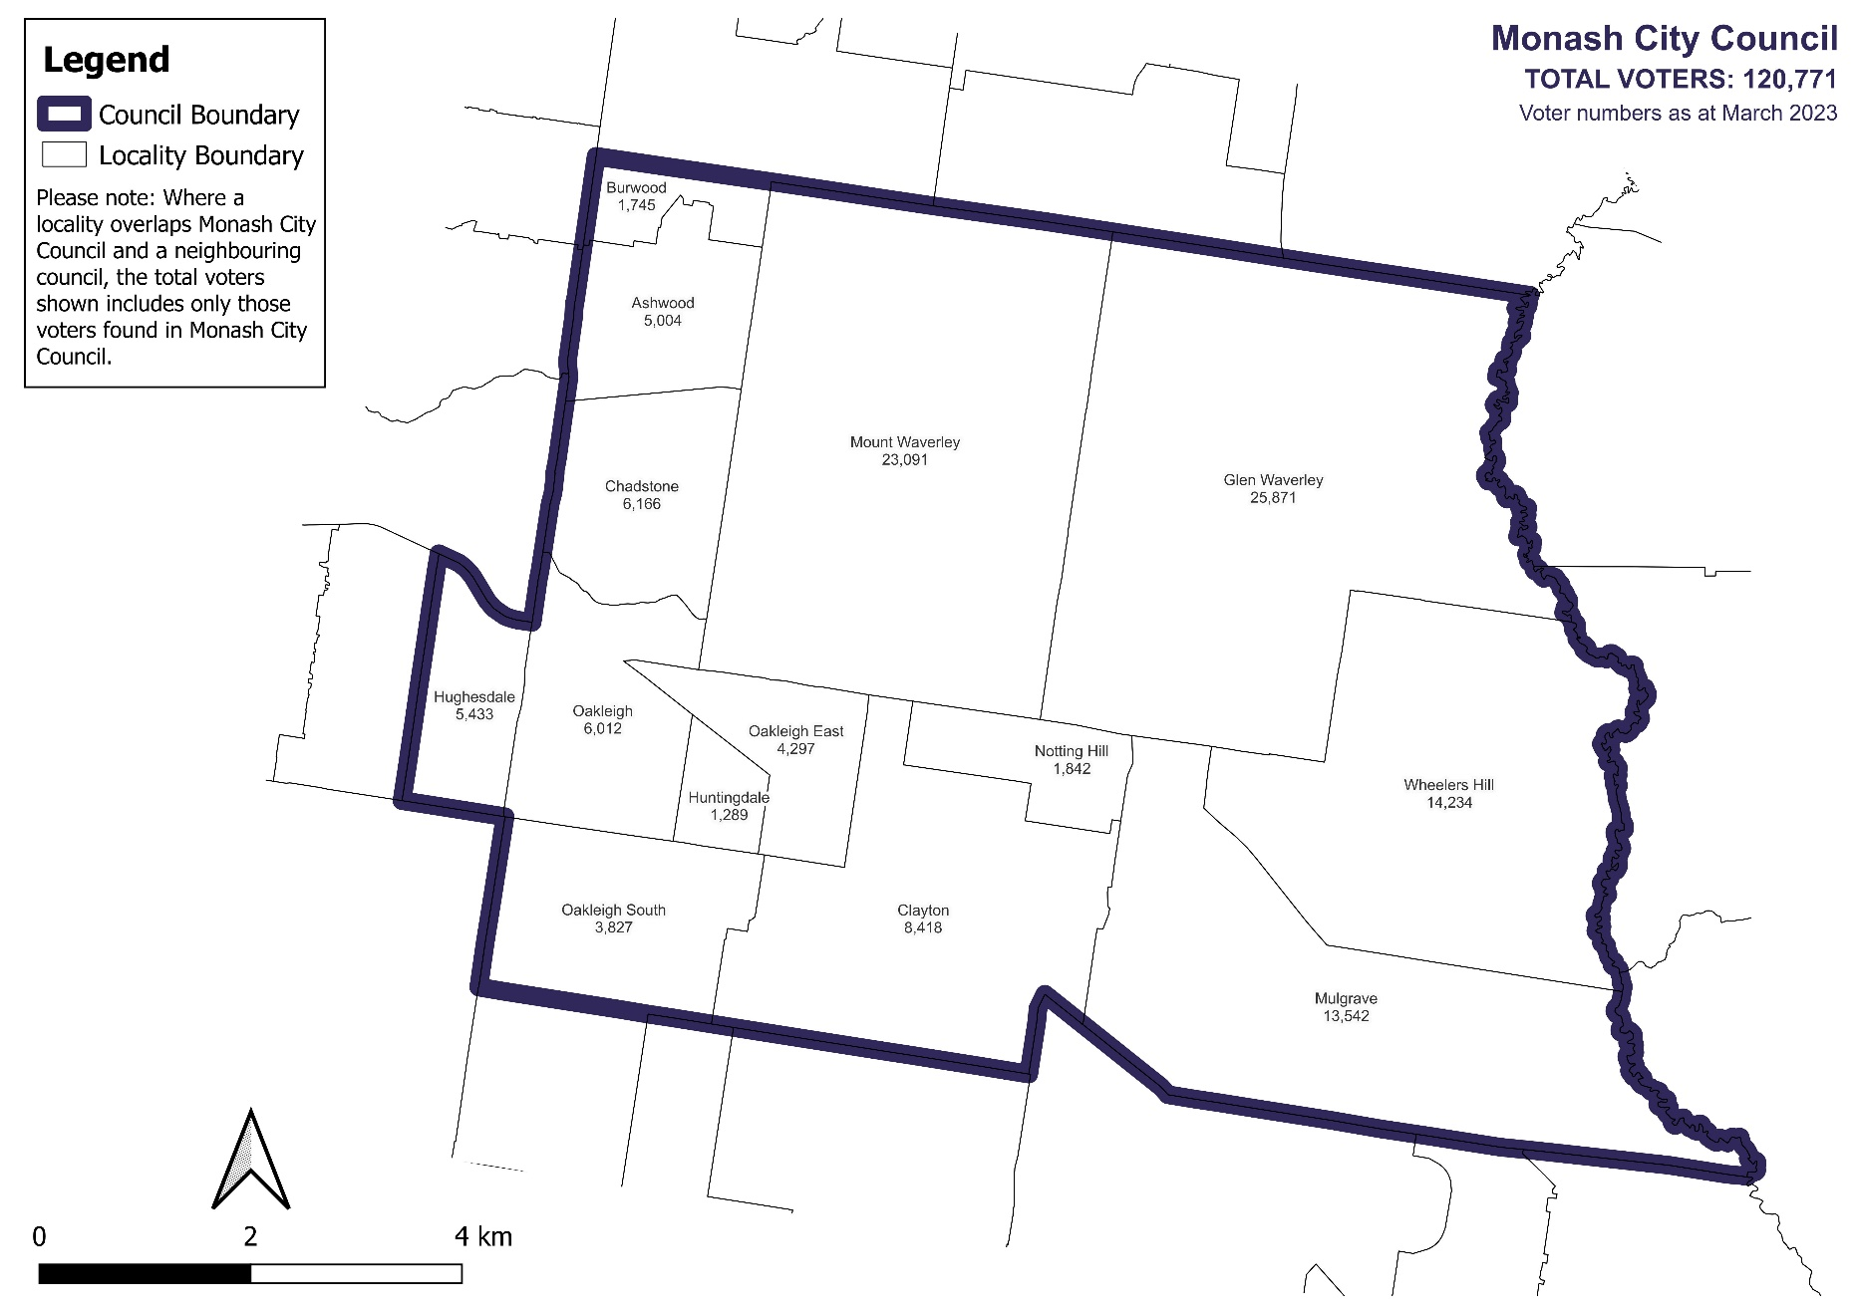

Voter numbers by locality (table)

## Monash City Council voter numbers as at 30 March 2023

|  |  |
| --- | --- |
| Locality | Voters |
| Ashwood | 5,004 |
| Burwood | 1,745 |
| Chadstone | 6,166 |
| Clayton | 8,418 |
| Glen Waverley | 25,871 |
| Hughesdale | 5,433 |
| Huntingdale | 1,289 |
| Mount Waverley | 23,091 |
| Mulgrave | 13,542 |
| Notting Hill | 1,842 |
| Oakleigh | 6,012 |
| Oakleigh East | 4,297 |
| Oakleigh South | 3,827 |
| Wheelers Hill | 14,234 |