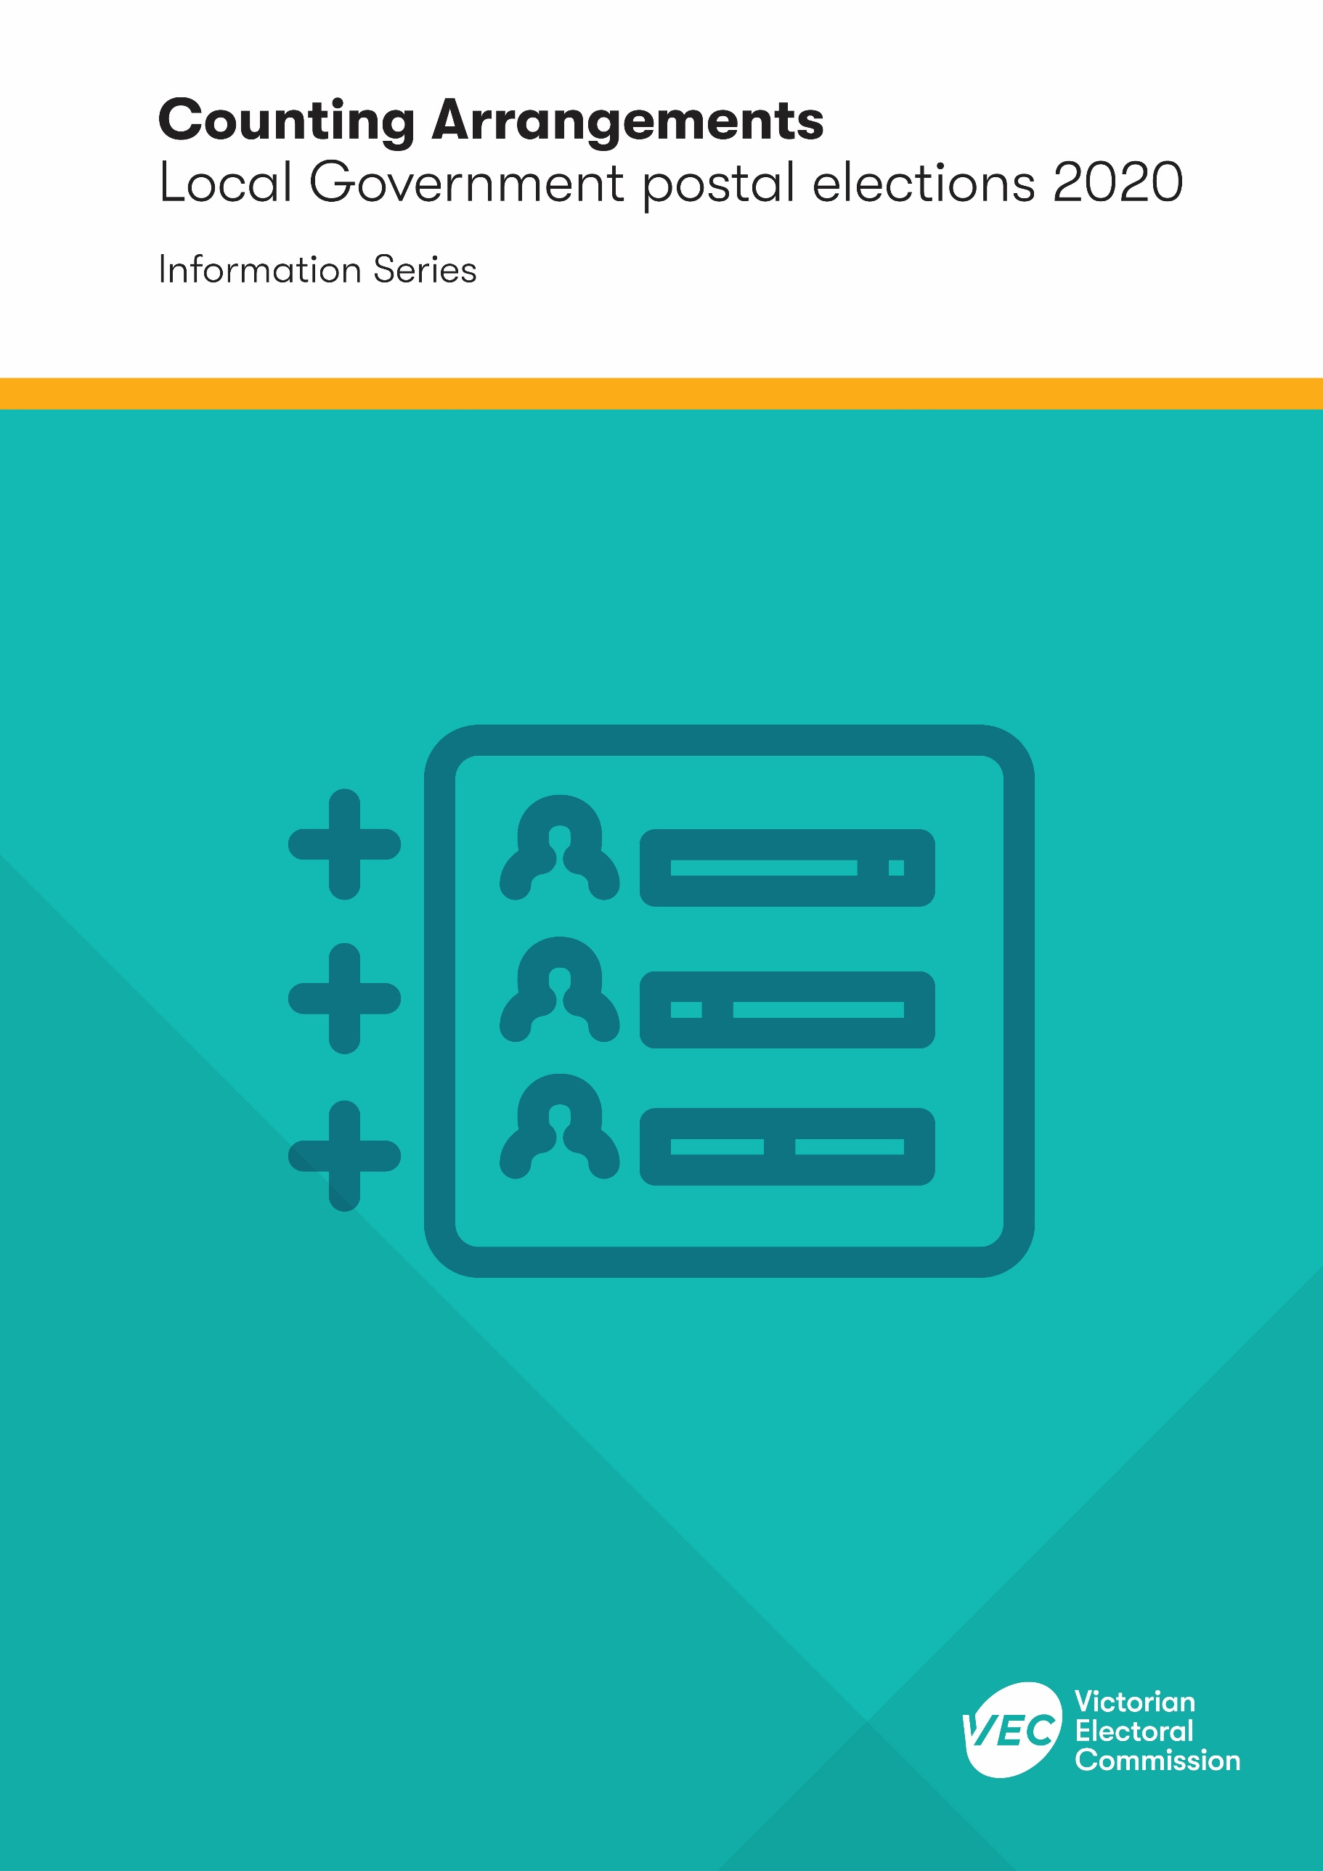
Election event
o
rt Template
Month Year

Acknowledgement
of Country
The VEC pays respect to Victoria's traditional owners and their elders past and present who have been custodians of this country for many thousands of years. Their living culture and their role in the life of Victoria is acknowledged by the VEC.

Version history
Subject matter expert | Date received | Date returned
Narelle Parsons | 22/05/2020 | 25/05/2020

Contents
Introduction 4
How are votes counted? 4
Preferential counting 4
Proportional counting 5
Melbourne City Council 5
What if there are two candidates with the same number of votes? 5
When are the results announced? 5
Victoria’s local council structures – effective from October 2020 7

Introduction
The Victorian Electoral Commission (VEC) is the statutory election service provider to local councils in the state. This publication provides an overview of the vote counting process. It is part of the 2020 Local Government Election Information Series on the VEC website.
In 2020, 76 councils in Victoria will be going to an election in October.
The South Gippsland Shire Council election has been postponed until October 2021, and the Casey City Council and Whittlesea City Council elections have been postponed until October 2024.
All 76 council elections will be by postal voting, as determined by the Minister for Local Government.
Once nominations have closed (12 noon, Tuesday 22 September 2020) and the number of candidates is known, the VEC prepares a counting timeline for each council.

How are votes counted?
Postal votes can be received in the mail until 12 noon on the fifth working day after election day, as long as the voter voted before the close of voting on Friday 23 October 2020.
To vote correctly in a local council election you must number every box on the ballot paper in the order of your choice. Ballot papers that are not completed correctly – for example, the voter uses ticks or crosses – are declared informal and set aside to be checked.
There are two counting methods used for local council elections: preferential counting and proportional counting. The method used for each council depends on the number of vacancies to be filled. Elections involving a single vacancy use the preferential counting method, whereas elections involving multiple vacancies use the proportional counting method.
Melbourne City Council elections are different to those of other Victorian councils. During a general election for Melbourne City Council, two elections are run at the same time – one to elect the Leadership Team of Lord Mayor and Deputy Lord Mayor, and one to elect nine councillors.

Preferential counting
Preferential counting is used for single councillor wards when only one person is to be elected. These counts are usually done manually. Computerised counting may be used where there are high numbers of ballot papers and/or candidates.
To be elected, a candidate must have more than 50% of the formal first preference votes. This is known as an absolute majority.
If no candidate has an absolute majority once all the votes are counted, then a preference distribution is required. The candidate with the fewest votes is excluded and the preferences on those ballot papers are given to the voter’s second choice. If there is still no candidate with an absolute majority, the process is repeated until someone is elected.

Proportional counting
Proportional counting is used when there is more than one vacancy to be filled. In local council elections, this means unsubdivided councils and multi-councillor wards. It ensures that candidates are elected in proportion to their support from voters.
Proportional counting is complex and time-consuming and is therefore done by computer. The preferences from formal ballot papers are entered into the VEC’s computer count application. Results are calculated once all data has been entered and any informal ballot papers have been checked.
To be elected, candidates must receive a proportion of votes known as a quota.
The quota is calculated as follows, with any remainder disregarded:
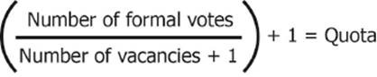
Candidates who achieve the quota are elected and any votes they receive over the quota are distributed to other candidates according to the preferences.
If no candidate achieves the quota, or if there are still vacancies to be filled once all votes over the quota have been distributed, the candidate with the fewest votes is excluded. Their votes are distributed to other candidates according to preferences. This is repeated until all vacancies are filled.

Melbourne City Council
Computer counts are used for the Melbourne City Council elections. Ballot papers for Melbourne City Council are separated into the Leadership Team and Councillors. The Councillor ballot papers are then sorted into groups and ungrouped candidates. The Leadership Team election is determined using preferential counting and the Councillor election is determined using the proportional counting method.

What if there are two candidates with the same number of votes?
If two candidates have the lowest number of votes at any exclusion, the candidate who had the fewest votes when they were last unequal will be excluded. However, if the candidates have not had an unequal number of votes at any point, the Election Manager will during a manual count conduct a draw by lot (using a bingo barrel), to determine which of the candidates will be excluded. Where this occurs during a computerised count the count application automatically chooses the candidate to be excluded.
If, on the final count, two candidates have an equal number of votes, the Election Manager conducts a draw using a bingo barrel to determine which candidate is to be excluded. The remaining candidate is declared successful. During a computerised count the system determines the successful candidate.

When are the results announced?
The Election Manager provides a provisional result when the counting has been completed. The Election Manager will review the results to determine if there are any close margins. Results will also be independently reviewed by staff in VEC Head Office. Where a sufficiently close margin is identified, or where other factors are present which may bring into question the accuracy of the results, the Election Manager will initiate a recount.
Between the provisional result and the declaration of final results (usually a minimum of two hours), a candidate may also request a recount. If the Election Manager is satisfied that the reasons provided by the candidate may have affected the election result, a recount will be required. Depending on the circumstances, a recount may involve some or all of the ballot papers from the initial count. In some cases, it may be deemed necessary to only review the informal ballot papers again. In other cases, it may be deemed necessary to only review ballot papers for particular candidates. If the result is not clear following recount activities, further recounting will occur.
The result of the recount (or partial recount) replaces the original count. The Election Manager then publicly declares the result. Results are published on the VEC’s website as they become available.

Victoria’s local council structures – effective from October 2020
PD = Preference Distribution (if required)
PR = Proportional Representation
Council | No. of Councillors | Electoral structure | Count type |  |  | Election Type
Alpine | 7 | Unsubdivided | Computer PR |  |  | Postal
Ararat | 7 | Unsubdivided | Computer PR |  |  | Postal
Ballarat | 9 | 3 three-Cr wards | Computer PR |  |  | Postal
Banyule | 9 | 9 single-Cr wards | Manual PD |  |  | Postal
Bass Coast | 9 | 3 three-Cr wards | Computer PR |  |  | Postal
Baw Baw | 9 | 3 three-Cr wards | Computer PR |  |  | Postal
Bayside | 7 | 7 single-Cr wards | Manual PD |  |  | Postal
Benalla | 7 | Unsubdivided | Computer PR |  |  | Postal
Boroondara | 11 | 11 Single-Cr wards | Manual PD |  |  | Postal
Brimbank | 11 | 3 three-Cr wards, 1 two-Cr ward | Computer PR |  |  | Postal
Buloke | 7 | 1 three-Cr ward, 2 two-Cr wards | Computer PR |  |  | Postal
Campaspe | 9 | 2 three-Cr wards, 3 single-Cr wards | Computer PR and Manual PD |  |  | Postal
Cardinia | 9 | 9 single-Cr wards | Manual PD |  |  | Postal
Casey | No election—next election scheduled for October 2024
Central Goldfields | 7 | 1 four-Cr ward, 3 single-Cr wards | Computer PR and Manual PD |  |  | Postal
Colac Otway | 7 | Unsubdivided | Computer PR |  |  | Postal
Corangamite | 7 | 1 three-Cr wards, 4 single-Cr wards | Computer PR and Manual PD |  |  | Postal
Darebin | 9 | 9 single-Cr wards | Manual PD |  |  | Postal
East Gippsland | 9 | Unsubdivided | Computer PR |  |  | Postal
Frankston | 9 | 3 three-Cr wards | Computer PR |  |  | Postal
Gannawarra | 7 | 1 three-Cr ward, 1 two-Cr ward, 2 single-Cr wards | Computer PR and Manual PD |  |  | Postal
Glen Eira | 9 | 3 three-Cr wards | Computer PR |  |  | Postal
Glenelg | 7 | Unsubdivided | Computer PR |  |  | Postal
Golden Plains | 7 | Unsubdivided | Computer PR |  |  | Postal
Greater Bendigo | 9 | 3 three-Cr wards | Computer PR |  |  | Postal
Greater Dandenong | 11 | 11 single-Cr wards | Manual PD |  |  | Postal
Greater Geelong | 11 | 3 three-Cr wards, 1 two-Cr ward |  | Computer PR | Postal
Greater Shepparton | 9 | Unsubdivided | Computer PR |  |  | Postal
Hepburn | 7 | 2 two-Cr wards, 3 single-Cr wards | Computer PR and Manual PD |  |  | Postal
Hindmarsh | 6 | 3 two-Cr wards | Computer PR |  |  | Postal
Hobsons Bay | 7 | 1 three-Cr ward, 2 two-Cr wards | Computer PR |  |  | Postal
Horsham | 7 | Unsubdivided | Computer PR |  |  | Postal
Hume | 11 | 2 four-Cr wards, 1 three-Cr ward | Computer PR |  |  | Postal
Indigo | 7 | Unsubdivided | Computer PR |  |  | Postal
Kingston | 11 | 11 single-Cr wards | Manual PD |  |  | Postal
Knox | 9 | 9 single-Cr wards | Manual PD |  |  | Postal
Latrobe | 9 | 1 four-Cr ward, 2 two-Cr wards, 1 single-Cr ward | Computer PR and Manual PD |  |  | Postal
Loddon | 5 | 5 single-Cr wards | Manual PD |  |  | Postal
Macedon Ranges | 9 | 3 three-Cr wards | Computer PR |  |  | Postal
Manningham | 9 | 9 single-Cr wards | Manual PD |  |  | Postal
Mansfield | 5 | Unsubdivided | Computer PR |  |  | Postal
Maribyrnong | 7 | 1 three-Cr ward, 2 two-Cr wards | Computer PR |  |  | Postal
Maroondah | 9 | 9 single-Cr wards | Manual PD |  |  | Postal
Melbourne | 2 + 9 | 1 vacancy (for Lord Mayor and Deputy Lord Mayor) and nine-Cr (unsubdivided) | Computer PD and Computer PR |  |  | Postal
Melton | 9 | 1 four-Cr ward, 1 three-Cr ward, 1 two-Cr ward | Computer PR |  |  | Postal
Mildura | 9 | Unsubdivided | Computer PR |  |  | Postal
Mitchell | 9 | 3 three-Cr wards | Computer PR |  |  | Postal
Moira | 9 | Unsubdivided | Computer PR |  |  | Postal
Monash | 11 | 3 three-Cr wards, 1 two-Cr ward | Computer PR |  |  | Postal
Moonee Valley | 9 | 3 three-Cr wards | Computer PR |  |  | Postal
Moorabool | 7 | 1 four-Cr ward, 3 single-Cr wards | Computer PR and Manual PD |  |  | Postal
Moreland | 11 | 2 four-Cr wards, 1 three-Cr ward | Computer PR |  |  | Postal
Mornington Peninsula | 11 | 2 three-Cr wards, 1 two-Cr ward, 3 single-Cr wards | Computer PR and Manual PD |  |  | Postal
Mount Alexander | 7 | 1 three-Cr ward, 4 single-Cr wards | Computer PR and Manual PD |  |  | Postal
Moyne | 7 | Unsubdivided | Computer PR |  |  | Postal
Murrindindi | 7 | 7 single-Cr wards | Manual PD |  |  | Postal
Nillumbik | 7 | 7 single-Cr wards | Manual PD |  |  | Postal
Northern Grampians | 7 | 1 three-Cr ward, 1 two-Cr ward, 2 single-Cr wards | Computer PR and Manual PD |  |  | Postal
Port Phillip | 9 | 3 three-Cr wards | Computer PR |  |  | Postal
Pyrenees | 5 | 5 single-Cr wards | Manual PD |  |  | Postal
Queenscliffe | 5 | Unsubdivided | Computer PR |  |  | Postal
South Gippsland | No election—next election scheduled for October 2021
Southern Grampians | 7 | Unsubdivided | Computer PR |  |  | Postal
Stonnington | 9 | 3 three-Cr wards | Computer PR |  |  | Postal
Strathbogie | 7 | 2 two-Cr wards, 3 single-Cr wards | Computer PR and Manual PD |  |  | Postal
Surf Coast | 9 | 1 four-Cr ward, 2 two-Cr wards, 1 single-Cr ward | Computer PR and Manual PD |  |  | Postal
Swan Hill | 7 | Unsubdivided | Computer PR |  |  | Postal
Towong | 5 | Unsubdivided | Computer PR |  |  | Postal
Wangaratta | 7 | 1 four-Cr ward, 3 single-Cr wards | Computer PR and Manual PD |  |  | Postal
Warrnambool | 7 | Unsubdivided | Computer PR |  |  | Postal
Wellington | 9 | 3 three-Cr wards | Computer PR |  |  | Postal
West Wimmera | 5 | Unsubdivided | Computer PR |  |  | Postal
Whitehorse | 11 | 11 single-Cr wards | Manual PD |  |  | Postal
Whittlesea | No election—next election scheduled for October 2024
Wodonga | 7 | Unsubdivided | Computer PR |  |  | Postal
Wyndham | 11 | 2 four-Cr wards, 1 three-Cr ward | Computer PR |  |  | Postal
Yarra | 9 | 3 three-Cr wards | Computer PR |  |  | Postal
Yarra Ranges | 9 | 9 single-Cr wards | Manual PD |  |  | Postal
Yarriambiack | 7 | 1 three-Cr ward, 2 two-Cr wards | Computer PR |  |  | Postal

PD = Preference Distribution (if required)
PR = Proportional Representation

