July 2023

Monash City Council

Local council electoral structure review

Preliminary   
Report

Acknowledgement of Country

The electoral representation advisory panel acknowledges the Wurundjeri and Bunurong peoples as the Traditional Custodians of the lands and waters for which it is holding this review and pays respects to ancestors and Elders past, present and emerging. The panel acknowledges their custodianship for many thousands of years and their continuing living culture.

Document history and version control

|  |  |  |  |
| --- | --- | --- | --- |
| **Version** | **Date approved** | **Submission approved by** | **Brief description** |
| 1 | 14 July 2023 | Strategic Advisor, Enrolment | Final version for publication |

Contents

Executive summary 4

Developing electoral structure models 4

Electoral structure models 4

Next steps 4

Background 6

About the 2023–24 electoral structure reviews 6

The electoral representation advisory panel 6

Public engagement 6

Developing recommendations 7

About Monash City Council 11

Profile 11

Current number of councillors and electoral structure 13

Last electoral structure review 13

Preliminary findings and models 15

Number of councillors 15

Electoral structure 16

Models for public feedback 21

Ward names 21

Next steps 23

Response submissions 23

Public hearing 24

Final report 24

References 25

Appendix 1: Model maps 26

# Executive summary

An independent electoral structure review panel appointed by the Minister for Local Government is reviewing the electoral structure of Monash City Council.

The purpose of the review is to advise the Minister on the appropriate number of councillors and electoral structure, including ward names, for the council.

Under Victoria’s *Local Government Act 2020* (the Act), Monash City Council must now have a single-councillor ward electoral structure.

The panel is looking at:

* + the appropriate number of councillors and wards for the council
  + the location of ward boundaries
  + appropriate ward names.

This report outlines the preliminary models the panel is presenting for public consultation, for the proposed new electoral structure of Monash City Council to meet the requirements of the Act.

More information about the background to the review is available on page 6.

## Developing electoral structure models

The panel considered a range of factors when deciding on the models in this report, including:

* + research and analysis
  + voter growth or decline over time.

More information on the way the panel decided on the models is available on page 7.

## Electoral structure models

After considering research and the requirements of the Act, the panel is presenting the following electoral structure models for public consultation:

* Model 1: a subdivided electoral structure with a total of 11 councillors – 11 wards with one councillor per ward.
* Model 2: a subdivided electoral structure with a total of 11 councillors – 11 wards with one councillor per ward, with different ward boundaries to Model 1.
* Model 3: a subdivided electoral structure with a total of 11 councillors – 11 wards with one councillor per ward, with different ward boundaries to Model 1 and Model 2.

Details on these models, including maps, are available in Appendix 1.

## Next steps

The panel is now seeking feedback on the preliminary electoral structure models. You can make a response submission to the preliminary models until 5 pm Wednesday 9 August. If any response submitters wish to speak at a public hearing, the panel will hold an online public hearing on Wednesday 16 August. Following this, the panel will present its final recommendation to the Minister on Wednesday 13 September 2023.

More information about the review process is available on the Victorian Electoral Commission (VEC) website at [vec.vic.gov.au](https://www.vec.vic.gov.au/).

# Background

## About the 2023–24 electoral structure reviews

In October 2022, the Minister for Local Government formed 2 electoral representation advisory panels to review and provide advice on the electoral structures of 39 local councils, under section 16 of the Act. If the Minister accepts the electoral structure recommended by the panel, any changes will take effect at the October 2024 local council elections.

The Act introduced several changes to local government representation, including the types of electoral structures local councils may have. All metropolitan, interface and regional city councils (including Monash City Council) must now have single-councillor ward electoral structures.

For Monash City Council, the electoral representation advisory panel is examining:

* the number of councillors and wards
  + where the ward boundaries should be
  + the name of each ward.

The Act requires electoral structures to provide fair and equitable representation and facilitate good governance. Each ward must have an approximately equal number of voters per councillor (within +/-10% of the average). While conducting the review, the panel also notes the role of a councillor as specified under section 28 of the Act.

## The electoral representation advisory panel

The panel conducting the electoral structure review of Monash City Council has 3 members:

* Ms Julie Eisenbise (Chairperson)
* Mr Tim Presnell
* Acting Electoral Commissioner Ms Dana Fleming.

The purpose of the review is to advise the Minister on the appropriate number of councillors and electoral structure, including ward names, for the council. The panel is independent of councils and the Victorian State government.

Under the Act, the VEC is not responsible for reviewing council electoral structures but must provide administrative and technical support to the panel. The Electoral Commissioner (or their delegate) must be a member of each panel.

## Public engagement

### Public information program

On behalf of the panel, the VEC has conducted a public information and awareness program to inform the public about the Monash City Council electoral structure review. This has included:

* + printed public notices in state-wide newspapers
  + public information sessions to outline the review process and respond to questions from the community
  + media releases to announce the start of the review
  + information on social media channels
  + notified voters in the council area who are subscribed to the VEC’s [VoterAlert](https://vec.vic.gov.au/voteralert) service of the release of the preliminary report and opening of response submissions
  + updated website content on [vec.vic.gov.au](https://www.vec.vic.gov.au/), including:
    - current information on the review process
    - submission guide and fact sheets for each council under review with background information.

The VEC will continue to promote the review on behalf of the panel during the response submission stage via media releases, the VEC’s social media channels and the VEC website.

### Public consultation

The panel now invites input to the electoral structure review of Monash City Council via:

* + response submissions to this preliminary report
  + an online public hearing for anyone who makes a response submission to speak to the panel and expand on their submission.

Public submissions are an important part of the review process and are considered alongside other factors addressed during the review. These are outlined below.

## Developing recommendations

The electoral structure models the panel is presenting in this preliminary report comply with the Act and were developed through careful consideration of:

* + research and analysis conducted by the VEC support team, including geospatial and demographic data
  + rates or patterns of population and voter change over time, and relevant forecasts of growth or decline based on forecast information provided by .id (informed decisions, a company specialising in demographics and forecasting).

### Deciding on the number of councillors

The Act allows local councils to have between 5 and 12 councillors, but neither the Act nor the Local Government (Electoral) Regulations 2020 specify how the number of councillors is to be determined. Therefore, the models put forward by the panel in this report are guided by the Act’s intention for fairness and equity in voter representation.

In examining the appropriate number of councillors for Monash City Council, the panel considered the following criteria:

* + the population and number of voters in the council area, compared to other councils with a similar population size and number of voters in the same category (for example, other comparable metropolitan, interface or regional city councils)
  + patterns of population change and voter growth or decline in the council area over time
  + the current and past numbers of councillors
  + the representation needs of the communities of interest in the council area.

The panel’s final recommendation will also consider any matters raised in public response submissions not already listed above.

Local councils with a larger number of voters will often have more councillors. Large populations generally have greater diversity, both in the type and number of communities of interest and issues relating to representation. However, the ideal number of councillors can also be influenced by the circumstances of each council, such as the:

* + nature and complexity of services the council provides
  + geographic size and topography of the area
  + forecast population and voter growth or decline
  + social diversity.

### Deciding the electoral structure

Under the Act, regional city, metropolitan and interface councils must now have single-councillor ward electoral structures.

When developing single-councillor ward models for Monash City Council, the panel considered these criteria:

* + whether the structure would comply with section 15(2) of the Act (see below), and for how long it would likely comply
  + the appropriate number of councillors, as outlined above
  + whether meaningful and effective ward boundaries could be established and whether these would be easily identifiable to local communities
  + the representation of communities of interest
  + the voter distribution and physical features of the area, and the impact these may have on the shape and size of wards
  + past elections for the council, including:
    - numbers of candidates nominating
    - incidences of uncontested elections
    - rates of informal voting.

The panel’s final recommendation will also consider any matters raised in public response submissions not already listed above.

Under section 15(2) of the Act, subdivided structures must aim for an approximately equal number of voters per councillor in each ward. This means the number of voters represented by each councillor in a ward should be within +/-10% of the average number of voters per councillor for all wards.

During this review, the panel aims to recommend a structure that will comply with section 15(2) at the time of the 2024 local council elections and, if possible, also comply based on voter numbers at the time the review is conducted. The panel uses forecasts of population and voter change to assess compliance at the 2024 elections with as much accuracy as possible. In some cases, population change and other factors impacting voter numbers mean it is not possible to create compliant subdivided structures based both on voter numbers that were current at the time of the review and forecast voter numbers. In these instances, the panel prioritises compliance at the 2024 local government elections to ensure each vote will have approximately equal value at the 2024 election.

One of the factors that may impact compliance with section 15(2) is the number of current and forecast voters with ratepayer-based voting entitlements, also known as council-enrolled electors. Voters’ rolls include both state-enrolled electors (the majority of the roll) and a smaller number of council-enrolled electors. The Act introduced changes to ratepayer-based entitlement categories, which come into full effect at the 2024 local council elections. The panel will take this change to the makeup of voters’ rolls, and therefore compliance with section 15(2) of the Act, into consideration during this review.

### Deciding on ward names

The panel has taken the following approach to naming wards.

1. Retaining existing ward names if these are still relevant to the area covered by the ward.
2. When a new name is required, the panel bases this on features such as:
   * + places (registered under the *Geographic Place Names Act 1998*) in the ward
     + compass directions
     + native flora or fauna.

### Use of Aboriginal language

The panel recognises that there should first be meaningful consultation with local Aboriginal communities and groups before a ward is named using Aboriginal language. Meaningful consultation is a significant process that the panel is not able to undertake within the timeframes of the current review program.

The panel also recognises that many of the place names in current use across Victoria are based on Aboriginal language. As such, the panel may put forward new ward names using Aboriginal language if:

* it is the name of a place within a ward
* it is currently in common use

and

* the name is registered under the *Geographic Place Names Act 1998*.

Unregistered names using Aboriginal language have not been put forward by the panel as new ward names. While the panel supports the adoption of names based on Aboriginal language, this requires appropriate consultation.

Accordingly, for the panel to consider an Aboriginal language ward name that is suggested in a public submission to the review, the name submitted needs to comply with the above guidelines.

# About Monash City Council

## Profile

Monash City Council covers an area of 82 km² and is located in the south-eastern suburbs of Melbourne, approximately 20 km from the Melbourne CBD. It shares its borders with Whitehorse City Council to the north, Knox City Council to the east, Greater Dandenong and Kingston city councils to the south-east, and Glen Eira, Stonnington and Boroondara city councils to the CBD side of the council’s western boundary.

The Traditional Custodians of the land within Monash City Council are the Wurundjeri and Bunurong peoples.

### Landscape

Monash City Council includes well-established suburbs in the north, such as Glen Waverley and Mount Waverley. These suburbs tend to be more affluent, housing a larger number of families and older workers. The suburbs in the southern part of the council area, such as Clayton and Oakleigh, have a greater proportion of students and younger adults (id 2022a).

Dandenong Creek forms the council’s eastern boundary, which is lined with several parks and open spaces including parts of Dandenong Valley Parklands, Jells Park and Mulgrave Reserve. Scotchmans Creek Trail runs east-west through the centre of the council area, with several golf courses and various parks and reserves located throughout.

The main transport corridor running through the council area is the Monash Freeway, separating the communities of interest to the north and south of the council. It is also serviced by several major arterial roads, including the Princes Highway, Ferntree Gully Road and Springvale Road. The council area is well connected to public transport, with the Glen Waverley train line running across the north and the Pakenham-Cranbourne train line in the south.

### Community

Monash City Council’s population was 190,397 at the 2021 census (ABS 2022a), an increase from 182,618 in 2016 and 169,280 in 2011 (ABS 2011, 2016). From 2022, the population in the council area is projected to increase by 0.6% each year to about 196,000 by 2028. The median age of residents in 2021 was 38 years, marginally higher than the median of 37 years for Greater Melbourne (ABS 2022a, 2022b).

Population density is high across the council area. In the older and more established suburbs of Wheelers Hill and Glen Waverley, most people and families live in free-standing or separate houses. Medium, high density and apartment living is more common in the south and close to the train line, in suburbs such as Oakleigh, Clayton and Notting Hill.

The council is culturally diverse, with over half the residents born overseas, and over half speaking a language other than English at home. These rates are significantly higher in some areas, with suburbs such as Glen Waverley and Clayton home to large Chinese and Indian communities (.id, 2022b). The number of Aboriginal and Torres Strait islander people at the 2021 census was 0.3%, lower than the 0.7% across Greater Melbourne (ABS 2022a, 2022b).

Home ownership, at 66.2% of all households is consistent with the Greater Melbourne rate of 66.8%. Less than a third (30.2%) of all households are renting, the same rate as in Greater Melbourne (ABS 2022a, 2022b).

The unemployment rate of residents in the council area was 5.8% in 2021, slightly higher than the rate for Greater Melbourne of 4.1%. The top employment sectors in 2021 were health care and social assistance, professional, scientific, and technical services, with professionals and managers accounting for over 45% of occupations (ABS 2022a).

The weekly median income in Monash City Council was $1,901 in 2021, the same as in Greater Melbourne. It is higher in some areas, especially in the north of the council, but lower in parts of the south (ABS 2022a, 2022b).

## Current number of councillors and electoral structure

Monash City Council is currently divided into 4 wards with a total of 11 councillors:

* one ward with 2 councillors (Glen Waverley Ward)
* 3 wards with 3 councillor each (Mount Waverley, Mulgrave, and Oakleigh wards).

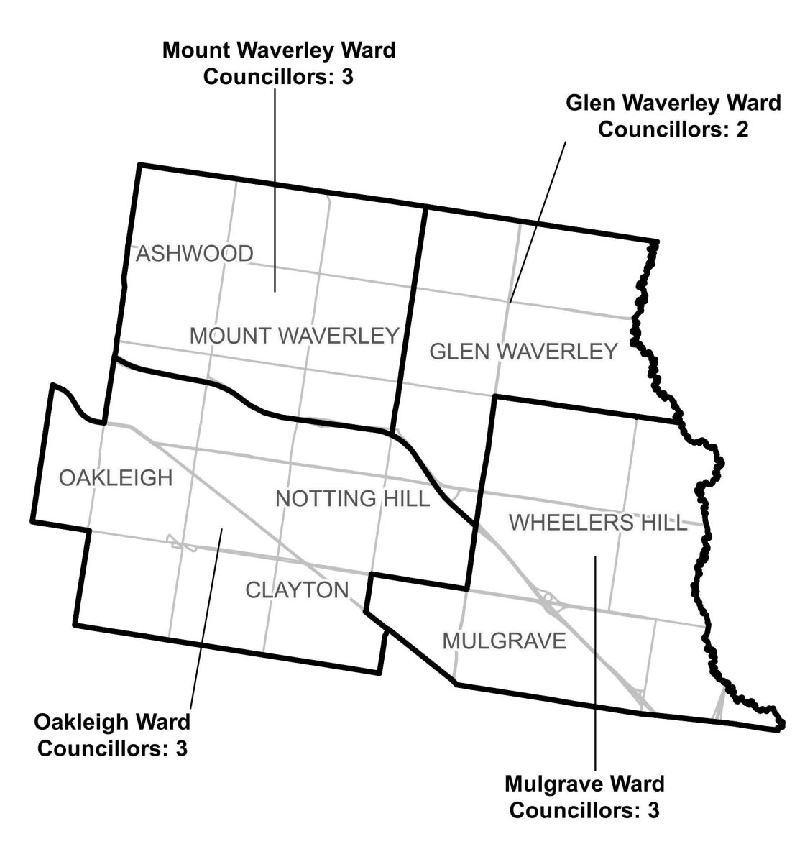

**Figure 1:** Diagram of current electoral structure of Monash City Council.

There are an estimated 120,771 voters in Monash City Council, with an approximate ratio of 10,979 voters per councillor.

Visit the VEC website at [vec.vic.gov.au](https://www.vec.vic.gov.au/electoral-boundaries/local-councils/monash-city-council) for more information on Monash City Council.

## Last electoral structure review

The VEC conducted an electoral representation review of Monash City Council in 2011. This review was carried out under the *Local Government Act 1989* (Vic), which was replaced by the *Local Government Act 2020* (Vic).

After conducting the review, the VEC recommended that Monash City Council continue to consist of 11 councillors elected from 4 wards (one ward with 2 councillors and 3 wards with 3 councillors each).

### Subdivision review

Since the 2011 representation review, the VEC also conducted a subdivision review of Monash City Council in 2020.

Subdivision reviews conducted under the *Local Government Act 1989* (Vic) adjusted the internal ward boundaries of a council but did not change the electoral structure or number of councillors. Subdivision reviews were conducted in situations where the voter-to-councillor ratios in one or more wards of a council were forecast to move outside the legislated +/-10% tolerance before the council’s next election, and aimed to ensure voter-to-councillor ratios for all wards were within tolerance at the election.

The 2020 review of Monash City Council aimed to return the Glen Waverley, Oakleigh and Mulgrave wards to within the permitted +/-10% tolerance before the 2020 local council elections. Visit the [Monash City Council profile page](https://www.vec.vic.gov.au/electoral-boundaries/local-councils/monash-city-council) on the VEC website to access a copy of the 2020 subdivision review final report.

# Preliminary findings and models

## Number of councillors

After taking into consideration the requirements of the Act and the agreed criteria, the panel found 11 councillors to be an appropriate number for Monash City Council.

The panel considered the characteristics of Monash City Council in relation to similar metropolitan councils, including its population, the number and distribution of voters, and the size and geography of the council.

|  |  |  |  |  |  |  |
| --- | --- | --- | --- | --- | --- | --- |
| Similar metropolitan councils to Monash City Council | | | | | | |
| Local council | Area (km2) | Number of voters at 2020 election | Population (2021 Census) | Current total estimate of voters | Number of councillors | Number of voters per councillor |
| Brimbank City* | 123 | 133,409 | 194,618 | 131,730 | 11 | 11,975 |
| Merri-bek City* | 51 | 131,631 | 171,357 | 131,523 | 11 | 11,956 |
| Boroondara City | 60 | 126,619 | 167,900 | 125,020 | 11 | 11,365 |
| Monash City | 82 | 120,823 | 190,397 | 120,771 | 11 | 10,979 |
| Kingston City | 91 | 118,779 | 158,129 | 119,474 | 11 | 10,861 |
| Knox City | 114 | 117,363 | 159,103 | 116,282 | 9 | 12,920 |
| Darebin City | 54 | 114,106 | 148,570 | 114,358 | 9 | 12,706 |
| Whitehorse City | 64 | 112,640 | 169,346 | 113,214 | 11 | 10,292 |

*These local councils are undergoing an electoral structure review during 2023–24.

### Maintaining 11 councillors

Monash City Council currently has an estimated 120,771 voters represented by 11 councillors. The council covers an area of 81.2 km2. Other metropolitan councils with a similar number of voters usually have 11 councillors. Forecasts indicate only modest population change is expected, and with no significant special circumstances evident across the council, the panel considers it appropriate for the total number of councillors to remain unchanged.

## Electoral structure

To identify the most appropriate electoral structure, various factors were considered. This included the requirements of the Act, the communities of interest in Monash City Council, the appropriateness of ward boundaries and which models best offered fair and equitable representation and consequently facilitated good governance.

In developing the preliminary models presented in this report, the panel considered a range of models. The strongest 3 models have been put forward for further public comment.

The panel proposes 3 models for the consideration of the Monash City Council community:

* a subdivided electoral structure of 11 single-councillor wards (Model 1)
* a subdivided electoral structure of 11 single-councillor wards, with different ward boundaries to Model 1 (Model 2)
* a subdivided electoral structure of 11 single-councillor wards, with different ward boundaries to Models 1 and 2 (Model 3).

Diagrams of the preliminary models are included in Appendix 1.

### A single-councillor ward structure with 11 councillors (Model 1)

Under this model, Monash City Council would adopt an 11-ward structure. Each ward would be represented by one councillor, in line with the requirements of the Act.

The approach taken in developing Model 1 was to use strong, identifiable boundaries to capture communities of interest as best as possible.

Represented by 5 councillors, the Mount Waverley and Glen Waverley wards in the northern area of the council have been divided into 5 single-councillor wards – Gardiners Creek, Huntingdale, Blackburn, Scotchmans Creek and Gallaghers. The creation of these wards continues to capture common communities of interest in the northern half of the council.

The boundary dividing Gardiners Creek Ward and Huntingdale Ward follows the Glen Waverley rail line from the council’s western boundary, wraps around Riversdale Golf Course via Huntingdale and High Street Roads, where it meets Stephensons Road. The Monash Freeway forms the southern boundary for the Huntingdale Ward.

Stephensons Road forms the western boundary for both Blackburn and Scotchmans Creek wards, which are separated by a boundary using the rail line and Coleman Parade. Blackburn Ward includes The Glen shopping centre, Mount Waverley Secondary College and Wesley College, while Scotchmans Creek Ward, bounded by the Monash Freeway in the south, includes parts of Glen Waverley and Mount Waverley localities, Bogong Reserve and Central Reserve, and the Monash Aquatic and Recreation Centre.

The proposed Gallaghers Ward covers around half of the current Glen Waverley Ward, with boundaries east of Springvale Road and north of Waverley Road. Jells Ward to the south is bounded by Stephensons Road in the west and includes part of the Glen Waverley locality and a large part of Wheelers Hill locality. The boundary follows the Monash Freeway and Wellington Road as far as Lum Road, covering the areas north of Phoenix Drive and Ferntree Gully Road. This ward includes Jells Park on the council’s eastern boundary, Caulfield Grammar School (Wheelers Hill campus) and Brandon Park Shopping Centre, all of which are key infrastructure for residents.

In the south-eastern part of the council area, the proposed Waverley Park and Wellington wards sit either side of the Monash Freeway. The Waverley Park Ward, while mainly residential in character, includes Mulgrave Wetland and Mulgrave Reserve along its eastern boundary. By contrast the Wellington Ward (with Police Road, Princes Highway and Blackburn Road as the southern and western boundaries) captures over half of the Notting Hill and Mulgrave localities and includes Waverley Gardens Shopping Centre in its south-eastern corner, along with a large commercial zone to the west of Springvale Road.

The proposed University, Warrigal and Banksia wards take in nearly all the current Oakleigh Ward. The University Ward is separated from Wellington Ward in the east by Blackburn Road and from the Warrigal and Banksia wards to the south by the Princes Highway. It extends north as far as the Monash Freeway to include a large area of the commercial / industrial zone in and around Notting Hill, as well as Monash University (Clayton campus) and part of Scotchmans Creek Trail. The Warrigal and Banksia wards are divided along North Road and Shafton Street, with both wards a combination of well-established residential housing and industrial zones. The Warrigal Ward includes the Oakleigh shopping and dining precinct, while the Banksia Ward is larger in area as it includes the well-known Metropolitan and Huntingdale golf courses.

The panel noted that, while there was moderate change to the existing ward boundaries, the ward structure of Model 1 captured the 3 broader communities of interest across the council:

* suburbs across the north of the council area
* suburbs in the east and south-east
* suburbs in the south and west.

This roughly reflects the housing and residential patterns, with the Monash Freeway functioning as a good divide.

### A single-councillor ward structure with 11 councillors (alternative version) (Model 2)

Under this model, Monash City Council would adopt an 11-ward structure. Each ward would be represented by one councillor, in line with the requirements of the Act.

A similar approach to Model 1 was taken in developing Model 2 - maintain a majority of the existing ward boundaries, though with the emphasis on using more roads as identifiable boundaries, particularly in the north of the council. The 6 wards in the south and east of the council have the same boundaries as in Model 1, whereas those in the northern half of the council run in a more vertical direction rather than horizontal, making greater use of main roads running north-south.

The current 3-councillor Mount Waverley Ward has been split into 3 single-councillor wards (Holmesglen, Damper Creek and Scotchmans Creek), and the 2-councillor Glen Waverley Ward into 2 single-councillor wards (Bogong and Gallaghers).

The proposed 3 wards comprising the current Mount Waverley Ward are split along major arterial roads:

* Huntingdale Road: separates the Holmesglen and Damper Creek wards for the most part, with the use of Montpellier Road and Arthur Street in the north.
* Stephensons Road: forms the entire north-south boundary between Damper Creek and Scotchmans Creek wards.
* Blackburn Road: forms the entire north-south boundary between Scotchmans Creek and Bogong wards.
* Springvale Road: is used for the most part to separate Bogong Ward from the 2 wards to its east.

In creating wards that comply with the +/-10% requirement, there was a need to compromise on building strong ward boundaries via the use of minor roads. Though the Monash Freeway is highly visible and a logical ward boundary in both Model 1 and Model 2, it could also be seen as a social divide within the council, given the higher level of social disadvantage more broadly in the southern half of the council.

The Glen Waverley Ward is replaced by the Bogong and Gallaghers wards, with the current east, north and west boundaries unchanged (Dandenong Creek, Highbury and Blackburn Roads respectively). The southern boundary of the Bogong Ward is the Monash Freeway, with Springvale Road forming the boundary with Jells Ward. Gyton Avenue, Rowitta Drive and Springvale Road form the boundary separating the Bogong and Gallaghers wards.

The remaining 6 wards proposed in Model 2 (Jells, Waverley Park, Wellington, University, Banksia and Warrigal) have the same boundary structures as those presented in Model 1.

The panel did note that there were downsides to Model 2:

* The long structure (north-south) of the Holmesglen, Damper Creek, Scotchmans Creek and Bogong wards, may not capture communities as well as the ward structures proposed in Model 1.
* The use of major roads could lead to the splitting of shopping areas, as is the case around Syndal Station where the shops are divided by a ward boundary using Blackburn Road
* The need to use minor artificial boundaries to ensure the wards comply with the +/-10% requirement at the 2024 local council election.

### A single-councillor ward structure with 11 councillors (alternative version) (Model 3)

Under this model, Monash City Council would adopt an 11-ward structure. Each ward would be represented by one councillor, in line with the requirements of the Act.

A different approach to Models 1 and 2 was used in developing the 11-ward structure presented in Model 3. The current two wards in the north of the council were divided into 5 single-councillor wards roughly even in area. In building the Huntingdale Ward, the panel departed from the current boundary approach by crossing the Monash Freeway to utilise Scotchmans Creek as the boundary. Gallaghers Ward uses a similar approach where the southern boundary uses a combination of Waverley and Wilson Roads rather than following Waverley Road entirely.

The Glen Waverley rail line is used to create a continuous boundary separating Gardiners Creek and Huntingdale wards, and Blackburn and Scotchmans Creek wards. The proposed Gardiners Creek, Huntingdale, Blackburn and Scotchmans Creek wards are split east-west along the Glen Waverley rail line and north-south along Stephensons Road.

The boundary separating the Huntingdale Ward from the wards to its south (Warrigal and University) follows Scotchmans Creek and a small section of the Monash Freeway. The use of the creek was also proposed during the boundary review conducted in 2019-20. These communities are connected by several arterial roads, including Atkinson Street, Huntingdale Road and Stanley Avenue, and may have more in common with those just north of the Monash Freeway than in the areas further south.

Gallaghers Ward in Model 3 has a southern ward boundary that follows Wilson, Gallaghers and Waverley Roads. Jells Ward runs in a southerly direction, following the council’s east boundary (Dandenong Creek) from Waverley Road to Police Road. It is separated from the Brentwood and Waverley Park wards to the west by Lum, Jells and Jackson Roads.

The 4 wards south of the Monash Freeway are a mix of residential and commercial areas, interspersed with numerous parks and reserves, and are more compact in shape:

* Waverley Park Ward includes the residential development in and around Waverley Park, Waverley Gardens Shopping Centre, as well as commercial office and warehousing complexes in an area bounded by Wellington Road, Blackburn Road and Princes Highway.
* University Ward takes in large parts of the Notting Hill, Huntingdale and Oakleigh East localities. Most of the ward’s east side is dominated by the commercial areas of Notting Hill and Monash University, while the western half of the ward is mainly residential.
* Warrigal Ward is separated from the Banksia Ward by North Road, and from the University Ward along Huntingdale Road. It combines well-established residential housing and industrial zones and is serviced by the shopping and entertainment precinct of central Oakleigh.
* The rectangular Banksia Ward has major arterial roads as its ward boundaries (North, Warrigal, Centre, Westall and Sarton) capturing established residential housing, as well as commercial and industrial areas on its eastern edge, Monash Medical Centre in the middle, and Metropolitan and Huntingdale Golf Courses on the western boundary.

The panel considered Model 3 to have some drawbacks, including:

* Two less compact wards in the east. Both the Jells and Brentwood wards were created by having to follow relatively minor roads in a zig-zag manner, leading to the possibility of not capturing clear communities of interest.
* Use of artificial boundaries in the council’s eastern wards, such as Wilson Road and Lum Road, and departing from the Monash in the south where it likely functions as a clearer division. This was to ensure all wards in this area comply with the +/-10% requirement at the 2024 local council elections.
* More changes are required to the current ward boundary structures than in Model 1 or Model 2.

### Summary

In summary, introducing single-councillor wards represents a large electoral change for Monash City Council, with this electoral structure last in place prior to 2005. Achieving models that divide communities into appropriate wards while also accounting for population growth and ensuring they comply with the +/-10% requirement can be challenging.

Nonetheless, the geography of the Monash City Council area, a fairly even rate of population growth throughout the council area, and the presence of strong features to draw on when developing ward boundaries, made the division of the current 4-ward structure into single-councillor wards somewhat easier. Compliance with the +/-10% rule did not always allow for the greatest use of these features when building ward boundaries, and because of this, all the models presented involved some compromises.

The panel now encourages public feedback on the 3 models presented in this report.

## Models for public feedback

The panel considers all models outlined below to be the single-councillor ward electoral structures with the best potential to offer fair and equitable representation for voters in Monash City Council and consequently facilitate good governance. Please see Appendix 1 for detailed maps of these models.

### Model 1

Monash City Council has 11 councillors and is divided into 11 wards with one councillor per ward.

Ward names: Banksia Ward, Blackburn Ward, Gallaghers Ward, Gardiners Creek Ward, Huntingdale Ward, Jells Ward, Scotchmans Creek Ward, University Ward, Warrigal Ward, Waverley Park Ward, Wellington Ward.

### Model 2

Monash City Council has 11 councillors and is divided into 11 wards with one councillor per ward.

Ward names: Banksia Ward, Bogong Ward, Damper Creek Ward, Gallaghers Ward, Holmesglen Ward, Jells Ward, Scotchmans Creek Ward, University Ward, Warrigal Ward, Waverley Park Ward, Wellington Ward.

### Model 3

Monash City Council has 11 councillors and is divided into 11 wards with one councillor per ward.

Ward names: Banksia Ward, Blackburn Ward, Brentwood Ward, Gallaghers Ward, Gardiners Creek Ward, Huntingdale Ward, Jells Ward, Scotchmans Creek Ward, University Ward, Warrigal Ward, Waverley Park Ward.

## Ward names

The panel has suggested ward names to identify the wards in each model and invites comments from the community on these names as part of submissions responding to the preliminary report. The basis of the ward name recommendations for each model are described below.

### Model 1

The Banksia, Blackburn, Gallaghers, Gardiners Creek, Huntingdale, Jells, Scotchmans Creek, University, Warrigal, Waverley Park and Wellington ward names are new and are based on natural features, localities, roads and buildings found within each ward.

### Model 2

The Banksia, Bogong, Damper Creek, Gallaghers, Holmesglen, Jells, Scotchmans Creek, University, Warrigal, Waverley Park and Wellington ward names are new and are based on natural features, localities, roads and buildings found within each ward.

### Model 3

The Banksia, Blackburn, Brentwood, Gallaghers, Gardiners Creek, Huntingdale, Jells, Scotchmans Creek, University, Warrigal and Waverley Park ward names are new and are based on natural features, localities, roads and buildings found within each ward.

The panel will review ward name suggestions received during the response submission stage when forming the final advice to the Minister for Local Government on the electoral structure of the council. Suggested ward names should comply with the panel’s approach to naming wards (see Deciding on ward names and Use of Aboriginal language). All ward name suggestions received during the response submission stage will be provided to the Minister for consideration at the conclusion of the electoral structure review.

# Next steps

## Response submissions

Any person or group, including the local council under review, can make a response submission to the electoral representation advisory panel. In your submission you should address the models proposed by the panel in this preliminary report.

You can make a submission:

|  |  |
| --- | --- |
|  | **Online** Visit [vec.vic.gov.au](http://vec.vic.gov.au/" \o "Link to VEC website home page) to make a submission online.  You will need to make an account to use the online Public Submission Tool and can save a draft submission to finish later. |
|  | **By email** [Monash.ERAPSubmissions@vec.vic.gov.au](mailto:Monash.ERAPSubmissions@vec.vic.gov.au) |
|  | **By post**  Electoral Representation Advisory Panel c/o Victorian Electoral Commission Level 11, 530 Collins St Melbourne VIC 3000 |

The panel must receive all response submissions before 5 pm on Wednesday 9 August 2023. If you post your submission, make sure it has enough time to reach the panel before the deadline. Late submissions will not be accepted.

### Required information

For your submission to be considered, you must include your:

* full name
* contact phone number or email address
* postal or residential address.

To protect the integrity and transparency of the review process, the panel will not consider submissions without this information. If you are submitting as a group or organisation, you must include the name of a nominated contact person who is authorised to submit on behalf of your group.

On behalf of the panel, the VEC will handle information provided by submitters in accordance with the privacy policy available at [vec.vic.gov.au/privacy](http://vec.vic.gov.au/privacy)

### Public access to submissions

To ensure transparency in the electoral structure review process, your submission will be published on the VEC website at [vec.vic.gov.au](http://www.vec.vic.gov.au/). The VEC will remove your signature and contact details, including residential and postal addresses, from all public copies but must publish your full name (or group name) and locality (suburb or town).

Please note that any submission content that is potentially defamatory, offensive, obscene or that includes the personal information of people or organisations who are not a party to the submission may also be redacted before publication.

## Public hearing

If you make a response submission, you can also ask to speak at an online public hearing to support your submission and expand on your views.

The online public hearing is scheduled for:

Time: 10 am

Date: Wednesday 16 August 2023

The panel encourages participation in the public hearing. If you wish to speak at the public hearing, you **must** indicate this in your response submission. The public hearing will not be held if there are no requests to speak.

Anyone can attend a public hearing, but you will only be able to speak if you asked to in your response submission. If you ask to speak, the VEC will contact you to arrange a time for you to speak at the hearing. You will have 10 minutes to address the public hearing panel, which will include at least 2 of the review panel members. The members of the public hearing panel may ask you questions.

Visit the VEC website at [vec.vic.gov.au](http://vec.vic.gov.au/) for more information on public hearings.

## Final report

Following the public hearing, the review panel will consider all evidence gathered and prepare a final report for the Minister for Local Government containing a recommendation for the number of councillors and the electoral structure for the local council.

The final report is scheduled to be provided to the Minister on Wednesday 13 September 2023. The Minister will consider the final reports, including any determination to make the reports publicly available. Any change to the electoral structure of Monash City Council following on from this review is expected to apply at the October 2024 local council elections. Under the Act, the final council electoral structure will be set by an Order in Council published in the Victoria Government Gazette.

# References

ABS (Australian Bureau of Statistics) (2022a) [*2021 Census All Person QuickStats, Monash (LGA)*](https://www.abs.gov.au/census/find-census-data/quickstats/2021/LGA24970), ABS, accessed 31 May 2023.

——(2022b) [*2021 Census All Persons QuickStats, Rest of Vic*](https://www.abs.gov.au/census/find-census-data/quickstats/2021/2RVIC), ABS, accessed 31 May 2023.

——(2022c) [*2021 Census All Persons QuickStats, Glen Waverley*](https://www.abs.gov.au/census/find-census-data/quickstats/2021/SAL21013), ABS, accessed 2 June 2023.

——(2022d) [*2021 Census All Persons QuickStats, Mount Waverley*](https://www.abs.gov.au/census/find-census-data/quickstats/2021/SAL21816), ABS, accessed 2 June 2023.

——(2022e) [*2021 Census All Persons QuickStats, Clayton*](https://www.abs.gov.au/census/find-census-data/quickstats/2021/SAL20569), ABS, accessed 2 June 2023.

——(2016) [*2016 Census All Person QuickStats, Monash (C) (LGA)*](https://www.abs.gov.au/census/find-census-data/quickstats/2016/LGA24970), ABS, accessed 2 June 2023.

——(2011) [*2011 Census All Person QuickStats, Monash (C) (LGA)*](https://www.abs.gov.au/census/find-census-data/quickstats/2011/LGA24970), ABS, accessed 2 June 2023.

Monash City Council (2023) [*Proposed developments*](https://www.monash.vic.gov.au/Planning-Development/Proposed-Developments)*,* Monash City Council, accessed 9 June 2023.

Geographic Place Names Act 1998 (Vic)

.id (informed decisions) (2022a) [*Welcome to the Monash City Council population forecast*](https://forecast.id.com.au/monash), .id, accessed 31 May 2023.

——(2022b) [*Welcome to Monash City Council community profile*](https://profile.id.com.au/monash), .id, accessed 31 May 2023.

Local Government Act 1989 (Vic)

Local Government Act 2020 (Vic)

Local Government (Electoral) Regulations 2020 (Vic)

# Appendix 1: Model maps

The following maps are included in this report:

|  |  |
| --- | --- |
| Map | Page |
| Model 1 – a single-councillor ward structure with 11 councillors – 11 wards with one councillor per ward. | 27 |
| Model 2 – a single-councillor ward structure with 11 councillors – 11 wards with one councillor per ward (with boundaries different to Model 1). | 28 |
| Model 3 – a single-councillor ward structure with 11 councillors – 11 wards with one councillor per ward (with boundaries different to Model 1 and Model 2). | 29 |

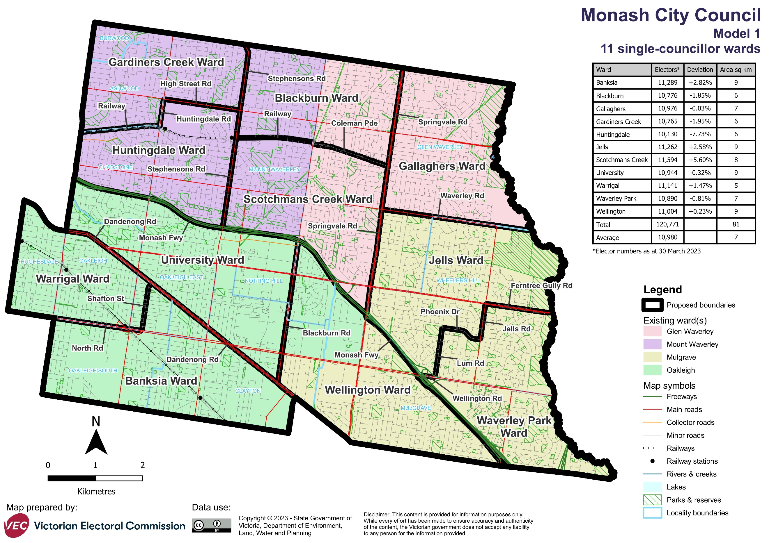

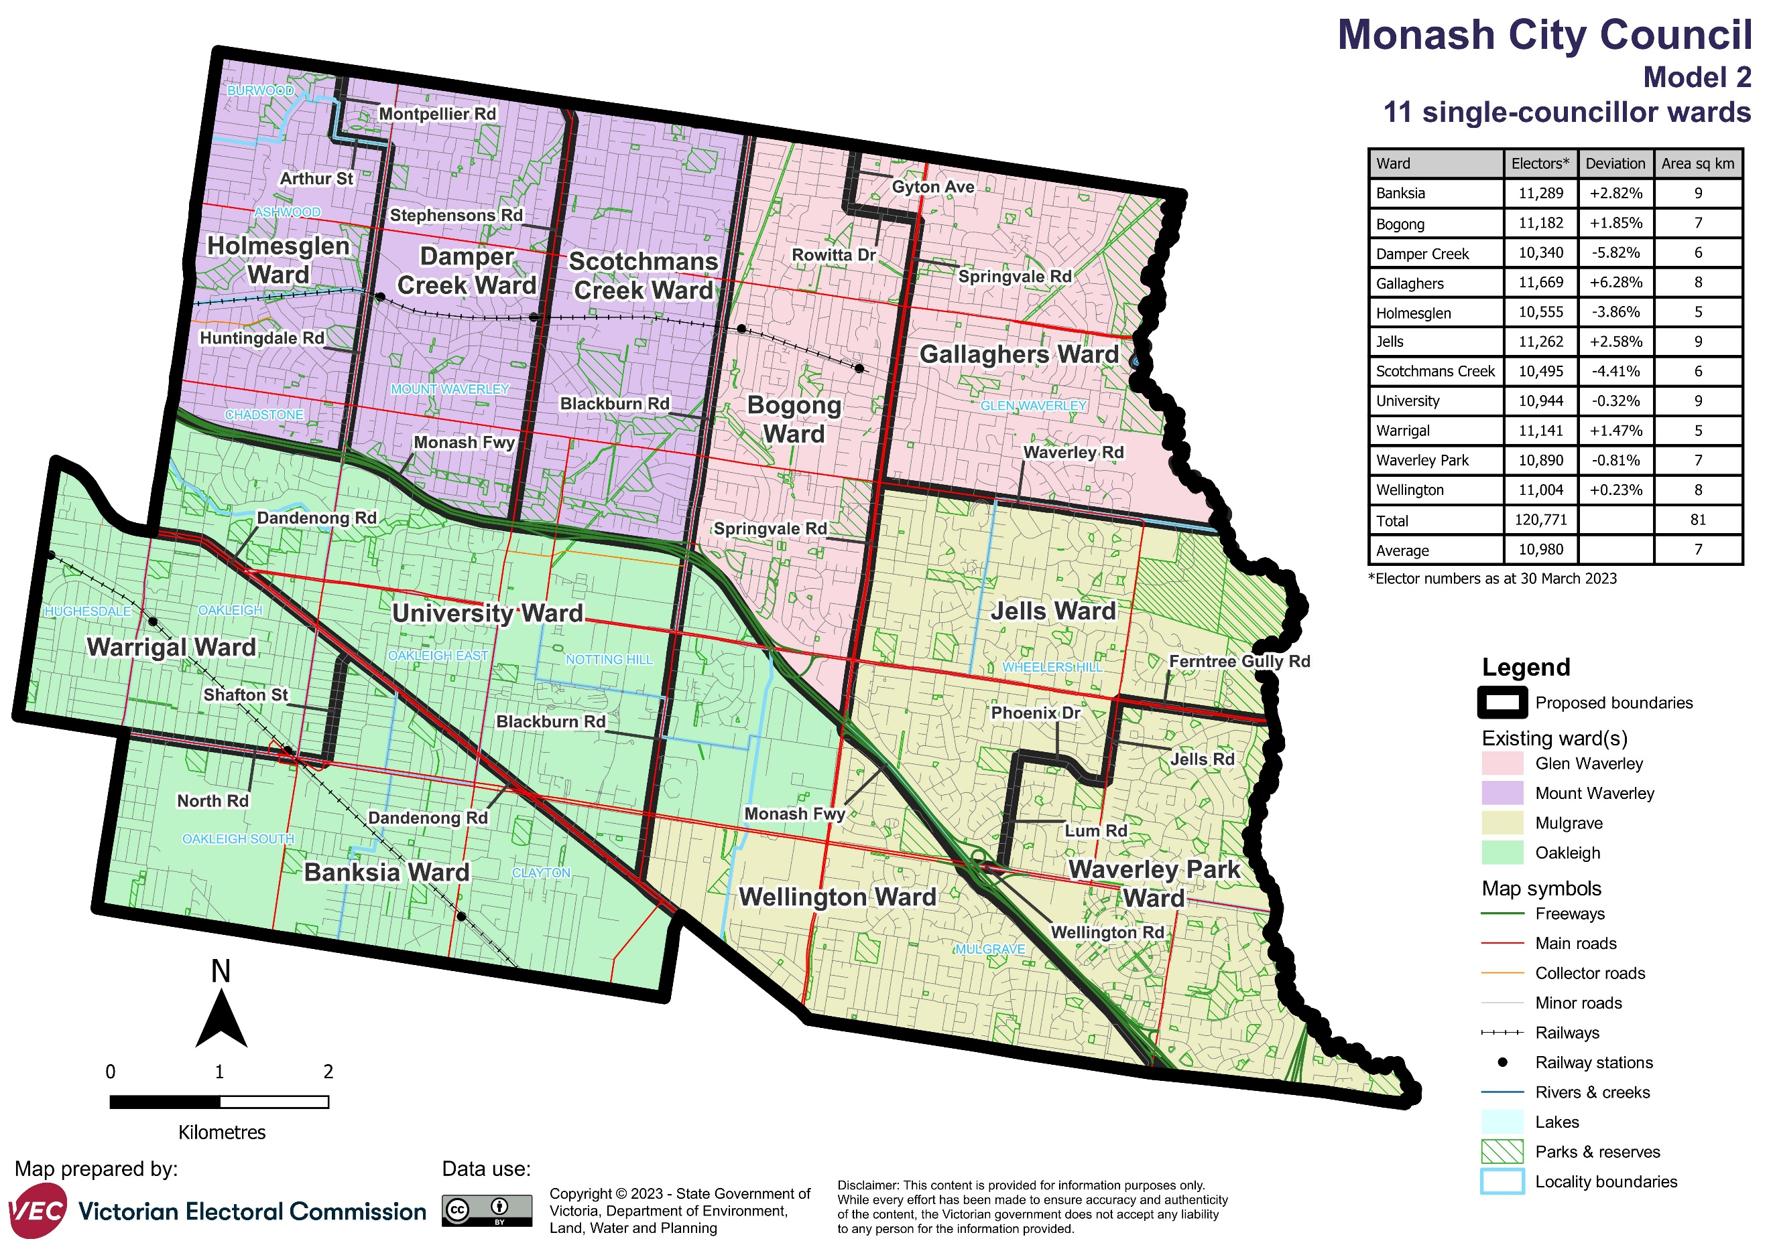

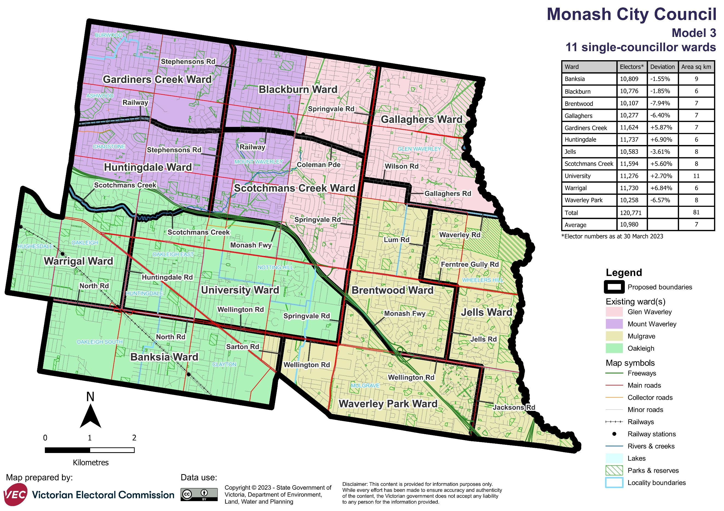

Forecast information referred to in the text of this report is based on forecasts prepared by .id – informed decisions [id.com.au](http://id.com.au/) .id and its licensors are the sole and exclusive owners of all rights, title and interest subsisting in that part of the report content where .id are identified. Some of .id content is a derivative of ABS Data, which can be accessed from the website of the Australian Bureau of Statistics at [abs.gov.au](http://abs.gov.au/), and licensed on terms published on the ABS website.