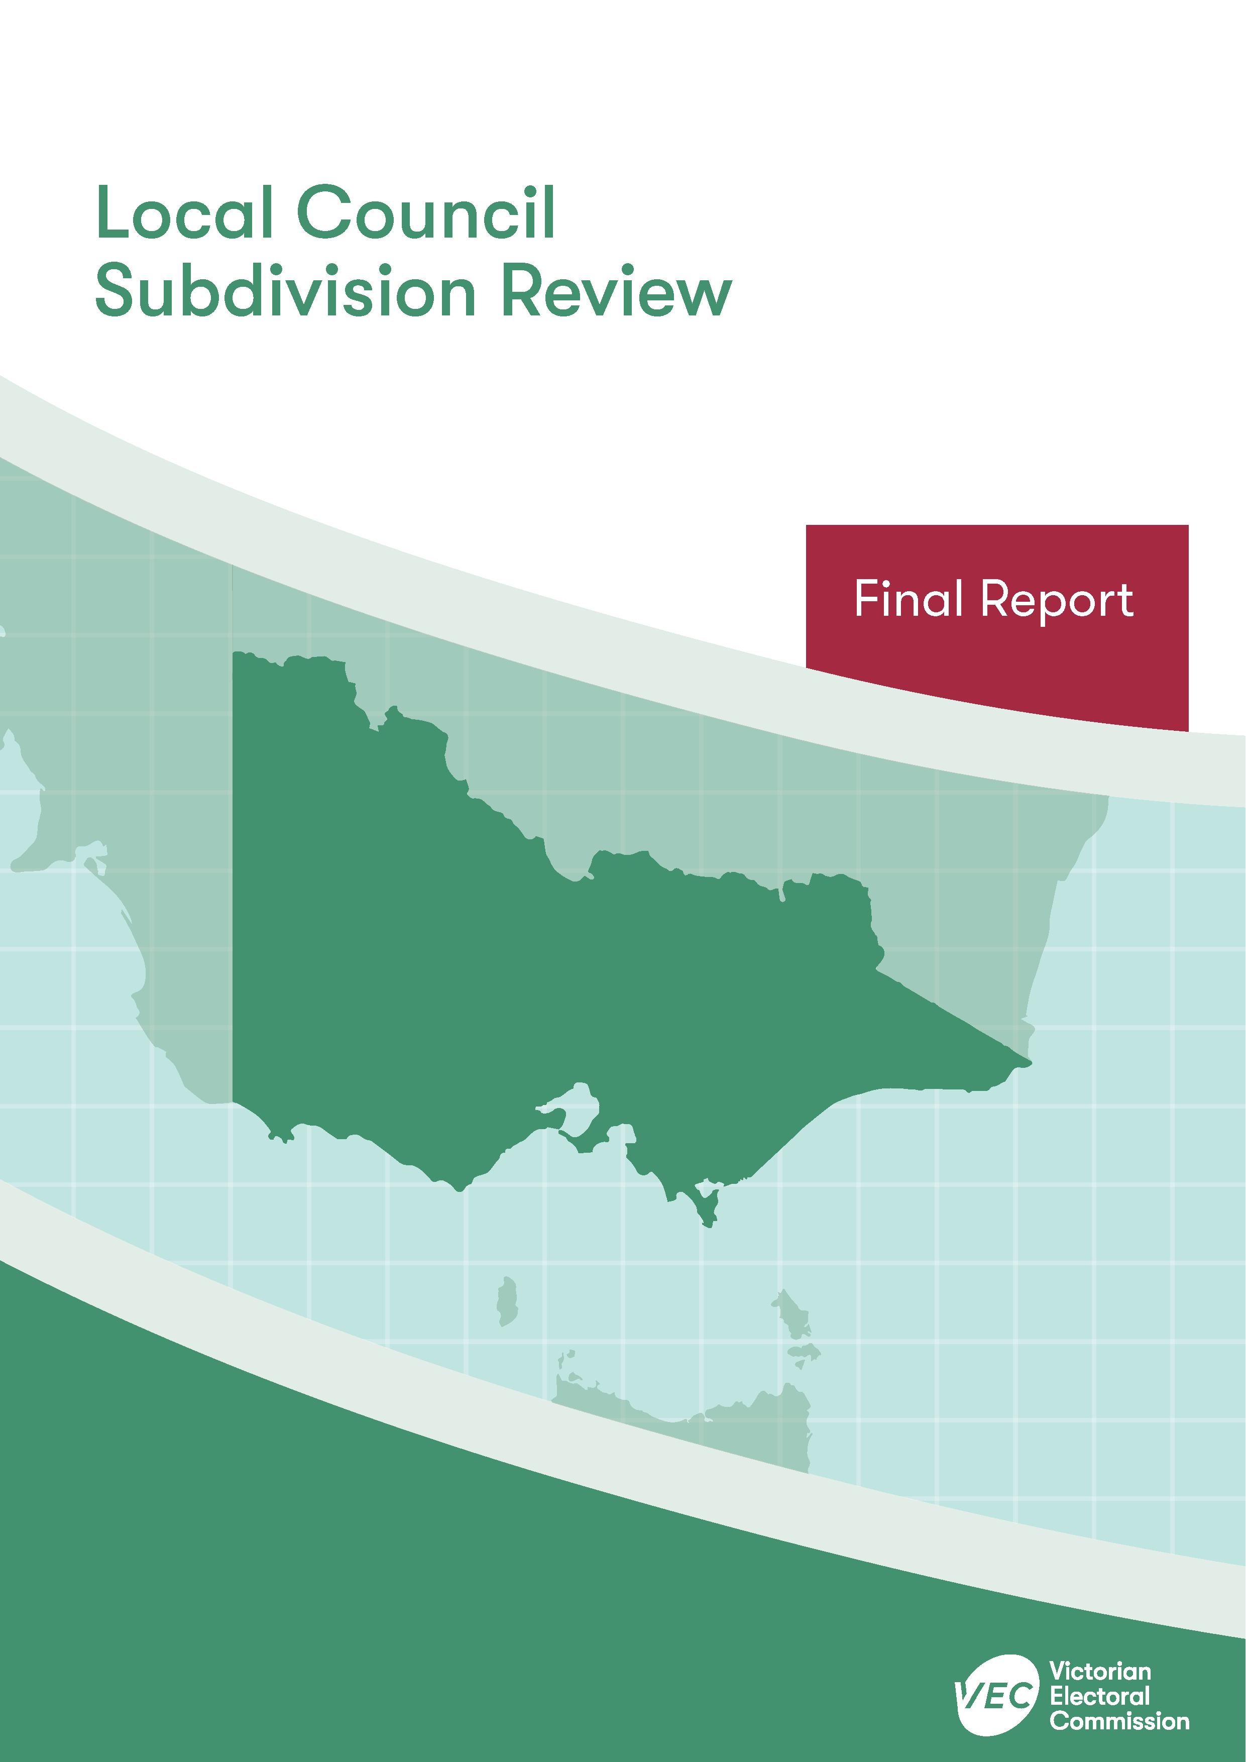


April 2020
Moorabool Shire Council

Contents
Recommendation 1
Executive summary 2
Background 4
Legislative basis 4
The VEC’s approach 5
Profile of Moorabool Shire Council 7
Population trends 9
Current number of councillors and electoral structure 9
Preliminary report 11
Public response 13
Response submissions 13
Public hearing 13
Findings and recommendation 14
The VEC’s findings 14
The VEC’s recommendation 15
Appendix 1: Recommended ward boundaries map 16
Appendix 2: Public information program 18

Recommendation
The Victorian Electoral Commission recommends adjustments to the boundaries of the following wards within Moorabool Shire Council:
- Central Moorabool Ward
- East Moorabool Ward
- West Moorabool Ward
- Woodlands Ward
This recommendation is submitted to the Minister for Local Government as required by the Local Government Act 1989.
Please see Appendix 2 for a detailed map of the recommended ward boundaries.

Executive summary
The Local Government Act 1989 (LG Act) requires the Victorian Electoral Commission (VEC) to conduct a subdivision review to ensure the equitable representation of all voters in a local council. The LG Act prescribes that the number of voters per councillor in each ward must be within plus-or-minus 10% of the average number of voters per councillor across the local council. This is known as the ‘equality requirement’.
As population changes affect voter numbers and distribution in subdivided local councils, one or more wards may be unlikely to meet this requirement at the next general election. In such circumstances, the VEC recommends adjustments to internal ward boundaries to ensure that all wards meet the equality requirement before the next election and ideally, until the next scheduled electoral representation review.
Current number of councillors and electoral structure
Moorabool Shire Council currently comprises seven councillors elected from four wards (one four-councillor ward and three single-councillor wards). More information on Moorabool Shire Council is available on the VEC website at vec.vic.gov.au.
In 2018, the VEC notified the Minister for Local Government that one or more wards were unlikely to meet the equality requirement at the 2020 general election. Accordingly, the Minister notified the VEC that a subdivision review of Moorabool Shire Council was required before the 2020 general election.
Preliminary report
A preliminary report was released on Wednesday 26 February 2020 proposing adjustments to the boundaries for all wards within Moorabool Shire Council:
- Central Moorabool Ward
- East Moorabool Ward
- West Moorabool Ward
- Woodlands Ward
Response submissions
The VEC did not receive any submissions responding to the preliminary report by the deadline of 5.00 pm on Wednesday 25 March 2020.
Public hearing
The VEC scheduled a public hearing for those wishing to speak about their response submission at 6.00 pm on Tuesday 31 March 2020. There were no requests to speak so the hearing was not held.
Recommendation
The Victorian Electoral Commission recommends adjustments to the boundaries of the following wards within Moorabool Shire Council:
- Central Moorabool Ward
- East Moorabool Ward
- West Moorabool Ward
- Woodlands Ward
This recommendation is submitted to the Minister for Local Government as required by the Local Government Act 1989.
Please see Appendix 1 for a detailed map of the recommended ward boundaries.

Background

Legislative basis
The Local Government Act 1989 (LG Act) requires the Victorian Electoral Commission (VEC) to conduct a subdivision review to ensure the equitable representation of all voters in a local council. The LG Act prescribes that the number of voters per councillor in each ward must be within plus-or-minus 10% of the average number of voters per councillor across the local council. This is known as the ‘equality requirement’.
As population changes affect voter numbers and distribution in subdivided local councils, one or more wards may be unlikely to meet this requirement at the next general election. In such circumstances, the VEC recommends adjustments to internal ward boundaries to ensure that all wards meet the equality requirement before the next election and ideally, until the next scheduled electoral representation review.
Subdivision reviews only apply to subdivided councils:
- that are not scheduled for an electoral representation review before the next general election
and
- where, two years before the council is to hold a general election, the VEC considers one or more wards are unlikely to meet the equality requirement at the time of the next general election.

Scope
A subdivision review only considers the location of ward boundaries. A subdivision review cannot consider changes to the number of councillors or wards.
These changes are considered in an electoral representation review. Following the passing of the Local Government Act 2020, such matters will be considered by an electoral representation advisory panel.
A subdivision review also cannot change the external boundaries of the local council, divide local councils, or amalgamate local councils. These changes can only be made by an Order in Council.

The VEC’s approach

Public information program
The VEC conducted a public information program to inform the community of the subdivision review, including:
- a public notice printed in local papers
- a media release announcing the release of the preliminary report
- an information email campaign targeted at known community groups and communities of interest in the local council area
- sponsored social media advertising geo-targeted to users within the local council
area
- ongoing information updates and publication of submissions on the VEC website.
More information on the VEC’s public information program for the subdivision review of Moorabool Shire Council can be found at Appendix 2.

Public consultation
Public input was encouraged by the VEC. However, the VEC did not receive any response submissions or requests to speak at the planned public hearing.

Developing recommendations
The VEC bases its recommendations for ward boundaries on:
- internal research specifically relating to the local council under review, including voter statistics from the Victorian electoral roll
- small area forecasts provided by .id
- the VEC’s expertise in mapping, demography and local government
- consideration of all input from the public in written submissions received during the review.
In determining which ward boundaries are most appropriate, the VEC considers the:
- number of voters in each ward, to ensure that each ward meets the equality requirement for the next election
- number of voters affected by the changes, with the aim of affecting as few voters as possible
- communities of interest
- significance of natural and man-made features (such as roads and waterways), to ensure clear and identifiable ward boundaries
- geographic factors, such as size and topography
- longevity of the structure.

Communities of interest
Each local council contains a number of communities of interest. Where practicable, ward boundaries should be designed to ensure they are fairly represented, and that geographic communities of interest are not split. This allows communities with shared concerns to elect a councillor.

Moorabool Shire Council

Profile of Moorabool Shire Council
Moorabool Shire Council is a peri-urban council area in Victoria’s south-west region. The Shire covers about 2,110 square kilometres and extends from Bacchus Marsh, Hopetoun Park and Long Forest to the outskirts of Ballarat in the west. Over 74% of the Shire includes water catchments, state forests and national parks. There are three major rivers (the Werribee, Lerderderg and Moorabool Rivers), which flow through the Shire. The Wombat State Forest, Lerderderg State Park, Brisbane Ranges National Park, Werribee Gorge State Park and the Avenue of Honour in Bacchus Marsh are some of the Shire’s key attractions.
Moorabool Shire’s population is growing rapidly with much of the growth occurring in the Bacchus Marsh area. Bacchus Marsh is about 45 minutes’ drive from Melbourne’s CBD and its proximity to employment in Melbourne as well as its rural atmosphere attracts families generally from western Melbourne. Located between Ballarat and Bacchus Marsh, Ballan is the next largest population centre. Ballan is also forecast to grow, although to a lesser extent, due to it being outside Melbourne’s commuter belt.
There are an estimated 19,000 residents in Bacchus Marsh and the adjacent localities of Darley and Maddingley, comprising about 60% of Moorabool Shire’s total population. Ballan has an estimated population of 3,000. Gordon is the next largest town with a population of over 1,000. The Shire is also made up of many small rural towns with populations of 200 or less. Besides Bacchus Marsh and Ballan, other distinct areas include the forested areas to the north where towns such as Blackwood and Greendale are located. The towns in the west of Moorabool Shire are within the City of Ballarat’s area of influence and people tend to travel to Ballarat for work, education, shopping and services.
Moorabool Shire’s median age is 40 years, which is slightly younger than the average for rural and regional Victoria (43 years) and older than the median for Greater Melbourne (36 years). The median ages in the rural areas and the more established towns are older (the median age in Bacchus Marsh and Ballan is 43 years), while the median ages in the newer residential areas surrounding Bacchus Marsh are younger, illustrating the predominance of younger families moving into these areas. The median age is 35 years in Darley and 34 years in Maddingley.
Much of the rural areas of Moorabool Shire are used for agriculture, including horticulture, sheep and beef farming, timber production and more recently, viticulture. Mining and quarrying are also activities to be found in the Shire. Over the past decade, the construction and service industries have grown. At the 2016 Census, the top three industries of employment were construction (12.2%), healthcare and social assistance (10.6%), and education and training (9.3%).
Just over 60% of Moorabool Shire’s residents travel outside of the area to work. There are a high number of commuters from Bacchus Marsh to Melbourne. Residents in Ballan are known to travel to Bacchus Marsh, Ballarat, or Melbourne for work.

Population trends
At the time of the 2016 Census, Moorabool Shire had a population of 31,818.
From 2011–2018, the population is estimated to have grown at an average rate of 2.5% per annum to 34,158. The population is expected to continue growing at an average rate of 2.1% per annum from 2018–2036, reaching 49,940 by 2036. This rate of growth is higher than the overall growth rate of 1.9% per annum expected for Greater Melbourne over the 2018–2036 period. It is also higher compared with the overall growth rate for rural and regional Victorian local council areas over the same period at 1.2%.
The greatest rates of population growth are anticipated in Bacchus Marsh and the surrounding area, particularly in the new areas of residential development in Merrimu, Hopetoun Park and Parwan. Ballan is also expected to sustain a higher rate of growth compared to the rural areas of the Shire.
There are currently an estimated 28,395 voters for Moorabool Shire Council, with an average of 4,056 voters per councillor.

Current number of councillors and electoral structure
Moorabool Shire Council currently comprises seven councillors elected from four wards (one four-councillor ward and three single-councillor wards). Prior to the last representation review in 2011, Moorabool Shire Council was comprised of seven councillors elected from four wards (one four-councillor ward and three single-councillor wards) with different boundaries to the current structure.
Diagram 1 (on the next page) illustrates this structure and voter statistics by ward as at 23 October 2019.
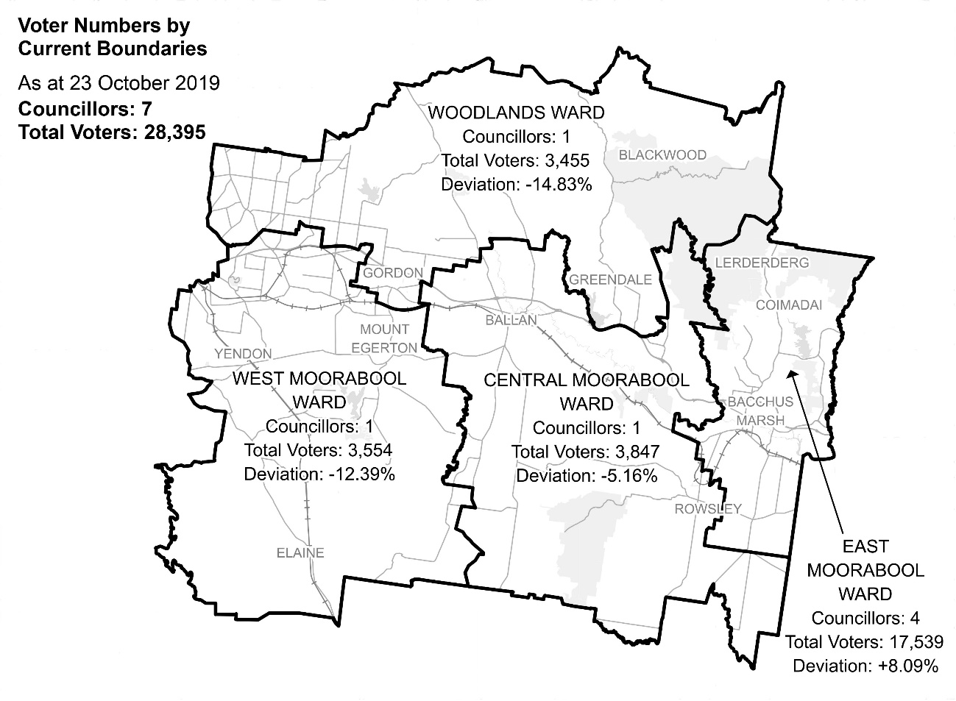
Diagram 1: Moorabool Shire Council electoral structure and voter statistics

Current subdivision review
The current subdivision review of Moorabool Shire Council is required due to the voter-to-councillor ratio in West Moorabool Ward and Woodlands Ward being more than 10% below the average voter-to-councillor ratio for the local council. Consequently, all ward boundaries need to be adjusted so that ward enrolments will be within the 10% tolerance at the 2020 general election.
Table 1 shows the number of voters in each ward as at 23 October 2019, ranked by the percentage this deviated from the average number of voters per councillor for the whole local council.
Table 1: Voter numbers per ward
Ward | Councillors | Voters | Deviation (%)
Central Moorabool | 1 | 3,847 | -5.16%
East Moorabool | 4 | 17,539 | +8.09%
West Moorabool | 1 | 3,554 | -12.39%
Woodlands | 1 | 3,455 | -14.83%
Total for council | 7 | 28,395

Preliminary report
The VEC’s subdivision review of Moorabool Shire Council commenced with the release of a preliminary report on Wednesday 26 February 2020. The report contained proposed ward boundary changes based on the analysis of enrolment information and internal research.
The main aim of this subdivision review was to devise ward boundary adjustments that would ensure that voter-to-councillor ratios for all wards were within the legislated plus-or-minus 10% tolerance at the time of the 2020 local government elections. More substantial changes to ward boundaries or the electoral structure of Moorabool Shire Council may be considered at the next representation review.
In the preliminary report, the VEC noted that East Moorabool Ward was the only ward with a deviation from the average voter-to-councillor ratio that was positive. It found that it needed to transfer voters from one adjacent ward to the other, ending with East Moorabool Ward, in order to return West Moorabool Ward and Woodlands Ward to the legislated deviation.
The proposed ward boundary adjustments comprised:
- Extending the northern boundary of West Moorabool Ward north to the Council’s external boundary, in order to return West Moorabool Ward to within the accepted 10% deviation. The towns of Bullarook, Clarkes Hill, Pootilla, Claretown and most of Springbank in Woodlands Ward would become part of West Moorabool Ward.
- To return Woodlands Ward to the accepted deviation, the VEC also proposed to shift a section of the boundary between Woodlands and Central Moorabool Wards south from Myrniong Creek to the Werribee River. This change meant areas of Myrniong, including its town centre (currently in Central Moorabool Ward) would become a part of Woodlands Ward. All of Myrniong would be in Woodlands Ward as a result.
- The above boundary adjustment was not enough, however, to return Woodlands Ward to the accepted deviation. The VEC proposed a ward boundary adjustment between Woodlands and East Moorabool Wards, which would shift the entire locality of Coimadai from East Moorabool Ward to Woodlands Ward.
- The VEC proposed a final boundary adjustment because the loss of the Myrniong area to Woodlands Ward put Central Moorabool Ward below the minus 10% deviation. The VEC adjusted East Moorabool Ward’s southern boundary so that Parwan, on the outskirts of Bacchus Marsh, would become a part of Central Moorabool Ward.
A total of 1,167 voters (4.11% of the total) would be affected by the proposed ward boundary changes.
Table 2 details the number of voters in each ward as a result of the proposed ward boundary changes, which would bring all wards within the 10% tolerance for the 2020 Council election.
Table 2: Voter numbers per ward with proposed boundaries
Ward | Councillors | Voters | Deviation (%)
Central Moorabool | 1 | 3,711 | -8.52%
East Moorabool | 4 | 17,044 | +5.04%
West Moorabool | 1 | 3,948 | -2.67%
Woodlands | 1 | 3,692 | -8.98%
Total for council | 7 | 28,395

Public response

Response submissions
The VEC accepted submissions responding to the preliminary report from Wednesday 26 February 2020 until 5.00 pm on Wednesday 25 March 2020. The VEC did not receive any response submissions.

Public hearing
The VEC scheduled a public hearing for those wishing to speak about their response submission at 6.00 pm on Tuesday 31 March 2020 in the Council Chamber, 15 Stead St, Ballan. There were no requests to speak so the hearing was not held.

Findings and recommendation

The VEC’s findings
While Moorabool Shire Council has not required a subdivision review to date, all ward boundaries have changed over its previous two electoral representation reviews. In this review, all ward boundaries again need to be adjusted. This is due to the Shire’s continued uneven population distribution and growth, which has led to the Bacchus Marsh area being home to approximately 60% of the total population.
At the final stage of the review, the VEC notes that it did not receive any community submissions opposed to its ward boundary adjustments. It therefore considers that its proposed ward boundaries are unlikely to represent a significant issue for the Shire’s communities.
Instead, the VEC reasoned that its ward boundary adjustments are likely to provide gains for local representation. It notes that its proposed boundary adjustments will return West Moorabool and Woodlands Wards to the legislated deviation while likely improving the recognition and representation of communities of interest in the Shire’s current electoral structure.
The VEC’s proposed extension of the northern boundary of West Moorabool Ward north to the Council’s external boundary will not only return West Moorabool Ward to the accepted deviation, it is likely to represent an improvement for communities of interest in the area as well. The boundary adjustment will mean that these west-facing farming communities return to West Moorabool Ward, where communities share the common feature of being within proximity to the City of Ballarat. The boundary adjustment will also reduce the area covered by Woodlands Ward so that it is focused, more exclusively, on the northern forested areas in the Shire, which is its key geographic community of interest.
To return Woodlands Ward to the accepted deviation, the VEC proposed to shift a section of the boundary between Woodlands and Central Moorabool Wards south from Myrniong Creek to the Werribee River. Although the township of Myrniong will change to Woodlands Ward, the VEC noted that Myrniong is currently split across the two wards and the ward boundary adjustment will unite Myrniong within Woodlands Ward, presenting another possible gain for local representation in the Shire.
As noted in the preliminary report, the VEC found that this boundary adjustment was not enough to return Woodlands Ward to the accepted deviation. It proposed an adjustment between Woodlands and East Moorabool Wards, which would shift the entire locality of Coimadai from East Moorabool Ward to Woodlands Ward. At the final stage, the VEC maintains the view that although Coimadai does not have direct road access to Woodlands Ward, its rural characteristics make it more suitable for inclusion in Woodlands Ward than urban Darley. The ward adjustment will also ensure that communities of interest in the growth areas are not separated from Bacchus Marsh.
The VEC proposed one more boundary adjustment in its preliminary report, as the loss of the Myrniong area to Woodlands Ward placed Central Moorabool Ward below minus 10% deviation. At the final stage, the VEC considers that the logical decision remains to adjust East Moorabool Ward’s southern boundary so that rural Parwan on the outskirts of Bacchus Marsh, will become part of Central Moorabool Ward.
In reaching its proposed ward boundary adjustments, the VEC also considered the central town of Ballan where the Council’s main office is located. It notes that the series of boundary adjustments proposed would maintain Ballan (as well as its rural outskirts) in Central Moorabool Ward. It notes that a Central Moorabool Ward containing Ballan has been another defining feature of the Shire’s electoral structure for close to two decades.
The VEC is confident that all wards will remain within the plus-or-minus 10% tolerance at least until the October 2020 general election and it recommends the proposed ward boundary adjustments, which were presented in the preliminary report, without any changes.

The VEC’s recommendation
The Victorian Electoral Commission recommends adjustments to the boundaries for all wards within Moorabool Shire Council:
- Central Moorabool Ward
- East Moorabool Ward
- West Moorabool Ward
- Woodlands Ward
This recommendation is submitted to the Minister for Local Government as required by the Local Government Act 1989.
Please see Appendix 1 for a detailed map of the recommended ward boundaries.

Appendix 1: Recommended ward boundaries map

The map is provided on the next page.

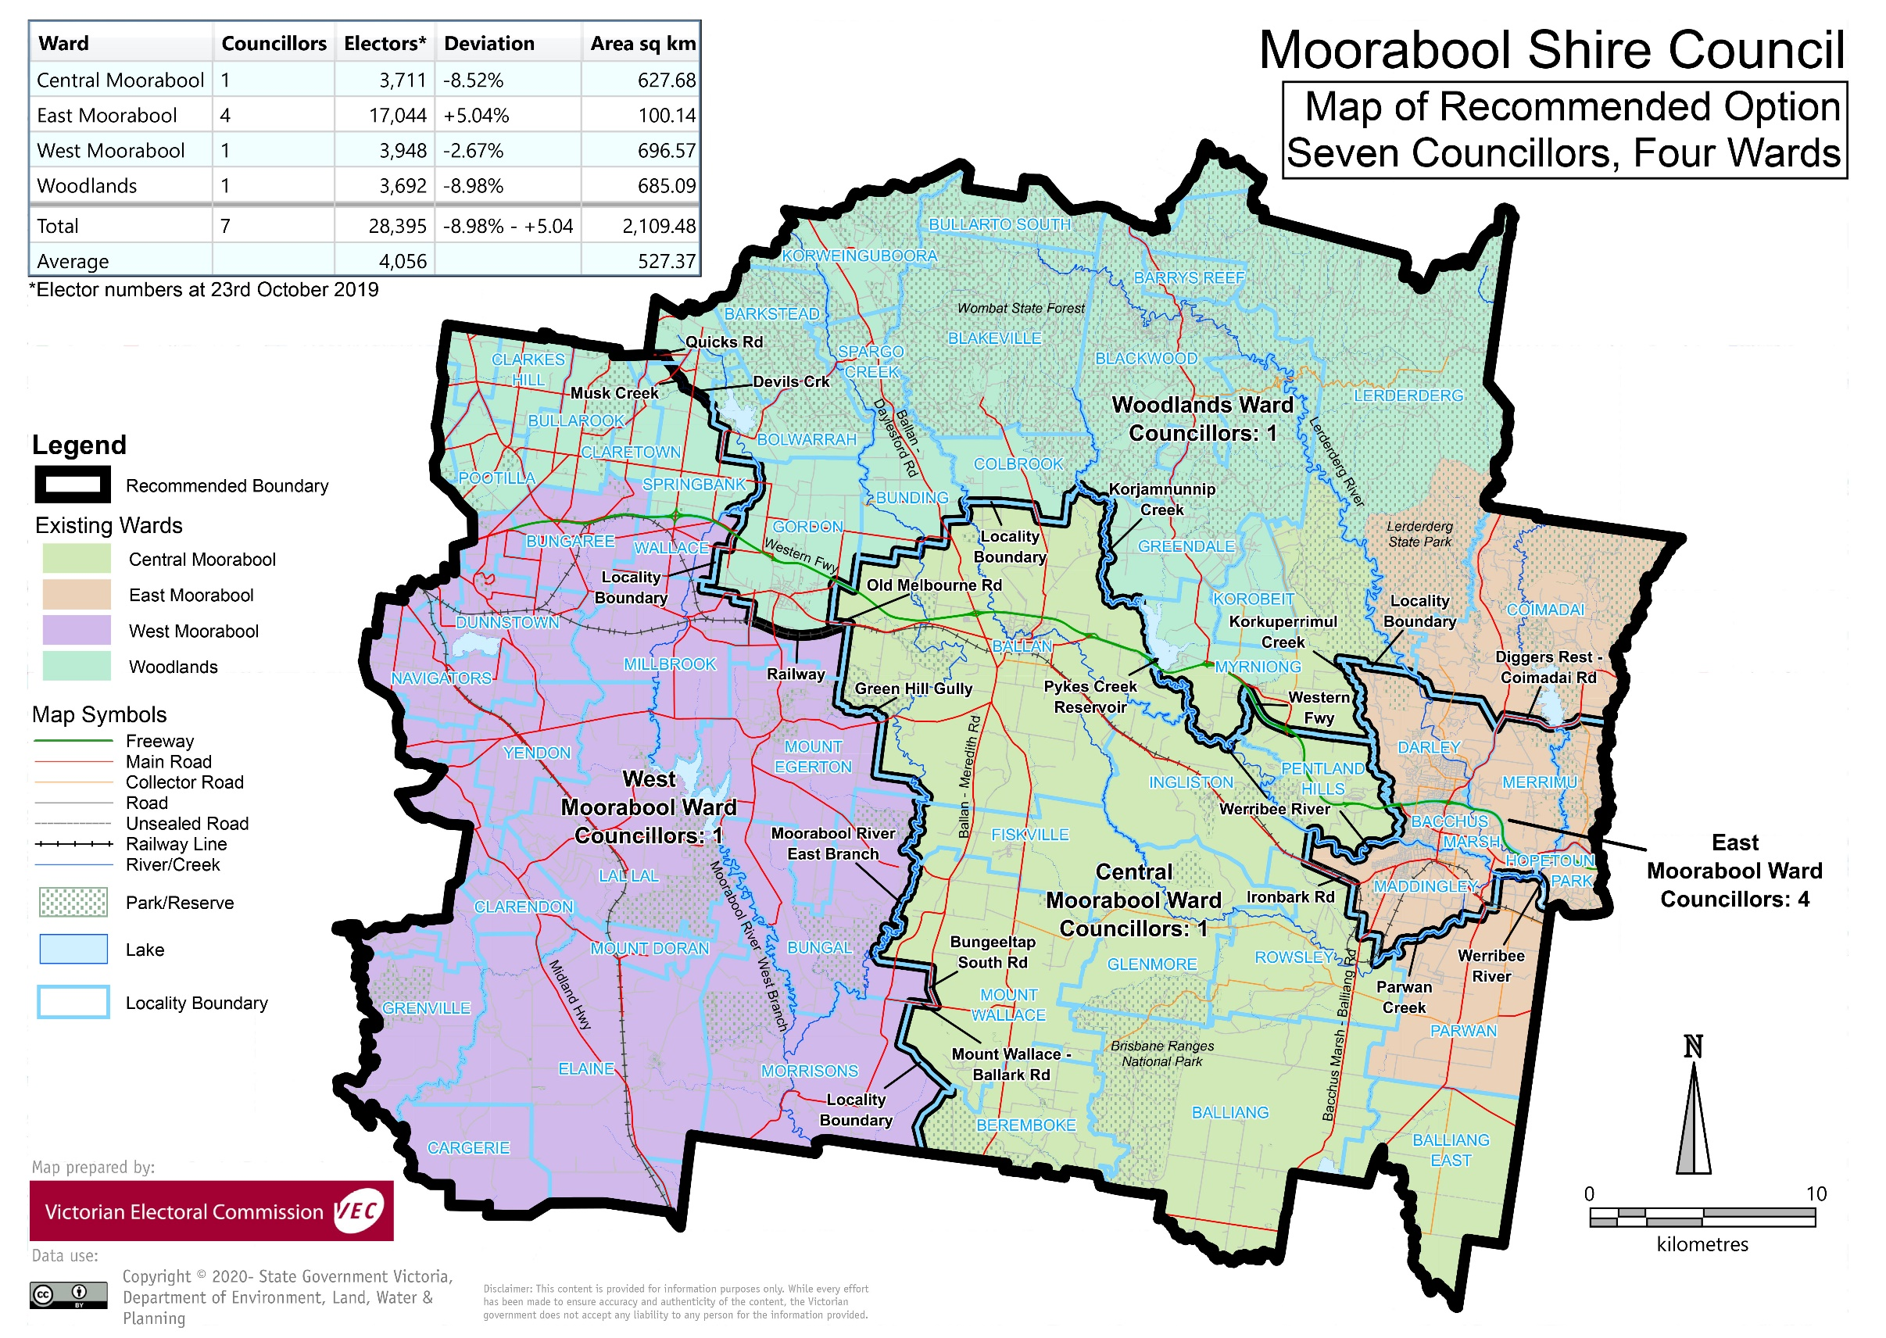

Appendix 2: Public information program
Advertising
Public notices of the release of the preliminary report were placed in the following newspapers:
Newspaper | Date of publication
Ballarat Courier | Saturday 22 February 2020
Bacchus Marsh Ballan Moorabool News | Tuesday 25 February 2020
Media releases
A media release was prepared and distributed to local media to promote the publication of the preliminary report on Friday 21 February 2020. A final media advisory was circulated on the publication date of this final report.
VEC website
The VEC website delivered up-to-date information to provide transparency and facilitate public participation during the review process. All public submissions were published on the website.

Online submission tool
An online submission tool was developed and made available during the submission period of the review. The tool allowed people to make a submission from the VEC website.
Email and social media engagement
The VEC delivered an information email campaign targeted at known community groups and communities of interest in the local council area. This included a reminder email at each milestone of the subdivision review process.
The VEC also published sponsored social media advertising that was geo-targeted to users within the local council area. The total reach of these posts was 2,562.

Council communication resources
The VEC provided the Council with a communication pack that included information on the review in various formats. While the council is encouraged to distribute this information and raise awareness about the review, the VEC is an independent reviewer and all communications resources include reference and links to the VEC website and core materials.

This page has been left intentionally blank

This page has been left intentionally blank

This page has been left intentionally blank

© State of Victoria
(Victorian Electoral Commission) April 2020
This work, the Local Council Subdivision Review – Final Report Moorabool Shire Council 2020,
is licensed under a Creative Commons Attribution 4.0 licence (http://creativecommons.org/ licenses/ by/4.0/). You are free to re-use the work under that licence, on the condition that you credit the State of Victoria (Victorian Electoral Commission) as author, indicate if changes were made and comply with the other licence terms. The licence does not apply to any branding, including government logos.
Level 11, 530 Collins Street
Melbourne Victoria 3000
T 131 832
info@vec.vic.gov.au
vec.vic.gov.au



Section 219H of the Local Government Act 1989.
Section 219L of the Local Government Act 1989.
Section 219L of the Local Government Act 1989.
.id is a consulting company specialising in population and demographic analysis and prediction information products in most jurisdictions in Australia and New Zealand.
Moorabool Shire Council, ‘Visit Moorabool’, accessed 6 April 2020, https://www.moorabool.vic.gov.au/visitors/visit-moorabool.
.id, ‘Moorabool Shire: about the profile areas’, accessed 6 April 2020, https://profile.id.com.au/moorabool/about.
.id, ‘Moorabool Shire: drivers of population change’, accessed 6 April 2020, https://forecast.id.com.au/moorabool/drivers-of-population-change.
.id, ‘Moorabool Shire: population summary’, accessed 6 April 2020, https://forecast.id.com.au/moorabool/population-summary. See also, .id, ‘Moorabool Shire: drivers of population change’.
Moorabool Shire Council, ‘About the Shire’, accessed 6 April 2020, https://www.moorabool.vic.gov.au/my-council/about-council/about-shire. See also, Moorabool Shire Council, Small Towns and Settlements Strategy: Part A, Moorabool Shire Council, [undated], p. 12. Available at: Moorabool Shire Council, ‘Moorabool 2041’, accessed 6 April 2020, https://www.moorabool.vic.gov.au/residents/building-and-planning/strategic-planning/moorabool-2041.
Australian Bureau of Statistics (ABS), ‘Census 2016 Quickstats: Gordon (Vic.)’, accessed 6 April 2020, https://quickstats.censusdata.abs.gov.au/census_services/getproduct/census/2016/quickstat/SSC21066?opendocument.
Moorabool Shire Council, Small Towns and Settlements Strategy: Part A.
Moorabool Shire Council, Small Towns and Settlements Strategy: Part A, pp.6-7.
.id, ‘Moorabool Shire: about the profile areas’.
.id, ‘Moorabool Shire: industry sector of employment’, accessed 6 April 2020, https://profile.id.com.au/moorabool/industries.
.id, ‘Moorabool Shire: residents place of work’, accessed 6 April 2020, https://economy.id.com.au/moorabool/residents-place-of-work?WebID=10.
Department of Environment, Land, Water and Planning (DELWP), Moorabool Planning Scheme, p. 164. The planning scheme was last updated 12 March 2020. Accessed 6 April 2020, available at: https://planning-schemes.delwp.vic.gov.au/schemes/moorabool.
DELWP, Moorabool Planning Scheme, p. 180.
Australian Bureau of Statistics (ABS), ‘2016 Census Quickstats: Moorabool (S)’, accessed 6 April 2020, https://quickstats.censusdata.abs.gov.au/census_services/getproduct/census/2016/quickstat/LGA25150?opendocument.
.id, ‘Moorabool Shire, Estimated Resident Population (ERP)’, accessed 6 April 2020, https://profile.id.com.au/moorabool/population-estimate.
DELWP, Victoria in Future: population projections 2012 to 2056, State Government of Victoria: Melbourne, 2019, p. 13.
Calculated from the VIF2019 Major Regions 2056 Data Table accompanying: DELWP, ‘Victoria in Future 2019’, https://www.planning.vic.gov.au/land-use-and-population-research/victoria-in-future, accessed 6 April 2020.
.id, ‘Moorabool Shire: dwellings and development map’, accessed 6 April 2020, https://forecast.id.com.au/moorabool/dwellings-development-map. See also, .id, ‘Moorabool Shire: population summary’.

