Local council elections
Voter education worksheets
August 2020

The VEC has created three voter education worksheets to help people who may have limited ability to read and /or understand written English.
The worksheets are designed as a co-read product and are best implemented by a supporter who can read through the information and relate it to the matching pictures, to support a person in their learning.
The worksheets are designed to introduce people to voting, and how to make their vote count in Victoria.
The VEC highly recommends that these worksheets be used after delivery of its remote video education sessions for the local council elections in October 2020.

More information
There are Easy English booklets about
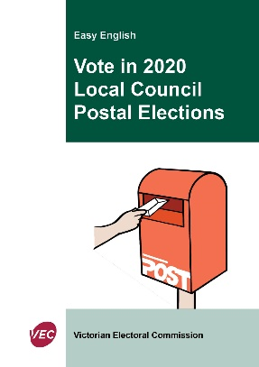
- voting in Local Council Postal Elections

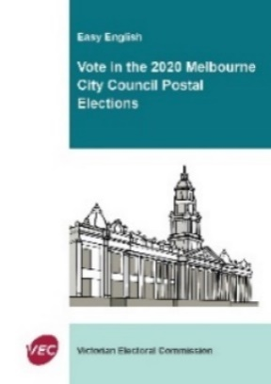

- voting in the Melbourne City Council elections
and

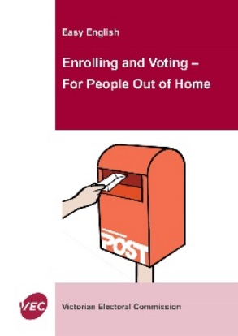

- For People Out of home.

Contact us
You can get more information from the Victorian Electoral Commission.

Website vec.vic.gov.au
Email info@vec.vic.gov.au

Worksheet 1

What is voting?
Voting is a way for people to make a choice.
Voting is about everyone being heard.
Voting is about us all being a part of decision making in the community.
We make choices every day. Let’s have a go

Activity 1.
What did you choose to eat today when you had breakfast?
(circle the items you had)
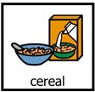  Cereal | Muffin | Coffee
Toast | Tea | Eggs
Fruit | Oats | Nothing

Activity 2.
What do you want to do today? (circle your choice)
Sleep/ relax | 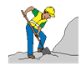  Go to work | 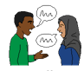  Talk to my friend
Go shopping | Go to school | 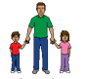  Look after family
Go to prayer | Go to gym | Watch TV

Voting in an election is also about us making a choice, but this time we need to choose between people.

We need to put our choices in an order.
We use numbers to show our order.
We write a different number against every person.

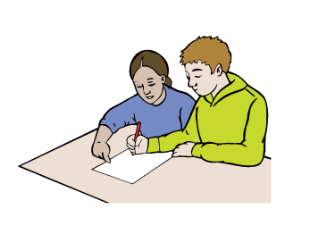
We can get someone to help us to learn about the different people before we choose, but we need to make the choice for ourselves when we write our numbers down.

Worksheet 2

How to enrol and who can enrol to vote

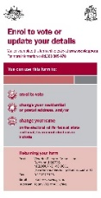

How to enrol
Enrolling means that you fill in an enrolment form with your name and details.
Sign your name to show you understand the form
or get help to sign it if you find this hard.
And post this form to the Victorian Electoral Commission

Activity 1.

Practice answering questions:
Write your first name ________________________________________
Write your last name ________________________________________
Write your date of birth _______________________________________
Write your address __________________________________________
Practice signing your name ___________________________________
Great work, you are ready to fill in an enrolment form now
The form is found on the VEC website or the Australian Electoral Commission website.
Let’s go look for the form vec.vic.gov.au
We must fill this form out every time we

- Move house
- Change our names

Who can enrol
Voting in all government elections is compulsory, so is enrolling.
We must do it. This makes it fair and equal that everyone gets a say.
In Australia, you must enrol if you are

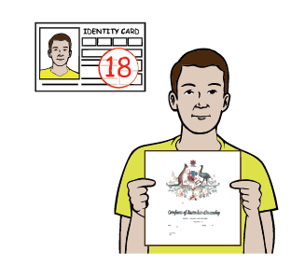
- 18 years old

- An Australian citizen

Even if you cannot read or write English, you must still enrol.
You can get help from others to enrol and to vote.

Activity 2.

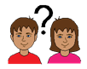
Who would you ask to help you to enrol and vote?

Write their name here__________________________________________

What councillors do
Your councillors make decisions about

- parks and sporting grounds
- community services
- libraries
- roads and footpaths
- rubbish and recycling
- public buildings and halls
- dog and cat registration
- building and construction.

Worksheet 3

How to fill out ballot papers
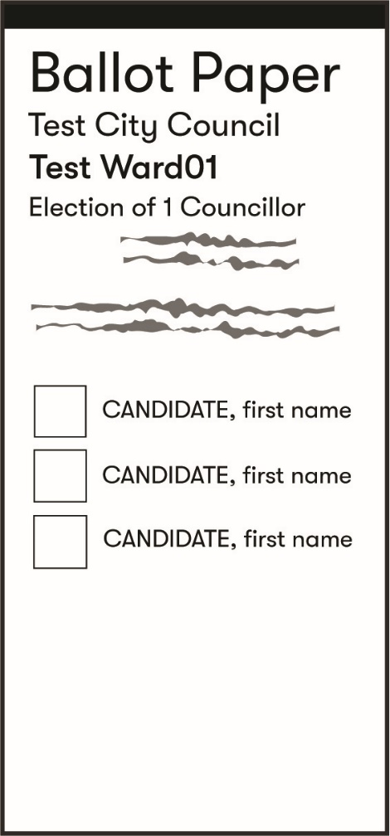
In Australia, we do our voting on a piece of paper called a ballot paper.
We must fill this ballot paper out the right way.
We use numbers to mark our choices in the order of who we want to win. This is called preferential voting.
You need to do some research first about the people on the ballot paper, so you know the top people you want to vote for.
Remember they will make choices about laws and your community on your behalf, so it is important.

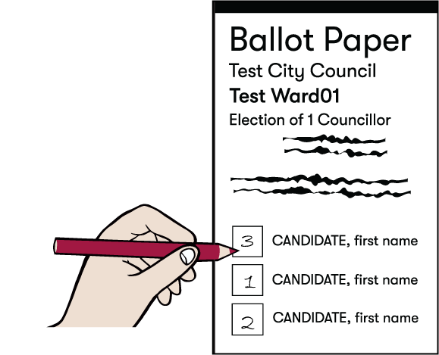
So your favourite person will be number 1.
Then your next favourite will be number 2.
And you keep filling in the boxes till every box has a different number in order of your choice.
Every ballot paper can be different, so get help to read the instructions before you start.
Do not leave any box empty.

Let’s have a go at this.
Can you write your numbers in order of your choice, from 1 to 8.
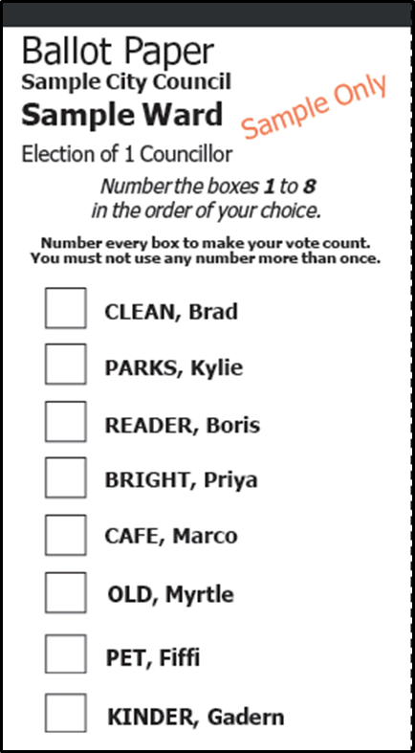
Then at times we get a bigger ballot paper to fill in.
We still use numbers to fill it in, but you must read the instructions as to how many boxes you have to fill out.
It could look like this example:
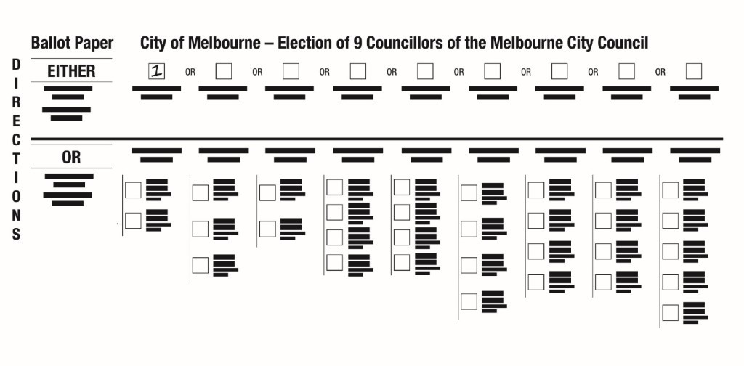
You must make a choice to either vote in the boxes above or below the line.
Above the line means just filling in one box with the number 1.
Voting below the line means you need to fill in ALL the boxes below the line.
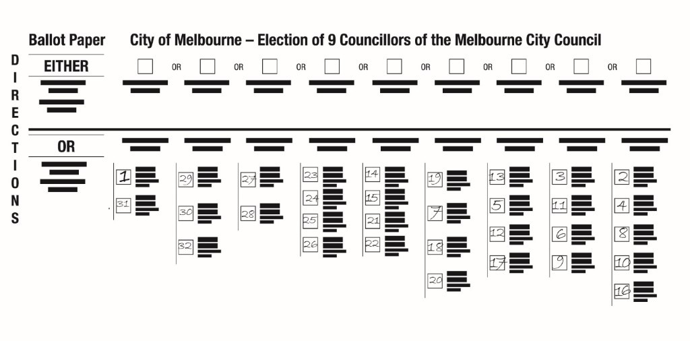
Remember to use your numbers and to fill in every box when asked to do so. Ask for help from someone you trust.

Who can help you to vote

If voting is hard for you to do by yourself, you can get some help.

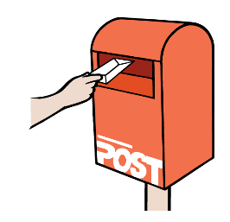
When we have a postal election and the ballot papers come by mail, you could get your family friends or supporters to help you.
They can guide you to read through and understand the instructions.
They can also help you to write out your voting choices, but YOU are the one who must decide how your vote will go.

A helper cannot make the choices for you, you must make the choices on who you want to vote for.
It is important to know you can get help, but you are the one who must make the choices for yourself.

