Local Council Elections 2020

Voting is   
for everyone

Facilitation guide

www.vec.vic.gov.au

Victorian Electoral Commission

Scope

Use this booklet to help you talk about the *Voting is for Everyone* video.

Who is this pack for?

This pack is for people with disabilities, their families and supporters/carers. It is designed to be used in combination with the online video *Voting is for Everyone* which looks at:

* how voting works
* how to enrol to vote
* why it is important for people with a disability to vote.

How to use this kit

Set a time to watch the *Voting is for Everyone* video online at <https://www.vec.vic.gov.au/resources/> with your family or group.

Also, if you need to enrol for the first time, or update your details, please print off an enrolment form at [www.vec.vic.gov.au](http://www.vec.vic.gov.au)

Before you start you will need these things:

* find the online video *Voting is for Everyone* at <https://www.vec.vic.gov.au/resources/>
* black or blue pen for filling in forms
* ID such as a driver licence, health care card or bank card
* citizenship number if you were not born in Australia.

This booklet has discussion points and support notes to help your group use this resource.

Contents

Part 1 What is democracy? 4

Part 2 Who can vote? 6

Part 3 Enrolling to vote 8

Part 4 Make a plan for voting 10

Part 5 Voting by post 12

Part 6 Election day 14

Election plan 16

This kit has been produced by the Victorian Electoral Commission (VEC). The VEC is responsible for running local and State elections, looking after the electoral roll, making sure that people and parties declare it when they donate or receive monies, and promoting public awareness of elections in Victoria.

The VEC would like to thank Scope for its valuable support in producing this resource.

Part 1 What is democracy?

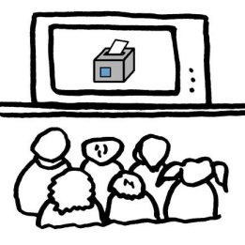 Watch Part 1 of the DVD.

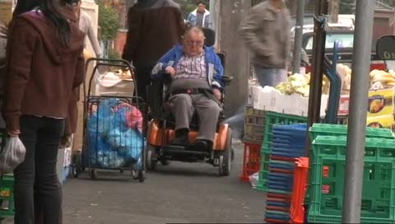



* What do you think when you hear the word democracy?
* How does democracy affect our everyday lives?
* What are some of the issues affecting our community?
* How many levels of government are there?
* Which levels are responsible for the different services in our community?

Support notes

Democracy comes from two ancient Greek words: *Demos* and *Kratos.* Democracy means ‘rule by the people’.

In Australia we have a representative democracy, which means we elect people to make decisions on our behalf.

There are three levels of government: local, State and Federal. Each level is responsible for different services in our community. See the Easy English guide *Vote in the 2020 Local Council Postal Elections*.

Part 2 Who can vote?

 Watch Part 2 of the DVD.



In the film David says, “I can’t read or write, I didn’t think I’d be able to do it”. If you can’t fill out a ballot paper, does that mean you can’t vote?

* Who can vote?
* Why is it important to vote?
* Who in our group has voted before?
* The next local council elections will be held in October 2020. Who wants to vote at this election?

Support notes

If you want to have a say about the different issues in our community - and are an Australian citizen aged 18 years or older - you should enrol and vote, regardless of whether you have a disability or not.

If you need help to fill out a ballot paper, you can ask a friend or relative or a support worker to help you complete your postal ballot pack this October for local council elections.

**Book a free electoral education session** with the VEC Education and Inclusion team to further support people to learn about voting and practice how to fill out ballot papers. We can do this remotely with you over the internet for local council elections 2020. Complete an online [VEC booking form](https://www.vec.vic.gov.au/voting/learn-to-vote/book-an-information-session) and we will call you to confirm a session with your group.

Part 3 Enrolling to vote

 Watch Part 3 of the DVD.

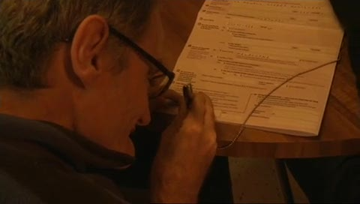



* What is the electoral roll?
* How do you enrol to vote?
* Is anyone in our group enrolled to vote?



If anyone would like to enrol to vote - fill out the forms provided. **Do it now** so you don’t forget!

You can check if you are enrolled by visiting   
[vec.vic.gov.au](http://www.vec.vic.gov.au)

Support notes

The electoral roll is a list of people who can vote in an election.

* If you are an Australian citizen over 18 years of age you must enrol to vote.
* The enrolment deadline if you need to enrol for the first time, or update your details like your name or address, is **4 pm on Friday 28 August 2020.**
* You only need to fill out one enrolment form to enrol to vote in local, State and Federal elections.

**What proof of identity do I need?**If you are using identification other than a driver licence (such as a Centrelink card), you will need someone else to verify your identity.

This person must know you and needs to be on the Commonwealth electoral roll.

**Can someone help me fill in the form?**Yes, you can ask someone to help you. They should read out **everything** on the form, so you understand what you are signing.

**What if I am unable to sign the form?**

If you cannot sign the enrolment form you can make a mark.

If you cannot sign or make a mark you can ask someone to fill in a special enrolment form: “Electoral enrolment for persons unable to sign their name due to physical incapacity” on your behalf. A doctor's certificate must be supplied with this form.

**Can someone be removed from the electoral roll?**

A person may be removed from the roll where a doctor has signed a certificate to say that the person is not able to understand the nature and significance of enrolment and voting. This certificate needs to be accompanied by a “Removal from the roll” form.

**Will I be fined if I have not enrolled in the past?**

No. Enrolment is compulsory, but you will not be fined if you have never enrolled to vote before now. If you have been enrolled to vote in the past and believe you have an unpaid fine for not voting, you should call the VEC on 131 832 for advice.

All forms are available from [vec.vic.gov.au](http://www.vec.vic.gov.au) or you can call   
131 832 and ask for them.

Part 4 Make a plan for voting

 Watch Part 4 of the DVD.

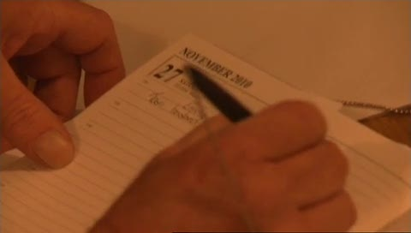

* Who might help you to vote (if you need it) in the election?
* How do we find out who the candidates are and what they stand for?
* What do the people in the DVD say about it?

On your election plan, fill out how you will vote in the election (in person or by post), and how you will find out who you can vote for.

If you live or work in a Specialist Disability Accommodation (SDA), write the election dates in the house diary.

Support notes

**How to vote in the 2020 local council elections**

All local council elections held in October 2020 will be postal. Ballot packs will be mailed out to all enrolled Victorians between **6-8 October**.

If you have not received your ballot pack by **16 October**, contact your local council election office. Contact details for your election office can be found at: <https://www.vec.vic.gov.au/voting/2020-local-council-election/elections>

**Local councils not having elections in 2020**

Only 76 of Victoria’s 79 local councils will be having elections in October 2020.

The three Councils **not** having elections are:

Casey City Council, Whittlesea City Council, and South Gippsland Shire Council.

**Who should I vote for?**

The VEC website will have a full list of local council election candidates after 22September 2020. See [vec.vic.gov.au](http://www.vec.vic.gov.au).

You can write down how you plan to find out about the candidates on the election plan at the end of this booklet.

Part 5 Voting by post

 Watch Part 5 of the DVD.

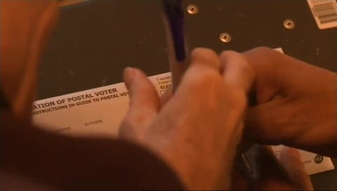



In the DVD Greg must work on election day so he has decided to vote by post.

Will anyone in your group need to vote by post?

* If yes, stay on this page
* If no go to page 15

Some people may already be general postal voters (GPV), which means they automatically receive ballot papers in the post for every local, State and Federal election**.

Support notes

The 2020 local council elections will be held by post only. No voting centres will be open.

For State elections, people can register as a General Postal Voter, so that you will automatically receive your ballot papers in the post.

You can also ask for a postal vote for State Elections if it is just a one-off request, by registering with the VEC at the time of a State election.

**Key dates for voting by post**

**6-8 October** Ballot packs will be posted out.

Open and fill out your ballot papers as soon as you get them in your letterbox and post them back to the VEC as quick as you can.

If you have not received your ballot pack by **16 October** **2020**, please call the VEC on **131 832**.

** Voters do not receive ballot packs for Federal elections if they applied to be a GPV under the age category (70 years or older).Part 6 Election Day

 Watch Part 4 of the DVD.

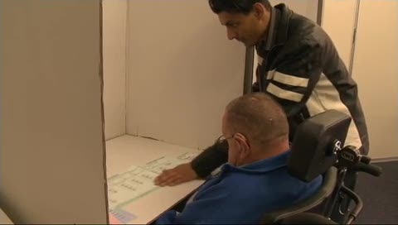



* What happens when you go to a voting centre?
* How do you fill out a ballot paper?
* When you vote can you ask for help? Can you take someone to the voting centre with you?

Support notes

**Remember** that the local council elections this October are being held by post. You will not be going to a voting centre to fill out your ballot paper - you need to fill it out at **home.**

**How do I fill out a ballot paper?**

To make your vote count you need to fill in the ballot paper correctly. Follow the instructions on the ballot paper or ask for help. **See page ## of the Easy English Guide — Vote in the 2020 Local Council Postal Elections** for more information.

**For State and Federal Elections** When you go to vote in person, the staff at the voting centre will ask you three questions:

* What is your name?
* Where do you live?
* Have you voted in this election before?*

**Can I take a support person?**

Yes. You can take someone with you to the voting centre to help you fill in the ballot paper. You can also take any writing aids or equipment you need. If you prefer, you can ask an election official to assist you. Remember, no one should tell you who you should vote for. It is up to you.

* The election official is required by law to ask this question. It is designed to stop people from accidently voting in the election more than once. Election plan

Fill out this plan before the election:

|  |  |
| --- | --- |
| who to vote for | Learn about who to vote for: |
| saturday | The date we are going fill out the ballot paper is: |
| 9 O'clock | The time we are going to vote at home is: |
| staff | Our support people will be: |
|  | The nearest post box is at: |
| Bus | We are going to get there by: |

How to contact us

You can get more information from the Victorian Electoral Commission.

 Website vec.vic.gov.au

 Email info@vec.vic.gov.au

**Postal address**

 Victorian Electoral Commission

Level 11, 530 Collins St, Melbourne, 3000.

**Phone**

 131 832

+61 3 86201100 (from outside Australia)

National Relay Service 133 677 and ask for 03 8620 1100

For speech-to-speech relay, phone 1300 555 727 and ask for 03 8620 1100

Blank Page

Blank Page

Address all enquiries to the Victorian Electoral Commission, Level 11, 530 Collins St, Melbourne, Victoria, 3000



© State of Victoria (Victorian Electoral Commission) 2020.

This work, Easy English Guide, is licensed under a Creative Commons Attribution Non-Derivatives 4.0 licence (http://creativecommons.org/licenses/by-nd/4.0/). You are free to share this work under that licence, on the condition that you do not change any content and you credit the State of Victoria (Victorian Electoral Commission) as author and comply with the other licence terms. The licence does not apply to any branding, including Government logos or the Easy English icon.